V5.2 North Slope Gas Hydrate Full ML Workflow Companion
This companion page explains the V5.2 diagram package requested for the slide refresh. The package connects source and schema controls, OpenScienceLab and approved-runtime inputs, the guarded pressure-temperature stability branch, well-log physics equations, the leakage barrier, occurrence classification, saturation regression, validation, and reviewed exports. The refreshed slide deck includes both complex architecture diagrams inside the presentation: the expanded full workflow map and the ML runtime/network detail.

Project Status In Plain Language
The project is building a defensible North Slope workflow for gas hydrate occurrence classification and saturation regression. The public GitHub/Streamlit side explains source-backed methods, public scaffold counts, diagrams, and public-safe outputs. OpenScienceLab and the later approved runtime are where raw source bundles, approved well logs, core/NMR information, target labels, feature engineering, model fitting, validation, and reviewed outputs belong.
The public scaffold currently has 8,084 wells, 43 GGD223 permafrost controls, 184 G10015 profiles, 3 hydrate AUs, 483 temperature-profile matches, and about 3 / 71 approved datasets visible for schema design only.

Three Visual Levels
- Slide 3 is the readable mentor-scale overview for a live presentation.
- Slide 4 embeds the expanded poster as the detailed architecture map with sources, equations, gates, features, targets, validation, outputs, and caveats.
- Slide 7 embeds the ML runtime detail focused on X allowed, the Y-only label rail, split/preprocess/model controls, output heads, and validation.
- Slides 5, 6, 8, and 9 are readable zoom slides that explain stability context, variable fingerprints, modeling decisions, and mentor decisions without cramming poster text into one slide.

Current ML Architecture Decisions
- Occurrence classification and saturation regression are linked but separate outputs. Occurrence uses approved evidence labels; saturation regression uses an approved saturation target field only after authority and units are confirmed.
- Numeric predictors use train-only 0-1 scaling after a whole-well, compartment, or geographic split. Depth remains the alignment and context axis unless a mentor explicitly approves depth as a predictor.
- The model ladder is baseline models first, tree or boosting models second, and ANN/Keras third. A candidate ANN is an architecture option, not a trained project result.
- Stability may enter X allowed only as context, mask, confidence, caveat, or blocked reason if approved. It cannot create occurrence labels, saturation targets, or validated predictions.
- Caliper coverage is checked before washout filtering. If caliper, CAL1, or differential caliper coverage is insufficient, the runtime carries a missing-QC flag instead of silently filtering rows.
- Missing-log adapters for Vp or RHOB remain optional and mentor-approved; alternate log combinations are the default lower-risk strategy until adapters are validated on North Slope data.

Variable Fingerprint And Intake Validator
Before a source column can enter X allowed, it needs a variable fingerprint: original header, unit, normalized name, role, normalized-or-raw status, feature-matrix permission, leakage risk, public-safe display status, and unresolved mentor question. This keeps origin headers such as DEPTH, GR, RHOB, Rt, Sgh, S_h, Sh, and NMR_SAT visible instead of hiding them behind aliases.
The public-safe validator in dashboard/approved_data_intake.py and the CLI runner in 01_pipeline/validate_approved_data_headers.py audit headers only. They can report recognized headers, unknown headers, missing required fields, target-only leakage, unresolved units, caliper-gate status, missing-log adapter status, occurrence/saturation target authority, blocked reasons, and training readiness without reading or printing approved row values.

Research Source Anchors
Chong et al. 2024 / USGS supports the architecture pattern of ANN-style hydrate occurrence classification and saturation prediction from well-log inputs. It classifies hydrate occurrence types and predicts saturation in a marine hydrate setting, so this project uses it as a model-architecture anchor rather than as North Slope performance evidence: https://pubs.usgs.gov/publication/70250169
Occurrence is treated here as a target or validation label, not something measured or proven by the pressure-temperature stability screen. In the approved runtime, occurrence evidence can come from core or pressure-core observations, NMR/core-derived saturation, validated multi-log interpretation, or documented seismic indicators. Each occurrence label needs source, interval, confidence, and caveat metadata before model training or validation.
The Singh/NETL source identifies Well-MTE as the Mt. Elbert Stratigraphic Test Well and Well-IGS as the Ignik Sikumi Test Well in the Alaska North Slope / Eileen Gas Hydrate Trend case-study context. The public workbook headers MTE_refined and IGS_refined should remain blue mentor questions until approved metadata confirms whether they are raw/refined processing stages: https://www.osti.gov/servlets/purl/1893637
The MDPI missing-log study supports the general plausibility of using machine learning to estimate missing Vp and bulk density logs in marine hydrate settings. It does not automatically validate missing-log adapters for North Slope permafrost sediments, so any Vp/RHOB adapter must be optional, mentor-approved, and validated before use: https://www.mdpi.com/1996-1073/16/23/7709

What Is Complete Outside Stability
- The public/runtime data boundary is documented and reflected in the V5.2 workflow diagrams.
- The approved-data schema coverage matrix preserves original headers and separates measured inputs, derived features, QC/alignment fields, calibration/reference fields, target-only fields, and unresolved fields.
- The target registry and leakage guardrails keep Sgh, S_h, Sh, NMR_SAT, hydrate-saturation fields, Swr, S_wr, and phase labels out of the predictor matrix.
- The Analyze Hydrates page includes Schema Coverage & Architecture, Public ML Readiness, and Target Registry & Leakage views without exposing approved rows or model metrics.
- The future ML architecture is defined as a leakage-safe path to linked occurrence classification and saturation regression, but final training and performance reporting remain blocked until approved labels and complete rows are available.

What Stability Currently Does
The baseline public stability screen has 8,084 rows, 22 calculated pressure-temperature admissibility intervals, 8 sufficient-input no-stable-interval rows, and 8,054 blocked rows. It uses the cited methane 5 ppt phase lookup, hydrostatic absolute pressure, public G10015/GGD223 temperature and permafrost context, and source-control caveats.
- It can serve the ML workflow as context, a mask, a confidence field, a caveat field, or a reason flag.
- It does not prove hydrate occurrence, estimate saturation, define final top/base/thickness for approved interpretation, rank sweet spots, or replace log/core evidence.
- Blocked rows mean the calculation refused to overclaim without required inputs; they do not mean no hydrate.

How Approved OSL Data Feed The Future ML Pipeline
- Approved LAS/CSV/core/NMR and workbook inputs are loaded only inside OSL or the approved runtime.
- Original headers, units, sheet/source identity, and depth references are preserved before alias mapping.
- Measured log families and approved derived physics equations build X allowed after unit checks, QC, and depth alignment.
- Target-only occurrence and saturation fields bypass X allowed and are used only for target mapping, calibration, and validation overlays.
- Occurrence evidence can come from core or pressure-core observations, NMR/core-derived saturation, validated log interpretation, or regional seismic indicators, but it remains target/validation evidence.
- Validation uses complete wells, compartments, or geographic holdouts selected before preprocessing, tuning, or model fitting.
- Reviewed outputs become occurrence probability, saturation estimate, uncertainty/QC/reason flags, plots, tables, GIS links, and public-safe summaries only after boundary review.

Slide 3 Mentor Overview
This version stays presentation-readable and leaves detailed evidence to the poster, runtime-detail slide, and later zoom slides.
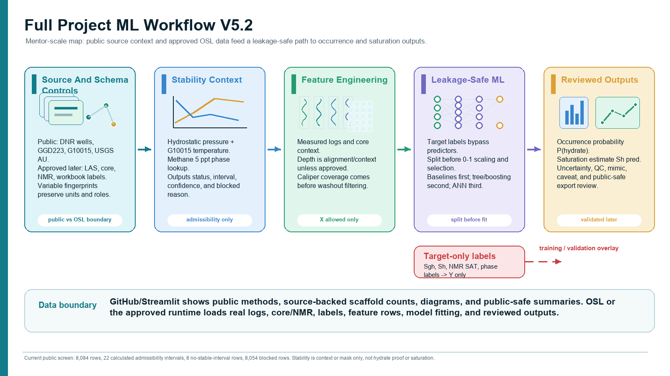

Expanded Poster Detail
This poster is the complete architecture reference. It includes the public source counts, approved OSL inputs later, stability equations, target-only labels, leakage controls, validation expectations, public-safe outputs, and mentor decision points.
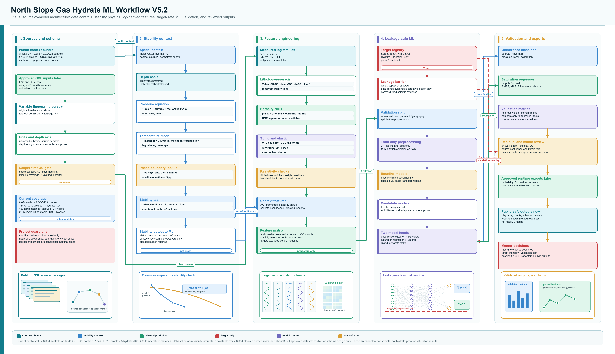

ML Architecture Detail
The companion architecture visual is embedded in slide 7 and expands the modeling block into feature groups, QC, the X allowed matrix, whole-well split controls, train-only preprocessing, a simplified candidate model, two output heads, and the target-only rail used for training labels and validation overlays.
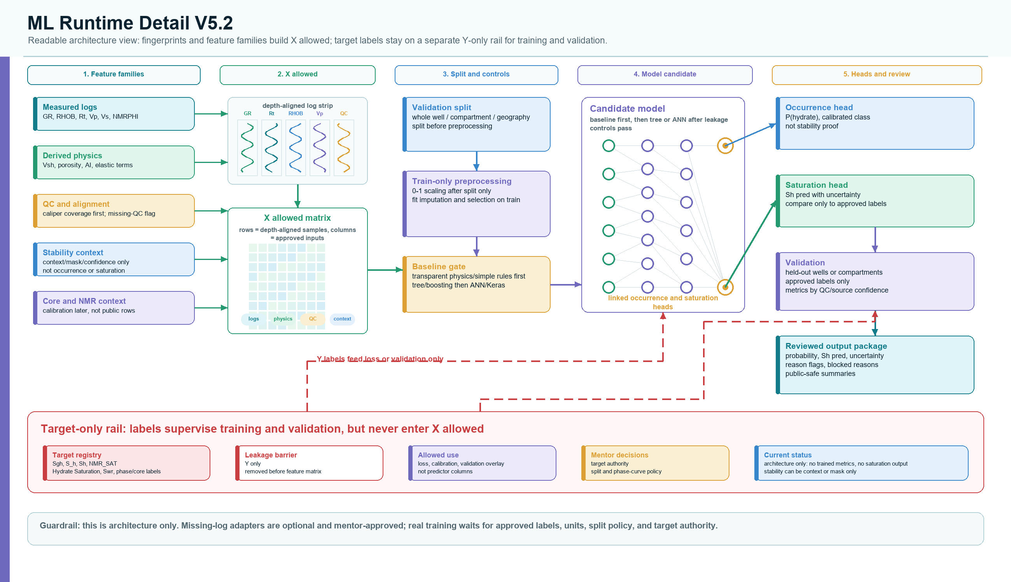

How To Read The Diagram
- The slide-sized summary separates source/schema controls, stability context, feature engineering, leakage-safe ML, and reviewed outputs.
- The expanded poster shows the full OSL and approved-runtime path: raw source rebuilds, approved logs/core/NMR later, pressure-temperature stability context, feature engineering, modeling, and validation.
- The equation blocks show how pressure, temperature, phase-boundary lookup, lithology, porosity, velocity, elastic, and saturation-baseline calculations become context fields, features, or validation checks.
- The stability branch feeds context, masks, confidence labels, and caveats into the ML workflow. It does not become hydrate proof or a saturation label.
- The leakage barrier keeps S_h, Sgh, NMR_SAT, phase labels, and final ranks out of predictor features unless a field is proven to be an independent measured input.
- The final ML design keeps occurrence classification and saturation regression linked but separate.

Current Status Shown In The Figure
Complete | Calculated | Blocked / Future
Public/OSL boundary; phase curve; pressure model; temperature-model logic; 8,084 public wells; 43 controls; 184 profiles; guarded writer. | 919 temperature key depths, 387 extrapolated key depths, and 22 baseline stability-admissibility intervals. | 15,249 temperature key-depth rows, 8,054 screen rows, approved logs/core/NMR, trained ML metrics, saturation outputs, hydrate proof, and sweet-spot ranking.

Required Guardrail Language
This is a workflow and admissibility-screen diagram. It does not claim final hydrate stability, hydrate proof, hydrate saturation, validated ML performance, producibility, or sweet spots.

Mentor Decisions Needed
- Phase-curve policy: keep methane 5 ppt as the only official baseline, or add a clearly labeled scenario table?
- Target authority: which occurrence and saturation labels are official when Sgh, S_h, Sh, NMR_SAT, hydrate saturation, or phase labels differ?
- Validation split: should final testing use whole-well holdout, compartment holdout, geographic holdout, or a staged combination?
- Temperature handling: when G10015 is missing, should rows stay blocked, use nearest-control proxy tiers, or use explicit scenario-only gradients?
- ML use of stability: is the stability screen allowed as context, confidence, reason flag, or mask only, never as an occurrence label?
- Public website outputs: which diagrams, counts, schema, caveat views, and readiness views are acceptable before approved model validation?

