V5.5 Mentor Update North Slope Gas Hydrate ML Workflow Companion
This companion explains the V5.5 revision built from the V5.4 corrected source-baseline deck. It keeps the personal/about-me opener, source-backed hydrate and North Slope context, the full complex workflow diagram, and the complex ML runtime architecture in the main nine-slide sequence. The update adds a clean DOE three-dataset prototype explanation, a visual model-run card, a stability-to-ML overlay, and a clearer done/not-claimed/next status section.

Current Public And Runtime Position
The public scaffold tracks 8,084 Arctic Slope public wells, 184 G10015 temperature profiles, 483 temperature-profile matches, and 22 methane 5 ppt calculated stability-admissibility intervals. The public side still supports schema/runtime prototyping, source-backed visuals, and guardrail documentation, not public approved-data rows or final model results.
The DOE side now has a public-safe runtime path for the three curated workbooks. Dataset 1 can train prototype saturation regressors, datasets 2 and 3 are treated as external review or alternate training sets depending on target availability, and row-level outputs, predictions, fitted models, and manifests remain in ignored runtime folders.

What V5.5 Adds
- Slide 5 explains the cleaned DOE three-dataset prototype and model-run card: targets S_h, S_wr, Sh, and Swr are Y-only; cleaned canonical features enter X_allowed; depth/helper/raw-alias columns are excluded; training-fit metrics are runtime proof only.
- Slide 8 makes the stability overlay explicit: context, mask, confidence, and caveat are allowed uses; occurrence proof, saturation, hydrate-present labels, and negative labels for blocked rows are not allowed.
- Slide 9 closes with what has been done, what is not claimed, and what must happen next before final ML or stability claims.

Guardrail Language
- Use 'training-fit/runtime proof only' for current DOE prototype metrics, not final model performance.
- Use 'stability-admissibility context' for the public screen, not hydrate proof, occurrence, or saturation.
- Keep S_h, S_wr, Sh, Swr, Sgh, NMR_SAT, hydrate saturation, occurrence labels, and phase labels out of X_allowed.
- Bring back only public-safe summaries after mentor, data-owner, and release review.

Slide-By-Slide Companion

Slide 1 - Personal/about-me opener
Preserved from V5.4 to keep the agreed mentor-facing opener style.
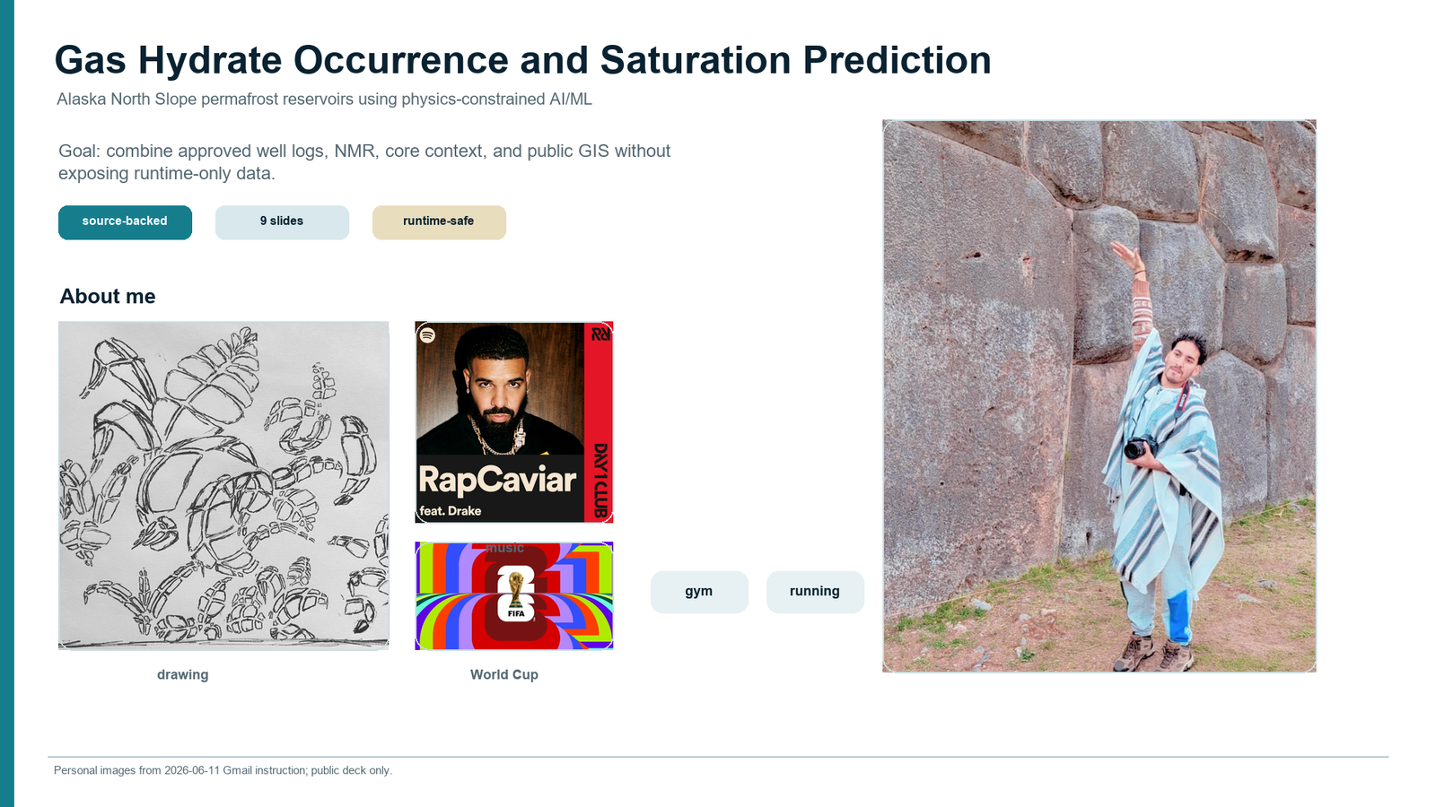

Slide 2 - Source-backed hydrate and North Slope context
Preserved V5.4 USGS hydrate, methane 5 ppt phase-curve, and public map provenance. No AI-looking hydrate/PT art is added.
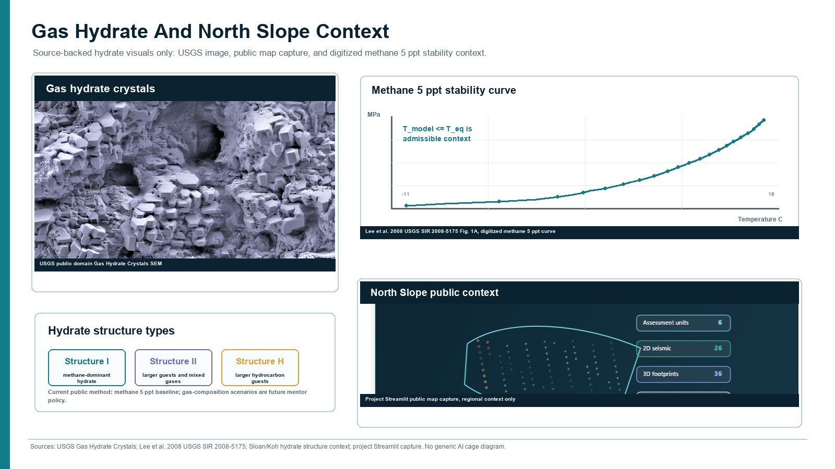

Slide 3 - Parameters and expected hydrate ranges
Preserved the registry-backed range board: working envelopes, mimics, roles, and Y-only labels.
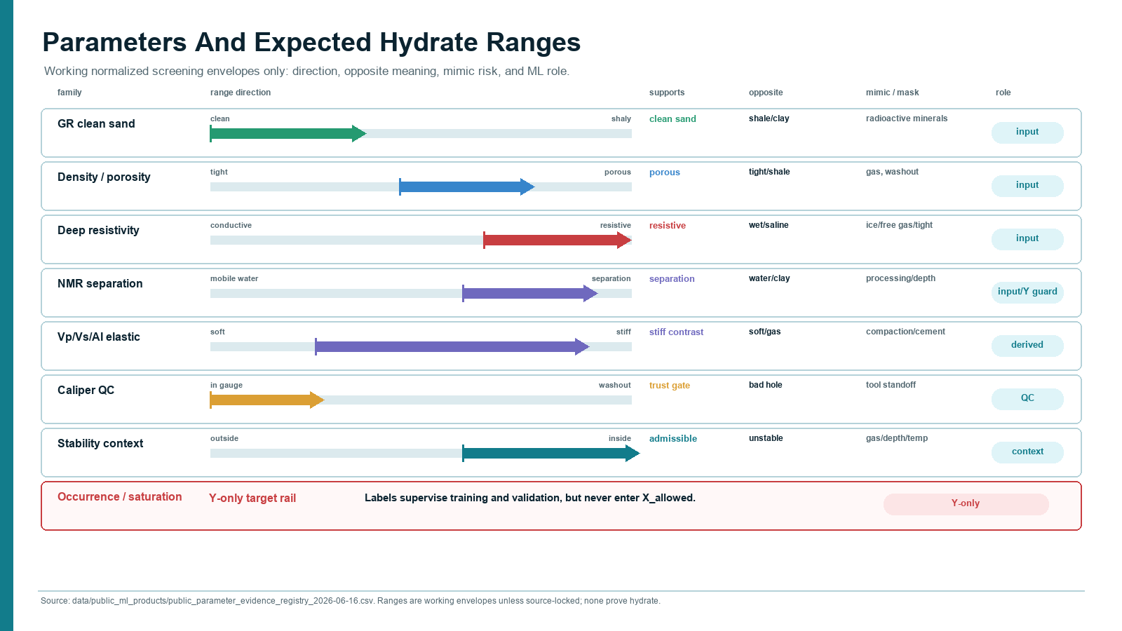

Slide 4 - Full complex project workflow
Kept the whole complex architecture as a main-sequence plate, not an appendix-only reference.
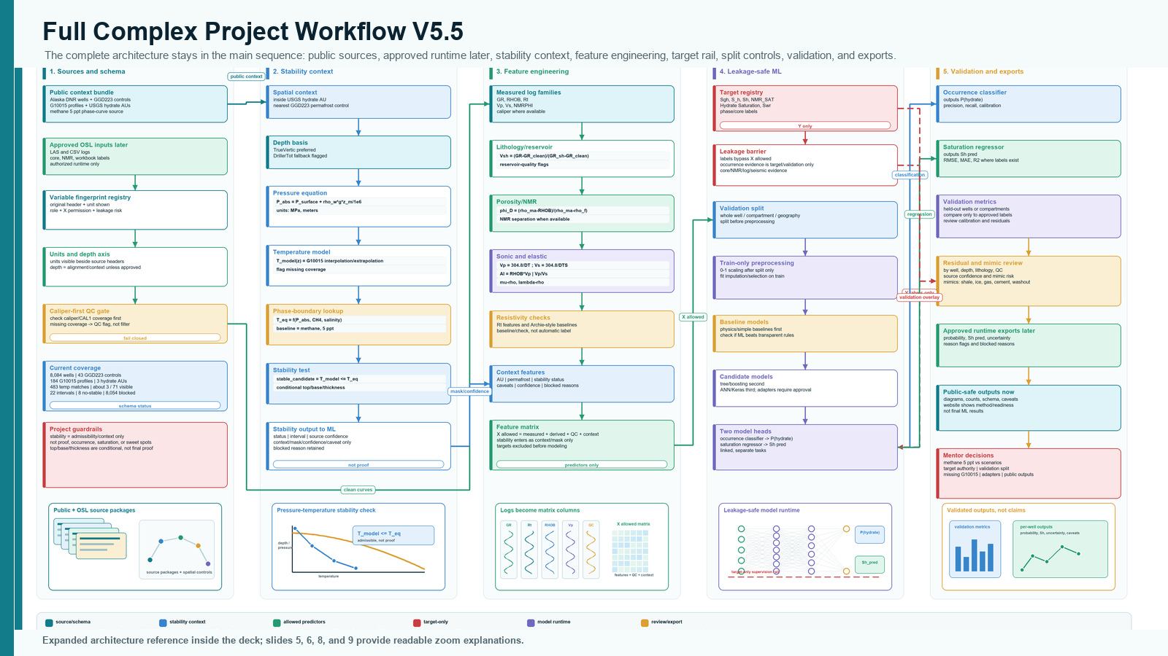

Slide 5 - DOE three-dataset prototype
Adds the cleaned prototype story, feature exclusions, target-only saturation variants, and training-fit disclaimer.
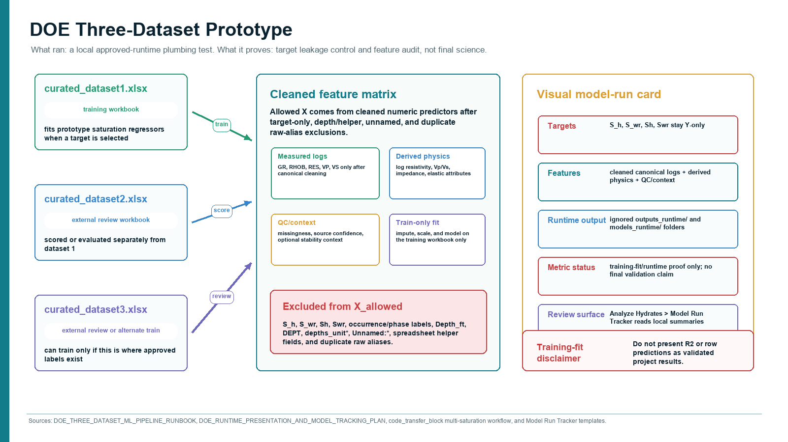

Slide 6 - Equations, feature engineering, and unit gate
Preserves the unit/QC/leakage gate for equation features.
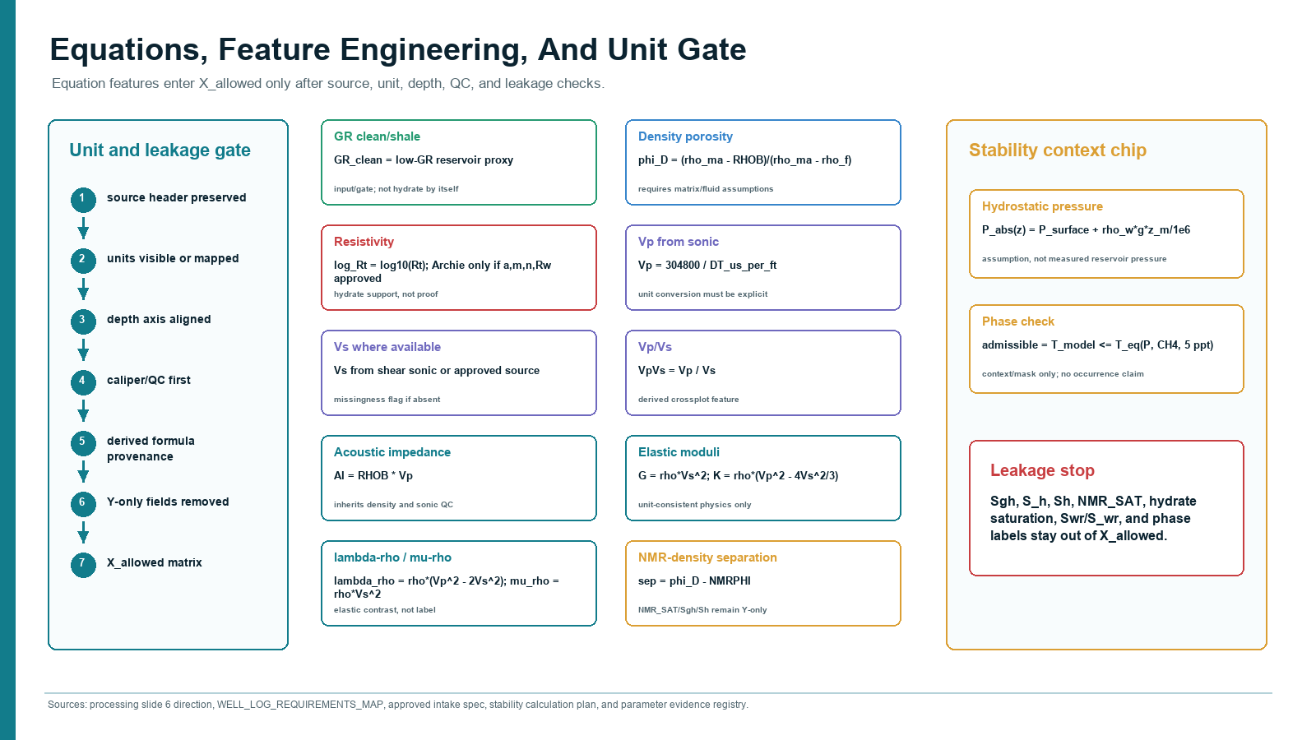

Slide 7 - Complex ML runtime architecture
Keeps the complete ML runtime plate in the main sequence.
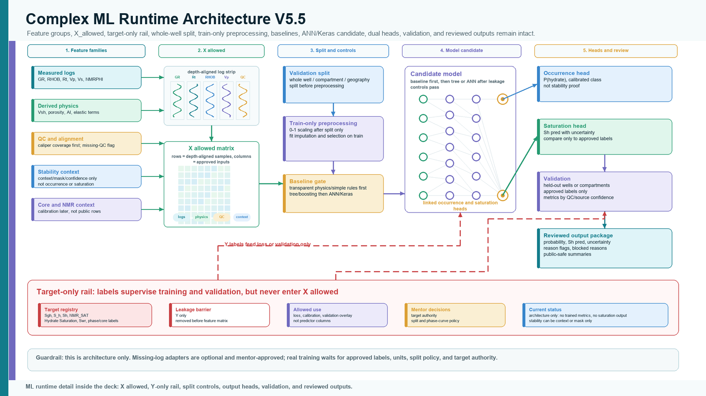

Slide 8 - Stability-to-ML overlay
Shows stability as context, mask, confidence, and caveat only.
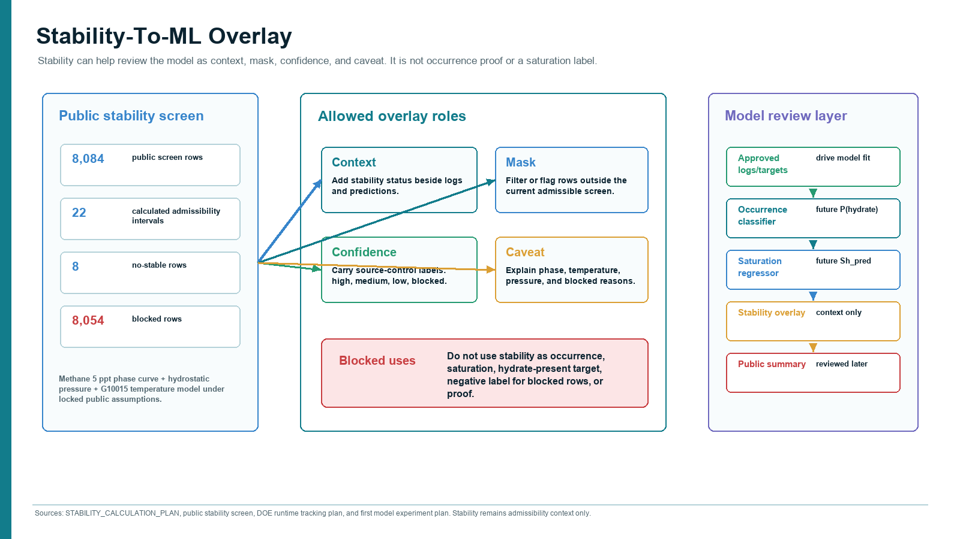

Slide 9 - Done / not claimed / next
Closes with current accomplishments, explicit non-claims, and next approved-runtime steps.
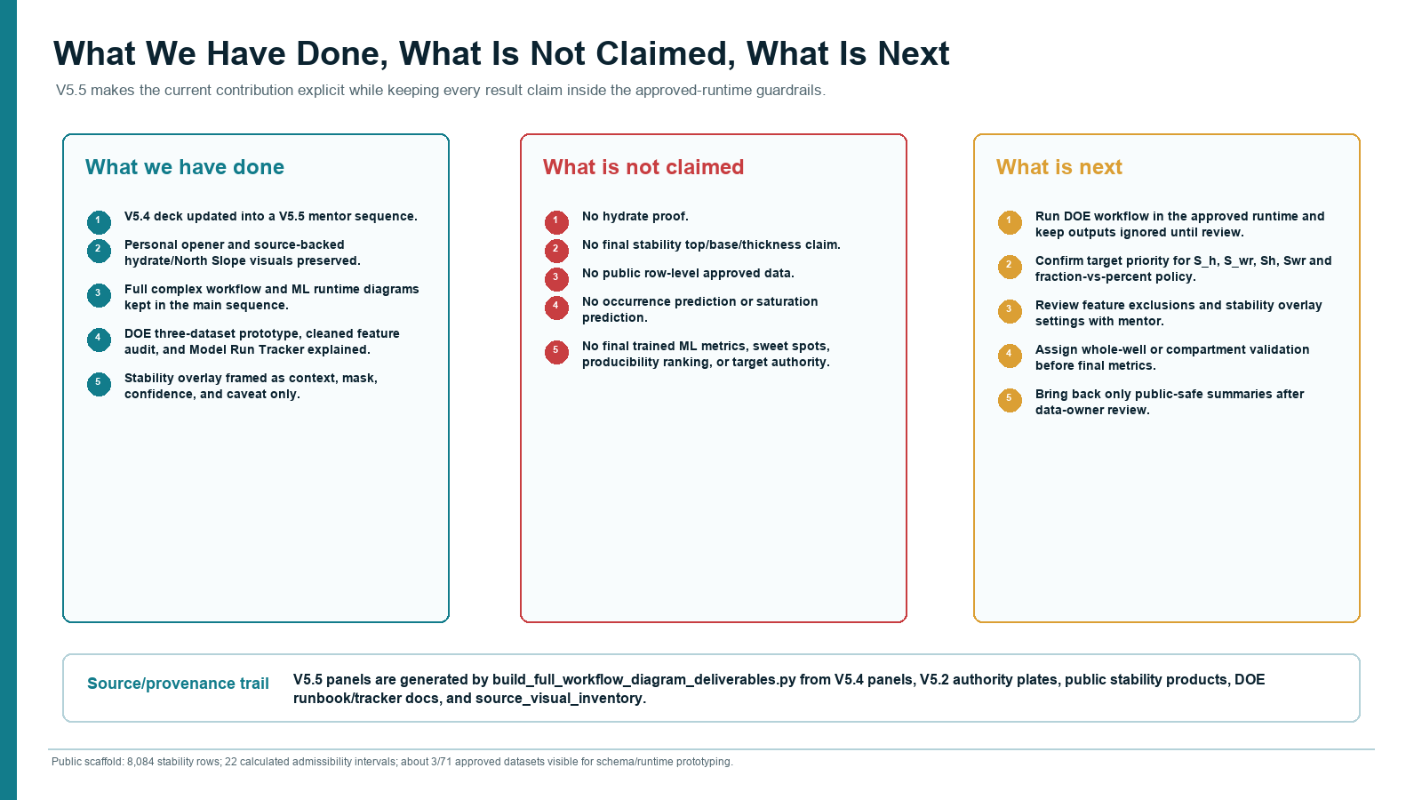

Contact Sheet
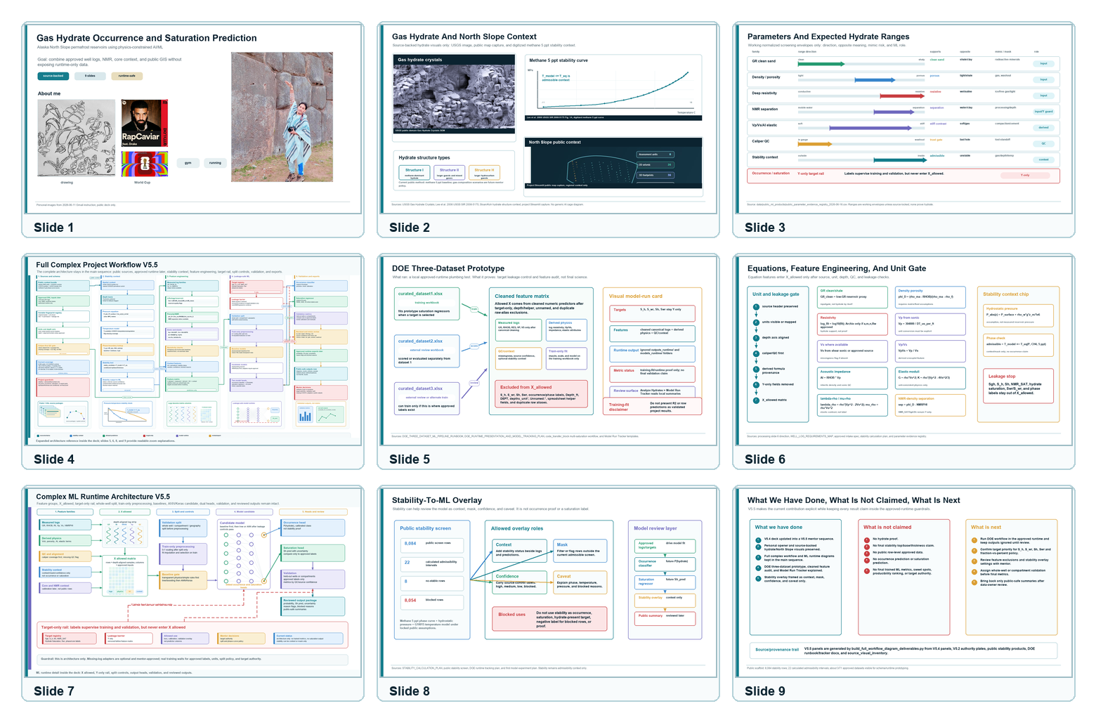

Source And Visual Provenance
- docs/project_blueprints/presentation_assets/v5_4_corrected_2026_06_16/ for the active V5.4 source panels.
- docs/project_blueprints/presentation_assets/full_workflow_diagram_2026_06_15/ for the V5.2 complex workflow and ML runtime authority plates.
- data/public_ml_products/source_visual_inventory_2026-06-16.csv for slide and website visual provenance.
- docs/DOE_THREE_DATASET_ML_PIPELINE_RUNBOOK_2026-06-16.md and docs/DOE_RUNTIME_PRESENTATION_AND_MODEL_TRACKING_PLAN_2026-06-16.md for the DOE prototype language.
- docs/STABILITY_CALCULATION_PLAN.md and public stability products for the stability overlay.

