V5.5 Slide 3 Signal Response Update North Slope Gas Hydrate ML Workflow Companion
This companion explains the V5.5 revision built from the V5.4 corrected source-baseline deck, with Slide 2 rebuilt from the selected USGS/DOE source screenshot, its cropped stability graph, the project website map, and the digitized methane 5 ppt project CSV inset. Slide 3 is now rebuilt from the local signal-response source package so the deck explains co-moving hydrate-indicator signals across depth rather than another parameter-range table. It keeps the personal/about-me opener, source-backed hydrate and North Slope context, the full complex workflow diagram, and the complex ML runtime architecture in the main nine-slide sequence. The update adds a clean DOE three-dataset prototype explanation, a visual model-run card, a stability-to-ML overlay, and a clearer done/not-claimed/next status section.

Current Public And Runtime Position
The public scaffold tracks 8,084 Arctic Slope public wells, 184 G10015 temperature profiles, 483 temperature-profile matches, 374 rows ready for phase-curve inputs, and 22 methane 5 ppt calculated stability-admissibility intervals. The public side still supports schema/runtime prototyping, source-backed visuals, and guardrail documentation, not public approved-data rows or final model results.
The DOE side now has a public-safe runtime path for the three curated workbooks. Dataset 1 can train prototype saturation regressors, datasets 2 and 3 are treated as external review or alternate training sets depending on target availability, and row-level outputs, predictions, fitted models, and manifests remain in ignored runtime folders.

What V5.5 Adds
- Slide 2 now uses the selected USGS/DOE page-3 hydrate stability source screenshot/crop as the primary stability visual, the project website regional map as North Slope context, and the digitized methane 5 ppt CSV only as a project input inset.
- Slide 3 now shows a depth-aligned signal-response stack: stability/BGHS context, GR, caliper QC, porosity/RHOB, Rt, Vp, Vs/mu-rho, and NMR/core move together with hydrate-compatible, free-gas-mimic, and bad-hole intervals.
- Slide 5 explains the cleaned DOE three-dataset prototype and model-run card: targets S_h, S_wr, Sh, and Swr are Y-only; cleaned canonical features enter X_allowed; depth/helper/raw-alias columns are excluded; training-fit metrics are runtime proof only.
- Slide 8 makes the stability overlay explicit: context, mask, confidence, and caveat are allowed uses; occurrence proof, saturation, hydrate-present labels, and negative labels for blocked rows are not allowed.
- Slide 9 closes with what has been done, what is not claimed, and what must happen next before final ML or stability claims.
Slide 2 structure language is intentionally narrow: Structure I methane-dominant hydrate is the project baseline. Structure II and Structure H can occur with larger hydrocarbons such as ethane, propane, butane, or heavier components, but they are not the current North Slope baseline claim. Variable gas composition stays a mentor-approved sensitivity path.

Guardrail Language
- Use 'training-fit/runtime proof only' for current DOE prototype metrics, not final model performance.
- Use 'stability-admissibility context' for the public screen, not hydrate proof, occurrence, or saturation.
- Keep S_h, S_wr, Sh, Swr, Sgh, NMR_SAT, hydrate saturation, occurrence labels, and phase labels out of X_allowed.
- Bring back only public-safe summaries after mentor, data-owner, and release review.

Slide-By-Slide Companion

Slide 1 - Personal/about-me opener
Preserved from V5.4 to keep the agreed mentor-facing opener style.
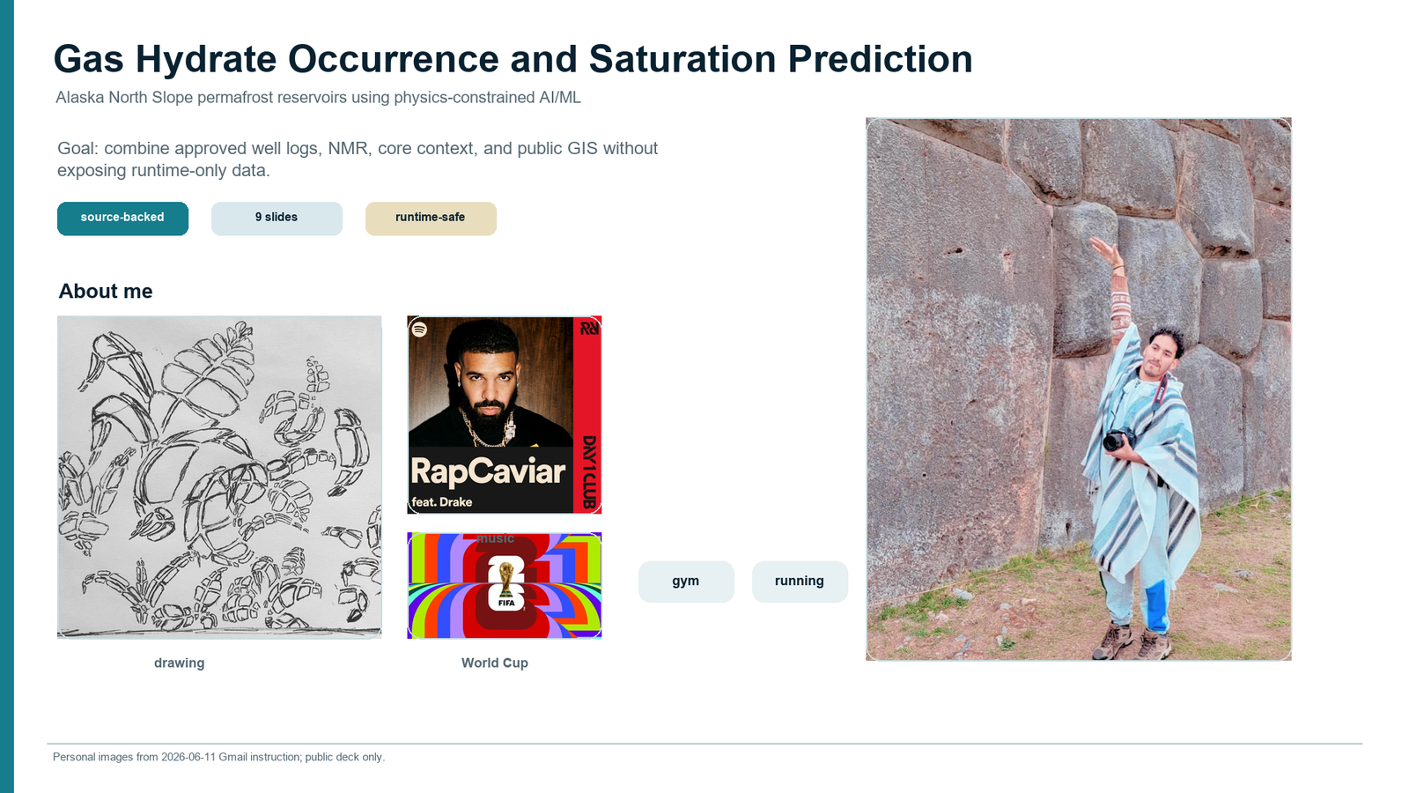

Slide 2 - Source-backed hydrate and North Slope context
Rebuilt with the selected USGS/DOE page-3 stability source screenshot/crop as the primary stability visual, a project website regional map for North Slope context, and the project digitized methane 5 ppt CSV only as a small input inset. The slide explains that Structure I methane-dominant hydrate is the current baseline; Structure II and Structure H can occur with larger hydrocarbons such as ethane, propane, butane, or heavier guests, but they are not the current claim. Stability remains a pressure-temperature admissibility screen only; occurrence and saturation evidence must come from approved logs, core, NMR, and mentor-reviewed labels.
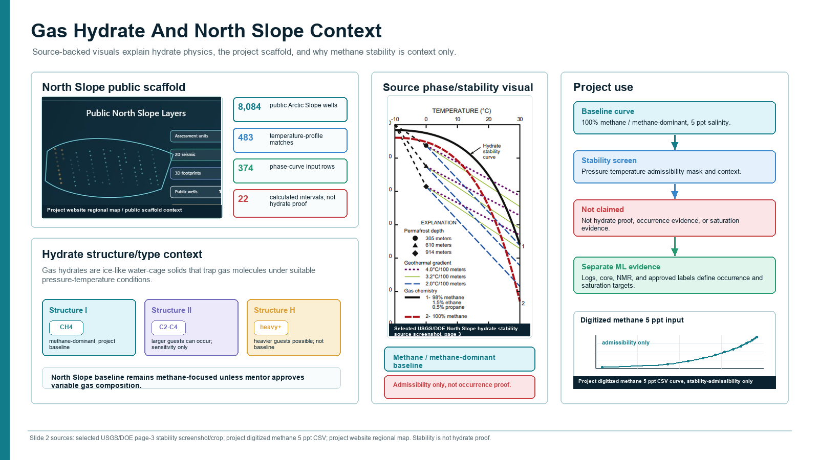

Slide 3 - Hydrate signal movements across depth
Rebuilt from the local Slide 3 signal-response source package. The slide uses a public-safe synthetic depth stack plus local CSV-derived stability and USGS public-domain log/QC references to show the interpretation ladder: stability context, clean porous host, electrical and elastic response, NMR/core calibration, and guardrails. It explicitly separates hydrate-compatible clean sand from free gas or resistive mimics and bad-hole QC, while keeping Sgh, S_h, Sh, Hydrate Saturation, NMR_SAT, Swr, and phase labels on the Y-only rail.
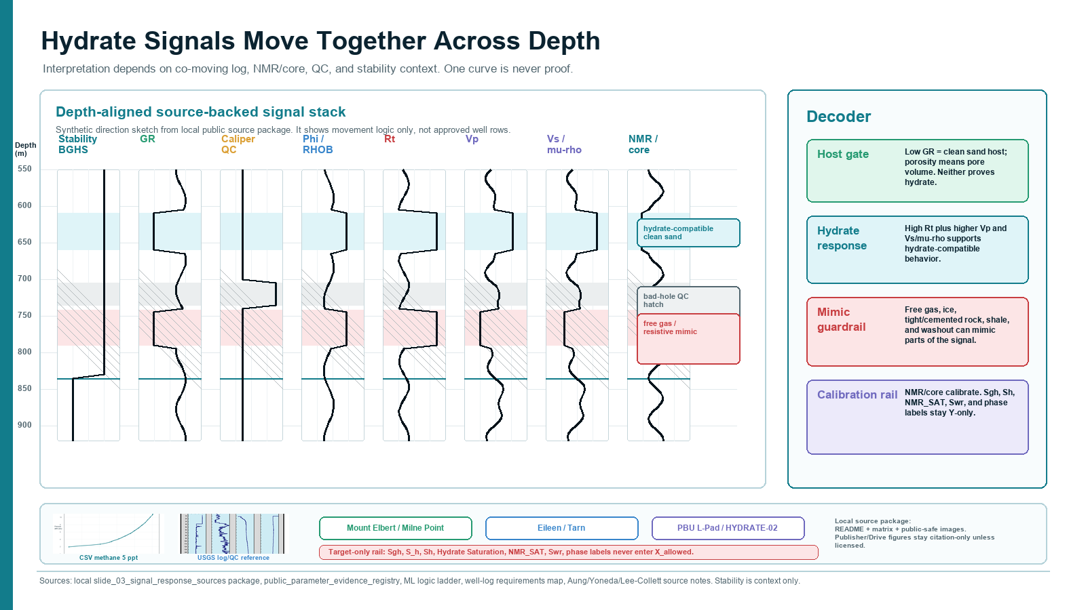

Slide 4 - Full complex project workflow
Kept the whole complex architecture as a main-sequence plate, not an appendix-only reference.
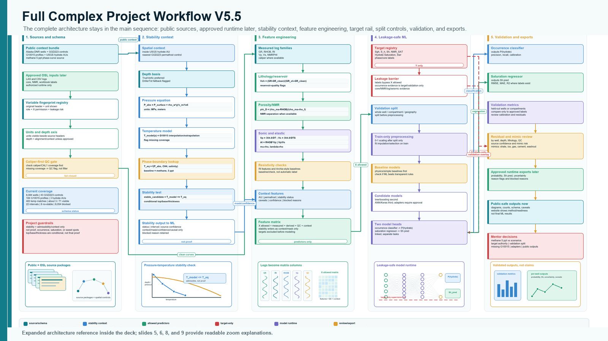

Slide 5 - DOE three-dataset prototype
Adds the cleaned prototype story, feature exclusions, target-only saturation variants, and training-fit disclaimer.
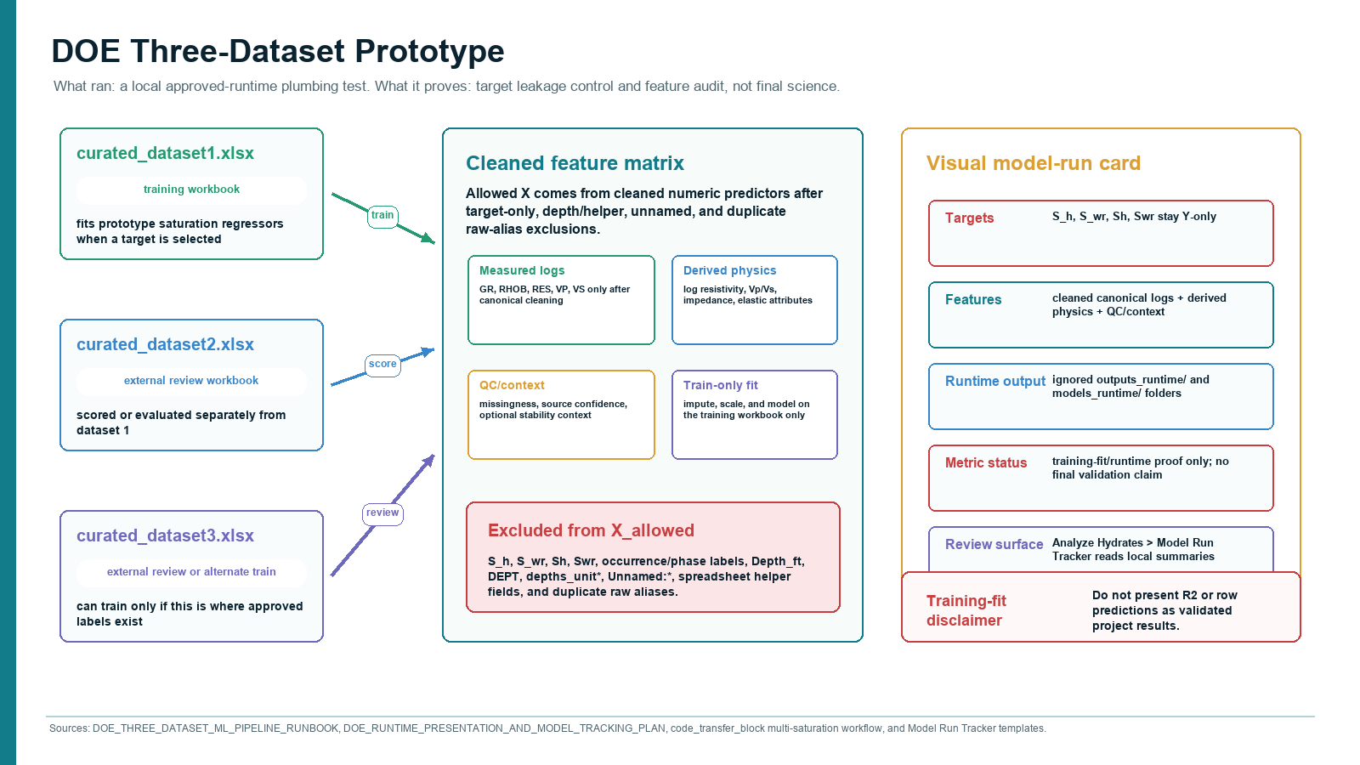

Slide 6 - Equations, feature engineering, and unit gate
Preserves the unit/QC/leakage gate for equation features.
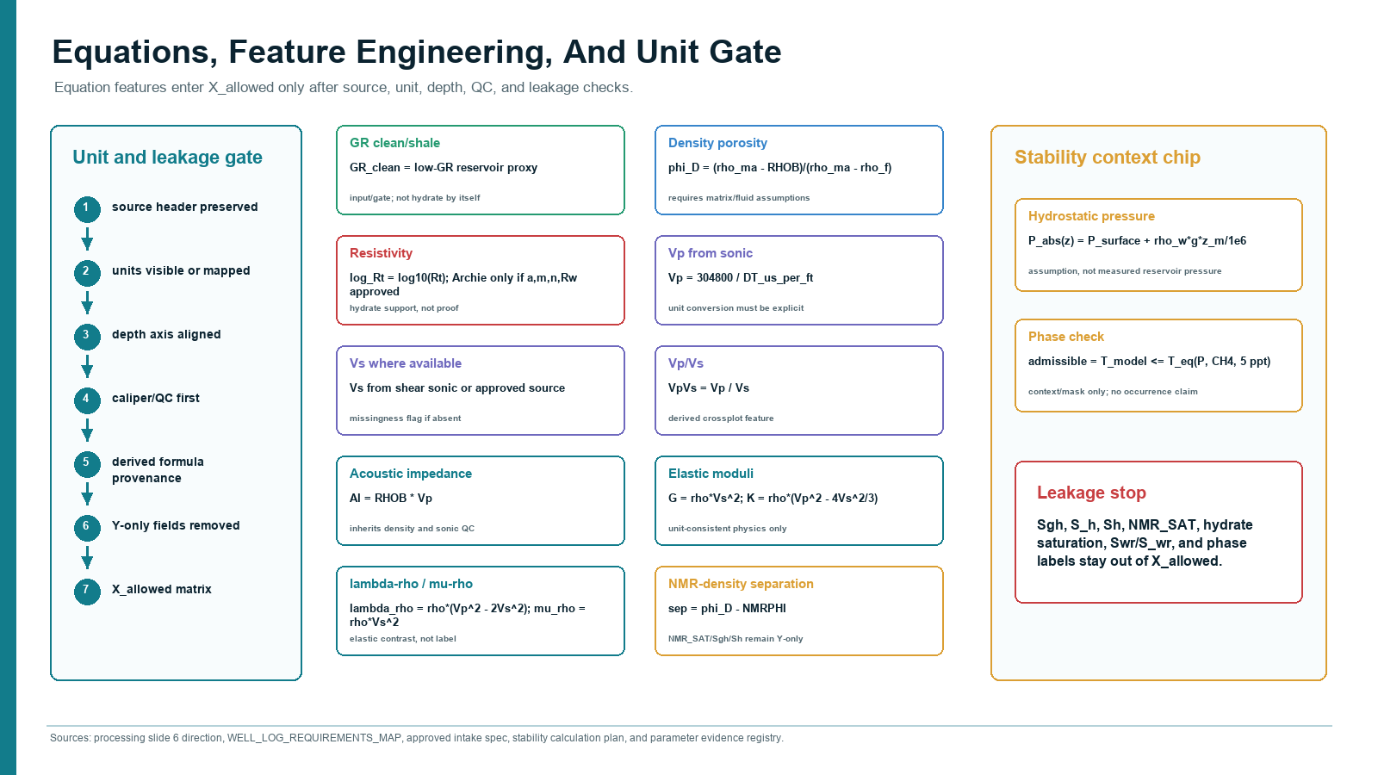

Slide 7 - Complex ML runtime architecture
Keeps the complete ML runtime plate in the main sequence.
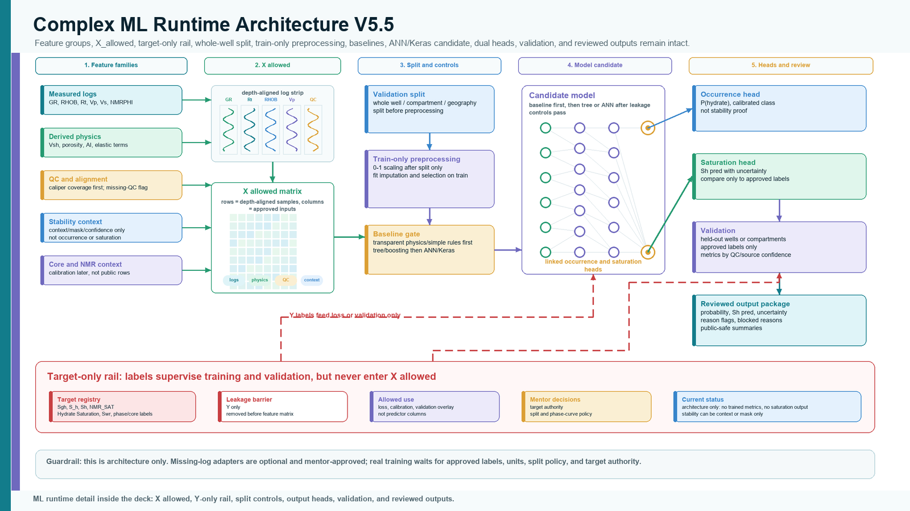

Slide 8 - Stability-to-ML overlay
Shows stability as context, mask, confidence, and caveat only.
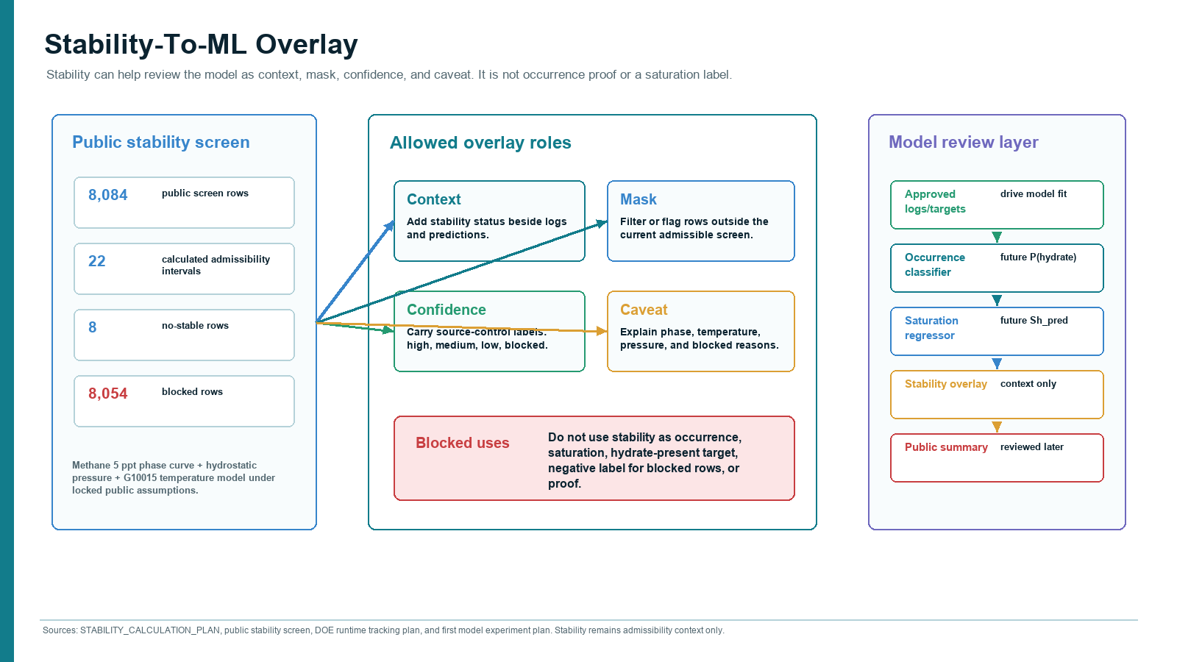

Slide 9 - Done / not claimed / next
Closes with current accomplishments, explicit non-claims, and next approved-runtime steps.
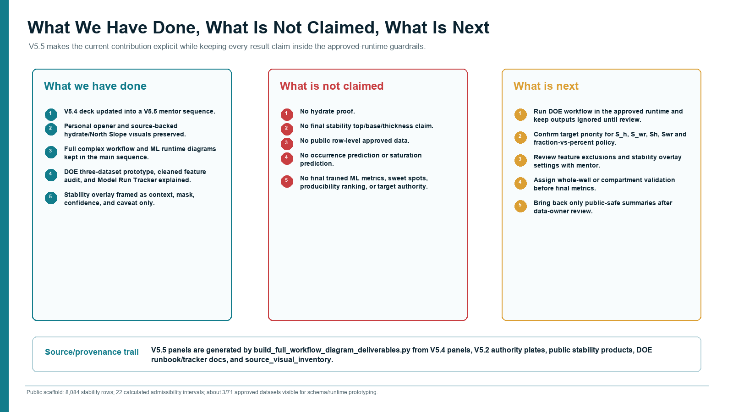

Contact Sheet
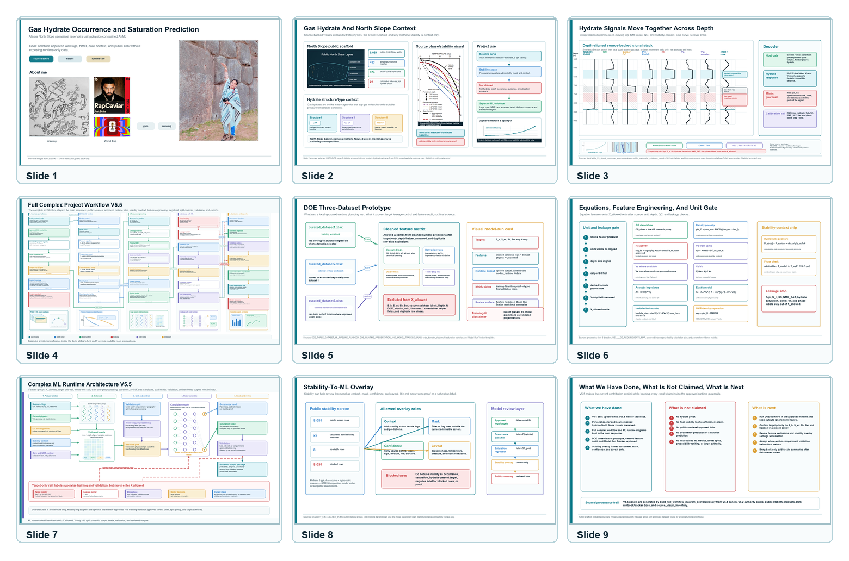

Source And Visual Provenance
- docs/evidence/slide02_source_bundle_2026_06_17/ for the rebuilt Slide 2 source bundle.
- docs/project_blueprints/presentation_assets/slide_03_signal_response_sources_2026_06_17/ for the rebuilt Slide 3 local source package, README, source-to-visual matrix, CSV-derived stability inset, USGS public-domain log/QC crops, and public-safe signal-response template.
- Original selected USGS/PDF page screenshot: https://drive.google.com/file/d/17T48zhoJKvxB21dJUovXhN-6V8DEgzf7/view?usp=drivesdk
- Cropped hydrate stability curve: https://drive.google.com/file/d/1_edIg2LrifTnCL2GP23fcWfnpvIGulYn/view?usp=drivesdk
- Digitized methane 5 ppt CSV inset: https://drive.google.com/file/d/1O7hFSgt3eEjaYt3FocJUlFhAZuswwlm3/view?usp=drivesdk
- Website regional map reference: https://drive.google.com/file/d/1CmfuViTiplCB9ayYOjSgLOiQlZaFGCx9/view?usp=drivesdk
- docs/project_blueprints/presentation_assets/v5_4_corrected_2026_06_16/ for the V5.4 reference panels.
- docs/project_blueprints/presentation_assets/full_workflow_diagram_2026_06_15/ for the V5.2 complex workflow and ML runtime authority plates.
- data/public_ml_products/source_visual_inventory_2026-06-16.csv for slide and website visual provenance.
- docs/DOE_THREE_DATASET_ML_PIPELINE_RUNBOOK_2026-06-16.md and docs/DOE_RUNTIME_PRESENTATION_AND_MODEL_TRACKING_PLAN_2026-06-16.md for the DOE prototype language.
- docs/STABILITY_CALCULATION_PLAN.md and public stability products for the stability overlay.

