V5.4 Corrected North Slope Gas Hydrate ML Workflow Companion
This companion explains the corrected nine-slide mentor deck. V5.4 restores the personal opener and the complex workflow/runtime diagrams, replaces AI-looking hydrate visuals with source-backed figures, and keeps the project guardrails explicit. It does not report hydrate proof, trained metrics, occurrence predictions, saturation predictions, or approved/private data rows.

Current Public State
The public scaffold currently tracks 8,084 Arctic Slope public wells, 184 G10015 temperature profiles, 483 temperature-profile matches, and 22 methane 5 ppt calculated stability-admissibility intervals. Only about 3/71 approved datasets are visible for schema design. The ML scaffold exists, but no model training has started.

Hydrate Structures And North Slope Methane Context
Gas hydrate is an ice-like crystalline solid where water cages trap guest gas molecules. Structure I is the methane-dominant hydrate structure used as the current public baseline. Structure II can host larger guest molecules and mixed gases, and Structure H involves larger hydrocarbon guests. Because gas composition shifts the stability boundary, V5.4 treats methane 5 ppt as the current public method and leaves mixed-gas scenarios as a mentor policy decision.

Stability Is Admissibility Only
The stability branch compares a public temperature model against a digitized methane 5 ppt phase curve under a hydrostatic pressure assumption. Intervals where modeled temperature is at or below the equilibrium temperature are physically admissible under those assumptions. This is not hydrate occurrence, saturation, producibility, final stability top/base/thickness, or proof.

Why Log Responses Are Useful But Ambiguous
Low gamma ray helps identify cleaner reservoir-quality sand, but clean sand alone is not hydrate. High deep resistivity can support hydrate interpretation in clean porous sand, but free gas, ice, tight rock, salinity, cement, invasion, and bad borehole conditions can mimic or mask the response. Density, porosity, NMR, velocity, Vp/Vs, acoustic impedance, and elastic attributes are useful only after unit, provenance, depth, QC, and lithology checks.

Leakage-Safe ML Design
The ML architecture keeps measured logs, derived physics, QC flags, alignment fields, and approved context in X_allowed after source and unit gates. Occurrence labels, Sgh, S_h, Sh, NMR_SAT, hydrate saturation, Swr/S_wr, and interpreted phase labels are Y-only targets. They supervise training and validation but never enter the feature matrix.

Separate Outputs
The future model has two separate outputs: occurrence classification as P(hydrate) and saturation regression as Sh_pred. Both require approved labels, whole-well or grouped validation, train-only preprocessing, and mentor review before public release. V5.4 shows planned output shapes and review flags only, not results.

Slide-By-Slide Companion

Slide 1 - Personal/about-me opener
Restores the original Gmail-style personal opener and keeps the project title, personal imagery, and old spine.
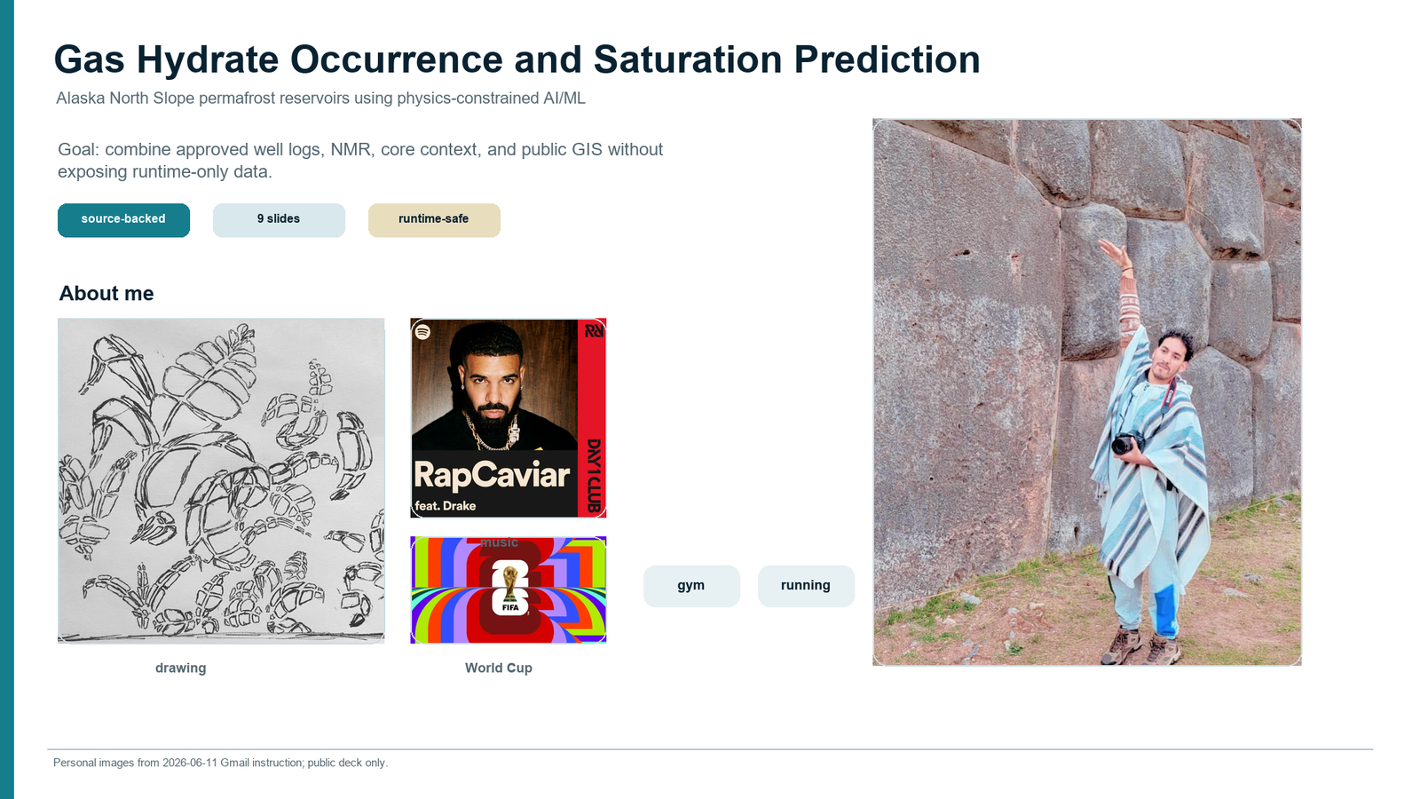

Slide 2 - Gas hydrate and North Slope context
Uses source-backed visuals only: USGS hydrate crystals, the digitized USGS SIR methane 5 ppt curve, and the public website map capture. Hydrate structures are explained in text rather than with generic cage art.
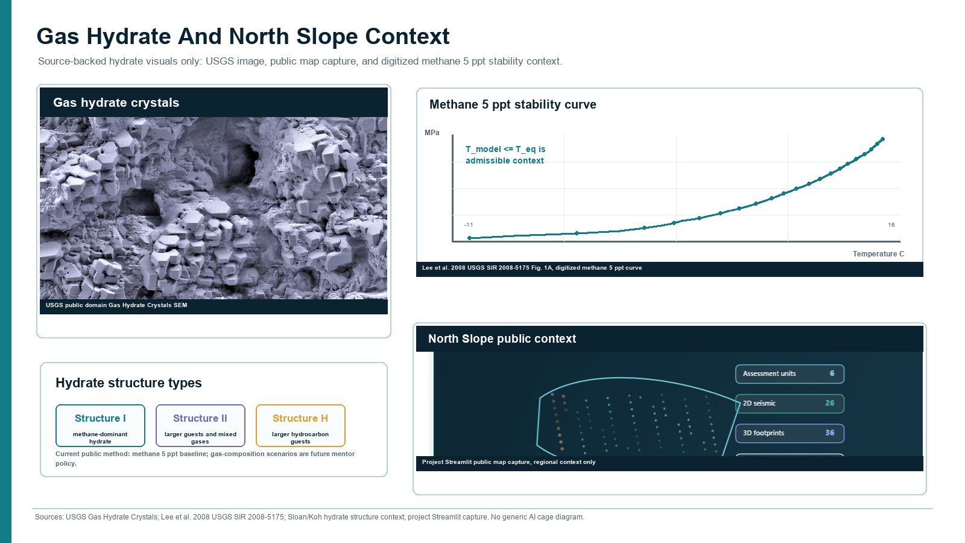

Slide 3 - Parameters and expected hydrate ranges
Shows only parameter families, normalized working envelopes, opposite meaning, mimic or mask risk, and ML role from the public parameter evidence registry.
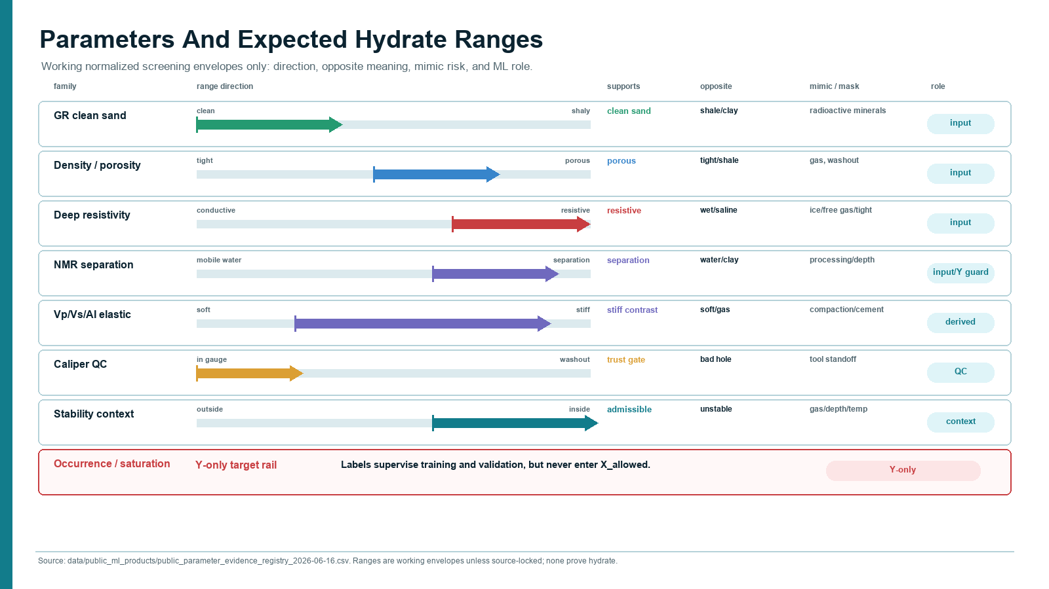

Slide 4 - Full complex project workflow
Restores the V5.2 complex workflow architecture as the main visual, including public sources, OSL later inputs, fingerprint registry, gates, feature engineering, leakage-safe ML, dual heads, validation, and exports.
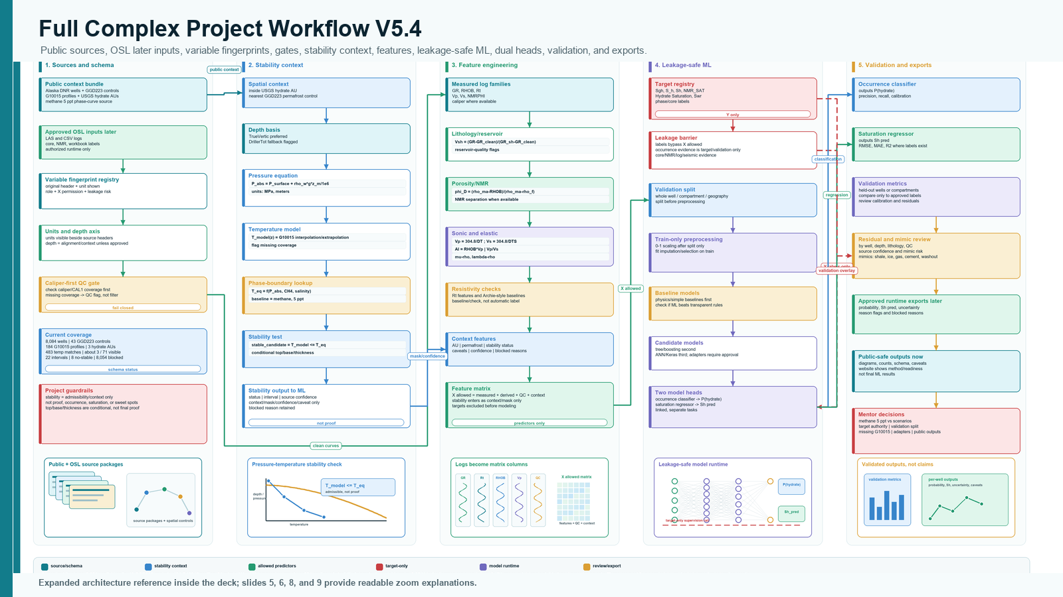

Slide 5 - Why parameter ranges matter
Explains why each family is scientifically useful and where it can fail. The point is evidence combination, not single-log proof.
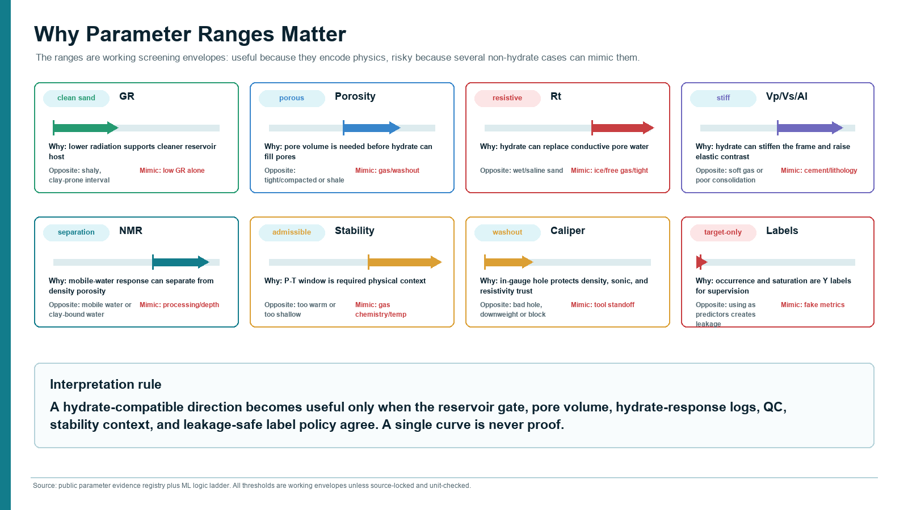

Slide 6 - Equations, feature engineering, and unit gate
Moves away from a pressure-temperature-only slide and centers the equations, unit checks, QC gates, and leakage stop that decide whether derived features enter X_allowed.
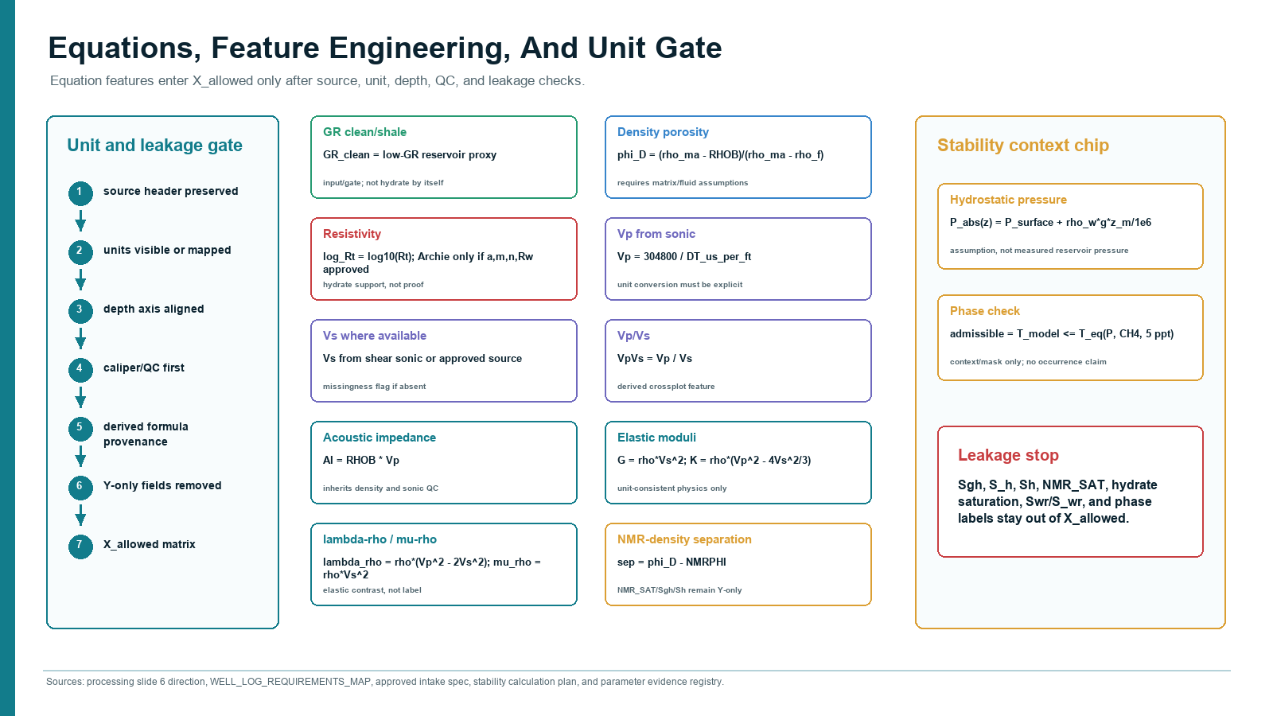

Slide 7 - Complex ML architecture
Restores the complex runtime diagram: measured logs, derived physics, QC, stability/core context, X_allowed, grouped split, train-only preprocessing, baselines, ANN/Keras candidate, dual heads, validation, reviewed output package, and Y-only rail.
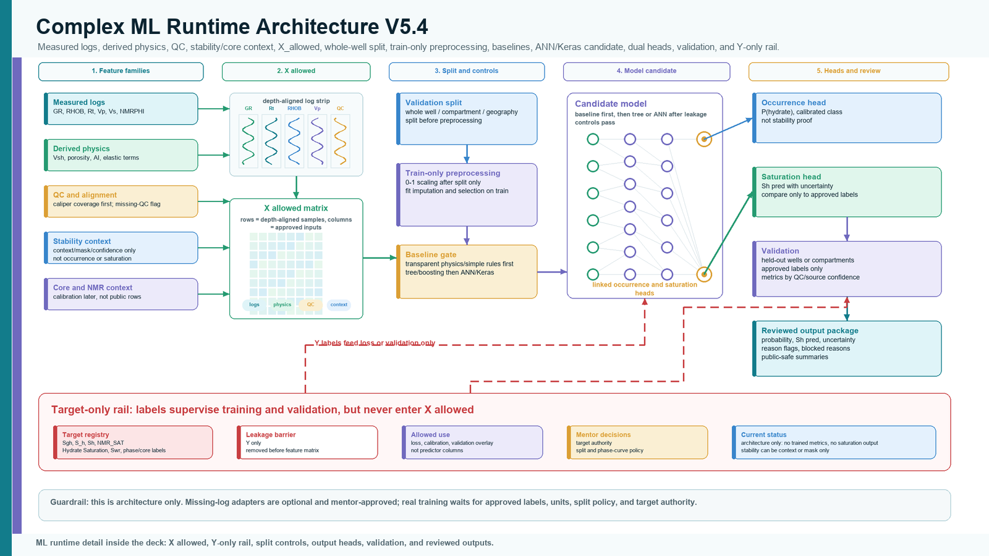

Slide 8 - Validation, uncertainty, and outputs
Connects whole-well validation, planned calibration and residual review, uncertainty and mimic flags, occurrence classification, saturation regression, and the reviewed output package. Metrics are intentionally absent.
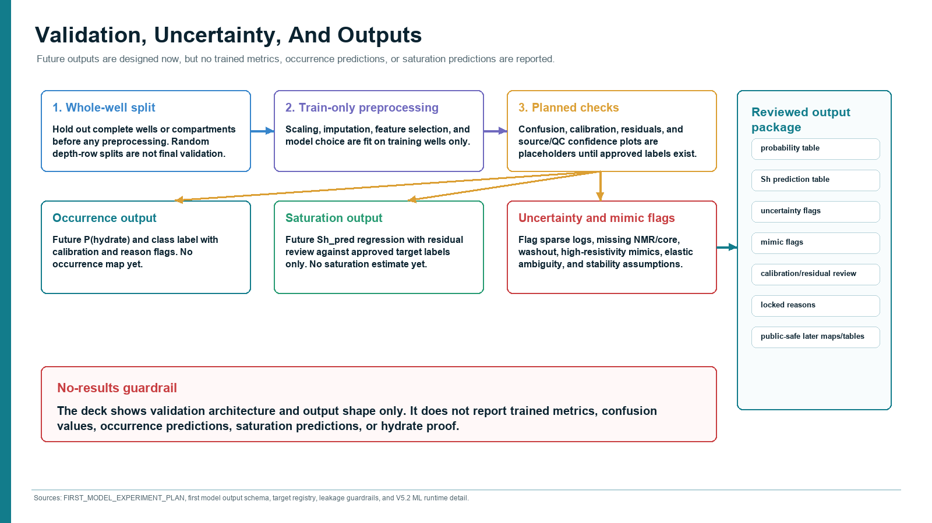

Slide 9 - Status, mentor decisions, and next steps
Summarizes current counts, unresolved mentor decisions, and the immediate OSL action: approved-data header audit and runtime mapping.
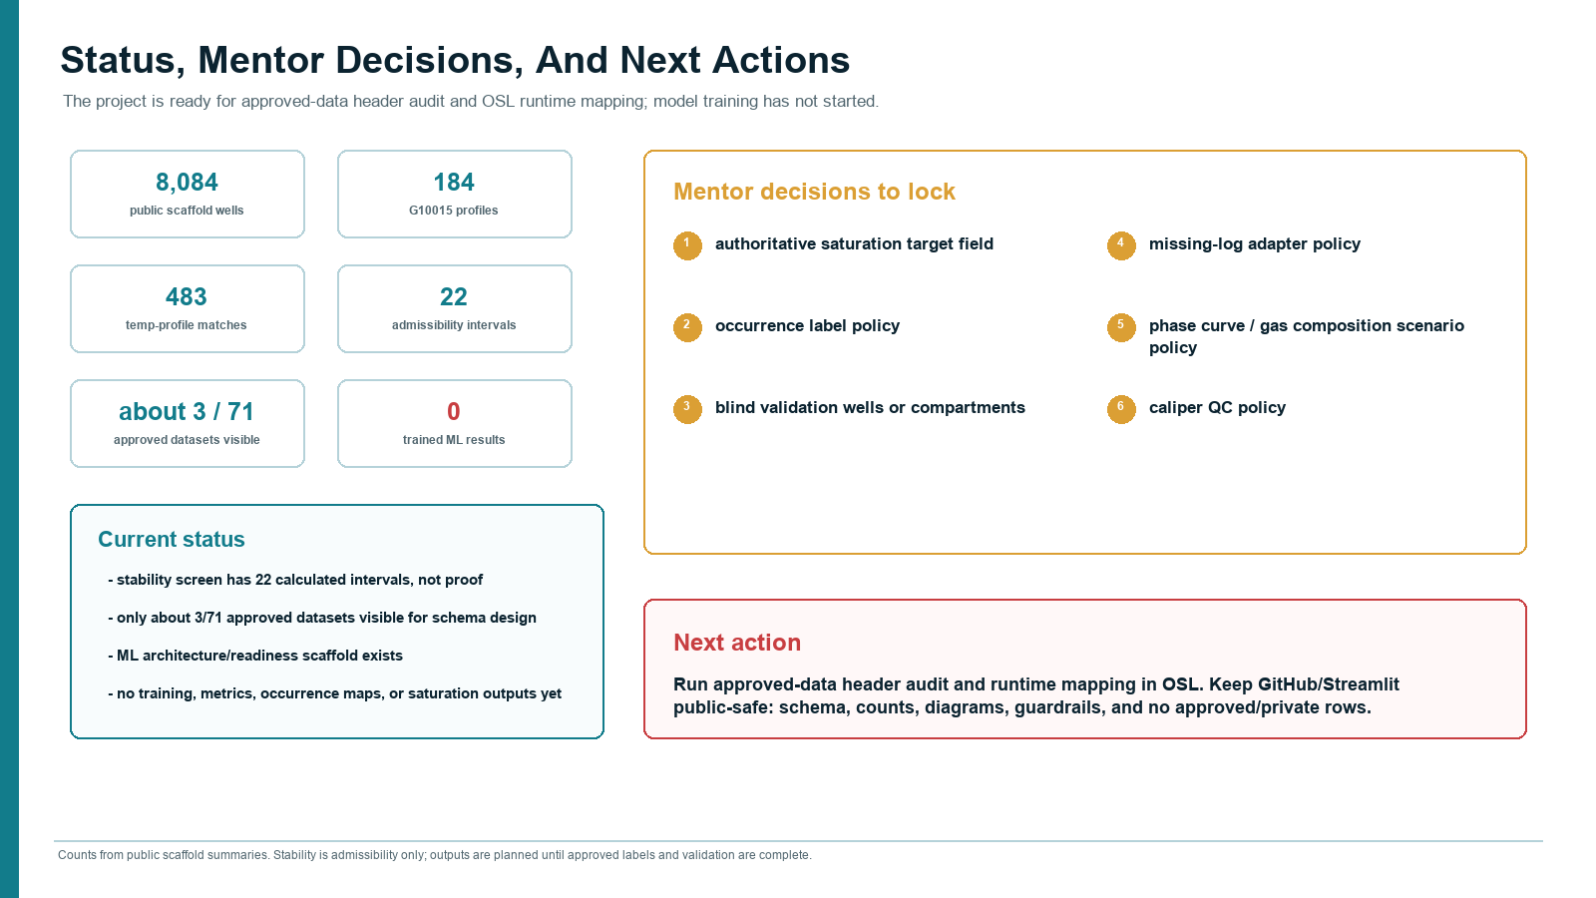

Contact Sheet
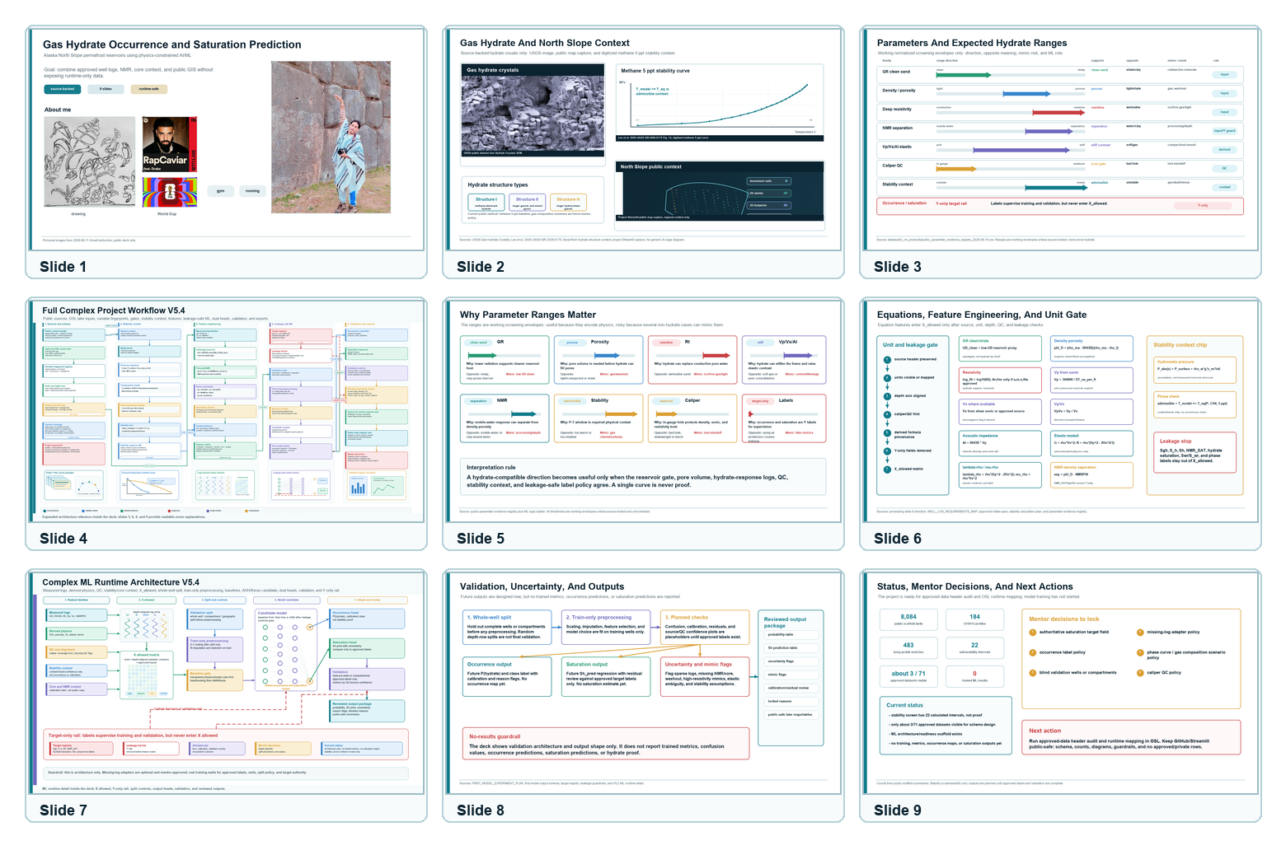

Source And Guardrail Anchors
- USGS Gas Hydrate Crystals public-domain image.
- Lee et al. 2008 USGS SIR 2008-5175 methane 5 ppt phase curve digitized product.
- data/public_ml_products/public_parameter_evidence_registry_2026-06-16.csv.
- docs/FULL_PROJECT_ML_WORKFLOW_DIAGRAM.md.
- docs/APPROVED_DATA_INTAKE_SPEC_2026-06-15.md and target leakage guardrails.
- docs/FIRST_MODEL_EXPERIMENT_PLAN_2026-06-15.md and first model output schema.

Language To Preserve
- Use 'admissible under assumptions' rather than hydrate proof.
- Use 'planned validation/output shape' rather than trained metrics.
- Use 'future occurrence classification' and 'future saturation regression' rather than predictions.
- Keep OpenScienceLab as the approved/private runtime workbench and GitHub/Streamlit as the public delivery surface.

