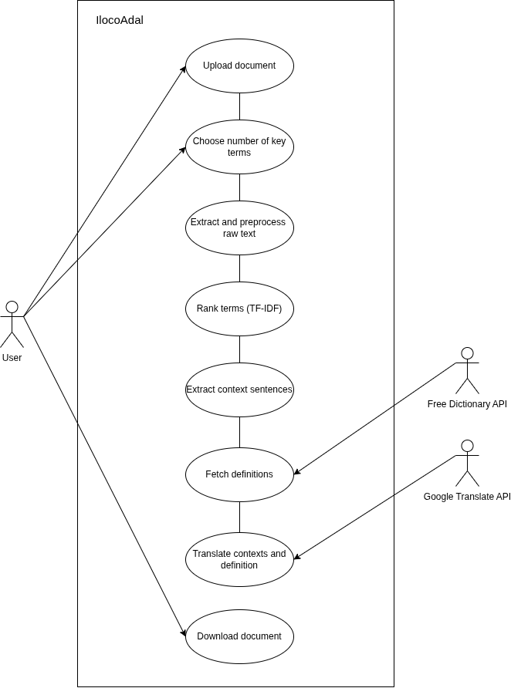
Use Case Name | Upload Document
Use Case ID | IA-001
Use Case Description | The user submits a document into the IlokoAdal system
Primary Actor | User
Secondary Actor | None
Precondition | The user has the PDF file ready
Postcondition | The document is accepted for the processing
Normal Flow | User Action | System Response
Normal Flow | - The user clicks on the  “Upload A Document” | - The system opens the  local file browsing app.
Normal Flow | - selects one or more PDF files in their local storage and clicks “upload” | - The system validates the uploaded file and size
Alternate Flow | If the file type is unsupported, the system shows an error and asks the User to choose another file.
Exception Flow | The upload is interrupted and the system cancels it and lets the User retry.
Non Functional Requirements | Uploaded files must undergo basic file validation to prevent malicious executions.

Use Case Name | Choose Number of Key Terms
Use Case ID | IA-002
Use Case Description | The user sets how many key terms the system extracts from the uploaded document(s)
Primary Actor | User
Secondary Actor | None
Precondition | At least one PDF has been added.
Postcondition | The chosen number of key terms is saved as a processing option and used for the job.
Normal Flow | User Action | System Response
Normal Flow | - The user moves the key terms slider on the Ready screen | - The system shows the selected value, from 10 to 40.
Normal Flow | - The user clicks “Start Processing”. System response | - The system starts processing with the uploaded files and the chosen number.
Alternate Flow | If the user doesn’t touch the slider, the system uses the default of 15.
Exception Flow | The job can’t be created, so the system shows an error and lets the user try again.
Non Functional Requirements | The slider only allows values from 10 to 40, so an invalid number can’t be entered.

Use Case Name | Extract and Preprocess Raw Text
Use Case ID | IA-003
Use Case Description | The system extracts and filters the raw text
Primary Actor | User
Secondary Actor | None
Precondition | The system has successfully accepted the document
Postcondition | Cleaned up and filtered the filler words from the raw text
Normal Flow | - The system extracts the raw text from the PDF.  - The system normalises the text.  - The system removes punctuation.  - The system filters out filler words.
Alternate Flow | If the PDF has no readable text (for example, a scanned image), the system notifies the User and stops.
Exception Flow | The extraction fails or the PDF is corrupted: the system stops and shows "Unable to read this document."  The text is empty after filtering: the system notifies the User that no analyzable content was found.
Non Functional Requirements | Text extraction and preprocessing should be completed under 5 seconds for standard document sizes

Use Case Name | Rank Terms (TF-IDF)
Use Case ID | IA-004
Use Case Description | The system scores and ranks the processed text by importance
Primary Actor | User
Secondary Actor | None
Precondition | Processed Text is available and the number of key terms is chosen.
Postcondition | The top N key terms and phrases are ranked
Normal Flow | - The system computes the TF-IDF score of each term.  - The system sorts the terms from highest to lowest score.  - The system selects the top N terms, where N is the number the user chose (10 to 40).
Alternate Flow | If the text is too short for meaningful scores, the system notifies the User and uses the available terms.
Exception Flow | No terms are found after scoring: the system stops and notifies the User.  The memory or processing limit is exceeded on a very large document: the system stops and asks for a smaller document.
Non Functional Requirements | Complete the ranking within the target time.

Use Case Name | Extract Context Sentences
Use Case ID | IA-005
Use Case Description | The system finds the sentences where each key term appears and adds them to the document
Primary Actor | User
Secondary Actor | None
Precondition | The key terms have been identified and ranked
Postcondition | The terms are paired with its context sentence(s) in the output document
Normal Flow | - The system searches the original text for each term.  - The system extracts the sentence(s) containing the term.  - The system adds the sentence(s) to the output document.
Alternate Flow | If a term appears in many sentences, the system keeps only a limited number of them
Exception Flow | A term has no usable prose sentence, so the system skips that term and continues.
Non Functional Requirements | Keep the original wording unchanged.

Use Case Name | Fetch Definition
Use Case ID | IA-006
Use Case Description | The system retrieves the definition of each term and adds it to the output document
Primary Actor | User
Secondary Actor | Free Dictionary API
Precondition | The terms are available and the system has an internet connection
Postcondition | Each terms has a definition in the output document
Normal Flow | - The system looks up each term in the Free Dictionary API.  - The API returns the definition.  - The system adds the definition to the output document.
Alternate Flow | If the API has no entry for a term, the system marks the definition as "not available" and continues.
Exception Flow | Some lookups fail: the system retries the missing terms, marks the rest as ‘not available’, and tells the User how many definitions couldn’t be fetched.  The API returns an error or rate-limit response: the system waits and retries, then falls back to "not available."  No lookup works: the system tells the User there is no internet connection.
Non Functional Requirements | A failed API call must never crash the pipeline.  Send only the individual terms, over HTTPS.  The Free Dictionary API covers English only.

Use Case Name | Translate Context and Definitions
Use Case ID | IA-007
Use Case Description | The system translates each context sentence and definition and adds the result to the document.
Primary Actor | User
Secondary Actor | Google Translate API
Precondition | The context and definitions are available in the document and the system has an internet connection
Postcondition | The translated text is added to the output document
Normal Flow | 1. The system sends each context sentence and definition to the Google Translate API.  2. The API returns the translation.  3. The system adds the translations to the output document.
Alternate Flow | If a definition is "not available," the system skips translating it.
Exception Flow | The API fails, times out, or exceeds its quota: the system retries, then leaves the translation blank and notifies the User.  There is no internet connection: the system notifies the User that the translation could not be retrieved and continues without them.
Non Functional Requirements | Send only the text to be translated, over HTTPS.  Rely on the availability and rate limits of the Google Translate API.

Use Case Name | Download Document
Use Case ID | IA-008
Use Case Description | The user can now save the finished document
Primary Actor | User
Secondary Actor | None
Precondition | The document has finished processing
Postcondition | The .docx document is saved on the User’s device.
Normal Flow | - The user clicks "Download". | - The system downloads the finished document and shows a “Save as” dialog with a suggested name.
Normal Flow | - The user chooses where to save and confirms. | - The system saves the file to the user’s device.
Alternate Flow | The user cancels the Save as dialog: nothing is saved and the user can download again.
Exception Flow | The file fails to generate: the system shows an error and lets the User retry.  The download is interrupted: the User can restart it.
Non Functional Requirements | The download should start within a few seconds.

