Richard Echeverria Project 5 Video Game CPSC 386 Recheverria04@csu.fullerton.edu CWID: 891720195
The game I created for project 5 is my take on a space shooter that I call “Galaxy Excavator”. What this game is about is you take control of a spaceship that has one job, and that is to extract power stars that reside in the roaming asteroids of space. To do that you must shoot the asteroids down one by one in hopes that one of them will contain a power star. Some of the asteroids will contain a hibernating alien that will attack you if awaken. They are indestructible so you cannot do anything but dodge them. Some asteroids can also hold a special power-up that allows your ship to shoot double lasers for a brief period. Your main objective to complete the game is to collect 7 power stars before you lose the three lives you are given. Collecting the seven power stars will grant you one wish, so you would have to be careful, and precise in your operation. The way to play Galaxy Excavator is very simple. You press the left arrow key to move your ship to the left, and press the right arrow key to move your ship to the right. You press the space bar to shoot lasers from your ship to protect yourself from incoming asteroids. If you were to get hit by an asteroid, or an alien you will lose a life, and for a brief moment have invincibility so that you can prepare for the next round. If you collect a power-up, you will now have the ability to shoot double lasers from your ship. This power-up only lasts for about 5 seconds, but if you collect the same power-up in the span of the time you are still using a power-up the lifespan of the power-up will stack up. This can be a good strategy in keeping your chances alive as there are some asteroids that will appear in an angle that will be too hard for you to hit. They are many shapes, and sizes of asteroids in space. Each asteroid comes at you at a different speed, and destroying any could result with a power star, power-up, alien, or even nothing. Destroying any asteroid however will grant you points added to your total score. The score will be tracked on the top left of the screen, and depending of the size of the asteroid destroyed will result in points. For example, a small asteroid will give you 50 points, but destroying a large one will give you 150 points. Points do matter in this game because they can help you reach your end goal quicker. I added a feature that once you have reached 1000 points, you now have the secret ability of making your lasers travel at a faster interval. The speed the lasers travel will double that can help destroy asteroids at a faster pace. Once you reach 2000 points, your ship now has the ability to shoot lasers at a faster rate. The cool down for each laser shot will be reduced to where you can shoot at almost double the speed. When starting up the game you will see the black screen that will tell you who created the game, and to whom it belongs. The next screen that appears is the main menu page where music from the Nintendo game “Star Fox” will be playing in the background. There will be an 8-bit image of space as the backdrop, and the title of the game on the top. You have three buttons to choose which are “star game”, “quit game”, and “controls”. Hovering your mouse over each button will light up, and clicking them will play a sound to make it know you selected. When you start the game all images are loaded up, and a new background is displayed where you will be playing on. If you lose, a game over screen will appear, and give you the option to play again, or return to the menu. If you win, an image of the power stars will appear congratulating you on your victory, and a victory song will be playing. Each game will run you at an average of 5-15 minutes depending on the randomness of the spawning function. I put the three possible items that can spawn from an asteroid in an array, and using the random.random() function I had it set so that if the decimal number generated is greater than 0.8, it gives each destroyed asteroid a 20 percent chance of one of the three items spawning. Sometimes with sheer luck the game will only take 2 minutes if each destroyed asteroid kept spawning power stars, but sometimes it can take you 10 minutes to just grab one power star if all you get are power-ups or aliens. The way you can win as I have stated before is to collect 7 power stars, but if you were to get hit by an asteroid, or an alien a total of 3 times then the game is over, and you must start again or quit the game. The way this game was built was with python’s pygame library. I had already set a template of how the game will be created using my code from the previous project. I already had the menu, and game play done, but in my previous project I only had the player dodge asteroids, and get a score on how many you dodged. I wanted to add lasers, items to pick up, a real objective, and more complex obstacles. I decided to split the game into kind of like two parts, one is a defined function that creates the main menu, and the other is another defined function that is called from the main menu that works all the classes, and sub functions. With the previous project I was first had to go through the basics of pygame so I did not have the time to get to understand using sprite functions, classes, and other complicated pygame library functions. With this project I wanted my game to look a bit more respectable on the coding side of things. I look at tutorials online such as pygame.org, and YouTube tutorial channels like ‘Sentdex’, and ‘KidsCanCode’. These are my main sources for learning pygame, and understanding how to use its library functions. I learned how to create, kill, and append sprites with the sprite.Sprite functions, and learned the update() method to keep track of asteroids destroyed, and the keeping track of the lasers shot from the player. In all the project was fun to make, but it took lots of hours, and trial and error to get code to work. Even following tutorials, I had to go out of my way to ensure I am understanding what I am typing, and what it does rather than copying and pasting. I wanted to make my code a little different than most, and modify some algorithms to either make them more readable to me. With the few weeks I had to make this game, I feel like with more time I could have added much more. I wanted to add levels, and boss battles, and maybe a first person view but again I am only beginning to learn pygame, and I didn’t want to bring myself with the burden of creating a sloppy game for the sake of complexity. Below I left images of the game, and a bibliography giving credit to all sources used for this project.

Screen shots:
Main Menu
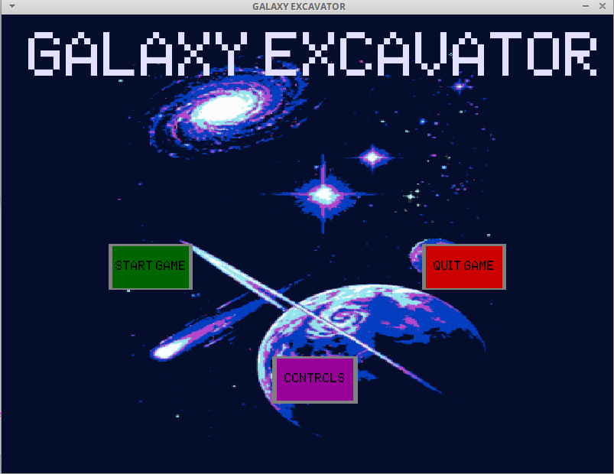

Game play:
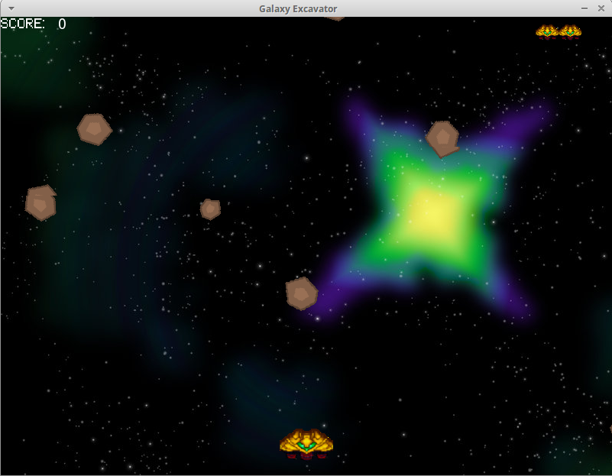

Game Over and Winner Screens:
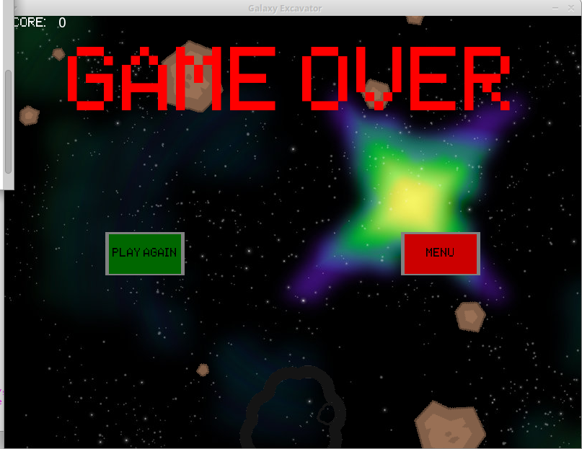
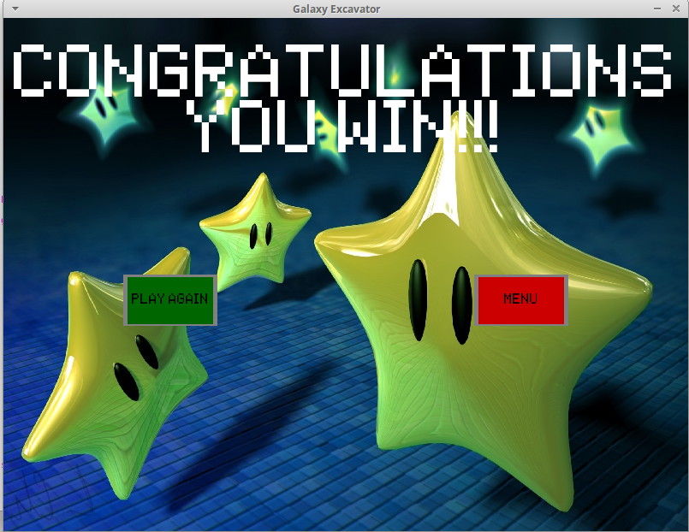

BIBLIOGRAPHY:
SOURCES USED TO HELP CREATE THIS PROJECT AND CREDIT GOES TOWARDS THEM. ANY IMAGES, MUSIC, OR SOFTWARE BELONGS TO THE RESPECTIVE OWNERS.

- Pygame.org
- Youtube.com/sentdex
- Youtube.com/KidsCanCode
- http://www.starfox-online.net/Media/sfx-sf64/
- http://www.soundboard.com/sb/Star_Fox_64
- https://www.spriters-resource.com/
- http://www.nerdparadise.com/tech/python/pygame/basics/part1/

