CHAPTER 3 - REVIEW QUESTIONS and ASSIGNMENTS

Name: Rafael Panesar Class: 109-101-MQ sect.00040

Teacher’s Comments

1. How would you define Cardiovascular Exercise?
 | Continuous physical activity that elevates your heartrate.
2. Identify 3 Psychological and 3 Physical benefits of participating in regular cardiovascular exercise:
 | 3 Psychological Benefits |  |  | Reduced stress | Improved mood |  | Better focus
 | 3 Physical Benefits |  |  | Better endurance | Lower blood pressure |  | Better health
3. Identify the FITT training guidelines for Cardiovascular Exercise:
 | Frequency: |  | 3 to 5 days per week
 | Intensity: (give 2 options) |  | 1. Target heart rate
 |  |  | 2. Rate of perceived exertion
 | Time : |  | 20 to 60 minutes per session
 | Type (list 2 activities) |  | 1. Running
 |  |  | 2. Swimming
4. What is your heart rate training range? Show your calculations in the space provided.
 | Lower limit=140bpm  Upper limit=173bpm |  |  |  |  | Max = 220-17(age) = 203bpm  HRR=max(203)—resting(70)=133bpm  Lower limit=60%HRR+60=140bpm  Upper limit=85%HRR+60=173bpm
5. What is the recommended intensity range for someone who wants to train in the Aerobic Zone?
 | 60% to 80% of maximum heart rate
6. a) How should you feel when you are at level 4 on the Vanier RPE scale?
b) Give an example of an activity that makes you feel like you are at level 4 on the scale.
Click here to enter text. | a) somewhat challenged |  |  |  | b) walking uphill
7. a) What is the difference between continuous and interval cardiovascular training?
b) Describe how you can make walking an interval workout.
a) Continuous means to constantly keep the same amount of effort thoughout the workout and interval is switching between higher and lower intensity.
b) walk at a normal pace for 2 minutes, then speedwalk for 1.
8. What are the 2 common sites/locations on the body for taking heart rate readings?
1. Neck
2. wrist
9. Describe the duration of the following elements of a safe and effective cardiovascular workout.
 | Warm-up | 5-10mins
 | Workout | 20-60mins
 | Cool-down | 5-10mins
10. Identify 3 reasons why all CEGEP students should participate in weekly cardiovascular activity.
 | 1. stress management
 | 2. improved focus
 | 3. moving around
11. Knowing the benefits that you could achieve by doing Cardiovascular Exercise, design a
sample cardiovascular workout for yourself using the FITT Principle.
 | Frequency |  | 3-4 days per week
 | Intensity |  | moderate
 | Time |  | 30mins
 | Type |  | cycling

CHAPTER 4
REVIEW QUESTIONS AND ASSIGNMENTS

- What does RM represent and what is the definition?
Repetition maximum. It’s the maximum weight someone can lift for a number of repetitions.

- If you trained the chest on Monday, how many days rest should you take before training it again?
You should wait 2 days before training that muscle again.

- Identify 3 exercise option for the Abdominals and 3 exercise options for the Triceps.

Abdominals: 1. Sit-ups 2. plank 3. Leg raises

Triceps: 1. Tricep extension 2. Bench dip 3. Tricep pushdown

- In order to improve upon a) muscular strength and b) general muscle fitness it is recommended to perform how many sets and repetitions maximum of each exercise?

a) muscle strength: # of sets =2 # of reps =3

b) general fitness: # of sets =2 # of reps =8

- What is the difference between a muscle conditioning exercise and a flexibility exercise?
Muscle conditioning focuses on strengthening muscles and flexibility exercise focuses on strengthening joints

- What is the recommended lifting speed or tempo for most weight training exercises?
2 seconds lifting and 3 seconds lowering

- A Full Body Workout should be completed how many times each week in order to be effective?
2 to 3 times per week

- Identify 3 training guidelines that are recommended to beginner weight trainers.

- Maintain proper form

- Warm up

- Start with light weights

ASSIGNMENT #4 MUSCLE ANATOMY

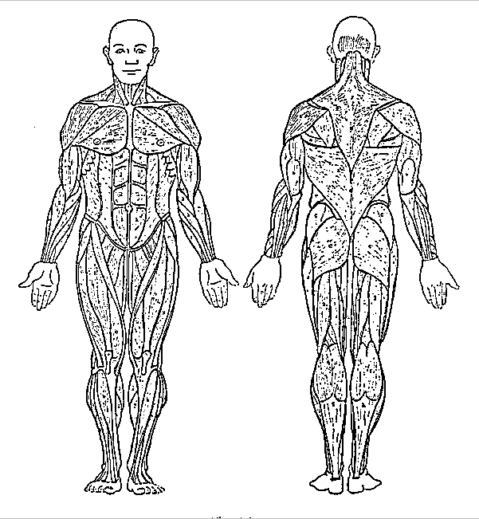
N
M
L
K
J
I
H
F
G
E

D
C
B
A
Retrieved from: Muscle Source: Wikipedia, the free encyclopaedia: http://webanatomy.net/anatomy/muscleman.gif

 | Name of Muscle | Exercise Example
A | Deltoids | Overhead shoulder press
B | Pectorals | Bench press
C | Biceps | Bicep curls
D | Obliques | Russian twists
E | Abdominals | planks
F | Lower back | Back extensions
G | Lats | Pull ups
H | Posterior deltoid | Face pulls
I | Trapezius | Dumbbell shrugs
J | Triceps | Tricep dips
K | Glutes | Hip thrusts
L | Hamstrings | Leg curls
M | Quadriceps | Leg extensions
N | Calves | Standing calf raises

CHAPTER 5
REVIEW QUESTIONS AND ASSIGNMENTS

- Identify 2 reasons why maintaining flexibility is important?

1. enhances joint mobility 2. Reduces risk of injury

- In order to improve upon flexibility, stretches should be held for how long?
Hold stretches for 15 seconds

- Identify the 2 major purposes of the warm-up segment.

1. increasing body temperature

2. preparing joints

- What type of stretching is recommended in the warm-up segment?
Dynamic stretching

- In the warm-up segment, which is more important? a or b

a) 5-8 minutes of low intensity cardiovascular activity or
b) static stretching

- Identify 2 reasons why it is important to cool-down for 2-3 minutes after aerobic activity

1. prevents blood pooling

2. promotes recovery

- What are 2 common postural errors?

- Rounded shoulders2.arching lower back

8. Identify 2 good exercises to help improve or maintain good posture.

1. face pulls

2. planks

ASSIGNMENT # 5: POSTURE EVALUATION

Proper posture is achieved when the spine is in neutral spinal alignment. The pull of gravity must be evenly distributed on the spine.

TEST YOUR POSTURE
To figure out if you have good posture, take the following posture tests:

THE WALL TEST
- Stand with the back of your head and your buttocks touching the wall and your heels six inches from the baseboard.  - Stick your hand between your lower back and the wall, and then between your neck and the wall.  - If you can get within an inch or two at the low back and two inches at the neck, you are close to having excellent posture. | 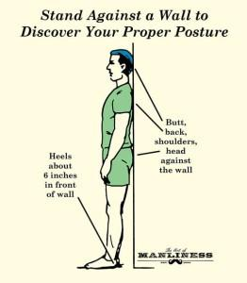
My lower back is 1 # inches from the wall.
My neck is 2 # inches from the wall.

THE MIRROR TEST
Stand facing a mirror and with a partner and check to see If you have good posture using the checklists provided.
Answer : Yes or No
From the Front – Checklist | 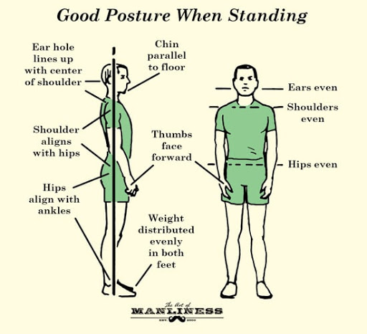
Head should be straight - not tilted to one side – yes
Shoulders should be level - yes
Hips should be level - yes
Kneecaps should face the front – no
Ankles should be straight ahead - yes
Feet should be straight ahead - no
From the Side– Checklist (need a partner)
Head should be straight - not tilted forward - yes
Chin should be parallel to the floor - yes
Shoulders should be in line with the ear - yes
Upper back should be slightly rounded - no
Lower back should be slightly rounded - no
Backs of legs should be flat - not rounded or bent - yes

WHAT YOU CAN DO FOR BETTER POSTURE
Once you determine your posture deviations, you can start working on them. Your first step is to be aware of your posture throughout the day; while standing, sitting, texting and lying down. Ask yourself if you're keeping everything in alignment. Depending on your problems, there are things you can do to help correct your posture. For example:
- If you have a forward head and rounded shoulders, you probably have tight chest muscles and loose upper back muscles. Try some stretching exercises for the chest area and strengthening exercises like seated rows for the upper back muscles.
- If you have an excessive arch in your lower back you may have tight lower back muscles and or weak abdominal muscles. Try some low back stretching and exercises and abdominal strengthening exercises like planks and birddog.

CHAPTER 6
REVIEW QUESTIONS AND ASSIGNMENTS

1. Identify the 6 essential nutrients?

Micronutrients: 1. vitamins 2. minerals 3.water

Macronutrients: 4. carbohydrates 5.proteins 6.fats

2. Identify 2 negative effects of excessive saturated fat intake?

1.increases cholesterol levels in the blood 2.increases heart attack risk

3. Which type of fat will be banned in Canada as of September 2018?

Trans fat
4. How many calories are in the following?

a)1 gram of fat = 9 calories b) 1 gram of carbohydrate =4 calories c) 1 gram of protein = 4 calories

5. What % of your daily caloric intake should come from:

a) Fat = 30 % b) Protein = 30 % c) Carbohydrates = 40 %

6. Go to the following site to calculate your protein requirements by the American Dietetic Association (ADA): http://www.calculator.net/protein-calculator.html

I should consume a minimum of 56 to a maximum of 108 grams of protein / day

7. Other than dairy products, list 2 other food sources that provide calcium.

1.dark leafy greens 2.plant milks

8. List 2 healthy sources of complex carbohydrates and 2 Unhealthy / Bad sources of Carbohydrate foods that are low in nutrients and fibre

Healthy: 1.whole grains 2.beans

Unhealthy: 1.sodas 2. White bread

9. Refer to the Healthy Eating Plate. How much of your plate should be filled with fruits and vegetables in a meal?
Half of your plate

10. Complete the food plate Nutrition Assignment. Make sure to attach the 2 pictures in this document.

My Plate – Nutrition Assignment

With a friend or family member, create a Healthy Balanced Meal (Plate) as shown below.
The meal must be home-made (not pre-packaged) and using food items that you would usually eat.
Refer to the nutrition recommendations and guidelines from the Harvard Chan medical school and website https://www.hsph.harvard.edu/nutritionsource or the 2019 Canada Food Guide Healthy Eating Plate.

Assignment Submission
Report + 2 Photos

1. For each Food Item on your Food Plate: (Typed your answers here)
a) Identify the name of the food and where it fits on the Eating Plate.

b) Identify the nutrients provided.

c) Provide the recipe and where it came from.

d) Identify one way that the food item meets the nutrition recommendation guidelines.

2. Photo Submission (you can put the 2 pictures here or at the end of this document…do not send them in a separate file or MIO)
a) Submit a photo of the chefs preparing the meal.
b) Submit a photo of the Final product – Your Healthy Eating Plate

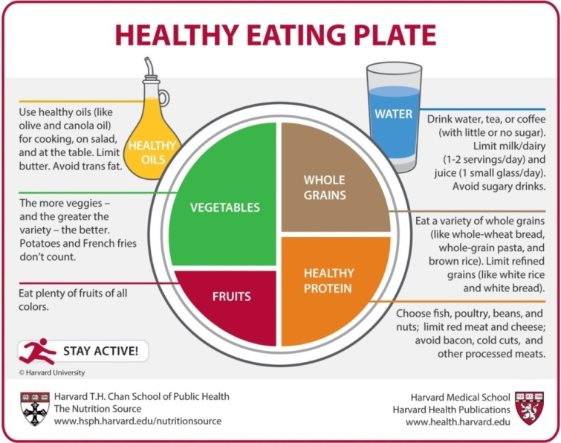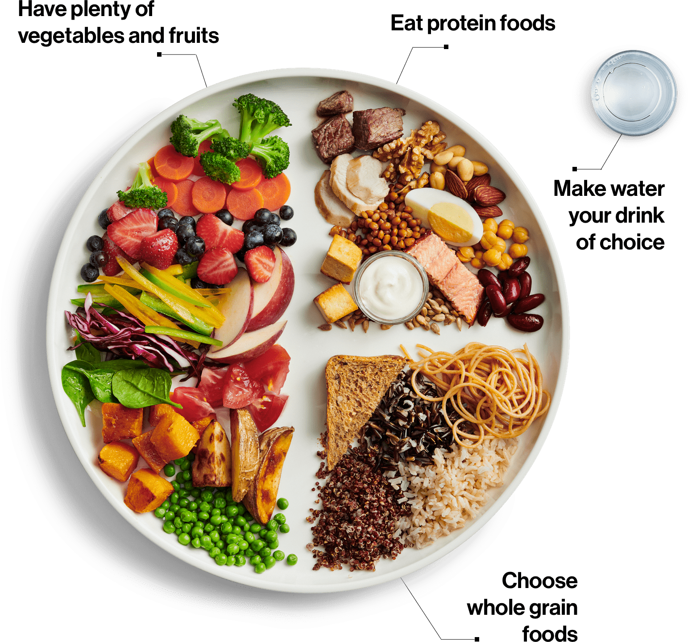

ASSIGNMENT # 6 (part 1). HOW HEALTHFUL IS YOUR DIET?

Respond to each of the following 25 questions as they relate to your general eating habits and score each question as noted for each of the four different sections. When you are finished complete Assignment # 8b.

Section A  Score questions 1 – 4 using this scale
Almost Always | Frequently or often | Sometimes / occasionally | Rarely or never
4 points | 3 points | 2 points | 1 point
Section A Total Points:
= ___________

_____ 1. Do you eat foods from each of the Macronutrient Groups each day?
(Proteins, Grains, Fruits and Vegetables)

_____ 2. Do you eat fruits and vegetables with every meal?

_____ 3. Do you eat legumes (such as: kidney beans, chickpeas, lentils) several times per week?

_____ 4. Do you eat breads and cereals that are high in dietary fibre – oats, multi grain, bran, whole wheat?

Section B  Score questions 5 - 12 using this scale
Almost Always | Frequently or often | Sometimes / occasionally | Rarely or never
1 point | 2 points | 3 points | 4 points
Section B Total Points:
= ___________

_____ 5. Do you eat foods that are high in refined sugar, such as table sugar, candy, cakes, or drink sodas?
_____ 6. Do you drink more than 1 cup of juice on a daily basis?

_____ 7. Do you eat a lot of packaged or deli lunch meats, such as salami, bologna, sliced ham etc.?

_____ 8. Do you add salt to your meals?

_____ 9. Do you have at least one typical meal per day at a fast food restaurant?

_____ 10. Do you eat a lot of highly processed packaged foods that contain numerous additives like
packaged soups, canned foods, pizza pockets?

_____ 11. Do you drink soft drinks, iced tea, Snapple on a daily basis?

_____ 12. Do you eat salty snacks, such as chips, nachos?

_____ 13. How often do you eat high fat dairy products such as hard cheeses, cream sauces, ice
cream, sour cream?

Section C  Score questions 13 – 19 using this scale
> than 5 days / week | 3 - 4 days/week | 1-2 days/week | 0-2 days / month
4 points | 3 points | 2 points | 1 point
Section C Total Points:
= ___________

_____ 14. How often do you have at least 2 pieces of fresh fruit?

_____ 15. How often do you have dark leafy green vegetables such as spinach, dark orange vegetables such
as carrots, or yellow vegetables such as squash?

_____ 16. How often do you have vegetables in the cabbage family such as broccoli, cauliflower, brussel sprouts
or cabbage?

_____ 17. When you eat animal protein, how often do you eat the recommended serving size
(1 serving = ¼ of your plate).

_____ 18. How often do you eat whole wheat breads, cereals, or other grain products?

_____ 19. How often do you consume non-meat protein sources such as legumes, nuts, seeds?

Section D  Score questions 20 - 25 as indicated
Section D Total Points:
= ___________

_____ 20. Which type of milk do you normally drink?
4 points - skim or non-fat milk
3 points - 1 % milk
2 points - 2 % milk
1 point - whole / homogenized milk

_____ 21. Which of the following protein sources do you normally select?
4 points - fish or plant protein such as beans
3 points - chicken, turkey or other poultry
2 points - red meat, such as beef or pork
1 point - hard cheeses

_____ 22. What do you normally put on bread?
4 points - nothing or low-sugar spreads
3 points – non hydrogenated margarine
2 -points - butter
1 point – hydrogenated margarine

_____ 23. What do you normally have for sweet snacks or desert?
4 points - fresh fruit
3 points - yogurt
2 points - sherbet or ice milk
1 point - ice cream, cakes, pastries, chocolate

_____ 24. What do you normally have on a sandwich?
4 points - tuna fish in water
3 points – fresh meat like chicken or turkey
2 points - roast beef or peanut butter
1 point - packaged, processed lunchmeat – salami, bologna, pastrami

_____ 25. How do you normally cook your foods?
4 points - bake, broil, steam
3 points – pan fry in olive oil, canola oil or peanut oil
2 points – pan fry with other vegetable oils – corn, sunflower, vegetable oils
1 point - use butter, lard, coconut or palm oil

My Total Score from sections A - D

= ______________

- Use the following scoring table as a guide to your dietary habits.
- You should strive to score in the good to excellent category.
- Check those answers in the 1 to 2 point categories for guidelines to improvement.
90 - 100  75 - 89  60 -74  45 - 59  24 - 44 | Excellent  Good  Average  Below Average  Poor

Adapted from: Williams, Melvin H. Lifetime Fitness & Wellness, (1996). Madison, WI: Brown & Benchmark Publishers, p. 275-276 of 368 pages.
ASSIGNMENT # 6 (part 2) - PERSONAL NUTRITION MODIFICATIONS

Step 1. Review your answers from The Health Questionnaire and highlight any areas where you scored 1-2 points.
Step 2: Complete the table below by referring to the highlighted areas (improvement needed areas in your diet)
Step 3: Identify 3 specific changes you can make to improve in that area.

Question #  from Questionnaire | PROBLEM  I … | What can I do to improve? What choices or changes can I make?  Identify specific changes.
1.
2.
3.

