import pandas as pd

import numpy as np

import csv

import urllib

url='https://raw.githubusercontent.com/rashida048/Datasets/master/movie_dataset.csv'

data = pd.read_csv(url,sep=",")

data.head()

data.columns

data.describe()

df=pd.DataFrame(data)

**#Question 1**

minimum=df['runtime'].min()

minimum

output: 0.0

Inference:Minimum runtime for a movie is Zero(0).

min_runtime=df[df['runtime']==minimum]

print(min_runtime['original_title'])

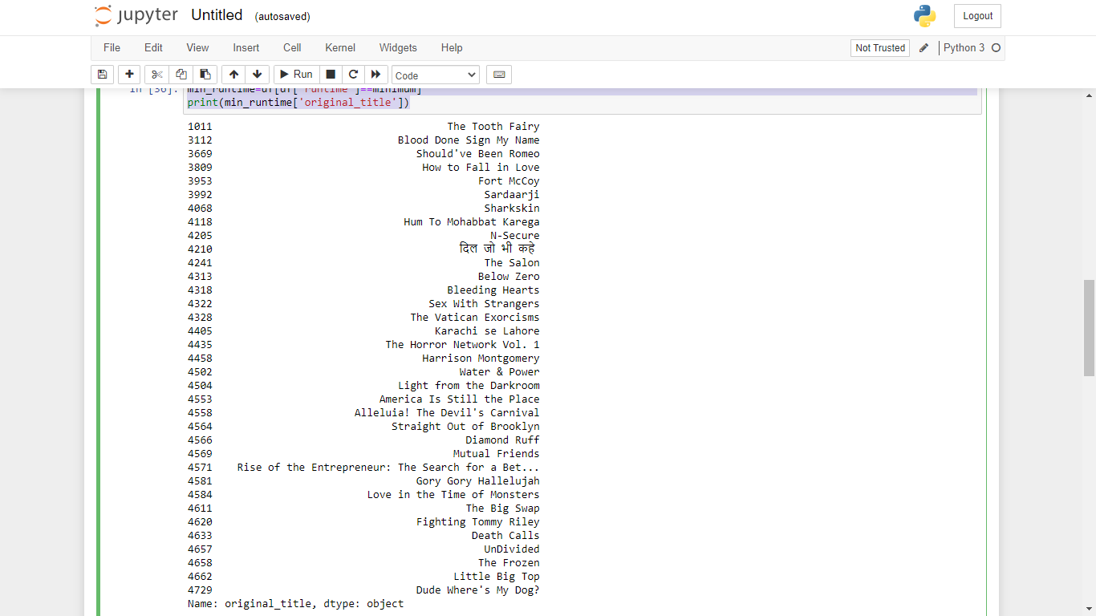

maximum=df['runtime'].max()

maximum

output: 338.0

max_runtime=df[df['runtime']==maximum]

print(max_runtime['original_title'])

output: 2384 Carlos

Name: original_title, dtype: object

**#Question 2**

one=df[['budget','production_companies' ]].drop_duplicates(keep='last').nlargest(10, 'budget')

one

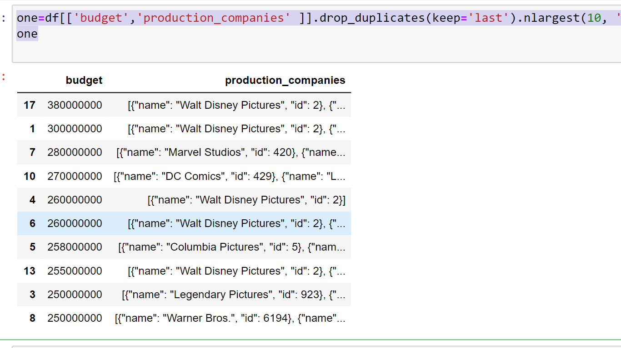

**Inference:Top 5 Production Companies(by Budget)= "Walt Disney Pictures","Marvel Studios", "DC Comics", "Columbia Pictures", "Legendary Pictures"**