Rohini Shrivastava

Homework 1

The donors_data.csv file was downloaded from Syracuse’s 2SU platform. The csv file was read and converted from a csv into a pandas data frame. On this data frame, any NaN values were dropped. The column values “zipconvert_2”, “zipconvert_3”, “zipconvert_4”, “zipconvert_5” were renamed to be “REG1”, “REG2”, “REG3”, “REG4” for the region they are a part of. The dataframe includes both donors and non-donors, so a new data frame was created for only donors.

The average wealth of the donors is 6.4. On a scale of 1-9, this is a little above average, showing the donors are in the middle-income to high-income end. The average amount donated is $113.29. The amount of donations was plotted between every wealth group (*Figure 1)* to see if there was a correlation between wealth and donation*.* Overall the majority of donations were under $500, no matter what status of wealth they were a part of. The max donation at one time was usually under 200 as well (*Figure 2).* It is interesting to see how what wealth category the donors fall into does not affect how much they donate.

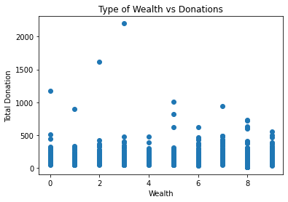

*Figure 1: Type of wealth vs donations*

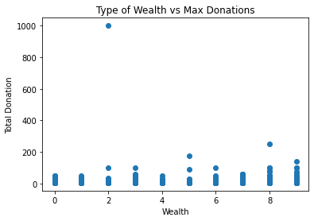

*Figure 2: Type of wealth vs max donations*

For further research into each of the wealth groups, new dataframe was created with “Wealth” as the index. The average for all the columns were found and compared between each other to see how they compared. A graph was created for the total donations. In Figure 3 people in wealth group 8 had the lowest donation, while groups 3 and 7 had about the same average donation. Another graph was created to look at home value versus wealth. As expected the higher the wealth group, the more expensive the average home value was (*Figure 4).* It was interesting to see that thought the wealth was higher, their donation was equal or smaller than the lower wealth groups. Group 4 had the highest time between the last donation and current day. Group 2 consistently donates money since they have the least amount of time (*Figure 5).*

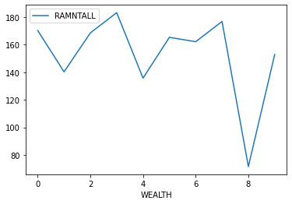

*Figure 3: Average donation per wealth group*

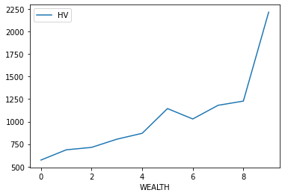

*Figure 4: Average home value per wealth group*

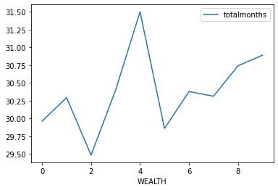*Figure 5: Average time (in months) since last donation per wealth group*

Overall, there was no correlation between the wealth groups and donations. The only correlation found was between wealth groups and average house value. For that, as the wealth group went up, the house value went up as well.