Rohini Shrivastava

IST707

HW 2

The dataset received contained data for schools about how much work students had completed in a certain class. There were five schools listed, A, B, C, D, and E, and each school was divided into sections- depending on how many students were enrolled. School A had 13 sections, B had 12, C had 3, and D and E both had 1. This is understandable as School A has the most students enrolled where D has the least. School A has more than twice the number of students enrolled than the second highest school, which in this case is School B (Figure 1).

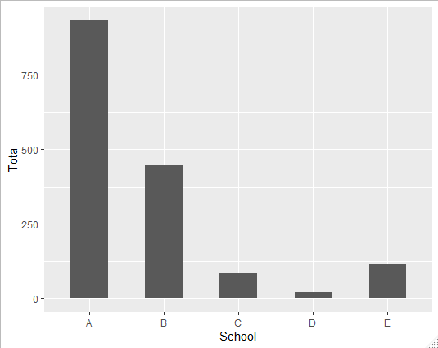

*Figure 1: Number of Students per School*

Each of the students are categorized into six categories: very ahead, middling, behind, more behind, very behind, or completed. To be “Very Ahead” the students need to be five or more classes ahead. “Middling” is zero to five classes ahead. “Behind” is one to five classes behind. “More Behind” is six to ten classes behind. “Very Behind” is more than 11 classes behind. Completed is when students have finished all their classes. I was curious to see how many students completed all the classes. I found that the most number of students who completed the classes were in School A, with the least being in School D (Figure 2).

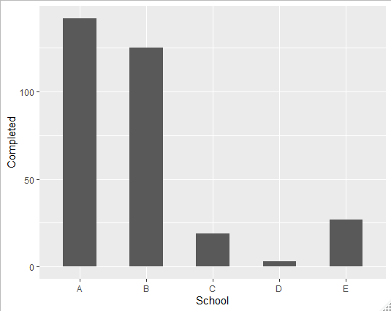

*Figure 2: Number of Students Completed per School*

Since School A has the most students, it’s highly expected that they would have higher number of students in every category. I wanted to see the proportions of students in each category to the overall population of the school (Figure 3). No students were “Very Ahead” in any of the schools. School B, proportionally, had the most students that were either on track or doing better than expected. They also had the most students that completed the course. School D had the most students falling behind, though School A was also high up there with the proportion of students that were falling behind.

*Figure 3: Percentage of Students in Each Category per School*