**Rogationist College**

**SCORE**

(St. Anthony’s Boys Village)

km.52 Emilio Aguinaldo Highway Lalaan II, Silang, Cavite

**DIRECTORATE FOR ACADEMIC AFFAIRS**

**COLLEGE DEPARTMENT**

COMPUTER STUDIES CLUSTER

**ITP55 – Advanced Database Systems**

**Final Examination**

**Name (Surname, Firstname, Middle Initial)**

|  |  |  |  |  |  |  |  |  |  |  |  |  |  |  |  |  |  |  |  |  |  |  |  |  |  |  |  |  |  |  |  |
| --- | --- | --- | --- | --- | --- | --- | --- | --- | --- | --- | --- | --- | --- | --- | --- | --- | --- | --- | --- | --- | --- | --- | --- | --- | --- | --- | --- | --- | --- | --- | --- |
|  |  |  |  |  |  |  |  |  |  |  |  |  |  |  |  |  |  |  |  |  |  |  |  |  |  |  |  |  |  |  |  |

**Student Number Course and Section Date (dd-mm-yyyy)**

|  |  |  |  |  |  |  |  |  |  |  |  |  |  |  |  |  |  |  |  |  |  |  |  |  |  |  |  |  |  |  |  |
| --- | --- | --- | --- | --- | --- | --- | --- | --- | --- | --- | --- | --- | --- | --- | --- | --- | --- | --- | --- | --- | --- | --- | --- | --- | --- | --- | --- | --- | --- | --- | --- |
| C | T |  |  | - |  |  |  |  |  |  |  |  |  |  |  |  |  |  |  |  |  |  |  | - |  |  | - |  |  |  |  |

**MULTIPLE CHOICE.**

On a separate answer sheet, shade the box that corresponds to the letter of the BEST answer.

ANY FORM OF ERASURES NULLIFY YOUR ANSWER.

1. What do we minimize when we normalize a relation or set of relations?

1. data
2. fields
3. redundancy
4. database

2. Normalization also eliminates _____________ anomalies.

1. insert
2. update
3. delete
4. all of the above

3. In what form is it when a relation has atomic values?

1. 1NF
2. 2NF
3. 3NF
4. none of the above

4. 2NF relations are those that are in 1NF with all the attribute types dependent on the _________ key.

1. primary
2. foreign
3. composite
4. alternate

5. A relation is in ________ if it is in Boyce Codd normal form and does not have any multivalued dependencies.

1. 1NF
2. 2NF
3. 3NF
4. none of the above

6. What is TRUE about the First Normal Form (1NF)?

1. if a relation contains an atomic value, it will be 1NF.
2. a table attribute cannot contain more than one value, according to this rule.
3. a single-valued attribute can only be stored in it.
4. all of the above

7. What is TRUE about the Second Normal Form (2NF)?

1. relational must belong to 1NF in the 2NF.
2. all attributes other than the primary key are fully functional in the second normal form
3. both A and B
4. none of the above

8. What is TRUE about the Third Normal Form (3NF)?

1. when a relation is in 2NF and does not contain transitive partial dependencies, it will be in 3NF.
2. data duplication is reduced by using 3NF.
3. it helps maintain the integrity of the data.
4. all of the above

9. What is TRUE about BCNF?

1. the advanced version of 3NF is BCNF.
2. BCNF is stricter than 3NF.
3. the super key is X for any functional dependency of X -> Y in the table.
4. all of the above

10. Which of the following is a type of Normal Form?

1. ACNF
2. BCNF
3. CCNF
4. DCNF

11. Which data type is NOT part of JSON standard?

1. string
2. number
3. date
4. array

12. Which code uses the correct JSON syntax to encode the key/value pair shown?

accountNum: '000605802'

1. "accountNum": "000605802"
2. accountNum: "000605802"
3. "accountNum": 000605802
4. accountNum: 000605802

13. What characters denote strings in JSON?

1. double quotes
2. smart (curly) quotes
3. single or double quotes
4. single quotes

14. Which array is valid JSON?

1. ['tatooine', 'hoth', 'dagobah']
2. [tatooine, hoth, dagobah]
3. ["tatooine", "hoth", "dagobah",]
4. ["tatooine", "hoth", "dagobah"]

15. Which code uses the correct JSON syntax for a key/Value pair containing a string?

1. "largest": "blue whale"
2. largest: 'blue whale'
3. 'largest': 'blue whale'
4. largest: "blue whale"

16. What is this code an example of?

<x/>

1. null element
2. self-closing tag
3. improperly named element
4. incorrect XML syntax

17. Which statement is not true about XML?

1. XML is flexible and customizable.
2. XML can be used to store data.
3. XML is independent of the Operating System.
4. XML is a replacement for HTML.

18. These store information related to spatial locations, and support efficient storage, indexing and querying of spatial data.

1. textual data
2. spatial databases
3. geographic data
4. geometric data

19. These design information about how objects are constructed.

1. textual data
2. spatial databases
3. geographic data
4. geometric data

20. This refers to a geometric information that can be represented by the coordinates of its endpoints

1. line segment
2. polyline
3. linestring
4. polygons

21. This is a program running on the server machine that accepts requests from a web browser and sends back results in the form of HTML documents.

1. application server
2. database server
3. web server
4. web service

22. This refers to an application layer that provides high level view of data and actions on data.

1. presentation layer
2. business logic layer
3. data access layer
4. none of the above

23. This refers to an application layer that contains the user interface of the application.

1. presentation layer
2. business logic layer
3. data access layer
4. none of the above

24. This is the application layer that interfaces between business logic layer and the underlying database

1. presentation layer
2. business logic layer
3. data access layer
4. none of the above

25. These allow data on web to be accessed using remote procedure call mechanism

1. application server
2. database server
3. web server
4. web service

26. This stores data across a large collection of machines, but provides single file-system view

1. distributed file system
2. sharding
3. key-value storage systems
4. parallel and distributed database

27. These store large numbers (billions or even more) of small (KB-MB) sized records.

1. distributed file system
2. sharding
3. key-value storage systems
4. parallel and distributed database

28. This partitions data across multiple databases

1. distributed file system
2. sharding
3. key-value storage systems
4. parallel and distributed database

29. This refers to the processing of data to infer patterns, correlations, or models for prediction

1. machine learning
2. data mining
3. data warehouse
4. data analytics

30. This refers to a repository (archive) of information gathered from multiple sources, stored under a unified schema, at a single site.

1. machine learning
2. data mining
3. data warehouse
4. data analytics

For items 31 – 40, refer to the table below.

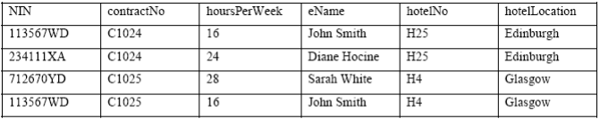

31. Which of the following can be used as candidate keys?

1. NIN, contractNo and hotelNo
2. NIN and contractNo
3. NIN and hotelNo
4. contractNo and hotelNo

32. How many functional dependencies are there?

1. 1
2. 2
3. 3
4. 4

33. Where is hotelLocation functionally dependent on?

1. NIN
2. contractNo
3. eName
4. hotelNo

34. Where is hoursPerWeek functionally dependent on?

1. NIN
2. contractNo
3. NIN and contractNo
4. eName

35. Where is eName functionally dependent on?

1. NIN
2. contractNo
3. NIN and contractNo
4. NIN, contractNo and hotelNo

36. In 2NF, which of the following is not the resulting table split?

1. NIN, contractNo, hoursPerWeek
2. NIN, eName
3. NIN, contractNo, hotelNo, hotelLocation
4. NIN, hotelNo, hotelLocation

37. In 3NF, how many resulting tables are there?

1. 1
2. 2
3. 3
4. 4

38. Which of the following is a correct resulting table of 3NF?

1. Staff(NIN, eName)
2. Staff(NIN, eName, hotelNo)
3. Staff(NIN, contractNo, eName)
4. Staff(NIN, hoursPerWeek, eName)

39. Which of the following is a correct resulting table of 3NF?

1. Hotel(NIN, hotelNo, hotelLocation)
2. Hotel(eName, hotelNo, hotelLocation)
3. Hotel(hotelNo, hotelLocation)
4. Hotel(contractNo, hotelNo, hotelLocation)

40. Which of the following cannot be a primary key?

1. NIN
2. contractNo
3. hoursPerWeek
4. hotelNo

For items 41 – 50, refer to the table below.

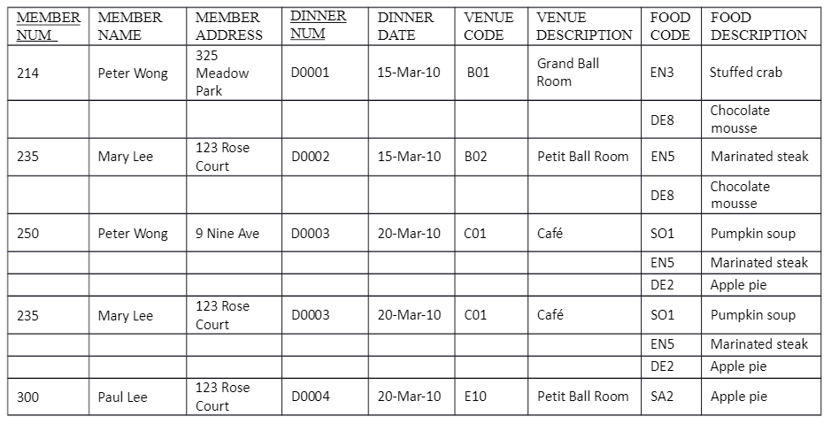

41. Which of the following fields has non-atomic data?

1. member address
2. dinner date
3. venue description
4. food description

42. How many functional dependencies are there?

1. 1
2. 2
3. 3
4. 4

43. Where is member address functionally dependent on?

1. member num
2. member name
3. member num and name
4. none of the above

44. Where is venue description functionally dependent on?

1. venue code
2. dinner num
3. dinner date
4. venue code and dinner num

45. Where is food description functionally dependent on?

1. food code
2. venue code
3. dinner num
4. member num

46. In 2NF, which of the following is not yet in 3NF after splitting?

1. Member Dinner Food (MEMBER NUM, DINNER NUM, FOOD CODE)
2. Member (MEMBER NUM, MEMBER NAME, MEMBER ADDRESS)
3. Dinner (DINNER NUM, DINNER DATE, VENUE CODE, VENUE DESCRIPTION)
4. Food (FOOD CODE, FOOD DESCRIPTION)

47. In 3NF, how many resulting tables are there?

1. 3
2. 4
3. 5
4. 6

48. Which of the following is a correct resulting table of 3NF?

1. Food (FOOD CODE, FOOD DESCRIPTION)
2. Food (MEMBER NUM, FOOD CODE, FOOD DESCRIPTION)
3. Food (DINNER NUM, FOOD CODE, FOOD DESCRIPTION)
4. none of the above

49. Which of the following is a correct resulting table of 3NF?

1. Dinner (DINNER NUM, DINNER DATE, VENUE CODE, VENUE DESCRIPTION)
2. Dinner (DINNER NUM, DINNER DATE, VENUE CODE)
3. Dinner (DINNER NUM, DINNER DATE, DESCRIPTION)
4. Dinner (DINNER NUM, VENUE CODE)

50. Which of the following cannot be a primary key?

1. member num
2. dinner num
3. food code
4. dinner date