


程序设计课程设计报告

题 目 医院管理系统
学 院 计算机学院
专 业 计算机类
年级班别 25级（ 2 ）班
学 号 3225004070
学生姓名 罗巧薇
指导教师 汪明慧

2025年12月
一、课程设计题目
题目：医院管理系统
- 基本功能需求说明(必须采用结构体和动态链表实现)
医院管理系统是一个用于管理医院日常运营的系统，包括患者、医生、药品 信息管理，挂号、住院、费用管理等功能。
1.患者信息管理：可以添加、修改、删除和查询患者的信息，包括姓名、年龄、 性别、联系方式、诊断结果、治疗方案等。
2.医生信息管理：可以添加、修改、删除和查询医生的信息，包括姓名、年龄、 性别、专业领域、联系方式等。
3.药品信息管理：可以添加、修改、删除和查询药品的信息，包括药品名称、规 格、生产厂家、价格等。
4.挂号管理：患者可以在系统中进行挂号，可以选择医生和科室，并且可以查看 医生的排班信息。
5.费用管理：可以管理患者的费用信息，包括收费项目和金额等.
6.保存功能：将数据保存在任何自定义的文件中。
7.读取功能：将保存在文件中的数据读取出来。
8. 排序功能：能对某一信息数据进行排序。
9.有一个清晰美观界面来调用各个功能。
二、加分项
1.使用图形界面。
2.可参考实际情况对数据信息扩充。
3.系统功能添加。
三、设计要求
1.数据放入指定文件。
2.有适当出错处理，并能给出错提示。如输入数据错误，文件操作错误等等。
3．以上各个功能均编写成子函数，有良好的注释说明，由主函数调用实现。
4．必须采用结构体和动态链表实现数据的存储和访问；
5. 必须使用文件保存数据。
6.应提供一个界面来调用各个功能,调用界面和各个功能的操作界面应尽可能清 晰美观。
7.管理员和用户的权限要分开。
四、测试数据 相关信息数据不少于10条。

二、总体设计
（一）功能模块
1.主函数 2.菜单函数 3.登录函数 4.输入和插入信息函数
5.查看查询信息函数 6.删除函数 7.修改信息函数 8.排序函数
9.从二进制文件读取数据 10.保存数据到二进制文件
（二）系统功能模块结构图
如图所示：
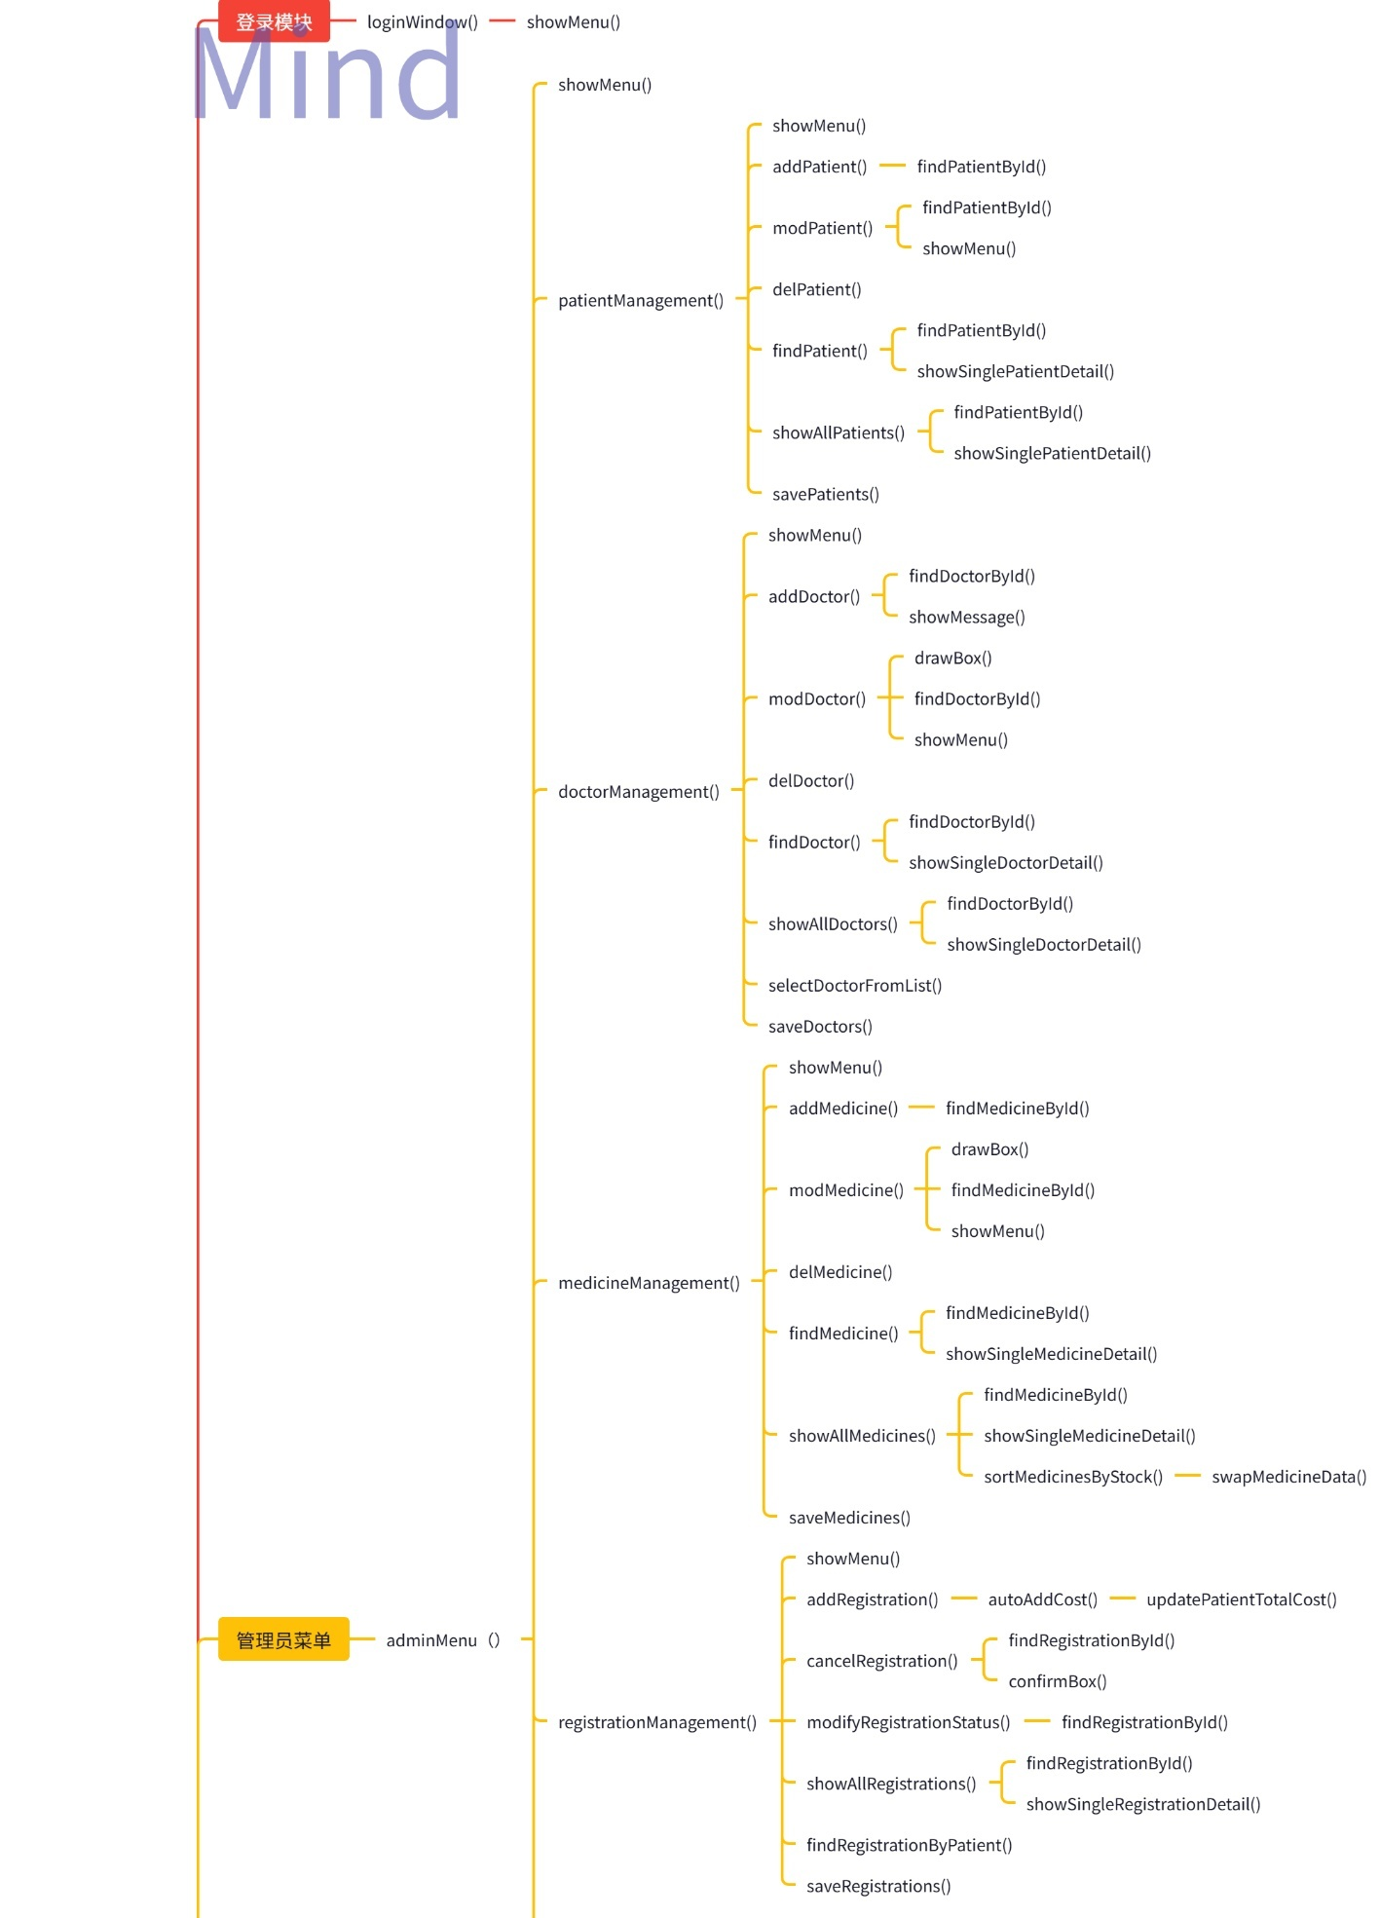
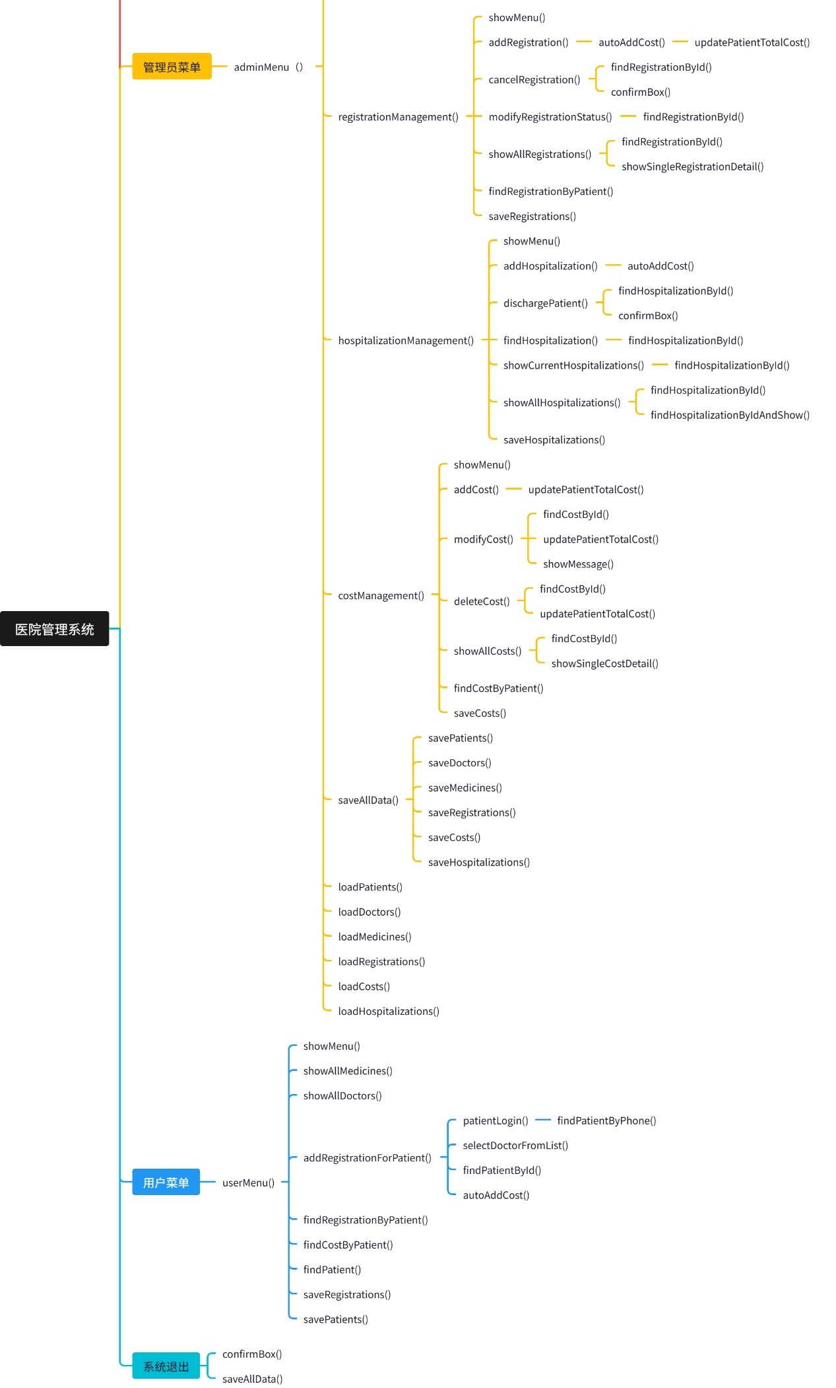
三、详细设计
（一）主函数
1. 功能介绍
（1）从对应的 .dat 文件读取数据，建立各个链表。
（2）生成首页菜单界面，选择身份（系统管理员/普通用户）或退出系统。
（3）根据选择，调用对应的登录函数，完成登录后生成相应界面。
（4）根据提示输入数字完成对应功能，错误输入则报错并能够重新输入。
（5）每次发生数据修改，都将数据重新保存至对应的 .dat 文件。

2. 管理员界面（正确输入管理员密码）
（1）患者信息管理
ⅰ. 查看所有患者的简略信息或查询指定患者的详细信息
ⅱ. 添加患者信息
ⅲ. 删除患者信息
ⅳ. 修改患者信息
ⅴ. 按患者查询费用记录
0. 返回

（2）医生信息管理
ⅰ. 查看所有医生的简略信息或查询指定医生的详细信息
ⅱ. 添加医生信息
ⅲ. 删除医生信息
ⅳ. 修改医生信息
ⅴ. 从医生列表中选择医生（用于挂号）
0. 返回

（3）药品信息管理
ⅰ. 查看所有药品的简略信息或查询指定药品的详细信息
ⅱ. 添加药品信息
ⅲ. 删除药品信息
ⅳ. 修改药品信息
ⅴ. 按药品库存进行升序排序
0. 返回

（4）挂号管理
ⅰ. 挂号登记
ⅱ. 取消挂号
ⅲ. 修改挂号状态
ⅳ. 显示所有挂号记录
ⅴ. 按患者查询挂号记录
0. 返回

（5）住院管理
ⅰ. 办理入院登记
ⅱ. 办理出院手续
ⅲ. 查询住院记录
ⅳ. 显示所有在院患者
ⅴ. 显示所有住院记录
0. 返回

（6）费用管理
ⅰ. 添加费用记录
ⅱ. 修改费用信息
ⅲ. 删除费用记录
ⅳ. 显示所有费用记录
ⅴ. 按患者查询费用记录
0. 返回

（7）数据保存
（8）数据读取
（0）退出登录

3. 用户界面（正确输入用户密码）
（1）查询药品信息（可查看详细信息）
（2）查询医生信息（可查看详细信息）
（3）我要挂号（需先手机号登录）
（4）挂号查询（需先手机号登录）
（5）费用查询（需先手机号登录）
（6）登录/修改个人信息
（0）返回登录界面
4. 循环选择结构流程图
如图所示：
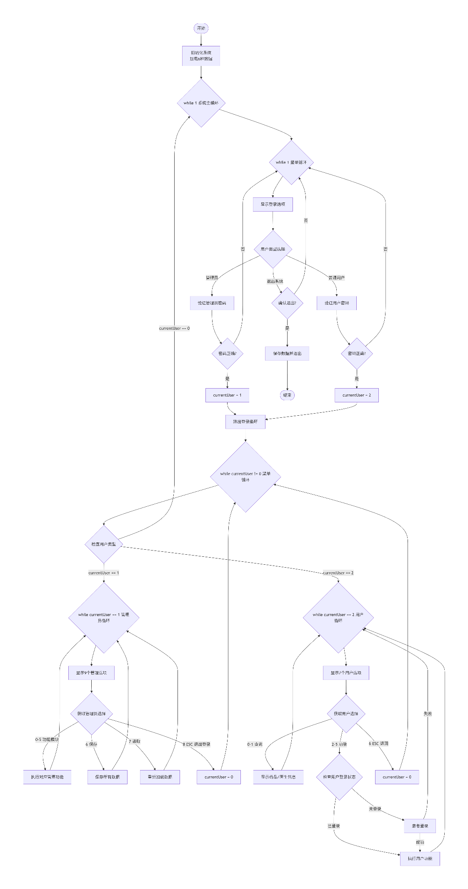

（二）登录函数（以管理员登录为例）
1. 功能介绍
（1）显示系统登录菜单，让用户选择身份（系统管理员/普通用户）。
（2）如果选择系统管理员，要求输入密码。
（3）密码输入支持Tab键按住显示明文功能，松开Tab键恢复显示星号。
（4）输入的密码与预设密码比较，正确则设置currentUser=1，否则报错。
（5）连续输入错误可重新输入，按ESC可返回身份选择。
（6）输入正确后显示登录成功消息并返回主循环。
2. 程序流程图
如图所示：

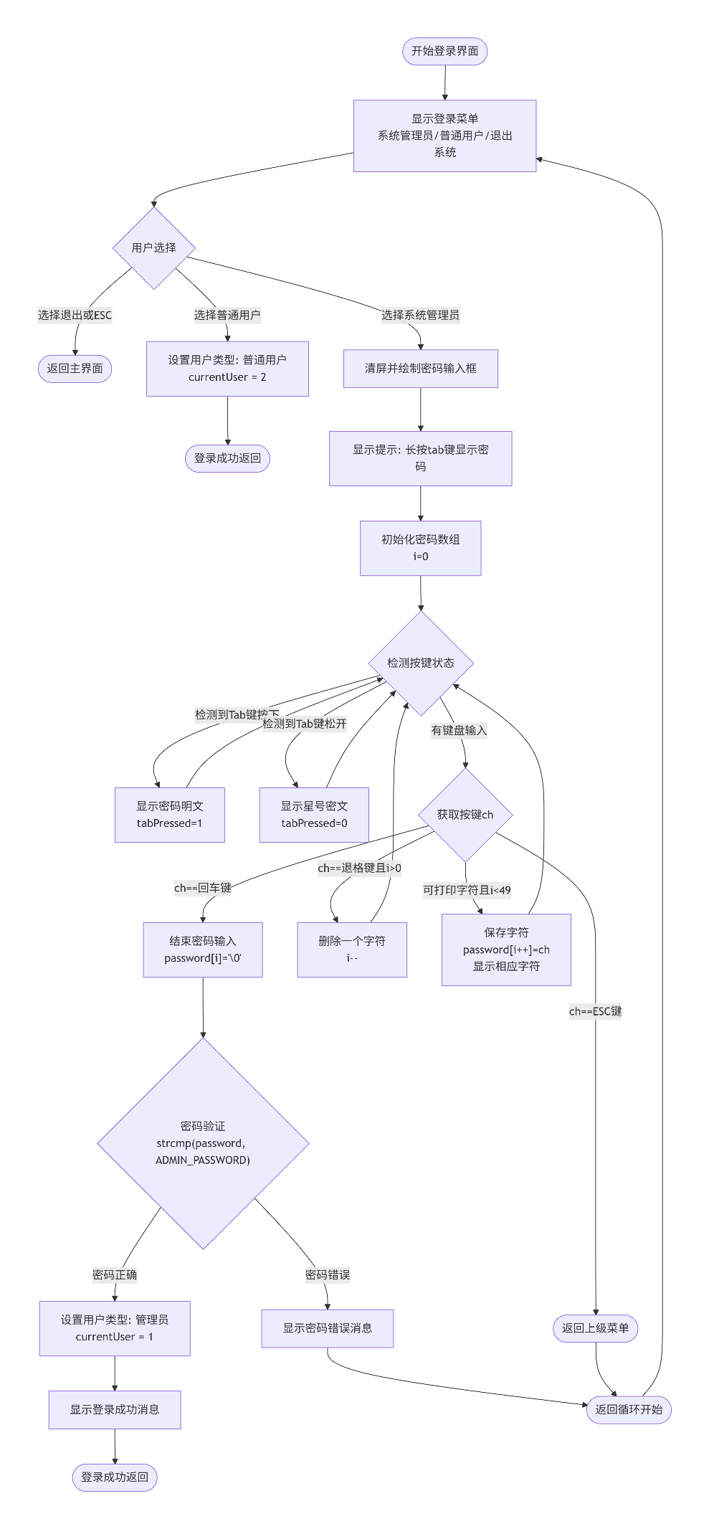
3.具体程序代码
void loginWindow() {
while(1) {
const char *items[] = {"系统管理员", "普通用户", "退出系统"};
int choice = showMenu("医院管理系统登录", items, 3);

if(choice == -1 || choice == 2) {
currentUser = 0;
return;
}

if(choice==1){
currentUser = 2;
return;
}

system("cls");

int width = 40;
int height = 8;
int screenWidth = 80;
int screenHeight = 25;
int x = (screenWidth - width) / 2;
int y = (screenHeight - height) / 2;

drawBox(x, y, x + width, y + height, CYAN, "请输入密码");

HANDLE a = GetStdHandle(STD_OUTPUT_HANDLE);
COORD pos;
pos.X = x + 20; pos.Y = y + height + 1;
SetConsoleCursorPosition(a, pos);
setColor(YELLOW);
printf("长按tab键显示密码");
pos.X = x + 3; pos.Y = y + 2;
SetConsoleCursorPosition(a, pos);
printf("密码: ");

char password[50];
int i = 0;
char ch;
int j;
int tabPressed = 0;

while(1) {
// 检测Tab键状态
if(GetAsyncKeyState(VK_TAB) & 0x8000) {
if(!tabPressed) {
tabPressed = 1;
// 重新显示实际字符
pos.X = x + 9; pos.Y = y + 2;
SetConsoleCursorPosition(a, pos);
for(j = 0; j < i; j++) {
putchar(password[j]);
}
}
} else {
if(tabPressed) {
tabPressed = 0;
// 恢复显示星号
pos.X = x + 9; pos.Y = y + 2;
SetConsoleCursorPosition(a, pos);
for(j = 0; j < i; j++) {
putchar('*');
}
}
}

// 检查普通按键
if(_kbhit()) {
ch = _getch();

if(ch == 13) break;
if(ch == 27) return;
if(ch == 8 && i > 0) {
printf("\b \b");
i--;
}
else if(i < 49 && ch >= 32 && ch <= 126) {
password[i++] = ch;

// 根据Tab状态显示
if(tabPressed) {
putchar(ch);
} else {
putchar('*');
}
}
}
}
password[i] = '\0';

const char *correctPass = ADMIN_PASSWORD;

if(strcmp(password, correctPass) == 0) {
currentUser = 1;
showMessage("管理员登录成功！", GREEN);
return;
} else {
showMessage("密码错误！", RED);
}
}
}

(三）输入和插入信息函数（以患者为例）
1. 功能介绍
（1）患者链表头指针作为全局变量，通过外部声明访问。
（2）动态分配新结点内存，使用malloc函数。
（3）输入患者ID，调用findPatientById函数判断是否已经存在，存在则重新输入。
（4）ID不重复时继续输入其他信息：姓名、年龄、性别、联系电话、入院日期、诊断结果、治疗方案、总费用。
（5）输入过程中支持ESC键取消输入。
（6）输入完后，显示所有信息汇总让用户确认。
（7）确认后，使用头插法插入到患者链表头部。
（8）显示添加成功消息并返回。
2. 程序流程图
插入操作流程图如图所示
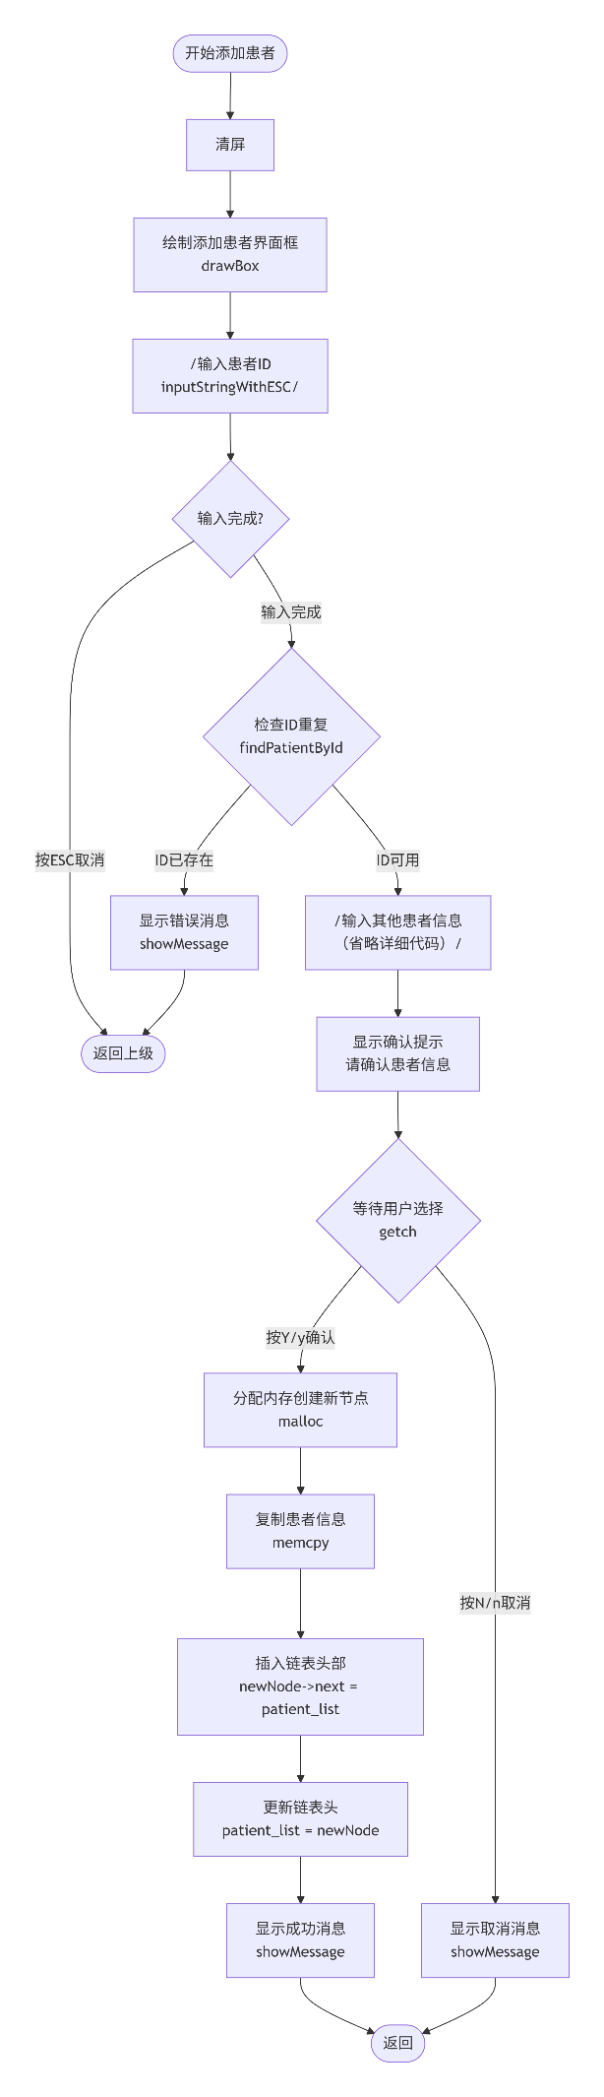
3.具体程序代码

（四）查看查询信息函数（以药品为例）
1. 功能介绍
（1）药品链表头指针作为全局变量访问。
（2）输出所有药品的简略信息：ID、名称、规格、单价、库存，方便查询。
（3）输入序号可查看对应药品的详细信息。
（4）输入0可对药品按库存进行升序排序。
（5）支持ESC键退出查询。
（6）可以循环查询，直到输入ESC退出。
2.程序流程图
如图所示：
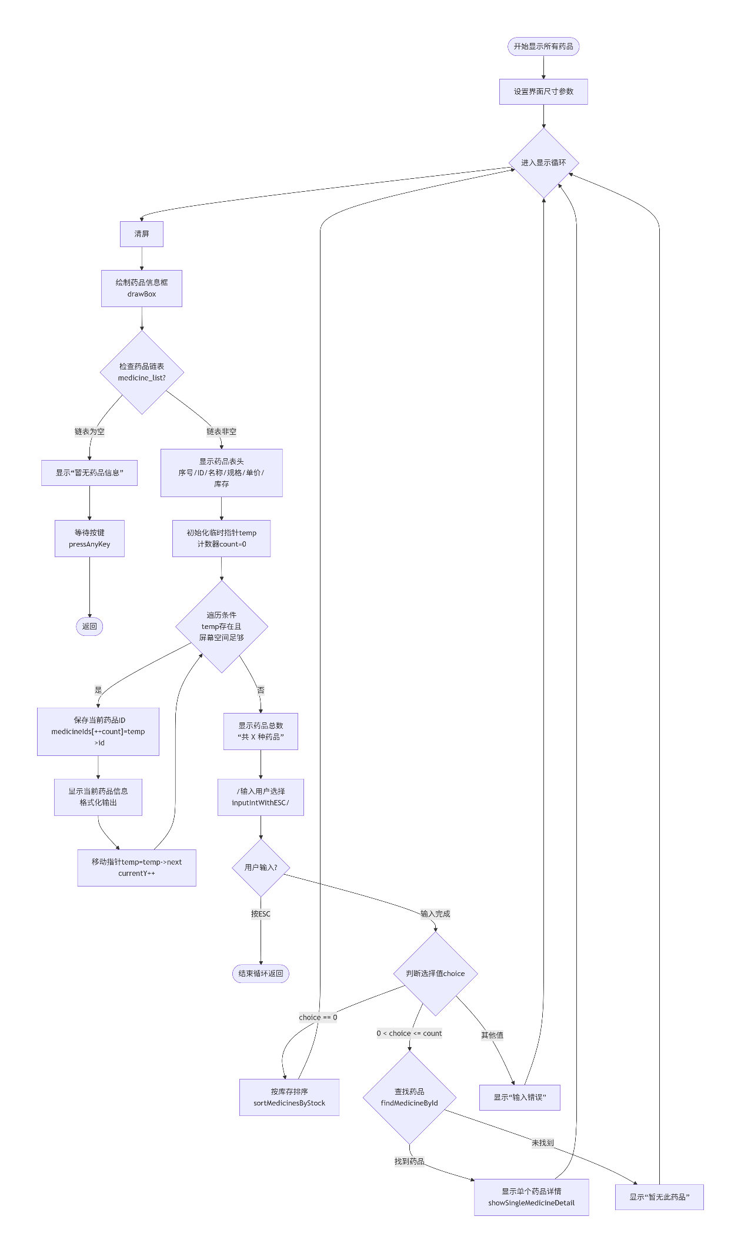
3.具体程序代码
void showAllMedicines() {
int width = 70;
int height = 20;
int screenWidth = 80;
int screenHeight = 25;
int x = (screenWidth - width) / 2;
int y = (screenHeight - height) / 2;

while(1){
system("cls");
drawBox(x, y, x + width, y + height, CYAN, "所有药品信息");

HANDLE a = GetStdHandle(STD_OUTPUT_HANDLE);
COORD pos;

if(!medicine_list) {
pos.X = x + 3; pos.Y = y + 2;
SetConsoleCursorPosition(a, pos);
setColor(YELLOW);
printf("暂无药品信息！");
setColor(WHITE);
pressAnyKey();
return;
}

// 显示表头
pos.X = x + 3; pos.Y = y + 2;
SetConsoleCursorPosition(a, pos);
setColor(YELLOW);
printf("%-5s %-10s %-15s %-10s %-8s %-6s", "序号","药品ID", "药品名称", "规格", "单价", "库存");
setColor(WHITE);

Medicine *temp = medicine_list;
int count = 0;
int currentY = y + 3;
char *medicineIds[100];

while(temp && currentY < y + height - 2) {
medicineIds[++count] = temp->id;
pos.X = x + 3; pos.Y = currentY++;
SetConsoleCursorPosition(a, pos);
printf("%-5d %-10s %-15s %-10s %-8.2f %-6d",
count, temp->id, temp->name, temp->specification, temp->price, temp->stock);
temp = temp->next;
}

pos.X = x + 3; pos.Y = y + height - 3;
SetConsoleCursorPosition(a, pos);
setColor(YELLOW);
printf("共 %d 种药品", count);

// 用户选择
int choice;
if(!inputIntWithESC(&choice, "输入序号查看详细信息（输入 0 库存由低到高排序）：", x+3, y + height - 2)) break;
setColor(WHITE);
if(choice==0) sortMedicinesByStock();
else if(choice > 0 && choice <= count) {
if(!findMedicineById(medicineIds[choice])) {
showMessage("暂无此药品", RED);
}
else showSingleMedicineDetail(medicineIds[choice]);
}
else {
showMessage("输入错误！请重试", RED);
}
}
return;
}
（五）删除函数（以患者为例）
1. 功能介绍
（1）以患者链表头指针和费用链表的头指针为全局变量。
（2）输入要删除的患者ID。
（3）查找患者节点，如果找到则从链表中删除。
（4）如果删除成功，调用updatePatientTotalCost函数更新相关费用记录。
（5）释放被删除节点的内存。
（6）显示删除成功或失败的消息。
（7）可以输入ESC退出。

2.程序流程图
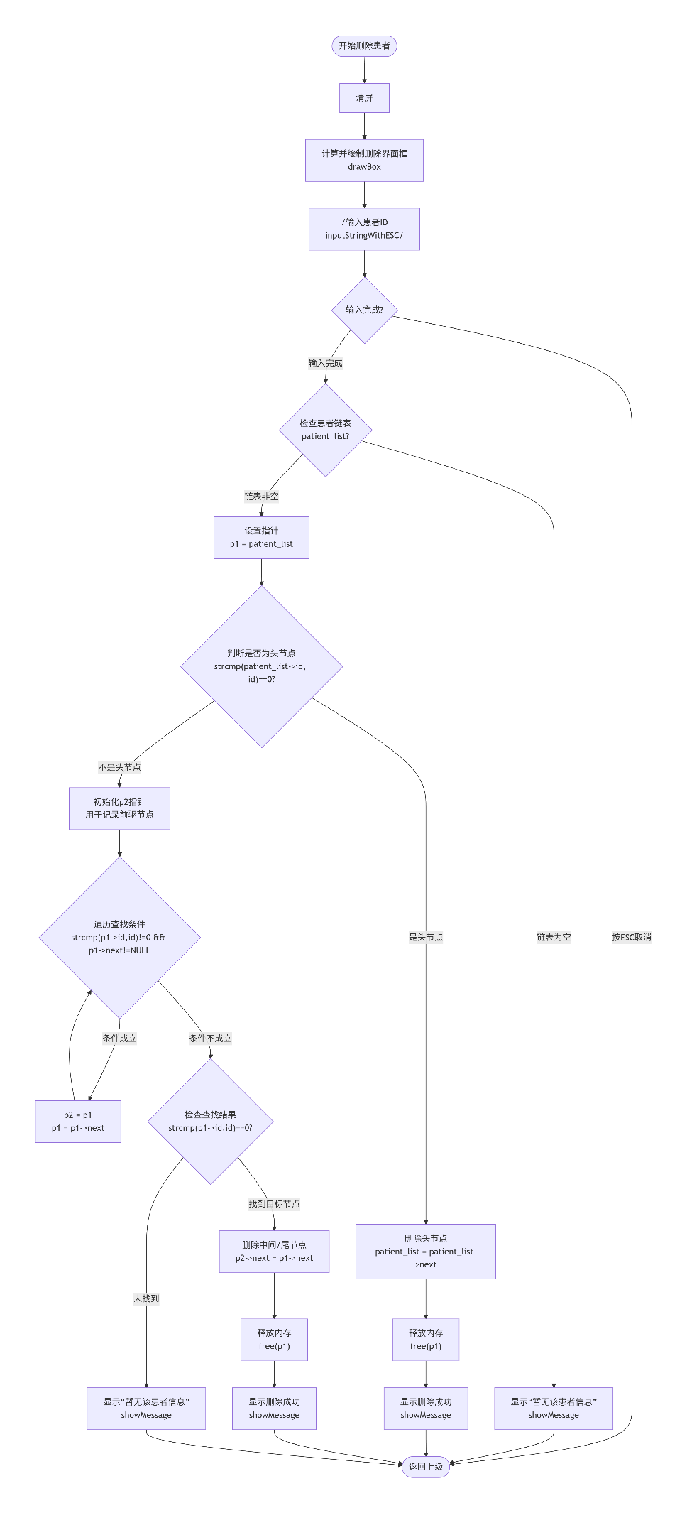
3.具体程序代码
void delPatient(){
system("cls");

int width = 60;
int height = 10;
int screenWidth = 80;
int screenHeight = 25;
int x = (screenWidth - width) / 2;
int y = (screenHeight - height) / 2;

drawBox(x, y, x + width, y + height, CYAN, "删除患者信息");

char id[20];

// 输入患者ID
if(!inputStringWithESC(id, MAX_ID, "患者ID: ", x + 3, y + 2)) {
return;
}

Patient *p1,*p2;
if(patient_list==NULL){
showMessage("暂无该患者信息", RED);
return;
}
p1=patient_list;
if(strcmp(patient_list->id,id)==0){
patient_list=patient_list->next;
free(p1);
showMessage("已删除该患者信息", YELLOW);
return;
}
while(strcmp(p1->id,id)!=0 && p1->next!=NULL) {
p2=p1;
p1=p1->next;
}
if(strcmp(p1->id,id)==0){
p2->next=p1->next;
free(p1);
showMessage("已删除该患者信息", YELLOW);
return;
}
showMessage("暂无该患者信息", RED);
return;
}
（六）修改信息函数（以患者为例）
1. 功能介绍
（1）以患者链表头指针为全局变量。
（2）输入要修改的患者ID，调用findPatientById查找患者。
（3）如果找到患者，显示修改菜单：姓名、年龄、性别、联系电话、入院日期、诊断结果、治疗方案、总费用、返回。
（4）根据用户选择，调用相应的输入函数修改对应字段。
（5）修改过程中支持ESC取消。
（6）修改完成后，数据会自动保存到文件。
（7）可以循环修改多个字段，直到选择返回。
2.程序流程图
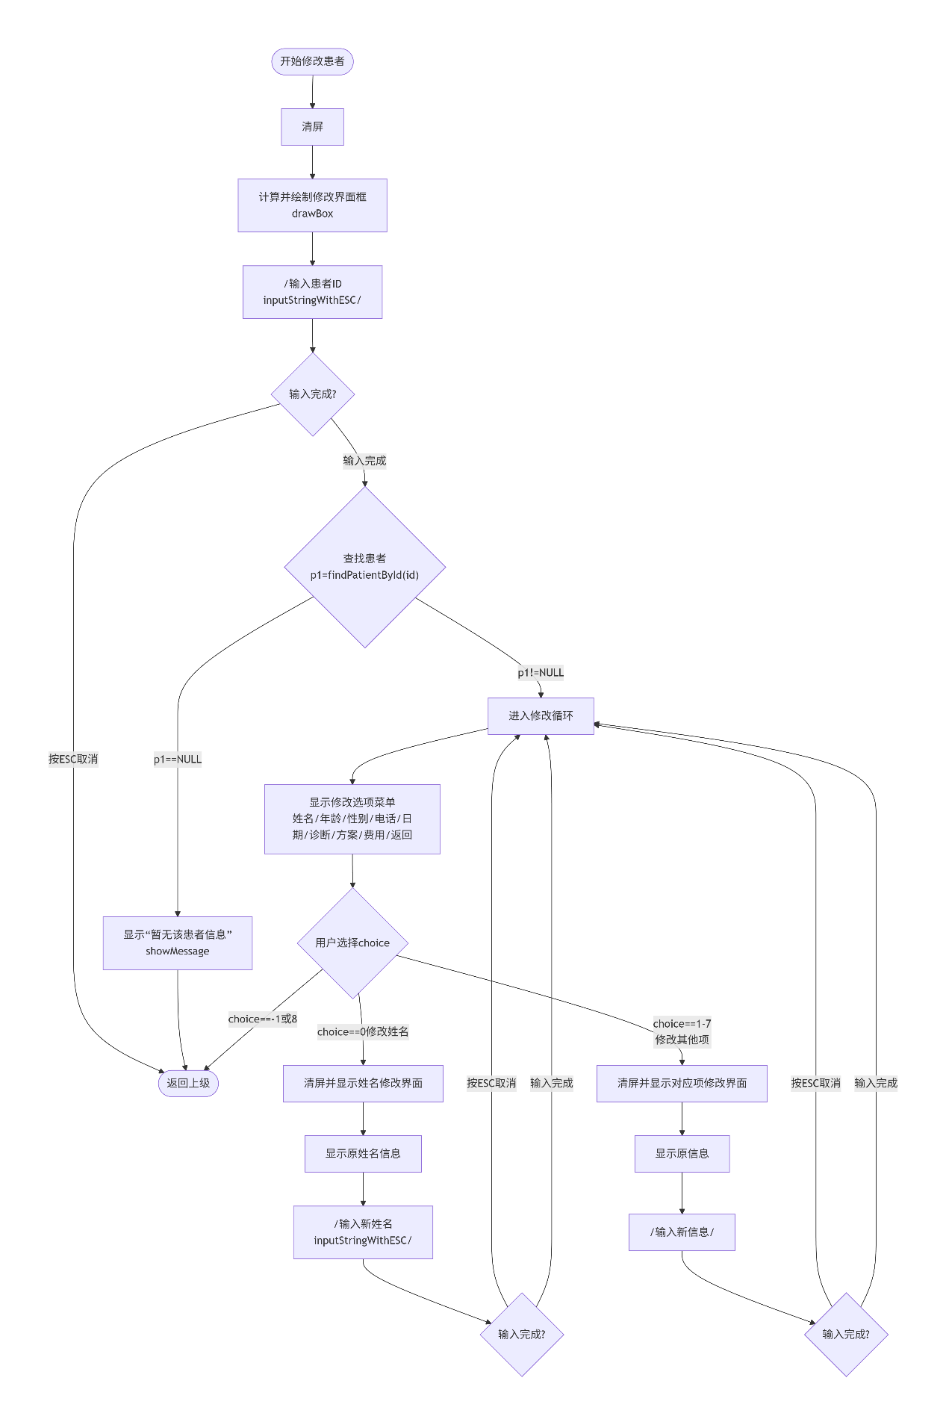

3.具体程序代码
void modPatient(){
system("cls");

int width = 60;
int height = 10;
int screenWidth = 80;
int screenHeight = 25;
int x = (screenWidth - width) / 2;
int y = (screenHeight - height) / 2;

drawBox(x, y, x + width, y + height, CYAN, "修改患者信息");

HANDLE a = GetStdHandle(STD_OUTPUT_HANDLE);
COORD pos;

char id[20];

// 输入患者ID
if(!inputStringWithESC(id, MAX_ID, "患者ID: ", x + 3, y + 2)) {
return;
}

Patient *p1=findPatientById(id);

if(p1!=NULL){
while(1) {
const char *items[] = {
"姓名",
"年龄",
"性别（男/女）",
"联系电话",
"入院日期",
"诊断结果",
"治疗方案",
"总费用",
"返回"
};

int choice = showMenu("选择修改的项", items, 9);

switch(choice) {
case 0:
system("cls");
drawBox(x, y, x + width, y + height, CYAN, "姓名");
pos.X = x + 3; pos.Y = y + 3;
SetConsoleCursorPosition(a, pos);
printf("原姓名: %s", p1->name);
if(!inputStringWithESC(p1->name, MAX_NAME, "更改为: ", x + 3, y + 7)) {
continue;
}
break;
// ... 其他选项类似处理
case 8:
case -1:
return;
}
}
}
showMessage("暂无该患者信息", RED);
return;
}
（七）排序函数（以药品库存排序为例）
1. 功能介绍
（1）函数形参为药品链表头指针（全局变量）。
（2）使用冒泡排序的方法对链表按库存升序排序。
（3）如果链表为空或只有一个节点，提示无需排序。
（4）通过交换节点数据（而不是节点指针）实现排序。
（5）返回排序后的链表（头指针不变）。
（6）显示排序完成消息。
2.程序流程图
如图所示：
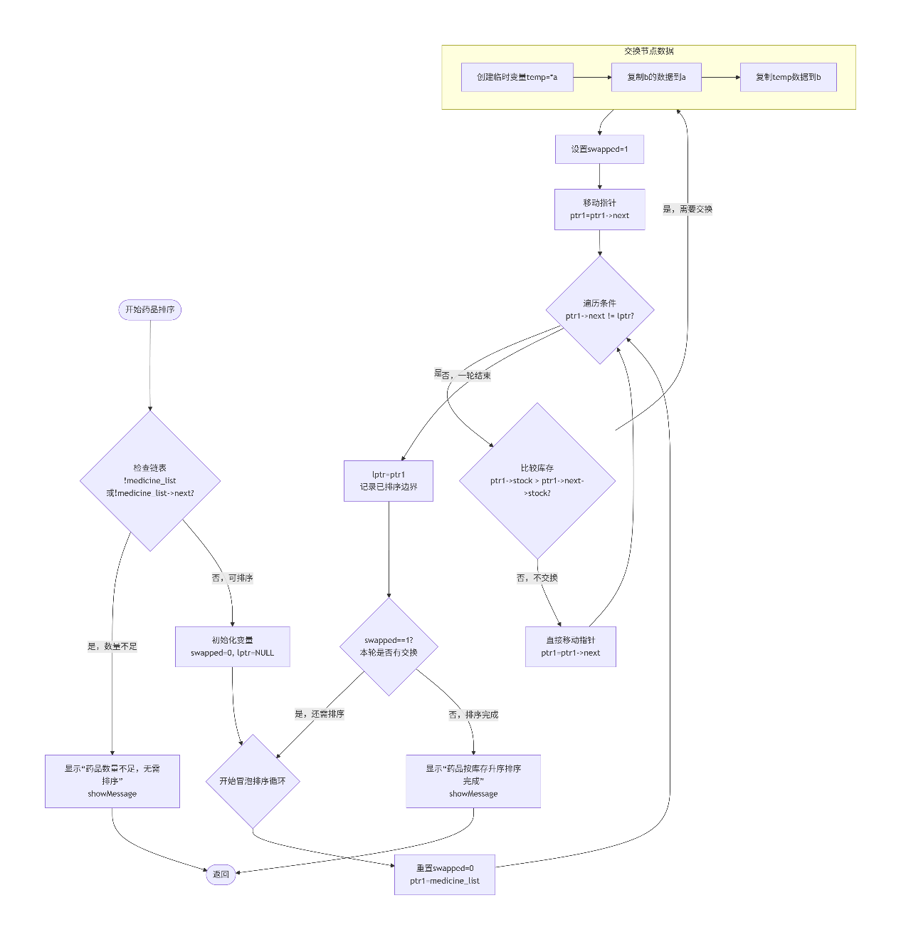
3.具体程序代码
void sortMedicinesByStock() {
if(!medicine_list || !medicine_list->next) {
showMessage("药品数量不足，无需排序", YELLOW);
return;
}

int swapped;
Medicine *ptr1;
Medicine *lptr = NULL;

// 使用冒泡排序
do {
swapped = 0;
ptr1 = medicine_list;

while(ptr1->next != lptr) {
// 比较库存，库存高的往后排
if(ptr1->stock > ptr1->next->stock) {
// 交换两个节点数据
swapMedicineData(ptr1, ptr1->next);
swapped = 1;
}
ptr1 = ptr1->next;
}
lptr = ptr1;
} while(swapped);

showMessage("药品按库存升序排序完成！", GREEN);
}

void swapMedicineData(Medicine *a, Medicine *b) {
// 创建临时变量保存a的数据
Medicine temp = *a;

// 复制b的数据到a
strcpy(a->id, b->id);
strcpy(a->name, b->name);
strcpy(a->specification, b->specification);
strcpy(a->manufacturer, b->manufacturer);
a->price = b->price;
a->stock = b->stock;
a->production_date = b->production_date;
a->expiry_date = b->expiry_date;

// 复制temp的数据到b
strcpy(b->id, temp.id);
strcpy(b->name, temp.name);
strcpy(b->specification, temp.specification);
strcpy(b->manufacturer, temp.manufacturer);
b->price = temp.price;
b->stock = temp.stock;
b->production_date = temp.production_date;
b->expiry_date = temp.expiry_date;
}
（八）从二进制文件读取数据（以患者为例）
1. 功能介绍
（1）打开 data/patients.dat 文件以二进制只读模式。
（2）如果文件不存在，返回空链表指针。
（3）循环读取文件中的患者记录，直到文件结束。
（4）为每条记录动态分配内存创建新节点。
（5）复制数据到新节点，设置next指针为NULL。
（6）使用尾插法将新节点添加到链表。
（7）返回构建好的链表头指针。
（8）关闭文件。
2.程序流程图
如图所示：
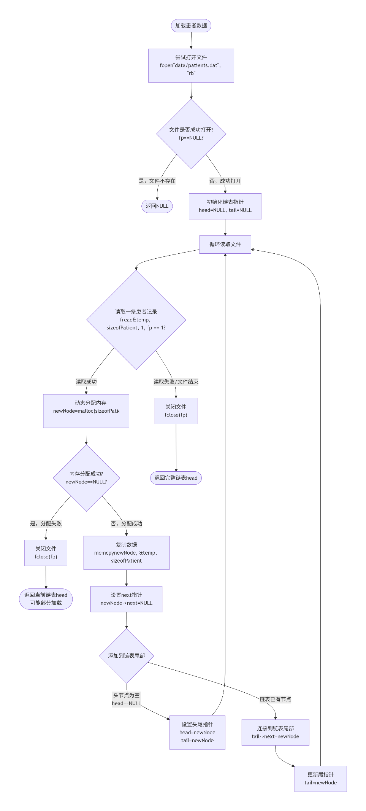
3.具体程序代码
Patient* loadPatients() {
FILE *fp = fopen("data/patients.dat", "rb");
if(fp == NULL) {
return NULL; // 文件不存在，返回空链表
}

Patient *head = NULL;
Patient *tail = NULL;
Patient temp;

while(fread(&temp, sizeof(Patient), 1, fp) == 1) {
Patient *newNode = (Patient*)malloc(sizeof(Patient));
if(newNode == NULL) {
fclose(fp);
return head;
}

// 复制数据
memcpy(newNode, &temp, sizeof(Patient));
newNode->next = NULL;

// 添加到链表
if(head == NULL) {
head = newNode;
tail = newNode;
} else {
tail->next = newNode;
tail = newNode;
}
}

fclose(fp);
return head;
}
（九）保存数据到二进制文件（以患者为例）
1. 功能介绍
（1）创建 data 目录（如果不存在）。
（2）打开 data/patients.dat 文件以二进制写入模式。
（3）如果文件打开失败，直接返回。
（4）遍历患者链表中的每个节点。
（5）为每个节点创建临时副本，清空next指针。
（6）将临时副本写入文件。
（7）继续遍历直到链表结束。
（8）关闭文件。
2.程序流程图
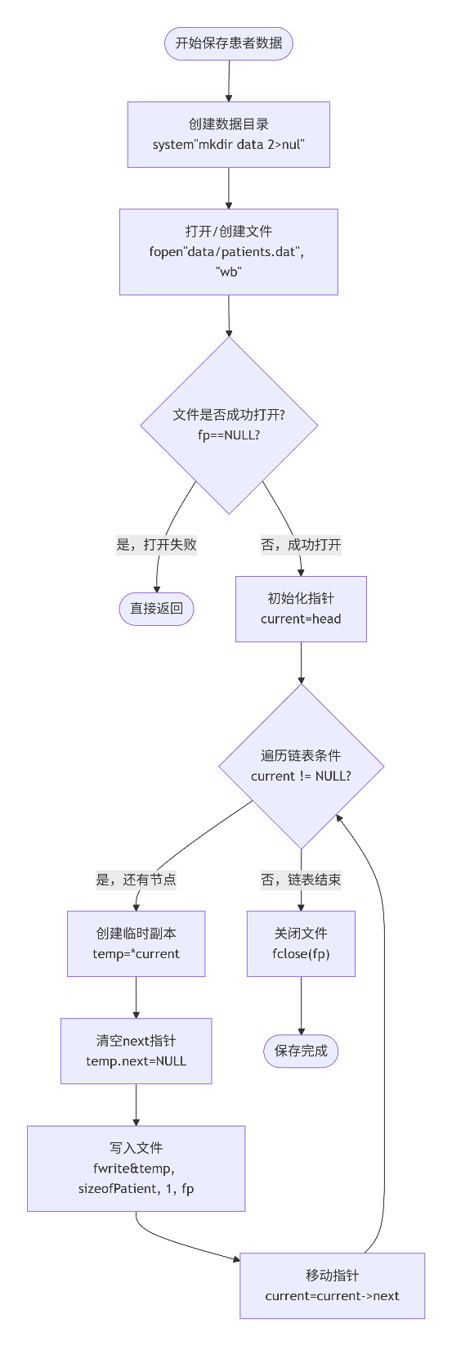

3.具体程序代码
void savePatients(Patient *head) {
system("mkdir data 2>nul");

FILE *fp = fopen("data/patients.dat", "wb");
if(fp == NULL) return;

Patient *current = head;
while(current != NULL) {
// 关键修复：创建临时副本
Patient temp = *current;
temp.next = NULL; // 清空指针

fwrite(&temp, sizeof(Patient), 1, fp);
current = current->next;
}

fclose(fp);
}
四、公用数据结构
（一）患者
1.结构设计
typedef struct Patient {
char id[MAX_ID];
char name[MAX_NAME];
int age;
char gender[10];
char phone[MAX_PHONE];
char diagnosis[MAX_DIAGNOSIS];
char treatment[MAX_TREATMENT];
Date admission_date;
double total_cost;
struct Patient *next;
} Patient;
2.用法说明
(1) 字符数组id存放患者病历号。
(2) 字符数组name存放患者姓名。
(3) 整型变量age存放患者年龄。
(4) 字符数组gender存放患者性别。
(5) 字符数组phone存放联系电话。
(6) 字符数组diagnosis存放诊断结果。
(7) 字符数组treatment存放治疗方案。
(8) 结构体Date变量admission_date存放入院日期。
(9) 双精度浮点型变量total_cost存放总费用。
(10) 指针next用于指向下一个结点，从而构造链表。
（二）医生
1.结构设计
typedef struct Doctor {
char id[MAX_ID];
char name[MAX_NAME];
int age;
char gender[10];
char department[MAX_DEPARTMENT];
char specialty[50];
char phone[MAX_PHONE];
char schedule[100];
struct Doctor *next;
} Doctor;
2.用法说明
(1) 字符数组id存放医生工号。
(2) 字符数组name存放医生姓名。
(3) 整型变量age存放医生年龄。
(4) 字符数组gender存放医生性别。
(5) 字符数组department存放所属科室。
(6) 字符数组specialty存放专业领域。
(7) 字符数组phone存放联系电话。
(8) 字符数组schedule存放排班信息。
(9) 指针next用于指向下一个结点，从而构造链表。
（三）药品
1. 结构设计
typedef struct Medicine {
char id[MAX_ID];
char name[MAX_MEDICINE];
char specification[50];
char manufacturer[50];
double price;
int stock;
Date production_date;
Date expiry_date;
struct Medicine *next;
} Medicine;
2. 用法说明
(1) 字符数组id存放药品编号。
(2) 字符数组name存放药品名称。
(3) 字符数组specification存放药品规格。
(4) 字符数组manufacturer存放生产厂家。
(5) 双精度浮点型变量price存放药品单价。
(6) 整型变量stock存放库存数量。
(7) 结构体Date变量production_date存放生产日期。
(8) 结构体Date变量expiry_date存放有效期至。
(9) 指针next用于指向下一个结点，从而构造链表。
（四）日期
1. 结构设计

typedef struct {
int year;
int month;
int day;
} Date;
2. 用法说明
(1) 整型变量year存放年份。
(2) 整型变量month存放月份。
(3) 整型变量day存放日期。
（五）挂号
1. 结构设计
typedef struct Registration {
char reg_id[MAX_ID];
char patient_id[MAX_ID];
char doctor_id[MAX_ID];
Date reg_date;
char department[MAX_DEPARTMENT];
double reg_fee;
int status;
struct Registration *next;
} Registration;
2. 用法说明
(1) 字符数组reg_id存放挂号单号。
(2) 字符数组patient_id存放患者ID。
(3) 字符数组doctor_id存放医生ID。
(4) 结构体Date变量reg_date存放挂号日期。
(5) 字符数组department存放科室。
(6) 双精度浮点型变量reg_fee存放挂号费用。
(7) 整型变量status存放挂号状态（1-已挂号，2-已就诊，3-已取消）。
(8) 指针next用于指向下一个结点，从而构造链表。
（六）费用
1. 结构设计
typedef struct Cost {
char cost_id[MAX_ID];
char patient_id[MAX_ID];
Date cost_date;
char item[50];
double amount;
int payment_status;
struct Cost *next;
} Cost;
2. 用法说明
(1) 字符数组cost_id存放费用单号。
(2) 字符数组patient_id存放患者ID。
(3) 结构体Date变量cost_date存放费用日期。
(4) 字符数组item存放费用项目。
(5) 双精度浮点型变量amount存放费用金额。
(6) 整型变量payment_status存放支付状态（0-未支付，1-已支付，2-部分支付）。
(7) 指针next用于指向下一个结点，从而构造链表。
（七）住院
1. 结构设计
typedef struct Hospitalization {
char hosp_id[MAX_ID];
char patient_id[MAX_ID];
char doctor_id[MAX_ID];
Date admission_date;
char bed_number[20];
char diagnosis[MAX_DIAGNOSIS];
double total_cost;
int status;
struct Hospitalization *next;
} Hospitalization;
2. 用法说明
(1) 字符数组hosp_id存放住院号。
(2) 字符数组patient_id存放患者ID。
(3) 字符数组doctor_id存放主治医生ID。
(4) 结构体Date变量admission_date存放入院日期。
(5) 字符数组bed_number存放床位号。
(6) 字符数组diagnosis存放住院诊断。
(7) 双精度浮点型变量total_cost存放总费用。
(8) 整型变量status存放住院状态（1-在院，2-已出院）。
(9) 指针next用于指向下一个结点，从而构造链表。

五、试验结果
（一）系统界面
1. 系统启动界面
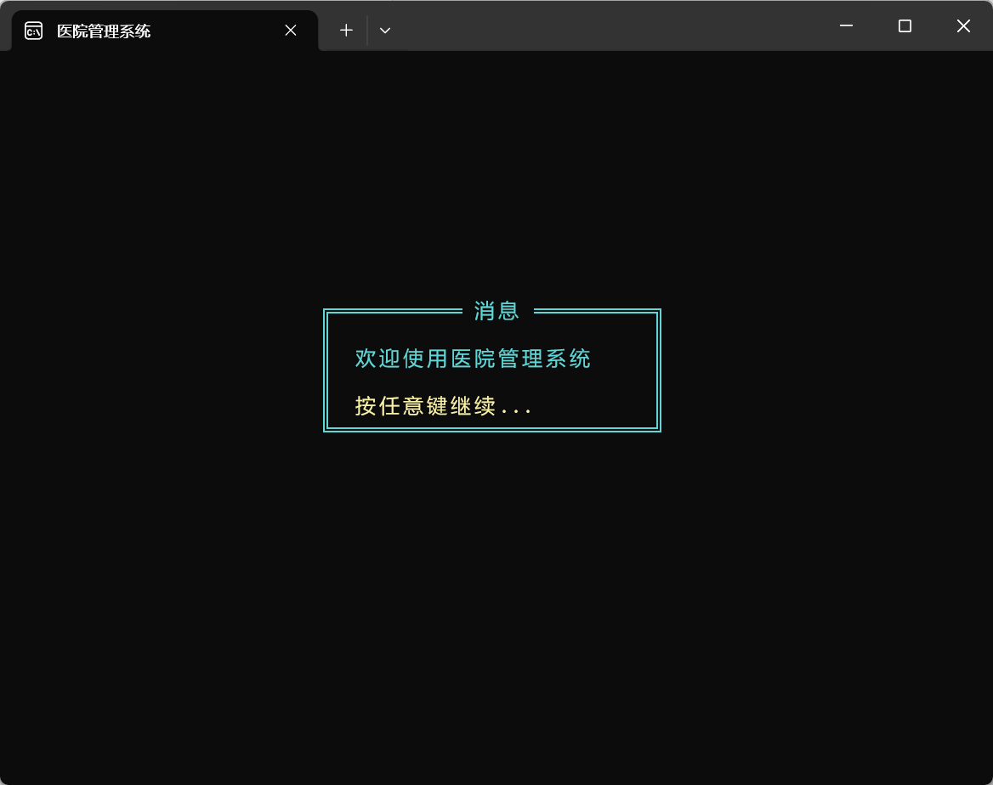

2. 登录选择界面
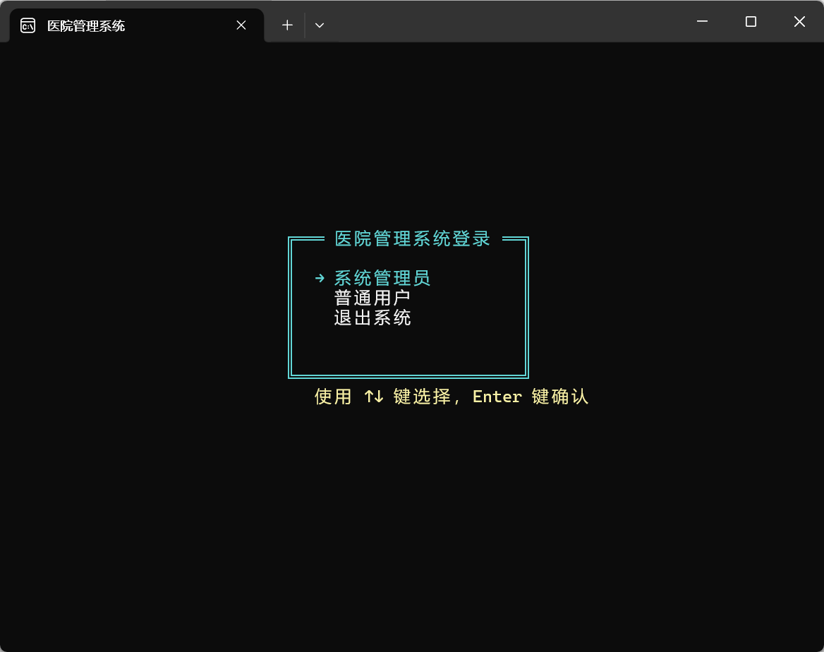

3. 管理员主菜单界面
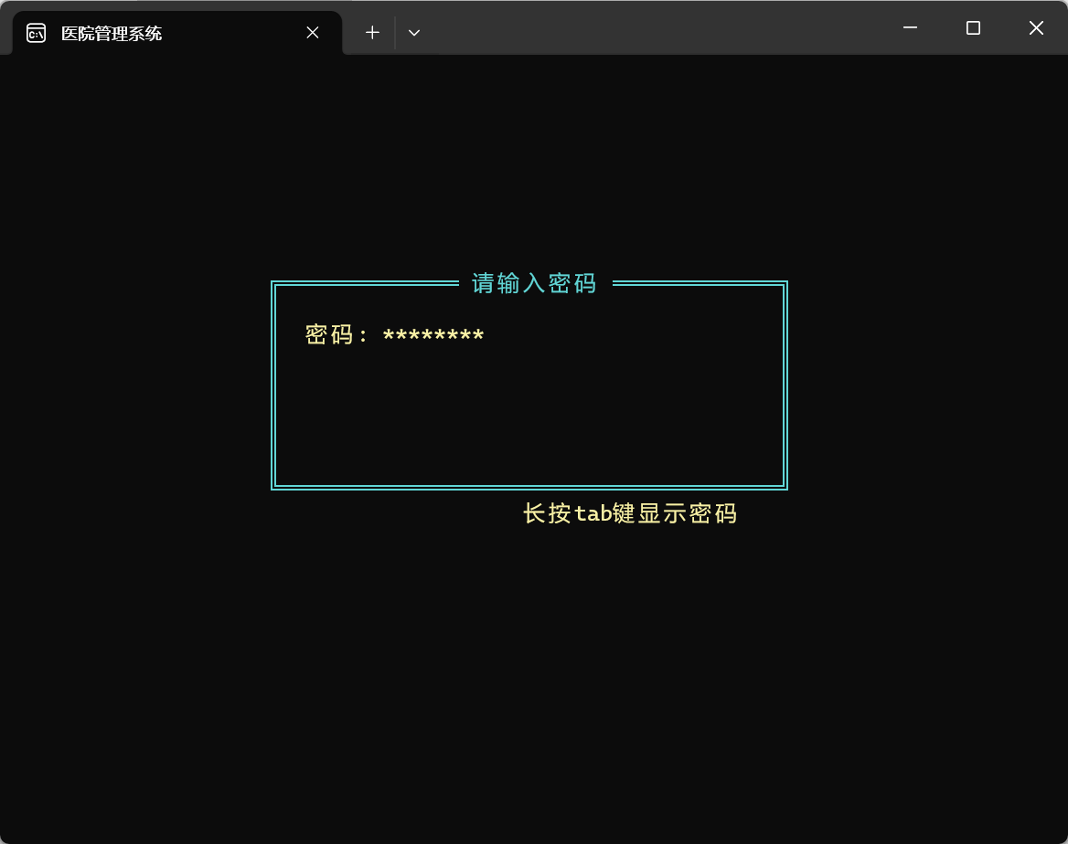
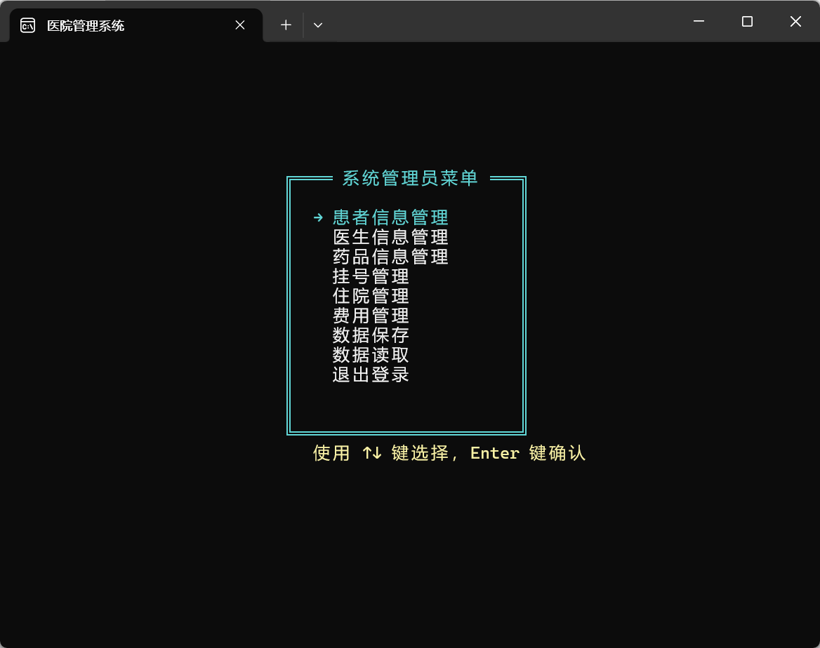

4. 患者信息管理界面
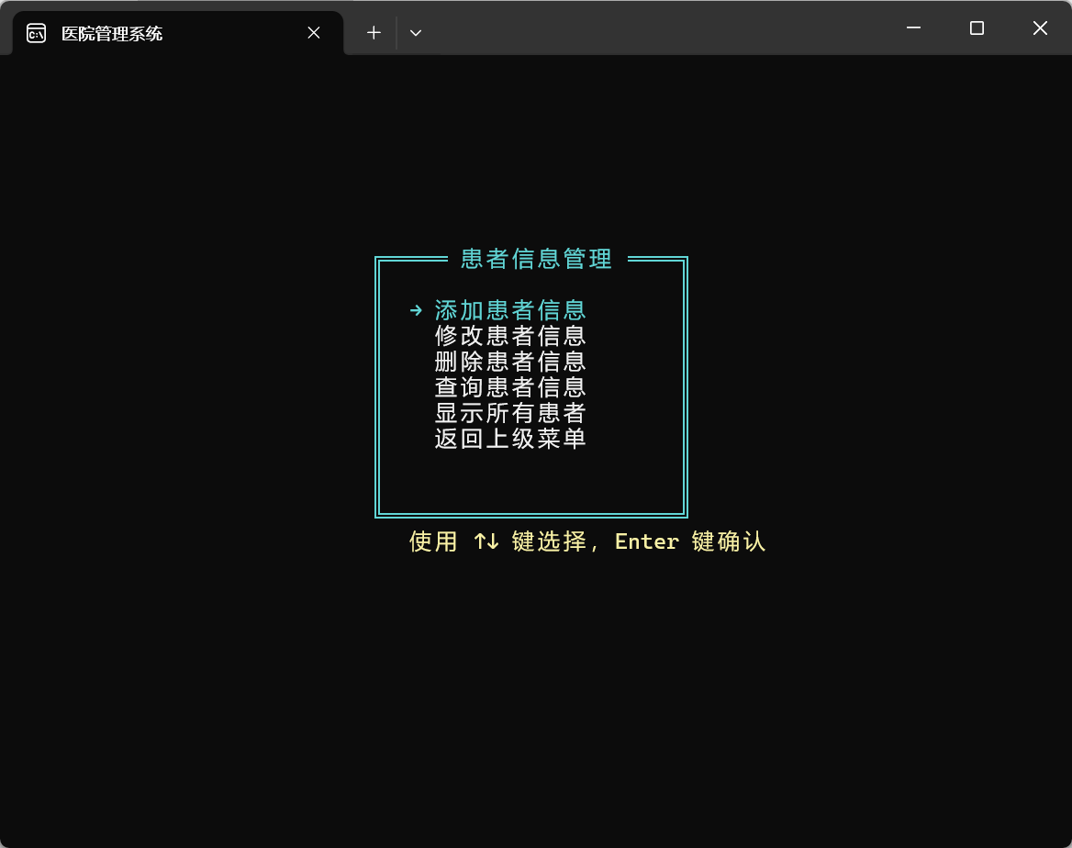

5. 医生信息管理界面
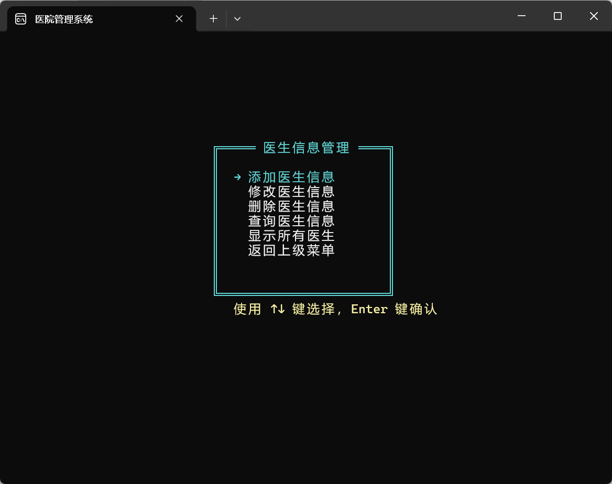

6. 药品信息管理界面
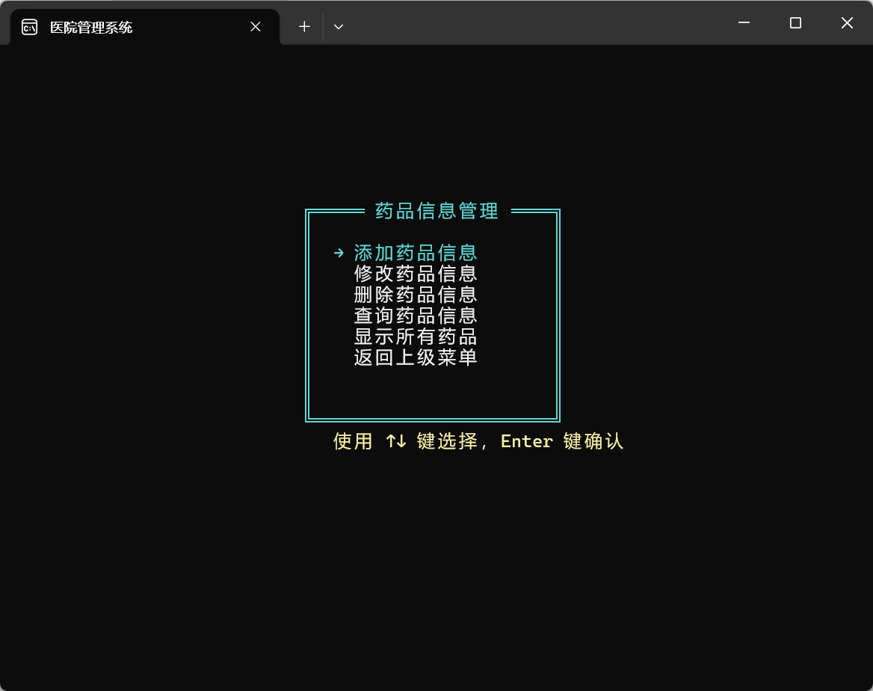

7. 挂号管理界面
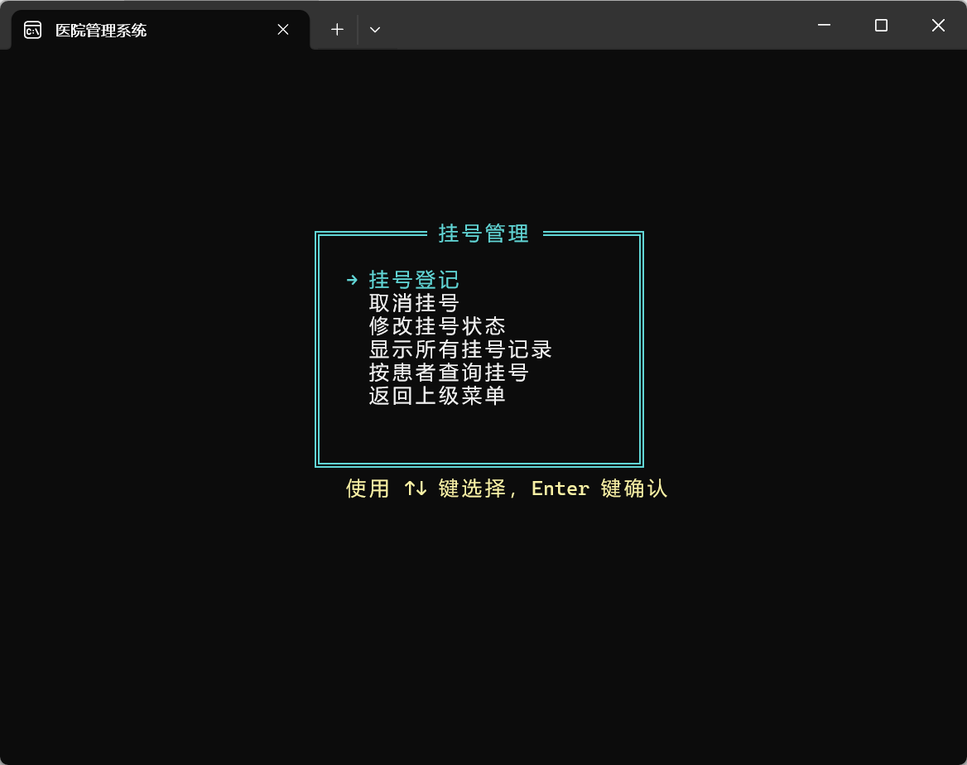

8. 住院管理界面
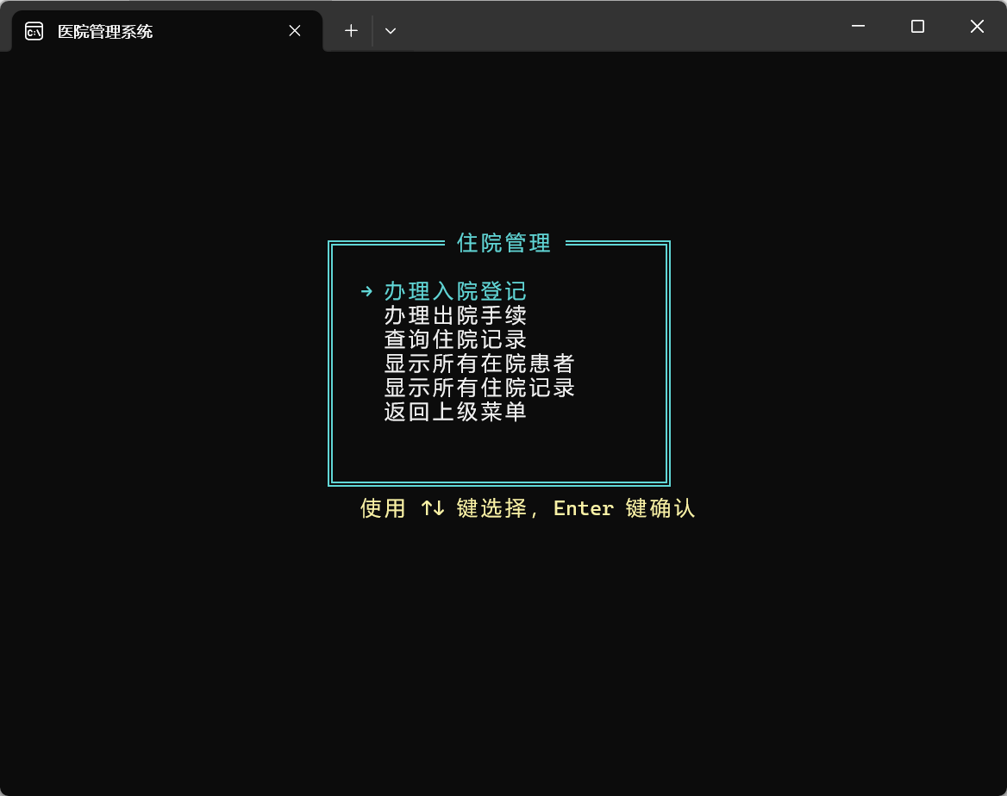

9. 费用管理界面
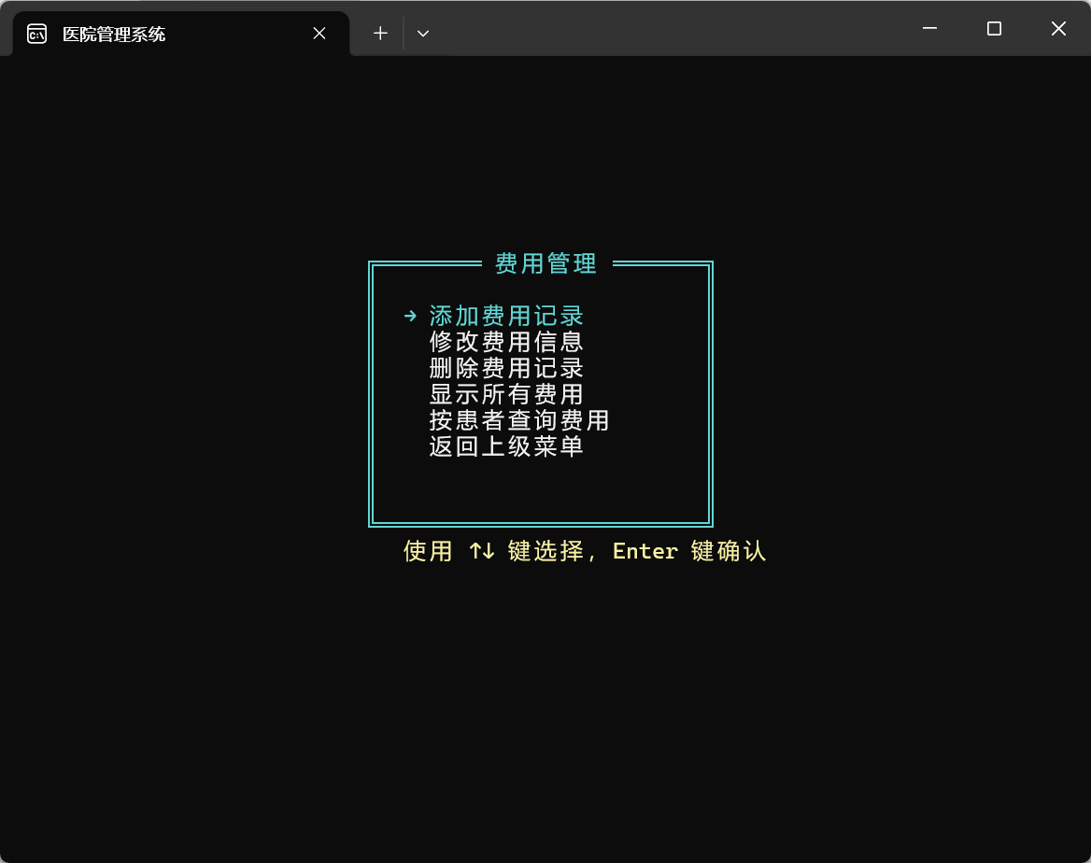

10. 用户主菜单界面
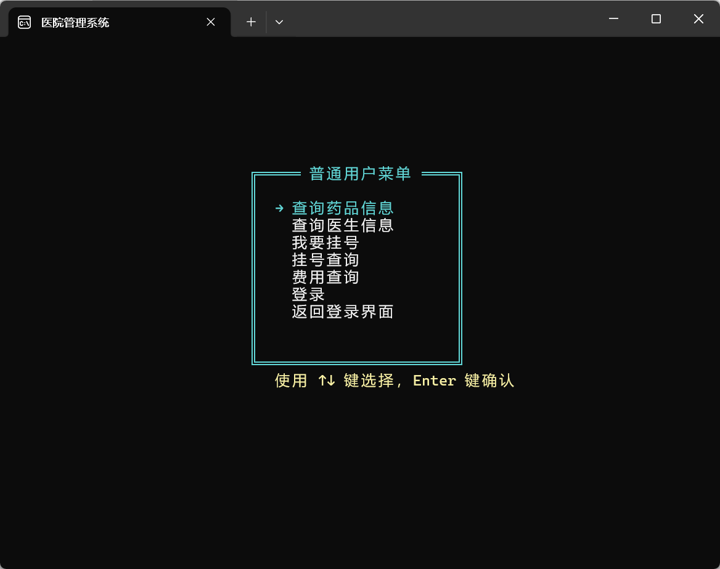

11. 用户挂号界面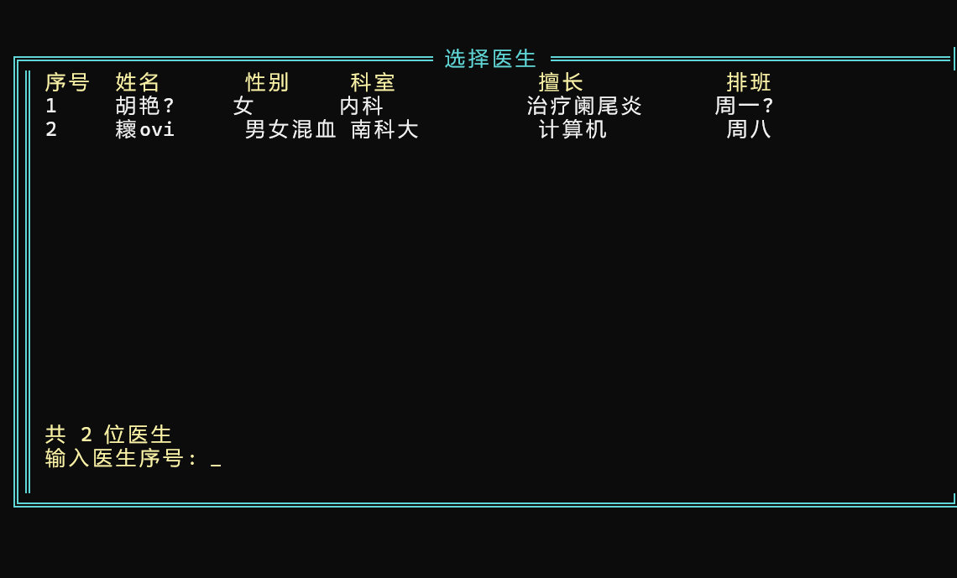

（二）信息数据处理
1. 患者信息录入
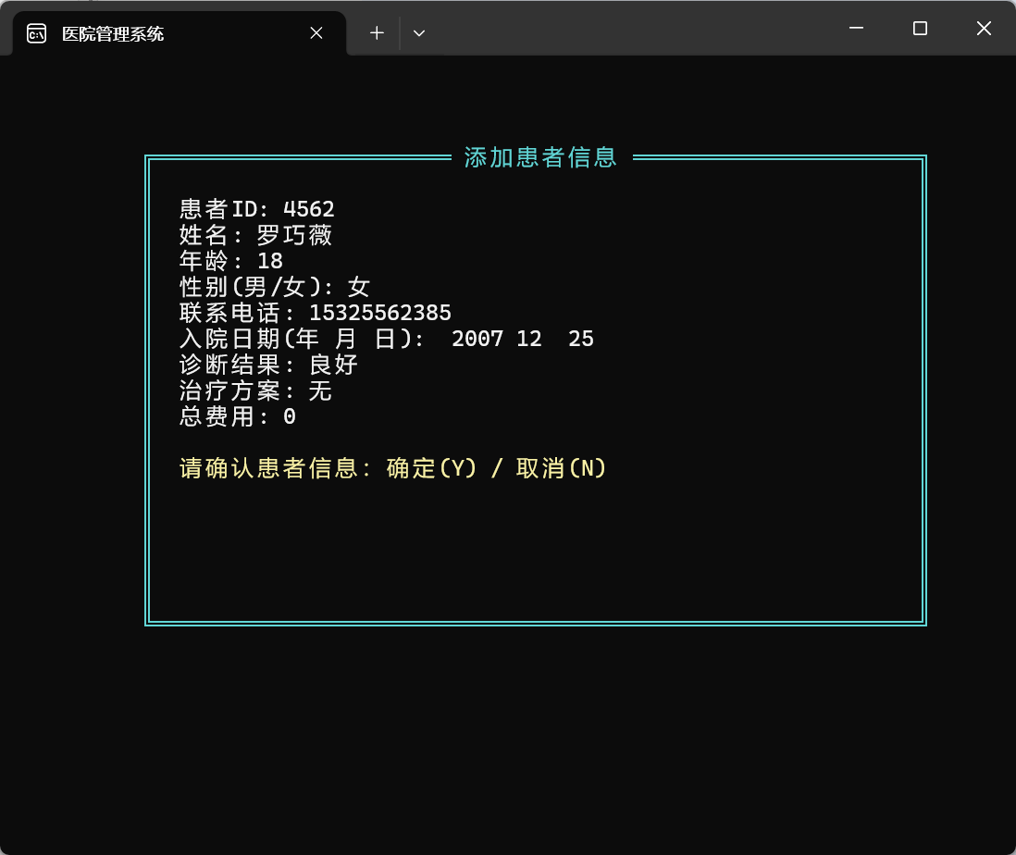

2. 医生信息录入
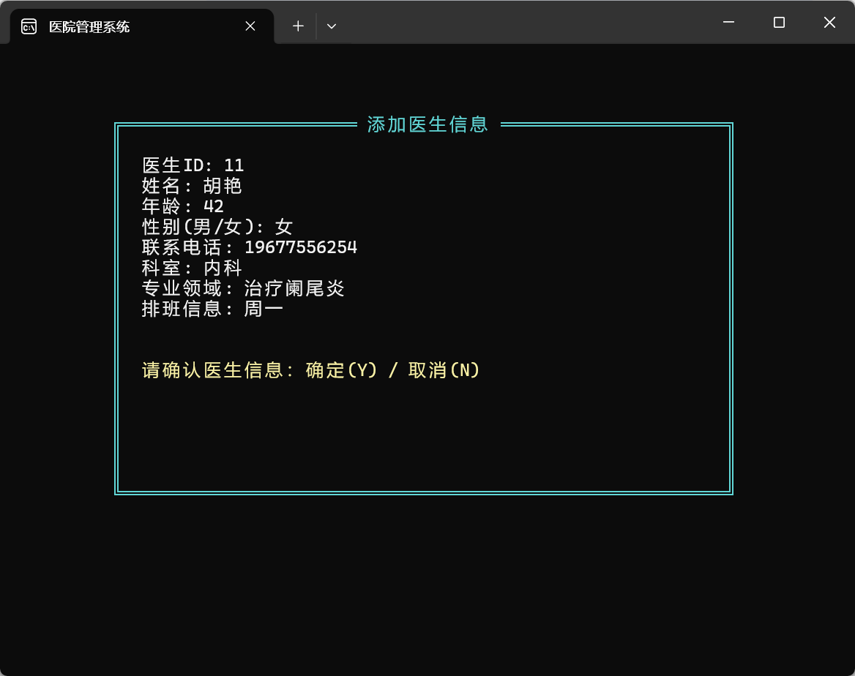
3. 药品信息录入
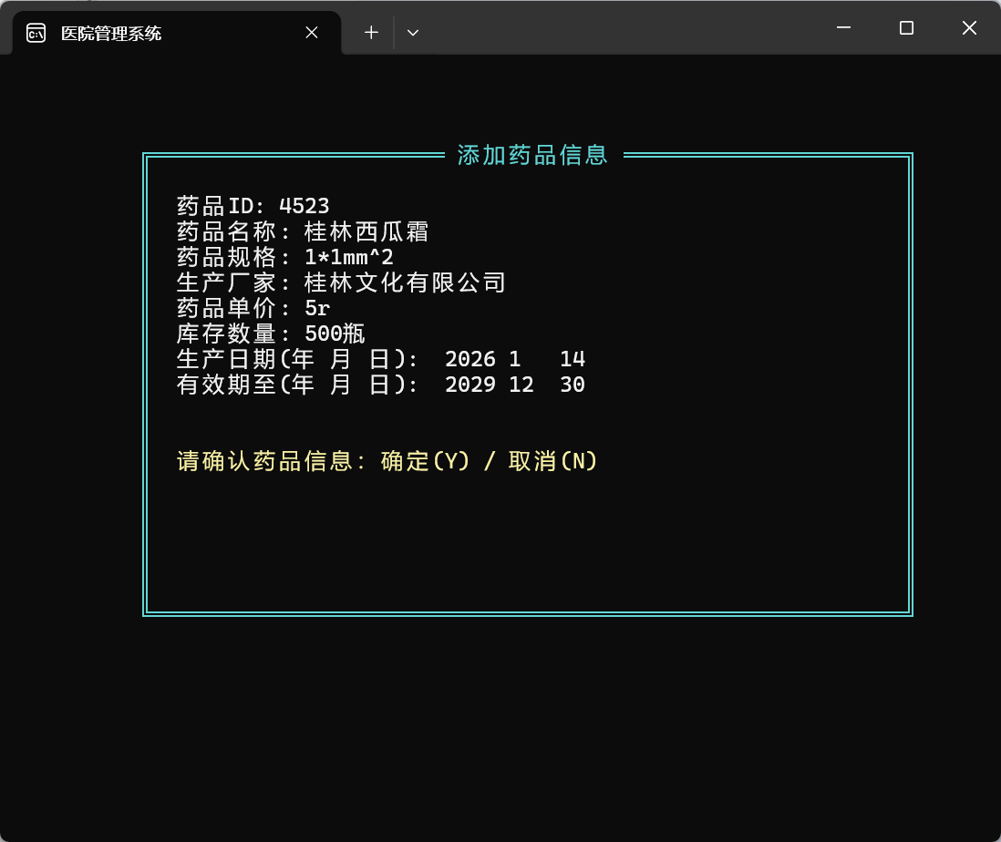
4. 挂号登记
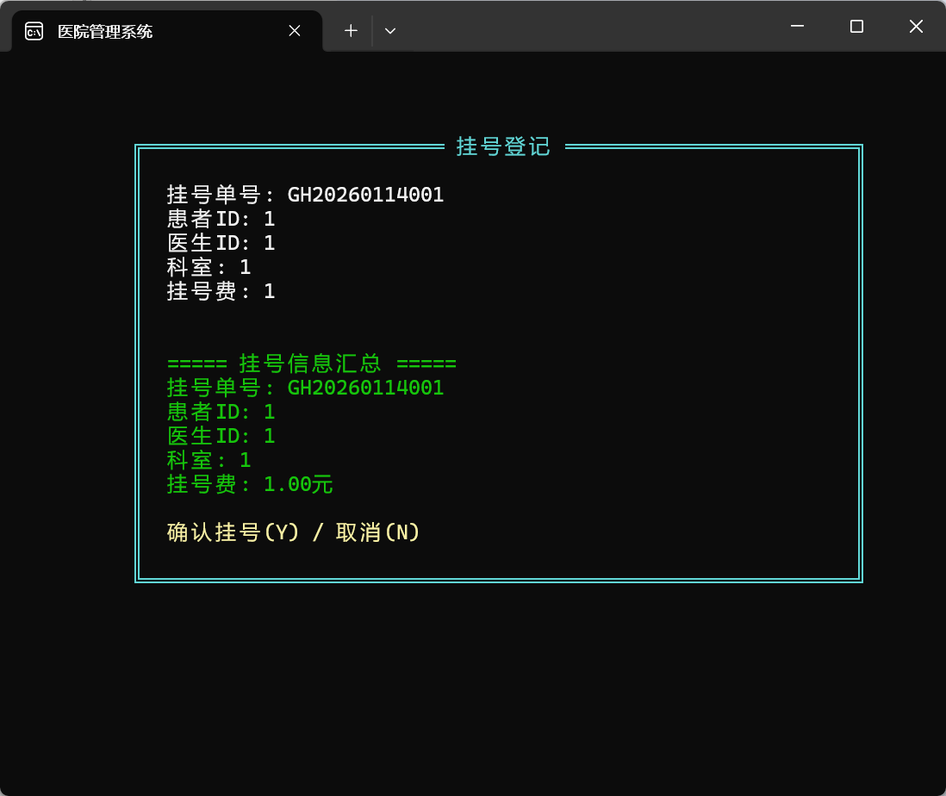

5. 信息查询
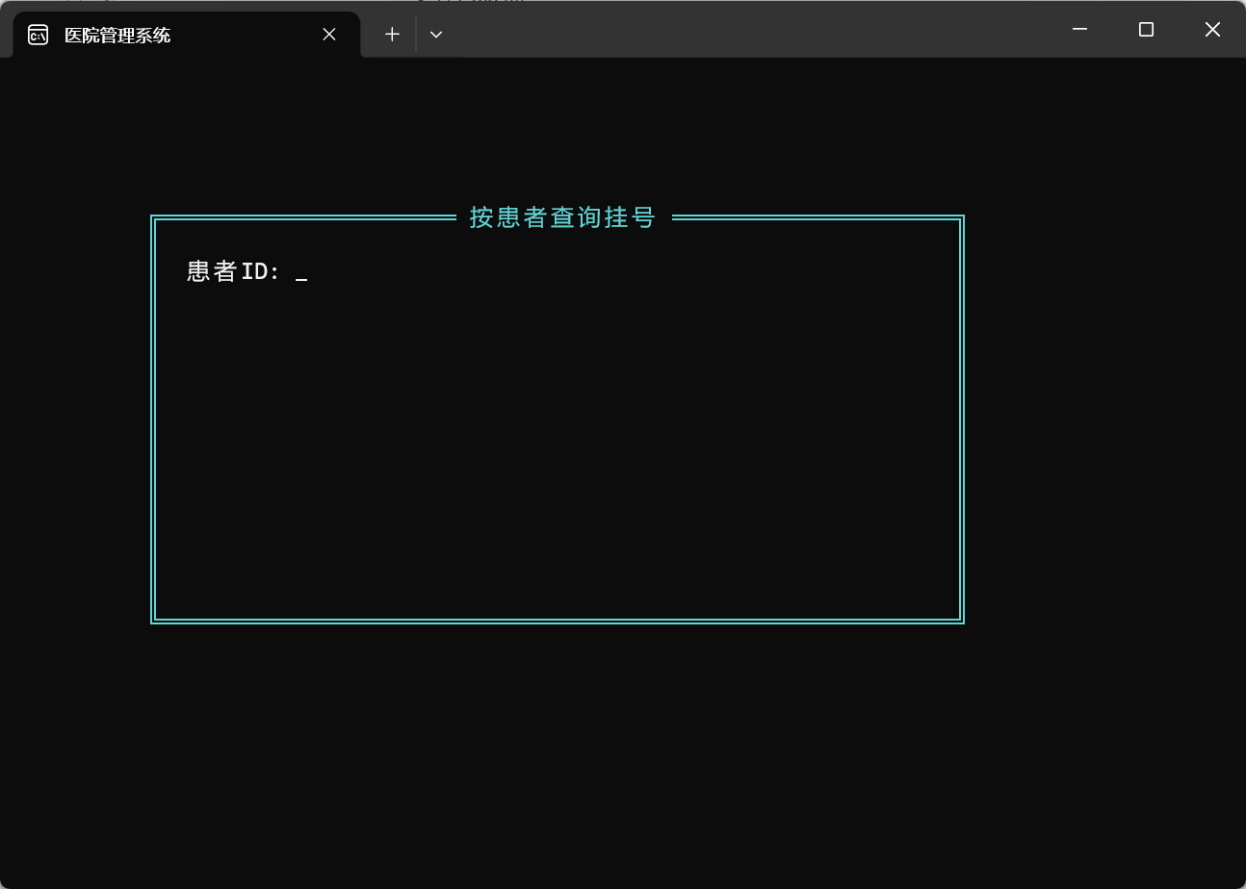
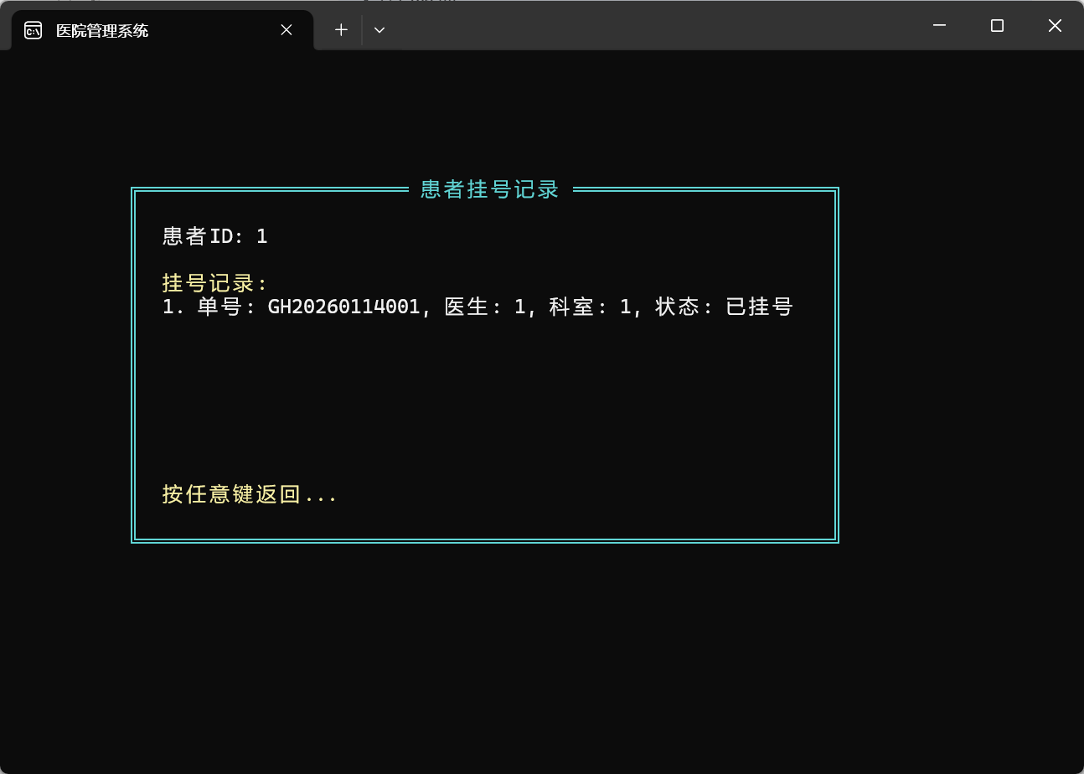

6. 信息修改
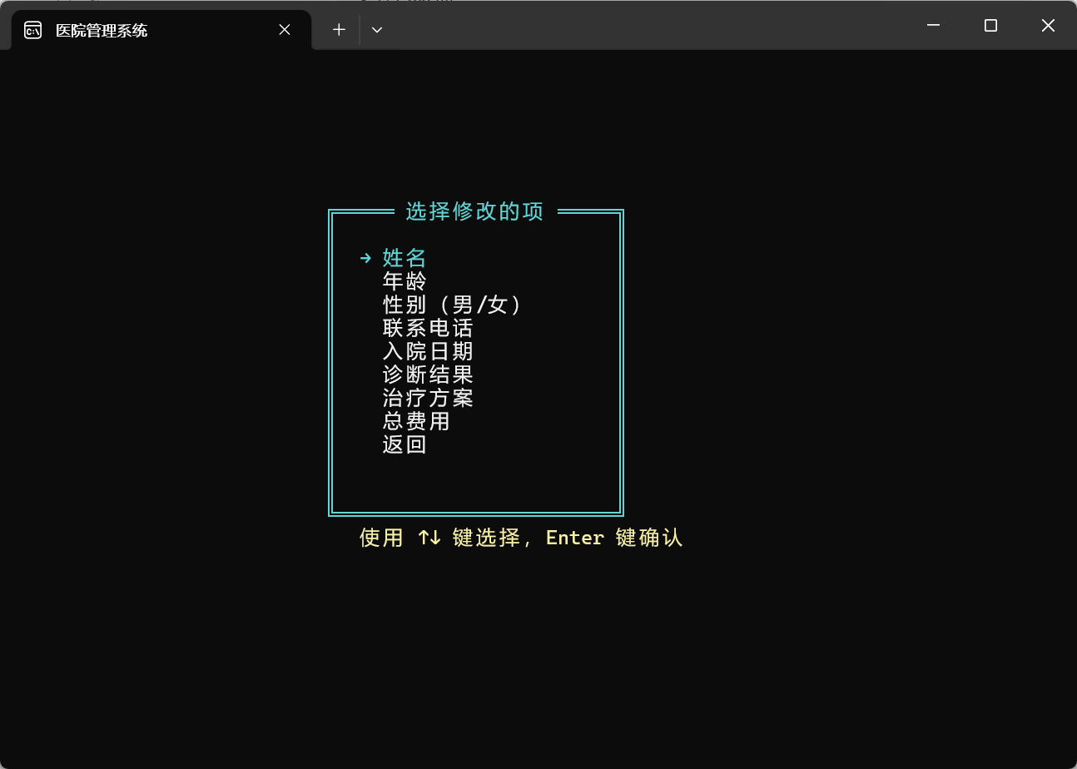

7. 信息删除
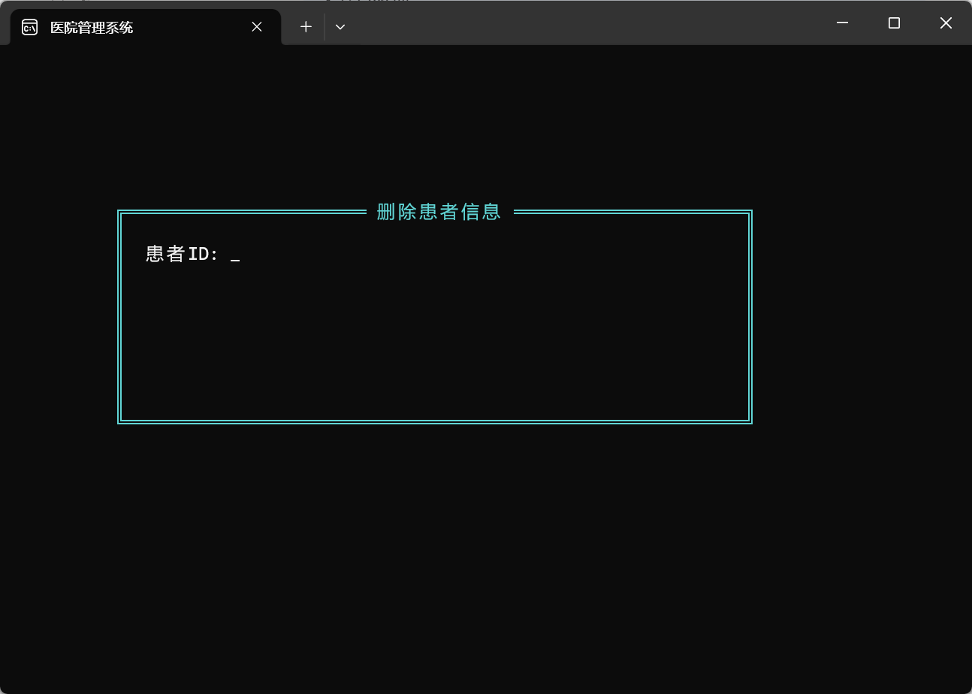

8. 药品库存排序
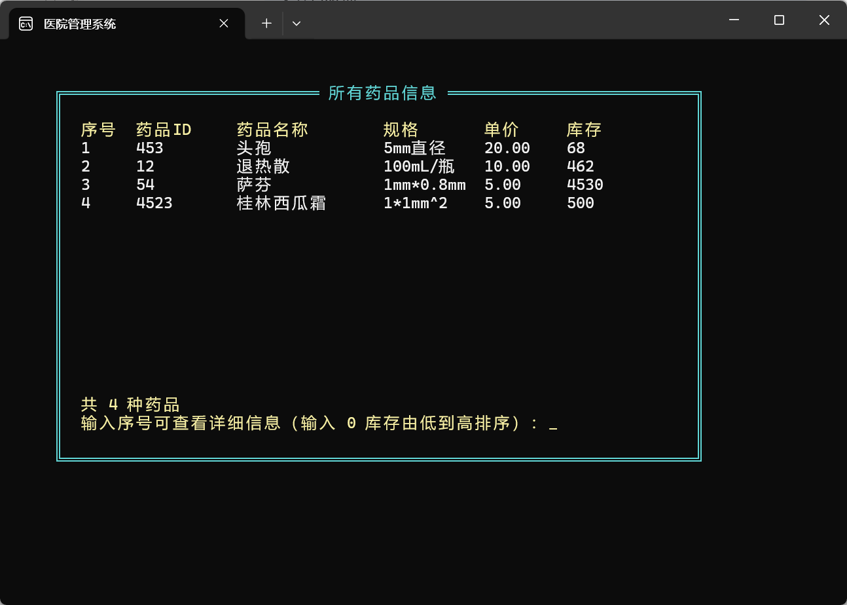

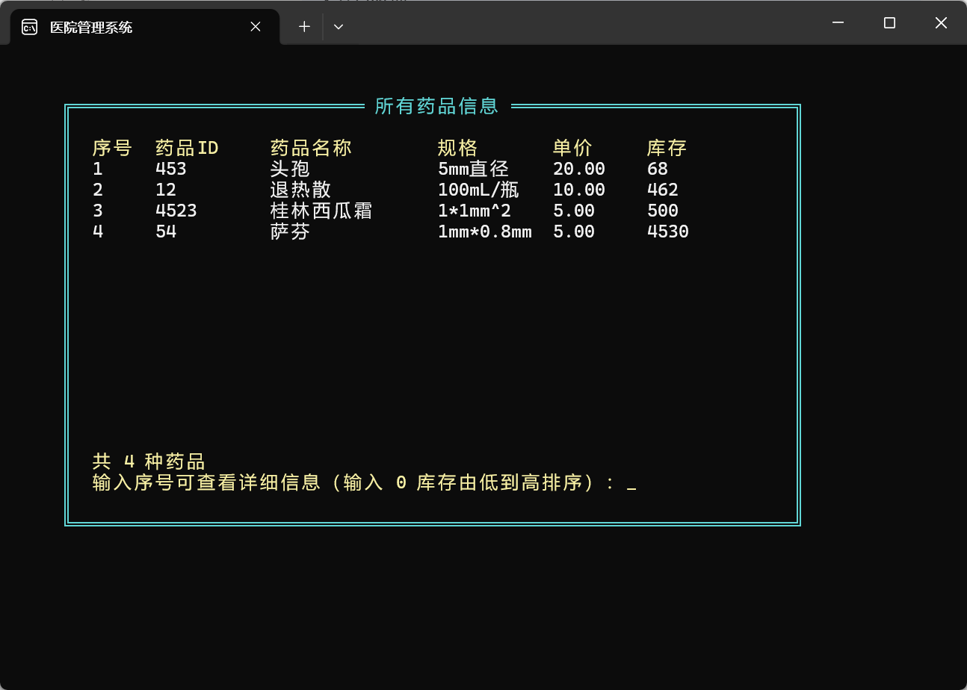

9. 费用统计
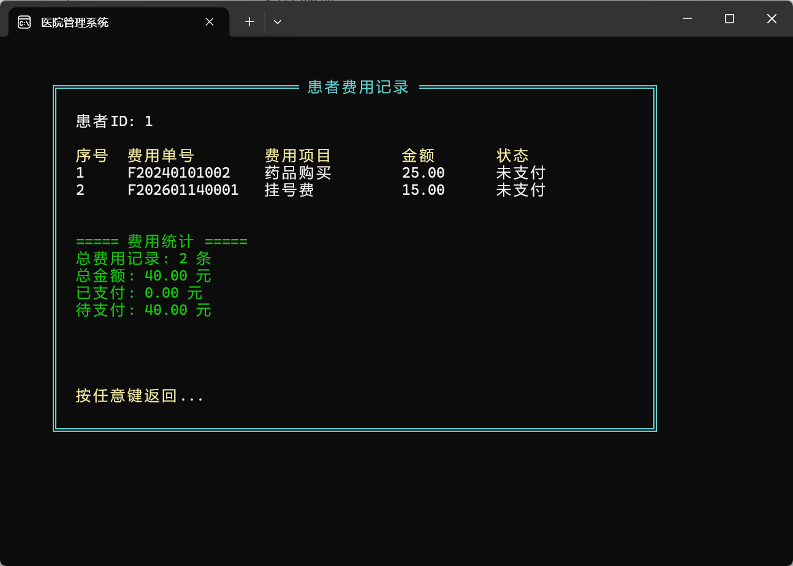

10. 在院患者统计
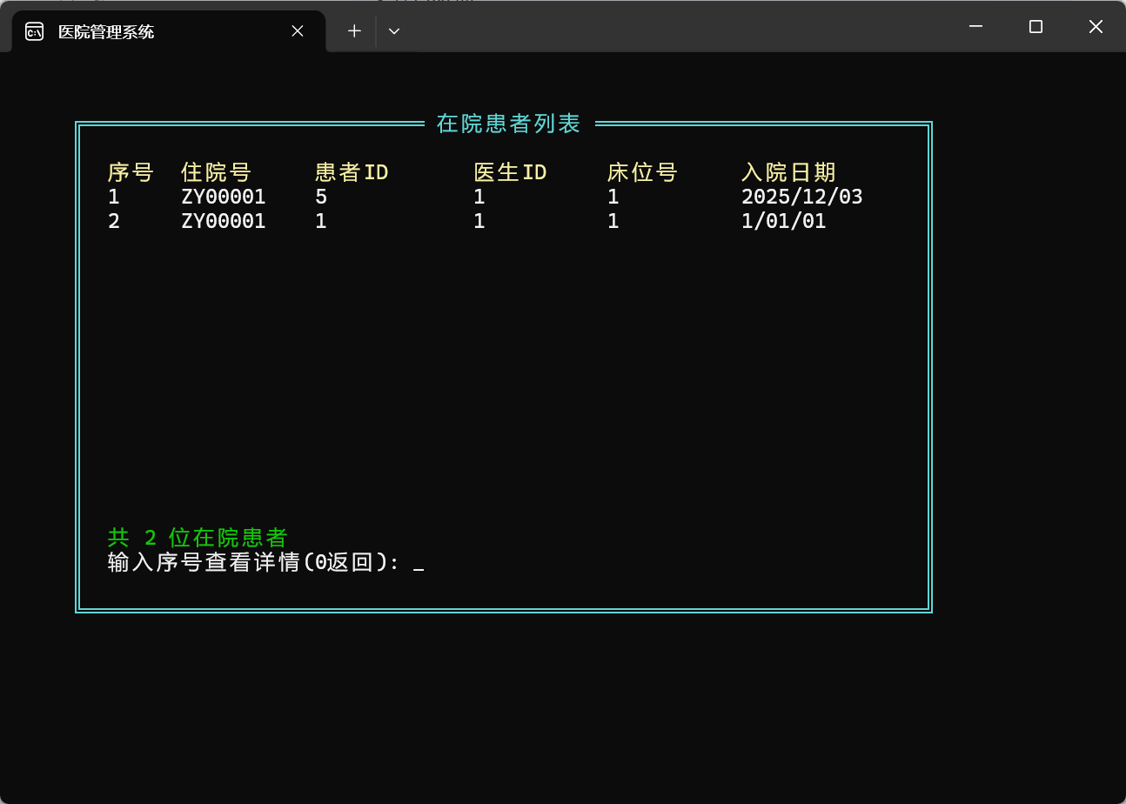11. 数据保存界面
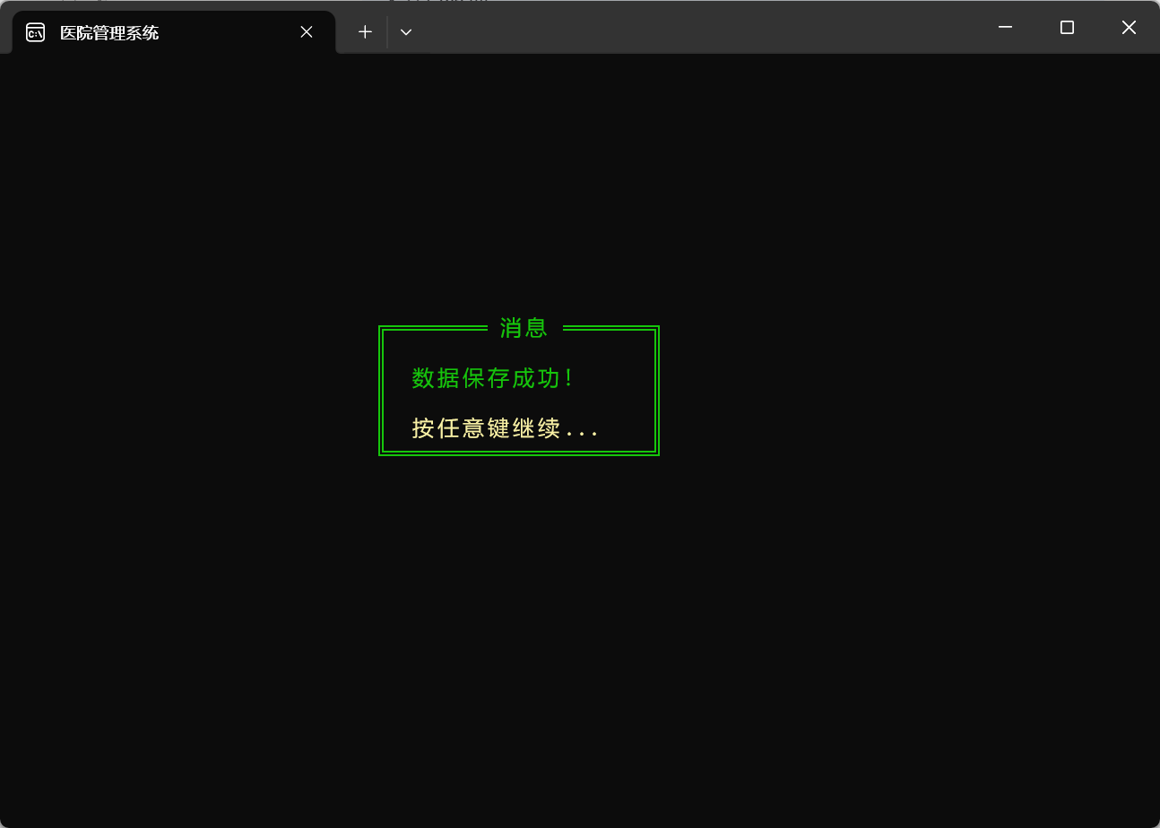

12. 登录验证界面

13. 系统退出界面
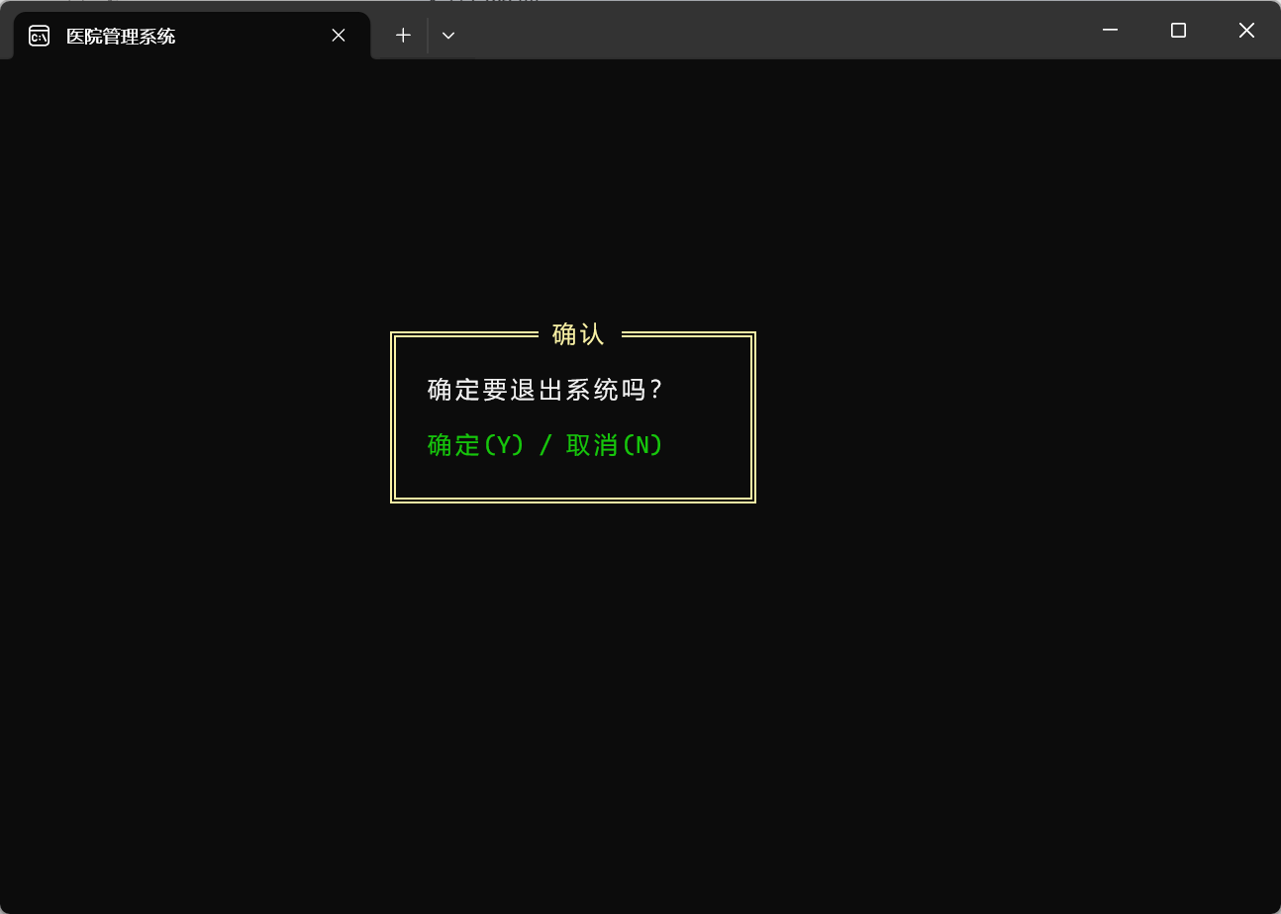

六、体会与总结
（一）完成的功能
1.全部实现了题目要求的基本功能
2.扩展
(1)实现了完整的住院管理系统。
(2)增加了自动费用生成功能（挂号/住院时自动生成费用记录），而且数据具有一致性，费用修改时自动更新患者总费用，删除时同步更新。
(3)增加药品库存预警排序功能。
(4)拥有较为完善的密码登录管理员和新旧患者手机号登录机制。
(5)大量使用暂停和清屏，使得界面清晰美观。
(6)交互流畅自然，用方向键选择菜单，支持全界面ESC取消操作返回上一级。
有清晰的输入提示和错误处理。密码输入长按Tab键显示功能。
（二）有待改进之处
1.编程时常使用复制粘贴加修改来实现其他类似的功能，这使得程序中存在较多重复的语句，或许可以整理成函数，使程序更加简洁。
2可增加更多维度的查询，如按科室查询医生、按日期查询挂号等。
3.数据量大时链表遍历效率较低，可考虑索引优化以减少计算机运算。
4.数据验证不够严谨，可以增加更严格的数据格式验证（如电话号、日期格式）。
（三）收获与体会
1.通过课程设计，我充分意识到在编写长程序和项目时，结构图以及独立模块的重要性，这可以使得编程时逻辑清晰，提高效率。
2.通过课程设计的项目编程，我深入理解了链表在动态数据管理中的优势和应用场景，在开发过程中遇到并解决了诸多指针、内存、文件操作相关的问题，提升了我的调试能力。
3.通过对课程设计报告的撰写，我学会了报告的排版以及格式呈现形式。

全部程序：
#include "cost.h"
#include "ui.h"
#include "data.h"
#include "patient.h"

extern Patient *patient_list;
extern Doctor *doctor_list;
extern Medicine *medicine_list;
extern Registration *registration_list;
extern Cost *cost_list;
extern Hospitalization *hosp_list;
extern int currentUser;
extern char universal_id[20];

// 查找费用记录
Cost* findCostById(const char *cost_id) {
Cost *temp = cost_list;
while(temp) {
if(strcmp(temp->cost_id, cost_id) == 0) {
return temp;
}
temp = temp->next;
}
return NULL;
}

// 查找患者的费用记录
Cost* findCostByPatientId(const char *patient_id) {
Cost *temp = cost_list;
while(temp) {
if(strcmp(temp->patient_id, patient_id) == 0) {
return temp;
}
temp = temp->next;
}
return NULL;
}

// 添加费用记录
void addCost() {
system("cls");

int width = 60;
int height = 16;
int screenWidth = 80;
int screenHeight = 25;
int x = (screenWidth - width) / 2;
int y = (screenHeight - height) / 2;

drawBox(x, y, x + width, y + height, CYAN, "添加费用记录");

HANDLE a = GetStdHandle(STD_OUTPUT_HANDLE);
COORD pos;

Cost newCost;

// 生成费用单号 (F + 年月日 + 序号)
static int counter = 1;
sprintf(newCost.cost_id, "F%04d%02d%02d%03d",
2024, 1, 1, counter++); // 简化版，你可以添加时间获取

// 显示生成的费用单号
pos.X = x + 3; pos.Y = y + 2;
SetConsoleCursorPosition(a, pos);
printf("费用单号: %s", newCost.cost_id);

// 输入患者ID
if(!inputStringWithESC(newCost.patient_id, MAX_ID, "患者ID: ", x + 3, y + 3)) {
return;
}

// 输入费用日期
pos.X = x + 3; pos.Y = y + 4;
SetConsoleCursorPosition(a, pos);
printf("费用日期(年 月 日): ");

if(!inputIntWithESC(&newCost.cost_date.year, "", x + 22, y + 4)) {
return;
}

if(!inputIntWithESC(&newCost.cost_date.month, "", x + 27, y + 4)) {
return;
}

if(!inputIntWithESC(&newCost.cost_date.day, "", x + 31, y + 4)) {
return;
}

// 输入费用项目
if(!inputStringWithESC(newCost.item, 50, "费用项目: ", x + 3, y + 5)) {
return;
}

// 输入费用金额
if(!inputDoubleWithESC(&newCost.amount, "费用金额: ", x + 3, y + 6)) {
return;
}

// 选择支付状态
pos.X = x + 3; pos.Y = y + 7;
SetConsoleCursorPosition(a, pos);
printf("支付状态: ");

const char *statusOptions[] = {"未支付", "已支付", "部分支付"};
pos.X = x + 13; pos.Y = y + 7;
SetConsoleCursorPosition(a, pos);
printf("1.未支付 2.已支付 3.部分支付");

int statusChoice;
pos.X = x + 3; pos.Y = y + 8;
SetConsoleCursorPosition(a, pos);
if(!inputIntWithESC(&statusChoice, "选择(1-3): ", x + 13, y + 8)) {
return;
}

switch(statusChoice) {
case 1: newCost.payment_status = 0; break; // 未支付
case 2: newCost.payment_status = 1; break; // 已支付
case 3: newCost.payment_status = 2; break; // 部分支付
default: newCost.payment_status = 0;
}

// 显示汇总信息
pos.X = x + 3; pos.Y = y + 10;
SetConsoleCursorPosition(a, pos);
setColor(GREEN);
printf("===== 费用信息汇总 =====");
pos.X = x + 3; pos.Y = y + 11;
SetConsoleCursorPosition(a, pos);
printf("费用单号: %s", newCost.cost_id);
pos.X = x + 3; pos.Y = y + 12;
SetConsoleCursorPosition(a, pos);
printf("患者ID: %s", newCost.patient_id);
pos.X = x + 3; pos.Y = y + 13;
SetConsoleCursorPosition(a, pos);
printf("费用项目: %s", newCost.item);
pos.X = x + 3; pos.Y = y + 14;
SetConsoleCursorPosition(a, pos);
printf("费用金额: %.2f元", newCost.amount);
pos.X = x + 3; pos.Y = y + 15;
SetConsoleCursorPosition(a, pos);
printf("支付状态: %s",
newCost.payment_status == 0 ? "未支付" :
newCost.payment_status == 1 ? "已支付" : "部分支付");

pos.X = x + 3; pos.Y = y + height - 3;
SetConsoleCursorPosition(a, pos);
setColor(YELLOW);
printf("确认添加(Y) / 取消(N)");
setColor(WHITE);

while(1) {
int ch = _getch();
if(ch == 'y' || ch == 'Y') {
// 添加到链表
Cost *newNode = (Cost*)malloc(sizeof(Cost));
memcpy(newNode, &newCost, sizeof(Cost));
newNode->next = cost_list;
cost_list = newNode;

updatePatientTotalCost(newCost.patient_id, newCost.amount);
showMessage("费用记录添加成功！", GREEN);
return;
}
if(ch == 'n' || ch == 'N') {
showMessage("已取消添加", YELLOW);
return;
}
}
}

// 自动添加费用函数
void autoAddCost(const char *patient_id, const char *item_name, double amount) {
if(patient_id == NULL || patient_id[0] == '\0' ||
item_name == NULL || item_name[0] == '\0' ||
amount <= 0) {
return;
}

// 2. 创建费用记录
Cost newCost;

// 生成费用单号
static int cost_counter = 1;
time_t t = time(NULL);
struct tm *tm_info = localtime(&t);

sprintf(newCost.cost_id, "F%04d%02d%02d%04d",
tm_info->tm_year + 1900,
tm_info->tm_mon + 1,
tm_info->tm_mday,
cost_counter++);

strcpy(newCost.patient_id, patient_id);
strcpy(newCost.item, item_name);
newCost.amount = amount;

newCost.cost_date.year = tm_info->tm_year + 1900;
newCost.cost_date.month = tm_info->tm_mon + 1;
newCost.cost_date.day = tm_info->tm_mday;

newCost.payment_status = 0;

Cost *newNode = (Cost*)malloc(sizeof(Cost));
if(newNode == NULL) {
return;
}

memcpy(newNode, &newCost, sizeof(Cost));
newNode->next = cost_list;
cost_list = newNode;

updatePatientTotalCost(patient_id, amount);
}

// 显示单个费用记录的详细信息
void showSingleCostDetail(const char *cost_id) {
Cost *p = findCostById(cost_id);
system("cls");
if(p == NULL) {
showMessage("费用记录不存在", RED);
return;
}

int width = 60;
int height = 14;
int screenWidth = 80;
int screenHeight = 25;
int x = (screenWidth - width) / 2;
int y = (screenHeight - height) / 2;

drawBox(x, y, x + width, y + height, CYAN, "费用详细信息");

COORD pos;
HANDLE a = GetStdHandle(STD_OUTPUT_HANDLE);

pos.X = x + 3; pos.Y = y + 2;
SetConsoleCursorPosition(a, pos);
printf(" 费用单号: %s", p->cost_id);

pos.X = x + 3; pos.Y = y + 3;
SetConsoleCursorPosition(a, pos);
printf(" 患者ID: %s", p->patient_id);

pos.X = x + 3; pos.Y = y + 4;
SetConsoleCursorPosition(a, pos);
printf(" 费用日期: %d年%d月%d日",
p->cost_date.year, p->cost_date.month, p->cost_date.day);

pos.X = x + 3; pos.Y = y + 5;
SetConsoleCursorPosition(a, pos);
printf(" 费用项目: %s", p->item);

pos.X = x + 3; pos.Y = y + 6;
SetConsoleCursorPosition(a, pos);
printf(" 费用金额: %.2f元", p->amount);

pos.X = x + 3; pos.Y = y + 7;
SetConsoleCursorPosition(a, pos);
printf(" 支付状态: ");
switch(p->payment_status) {
case 0: printf("未支付"); break;
case 1: printf("已支付"); break;
case 2: printf("部分支付"); break;
default: printf("未知");
}

pos.X = x + 3; pos.Y = y + 10;
SetConsoleCursorPosition(a, pos);
setColor(YELLOW);
printf("按任意键返回...");
setColor(WHITE);
_getch();
}

// 显示所有费用记录
void showAllCosts() {
int width = 70;
int height = 20;
int screenWidth = 80;
int screenHeight = 25;
int x = (screenWidth - width) / 2;
int y = (screenHeight - height) / 2;

while(1) {
system("cls");
drawBox(x, y, x + width, y + height, CYAN, "所有费用记录");

HANDLE a = GetStdHandle(STD_OUTPUT_HANDLE);
COORD pos;

if(!cost_list) {
pos.X = x + 3; pos.Y = y + 2;
SetConsoleCursorPosition(a, pos);
setColor(YELLOW);
printf("暂无费用记录！");
setColor(WHITE);
pressAnyKey();
return;
}

// 显示表头
pos.X = x + 3; pos.Y = y + 2;
SetConsoleCursorPosition(a, pos);
setColor(YELLOW);
printf("%-5s %-15s %-12s %-15s %-10s %-10s",
"序号", "费用单号", "患者ID", "费用项目", "金额", "状态");
setColor(WHITE);

Cost *temp = cost_list;
int count = 0;
int currentY = y + 3;
char *costIds[100];

while(temp && currentY < y + height - 3) {
costIds[++count] = temp->cost_id;

pos.X = x + 3; pos.Y = currentY++;
SetConsoleCursorPosition(a, pos);

printf("%-5d %-15s %-12s %-15s %-10.2f ",
count, temp->cost_id, temp->patient_id,
temp->item, temp->amount);

// 显示状态
switch(temp->payment_status) {
case 0: printf("未支付"); break;
case 1: printf("已支付"); break;
case 2: printf("部分支付"); break;
default: printf("未知");
}

temp = temp->next;
}

pos.X = x + 3; pos.Y = y + height - 3;
SetConsoleCursorPosition(a, pos);
setColor(YELLOW);
printf("共 %d 条费用记录", count);

// 查看详细
int choice;
if(!inputIntWithESC(&choice, "输入序号查看详情(0返回): ", x + 3, y + height - 2)) {
break;
}
setColor(WHITE);

if(choice == 0) {
break;
} else if(choice > 0 && choice <= count) {
showSingleCostDetail(costIds[choice]);
} else {
showMessage("输入错误！请重试", RED);
}
}
return;
}

// 修改费用信息
void modifyCost() {
system("cls");

int width = 60;
int height = 10;
int screenWidth = 80;
int screenHeight = 25;
int x = (screenWidth - width) / 2;
int y = (screenHeight - height) / 2;

drawBox(x, y, x + width, y + height, CYAN, "修改费用信息");

char cost_id[20];

// 输入费用单号
if(!inputStringWithESC(cost_id, MAX_ID, "费用单号: ", x + 3, y + 2)) {
return;
}

Cost *p = findCostById(cost_id);

if(p == NULL) {
showMessage("未找到该费用记录！", RED);
return;
}

// 显示修改菜单
while(1) {
system("cls");
drawBox(x, y, x + width, y + height, CYAN, "选择修改项目");

HANDLE a = GetStdHandle(STD_OUTPUT_HANDLE);
COORD pos;

// 显示当前信息
pos.X = x + 3; pos.Y = y + 2;
SetConsoleCursorPosition(a, pos);
printf("费用单号: %s", p->cost_id);

pos.X = x + 3; pos.Y = y + 3;
SetConsoleCursorPosition(a, pos);
printf("当前信息:");

pos.X = x + 3; pos.Y = y + 4;
SetConsoleCursorPosition(a, pos);
printf("患者ID: %s", p->patient_id);

pos.X = x + 3; pos.Y = y + 5;
SetConsoleCursorPosition(a, pos);
printf("费用项目: %s", p->item);

pos.X = x + 3; pos.Y = y + 6;
SetConsoleCursorPosition(a, pos);
printf("费用金额: %.2f", p->amount);

// 修改选项
pos.X = x + 3; pos.Y = y + 8;
SetConsoleCursorPosition(a, pos);
printf("选择修改项目:");

pos.X = x + 3; pos.Y = y + 9;
SetConsoleCursorPosition(a, pos);
printf("1. 修改费用项目");

pos.X = x + 3; pos.Y = y + 10;
SetConsoleCursorPosition(a, pos);
printf("2. 修改费用金额");

pos.X = x + 3; pos.Y = y + 11;
SetConsoleCursorPosition(a, pos);
printf("3. 修改支付状态");

pos.X = x + 3; pos.Y = y + 12;
SetConsoleCursorPosition(a, pos);
printf("0. 返回");

int choice;
pos.X = x + 3; pos.Y = y + 14;
SetConsoleCursorPosition(a, pos);
if(!inputIntWithESC(&choice, "请选择(0-3): ", x + 20, y + 14)) {
continue;
}

switch(choice) {
case 0:
return;

case 1: // 修改费用项目
system("cls");
drawBox(x, y, x + width, y + height, CYAN, "修改费用项目");
pos.X = x + 3; pos.Y = y + 3;
SetConsoleCursorPosition(a, pos);
printf("原费用项目: %s", p->item);
if(!inputStringWithESC(p->item, 50, "新费用项目: ", x + 3, y + 5)) {
break;
}
showMessage("费用项目修改成功！", GREEN);
break;

case 2: // 修改费用金额
system("cls");
drawBox(x, y, x + width, y + height, CYAN, "修改费用金额");
pos.X = x + 3; pos.Y = y + 3;
SetConsoleCursorPosition(a, pos);
printf("原费用金额: %.2f", p->amount);
double old_amount = p->amount;
if(!inputDoubleWithESC(&p->amount, "新费用金额: ", x + 3, y + 5)) {
break;
}
double difference = p->amount - old_amount;
updatePatientTotalCost(p->patient_id, difference);
showMessage("费用金额修改成功！", GREEN);
break;

case 3: // 修改支付状态
system("cls");
drawBox(x, y, x + width, y + height, CYAN, "修改支付状态");
pos.X = x + 3; pos.Y = y + 3;
SetConsoleCursorPosition(a, pos);
printf("原支付状态: ");
switch(p->payment_status) {
case 0: printf("未支付"); break;
case 1: printf("已支付"); break;
case 2: printf("部分支付"); break;
default: printf("未知");
}

pos.X = x + 3; pos.Y = y + 5;
SetConsoleCursorPosition(a, pos);
printf("新支付状态:");

pos.X = x + 3; pos.Y = y + 6;
SetConsoleCursorPosition(a, pos);
printf("1. 未支付");

pos.X = x + 3; pos.Y = y + 7;
SetConsoleCursorPosition(a, pos);
printf("2. 已支付");

pos.X = x + 3; pos.Y = y + 8;
SetConsoleCursorPosition(a, pos);
printf("3. 部分支付");

int statusChoice;
pos.X = x + 3; pos.Y = y + 10;
SetConsoleCursorPosition(a, pos);
if(!inputIntWithESC(&statusChoice, "选择(1-3): ", x + 15, y + 10)) {
break;
}

switch(statusChoice) {
case 1: p->payment_status = 0; break;
case 2: p->payment_status = 1; break;
case 3: p->payment_status = 2; break;
default: break;
}

showMessage("支付状态修改成功！", GREEN);
break;

default:
showMessage("无效选择！", RED);
}
}
}

// 删除费用记录
void deleteCost() {
system("cls");

int width = 60;
int height = 10;
int screenWidth = 80;
int screenHeight = 25;
int x = (screenWidth - width) / 2;
int y = (screenHeight - height) / 2;

drawBox(x, y, x + width, y + height, CYAN, "删除费用记录");

char cost_id[20];

// 输入费用单号
if(!inputStringWithESC(cost_id, MAX_ID, "费用单号: ", x + 3, y + 2)) {
return;
}

Cost *p1, *p2;

if(cost_list == NULL) {
showMessage("暂无费用记录！", RED);
return;
}

// 删除头节点
if(strcmp(cost_list->cost_id, cost_id) == 0) {
p1 = cost_list;
updatePatientTotalCost(p1->patient_id, -p1->amount);
cost_list = cost_list->next;
free(p1);
showMessage("费用记录删除成功！", GREEN);
return;
}

// 查找并删除中间或尾部节点
p1 = cost_list;
while(p1 != NULL && strcmp(p1->cost_id, cost_id) != 0) {
p2 = p1;
p1 = p1->next;
}

if(p1 == NULL) {
showMessage("未找到该费用记录！", RED);
return;
}
updatePatientTotalCost(p1->patient_id, -p1->amount);
p2->next = p1->next;
free(p1);
showMessage("费用记录删除成功！", GREEN);
}

// 患者费用更新
void updatePatientTotalCost(const char *patient_id, double amount_change) {
if(patient_id == NULL || patient_id[0] == '\0') return;

Patient *patient = findPatientById(patient_id);
if(patient == NULL) {
return;
}

patient->total_cost += amount_change;

if(patient->total_cost < 0) {
patient->total_cost = 0.0;
}
}
// 按患者查询费用记录
void findCostByPatient(const char *id) {
system("cls");

int width = 70;
int height = 20;
int screenWidth = 80;
int screenHeight = 25;
int x = (screenWidth - width) / 2;
int y = (screenHeight - height) / 2;

drawBox(x, y, x + width, y + height, CYAN, "按患者查询费用");

char patient_id[20];

// 输入患者ID
if(id[0]=='\0'){
if(!inputStringWithESC(patient_id, MAX_ID, "患者ID: ", x + 3, y + 2)) {
return;
}
}
else strcpy(patient_id,id);

system("cls");
drawBox(x, y, x + width, y + height, CYAN, "患者费用记录");

HANDLE a = GetStdHandle(STD_OUTPUT_HANDLE);
COORD pos;

Cost *temp = cost_list;
int count = 0;
double totalAmount = 0.0;
double paidAmount = 0.0;

pos.X = x + 3; pos.Y = y + 2;
SetConsoleCursorPosition(a, pos);
printf("患者ID: %s", patient_id);

// 显示表头
pos.X = x + 3; pos.Y = y + 4;
SetConsoleCursorPosition(a, pos);
setColor(YELLOW);
printf("%-5s %-15s %-15s %-10s %-10s",
"序号", "费用单号", "费用项目", "金额", "状态");
setColor(WHITE);

int currentY = y + 5;

while(temp) {
if(strcmp(temp->patient_id, patient_id) == 0) {
count++;
totalAmount += temp->amount;
if(temp->payment_status == 1) {
paidAmount += temp->amount;
} else if(temp->payment_status == 2) {
paidAmount += temp->amount * 0.5; // 假设部分支付为50%
}

pos.X = x + 3; pos.Y = currentY++;
SetConsoleCursorPosition(a, pos);

printf("%-5d %-15s %-15s %-10.2f ",
count, temp->cost_id, temp->item, temp->amount);

// 显示状态
switch(temp->payment_status) {
case 0: printf("未支付"); break;
case 1: printf("已支付"); break;
case 2: printf("部分支付"); break;
default: printf("未知");
}
}
temp = temp->next;
}

if(count == 0) {
pos.X = x + 3; pos.Y = currentY;
SetConsoleCursorPosition(a, pos);
setColor(RED);
printf("未找到该患者的费用记录");
setColor(WHITE);
} else {
// 显示统计信息
pos.X = x + 3; pos.Y = currentY + 2;
SetConsoleCursorPosition(a, pos);
setColor(GREEN);
printf("===== 费用统计 =====");

pos.X = x + 3; pos.Y = currentY + 3;
SetConsoleCursorPosition(a, pos);
printf("总费用记录: %d 条", count);

pos.X = x + 3; pos.Y = currentY + 4;
SetConsoleCursorPosition(a, pos);
printf("总金额: %.2f 元", totalAmount);

pos.X = x + 3; pos.Y = currentY + 5;
SetConsoleCursorPosition(a, pos);
printf("已支付: %.2f 元", paidAmount);

pos.X = x + 3; pos.Y = currentY + 6;
SetConsoleCursorPosition(a, pos);
printf("待支付: %.2f 元", totalAmount - paidAmount);

setColor(WHITE);
}

pos.X = x + 3; pos.Y = y + height - 2;
SetConsoleCursorPosition(a, pos);
setColor(YELLOW);
printf("按任意键返回...");
setColor(WHITE);
_getch();
}

// 费用管理主菜单
void costManagement() {
while(1) {

saveCosts();
savePatients(patient_list);

const char *items[] = {
"添加费用记录",
"修改费用信息",
"删除费用记录",
"显示所有费用",
"按患者查询费用",
"返回上级菜单"
};

int choice = showMenu("费用管理", items, 6);

switch(choice) {
case 0: addCost(); break;
case 1: modifyCost(); break;
case 2: deleteCost(); break;
case 3: showAllCosts(); break;
case 4: findCostByPatient(universal_id); break;
case 5: return;
case -1: return;
}
}
}

#ifndef HOSPITALIZATION_H
#define HOSPITALIZATION_H
#include "utils.h"
// 函数声明
void hospitalizationManagement();
void addHospitalization();
void dischargePatient();
void findHospitalization();
void showCurrentHospitalizations();
void showAllHospitalizations();
Hospitalization* findHospitalizationById(const char *hosp_id);
void findHospitalizationByIdAndShow(const char *hosp_id);
#endif // HOSPITALIZATION_H
#include "data.h"
#include "ui.h"
extern Patient *patient_list;
extern Doctor *doctor_list;
extern Medicine *medicine_list;
extern Registration *registration_list;
extern Cost *cost_list;
extern Hospitalization *hosp_list;
extern int currentUser;
extern char universal_id[20];
// 保存所有数据
void saveAllData() {
savePatients(patient_list);
saveDoctors(doctor_list);
saveMedicines(medicine_list);
saveRegistrations();
saveCosts();
saveHospitalizations();
showMessage("数据保存成功！", GREEN);
}
void savePatients(Patient *head) {
system("mkdir data 2>nul");
FILE *fp = fopen("data/patients.dat", "wb");
if(fp == NULL) return;
Patient *current = head;
while(current != NULL) {
// 关键修复：创建临时副本
Patient temp = *current;
temp.next = NULL; // 清空指针
fwrite(&temp, sizeof(Patient), 1, fp);
current = current->next;
}
fclose(fp);
}
Patient* loadPatients() {
FILE *fp = fopen("data/patients.dat", "rb");
if(fp == NULL) {
return NULL; // 文件不存在，返回空链表
}
Patient *head = NULL;
Patient *tail = NULL;
Patient temp;
while(fread(&temp, sizeof(Patient), 1, fp) == 1) {
Patient *newNode = (Patient*)malloc(sizeof(Patient));
if(newNode == NULL) {
fclose(fp);
return head;
}
// 复制数据
memcpy(newNode, &temp, sizeof(Patient));
newNode->next = NULL;
// 添加到链表
if(head == NULL) {
head = newNode;
tail = newNode;
} else {
tail->next = newNode;
tail = newNode;
}
}
fclose(fp);
return head;
}
void saveDoctors(Doctor *head) {
system("mkdir data 2>nul");
FILE *fp = fopen("data/doctors.dat", "wb");
if(fp == NULL) return;
Doctor *current = head;
while(current != NULL) {
Doctor temp = *current;
temp.next = NULL;
fwrite(&temp, sizeof(Doctor), 1, fp);
current = current->next;
}
fclose(fp);
}
Doctor* loadDoctors() {
FILE *fp = fopen("data/doctors.dat", "rb");
if(fp == NULL) {
return NULL; // 文件不存在，返回空链表
}
Doctor *head = NULL;
Doctor *tail = NULL;
Doctor temp;
while(fread(&temp, sizeof(Doctor), 1, fp) == 1) {
Doctor *newNode = (Doctor*)malloc(sizeof(Doctor));
if(newNode == NULL) {
fclose(fp);
return head;
}
// 复制数据
memcpy(newNode, &temp, sizeof(Doctor));
newNode->next = NULL;
// 添加到链表
if(head == NULL) {
head = newNode;
tail = newNode;
} else {
tail->next = newNode;
tail = newNode;
}
}
fclose(fp);
return head;
}
void saveMedicines(Medicine *head) {
system("mkdir data 2>nul");
FILE *fp = fopen("data/medicines.dat", "wb");
if(fp == NULL) return;
Medicine *current = head;
while(current != NULL) {
Medicine temp = *current;
temp.next = NULL;
fwrite(&temp, sizeof(Medicine), 1, fp);
current = current->next;
}
fclose(fp);
}
Medicine* loadMedicines() {
FILE *fp = fopen("data/medicines.dat", "rb");
if(fp == NULL) {
return NULL; // 文件不存在，返回空链表
}
Medicine *head = NULL;
Medicine *tail = NULL;
Medicine temp;
while(fread(&temp, sizeof(Medicine), 1, fp) == 1) {
Medicine *newNode = (Medicine*)malloc(sizeof(Medicine));
if(newNode == NULL) {
fclose(fp);
return head;
}
// 复制数据
memcpy(newNode, &temp, sizeof(Medicine));
newNode->next = NULL;
// 添加到链表
if(head == NULL) {
head = newNode;
tail = newNode;
} else {
tail->next = newNode;
tail = newNode;
}
}
fclose(fp);
return head;
}
// 保存挂号数据
void saveRegistrations() {
system("mkdir data 2>nul");
FILE *fp = fopen("data/registrations.dat", "wb");
if(fp == NULL) return;
Registration *current = registration_list;
while(current != NULL) {
Registration temp = *current;
temp.next = NULL;
fwrite(&temp, sizeof(Registration), 1, fp);
current = current->next;
}
fclose(fp);
}
// 从文件加载挂号数据
void loadRegistrations() {
FILE *fp = fopen("registrations.dat", "rb");
if(fp == NULL) return;
Registration reg;
while(fread(&reg, sizeof(Registration), 1, fp)) {
Registration *newNode = (Registration*)malloc(sizeof(Registration));
memcpy(newNode, &reg, sizeof(Registration));
newNode->next = registration_list;
registration_list = newNode;
}
fclose(fp);
}
// 保存费用数据到文件
void saveCosts() {
system("mkdir data 2>nul");
FILE *fp = fopen("data/costs.dat", "wb");
if(fp == NULL) return;
Cost *current = cost_list;
while(current != NULL) {
Cost temp = *current;
temp.next = NULL;
fwrite(&temp, sizeof(Cost), 1, fp);
current = current->next;
}
fclose(fp);
}
// 从文件加载费用数据
void loadCosts() {
FILE *fp = fopen("costs.dat", "rb");
if(fp == NULL) return;
Cost cost;
while(fread(&cost, sizeof(Cost), 1, fp)) {
Cost *newNode = (Cost*)malloc(sizeof(Cost));
memcpy(newNode, &cost, sizeof(Cost));
newNode->next = cost_list;
cost_list = newNode;
}
fclose(fp);
}
// 保存住院数据
void saveHospitalizations() {
system("mkdir data 2>nul");
FILE *fp = fopen("data/hospitalizations.dat", "wb");
if(fp == NULL) return;
Hospitalization *current = hosp_list;
while(current != NULL) {
Hospitalization temp = *current;
temp.next = NULL;
fwrite(&temp, sizeof(Hospitalization), 1, fp);
current = current->next;
}
fclose(fp);
}
// 加载住院数据
void loadHospitalizations() {
// 清空现有链表
Hospitalization *temp;
while(hosp_list) {
temp = hosp_list;
hosp_list = hosp_list->next;
free(temp);
}
FILE *fp = fopen("data/hospitalizations.dat", "rb");
if(fp == NULL) return;
Hospitalization tempHosp;
Hospitalization *tail = NULL;
while(fread(&tempHosp, sizeof(Hospitalization), 1, fp) == 1) {
Hospitalization *newNode = (Hospitalization*)malloc(sizeof(Hospitalization));
if(newNode == NULL) break;
memcpy(newNode, &tempHosp, sizeof(Hospitalization));
newNode->next = NULL;
if(hosp_list == NULL) {
hosp_list = newNode;
tail = newNode;
} else {
tail->next = newNode;
tail = newNode;
}
}
fclose(fp);
}
#ifndef DATA_H
#define DATA_H

#include "utils.h"

// 前向声明
struct Patient;
struct Doctor;
struct Medicine;
struct Registration;
struct Cost;
struct Hospitalization;

// 数据管理函数
void saveAllData();
void savePatients(struct Patient *head);
struct Patient* loadPatients();
void saveDoctors(struct Doctor *head);
struct Doctor* loadDoctors();
void saveMedicines(struct Medicine *head);
struct Medicine* loadMedicines();
void saveRegistrations();
void loadRegistrations();
void saveCosts();
void loadCosts();
void saveHospitalizations();
void loadHospitalizations();

#endif // DATA_H

#include "doctor.h"
#include "ui.h"
#include "data.h"

extern Patient *patient_list;
extern Doctor *doctor_list;
extern Medicine *medicine_list;
extern Registration *registration_list;
extern Cost *cost_list;
extern Hospitalization *hosp_list;
extern int currentUser;
extern char universal_id[20];

// 医生管理
void doctorManagement() {
while(1) {

saveDoctors(doctor_list);

const char *items[] = {
"添加医生信息",
"修改医生信息",
"删除医生信息",
"查询医生信息",
"显示所有医生",
"返回上级菜单"
};

int choice = showMenu("医生信息管理", items, 6);

switch(choice) {
case 0: addDoctor(); break;
case 1: modDoctor(); break;
case 2: delDoctor(); break;
case 3: findDoctor(); break;
case 4: showAllDoctors(1); break;
case 5: return;
case -1: return;
}
}
}

// 添加医生
void addDoctor() {
system("cls");

int width = 60;
int height = 18;
int screenWidth = 80;
int screenHeight = 25;
int x = (screenWidth - width) / 2;
int y = (screenHeight - height) / 2;

drawBox(x, y, x + width, y + height, CYAN, "添加医生信息");

HANDLE a = GetStdHandle(STD_OUTPUT_HANDLE);
COORD pos;

Doctor newDoctor;

if(!inputStringWithESC(newDoctor.id, MAX_ID, "医生ID: ", x + 3, y + 2)) {
return;
}

// 检查ID是否重复
if(findDoctorById(newDoctor.id) != NULL) {
showMessage("该医生ID已存在！", RED);
return;
}

if(!inputStringWithESC(newDoctor.name, MAX_NAME, "姓名: ", x + 3, y + 3)) {
return;
}

if(!inputIntWithESC(&newDoctor.age, "年龄: ", x + 3, y + 4)) {
return;
}

if(!inputStringWithESC(newDoctor.gender, 10, "性别(男/女): ", x + 3, y + 5)) {
return;
}

if(!inputStringWithESC(newDoctor.phone, MAX_PHONE, "联系电话: ", x + 3, y + 6)) {
return;
}

if(!inputStringWithESC(newDoctor.department, MAX_DEPARTMENT, "科室: ", x + 3, y + 7)) {
return;
}

if(!inputStringWithESC(newDoctor.specialty, 50, "专业领域: ", x + 3, y + 8)) {
return;
}

if(!inputStringWithESC(newDoctor.schedule, 50, "排班信息: ", x + 3, y + 9)) {
return;
}

pos.X = x + 3; pos.Y = y + 12;
SetConsoleCursorPosition(a, pos);
setColor(YELLOW);
printf("请确认医生信息：");
pos.X = x + 3; pos.Y = y + 13;
printf("确定(Y) / 取消(N)");
setColor(WHITE);

while(1) {
int ch = _getch();
if(ch == 'y' || ch == 'Y') {
// 添加到链表
Doctor *newNode = (Doctor*)malloc(sizeof(Doctor));
memcpy(newNode, &newDoctor, sizeof(Doctor));
newNode->next = doctor_list;
doctor_list = newNode;

showMessage("医生信息添加成功！", GREEN);
return;
}
if(ch == 'n' || ch == 'N') {
showMessage("已取消添加医生", YELLOW);
return;
}
}

}

// 显示单个医生的完整信息
void showSingleDoctorDetail(const char *id) {
Doctor *p = findDoctorById(id);
system("cls");
if(p == NULL) {
showMessage("患者不存在", RED);
return;
}

int width = 60;
int height = 18;
int screenWidth = 80;
int screenHeight = 25;
int x = (screenWidth - width) / 2;
int y = (screenHeight - height) / 2;

drawBox(x, y, x + width, y + height, CYAN, "医生详细信息");
COORD pos;//坐标
HANDLE a = GetStdHandle(STD_OUTPUT_HANDLE);
pos.X = x + 3; pos.Y = y + 2;
SetConsoleCursorPosition(a, pos);
printf(" 医生id号: %s\n", p->id);
pos.X = x + 3; pos.Y = y + 3;
SetConsoleCursorPosition(a, pos);
printf(" 姓名: %s\n", p->name);
pos.X = x + 3; pos.Y = y + 4;
SetConsoleCursorPosition(a, pos);
printf(" 年龄: %d\n", p->age);
pos.X = x + 3; pos.Y = y + 5;
SetConsoleCursorPosition(a, pos);
printf(" 性别: %s\n", p->gender);
pos.X = x + 3; pos.Y = y + 6;
SetConsoleCursorPosition(a, pos);
printf(" 联系电话: %s\n", p->phone);
pos.X = x + 3; pos.Y = y + 7;
SetConsoleCursorPosition(a, pos);
printf(" 科室: %s\n", p->department);
pos.X = x + 3; pos.Y = y + 8;
SetConsoleCursorPosition(a, pos);
printf(" 专业领域: %s\n", p->specialty);
pos.X = x + 3; pos.Y = y + 9;
SetConsoleCursorPosition(a, pos);
printf(" 排班信息: %s\n", p->schedule);
pos.X = x + 3; pos.Y = y + 19;
SetConsoleCursorPosition(a, pos);
setColor(YELLOW);
printf("按任意键返回...");
setColor(WHITE);
_getch();
}

// 显示所有医生
void showAllDoctors(int m) {

int width = 80;
int height = 20;
int screenWidth = 80;
int screenHeight = 25;
int x = (screenWidth - width) / 2;
int y = (screenHeight - height) / 2;

while(1){
system("cls");
drawBox(x, y, x + width, y + height, CYAN, "所有医生信息");

HANDLE a = GetStdHandle(STD_OUTPUT_HANDLE);
COORD pos;

if(!doctor_list) {
pos.X = x + 3; pos.Y = y + 2;
SetConsoleCursorPosition(a, pos);
setColor(YELLOW);
printf("暂无医生信息！");
setColor(WHITE);
pressAnyKey();
return;
}

//逐一显示信息
pos.X = x + 3; pos.Y = y + 2;
SetConsoleCursorPosition(a, pos);
setColor(YELLOW);
if(m)
printf("%-5s %-10s %-10s %-5s %-5s %-15s %-10s", "序号","医生ID", "姓名", "年龄", "性别", "联系电话","科室");
else
printf("%-5s %-8s %-5s %-5s %-15s %-15s %-10s",
"序号", "姓名", "性别", "年龄","科室", "擅长","排班");
setColor(WHITE);

Doctor *temp = doctor_list;
int count = 0;
int currentY = y + 3;
char *doctorIds[100];

if(!m){
while(temp && currentY < y + height - 2) {
doctorIds[++count] = temp->id;
pos.X = x + 3; pos.Y = currentY++;
SetConsoleCursorPosition(a, pos);
printf("%-5d %-8s %-5s %-5d %-15s %-15s %-10s",
count, temp->name, temp->gender, temp->age,
temp->department, temp->specialty,temp->schedule);
temp = temp->next;

}
}
else{
while(temp && currentY < y + height - 2) {
doctorIds[++count] = temp->id;
pos.X = x + 3; pos.Y = currentY++;
SetConsoleCursorPosition(a, pos);
printf("%-5d %-10s %-10s %-5d %-5s %-15s %-10s",
count,temp->id, temp->name, temp->age, temp->gender, temp->phone,temp->department);
temp = temp->next;

}
}

pos.X = x + 3; pos.Y = y + height - 3;
SetConsoleCursorPosition(a, pos);
setColor(YELLOW);
printf("共 %d 位医生", count);

//点菜
if(m){
int choice;
if(!inputIntWithESC(&choice, "输入序号可查看详细信息：", x+3, y + height - 2))break;
setColor(WHITE);
if(choice > 0 && choice <= count) {
if(!findDoctorById(doctorIds[choice])) {
showMessage("未查询到此医生", RED);
}
else showSingleDoctorDetail(doctorIds[choice]);
}
else {
showMessage("输入错误！请重试", RED);
}
}
else {
pressAnyKey();
return;
}
}
return;
}

//查找医生信息
void findDoctor(){
system("cls");

int width = 60;
int height = 10;
int screenWidth = 80;
int screenHeight = 25;
int x = (screenWidth - width) / 2;
int y = (screenHeight - height) / 2;

drawBox(x, y, x + width, y + height, CYAN, "查找医生信息");

HANDLE a = GetStdHandle(STD_OUTPUT_HANDLE);
COORD pos;

char id[20];

// 输入医生ID
if(!inputStringWithESC(id, MAX_ID, "医生ID: ", x + 3, y + 2)) {
return;
}

Doctor *p1=findDoctorById(id);

if(p1!=NULL){
showSingleDoctorDetail(id);
return;
}
showMessage("未查询到此医生", RED);
return;
}

//删除医生
void delDoctor(){
system("cls");

int width = 60;
int height = 10;
int screenWidth = 80;
int screenHeight = 25;
int x = (screenWidth - width) / 2;
int y = (screenHeight - height) / 2;

drawBox(x, y, x + width, y + height, CYAN, "删除医生信息");

char id[20];

// 输入医生ID
if(!inputStringWithESC(id, MAX_ID, "医生ID: ", x + 3, y + 2)) {
return;
}

Doctor *p1,*p2;
if(doctor_list==NULL){
showMessage("未查询到此医生", RED);
return;
}
p1=doctor_list;
if(strcmp(doctor_list->id,id)==0){
doctor_list=doctor_list->next;
free(p1);
showMessage("已删除该医生信息", YELLOW);
return;
}
while(strcmp(p1->id,id)!=0 &&p1->next!=NULL) {
p2=p1;
p1=p1->next;
}
if(strcmp(p1->id,id)==0){
p2->next=p1->next;
free(p1);
showMessage("已删除该医生信息", YELLOW);
return;
}
showMessage("未查询到此医生", RED);
return;
}

//修改医生信息
void modDoctor(){
system("cls");

int width = 60;
int height = 10;
int screenWidth = 80;
int screenHeight = 25;
int x = (screenWidth - width) / 2;
int y = (screenHeight - height) / 2;

drawBox(x, y, x + width, y + height, CYAN, "修改医生信息");

HANDLE a = GetStdHandle(STD_OUTPUT_HANDLE);
COORD pos;

char id[20];

// 输入医生ID
if(!inputStringWithESC(id, MAX_ID, "医生ID: ", x + 3, y + 2)) {
return;
}

Doctor *p1=findDoctorById(id);

if(p1!=NULL){
while(1) {
const char *items[] = {
"姓名",
"年龄",
"性别（男/女）",
"联系电话",
"科室",
"专业领域",
"排班信息",
"返回"
};

int choice = showMenu("选择修改的项", items, 8);

switch(choice) {
case 0:
system("cls");
drawBox(x, y, x + width, y + height, CYAN, "姓名");
pos.X = x + 3; pos.Y = y + 3;
SetConsoleCursorPosition(a, pos);
printf("原姓名: %s", p1->name);
if(!inputStringWithESC(p1->name, MAX_NAME, "更改为: ", x + 3, y + 7)) {
continue;
}
break;
case 1:
system("cls");
drawBox(x, y, x + width, y + height, CYAN, "年龄");
pos.X = x + 3; pos.Y = y + 3;
SetConsoleCursorPosition(a, pos);
printf("原年龄: %d", p1->age);
if(!inputIntWithESC(&(p1->age), "更改为: ", x + 3, y + 7)) {
continue;
}
break;
case 2:
system("cls");
drawBox(x, y, x + width, y + height, CYAN, "性别（男/女）");
pos.X = x + 3; pos.Y = y + 3;
SetConsoleCursorPosition(a, pos);
printf("原性别: %s", p1->gender);
if(!inputStringWithESC(p1->gender, 10, "更改为: ", x + 3, y + 7)) {
continue;
}
break;
case 3:
system("cls");
drawBox(x, y, x + width, y + height, CYAN, "联系电话");
pos.X = x + 3; pos.Y = y + 3;
SetConsoleCursorPosition(a, pos);
printf("原电话: %s", p1->phone);
if(!inputStringWithESC(p1->phone, MAX_PHONE, "更改为: ", x + 3, y + 7)) {
continue;
}
break;
case 4:
system("cls");
drawBox(x, y, x + width, y + height, CYAN, "科室");
pos.X = x + 3; pos.Y = y + 3;
SetConsoleCursorPosition(a, pos);
printf("原结果: %s", p1->department);
if(!inputStringWithESC(p1->department, MAX_DEPARTMENT, "更改为: ", x + 3, y + 7)) {
continue;
}
break;
case 5:
system("cls");
drawBox(x, y, x + width, y + height, CYAN, "专业领域");
pos.X = x + 3; pos.Y = y + 3;
SetConsoleCursorPosition(a, pos);
printf("原结果: %s", p1->specialty);
if(!inputStringWithESC(p1->specialty, 50, "更改为: ", x + 3, y + 7)) {
continue;
}
break;
case 6:
system("cls");
drawBox(x, y, x + width, y + height, CYAN, "排班信息");
pos.X = x + 3; pos.Y = y + 3;
SetConsoleCursorPosition(a, pos);
printf("原方案: %s", p1->schedule);
if(!inputStringWithESC(p1->schedule, 50, "更改为: ", x + 3, y + 7)) {
continue;
}
break;
case 7:
case -1:
//showMessage("修改信息已保存", GREEN);
return;
}
}
}
showMessage("暂无该医生信息", RED);
return;
}
// 查找医生
Doctor* findDoctorById(const char *id) {
Doctor *temp = doctor_list;
while(temp) {
if(strcmp(temp->id, id) == 0) {
return temp;
}
temp = temp->next;
}
return NULL;
}

// 显示医生列表并让用户选择的函数
Doctor* selectDoctorFromList() {
system("cls");

int width = 80;
int height = 20;
int screenWidth = 80;
int screenHeight = 25;
int x = (screenWidth - width) / 2;
int y = (screenHeight - height) / 2;

while(1) {
system("cls");
drawBox(x, y, x + width, y + height, CYAN, "选择医生");

HANDLE a = GetStdHandle(STD_OUTPUT_HANDLE);
COORD pos;

if(!doctor_list) {
pos.X = x + 3; pos.Y = y + 2;
SetConsoleCursorPosition(a, pos);
setColor(YELLOW);
printf("暂无医生信息！");
setColor(WHITE);

pos.X = x + 3; pos.Y = y + 4;
SetConsoleCursorPosition(a, pos);
printf("按任意键返回...");
_getch();
return NULL;
}

// 显示表头（使用现有字段）
pos.X = x + 3; pos.Y = y + 2;
SetConsoleCursorPosition(a, pos);
setColor(YELLOW);
printf("%-5s %-10s %-8s %-15s %-15s %-15s",
"序号", "姓名", "性别", "科室", "擅长","排班");
setColor(WHITE);

Doctor *temp = doctor_list;
int count = 0;
int currentY = y + 3;
Doctor *doctor_ptrs[100]; // 保存医生指针

while(temp && currentY < y + height - 3) {
doctor_ptrs[++count] = temp;

pos.X = x + 3; pos.Y = currentY++;
SetConsoleCursorPosition(a, pos);

printf("%-5d %-10s %-8s %-15s %-15s %-15s",
count, temp->name, temp->gender,
temp->department, temp->specialty,temp->schedule);

temp = temp->next;
}

pos.X = x + 3; pos.Y = y + height - 3;
SetConsoleCursorPosition(a, pos);
setColor(YELLOW);
printf("共 %d 位医生", count);

// 让用户选择
int choice;
if(!inputIntWithESC(&choice, "输入医生序号: ", x + 3, y + height - 2)) {
return NULL;
}

if(choice > 0 && choice <= count) {
return doctor_ptrs[choice];
} else {
showMessage("序号无效！", RED);
}
}
}

#ifndef DOCTOR_H
#define DOCTOR_H

#include "utils.h"

// 函数声明
void doctorManagement();
void addDoctor();
void showAllDoctors(int m);
Doctor* findDoctorById(const char *id);
void showSingleDoctorDetail(const char *id);
void findDoctor();
void delDoctor();
void modDoctor();
Doctor*selectDoctorFromList ();

#endif // DOCTOR_H

#include "hospitalization.h"
#include "ui.h"
#include "data.h"
#include "patient.h"
#include "doctor.h"
#include "cost.h"

extern Patient *patient_list;
extern Doctor *doctor_list;
extern Medicine *medicine_list;
extern Registration *registration_list;
extern Cost *cost_list;
extern Hospitalization *hosp_list;
extern int currentUser;
extern char universal_id[20];

// 住院管理主菜单
void hospitalizationManagement() {
while(1) {
const char *items[] = {
"办理入院登记",
"办理出院手续",
"查询住院记录",
"显示所有在院患者",
"显示所有住院记录",
"返回上级菜单"
};

int choice = showMenu("住院管理", items, 6);

switch(choice) {
case 0: addHospitalization(); break;
case 1: dischargePatient(); break;
case 2: findHospitalization(); break;
case 3: showCurrentHospitalizations(); break;
case 4: showAllHospitalizations(); break;
case 5:
case -1:
saveHospitalizations();
return;
}
}
}

// 办理入院登记
void addHospitalization() {
system("cls");

int width = 60;
int height = 15;
int screenWidth = 80;
int screenHeight = 25;
int x = (screenWidth - width) / 2;
int y = (screenHeight - height) / 2;

drawBox(x, y, x + width, y + height, CYAN, "办理入院登记");

HANDLE a = GetStdHandle(STD_OUTPUT_HANDLE);
COORD pos;

Hospitalization newHosp;

// 生成住院号
static int hosp_counter = 1;
sprintf(newHosp.hosp_id, "ZY%05d", hosp_counter++);

pos.X = x + 3; pos.Y = y + 2;
SetConsoleCursorPosition(a, pos);
printf("住院号: %s", newHosp.hosp_id);

if(!inputStringWithESC(newHosp.patient_id, MAX_ID, "患者ID: ", x + 3, y + 3)) {
return;
}

if(!inputStringWithESC(newHosp.doctor_id, MAX_ID, "主治医生ID: ", x + 3, y + 4)) {
return;
}

if(!inputStringWithESC(newHosp.bed_number, 20, "床位号: ", x + 3, y + 5)) {
return;
}

pos.X = x + 3; pos.Y = y + 6;
SetConsoleCursorPosition(a, pos);
printf("入院日期(年 月 日): ");
if(!inputIntWithESC(&newHosp.admission_date.year, "", x + 22, y + 6)) return;
if(!inputIntWithESC(&newHosp.admission_date.month, "", x + 27, y + 6)) return;
if(!inputIntWithESC(&newHosp.admission_date.day, "", x + 31, y + 6)) return;
if(!inputStringWithESC(newHosp.diagnosis, MAX_DIAGNOSIS, "住院诊断: ", x + 3, y + 7)) {
return;
}

// 初始总费用为0
newHosp.total_cost = 0.0;

// 状态为在院
newHosp.status = 1;

// 汇总信息
pos.X = x + 3; pos.Y = y + 10;
SetConsoleCursorPosition(a, pos);
setColor(GREEN);
printf("===== 入院信息汇总 =====");
pos.X = x + 3; pos.Y = y + 11;
printf("住院号: %s", newHosp.hosp_id);
pos.X = x + 3; pos.Y = y + 12;
printf("患者ID: %s", newHosp.patient_id);
pos.X = x + 3; pos.Y = y + 13;
printf("医生ID: %s", newHosp.doctor_id);
pos.X = x + 3; pos.Y = y + 14;
printf("床位号: %s", newHosp.bed_number);

pos.X = x + 3; pos.Y = y + height - 3;
SetConsoleCursorPosition(a, pos);
setColor(YELLOW);
printf("确认办理入院(Y) / 取消(N)");
setColor(WHITE);

while(1) {
int ch = _getch();
if(ch == 'y' || ch == 'Y') {
// 添加到链表
Hospitalization *newNode = (Hospitalization*)malloc(sizeof(Hospitalization));
memcpy(newNode, &newHosp, sizeof(Hospitalization));
newNode->next = hosp_list;
hosp_list = newNode;
Cost hospCost;
static int hosp_cost_counter = 1;
sprintf(hospCost.cost_id, "ZYF%05d", hosp_cost_counter++);
strcpy(hospCost.patient_id, newHosp.patient_id);
strcpy(hospCost.item, "住院费用");
hospCost.amount = newHosp.total_cost;

// 使用入院日期
hospCost.cost_date = newHosp.admission_date;
hospCost.payment_status = 0;

// 添加到费用链表
Cost *costNode = (Cost*)malloc(sizeof(Cost));
memcpy(costNode, &hospCost, sizeof(Cost));
costNode->next = cost_list;
cost_list = costNode;

// 更新患者总费用
updatePatientTotalCost(newHosp.patient_id, newHosp.total_cost);
showMessage("入院登记成功！", GREEN);
return;
}
if(ch == 'n' || ch == 'N') {
showMessage("已取消入院登记", YELLOW);
return;
}
}
}

// 办理出院手续
void dischargePatient() {
system("cls");

int width = 60;
int height = 10;
int screenWidth = 80;
int screenHeight = 25;
int x = (screenWidth - width) / 2;
int y = (screenHeight - height) / 2;

drawBox(x, y, x + width, y + height, CYAN, "办理出院手续");

char hosp_id[20];

// 输入住院号
if(!inputStringWithESC(hosp_id, MAX_ID, "住院号: ", x + 3, y + 2)) {
return;
}

// 查找住院记录
Hospitalization *hosp = findHospitalizationById(hosp_id);
if(hosp == NULL) {
showMessage("未找到该住院记录！", RED);
return;
}

if(hosp->status == 2) {
showMessage("该患者已出院！", YELLOW);
return;
}

// 确认出院
if(!confirmBox("确认办理出院手续？")) {
showMessage("已取消出院手续", YELLOW);
return;
}

// 更新状态为已出院
hosp->status = 2;
showMessage("出院手续办理成功！", GREEN);
}

// 查询住院记录
void findHospitalization() {
system("cls");

int width = 60;
int height = 10;
int screenWidth = 80;
int screenHeight = 25;
int x = (screenWidth - width) / 2;
int y = (screenHeight - height) / 2;

drawBox(x, y, x + width, y + height, CYAN, "查询住院记录");

char hosp_id[20];

// 输入住院号
if(!inputStringWithESC(hosp_id, MAX_ID, "住院号: ", x + 3, y + 2)) {
return;
}

// 查找并显示
Hospitalization *hosp = findHospitalizationById(hosp_id);
if(hosp == NULL) {
showMessage("未找到该住院记录！", RED);
return;
}

// 显示详细信息
system("cls");
drawBox(x, y, x + width, y + height + 5, CYAN, "住院详细信息");

HANDLE a = GetStdHandle(STD_OUTPUT_HANDLE);
COORD pos;

pos.X = x + 3; pos.Y = y + 2;
SetConsoleCursorPosition(a, pos);
printf("住院号: %s", hosp->hosp_id);

pos.X = x + 3; pos.Y = y + 3;
SetConsoleCursorPosition(a, pos);
printf("患者ID: %s", hosp->patient_id);

pos.X = x + 3; pos.Y = y + 4;
SetConsoleCursorPosition(a, pos);
printf("主治医生ID: %s", hosp->doctor_id);

pos.X = x + 3; pos.Y = y + 5;
SetConsoleCursorPosition(a, pos);
printf("入院日期: %d年%d月%d日",
hosp->admission_date.year, hosp->admission_date.month, hosp->admission_date.day);

pos.X = x + 3; pos.Y = y + 6;
SetConsoleCursorPosition(a, pos);
printf("床位号: %s", hosp->bed_number);

pos.X = x + 3; pos.Y = y + 7;
SetConsoleCursorPosition(a, pos);
printf("住院诊断: %s", hosp->diagnosis);

pos.X = x + 3; pos.Y = y + 8;
SetConsoleCursorPosition(a, pos);
printf("总费用: %.2f元", hosp->total_cost);

pos.X = x + 3; pos.Y = y + 9;
SetConsoleCursorPosition(a, pos);
printf("状态: %s", hosp->status == 1 ? "在院" : "已出院");

pos.X = x + 3; pos.Y = y + height + 3;
SetConsoleCursorPosition(a, pos);
setColor(YELLOW);
printf("按任意键返回...");
setColor(WHITE);
_getch();
}

// 显示所有在院患者
void showCurrentHospitalizations() {
int width = 70;
int height = 20;
int screenWidth = 80;
int screenHeight = 25;
int x = (screenWidth - width) / 2;
int y = (screenHeight - height) / 2;

while(1) {
system("cls");
drawBox(x, y, x + width, y + height, CYAN, "在院患者列表");

HANDLE a = GetStdHandle(STD_OUTPUT_HANDLE);
COORD pos;

if(!hosp_list) {
pos.X = x + 3; pos.Y = y + 2;
SetConsoleCursorPosition(a, pos);
setColor(YELLOW);
printf("暂无在院患者！");
setColor(WHITE);
pressAnyKey();
return;
}

// 显示表头
pos.X = x + 3; pos.Y = y + 2;
SetConsoleCursorPosition(a, pos);
setColor(YELLOW);
printf("%-5s %-10s %-12s %-10s %-10s %-12s",
"序号", "住院号", "患者ID", "医生ID", "床位号", "入院日期");
setColor(WHITE);

Hospitalization *temp = hosp_list;
int count = 0;
int currentY = y + 3;
char *hospIds[100];

while(temp && currentY < y + height - 2) {
if(temp->status == 1) { // 只显示在院患者
hospIds[++count] = temp->hosp_id;

pos.X = x + 3; pos.Y = currentY++;
SetConsoleCursorPosition(a, pos);

printf("%-5d %-10s %-12s %-10s %-10s %d/%02d/%02d",
count, temp->hosp_id, temp->patient_id, temp->doctor_id,
temp->bed_number, temp->admission_date.year,
temp->admission_date.month, temp->admission_date.day);
}
temp = temp->next;
}

if(count == 0) {
pos.X = x + 3; pos.Y = y + 4;
SetConsoleCursorPosition(a, pos);
setColor(YELLOW);
printf("暂无在院患者！");
setColor(WHITE);
} else {
pos.X = x + 3; pos.Y = y + height - 3;
SetConsoleCursorPosition(a, pos);
setColor(GREEN);
printf("共 %d 位在院患者", count);
setColor(WHITE);
}

// 选择查看详情
int choice;
if(!inputIntWithESC(&choice, "输入序号查看详情(0返回): ", x + 3, y + height - 2)) {
break;
}

if(choice == 0) {
break;
} else if(choice > 0 && choice <= count) {
// 这里可以调用显示详细信息的函数
// 简单起见，直接显示基本信息
Hospitalization *hosp = findHospitalizationById(hospIds[choice]);
if(hosp) {
char msg[200];
sprintf(msg, "住院号: %s\n患者ID: %s\n医生ID: %s\n床位: %s\n诊断: %s",
hosp->hosp_id, hosp->patient_id, hosp->doctor_id,
hosp->bed_number, hosp->diagnosis);
showMessage(msg, CYAN);
}
} else {
showMessage("输入错误！", RED);
}
}
}

// 显示所有住院记录
void showAllHospitalizations() {
int width = 70;
int height = 20;
int screenWidth = 80;
int screenHeight = 25;
int x = (screenWidth - width) / 2;
int y = (screenHeight - height) / 2;

while(1) {
system("cls");
drawBox(x, y, x + width, y + height, CYAN, "所有住院记录");

HANDLE a = GetStdHandle(STD_OUTPUT_HANDLE);
COORD pos;

if(!hosp_list) {
pos.X = x + 3; pos.Y = y + 2;
SetConsoleCursorPosition(a, pos);
setColor(YELLOW);
printf("暂无住院记录！");
setColor(WHITE);
pressAnyKey();
return;
}

// 显示表头
pos.X = x + 3; pos.Y = y + 2;
SetConsoleCursorPosition(a, pos);
setColor(YELLOW);
printf("%-5s %-10s %-12s %-10s %-8s %-12s %-8s",
"序号", "住院号", "患者ID", "医生ID", "床位", "入院日期", "状态");
setColor(WHITE);

Hospitalization *temp = hosp_list;
int count = 0;
int currentY = y + 3;
char *hospIds[100];

while(temp && currentY < y + height - 2) {
hospIds[++count] = temp->hosp_id;

pos.X = x + 3; pos.Y = currentY++;
SetConsoleCursorPosition(a, pos);

printf("%-5d %-10s %-12s %-10s %-8s %d/%02d/%02d %-8s",
count, temp->hosp_id, temp->patient_id, temp->doctor_id,
temp->bed_number, temp->admission_date.year,
temp->admission_date.month, temp->admission_date.day,
temp->status == 1 ? "在院" : "出院");
temp = temp->next;
}

pos.X = x + 3; pos.Y = y + height - 3;
SetConsoleCursorPosition(a, pos);
setColor(GREEN);
printf("共 %d 条住院记录", count);
setColor(WHITE);

// 选择查看详情
int choice;
if(!inputIntWithESC(&choice, "输入序号查看详情(0返回): ", x + 3, y + height - 2)) {
break;
}

if(choice == 0) {
break;
} else if(choice > 0 && choice <= count) {
findHospitalizationByIdAndShow(hospIds[choice]);
} else {
showMessage("输入错误！", RED);
}
}
}

// 按ID查找并显示
void findHospitalizationByIdAndShow(const char *hosp_id) {
Hospitalization *hosp = findHospitalizationById(hosp_id);
if(hosp) {
char msg[300];
sprintf(msg,
"=== 住院详细信息 ===\n"
"住院号: %s\n"
"患者ID: %s\n"
"主治医生ID: %s\n"
"入院日期: %d年%d月%d日\n"
"床位号: %s\n"
"住院诊断: %s\n"
"总费用: %.2f元\n"
"状态: %s",
hosp->hosp_id, hosp->patient_id, hosp->doctor_id,
hosp->admission_date.year, hosp->admission_date.month, hosp->admission_date.day,
hosp->bed_number, hosp->diagnosis, hosp->total_cost,
hosp->status == 1 ? "在院" : "已出院");
showMessage(msg, CYAN);
}
}

// 按住院号查找
Hospitalization* findHospitalizationById(const char *hosp_id) {
Hospitalization *temp = hosp_list;
while(temp) {
if(strcmp(temp->hosp_id, hosp_id) == 0) {
return temp;
}
temp = temp->next;
}
return NULL;
}

#ifndef HOSPITALIZATION_H
#define HOSPITALIZATION_H
#include "utils.h"
// 函数声明
void hospitalizationManagement();
void addHospitalization();
void dischargePatient();
void findHospitalization();
void showCurrentHospitalizations();
void showAllHospitalizations();
Hospitalization* findHospitalizationById(const char *hosp_id);
void findHospitalizationByIdAndShow(const char *hosp_id);
#endif // HOSPITALIZATION_H
#include "utils.h"
#include "ui.h"
#include "data.h"
#include "patient.h"
#include "doctor.h"
#include "medicine.h"
#include "registration.h"
#include "cost.h"
#include "hospitalization.h"

Patient *patient_list = NULL;
Doctor *doctor_list = NULL;
Medicine *medicine_list = NULL;
Registration *registration_list = NULL;
Cost *cost_list = NULL;
Hospitalization *hosp_list = NULL;
int currentUser = 0;
char universal_id[20] = {'\0'};

// 登录窗口
void loginWindow() {
while(1) {
const char *items[] = {"系统管理员", "普通用户", "退出系统"};
int choice = showMenu("医院管理系统登录", items, 3);

if(choice == -1 || choice == 2) {
currentUser = 0;
return;
}

if(choice==1){
currentUser = 2;
return;

}

system("cls");

int width = 40;
int height = 8;
int screenWidth = 80;
int screenHeight = 25;
int x = (screenWidth - width) / 2;
int y = (screenHeight - height) / 2;

//考虑加入医生系统
drawBox(x, y, x + width, y + height, CYAN, "请输入密码");

HANDLE a = GetStdHandle(STD_OUTPUT_HANDLE);
COORD pos;
pos.X = x + 20; pos.Y = y + height + 1;
SetConsoleCursorPosition(a, pos);
setColor(YELLOW);
printf("长按tab键显示密码");
pos.X = x + 3; pos.Y = y + 2;
SetConsoleCursorPosition(a, pos);
printf("密码: ");

char password[50];
int i = 0;
char ch;

// 密码输入 Tab键按住显示
int j;
int tabPressed = 0;

while(1) {
// 检测Tab键状态
if(GetAsyncKeyState(VK_TAB) & 0x8000) { // Tab键被按住
if(!tabPressed) { // 刚刚按下
tabPressed = 1;
// 重新显示实际字符
pos.X = x + 9; pos.Y = y + 2;
SetConsoleCursorPosition(a, pos);
for( j = 0; j < i; j++) {
putchar(password[j]);
}
}
} else { // Tab键没被按住
if(tabPressed) { // 刚刚松开
tabPressed = 0;
// 恢复显示星号
pos.X = x + 9; pos.Y = y + 2;
SetConsoleCursorPosition(a, pos);
for( j = 0; j < i; j++) {
putchar('*');
}
}
}

// 检查普通按键
if(_kbhit()) {
ch = _getch();

if(ch == 13) break; // Enter
if(ch == 27) return; // ESC
if(ch == 8 && i > 0) {
printf("\b \b");
i--;
}
else if(i < 49 && ch >= 32 && ch <= 126) {
password[i++] = ch;

// 根据Tab状态显示
if(tabPressed) {
putchar(ch); // 按住Tab，显示实际字符
} else {
putchar('*'); // 没按Tab，显示星号
}
}
}
}
password[i] = '\0';

const char *correctPass = choice ? USER_PASSWORD : ADMIN_PASSWORD;

if(strcmp(password, correctPass) == 0) {
currentUser = choice ? 2 : 1;
showMessage(choice ? "用户登录成功！" : "管理员登录成功！", GREEN);
return;
} else {
showMessage("密码错误！", RED);
}
}
}

// 管理员菜单
void adminMenu() {
while(currentUser == 1) {
const char *items[] = {
"患者信息管理",
"医生信息管理",
"药品信息管理",
"挂号管理",
"住院管理",
"费用管理",
"数据保存",
"数据读取",
"退出登录"
};

int choice = showMenu("系统管理员菜单", items, 9);

switch(choice) {
case 0: patientManagement(); break;
case 1: doctorManagement(); break;
case 2: medicineManagement(); break;
case 3: registrationManagement(); break;
case 4: hospitalizationManagement(); break;
case 5: costManagement(); break;
case 6: saveAllData(); break;
case 7: patient_list = loadPatients();
doctor_list = loadDoctors();
medicine_list = loadMedicines();
loadRegistrations();
loadCosts();
break;
case 8: currentUser = 0; break;
case -1: currentUser = 0; break;
}
}
}

// 用户菜单
void userMenu() {
// 局部变量存储登录状态
int patient_logged_in = 0;
char current_patient_id[20] = "";
char current_patient_phone[20] = "";

while(currentUser == 2) {
const char *items[] = {
"查询药品信息",
"查询医生信息",
"我要挂号",
"挂号查询",
"费用查询",
(patient_logged_in ? "我的账号": "登录" ),
"返回登录界面"
};

int choice = showMenu("普通用户菜单", items, 7);

switch(choice) {
case 0:
showAllMedicines();
break;

case 1:
showAllDoctors(0);
break;

case 2: // 我要挂号
if(!patient_logged_in) {
showMessage("请先登录！", RED);
if(!patientLogin(current_patient_id, current_patient_phone)) {
break; // 登录失败
}
patient_logged_in = 1;
}
addRegistrationForPatient(current_patient_id, current_patient_phone);
saveRegistrations();
savePatients(patient_list);
break;

case 3: // 挂号查询
if(!patient_logged_in) {
showMessage("请先登录！", RED);
if(!patientLogin(current_patient_id, current_patient_phone)) {
break;
}
patient_logged_in = 1;
}
findRegistrationByPatient(current_patient_id);
break;

case 4: // 费用查询
if(!patient_logged_in) {
showMessage("请先登录！", RED);
if(!patientLogin(current_patient_id, current_patient_phone)) {
break;
}
patient_logged_in = 1;
}
findCostByPatient(current_patient_id);
break;

case 5: // 登录/修改个人信息
if(patient_logged_in) {
//菜单

findPatient(current_patient_id);
}
else {
if(patientLogin(current_patient_id, current_patient_phone)) {
patient_logged_in = 1;
}
}
break;

case 6: // 返回登录界面
currentUser = 0;
return;

case -1:
currentUser = 0;
return;
}
}
}

// 主菜单
void mainMenu() {
while(currentUser != 0) {
if(currentUser == 1) {
adminMenu();
} else if(currentUser == 2) {
userMenu();
}
}
}

int main() {
SetConsoleTitle("医院管理系统");

HANDLE a = GetStdHandle(STD_OUTPUT_HANDLE);

// 隐藏光标
CONSOLE_CURSOR_INFO cursorInfo;
GetConsoleCursorInfo(a, &cursorInfo);
cursorInfo.bVisible = FALSE;
SetConsoleCursorInfo(a, &cursorInfo);

// 加载数据
patient_list = loadPatients();
doctor_list = loadDoctors();
medicine_list = loadMedicines();
loadRegistrations();
loadCosts();
loadHospitalizations();

// 显示欢迎信息
showMessage("欢迎使用医院管理系统", CYAN);

// 主循环
while(1) {
loginWindow();
if(currentUser == 0) {
if(confirmBox("确定要退出系统吗？")) {
saveAllData();
showMessage("感谢使用医院管理系统！", GREEN);
break;
}
} else {
mainMenu();
}
}

// 显示光标
//力竭了
cursorInfo.bVisible = TRUE;
SetConsoleCursorInfo(a, &cursorInfo);

return 0;
}

#include "medicine.h"
#include "ui.h"
#include "data.h"

extern Patient *patient_list;
extern Doctor *doctor_list;
extern Medicine *medicine_list;
extern Registration *registration_list;
extern Cost *cost_list;
extern Hospitalization *hosp_list;
extern int currentUser;
extern char universal_id[20];

// 药品管理
void medicineManagement() {
while(1) {

saveMedicines(medicine_list);

const char *items[] = {
"添加药品信息",
"修改药品信息",
"删除药品信息",
"查询药品信息",
"显示所有药品",
"返回上级菜单"
};

int choice = showMenu("药品信息管理", items, 6);

switch(choice) {
case 0: addMedicine(); break;
case 1: modMedicine(); break;
case 2: delMedicine(); break;
case 3: findMedicine(); break;
case 4: showAllMedicines(); break;
case 5: return;
case -1: return;
}
}
}

// 添加药品
void addMedicine() {
system("cls");

int width = 60;
int height = 18;
int screenWidth = 80;
int screenHeight = 25;
int x = (screenWidth - width) / 2;
int y = (screenHeight - height) / 2;

drawBox(x, y, x + width, y + height, CYAN, "添加药品信息");

HANDLE a = GetStdHandle(STD_OUTPUT_HANDLE);
COORD pos;

Medicine newMedicine;

// 输入药品ID
if(!inputStringWithESC(newMedicine.id, MAX_ID, "药品ID: ", x + 3, y + 2)) {
return;
}

// 检查ID是否重复
if(findMedicineById(newMedicine.id) != NULL) {
showMessage("该药品ID已存在！", RED);
return;
}

if(!inputStringWithESC(newMedicine.name, MAX_MEDICINE, "药品名称: ", x + 3, y + 3)) {
return;
}

if(!inputStringWithESC(newMedicine.specification, 50, "药品规格: ", x + 3, y + 4)) {
return;
}

if(!inputStringWithESC(newMedicine.manufacturer, 50, "生产厂家: ", x + 3, y + 5)) {
return;
}

if(!inputDoubleWithESC(&newMedicine.price, "药品单价: ", x + 3, y + 6)) {
return;
}

if(!inputIntWithESC(&newMedicine.stock, "库存数量: ", x + 3, y + 7)) {
return;
}

pos.X = x + 3; pos.Y = y + 8;
SetConsoleCursorPosition(a, pos);
printf("生产日期(年 月 日): ");

// 分别输入年月日
if(!inputIntWithESC(&newMedicine.production_date.year, "", x + 24, y + 8)) {
return;
}

if(!inputIntWithESC(&newMedicine.production_date.month, "", x + 29, y + 8)) {
return;
}

if(!inputIntWithESC(&newMedicine.production_date.day, "", x + 33, y + 8)) {
return;
}

pos.X = x + 3; pos.Y = y + 9;
SetConsoleCursorPosition(a, pos);
printf("有效期至(年 月 日): ");

// 分别输入年月日
if(!inputIntWithESC(&newMedicine.expiry_date.year, "", x + 24, y + 9)) {
return;
}

if(!inputIntWithESC(&newMedicine.expiry_date.month, "", x + 29, y + 9)) {
return;
}

if(!inputIntWithESC(&newMedicine.expiry_date.day, "", x + 33, y + 9)) {
return;
}

pos.X = x + 3; pos.Y = y + 12;
SetConsoleCursorPosition(a, pos);
setColor(YELLOW);
printf("请确认药品信息：");
pos.X = x + 3; pos.Y = y + 13;
printf("确定(Y) / 取消(N)");
setColor(WHITE);

while(1) {
int ch = _getch();
if(ch == 'y' || ch == 'Y') {
// 添加到链表
Medicine *newNode = (Medicine*)malloc(sizeof(Medicine));
memcpy(newNode, &newMedicine, sizeof(Medicine));
newNode->next = medicine_list;
medicine_list = newNode;

showMessage("药品信息添加成功！", GREEN);
return;
}
if(ch == 'n' || ch == 'N') {
showMessage("已取消添加药品", YELLOW);
return;
}
}
}

// 显示单个药品的完整信息
void showSingleMedicineDetail(const char *id) {
Medicine *p = findMedicineById(id);
system("cls");
if(p == NULL) {
showMessage("药品不存在", RED);
return;
}

int width = 60;
int height = 18;
int screenWidth = 80;
int screenHeight = 25;
int x = (screenWidth - width) / 2;
int y = (screenHeight - height) / 2;

drawBox(x, y, x + width, y + height, CYAN, "药品详细信息");
COORD pos;//坐标
HANDLE a = GetStdHandle(STD_OUTPUT_HANDLE);
pos.X = x + 3; pos.Y = y + 2;
SetConsoleCursorPosition(a, pos);
printf(" 药品编号: %s\n", p->id);
pos.X = x + 3; pos.Y = y + 3;
SetConsoleCursorPosition(a, pos);
printf(" 药品名称: %s\n", p->name);
pos.X = x + 3; pos.Y = y + 4;
SetConsoleCursorPosition(a, pos);
printf(" 药品规格: %s\n", p->specification);
pos.X = x + 3; pos.Y = y + 5;
SetConsoleCursorPosition(a, pos);
printf(" 生产厂家: %s\n", p->manufacturer);
pos.X = x + 3; pos.Y = y + 6;
SetConsoleCursorPosition(a, pos);
printf(" 药品单价: %.2f元\n", p->price);
pos.X = x + 3; pos.Y = y + 7;
SetConsoleCursorPosition(a, pos);
printf(" 库存数量: %d\n", p->stock);
pos.X = x + 3; pos.Y = y + 8;
SetConsoleCursorPosition(a, pos);
printf(" 生产日期: %d年%d月%d日\n",
p->production_date.year,
p->production_date.month,
p->production_date.day);
pos.X = x + 3; pos.Y = y + 9;
SetConsoleCursorPosition(a, pos);
printf(" 有效期至: %d年%d月%d日\n",
p->expiry_date.year,
p->expiry_date.month,
p->expiry_date.day);
pos.X = x + 3; pos.Y = y + 11;
SetConsoleCursorPosition(a, pos);
setColor(YELLOW);
printf("按任意键返回...");
setColor(WHITE);
_getch();
}

// 显示所有药品
void showAllMedicines() {

int width = 70;
int height = 20;
int screenWidth = 80;
int screenHeight = 25;
int x = (screenWidth - width) / 2;
int y = (screenHeight - height) / 2;

while(1){
system("cls");
drawBox(x, y, x + width, y + height, CYAN, "所有药品信息");

HANDLE a = GetStdHandle(STD_OUTPUT_HANDLE);
COORD pos;

if(!medicine_list) {
pos.X = x + 3; pos.Y = y + 2;
SetConsoleCursorPosition(a, pos);
setColor(YELLOW);
printf("暂无药品信息！");
setColor(WHITE);
pressAnyKey();
return;
}

//逐一显示信息
pos.X = x + 3; pos.Y = y + 2;
SetConsoleCursorPosition(a, pos);
setColor(YELLOW);
printf("%-5s %-10s %-15s %-10s %-8s %-6s", "序号","药品ID", "药品名称", "规格", "单价", "库存");
setColor(WHITE);

Medicine *temp = medicine_list;
int count = 0;
int currentY = y + 3;
char *medicineIds[100];

while(temp && currentY < y + height - 2) {
medicineIds[++count] = temp->id;
pos.X = x + 3; pos.Y = currentY++;
SetConsoleCursorPosition(a, pos);
printf("%-5d %-10s %-15s %-10s %-8.2f %-6d",
count, temp->id, temp->name, temp->specification, temp->price, temp->stock);
temp = temp->next;

}

pos.X = x + 3; pos.Y = y + height - 3;
SetConsoleCursorPosition(a, pos);
setColor(YELLOW);
printf("共 %d 种药品", count);

//点菜

int choice;
if(!inputIntWithESC(&choice, "输入序号可查看详细信息（输入 0 库存由低到高排序）：", x+3, y + height - 2))break;
setColor(WHITE);
if(choice==0) sortMedicinesByStock();
else if(choice > 0 && choice <= count) {
if(!findMedicineById(medicineIds[choice])) {
showMessage("暂无此药品", RED);
}
else showSingleMedicineDetail(medicineIds[choice]);
}
else {
showMessage("输入错误！请重试", RED);
}
}
return;
}

// 药品按库存升序排序（库存少的排前面）
void sortMedicinesByStock() {
if(!medicine_list || !medicine_list->next) {
showMessage("药品数量不足，无需排序", YELLOW);
return;
}

int swapped;
Medicine *ptr1;
Medicine *lptr = NULL;

// 使用冒泡排序
do {
swapped = 0;
ptr1 = medicine_list;

while(ptr1->next != lptr) {
// 比较库存，库存高的往后排
if(ptr1->stock > ptr1->next->stock) {
// 交换两个节点数据
swapMedicineData(ptr1, ptr1->next);
swapped = 1;
}
ptr1 = ptr1->next;
}
lptr = ptr1;
} while(swapped);

showMessage("药品按库存升序排序完成！", GREEN);
}

// 交换两个药品节点数据的辅助函数
void swapMedicineData(Medicine *a, Medicine *b) {
// 创建临时变量保存a的数据
Medicine temp = *a;

// 复制b的数据到a
strcpy(a->id, b->id);
strcpy(a->name, b->name);
strcpy(a->specification, b->specification);
strcpy(a->manufacturer, b->manufacturer);
a->price = b->price;
a->stock = b->stock;
a->production_date = b->production_date;
a->expiry_date = b->expiry_date;

// 复制temp的数据到b
strcpy(b->id, temp.id);
strcpy(b->name, temp.name);
strcpy(b->specification, temp.specification);
strcpy(b->manufacturer, temp.manufacturer);
b->price = temp.price;
b->stock = temp.stock;
b->production_date = temp.production_date;
b->expiry_date = temp.expiry_date;
}
//查找药品信息
void findMedicine(){
system("cls");

int width = 60;
int height = 10;
int screenWidth = 80;
int screenHeight = 25;
int x = (screenWidth - width) / 2;
int y = (screenHeight - height) / 2;

drawBox(x, y, x + width, y + height, CYAN, "查找药品信息");

HANDLE a = GetStdHandle(STD_OUTPUT_HANDLE);
COORD pos;

char id[20];

// 输入药品ID
if(!inputStringWithESC(id, MAX_ID, "药品ID: ", x + 3, y + 2)) {
return;
}

Medicine *p1=findMedicineById(id);

if(p1!=NULL){
showSingleMedicineDetail(id);
return;
}
showMessage("暂无该药品信息", RED);
return;
}

//删除药品
void delMedicine(){
system("cls");

int width = 60;
int height = 10;
int screenWidth = 80;
int screenHeight = 25;
int x = (screenWidth - width) / 2;
int y = (screenHeight - height) / 2;

drawBox(x, y, x + width, y + height, CYAN, "删除药品信息");

char id[20];

// 输入药品ID
if(!inputStringWithESC(id, MAX_ID, "药品ID: ", x + 3, y + 2)) {
return;
}

Medicine *p1,*p2;
if(medicine_list==NULL){
showMessage("暂无该药品信息", RED);
return;
}
p1=medicine_list;
if(strcmp(medicine_list->id,id)==0){
medicine_list=medicine_list->next;
free(p1);
showMessage("已删除该药品信息", YELLOW);
return;
}
while(strcmp(p1->id,id)!=0 &&p1->next!=NULL) {
p2=p1;
p1=p1->next;
}
if(strcmp(p1->id,id)==0){
p2->next=p1->next;
free(p1);
showMessage("已删除该药品信息", YELLOW);
return;
}
showMessage("暂无该药品信息", RED);
return;
}

//修改药品信息
void modMedicine(){
system("cls");

int width = 60;
int height = 10;
int screenWidth = 80;
int screenHeight = 25;
int x = (screenWidth - width) / 2;
int y = (screenHeight - height) / 2;

drawBox(x, y, x + width, y + height, CYAN, "修改药品信息");

HANDLE a = GetStdHandle(STD_OUTPUT_HANDLE);
COORD pos;

char id[20];

// 输入药品ID
if(!inputStringWithESC(id, MAX_ID, "药品ID: ", x + 3, y + 2)) {
return;
}

Medicine *p1=findMedicineById(id);

if(p1!=NULL){
while(1) {
const char *items[] = {
"药品名称",
"药品规格",
"生产厂家",
"药品单价",
"库存数量",
"生产日期",
"有效期至",
"返回"
};

int choice = showMenu("选择修改的项", items, 8);

switch(choice) {
case 0:
system("cls");
drawBox(x, y, x + width, y + height, CYAN, "药品名称");
pos.X = x + 3; pos.Y = y + 3;
SetConsoleCursorPosition(a, pos);
printf("原名称: %s", p1->name);
if(!inputStringWithESC(p1->name, MAX_MEDICINE, "更改为: ", x + 3, y + 7)) {
continue;
}
break;
case 1:
system("cls");
drawBox(x, y, x + width, y + height, CYAN, "药品规格");
pos.X = x + 3; pos.Y = y + 3;
SetConsoleCursorPosition(a, pos);
printf("原规格: %s", p1->specification);
if(!inputStringWithESC(p1->specification, 50, "更改为: ", x + 3, y + 7)) {
continue;
}
break;
case 2:
system("cls");
drawBox(x, y, x + width, y + height, CYAN, "生产厂家");
pos.X = x + 3; pos.Y = y + 3;
SetConsoleCursorPosition(a, pos);
printf("原厂家: %s", p1->manufacturer);
if(!inputStringWithESC(p1->manufacturer, 50, "更改为: ", x + 3, y + 7)) {
continue;
}
break;
case 3:
system("cls");
drawBox(x, y, x + width, y + height, CYAN, "药品单价");
pos.X = x + 3; pos.Y = y + 3;
SetConsoleCursorPosition(a, pos);
printf("原单价: %.2f", p1->price);
if(!inputDoubleWithESC(&(p1->price), "更改为: ", x + 3, y + 7)) {
continue;
}
break;
case 4:
system("cls");
drawBox(x, y, x + width, y + height, CYAN, "库存数量");
pos.X = x + 3; pos.Y = y + 3;
SetConsoleCursorPosition(a, pos);
printf("原库存: %d", p1->stock);
if(!inputIntWithESC(&(p1->stock), "更改为: ", x + 3, y + 7)) {
continue;
}
break;
case 5:
system("cls");
drawBox(x, y, x + width, y + height, CYAN, "生产日期");
pos.X = x + 3; pos.Y = y + 3;
SetConsoleCursorPosition(a, pos);
printf("原日期: %d 年 %d 月 %d日",
p1->production_date.year, p1->production_date.month, p1->production_date.day);
pos.X = x + 3; pos.Y = y + 7;
SetConsoleCursorPosition(a, pos);
printf("更改为(年 月 日): ");
if(!inputIntWithESC(&p1->production_date.year, "", x + 20, y + 7)) {
continue;
}

if(!inputIntWithESC(&p1->production_date.month, "", x + 25, y + 7)) {
continue;
}

if(!inputIntWithESC(&p1->production_date.day, "", x + 28, y + 7)) {
continue;
}
break;
case 6:
system("cls");
drawBox(x, y, x + width, y + height, CYAN, "有效期至");
pos.X = x + 3; pos.Y = y + 3;
SetConsoleCursorPosition(a, pos);
printf("原有效期: %d 年 %d 月 %d日",
p1->expiry_date.year, p1->expiry_date.month, p1->expiry_date.day);
pos.X = x + 3; pos.Y = y + 7;
SetConsoleCursorPosition(a, pos);
printf("更改为(年 月 日): ");
if(!inputIntWithESC(&p1->expiry_date.year, "", x + 20, y + 7)) {
continue;
}

if(!inputIntWithESC(&p1->expiry_date.month, "", x + 25, y + 7)) {
continue;
}

if(!inputIntWithESC(&p1->expiry_date.day, "", x + 28, y + 7)) {
continue;
}
break;
case 7:
case -1:
return;
}
}
}
showMessage("暂无该药品信息", RED);
return;
}

// 查找药品
Medicine* findMedicineById(const char *id) {
Medicine *temp = medicine_list;
while(temp) {
if(strcmp(temp->id, id) == 0) {
return temp;
}
temp = temp->next;
}
return NULL;
}

#ifndef MEDICINE_H
#define MEDICINE_H

#include "utils.h"

// 函数声明
void medicineManagement();
void addMedicine();
void showAllMedicines();
Medicine* findMedicineById(const char *id);
void showSingleMedicineDetail(const char *id);
void findMedicine();
void delMedicine();
void modMedicine();
void sortMedicinesByStock();
void swapMedicineData(Medicine *a, Medicine *b);

#endif // MEDICINE_H

#include "patient.h"
#include "doctor.h"
#include "ui.h"
#include "data.h"

extern Patient *patient_list;
extern Doctor *doctor_list;
extern Medicine *medicine_list;
extern Registration *registration_list;
extern Cost *cost_list;
extern Hospitalization *hosp_list;
extern int currentUser;
extern char universal_id[20];

// 患者管理
void patientManagement() {
while(1) {
savePatients(patient_list);

const char *items[] = {
"添加患者信息",
"修改患者信息",
"删除患者信息",
"查询患者信息",
"显示所有患者",
"返回上级菜单"
};

int choice = showMenu("患者信息管理", items, 6);

switch(choice) {
case 0: addPatient(); break;
case 1: modPatient(); break;
case 2: delPatient(); break;
case 3: findPatient(universal_id); break;
case 4: showAllPatients(); break;
case 5: return;
case -1: return;
}
}
}

// 添加患者
void addPatient() {
system("cls");

int width = 60;
int height = 18;
int screenWidth = 80;
int screenHeight = 25;
int x = (screenWidth - width) / 2;
int y = (screenHeight - height) / 2;

drawBox(x, y, x + width, y + height, CYAN, "添加患者信息");

HANDLE a = GetStdHandle(STD_OUTPUT_HANDLE);
COORD pos;

Patient newPatient;

// 输入患者ID
if(!inputStringWithESC(newPatient.id, MAX_ID, "患者ID: ", x + 3, y + 2)) {
return;
}

// 检查ID是否重复
if(findPatientById(newPatient.id) != NULL) {
showMessage("该患者ID已存在！", RED);
return;
}

if(!inputStringWithESC(newPatient.name, MAX_NAME, "姓名: ", x + 3, y + 3)) {
return;
}

if(!inputIntWithESC(&newPatient.age, "年龄: ", x + 3, y + 4)) {
return;
}

if(!inputStringWithESC(newPatient.gender, 10, "性别(男/女): ", x + 3, y + 5)) {
return;
}

if(!inputStringWithESC(newPatient.phone, MAX_PHONE, "联系电话: ", x + 3, y + 6)) {
return;
}

pos.X = x + 3; pos.Y = y + 7;
SetConsoleCursorPosition(a, pos);
printf("入院日期(年 月 日): ");

// 分别输入年月日
if(!inputIntWithESC(&newPatient.admission_date.year, "", x + 24, y + 7)) {
return;
}

if(!inputIntWithESC(&newPatient.admission_date.month, "", x + 29, y + 7)) {
return;
}

if(!inputIntWithESC(&newPatient.admission_date.day, "", x + 33, y + 7)) {
return;
}

if(!inputStringWithESC(newPatient.diagnosis, MAX_DIAGNOSIS, "诊断结果: ", x + 3, y + 8)) {
return;
}

if(!inputStringWithESC(newPatient.treatment, MAX_TREATMENT, "治疗方案: ", x + 3, y + 9)) {
return;
}

if(!inputDoubleWithESC(&newPatient.total_cost, "总费用: ", x + 3, y + 10)) {
return;
}

pos.X = x + 3; pos.Y = y + 12;
SetConsoleCursorPosition(a, pos);
setColor(YELLOW);
printf("请确认患者信息：");
pos.X = x + 3; pos.Y = y + 13;
printf("确定(Y) / 取消(N)");
setColor(WHITE);

while(1) {
int ch = _getch();
if(ch == 'y' || ch == 'Y') {
// 添加到链表
Patient *newNode = (Patient*)malloc(sizeof(Patient));
memcpy(newNode, &newPatient, sizeof(Patient));
newNode->next = patient_list;
patient_list = newNode;

showMessage("患者信息添加成功！", GREEN);
return;
}
if(ch == 'n' || ch == 'N') {
showMessage("已取消添加患者", YELLOW);
return;
}
}

}

// 显示单个患者的完整信息
void showSinglePatientDetail(const char *id) {
Patient *p = findPatientById(id);
system("cls");
if(p == NULL) {
showMessage("患者不存在", RED);
return;
}

int width = 60;
int height = 18;
int screenWidth = 80;
int screenHeight = 25;
int x = (screenWidth - width) / 2;
int y = (screenHeight - height) / 2;

drawBox(x, y, x + width, y + height, CYAN, "患者详细信息");
COORD pos;//坐标
HANDLE a = GetStdHandle(STD_OUTPUT_HANDLE);
pos.X = x + 3; pos.Y = y + 2;
SetConsoleCursorPosition(a, pos);
printf(" 病历号: %s\n", p->id);
pos.X = x + 3; pos.Y = y + 3;
SetConsoleCursorPosition(a, pos);
printf(" 姓名: %s\n", p->name);
pos.X = x + 3; pos.Y = y + 4;
SetConsoleCursorPosition(a, pos);
printf(" 年龄: %d\n", p->age);
pos.X = x + 3; pos.Y = y + 5;
SetConsoleCursorPosition(a, pos);
printf(" 性别: %s\n", p->gender);
pos.X = x + 3; pos.Y = y + 6;
SetConsoleCursorPosition(a, pos);
printf(" 联系电话: %s\n", p->phone);
pos.X = x + 3; pos.Y = y + 7;
SetConsoleCursorPosition(a, pos);
printf(" 入院日期: %d年%d月%d日\n",
p->admission_date.year,
p->admission_date.month,
p->admission_date.day);
pos.X = x + 3; pos.Y = y + 8;
SetConsoleCursorPosition(a, pos);
printf(" 诊断结果: %s\n", p->diagnosis);
pos.X = x + 3; pos.Y = y + 9;
SetConsoleCursorPosition(a, pos);
printf(" 治疗方案: %s\n", p->treatment);
pos.X = x + 3; pos.Y = y + 10;
SetConsoleCursorPosition(a, pos);
printf(" 总费用: %.2f元\n", p->total_cost);
pos.X = x + 3; pos.Y = y + 19;
SetConsoleCursorPosition(a, pos);
setColor(YELLOW);
printf("按任意键返回...");
setColor(WHITE);
_getch();
}

// 显示所有患者
void showAllPatients() {

int width = 70;
int height = 20;
int screenWidth = 80;
int screenHeight = 25;
int x = (screenWidth - width) / 2;
int y = (screenHeight - height) / 2;

while(1){
system("cls");
drawBox(x, y, x + width, y + height, CYAN, "所有患者信息");

HANDLE a = GetStdHandle(STD_OUTPUT_HANDLE);
COORD pos;

if(!patient_list) {
pos.X = x + 3; pos.Y = y + 2;
SetConsoleCursorPosition(a, pos);
setColor(YELLOW);
printf("暂无患者信息！");
setColor(WHITE);
pressAnyKey();
return;
}

//逐一显示信息
pos.X = x + 3; pos.Y = y + 2;
SetConsoleCursorPosition(a, pos);
setColor(YELLOW);
printf("%-5s %-10s %-10s %-5s %-5s %-15s", "序号","患者ID", "姓名", "年龄", "性别", "联系电话");
setColor(WHITE);

Patient *temp = patient_list;
int count = 0;
int currentY = y + 3;
char *patientIds[100];

while(temp && currentY < y + height - 2) {
patientIds[++count] = temp->id;
pos.X = x + 3; pos.Y = currentY++;
SetConsoleCursorPosition(a, pos);
printf("%-5d %-10s %-10s %-5d %-5s %-15s",
count,temp->id, temp->name, temp->age, temp->gender, temp->phone);
temp = temp->next;

}

pos.X = x + 3; pos.Y = y + height - 3;
SetConsoleCursorPosition(a, pos);
setColor(YELLOW);
printf("共 %d 位患者", count);

//点菜

int choice;
if(!inputIntWithESC(&choice, "输入序号可查看详细信息：", x+3, y + height - 2))break;
setColor(WHITE);
if(choice > 0 && choice <= count) {
if(!findPatientById(patientIds[choice])) {
showMessage("暂无此患者", RED);
}
else showSinglePatientDetail(patientIds[choice]);
}
else {
showMessage("输入错误！请重试", RED);
}
}
return;
}

// 用id查找患者
Patient* findPatientById(const char *id) {
Patient *temp = patient_list;
while(temp) {
if(strcmp(temp->id, id) == 0) {
return temp;
}
temp = temp->next;
}
return NULL;
}
// 用电话号码查找患者
Patient* findPatientByPhone(const char *phone) {
Patient *temp = patient_list;
while(temp) {
if(strcmp(temp->phone,phone) == 0) {
return temp;
}
temp = temp->next;
}
return NULL;
}

//查找患者信息
void findPatient(const char *id){
system("cls");

int width = 60;
int height = 10;
int screenWidth = 80;
int screenHeight = 25;
int x = (screenWidth - width) / 2;
int y = (screenHeight - height) / 2;

drawBox(x, y, x + width, y + height, CYAN, "查找患者信息");

HANDLE a = GetStdHandle(STD_OUTPUT_HANDLE);
COORD pos;

char patient_id[20];

// 输入患者ID
if(id[0]=='\0'){
if(!inputStringWithESC(patient_id, MAX_ID, "患者ID: ", x + 3, y + 2)) {
return;
}
}
else strcpy(patient_id,id);

Patient *p1=findPatientById(patient_id);

if(p1!=NULL){
showSinglePatientDetail(patient_id);
return;
}
showMessage("暂无该患者信息", RED);
return;
}

//删除患者
void delPatient(){
system("cls");

int width = 60;
int height = 10;
int screenWidth = 80;
int screenHeight = 25;
int x = (screenWidth - width) / 2;
int y = (screenHeight - height) / 2;

drawBox(x, y, x + width, y + height, CYAN, "删除患者信息");

char id[20];

// 输入患者ID
if(!inputStringWithESC(id, MAX_ID, "患者ID: ", x + 3, y + 2)) {
return;
}

Patient *p1,*p2;
if(patient_list==NULL){
showMessage("暂无该患者信息", RED);
return;
}
p1=patient_list;
if(strcmp(patient_list->id,id)==0){
patient_list=patient_list->next;
free(p1);
showMessage("已删除该患者信息", YELLOW);
return;
}
while(strcmp(p1->id,id)!=0 &&p1->next!=NULL) {
p2=p1;
p1=p1->next;
}
if(strcmp(p1->id,id)==0){
p2->next=p1->next;
free(p1);
showMessage("已删除该患者信息", YELLOW);
return;
}
showMessage("暂无该患者信息", RED);
return;
}

//修改患者信息
void modPatient(){
system("cls");

int width = 60;
int height = 10;
int screenWidth = 80;
int screenHeight = 25;
int x = (screenWidth - width) / 2;
int y = (screenHeight - height) / 2;

drawBox(x, y, x + width, y + height, CYAN, "修改患者信息");

HANDLE a = GetStdHandle(STD_OUTPUT_HANDLE);
COORD pos;

char id[20];

// 输入患者ID
if(!inputStringWithESC(id, MAX_ID, "患者ID: ", x + 3, y + 2)) {
return;
}

Patient *p1=findPatientById(id);

if(p1!=NULL){
while(1) {
const char *items[] = {
"姓名",
"年龄",
"性别（男/女）",
"联系电话",
"入院日期",
"诊断结果",
"治疗方案",
"总费用",
"返回"
};

int choice = showMenu("选择修改的项", items, 9);

switch(choice) {
case 0:
system("cls");
drawBox(x, y, x + width, y + height, CYAN, "姓名");
pos.X = x + 3; pos.Y = y + 3;
SetConsoleCursorPosition(a, pos);
printf("原姓名: %s", p1->name);
if(!inputStringWithESC(p1->name, MAX_NAME, "更改为: ", x + 3, y + 7)) {
continue;
}
break;
case 1:
system("cls");
drawBox(x, y, x + width, y + height, CYAN, "年龄");
pos.X = x + 3; pos.Y = y + 3;
SetConsoleCursorPosition(a, pos);
printf("原年龄: %d", p1->age);
if(!inputIntWithESC(&(p1->age), "更改为: ", x + 3, y + 7)) {
continue;
}
break;
case 2:
system("cls");
drawBox(x, y, x + width, y + height, CYAN, "性别（男/女）");
pos.X = x + 3; pos.Y = y + 3;
SetConsoleCursorPosition(a, pos);
printf("原性别: %s", p1->gender);
if(!inputStringWithESC(p1->gender, 10, "更改为: ", x + 3, y + 7)) {
continue;
}
break;
case 3:
system("cls");
drawBox(x, y, x + width, y + height, CYAN, "联系电话");
pos.X = x + 3; pos.Y = y + 3;
SetConsoleCursorPosition(a, pos);
printf("原电话: %s", p1->phone);
if(!inputStringWithESC(p1->phone, MAX_PHONE, "更改为: ", x + 3, y + 7)) {
continue;
}
break;
case 4:
system("cls");
drawBox(x, y, x + width, y + height, CYAN, "入院日期");
pos.X = x + 3; pos.Y = y + 3;
SetConsoleCursorPosition(a, pos);
printf("原日期: %d 年 %d 月 %d日：",
p1->admission_date.year,p1->admission_date.month,p1->admission_date.day);
pos.X = x + 3; pos.Y = y + 7;
SetConsoleCursorPosition(a, pos);
printf("更改为(年 月 日): ");
if(!inputIntWithESC(&p1->admission_date.year, "", x + 20, y + 7)) {
continue;
}

if(!inputIntWithESC(&p1->admission_date.month, "", x + 25, y + 7)) {
continue;
}

if(!inputIntWithESC(&p1->admission_date.day, "", x + 28, y + 7)) {
continue;
}
break;
case 5:
system("cls");
drawBox(x, y, x + width, y + height, CYAN, "诊断结果");
pos.X = x + 3; pos.Y = y + 3;
SetConsoleCursorPosition(a, pos);
printf("原结果: %s", p1->diagnosis);
if(!inputStringWithESC(p1->diagnosis, MAX_DIAGNOSIS, "更改为: ", x + 3, y + 7)) {
continue;
}
break;
case 6:
system("cls");
drawBox(x, y, x + width, y + height, CYAN, "治疗方案");
pos.X = x + 3; pos.Y = y + 3;
SetConsoleCursorPosition(a, pos);
printf("原方案: %s", p1->treatment);
if(!inputStringWithESC(p1->treatment, MAX_TREATMENT, "更改为: ", x + 3, y + 7)) {
continue;
}
break;
case 7:
system("cls");
drawBox(x, y, x + width, y + height, CYAN, "总花费");
pos.X = x + 3; pos.Y = y + 3;
SetConsoleCursorPosition(a, pos);
printf("原花费: %lf", p1->total_cost);
if(!inputDoubleWithESC(&(p1->total_cost), "更改为: ", x + 3, y + 7)) {
continue;
}
break;
case 8:
case -1:
return;
}
}
}
showMessage("暂无该患者信息", RED);
return;
}

int patientLogin(char *patient_id, char *phone) {
system("cls");

int width = 50;
int height = 10;
int screenWidth = 80;
int screenHeight = 25;
int x = (screenWidth - width) / 2;
int y = (screenHeight - height) / 2;

drawBox(x, y, x + width, y + height, CYAN, "患者登录");

char input_phone[20];

// 输入手机号
if(!inputStringWithESC(input_phone, 20, "请输入手机号: ", x + 3, y + 2)) {
return 0; // 用户取消
}

// 查找患者
Patient *p = findPatientByPhone(input_phone);

if(p == NULL) {
// 新患者
strcpy(patient_id, input_phone); // 临时用手机号作为ID
strcpy(phone, input_phone);
showMessage("临时登录", GREEN);
}
else {
// 老患者
strcpy(patient_id, p->id);
strcpy(phone, input_phone);

char msg[100];
sprintf(msg, "欢迎回来，%s！", p->name);
showMessage(msg, GREEN);
}
return 1;
}

// 患者专用挂号函数
void addRegistrationForPatient(const char *patient_id, const char *phone) {
if(patient_id[0] == '\0' || phone[0] == '\0') {
showMessage("请先登录！", RED);
return;
}

system("cls");

int width = 60;
int height = 15;
int screenWidth = 80;
int screenHeight = 25;
int x = (screenWidth - width) / 2;
int y = (screenHeight - height) / 2;

drawBox(x, y, x + width, y + height, CYAN, "患者挂号");

HANDLE a = GetStdHandle(STD_OUTPUT_HANDLE);
COORD pos;

// 显示当前患者
pos.X = x + 3; pos.Y = y + 2;
SetConsoleCursorPosition(a, pos);
printf("当前患者手机号: %s", phone);

// 先显示医生列表供选择
pos.X = x + 3; pos.Y = y + 4;
SetConsoleCursorPosition(a, pos);
printf("正在加载医生列表...");

Sleep(500); // 短暂等待

// 调用医生选择函数
Doctor *selected_doctor = selectDoctorFromList();

if(selected_doctor == NULL) {
showMessage("未选择医生，挂号取消", YELLOW);
return;
}

// 清屏显示确认信息
system("cls");
drawBox(x, y, x + width, y + height, CYAN, "确认挂号信息");

// 固定挂号费
double registration_fee = 15.00;

pos.X = x + 3; pos.Y = y + 2;
SetConsoleCursorPosition(a, pos);
printf("===== 挂号信息 =====\n");

pos.X = x + 3; pos.Y = y + 4;
SetConsoleCursorPosition(a, pos);
printf("患 者: %s\n", phone);

pos.X = x + 3; pos.Y = y + 5;
SetConsoleCursorPosition(a, pos);
printf("医 生: %s\n", selected_doctor->name);

pos.X = x + 3; pos.Y = y + 6;
SetConsoleCursorPosition(a, pos);
printf("科 室: %s\n", selected_doctor->department);

pos.X = x + 3; pos.Y = y + 7;
SetConsoleCursorPosition(a, pos);
printf("挂号费: 15.00 元\n");

// 确认挂号
pos.X = x + 3; pos.Y = y + 9;
SetConsoleCursorPosition(a, pos);
setColor(YELLOW);
printf("确认挂号(Y) / 取消(N)");
setColor(WHITE);

while(1) {
int ch = _getch();
if(ch == 'y' || ch == 'Y') {
Patient *existing_patient = findPatientById(patient_id);
char name[MAX_NAME];
int age;
char gender[10];
if(existing_patient == NULL && strcmp(patient_id, phone) == 0){
system("cls");
drawBox(x, y, x + width, y + height, CYAN, "请先完善个人信息");
if(!inputStringWithESC(name, MAX_NAME, "姓名: ", x + 3, y + 3)) {
return;
}

if(!inputIntWithESC(&age, "年龄: ", x + 3, y + 4)) {
return;
}

if(!inputStringWithESC(gender, 10, "性别(男/女): ", x + 3, y + 5)) {
return;
}
}
// 创建挂号记录
Registration newReg;

// 生成挂号单号
static int counter = 1;
sprintf(newReg.reg_id, "GH%04d%02d%02d%03d", 2024, 1, 1, counter++);

// 填充信息（关键修改！）
strcpy(newReg.patient_id, patient_id);
strcpy(newReg.doctor_id, selected_doctor->id); // 使用id字段，不是doctor_id
strcpy(newReg.department, selected_doctor->department);
newReg.reg_fee = registration_fee;
newReg.status = 1; // 已挂号

// 设置日期
newReg.reg_date.year = 2024;
newReg.reg_date.month = 1;
newReg.reg_date.day = 1;

// 添加到链表
Registration *newNode = (Registration*)malloc(sizeof(Registration));
memcpy(newNode, &newReg, sizeof(Registration));
newNode->next = registration_list;
registration_list = newNode;

// 创建挂号费用
autoAddCost(patient_id, "挂号费", 15.00);

// 新患者创建档案
if(existing_patient == NULL && strcmp(patient_id, phone) == 0) {
Patient newPatient;
strcpy(newPatient.id, patient_id);
strcpy(newPatient.phone, phone);
strcpy(newPatient.name, name);
strcpy(newPatient.gender, gender);
strcpy(newPatient.diagnosis, "");
strcpy(newPatient.treatment, "");
newPatient.age = age;
newPatient.admission_date.year = 0;
newPatient.admission_date.month = 0;
newPatient.admission_date.day = 0;
newPatient.total_cost = 15.00;

// 添加到链表
Patient *newPatientNode = (Patient*)malloc(sizeof(Patient));
memcpy(newPatientNode, &newPatient, sizeof(Patient));
newPatientNode->next = patient_list;
patient_list = newPatientNode;
}
showMessage("挂号成功！", GREEN);
return;
}
if(ch == 'n' || ch == 'N') {
showMessage("已取消挂号", YELLOW);
return;
}
}
}

#ifndef PATIENT_H
#define PATIENT_H

#include "utils.h"

// 函数声明
void patientManagement();
void addPatient();
void showSinglePatientDetail(const char *id);
void findPatient(const char *id);
void delPatient();
void modPatient();
void showAllPatients();
Patient* findPatientById(const char *id);
Patient* findPatientByPhone(const char *phone);
int patientLogin(char *patient_id, char *phone);
void addRegistrationForPatient(const char *patient_id, const char *phone);

#endif // PATIENT_H

#include "registration.h"
#include "ui.h"
#include "data.h"
#include "patient.h"
#include "doctor.h"

extern Patient *patient_list;
extern Doctor *doctor_list;
extern Medicine *medicine_list;
extern Registration *registration_list;
extern Cost *cost_list;
extern Hospitalization *hosp_list;
extern int currentUser;
extern char universal_id[20];

// 查找挂号记录
Registration* findRegistrationById(const char *reg_id) {
Registration *temp = registration_list;
while(temp) {
if(strcmp(temp->reg_id, reg_id) == 0) {
return temp;
}
temp = temp->next;
}
return NULL;
}

// 查找患者的挂号记录
Registration* findRegistrationByPatientId(const char *patient_id) {
Registration *temp = registration_list;
while(temp) {
if(strcmp(temp->patient_id, patient_id) == 0) {
return temp;
}
temp = temp->next;
}
return NULL;
}

// 挂号登记
void addRegistration() {
system("cls");

int width = 60;
int height = 18;
int screenWidth = 80;
int screenHeight = 25;
int x = (screenWidth - width) / 2;
int y = (screenHeight - height) / 2;

drawBox(x, y, x + width, y + height, CYAN, "挂号登记");

HANDLE a = GetStdHandle(STD_OUTPUT_HANDLE);
COORD pos;

Registration newReg;

// 生成挂号单号 (GH + 年月日 + 序号)
time_t t = time(NULL);
struct tm *tm_info = localtime(&t);
static int counter = 1;
sprintf(newReg.reg_id, "GH%04d%02d%02d%03d",
tm_info->tm_year + 1900,
tm_info->tm_mon + 1,
tm_info->tm_mday,
counter++);

// 显示生成的挂号单号
pos.X = x + 3; pos.Y = y + 2;
SetConsoleCursorPosition(a, pos);
printf("挂号单号: %s", newReg.reg_id);

// 输入患者ID
pos.X = x + 3; pos.Y = y + 3;
SetConsoleCursorPosition(a, pos);
printf("患者ID: ");

// 这里可以添加患者ID验证
if(!inputStringWithESC(newReg.patient_id, MAX_ID, "", x + 11, y + 3)) {
return;
}

// 输入医生ID
pos.X = x + 3; pos.Y = y + 4;
SetConsoleCursorPosition(a, pos);
printf("医生ID: ");

// 这里可以添加医生ID验证
if(!inputStringWithESC(newReg.doctor_id, MAX_ID, "", x + 11, y + 4)) {
return;
}

// 输入科室
if(!inputStringWithESC(newReg.department, MAX_DEPARTMENT, "科室: ", x + 3, y + 5)) {
return;
}

// 输入挂号费用
if(!inputDoubleWithESC(&newReg.reg_fee, "挂号费: ", x + 3, y + 6)) {
return;
}

// 设置挂号日期为当前日期
newReg.reg_date.year = tm_info->tm_year + 1900;
newReg.reg_date.month = tm_info->tm_mon + 1;
newReg.reg_date.day = tm_info->tm_mday;

// 挂号状态 (1:已挂号, 2:已就诊, 3:已取消)
newReg.status = 1;

// 显示汇总信息
pos.X = x + 3; pos.Y = y + 9;
SetConsoleCursorPosition(a, pos);
setColor(GREEN);
printf("===== 挂号信息汇总 =====");
pos.X = x + 3; pos.Y = y + 10;
SetConsoleCursorPosition(a, pos);
printf("挂号单号: %s", newReg.reg_id);
pos.X = x + 3; pos.Y = y + 11;
SetConsoleCursorPosition(a, pos);
printf("患者ID: %s", newReg.patient_id);
pos.X = x + 3; pos.Y = y + 12;
SetConsoleCursorPosition(a, pos);
printf("医生ID: %s", newReg.doctor_id);
pos.X = x + 3; pos.Y = y + 13;
SetConsoleCursorPosition(a, pos);
printf("科室: %s", newReg.department);
pos.X = x + 3; pos.Y = y + 14;
SetConsoleCursorPosition(a, pos);
printf("挂号费: %.2f元", newReg.reg_fee);

pos.X = x + 3; pos.Y = y + 16;
SetConsoleCursorPosition(a, pos);
setColor(YELLOW);
printf("确认挂号(Y) / 取消(N)");
setColor(WHITE);

while(1) {
int ch = _getch();
if(ch == 'y' || ch == 'Y') {
// 添加到链表
Registration *newNode = (Registration*)malloc(sizeof(Registration));
memcpy(newNode, &newReg, sizeof(Registration));
newNode->next = registration_list;
registration_list = newNode;
autoAddCost(newReg.patient_id, "挂号费", 15.00);
showMessage("挂号成功！", GREEN);
return;
}
if(ch == 'n' || ch == 'N') {
showMessage("已取消挂号", YELLOW);
return;
}
}
}

// 取消挂号
void cancelRegistration() {
system("cls");

int width = 60;
int height = 10;
int screenWidth = 80;
int screenHeight = 25;
int x = (screenWidth - width) / 2;
int y = (screenHeight - height) / 2;

drawBox(x, y, x + width, y + height, CYAN, "取消挂号");

char reg_id[20];

// 输入挂号单号
if(!inputStringWithESC(reg_id, MAX_ID, "挂号单号: ", x + 3, y + 2)) {
return;
}

Registration *p = findRegistrationById(reg_id);

if(p == NULL) {
showMessage("未找到该挂号记录！", RED);
return;
}

if(p->status == 3) {
showMessage("该挂号已取消！", YELLOW);
return;
}

if(p->status == 2) {
showMessage("该挂号已就诊，不能取消！", RED);
return;
}

// 确认取消
int width2 = 40;
int height2 = 8;
int x2 = (screenWidth - width2) / 2;
int y2 = (screenHeight - height2) / 2;

drawBox(x2, y2, x2 + width2, y2 + height2, YELLOW, "确认取消挂号");

HANDLE a = GetStdHandle(STD_OUTPUT_HANDLE);
COORD pos;

pos.X = x2 + 3; pos.Y = y2 + 2;
SetConsoleCursorPosition(a, pos);
printf("挂号单号: %s", p->reg_id);
pos.X = x2 + 3; pos.Y = y2 + 3;
SetConsoleCursorPosition(a, pos);
printf("患者ID: %s", p->patient_id);
pos.X = x2 + 3; pos.Y = y2 + 4;
SetConsoleCursorPosition(a, pos);
printf("医生ID: %s", p->doctor_id);

pos.X = x2 + 3; pos.Y = y2 + 6;
SetConsoleCursorPosition(a, pos);
setColor(YELLOW);
printf("确定取消挂号？(Y/N)");
setColor(WHITE);

while(1) {
int ch = _getch();
if(ch == 'y' || ch == 'Y') {
p->status = 3; // 设置为已取消
showMessage("挂号已取消！", GREEN);
return;
}
if(ch == 'n' || ch == 'N') {
showMessage("操作已取消", YELLOW);
return;
}
}
}

// 显示单个挂号记录的详细信息
void showSingleRegistrationDetail(const char *reg_id) {
Registration *p = findRegistrationById(reg_id);
system("cls");
if(p == NULL) {
showMessage("挂号记录不存在", RED);
return;
}

int width = 60;
int height = 16;
int screenWidth = 80;
int screenHeight = 25;
int x = (screenWidth - width) / 2;
int y = (screenHeight - height) / 2;

drawBox(x, y, x + width, y + height, CYAN, "挂号详细信息");

COORD pos;
HANDLE a = GetStdHandle(STD_OUTPUT_HANDLE);

pos.X = x + 3; pos.Y = y + 2;
SetConsoleCursorPosition(a, pos);
printf(" 挂号单号: %s\n", p->reg_id);

pos.X = x + 3; pos.Y = y + 3;
SetConsoleCursorPosition(a, pos);
printf(" 患者ID: %s\n", p->patient_id);

pos.X = x + 3; pos.Y = y + 4;
SetConsoleCursorPosition(a, pos);
printf(" 医生ID: %s\n", p->doctor_id);

pos.X = x + 3; pos.Y = y + 5;
SetConsoleCursorPosition(a, pos);
printf(" 挂号日期: %d年%d月%d日\n",
p->reg_date.year, p->reg_date.month, p->reg_date.day);

pos.X = x + 3; pos.Y = y + 6;
SetConsoleCursorPosition(a, pos);
printf(" 科室: %s\n", p->department);

pos.X = x + 3; pos.Y = y + 7;
SetConsoleCursorPosition(a, pos);
printf(" 挂号费用: %.2f元\n", p->reg_fee);

pos.X = x + 3; pos.Y = y + 8;
SetConsoleCursorPosition(a, pos);
printf(" 挂号状态: ");
switch(p->status) {
case 1: printf("已挂号"); break;
case 2: printf("已就诊"); break;
case 3: printf("已取消"); break;
default: printf("未知");
}
printf("\n");

pos.X = x + 3; pos.Y = y + 11;
SetConsoleCursorPosition(a, pos);
setColor(YELLOW);
printf("按任意键返回...");
setColor(WHITE);
_getch();
}

// 显示所有挂号记录
void showAllRegistrations() {
int width = 70;
int height = 20;
int screenWidth = 80;
int screenHeight = 25;
int x = (screenWidth - width) / 2;
int y = (screenHeight - height) / 2;

while(1) {
system("cls");
drawBox(x, y, x + width, y + height, CYAN, "所有挂号记录");

HANDLE a = GetStdHandle(STD_OUTPUT_HANDLE);
COORD pos;

if(!registration_list) {
pos.X = x + 3; pos.Y = y + 2;
SetConsoleCursorPosition(a, pos);
setColor(YELLOW);
printf("暂无挂号记录！");
setColor(WHITE);
pressAnyKey();
return;
}

// 显示表头
pos.X = x + 3; pos.Y = y + 2;
SetConsoleCursorPosition(a, pos);
setColor(YELLOW);
printf("%-5s %-15s %-12s %-12s %-10s %-8s %-10s",
"序号", "挂号单号", "患者ID", "医生ID", "科室", "费用", "状态");
setColor(WHITE);

Registration *temp = registration_list;
int count = 0;
int currentY = y + 3;
char *regIds[100];

while(temp && currentY < y + height - 3) {
regIds[++count] = temp->reg_id;

pos.X = x + 3; pos.Y = currentY++;
SetConsoleCursorPosition(a, pos);

printf("%-5d %-15s %-12s %-12s %-10s %-8.2f ",
count, temp->reg_id, temp->patient_id, temp->doctor_id,
temp->department, temp->reg_fee);

// 显示状态
switch(temp->status) {
case 1: printf("已挂号"); break;
case 2: printf("已就诊"); break;
case 3: printf("已取消"); break;
default: printf("未知");
}

temp = temp->next;
}

pos.X = x + 3; pos.Y = y + height - 3;
SetConsoleCursorPosition(a, pos);
setColor(YELLOW);
printf("共 %d 条挂号记录", count);

// 查看详细
int choice;
if(!inputIntWithESC(&choice, "输入序号查看详情(0返回): ", x + 3, y + height - 2)) {
break;
}
setColor(WHITE);

if(choice == 0) {
break;
} else if(choice > 0 && choice <= count) {
showSingleRegistrationDetail(regIds[choice]);
} else {
showMessage("输入错误！请重试", RED);
}
}
return;
}

// 修改挂号信息（如状态更新）
void modifyRegistrationStatus() {
system("cls");

int width = 60;
int height = 15;
int screenWidth = 80;
int screenHeight = 25;
int x = (screenWidth - width) / 2;
int y = (screenHeight - height) / 2;

drawBox(x, y, x + width, y + height, CYAN, "修改挂号状态");

char reg_id[20];

// 输入挂号单号
if(!inputStringWithESC(reg_id, MAX_ID, "挂号单号: ", x + 3, y + 2)) {
return;
}

Registration *p = findRegistrationById(reg_id);

if(p == NULL) {
showMessage("未找到该挂号记录！", RED);
return;
}

// 显示当前信息
HANDLE a = GetStdHandle(STD_OUTPUT_HANDLE);
COORD pos;

pos.X = x + 3; pos.Y = y + 4;
SetConsoleCursorPosition(a, pos);
printf("当前状态: ");
switch(p->status) {
case 1: printf("已挂号"); break;
case 2: printf("已就诊"); break;
case 3: printf("已取消"); break;
default: printf("未知");
}

// 选择新状态 - 使用简单的选择方式
pos.X = x + 3; pos.Y = y + 6;
SetConsoleCursorPosition(a, pos);
printf("选择新状态:");

pos.X = x + 3; pos.Y = y + 7;
SetConsoleCursorPosition(a, pos);
printf("1. 已挂号");

pos.X = x + 3; pos.Y = y + 8;
SetConsoleCursorPosition(a, pos);
printf("2. 已就诊");

pos.X = x + 3; pos.Y = y + 9;
SetConsoleCursorPosition(a, pos);
printf("3. 已取消");

pos.X = x + 3; pos.Y = y + 10;
SetConsoleCursorPosition(a, pos);
printf("0. 返回");

pos.X = x + 3; pos.Y = y + 12;
SetConsoleCursorPosition(a, pos);
printf("请选择(0-3): ");

int choice;
if(!inputIntWithESC(&choice, "", x + 17, y + 12)) {
return;
}

switch(choice) {
case 1: p->status = 1; break;
case 2: p->status = 2; break;
case 3: p->status = 3; break;
case 0: return;
default:
showMessage("无效选择！", RED);
return;
}

showMessage("状态更新成功！", GREEN);
}

// 根据患者ID查询挂号记录
void findRegistrationByPatient(const char *id) {
system("cls");

int width = 60;
int height = 15;
int screenWidth = 80;
int screenHeight = 25;
int x = (screenWidth - width) / 2;
int y = (screenHeight - height) / 2;

drawBox(x, y, x + width, y + height, CYAN, "按患者查询挂号");

char patient_id[20];

// 输入患者ID
if(id[0]=='\0'){
if(!inputStringWithESC(patient_id, MAX_ID, "患者ID: ", x + 3, y + 2)) {
return;
}
}
else strcpy(patient_id,id);

system("cls");
drawBox(x, y, x + width, y + height, CYAN, "患者挂号记录");

HANDLE a = GetStdHandle(STD_OUTPUT_HANDLE);
COORD pos;

Registration *temp = registration_list;
int count = 0;
int found = 0;

pos.X = x + 3; pos.Y = y + 2;
SetConsoleCursorPosition(a, pos);
printf("患者ID: %s", patient_id);

pos.X = x + 3; pos.Y = y + 4;
SetConsoleCursorPosition(a, pos);
setColor(YELLOW);
printf("挂号记录:");
setColor(WHITE);

int currentY = y + 5;

while(temp) {
if(strcmp(temp->patient_id, patient_id) == 0) {
found = 1;
count++;

pos.X = x + 3; pos.Y = currentY++;
SetConsoleCursorPosition(a, pos);
printf("%d. 单号: %s, 医生: %s, 科室: %s, 状态: ",
count, temp->reg_id, temp->doctor_id, temp->department);

switch(temp->status) {
case 1: printf("已挂号"); break;
case 2: printf("已就诊"); break;
case 3: printf("已取消"); break;
default: printf("未知");
}
}
temp = temp->next;
}

if(!found) {
pos.X = x + 3; pos.Y = currentY;
SetConsoleCursorPosition(a, pos);
setColor(RED);
printf("未找到该患者的挂号记录");
setColor(WHITE);
}

pos.X = x + 3; pos.Y = y + height - 2;
SetConsoleCursorPosition(a, pos);
setColor(YELLOW);
printf("按任意键返回...");
setColor(WHITE);
_getch();
}

// 挂号管理菜单
void registrationManagement() {
while(1) {

saveRegistrations();

const char *items[] = {
"挂号登记",
"取消挂号",
"修改挂号状态",
"显示所有挂号记录",
"按患者查询挂号",
"返回上级菜单"
};

int choice = showMenu("挂号管理", items, 6);

switch(choice) {
case 0: addRegistration(); break;
case 1: cancelRegistration(); break;
case 2: modifyRegistrationStatus(); break;
case 3: showAllRegistrations(); break;
case 4: findRegistrationByPatient(universal_id); break;
case 5: return;
case -1: return;
}
}
}

#ifndef REGISTRATION_H
#define REGISTRATION_H

#include "utils.h"

// 函数声明
void registrationManagement();
Registration* findRegistrationById(const char *reg_id);
Registration* findRegistrationByPatientId(const char *patient_id);
void addRegistration();
void addRegistrationForPatient(const char *patient_id, const char *phone);
void cancelRegistration();
void showSingleRegistrationDetail(const char *reg_id);
void showAllRegistrations();
void modifyRegistrationStatus();
void findRegistrationByPatient(const char *patient_id);

#endif // REGISTRATION_H

#include "ui.h"

extern Patient *patient_list;
extern Doctor *doctor_list;
extern Medicine *medicine_list;
extern Registration *registration_list;
extern Cost *cost_list;
extern Hospitalization *hosp_list;
extern int currentUser;
extern char universal_id[20];

// 设置控制台颜色
void setColor(int color) {
HANDLE a = GetStdHandle(STD_OUTPUT_HANDLE);
SetConsoleTextAttribute(a, color);
}

// 绘制方框
void drawBox(int x1, int y1, int x2, int y2, int color, const char* title) {
setColor(color);

COORD pos;//坐标
HANDLE a = GetStdHandle(STD_OUTPUT_HANDLE);

// 画上边框
pos.X = x1; pos.Y = y1;
SetConsoleCursorPosition(a, pos);
printf("╔");
int i;
for(i = x1 + 1; i < x2; i++) {
pos.X = i; pos.Y = y1;
SetConsoleCursorPosition(a, pos);
printf("═");
}

pos.X = x2; pos.Y = y1;
SetConsoleCursorPosition(a, pos);
printf("╗");

// 画标题
if(title != NULL) {
int titleLen = strlen(title);
int titleX = x1 + (x2 - x1 - titleLen) / 2;
pos.X = titleX; pos.Y = y1;
SetConsoleCursorPosition(a, pos);
printf(" %s ", title);
}

// 画垂直边框
for( i = y1 + 1; i < y2; i++) {
pos.X = x1; pos.Y = i;
SetConsoleCursorPosition(a, pos);
printf("║");
pos.X = x2; pos.Y = i;
SetConsoleCursorPosition(a, pos);
printf("║");
}

// 画下边框
pos.X = x1; pos.Y = y2;
SetConsoleCursorPosition(a, pos);
printf("╚");
for(i = x1 + 1; i < x2; i++) {
pos.X = i; pos.Y = y2;
SetConsoleCursorPosition(a, pos);
printf("═");
}
pos.X = x2; pos.Y = y2;
SetConsoleCursorPosition(a, pos);
printf("╝");

setColor(WHITE);
}

// 绘制菜单栏
void drawMenu(int x, int y, const char* items[], int count, int highlight) {
HANDLE a = GetStdHandle(STD_OUTPUT_HANDLE);
COORD pos;
int i;
for( i = 0; i < count; i++) {
pos.X = x; pos.Y = y + i;
SetConsoleCursorPosition(a, pos);

if(i == highlight) {
setColor(CYAN);
printf("→ %s", items[i]);
setColor(WHITE);
} else {
setColor(WHITE);
printf(" %s", items[i]);
}
}
}

// 显示完整菜单界面并获取动态选择操作
int showMenu(const char *title, const char *items[], int count) {
system("cls");

int maxLen = strlen(title);
int i;
for( i = 0; i < count; i++) {
int len = strlen(items[i]) + 4;
if(len > maxLen) maxLen = len;
}

int width = maxLen + 8;
int height = count + 4;
int screenWidth = 80;//待修改！！！！！！！！
int screenHeight = 25;//待修改！！！！！！！！
//为什么怎么改都不会移动位置
// 居中显示
int x = (screenWidth - width) / 2;
int y = (screenHeight - height) / 2;

drawBox(x, y, x + width, y + height, CYAN, title);

int highlight = 0;//调整画面＋选择值
int choice = -1;

while(1) {
drawMenu(x + 3, y + 2, items, count, highlight);

// 显示操作提示
HANDLE a = GetStdHandle(STD_OUTPUT_HANDLE);
COORD pos;
pos.X = x + 3; pos.Y = y + height + 1;
SetConsoleCursorPosition(a, pos);
setColor(YELLOW);
printf("使用 ↑↓ 键选择，Enter 键确认");
setColor(WHITE);

int ch = _getch();
if(ch == 224) { // 方向键前缀
ch = _getch();
switch(ch) {
case 72: // 上箭头
highlight = (highlight - 1 + count) % count;
break;
case 80: // 下箭头
highlight = (highlight + 1) % count;
break;
}
} else if(ch == 13) { // Enter键
choice = highlight;
break;
} else if(ch == 27) { // ESC键
choice = -1;
break;
}
}

return choice;
}

// 显示消息提示框
void showMessage(const char *msg, int color) {
int len = strlen(msg);
int width = len + 8;
int height = 5;
int screenWidth = 80;
int screenHeight = 25;

int x = (screenWidth - width) / 2;
int y = (screenHeight - height) / 2;

system("cls");
drawBox(x, y, x + width, y + height, color, "消息");

HANDLE a = GetStdHandle(STD_OUTPUT_HANDLE);
COORD pos;
pos.X = x + 3; pos.Y = y + 2;
SetConsoleCursorPosition(a, pos);
setColor(color);
printf("%s", msg);
setColor(WHITE);

pos.X = x + 3; pos.Y = y + height - 1;
SetConsoleCursorPosition(a, pos);
setColor(YELLOW);
printf("按任意键继续...");
setColor(WHITE);

_getch();
}

// 确认框
int confirmBox(const char *msg) {
int len = strlen(msg);
int width = len + 8;
int height = 6;
int screenWidth = 80;
int screenHeight = 25;

int x = (screenWidth - width) / 2;
int y = (screenHeight - height) / 2;

system("cls");
drawBox(x, y, x + width, y + height, YELLOW, "确认");

HANDLE a = GetStdHandle(STD_OUTPUT_HANDLE);
COORD pos;
pos.X = x + 3; pos.Y = y + 2;
SetConsoleCursorPosition(a, pos);
printf("%s", msg);

pos.X = x + 3; pos.Y = y + height - 2;
SetConsoleCursorPosition(a, pos);
setColor(GREEN);
printf("确定(Y) / 取消(N)");
setColor(WHITE);

while(1) {
int ch = _getch();
if(ch == 'y' || ch == 'Y') return 1;
if(ch == 'n' || ch == 'N') return 0;
}
}
// 按任意键继续
void pressAnyKey() {
HANDLE a = GetStdHandle(STD_OUTPUT_HANDLE);
COORD pos;
pos.X = 0; pos.Y = 24;
SetConsoleCursorPosition(a, pos);
setColor(YELLOW);
printf("按任意键继续...");
setColor(WHITE);
_getch();
}

// 支持ESC的字符串输入函数
int inputStringWithESC(char *buffer, int maxLen, const char *prompt, int x, int y) {
HANDLE a = GetStdHandle(STD_OUTPUT_HANDLE);
int i=0;
char temp[50];

COORD pos = {x, y};
SetConsoleCursorPosition(a, pos);
printf("%s_\b", prompt);

//完全清空键盘缓冲区
while(_kbhit()) {
_getch();
}

// 初始化缓冲区
memset(temp, 0, 50);

while(1) {
int ch = _getch();

// 处理功能键
if(ch == 0 || ch == 224) {
_getch(); // 丢弃功能键第二字节
continue;
}

// 处理回车
if(ch == 13) {
strcpy(buffer,temp);
return 1;
}

// 处理ESC
if(ch == 27) {
return 0;
}

// 处理退格
if(ch == 8) {
if(i > 0) {
printf("\b \b");
temp[--i] = '\0';
}
continue;
}

// 处理普通输入
if(i < 49 && ch >= 32) {
temp[i++] = (char)ch;
putchar(ch);
temp[i] = '\0';
}
}
}

// 支持ESC的整数输入
int inputIntWithESC(int *value, const char *prompt, int x, int y) {
char buffer[20];
if(!inputStringWithESC(buffer, 20, prompt, x, y)) {
return 0; // ESC取消
}

*value = atoi(buffer);
return 1; // 成功
}

// 支持ESC的double输入
int inputDoubleWithESC(double *value, const char *prompt, int x, int y) {
char buffer[20];
if(!inputStringWithESC(buffer, 20, prompt, x, y)) {
return 0; // ESC取消
}

*value = atof(buffer);
return 1; // 成功
}

#ifndef UI_H
#define UI_H
#include "utils.h"
// 界面函数声明
void setColor(int color);
void drawBox(int x1, int y1, int x2, int y2, int color, const char* title);
void drawMenu(int x, int y, const char* items[], int count, int highlight);
int showMenu(const char *title, const char *items[], int count);
void showMessage(const char *msg, int color);
int confirmBox(const char *msg);
void pressAnyKey();
int inputStringWithESC(char *buffer, int maxLen, const char *prompt, int x, int y);
int inputIntWithESC(int *value, const char *prompt, int x, int y);
int inputDoubleWithESC(double *value, const char *prompt, int x, int y);
#endif // UI_H

#ifndef UTILS_H
#define UTILS_H

#include <stdio.h>
#include <stdlib.h>
#include <string.h>
#include <windows.h>
#include <conio.h>
#include <locale.h>
#include <time.h>

// 颜色定义
#define RED FOREGROUND_RED | FOREGROUND_INTENSITY
#define GREEN FOREGROUND_GREEN | FOREGROUND_INTENSITY
#define BLUE FOREGROUND_BLUE | FOREGROUND_INTENSITY
#define YELLOW FOREGROUND_RED | FOREGROUND_GREEN | FOREGROUND_INTENSITY
#define WHITE FOREGROUND_RED | FOREGROUND_GREEN | FOREGROUND_BLUE | FOREGROUND_INTENSITY
#define CYAN FOREGROUND_GREEN | FOREGROUND_BLUE | FOREGROUND_INTENSITY
#define MAGENTA FOREGROUND_RED | FOREGROUND_BLUE | FOREGROUND_INTENSITY

// 常量定义
#define MAX_NAME 50
#define MAX_ID 20
#define MAX_PHONE 15
#define MAX_DEPARTMENT 30
#define MAX_MEDICINE 40
#define MAX_DIAGNOSIS 100
#define MAX_TREATMENT 100
#define ADMIN_PASSWORD "admin123"
#define USER_PASSWORD "user123"

// 日期结构体
typedef struct {
int year;
int month;
int day;
} Date;

typedef struct Patient {
char id[MAX_ID];
char name[MAX_NAME];
int age;
char gender[10];
char phone[MAX_PHONE];
char diagnosis[MAX_DIAGNOSIS];
char treatment[MAX_TREATMENT];
Date admission_date;
double total_cost;
struct Patient *next;
} Patient;

typedef struct Doctor {
char id[MAX_ID];
char name[MAX_NAME];
int age;
char gender[10];
char department[MAX_DEPARTMENT];
char specialty[50];
char phone[MAX_PHONE];
char schedule[100];
struct Doctor *next;
} Doctor;

typedef struct Medicine {
char id[MAX_ID];
char name[MAX_MEDICINE];
char specification[50];
char manufacturer[50];
double price;
int stock;
Date production_date;
Date expiry_date;
struct Medicine *next;
} Medicine;

typedef struct Registration {
char reg_id[MAX_ID];
char patient_id[MAX_ID];
char doctor_id[MAX_ID];
Date reg_date;
char department[MAX_DEPARTMENT];
double reg_fee;
int status;
struct Registration *next;
} Registration;

typedef struct Cost {
char cost_id[MAX_ID];
char patient_id[MAX_ID];
Date cost_date;
char item[50];
double amount;
int payment_status;
struct Cost *next;
} Cost;

typedef struct Hospitalization {
char hosp_id[MAX_ID];
char patient_id[MAX_ID];
char doctor_id[MAX_ID];
Date admission_date;
char bed_number[20];
char diagnosis[MAX_DIAGNOSIS];
double total_cost;
int status;
struct Hospitalization *next;
} Hospitalization;

#endif // UTILS_H

附录：程序清单
项目文件：医院管理系统.dev
源程序文件：
- main1.c
- ui.c/ui.h
- data.c/data.h
- patient.c/patient.h
- doctor.c/doctor.
- medicine.c/medicine.h
- registration.c/registration.h
- cost.c/cost.h
- hospitalization.c/hospitalization.h
- utils.h
数据文件：
patients.dat
doctors.dat
medicines.dat
registrations.dat
costs.dat
hospitalizations.dat

课程设计总结表
设计题目 | 医院管理系统
学生姓名 | 罗巧薇
班级和学号 | 计算机类（2）班 3225004070
完成要求的  系统功能 | 1. 患者信息管理：完整CRUD操作，支持ID重复检查  2. 医生信息管理：包括专业领域、排班信息等扩展字段  3. 药品信息管理：含生产日期、有效期等详细信息  4. 挂号管理：支持患者选择医生、状态管理（已挂号/已就诊/已取消）  5. 费用管理：费用记录增删改查，自动更新患者总费用  6. 数据文件操作：二进制文件保存/读取，自动创建data目录  7. 排序功能：药品按库存升序排序
开发平台 | c语言编译器Dev c++
增添功能  （如果有） | 1.住院管理系统：入院登记、出院办理、在院患者查询、床位管理  2. 自动费用生成：挂号/住院自动生成挂号费/住院费，同时费用单号自动生成（F+年月日+序号）  3.患者手机号登录：手机号作为登录凭证：新患者临时登录，老患者自动识别  4.彩色控制台界面：方框式菜单设计，支持全界面ESC取消操作
特色  （如果有） | 权限分离、模块化设计、数据一致性维护、用户友好界面  1. 权限分离：管理员可进行全功能管理+数据维护  ，普通用户进行查询信息+自助挂号  2.数据一致性维护：费用单修改自动更新患者总费用，每次操作后自动保存数据  3.用户友好界面：键盘↑↓导航，Enter确认，长按Tab键显示密，ESC随时取消操作，有清晰的错误提示以及操作确认对话框
源文件 | 医院管理系统.dev 医院管理系统.exe  main1.c ui.c/ui.h data.c/data.h patient.c/patient.h doctor.c/doctor. medicine.c/medicine.h registration.c/registration.h cost.c/cost.h hospitalization.c/hospitalization.h utils.h

