**PRACTICAL NO – 4**

**TITLE- SVM**

**THEORY**

A Support Vector Machine (SVM) is a discriminative classifier formally defined by a separating hyperplane. In other words, given labelled training data (supervised learning), the algorithm outputs an optimal hyperplane which categorizes new examples. In two-dimensional space this hyperplane is a line dividing a plane in two parts where in each class lay in either side*.*

There are kernels present in SVM:

we have different types of the kernels

1)linear--straight line

2)polynomial----polyline

3)radial basis function---rounded but separately rooted

**PROBLEM STATEMENT**- To develop an algorithm for SVM Classifier

**ALGORITHM-**

1. import libs
2. import dataset
3. Split
4. Normalization
5. fitting the SVM
6. predicting
7. confusion matrix
8. visualize

**CODE-**

# -*- coding: utf-8 -*-

"""

Created on Mon Feb 25 12:40:32 2019

@author: RoKu

"""

#import libraries

import numpy as np

import matplotlib.pyplot as plt

import pandas as pd

#import dataset

dataset = pd.read_csv('ads_v.csv')

X = dataset.iloc[:,[2,3]].values

y = dataset.iloc[:,4].values

#split the dataset

from sklearn.model_selection import train_test_split

X_train,X_test,y_train,y_test = train_test_split(X,y,test_size = 0.25,random_state=0)

#perform feature scaling

from sklearn.preprocessing import StandardScaler

sc = StandardScaler()

X_train = sc.fit_transform(X_train)

X_test = sc.fit_transform(X_test)

#fit the SVM to the training set

from sklearn.svm import SVC

classifier = SVC(kernel='rbf',degree=3,random_state=0)

classifier.fit(X_train,y_train)

#predicting the results

y_pred = classifier.predict(X_test)

#deriving confusion matrix

from sklearn.metrics import confusion_matrix

cm = confusion_matrix(y_test,y_pred)

# Visualising the Training set results

from matplotlib.colors import ListedColormap

X_set, y_set = X_train, y_train

X1, X2 = np.meshgrid(np.arange(start = X_set[:, 0].min() - 1, stop = X_set[:, 0].max() + 1, step = 0.01),

np.arange(start = X_set[:, 1].min() - 1, stop = X_set[:, 1].max() + 1, step = 0.01))

plt.contourf(X1, X2, classifier.predict(np.array([X1.ravel(), X2.ravel()]).T).reshape(X1.shape),

alpha = 0.75, cmap = ListedColormap(('red', 'green')))

plt.xlim(X1.min(), X1.max())

plt.ylim(X2.min(), X2.max())

for i, j in enumerate(np.unique(y_set)):

plt.scatter(X_set[y_set == j, 0], X_set[y_set == j, 1],

c = ListedColormap(('red', 'green'))(i), label = j)

plt.title('SVM (Training set)')

plt.xlabel('Age')

plt.ylabel('Estimated Salary')

plt.legend()

plt.show()

# Visualising the Test set results

from matplotlib.colors import ListedColormap

X_set, y_set = X_test, y_test

X1, X2 = np.meshgrid(np.arange(start = X_set[:, 0].min() - 1, stop = X_set[:, 0].max() + 1, step = 0.01),

np.arange(start = X_set[:, 1].min() - 1, stop = X_set[:, 1].max() + 1, step = 0.01))

plt.contourf(X1, X2, classifier.predict(np.array([X1.ravel(), X2.ravel()]).T).reshape(X1.shape),

alpha = 0.75, cmap = ListedColormap(('red', 'green')))

plt.xlim(X1.min(), X1.max())

plt.ylim(X2.min(), X2.max())

for i, j in enumerate(np.unique(y_set)):

plt.scatter(X_set[y_set == j, 0], X_set[y_set == j, 1],

c = ListedColormap(('red', 'green'))(i), label = j)

plt.title('SVM (Testing set)')

plt.xlabel('Age')

plt.ylabel('Estimated Salary')

plt.legend()

plt.show()

**RESULTS**-

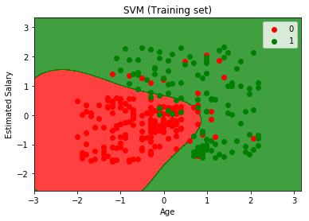 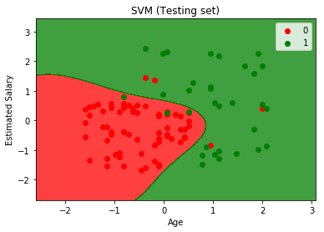

Fig.1- Visualization

**DISCUSSIONS-**

We firstly discussed the Bayes theorem and the mathematics behind it. Then we went on for how it is beneficial to use the Bayes theorem for classification and how we can use it in machine learning terms. Then the algorithm was discussed and we went on for actual implementation.

**CONCLUSIONS-** Naïve Bayes may not be the best of classifiers but it works great with the data that is purely in numeric form.

|  |  |
| --- | --- |
| **SUBMISSION DATE**-  /0/2019 | **SIGN OF COURSE INSTRUCTOR**- |
| **ROLL NO OF THE STUDENT-**  **I-62** | **NAME OF THE STUDENT-**  **Rohit Kulkarni** |