**TITLE: RANDOM FOREST REGRESSION**

**CODE: -**

# -*- coding: utf-8 -*-

"""

Created on Wed Feb 27 14:39:20 2019

@author: RoKu

"""

# Random Forest Regression

# Importing the libraries

import numpy as np

import matplotlib.pyplot as plt

import pandas as pd

# Importing the dataset

dataset = pd.read_csv('Dataset_flwr.csv')

X = dataset.iloc[:, 1:2].values

y = dataset.iloc[:, 2:].values

# Splitting the dataset into the Training set and Test set

from sklearn.model_selection import train_test_split

X_train, X_test, y_train, y_test = train_test_split(X, y, test_size = 0.2, random_state = 0)

# Feature Scaling

from sklearn.preprocessing import StandardScaler

sc_X = StandardScaler()

X_train = sc_X.fit_transform(X_train)

X_test = sc_X.transform(X_test)

sc_y = StandardScaler()

y_train = sc_y.fit_transform(y_train)

# Fitting the Random Forest Regression to the dataset

from sklearn.ensemble import RandomForestRegressor

regressor = RandomForestRegressor(n_estimators = 300, random_state = 0)

regressor.fit(X, y)

# Predicting a new result

y_pred = regressor.predict(y_test)

# Visualising the Regression results (for higher resolution and smoother curve)

X_grid = np.arange(min(X), max(X), 0.01)

X_grid = X_grid.reshape((len(X_grid), 1))

plt.scatter(X, y, color = 'red')

plt.plot(X_grid, regressor.predict(X_grid), color = 'green')

plt.title('Sepal length Predictor')

plt.xlabel = ('Petal Length')

plt.ylabel = ('Species')

plt.show()

**RESULT:**

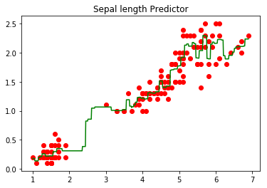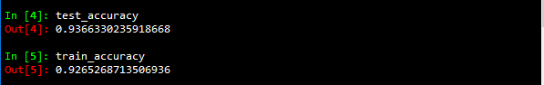

**ACCURACIES**

**TITLE: Decision Tree REGRESSION**

**CODE: -**

import numpy as np

import matplotlib.pyplot as plt

import pandas as pd

# Importing the dataset

dataset = pd.read_csv('Dataset_flwr.csv')

X = dataset.iloc[:, 0:1].values

y = dataset.iloc[:, 1:].values

# Splitting the dataset into the Training set and Test set

from sklearn.model_selection import train_test_split

X_train, X_test, y_train, y_test = train_test_split(X, y, test_size = 0.2, random_state = 0)

# Feature Scaling

from sklearn.preprocessing import StandardScaler

sc_X = StandardScaler()

X_train = sc_X.fit_transform(X_train)

X_test = sc_X.transform(X_test)

sc_y = StandardScaler()

y_train = sc_y.fit_transform(y_train)

y_test = sc_y.fit_transform(y_test)

# Fitting the Decision Tree Regression to the dataset

from sklearn.tree import DecisionTreeRegressor

regressor = DecisionTreeRegressor(random_state = 0)

regressor.fit(X, y)

# Predicting a new result

y_pred = regressor.predict(y_test)

# Visualising the Regression results

plt.scatter(X, y, color = 'red')

plt.plot(X, regressor.predict(X), color = 'blue')

plt.title('Sepal length Predictor')

plt.xlabel = ('Petal Length')

plt.ylabel = ('Species')

plt.show()

# Visualising the Regression results (for higher resolution and smoother curve)

X_grid = np.arange(min(X), max(X), 0.1)

X_grid = X_grid.reshape((len(X_grid), 1))

plt.scatter(X, y, color = 'red')

plt.plot(X_grid, regressor.predict(X_grid), color = 'blue')

plt.title('Sepal length Predictor')

plt.xlabel = ('Petal Length')

plt.ylabel = ('Species')

plt.show()

**RESULT:**

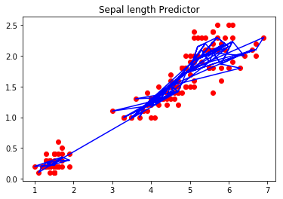

**(PLOT without NP arrange)**

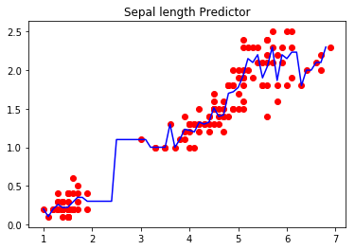

**(plot with arrange)**

|  |  |
| --- | --- |
| **SUBMISSION DATE**-  **15-02-19** | **SIGN OF COURSE INSTRUCTOR**- |
| **ROLL NO OF THE STUDENT-**  **01** | **NAME OF THE STUDENT-**  **Rohit Kulkarni** |