*Documentation*

Documentation for Case 2: UCR Medical Center Volunteers

***Base Program Function***

The base of function of this program is to help assist in the selection of country for the “Doctors Without Borders Program” which helps in selecting a graduate student to be selected and sent to a specific location based on matched preferences such as specialized areas, language fluency and other specified preferences. After running the program, it sets a preference in the selection of a doctor to be paired with a country based on the physician’s preferences whether it’s an exact match or close to exact, thus forth the volunteer being matched with a country and sent to do volunteer work in their specific locations.

***Program Approaches***

As for approaches the program task asked for the assignment of the student to use both language and specialization to assign the student to a location, but rather than assigning a student off preference only, we set the program to assign the student randomly to a country based off their specifications such as language preference and specialization. In the process of creating this program, using probability and algorithms were used to make this program run as if its in a “Real World” situation.

***Application of Course Concepts***

Methods learned and applied in to the creation of this program from the course were probability and algorithms. Adding in the probability allowed the program to be in a more “real world” setting which gave equal chance of getting one of the few countries that matched the students specified language and specialization.

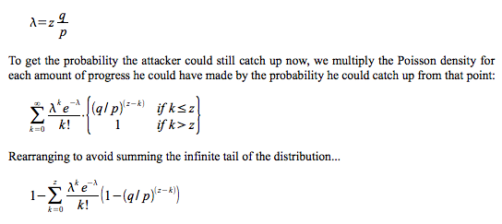

The image above shows an example problem of “Probability” and how the equation would be solved.