*Documentation*

Documentation for Case 3: Vigenere Cipher Decryption

***Base Program Function***

This program is a Cipher Encryption and Decryption program, which for the users who load this program can input a message to be encrypted and enter a key for the message they inputted earlier to be encrypted to now be decrypted. The program uses a substitution method for encryption.

***Program Approaches***

A program approach that was used to create this program was the substitution cipher method. Along with the substitution method, a cast char as an int to retrieve the ascii value number. The cast char was used to solve an issue involving range with the characters used whether the character range was too high or too low, which in end would result in issues of output. A mod operator was utilized in a for loop to create a repeating key. “a-z” was set as 1-26 for the character shift, which “a” being 1.

***Application of Course Concepts***

One application of course concept used in help creating this programming was again the Substitution Method, which was learned in an earlier lab from class which helped assist in the base structure creation of the code.

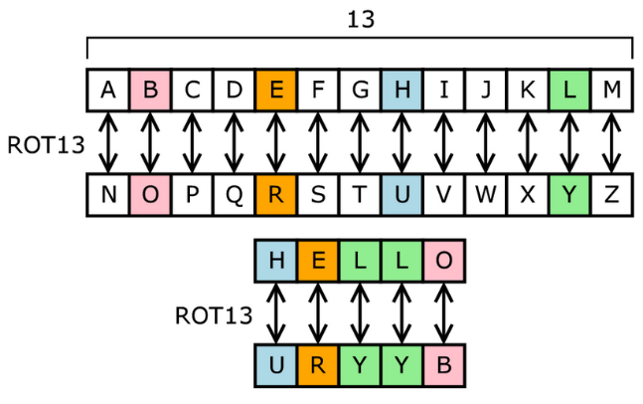

The image above is a visual representation of the algorithm used in this Cipher Encryption Program known as the “Substitution Method” which is one of the few method approaches that can be used in creating an encryption program, alongside with using the ascii for value number for the characters used.

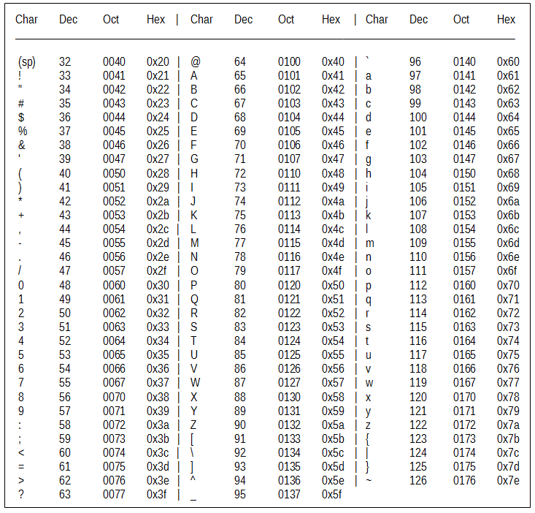

The image above is a visual image of the “ASCII Table” which helps mapping a character to and integer number. The program used a cast char as an int to retrieve the ascii value number which helped us in our algorithm of encrypting a message without any character range issues which in this case for the program “a” equals 1 and so on and so forth.