# Growth Analysis of titanium Nanotubes on various parameters

### Introduction

Titanium Nanotubes have their major application in biomedical implants due to biocompatibility of Ti in the body. The analysis of the properties of Nanotubes become crucial since the Nanotubes increase the surface area by large extent, thus enhancing the catalytic and reactive properties. Specially in biomedical implants the TNTs enhance the tissue attachment process due to the presence of the nano-scale surface characteristics. one-dimensional nanostructure-like nanotubes can exhibit large internal and external surfaces along with a surface in their vertex and a surface in the interlayer regions. Among the various nanostructured oxide materials, special attention has been directed to TiO2 nanotubes (TNT) due to its enhanced properties, cost-effective construction, and higher surface-to-volume ratio.

Mechanism of TNT formation

During anodization, the color of the TiO2 layer changes from dark purple to blue, yellow, and green swiftly .The color change is due to an increase in the thickness of TiO2. The formation mechanism of porous titania is similar to porous anodic alumina and silicon. Presence of chloride (Cl-) and bromide (Br-) ions caused severe pitting corrosion and when pitting occurred, porous anodic oxide cannot be observed. Fluoride ions (F-) are necessary for the formation of porous anodic film. In the figure presents there is schematic representation of the formation mechanism of TNT.

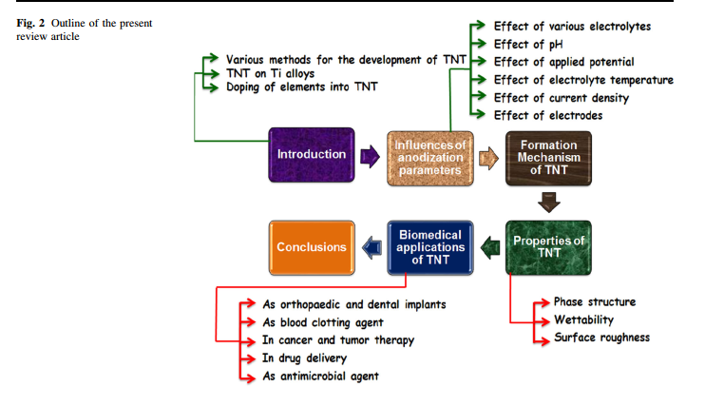

Fluoride ion (F-) is an essential factor for the formation of tubular structure because of its ability to form soluble hexafluoro titanium complexes ([TiF6]2-). In addition, it has a small ionic radius that makes it suitable to enter into the growing TiO2 lattice and be transported through the oxide by applied field. Simply, it acts as an oxide dissolution agent. The reactions involved in the formation of tubular Nanostructure are given below.

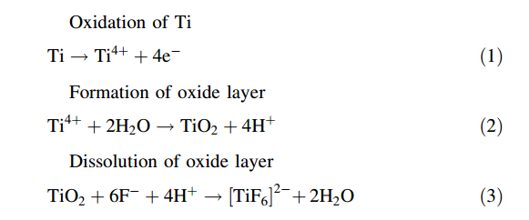

Dependence of TNT formation on various parameters

Voltage dependence

Time period of electrolysis

Surface and curvature characteristics.

* Spatial variation of density length of the nanotubes
* Creating a mathematical model to determine structural properties on various characteristic parameters
* Effects of electrical and electro-chemical parameters on the nano-tube growth.
* Growth characteristics in surfaces with curvature
* Deciding use of efficient monitoring techniques
* Possibility of controlling growth through complex electric fields
* Possibility of controlling growth through microfluidics

Experimental setup and procedures

**Aim:**

Analysis of TNT growth with variation in spatial geometry of the electrodes.

Analysis of TNT growth on variation of the voltages and time period.

**Experimental specifications:**

Electrolyte- H3PO4+NH4F

Cathode-pure Ti, Anode-Carbon/Copper Electrode.

Concentration of Electrolyte 0.3M H3PO4 + 0.3M NH4

Normal Temperature Pressure Conditions.

**Details:**

Two configurations will be considered. Firstly the TNT will be grown on the flat plate with the copper at a certain distance. In the second case the Ti plate will be kept in a cylindrical fashion around the copper electrode. Thus the effect of the geometry variation is expected to be observed.

The TNT nano tubes will be analyzed under variation of different growth parameters i.e Voltage (10V,20V,30V) and Time period.(1 hr, 2hr 3hr)

Characteristics to be observed: diameter of the tubes, wall thickness and length of the TNTs.

Experimental Conditions

* Electrolyte with 0.3M H3PO4 and 0.3M NH4F was used at normal room temperature pressure conditions.
* The setup had Titanium sheets rolled into a cylindrical shape of diameter 8 mm and kept in form.
* Copper electrodes were held in position between the sheets to maintain a uniform distance from the walls of the sheet.
* The setups were run for 2 varying input parameters : Voltage, Anodization time.
* Voltage setups were run for incremental voltages of 20 V, 30 V and 40V.
* Anodization time for each of the voltages were 1 hour, 2 hour and 3 hours.

**Observation And Results**

**Variation With Anodisation Time At 30V**

|  |  |  |  |
| --- | --- | --- | --- |
| Time(hrs) | Diameter(nm) | Length(nm) | Aspect Ratio |
| 1 | 85 | 645 | 7.59 |
| 2 | 86 | 110 | 12.94 |
| 3 | 86 | 1770 | 20.82 |

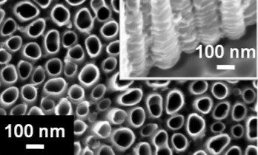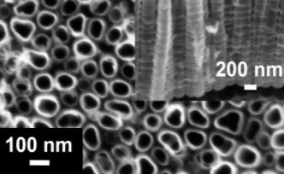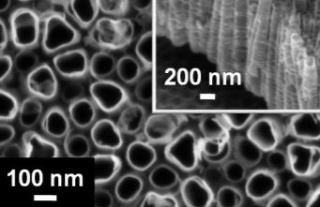

*Fig. FESEM images of TiO2 nanotubes formed at 30V in (a) 1, (b) 2 and (c) 3 hrs.*

**Variation with Voltage**

|  |  |  |  |
| --- | --- | --- | --- |
| Voltage | Diameter(nm) | Length(um) | Aspect Ratio |
| 20 | 80 | 1.0 | 12.5 |
| 30 | 85 | 1.1 | 12.94 |
| 40 | 115 | 2.0 | 17.39 |

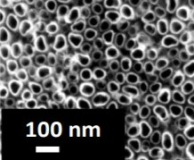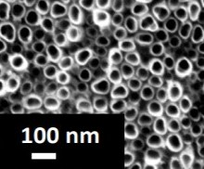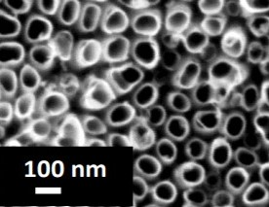

*Fig. FESEM images of TiO2 nanotubes formed 20, (b) 30 and (c) 40V.*