A MINI PROJECT REPORT ON
STUDENT ATTENDANCE & MANAGEMENT SYSTEM
Developed using ASP.NET Core MVC (.NET 8), Entity Framework Core and SQL Server
Submitted by
Detail | Information
Student Name | Aditya Kumar Roy
Course | BCA Regular
Enrollment No. | 2405101010001
Division | B
Subject | .NET
Academic Year | 2026-27

1. Project Abstract
The Student Attendance & Management System is a web application developed with ASP.NET Core MVC on the .NET 8 platform. It replaces the traditional paper attendance register with a secure, centralised and easy-to-use digital system. The application allows an administrator to manage students, faculty and subjects, record daily subject-wise attendance, and generate attendance reports.
The system uses Entity Framework Core to communicate with a SQL Server database, Bootstrap 5 for a responsive user interface, and cookie-based authentication with hashed passwords to protect the admin pages. Duplicate attendance entries and duplicate enrollment numbers are prevented both in the application code and by unique database constraints. The dashboard provides quick statistics and charts, while the reports module gives student-wise, subject-wise and date-wise attendance with filters.

2. Problem Statement
Many colleges still record attendance in paper registers. This causes several problems:
- Manual calculation of attendance percentage is slow and error-prone.
- Registers can be lost, damaged or altered.
- It is difficult to search a student's record or produce a report for a date range.
- The same attendance can be entered twice and there is no validation.
- Students, faculty and subject details are kept in different places without any link between them.
There is a need for a simple computerised system that stores all this information in one database, prevents duplicate entries, and produces instant attendance reports.

3. Objectives
- To build a web-based system to manage students, faculty and subjects.
- To allow subject-wise and division-wise daily attendance marking.
- To prevent duplicate attendance and duplicate enrollment numbers.
- To generate student-wise, subject-wise and date-wise reports with filters.
- To calculate attendance percentage automatically and highlight shortages below 75%.
- To provide secure admin login with hashed passwords.
- To apply MVC architecture, Entity Framework Core and SQL Server in a real-life project.

4. Existing System
In the existing system attendance is taken manually in registers or Excel sheets.
- Disadvantages: time-consuming, high chance of human error, no data security, no automatic percentage calculation, difficult searching, no duplicate checking, and reports must be prepared by hand.

5. Proposed System
The proposed system is a centralised web application. All data is stored in SQL Server and accessed through Entity Framework Core.
- Advantages: fast and accurate attendance entry, automatic calculation, secure login, search and filter options, instant reports, dashboard with charts, duplicate prevention, responsive design that works on desktop, tablet and mobile.

6. Hardware Requirements
Component | Minimum | Recommended
Processor | Intel Core i3 | Intel Core i5 or higher
RAM | 4 GB | 8 GB or more
Hard disk | 10 GB free | 20 GB free (SSD)
Display | 1366 x 768 | 1920 x 1080
Network | Required for CDN files | Broadband connection

7. Software Requirements
Software | Details
Operating System | Windows 10 / 11
IDE | Visual Studio 2022
Framework | .NET 8 SDK, ASP.NET Core MVC
Language | C#, HTML5, CSS3, JavaScript
ORM | Entity Framework Core 8
Database | SQL Server / SQL Server LocalDB / Express
UI Library | Bootstrap 5, Bootstrap Icons, Chart.js, jQuery
Browser | Google Chrome, Microsoft Edge, Firefox

8. Functional Requirements
- The admin shall log in with username and password and log out securely.
- The system shall show a dashboard with total students, faculty, subjects, today's attendance and overall attendance percentage.
- The admin shall add, view, edit, delete and search students.
- The admin shall add, view, edit, delete and search faculty.
- The admin shall add, view, edit and delete subjects and assign a faculty to each subject.
- The user shall select date, subject and division, view the student list and mark Present/Absent.
- The system shall not allow duplicate attendance for the same student, subject and date.
- The system shall generate student-wise, subject-wise and date-wise reports.
- Reports shall be filterable by student, subject, semester, division and date range.
- The system shall validate required fields, email, phone and enrollment number.

9. Non-Functional Requirements
- Security: PBKDF2 password hashing with salt, cookie authentication, anti-forgery tokens on all forms, and authorization on every page.
- Usability: clean sidebar navigation, Bootstrap forms, clear alerts and validation messages.
- Performance: pages load within two seconds for a normal college dataset; queries use LINQ with database-side grouping.
- Reliability: foreign keys and unique indexes keep data consistent.
- Maintainability: MVC separation makes code easy to understand and extend.
- Responsiveness: works on desktop, tablet and mobile screens.
- Portability: runs on any system with .NET 8 and SQL Server.

10. Modules
Module | Description
Authentication | Admin login page, PBKDF2 hashed password, logout, protected pages.
Dashboard | Bootstrap cards for totals, today's attendance, overall %, and Chart.js charts.
Student Management | Add, view, edit, delete, search students; duplicate enrollment prevention.
Faculty Management | Add, view, edit, delete faculty with search.
Subject Management | CRUD for subjects with a faculty dropdown.
Attendance Management | Select date, subject, division; mark present/absent; save without duplicates.
Attendance Reports | Student, subject and date-wise reports with filters and percentage.

11. Database Design
The database StudentAttendanceDB is created by Entity Framework Core and contains five tables.

Users
Column | Type | Constraint
UserId | int | Primary Key, Identity
Username | nvarchar(50) | Unique, Required
PasswordHash | nvarchar(max) | Required (PBKDF2 hash)
FullName | nvarchar(100) | Required
Role | nvarchar(20) | Required (Admin)

Students
Column | Type | Constraint
StudentId | int | Primary Key, Identity
EnrollmentNumber | nvarchar(450) | Unique, Required
Name | nvarchar(100) | Required
Email | nvarchar(100) | Required, valid email
Phone | nvarchar(max) | Required, 10 digits
Program | nvarchar(50) | Required
Semester | int | Required, 1 to 8
Division | nvarchar(1) | Required

Faculty
Column | Type | Constraint
FacultyId | int | Primary Key, Identity
FacultyName | nvarchar(100) | Required
Email | nvarchar(100) | Required, valid email
Phone | nvarchar(max) | Required, 10 digits
Department | nvarchar(100) | Required

Subjects
Column | Type | Constraint
SubjectId | int | Primary Key, Identity
SubjectCode | nvarchar(20) | Unique, Required
SubjectName | nvarchar(100) | Required
Semester | int | Required, 1 to 8
FacultyId | int | Foreign Key -> Faculty(FacultyId), Restrict delete

Attendance
Column | Type | Constraint
AttendanceId | int | Primary Key, Identity
StudentId | int | Foreign Key -> Students(StudentId), Cascade delete
SubjectId | int | Foreign Key -> Subjects(SubjectId), Restrict delete
Date | date | Required
IsPresent | bit | 1 = Present, 0 = Absent
Unique index | - | (StudentId, SubjectId, Date) prevents duplicates

12. ER Diagram Description
The system has four related entities and one standalone table.
- One Faculty teaches many Subjects (1 : M). A faculty cannot be deleted while subjects are assigned.
- One Student has many Attendance records (1 : M). Deleting a student removes the student's attendance.
- One Subject has many Attendance records (1 : M). A subject with attendance cannot be deleted.
- Attendance is the link (junction) table between Students and Subjects; each row says whether one student was present in one subject on one date.
- Users is a standalone table used only for admin login.
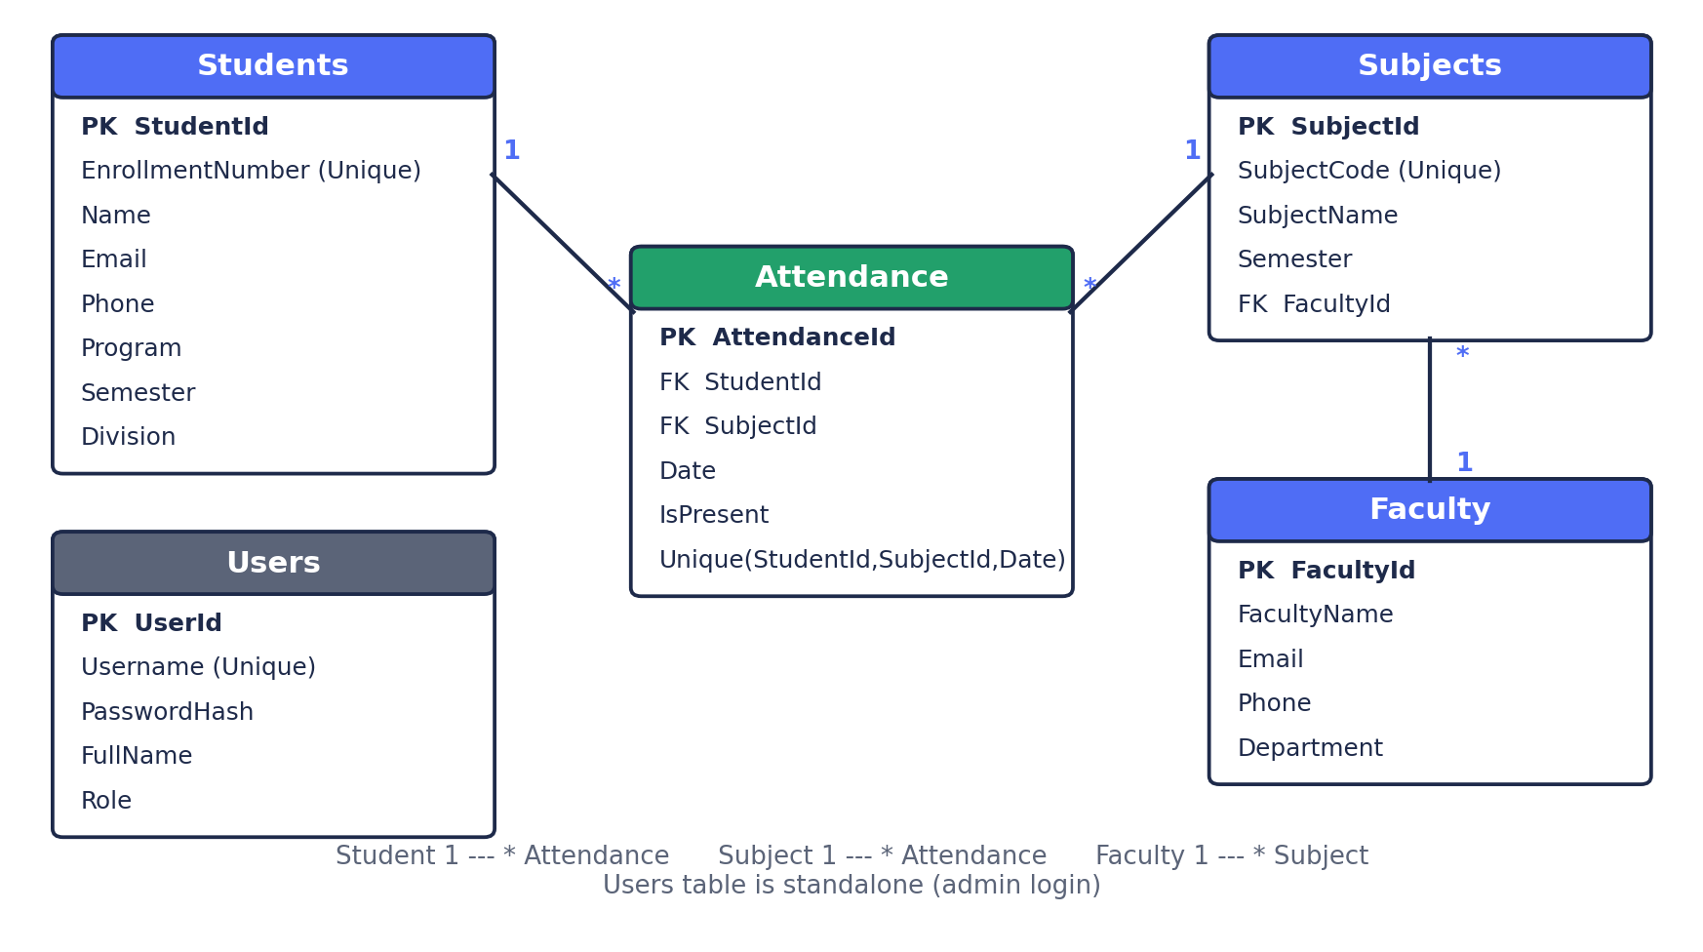
Figure 1: Entity Relationship Diagram

13. System Architecture
The application follows the Model-View-Controller (MVC) pattern:
- Model: C# classes (Student, Faculty, Subject, Attendance, User) and the EF Core AppDbContext that map to database tables.
- View: Razor (.cshtml) pages styled with Bootstrap 5 that show data to the user.
- Controller: C# classes that receive the browser request, use the database context, and return a view.
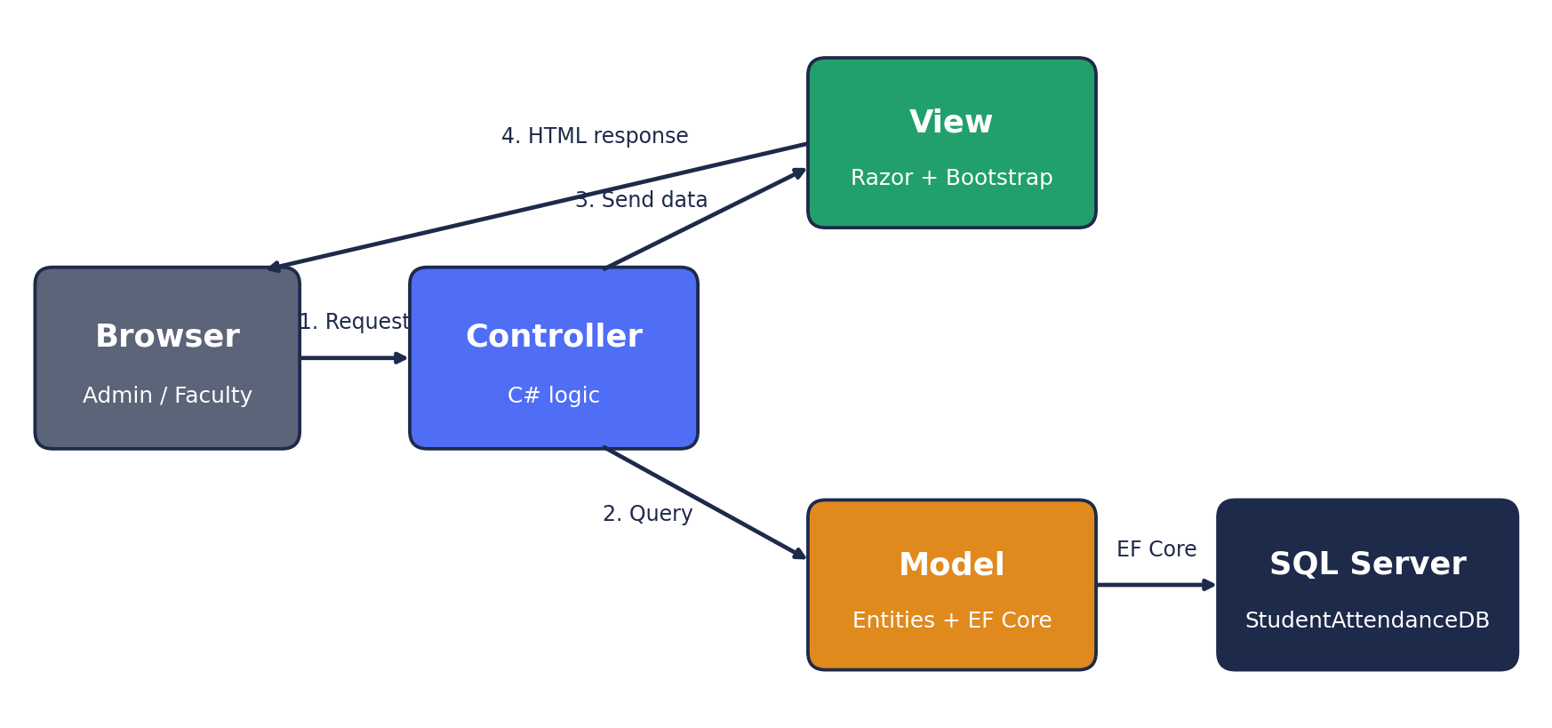
Figure 2: MVC request flow
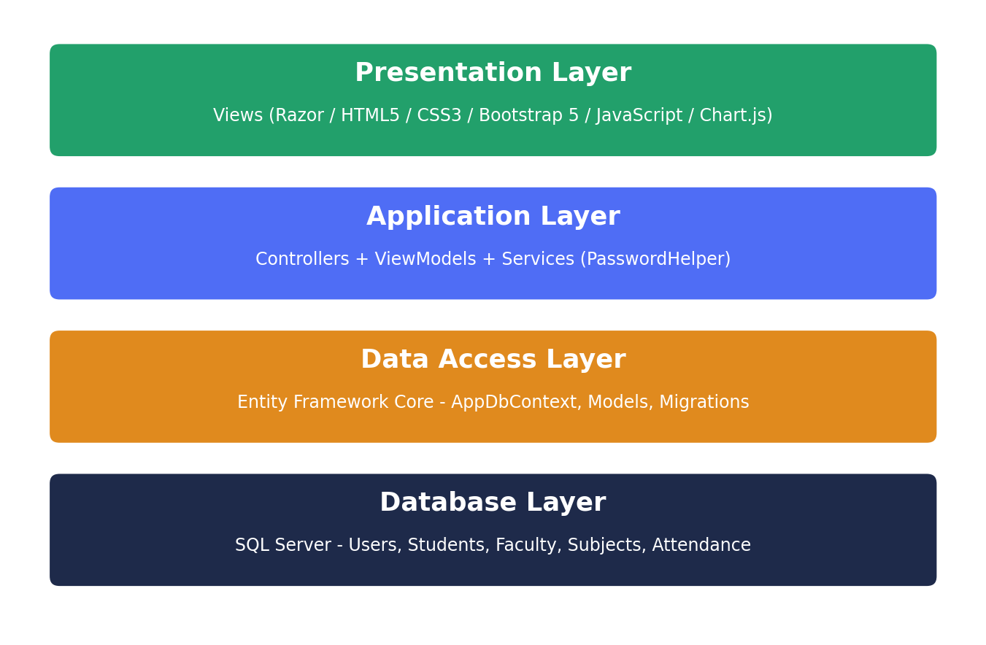
Figure 3: Layered architecture

Project folder structure
Folder / File | Purpose
Program.cs | Registers services (EF Core, authentication, MVC filters), runs migrations and seeding, configures the request pipeline and default route.
appsettings.json | Stores the SQL Server connection string and logging settings.
Controllers/ | Account, Home (dashboard), Students, Faculty, Subjects, Attendance, Reports.
Models/ | Entity classes with validation attributes (Required, EmailAddress, RegularExpression, Range).
ViewModels/ | Classes made for one screen: login, dashboard, mark-attendance, report.
Data/ | AppDbContext (relationships, unique indexes) and DbSeeder (sample data).
Services/ | PasswordHelper for hashing and verifying passwords.
Views/ | Razor pages; Shared/_Layout.cshtml holds the sidebar, navbar and alerts.
wwwroot/ | Static files: css/site.css and js/site.js.

14. Key Implementation Points
- Secure passwords: the password is hashed with PBKDF2 (SHA-256, 100000 iterations, 16-byte random salt). Only the hash is stored.
- Page protection: a global AuthorizeFilter is added in Program.cs so every controller needs login; only the login action uses [AllowAnonymous].
- Duplicate attendance: the controller loads existing records for the subject and date and updates them; the unique index (StudentId, SubjectId, Date) is a second safety net.
- Duplicate enrollment number: checked with AnyAsync before saving and enforced by a unique index.
- Reports: filters are combined on one IQueryable and GroupBy is executed by SQL Server.
- CSRF protection: AutoValidateAntiforgeryToken filter validates the token on every POST.

15. Setup Summary
- Open StudentAttendanceSystem.csproj in Visual Studio 2022.
- Check the connection string in appsettings.json.
- Open Package Manager Console and run: Add-Migration InitialCreate
- Run: Update-Database
- Press F5. Log in with admin / Admin@123.

16. Sample Data
On the first run the application inserts: 1 admin user, 5 faculty, 6 subjects (Semester 5), 12 students (Divisions A and B, including the author) and about 200 attendance records for demonstration.
Subject Code | Subject Name | Faculty
BCA501 | .NET Programming | Prof. Ramesh Sharma
BCA502 | Web Technologies | Dr. Anita Verma
BCA503 | Software Engineering | Prof. Sunil Mehta
BCA504 | Discrete Mathematics | Prof. Kavita Singh
BCA505 | Computer Networks | Dr. Rajiv Nair
BCA506 | Python Programming | Dr. Anita Verma

17. Testing Summary
Test case | Expected result
Login with wrong password | Error message; no access
Open /Students without login | Redirected to login page
Add student with existing enrollment number | Error: enrollment number already exists
Add student with invalid email or phone | Validation message shown
Save attendance twice for same subject and date | Existing records updated; no duplicates
Delete faculty with assigned subjects | Blocked with a message
Report filtered by division and date range | Only matching records counted

18. Future Scope
- Separate login for faculty and students with role-based access.
- SMS / email alerts to parents when attendance falls below 75%.
- Export reports to Excel and PDF.
- QR-code, biometric or face-recognition attendance.
- Timetable management and leave applications.
- Mobile application and REST API using ASP.NET Core Web API.
- Cloud deployment on Azure.

19. Conclusion
The Student Attendance & Management System meets the objective of digitising attendance handling in a college. It demonstrates MVC architecture, Entity Framework Core with SQL Server, secure authentication, validation, and a responsive Bootstrap interface. The system is simple enough to explain in a viva, yet complete enough to be used in a real classroom, and it can be extended in many directions.

20. References
- Microsoft Learn - ASP.NET Core MVC documentation: learn.microsoft.com/aspnet/core
- Microsoft Learn - Entity Framework Core documentation: learn.microsoft.com/ef/core
- Bootstrap 5 documentation: getbootstrap.com
- Chart.js documentation: chartjs.org

