Software Requirements Specification
for
SharpBank
Version 1.0 approved
Prepared by Roman Valentin Remus
Paraschivescu Maria-Cristiana
Batrana Teodor-Ioan
ACE UCV
<date created>
Table of Contents
Table of Contents ii
Revision History ii
1. Introduction 1
1.1 Purpose 1
1.2 Document Conventions 1
1.3 Intended Audience and Reading Suggestions 1
1.4 Product Scope 1
1.5 References 2
2. Overall Description 2
2.1 Product Perspective 2
2.2 Product Functions 2
2.3 User Classes and Characteristics 2
2.4 Operating Environment 3
2.5 Design and Implementation Constraints 3
2.6 User Documentation 3
2.7 Assumptions and Dependencies 3
3. External Interface Requirements 3
3.1 User Interfaces 4
3.2 Hardware Interfaces 10
3.3 Software Interfaces 10
3.4 Communications Interfaces 11
4. System Features 12
4.1 Login 12
4.2 Home 13
4.3 Make transaction 13
4.4 Pay Bill 13
4.5 Cards overview 14
4.6 Add card 14
5. Other Nonfunctional Requirements 15
5.1 Performance Requirements 15
5.2 Safety Requirements 15
5.3 Security Requirements 15
5.4 Software Quality Attributes 15
5.5 Business Rules 15
6. Other Requirements 16
Appendix A: Glossary 16
Appendix B: Analysis Models 16
Appendix C: To Be Determined List 16

Revision History
Name | Date | Reason For Changes | Version

Introduction

Purpose
SharpBank is a product that provides users with the ability to manage their bank accounts, to create transactions, to pay bills and to manage their cards in a secure and fast way.

It also provides a way for bank admins to check ongoing or past transactions, to freeze accounts or cards.

Document Conventions
<Describe any standards or typographical conventions that were followed when writing this SRS, such as fonts or highlighting that have special significance. For example, state whether priorities for higher-level requirements are assumed to be inherited by detailed requirements, or whether every requirement statement is to have its own priority.>

Intended Audience and Reading Suggestions
This document is intended for the client but also for the developers that are working on the project. The rest of the document contains details about the implementation of the application and it is organized from the higher level of abstraction towards a higher level of technical detail.

A client should start reading the overall description, continue with the external interfaces (mostly the user interface) and should read briefly the functional requirements.

A developer should start with the external interfaces with emphasis on software interfaces and continue with functional requirements, ending with a brief review of the other non-functional requirements.

Product Scope
Sharp bank intends to facilitate user interaction with the bank by providing a fast and secure way to manage accounts and transactions.

To the user, this application is a way to minimize interaction with physical bank locations for common tasks like making transactions or checking account history.

To the admin, this application is a way to see in real time what operations are going on, the history of transactions, it provides a way to handle frauds by blocking accounts or freezing cards.

References
https://auth0.com/blog/secure-browser-storage-the-facts/

Overall Description

Product Perspective
This product is one of the many banking applications that exist throughout the world, appearing from the context of digitalization and the need to keep up with the increased demands of the users. People no longer want to travel and waste time waiting in lines at banks, instead they want to be able to minimize this type of interaction.

Product Functions
SharpBank provides the following functions
- A user/admin is able to login
- An admin is able to create user accounts
- An admin is able to assign bank accounts to user accounts
- An admin is able to create bank accounts
- An admin is able to freeze bank accounts/cards
- A user can associate cards with accounts
- A user/admin can change his password
- A user can see his available funds on each account/card
- A user can see a history of transactions
- A user can create a transaction
- A user can create a bill
- A user can see a list of bills
- A user can see a chart of his expenditures during current month
- A user can see his personal information and change his address

User Classes and Characteristics
User classes:
- Ordinary user with small transactions
- Business users that make big transactions
- Private companies
- Bank administrators

Operating Environment
This project will be cross-platform, meaning that it can be deployed on Windows 10, MacOS and UNIX distributions.

Design and Implementation Constraints
This application will run on personal computers, mobile phones and tablets. The application will be available only in English. The client application should connect to the server application that handles the database, so any communication between those modules must be encrypted.
The hardware that hosts the database and Bank API must be sufficiently performant to handle many requests at the same time.

User Documentation
Users have access to a help page where there are examples on how to use the software.

Assumptions and Dependencies
- The application will use ASP.NET MVC Core 3.1 for Client side operations
- Bootstrap for front end
- C#.NET Core for Bank API
- SQL Server for Database

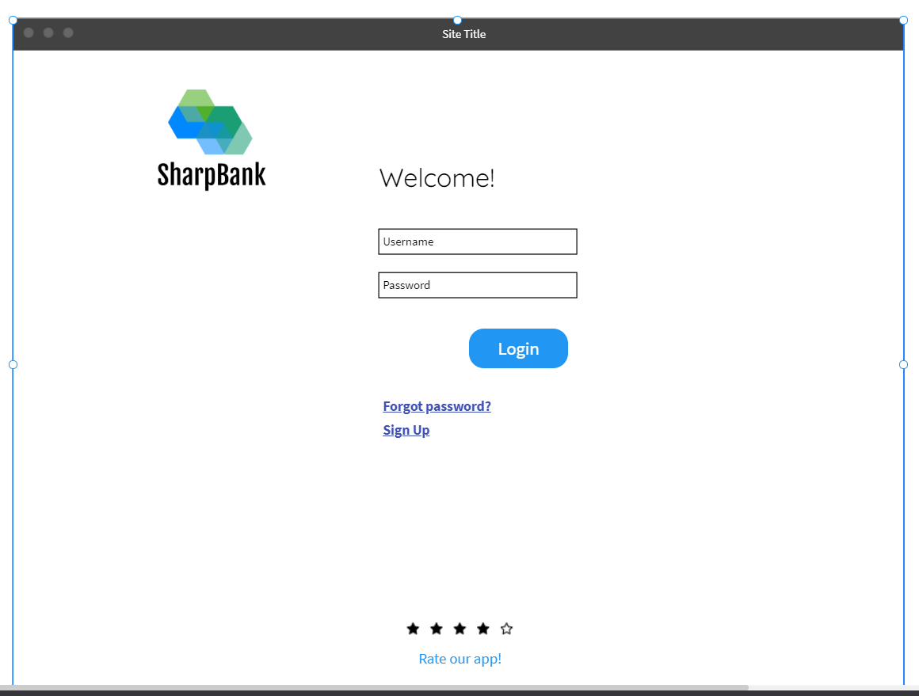
External Interface Requirements

User Interfaces

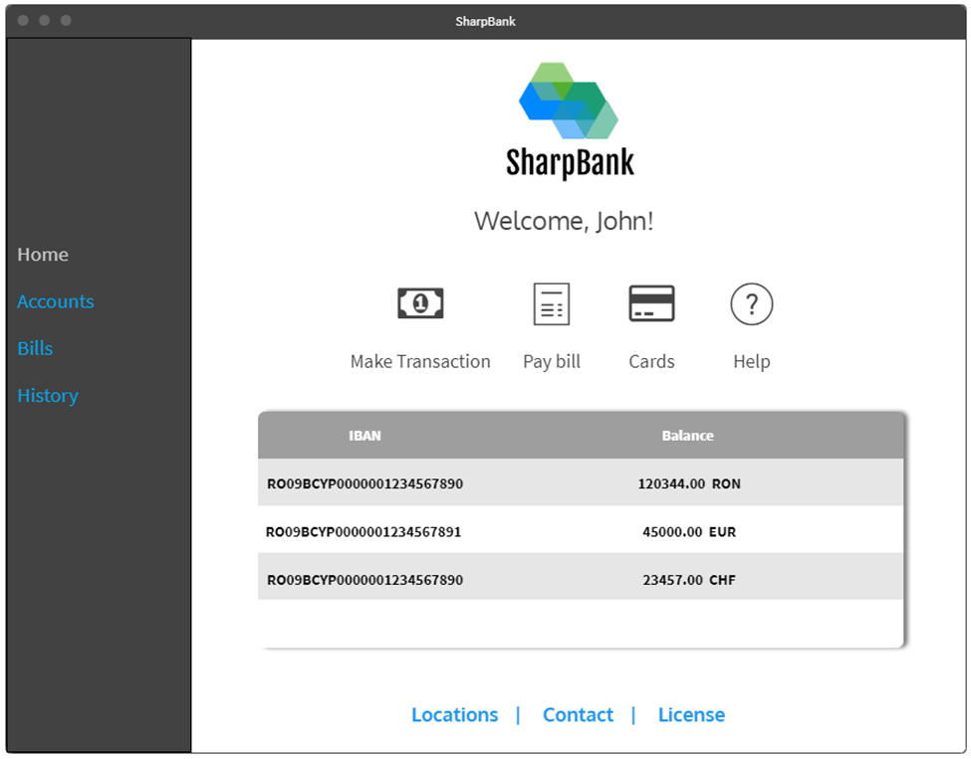

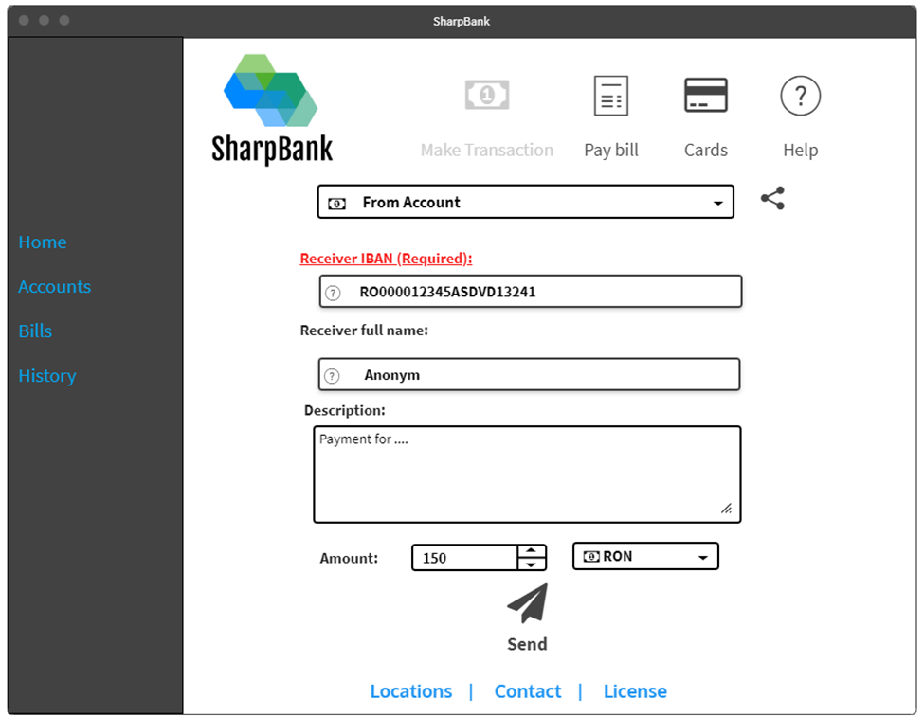

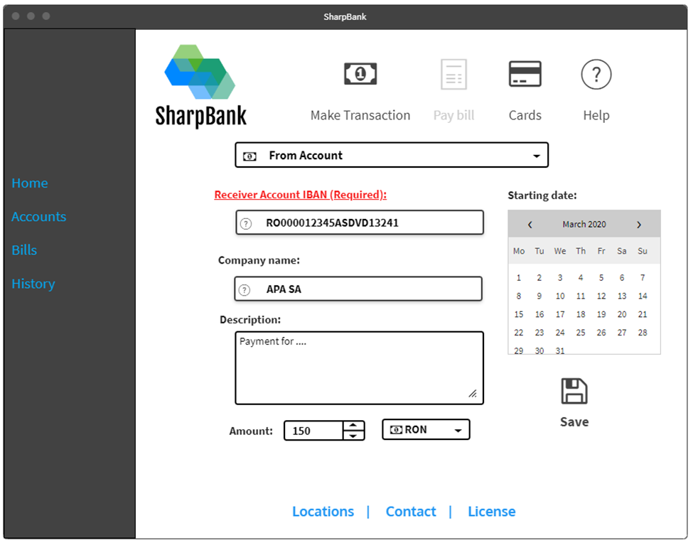

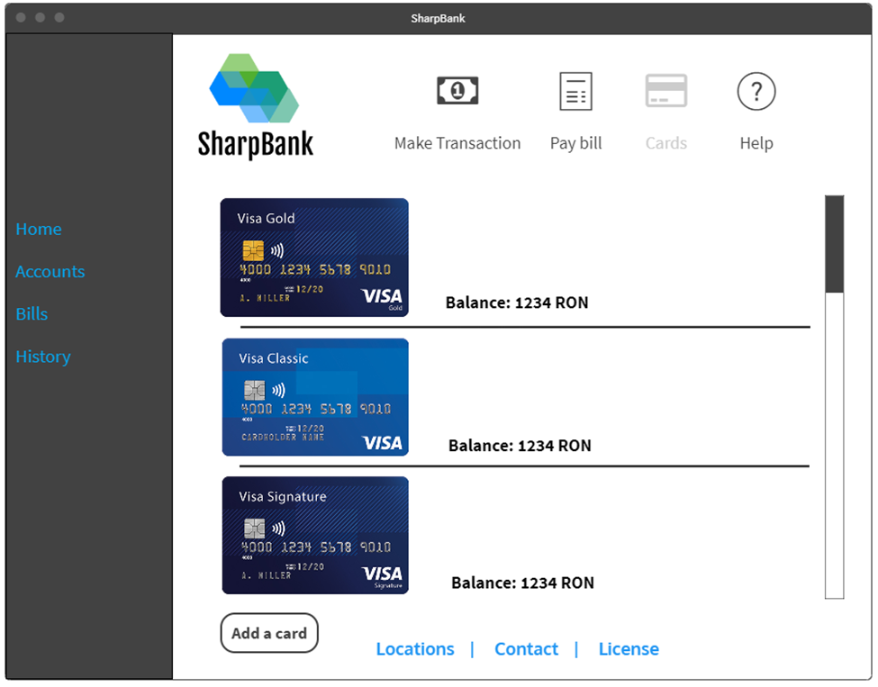

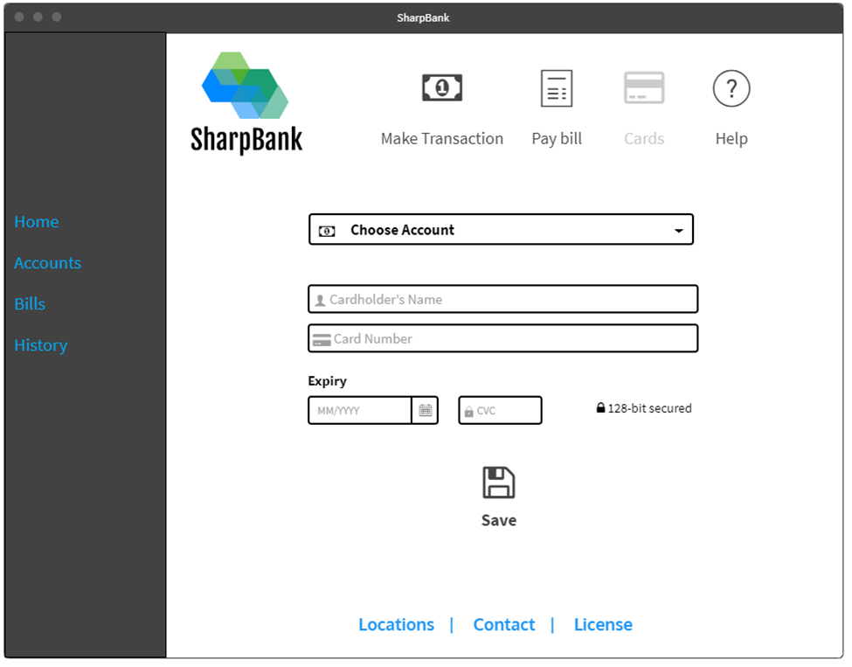

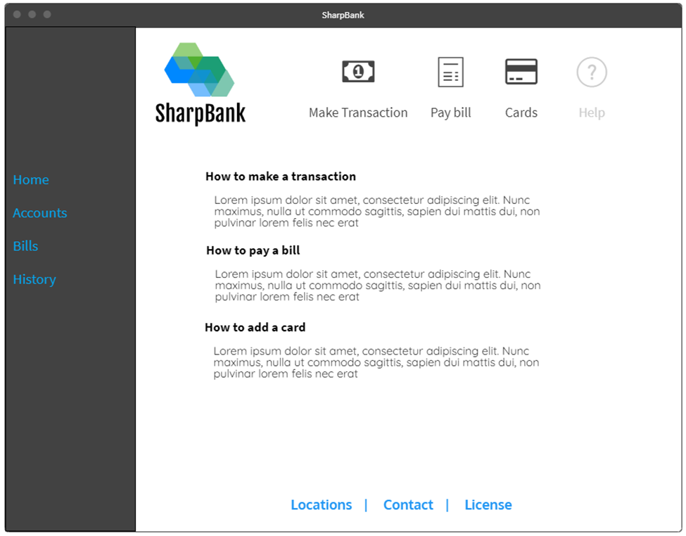

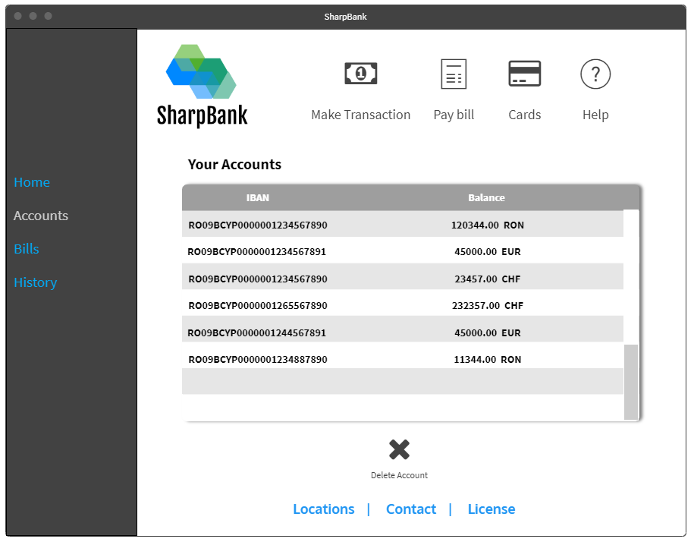

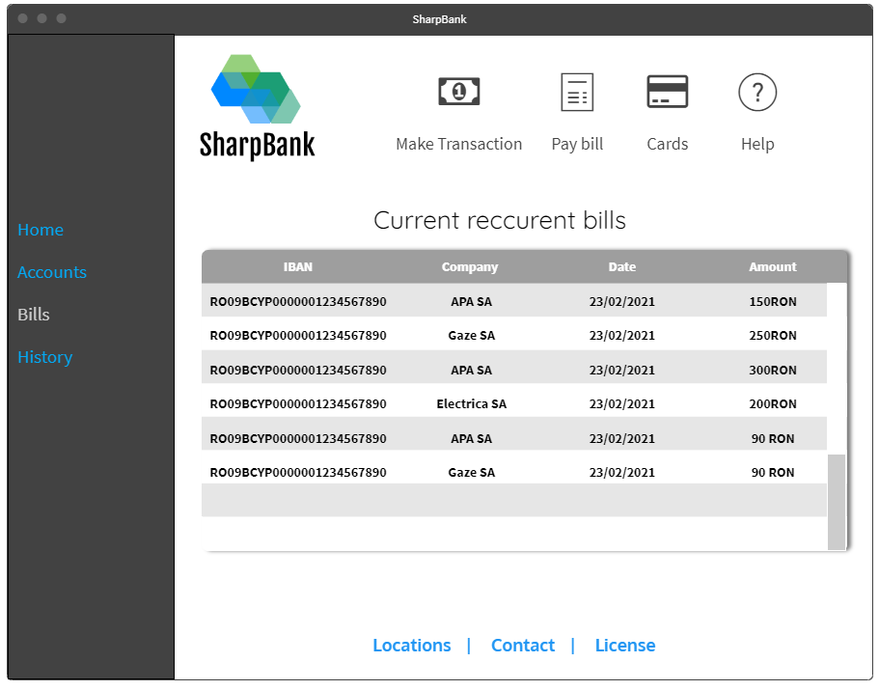

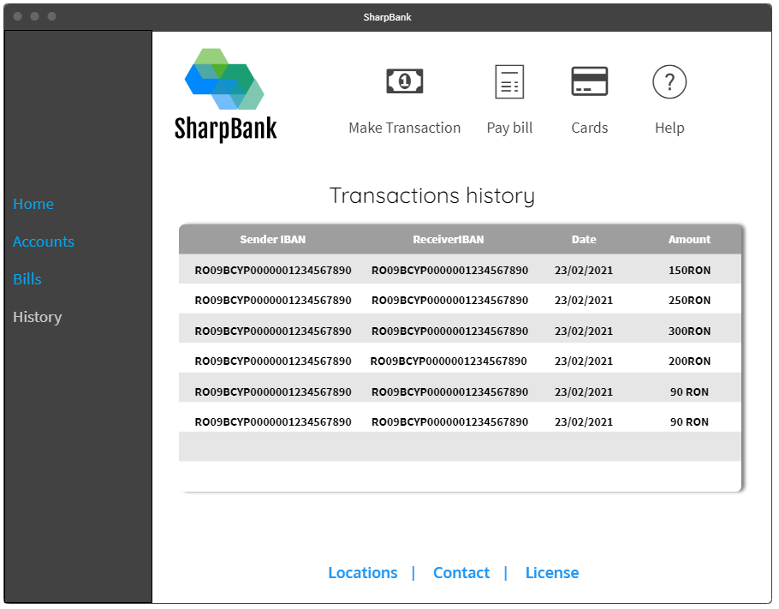

Reference: https://wireframepro.mockflow.com/

Hardware Interfaces
Not applicable

Software Interfaces
Client side will be a Model View Controller created in ASP.NET MVC 3.1. Models will make request to an API that is connected to an SQL Server database, that will encrypt the data and send it to the model to be decrypted.

Database entities:
-User
-Account
-Transaction
-Bill

Models:
- UserModel
- AccountModel – an user can have multiple bank accounts
- TransactionModel
- BillModel

Controllers:
- UserController
  - GET
    - user + json body
  - POST user + json body
  - DELETE
    - user + json body
  - PUT user + json body
- Account Controller
  - GET
    - Account + json body
  - POST user + json body
  - DELETE
    - Account + json body
  - PUT user + json body
- TransactionController
  - GET
    - users/{id}/transactions/{id} + json body
  - POST user/{id}/transactions + json body

- BillController
  - GET
    - users/{id}/bills/{id}
  - POST user/{id}/ bills + json body
  - DELETE users/{id}/bills/{id}
  - PUT user/{id}/ bills + json body

Communications Interfaces
Communication from models to the Bank API and back will be encrypted and signed using public-private key pair, so that the information cannot get corrupted or accessed from other parts using HTTPS requests.

System Features

Login
4.1.1 Description and Priority
High priority – A user must be able to access the application by providing his credentials.
4.1.2 Stimulus/Response Sequences
The user must enter his credentials. The credentials must be valid(no invalid characters). After pressing log in button, a user must be redirected to the home page if the credentials provided are correct. If the credentials are not right(wrong username/password) the user will get a warning and will be prompted to try again.

4.1.3 Functional Requirements

REQ-1: A user must be able to enter his credentials in a form
REQ-2: A user must be able to submit his credentials
REQ-3: A user must be able to reset his password
REQ-4: A warning must be sent if the entered credentials are incorrect and access should be denied
REQ-5: The user must be granted access to the product (trough an access token) if his credentials are correct
REQ-6: Every route must be secured, redirecting to the login page if the user token is not valid
REQ-7: A client must be able to create a user account
REQ-8: A client must be able to rate the app

Home
4.2.1 Description and Priority
High priority – An user must have a home page where to access all major functionalities/modules of the application.
4.2.2 Stimulus/Response Sequences
The user must be able to access banking operations from this page, like making transactions, seeing transaction history and accessing his cards. Each of this routes must take the user to the proper page that handles that specific operation.

4.2.3 Functional Requirements

REQ-1: A user must be able to see a small overview of his most used/valuable accounts
REQ-2: A user must be able to access “make transaction” page
REQ-3: A user must be able to see his cards
REQ-4: Make Bill can be accessed from this page
REQ-5: A help page must be accessible to provide tutorials and guidance on how to use the application
REQ-6: A page with banks/atms locations must be easily accessed
REQ-7: A page with contact info must be easily accessed from this page
REQ-8: A page with license and producer info can be easily accessed from this page

Make transaction
4.2.1 Description and Priority
High priority – A user must be able to make transactions from his accounts to other accounts.
4.2.2 Stimulus/Response Sequences
The user must first choose the account from which the money will be drawn from. The receiver IBAN and full name must be provided. Also, a short description of the transaction can be provided. The amount and currency must be validated(no negative or 0 values, no sums bigger than balance). After all form inputs have been completed, the user can complete the transaction by pressing send. A pop-up will notify the user if the transaction has been accepted or denied by the server.

4.2.3 Functional Requirements

REQ-1: A user must be able to provide all necessary transaction info
REQ-2: A user must receive a warning if some required information are not written.
REQ-3: A user must be able to copy to clipboard or share his account IBAN
REQ-4: After pressing send, a notification must appear that the transaction has been sent successfully, otherwise a warning should be displayed, prompting the user to try again
REQ-5: After pressing send, the amount must be checked for validity

Pay bill
4.2.1 Description and Priority
High priority – A user must be able to create automated recurring payments. Transactions should be automatically created at any date, after a set amount of days have passed or on a monthly basis.
4.2.2 Stimulus/Response Sequences
The user must first choose the account from which the money will be drawn from. After that, an IBAN for the receiver account must be provided. A starting date, and a number of days must be chosen, also the receiving company name and a short description can be provided (optional).

When pressing save, a pop-up should notify the user with the status of the operation.

4.2.3 Functional Requirements

REQ-1: The user must input all necessary data into input form
REQ-2: A user must receive a warning if some of the required fields are not written.
REQ-4: After pressing send, a notification must appear that the transaction has been sent successfully, otherwise a warning should be displayed, prompting the user to try again
REQ-5: After pressing save, the amount must be checked for validity
REQ-6: Each automated transaction made by bills must be also sent to the history of transactions and treated as a normal transaction
REQ-7: If a transaction fails(due to lack of funds or other reasons), the transaction must also appear in the history with status FAILED and a notification should be sent to the user

Cards overview
4.2.1 Description and Priority
Medium priority – A user must be able to see a list of his cards, each associated with its own account. For each card, information about it must be displayed.
4.2.2 Stimulus/Response Sequences
The user can scroll trough the list of cards. An option to add new cards is also available

4.2.3 Functional Requirements

REQ-1: The user must see details about each card
REQ-2: The user must be able to see his balance on each card
REQ-3: Debit cards have imposed limits, the user must see those limits in case the card is that type
REQ-4: The user must be able to add new cards associated to an account.
REQ-5: The request to add a new card is validated by the server and a response must be returned(if the request is valid, the user is routed to add card view, if not – a notification is sent with the reason the user cannot add a new card)

Add card
4.2.1 Description and Priority
Medium priority – A user must be able to associate a new card(physical existing one) with an account.

4.2.2 Stimulus/Response Sequences
All input fields must be validated as the user types them. A warning must be displayed if any of the required fields are invalid.

4.2.3 Functional Requirements

REQ-1: The user must input all his card details
REQ-2: All input fields must be validated
REQ-3: After pressing save, the user must receive a notification that the action completed or that it had a problem

Other Nonfunctional Requirements

Performance Requirements
Not applicable

Safety Requirements
Not applicable

Security Requirements
Data security is crucial when dealing with banking information. Every bit of communication must be encrypted and the keys should be securely stored or generated. The user tokens must be short-lived, so that the user does not leave traces in the browser storage for too much time. All passwords must be hashed using SHA256 and also a long random string should be appended to the end of the hash, so that if anyone breaks the database security and steals the hashes, they are also cluttered with other characters.

Software Quality Attributes
The software must produce valid operations, information must remain intact and valid. Ease of use and ease of learning must be a priority.

Business Rules
There can be users and admins, each with his own privileges and constraints. Users can be separated into multiple types:

- Ordinary user with small transactions
- Business users that make big transactions
- Private companies
- Bank administrators

Other Requirements
<Define any other requirements not covered elsewhere in the SRS. This might include database requirements, internationalization requirements, legal requirements, reuse objectives for the project, and so on. Add any new sections that are pertinent to the project.>
Appendix A: Glossary
<Define all the terms necessary to properly interpret the SRS, including acronyms and abbreviations. You may wish to build a separate glossary that spans multiple projects or the entire organization, and just include terms specific to a single project in each SRS.>
Appendix B: Analysis Models
<Optionally, include any pertinent analysis models, such as data flow diagrams, class diagrams, state-transition diagrams, or entity-relationship diagrams.>
Appendix C: To Be Determined List
<Collect a numbered list of the TBD (to be determined) references that remain in the SRS so they can be tracked to closure.>

