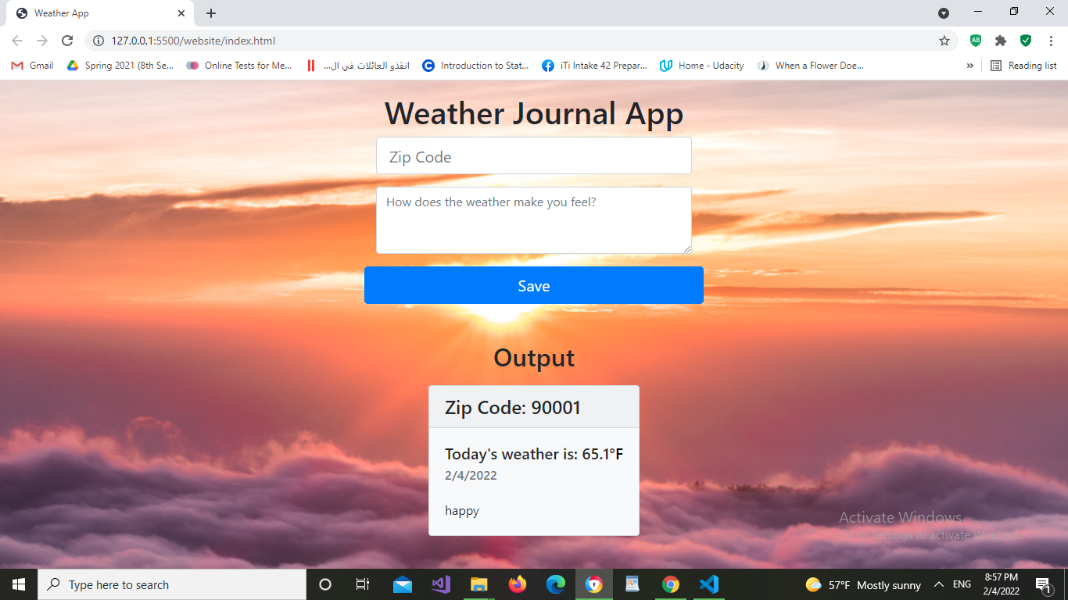

For the zipcode 190001 the result is shown above