**POS Store Software Bug Report**

**Bug Id:**

POS_unable to resize the page and it needs more enhancement.

**Description:**

When the user opens the software on the browser and tries to make the page bigger or smaller, the system does not adapt to the page size. Also, the page needs to be more organized.

**Steps to reproduce:**

1. Open a web browser (Google Chrome, Microsoft Edge).

2. Navigate to the POS store software's URL.

3. Observe the page and the default size of it.

4. Try to resize the browser window to make it smaller by dragging its edge.

5. Try to resize the browser window to make it bigger by dragging its edge.

6. Observe that the POS store software page does not modify its content to fit the browser window.

**Priority / Severity:**

Priority:Low.

Severity:Medium.

**Environment:**

https://test-project-c6cd7.web.app/home

web browser (Google Chrome, Microsoft Edge).

Mobile (iPhone, Android).

**Expected Result:**

When the user opens the POS software on the browser and tries to resize the page, the system should modify its content and layout to fit the size of the browser window.

**Actual Result:**

The POS store software does not respond to modifying its size, it remains static and does not fit the available space.

**Attachment:**

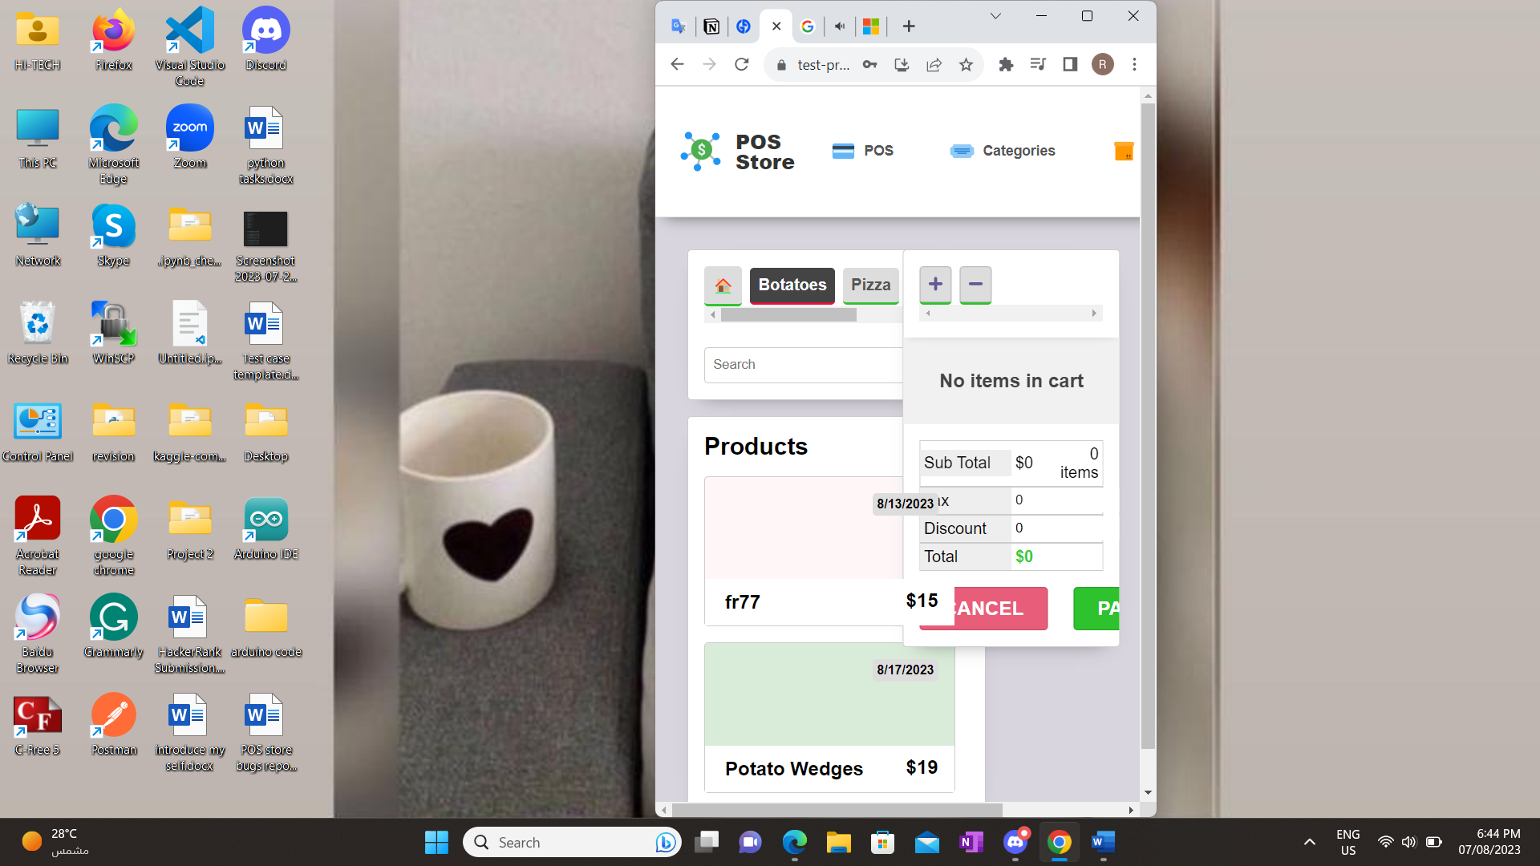

**Bug Id:**

POS_Payment button fails.

**Description:**

When the user attempts to pay after he filled the cart, and clicks on the payment button, the system fails to redirect the user to the payment page.

**Steps to reproduce:**

1. Open the POS store software's URL.

2. Add at least one item to the cart.

4. Click on the payment button to move to the payment page.

**Priority / Severity:**

Priority:High.

Severity:Major.

**Environment:**

https://test-project-c6cd7.web.app/home

web browser (Google Chrome, Microsoft Edge).

Mobile (iPhone, Android).

**Expected Result:**

When the user chooses what he needs and fills the cart, then clicks on the payment button the system should redirect the user to the payment page to allow him to complete the payment process for the items in their cart.

**Actual Result:**

When the user chooses what he needs and fills the cart, then clicks on the payment button the system does not redirect him to the payment page, he is still on the same page and does not complete the payment process.

**Attachment:**



**Bug Id:**

POS_Search grid on the product page.

**Description:**

When the user attempts to search for a product on the record products, no search results are displayed.

**Steps to reproduce:**

1. Open the POS store software's URL.

2. Move to the product page from the header and search grid.

3. Enter the name of the product to start the search.

**Priority / Severity:**

Priority:High.

Severity:Major.

**Environment:**

https://test-project-c6cd7.web.app/home

web browser (Google Chrome, Microsoft Edge).

Mobile (iPhone, Android).

**Expected Result:**

When the user moves to the product page and enters the name of the product on the search grid, the system should display the required results and provide information about it such as its code, price, category, etc.

**Actual Result:**

When the user moves to the product page and enters the name of the product on the search grid, the system does not display any results.

**Attachment:**



**Bug Id:**

POS_POS Store software crash when adding products in multiple carts.

**Description:**

The POS store system crash when the user tries to add products in two different carts simultaneously.

**Steps to reproduce:**

1. Open the POS store software's URL.

2. Add two carts.

3. Try to add a product to the first cart.

4. Then try to add products to the second cart.

5. Observe the system's response.

**Priority / Severity:**

Priority:High.

Severity:Critical.

**Environment:**

https://test-project-c6cd7.web.app/home

web browser (Google Chrome, Microsoft Edge).

Mobile (iPhone, Android).

**Expected Result:**

The system should allow the user to add two carts and add products simultaneously without any system crashes or errors.

**Actual Result:**

The system adds two cards and adds a product to the first cart when he adds a product to another cart the system crash and fails to open.

**Attachment:**

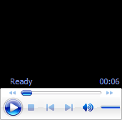

**Bug Id:**

POS_Search grid on the category page.

**Description:**

When the user attempts to search for a category on the record categories on the next pages, no search results are displayed.

**Steps to reproduce:**

1. Open the POS store software's URL.

2. Move to the category page from the header and search grid.

3. Enter the name of the category on the first (shown categories) to start the search.

4. Observe the results that appear.

5. Move to the next page categories and enter the name of the category you want to search.

6. Observe no result appears.

**Priority / Severity:**

Priority:Medium.

Severity:low.

**Environment:**

https://test-project-c6cd7.web.app/home

web browser (Google Chrome, Microsoft Edge).

Mobile (iPhone, Android).

**Expected Result:**

When the user moves to the category page and enters the name of the category on the search grid on the next page categories, the system should display the required results and provide information.

**Actual Result:**

When the user moves to the category page and enters the name of the category on the search grid on the next categories, the system does not appear any results.

**Attachment:**



**Bug Id:**

POS_Missing categories.

**Description:**

When the user opens the POS software all categories will be shown, but the issue is that when he opens the category page, not all categories are appearing on the displayed page and subsequent pages within the category grid.

**Steps to reproduce:**

1. Open the POS store software's URL.

2. Observe the categories shown on the POS page.

3. Move to the category page.

4. Observe the shown categories.

5. Attempt to move to the next page.

6. Observe all the categories and if there are missing ones.

**Priority / Severity:**

Priority:Medium.

Severity:Medium.

**Environment:**

https://test-project-c6cd7.web.app/home

web browser (Google Chrome, Microsoft Edge).

Mobile (iPhone, Android).

**Expected Result:**

When the user opens the POS software and moves to the category page, all categories which are shown on the home page should be visible on the displayed page or subsequent page.

**Actual Result:**

The categories which are shown on the home page does not visible on the displayed page or subsequent page on the category grid.

**Attachment:**



**Bug Id:**

POS_product grid.

**Description:**

When the user needs to add a product to the cart there is an equal icon appears and hides the price.

**Steps to reproduce:**

1. Open the POS store software.

2. Add a cart.

3. Choose a product to add to the cart.

4. Observe that if you hover the product's price equals icon appears and if you click it will add to the cart.

**Priority / Severity:**

Priority: Low.

Severity: Minor.

**Environment:**

https://test-project-c6cd7.web.app/home

web browser (Google Chrome, Microsoft Edge).

Mobile (iPhone, Android).

**Expected Result:**

When the user clicks on the product on the POS page it Should select to be in the cart.

**Actual Result:**

The user can add a product to the cart only when clicking on the equal icon that appears where the price is.

**Attachment:**



**Bug Id:**

Product_Add product.

**Description:**

When the user needs to add a product to the product grid when he needs to fill price and raw price fields the zero is still, and write a number beside it.

**Steps to reproduce:**

1. Open the POS store software.

2. Move to the product page.

3. Try to add a product.

4. Observe when you enter the price and raw price fields.

**Priority / Severity:**

Priority: Low.

Severity: Minor.

**Environment:**

https://test-project-c6cd7.web.app/home

web browser (Google Chrome, Microsoft Edge).

Mobile (iPhone, Android).

**Expected Result:**

When the user needs to add a product to the product grid, he needs to fill the price and raw price fields when he enters a number zero should be hidden.

**Actual Result:**

When the user needs to add a product to the product grid, he needs to fill the price and raw price fields when he enters a number the number written beside the zero.

**Attachment:**



**Bug Id:**

POS_edit category.

**Description:**

When the user attempts to edit a category name the system does not modify it in the product grid.

**Steps to reproduce:**

1. Open the POS store software.

2. Move to the category page.

3. Try to edit the name for any category.

4. Move to the product page and observe the category you edit.

**Priority / Severity:**

Priority:High.

Severity:Medium.

**Environment:**

https://test-project-c6cd7.web.app/home

web browser (Google Chrome, Microsoft Edge).

Mobile (iPhone, Android).

**Expected Result:**

When the user moves to the category page and edits the name of any category, then moves to the product page, the product in this category should be modified name according to what the user edited.

**Actual Result:**

When the user moves to the category page and edits the name of any category, then moves to the product page, the product in this category has the previous category name.

**Attachment:**

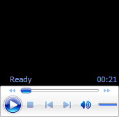

**Bug Id:**

POS_product's tax.

**Description:**

When a user selects a product and adds it to the cart in the POS store software, the applicable tax for the product is not displayed, and the tax amount is not calculated in the cart total.

**Steps to reproduce:**

1. Open the POS store software.

2. Add a cart.

3. Try to add a product to the cart.

4. Observe the product's tax and the total .

**Priority / Severity:**

Priority:High.

Severity:Medium.

**Environment:**

https://test-project-c6cd7.web.app/home

web browser (Google Chrome, Microsoft Edge).

Mobile (iPhone, Android).

**Expected Result:**

When the user adds a product to the cart, the appropriate tax for the selected product does not display in the product details. The tax amount should also be included in the calculation of the cart total.

**Actual Result:**

When the user adds a product to the cart, the appropriate tax for the selected product should be displayed in the product details. The tax amount is not calculated with the total.

**Attachment:**

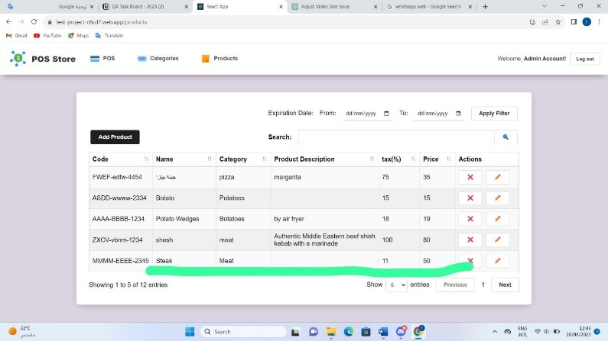

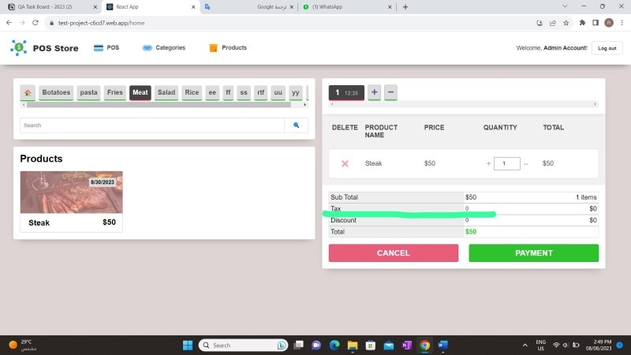

**Bug Id:**

The picture of the product.

**Description:**

When the user selects the picture of the product it appears, but it is hidden from the product details.

**Steps to reproduce:**

1. Open the POS store software.

2. Move to the product page.

3. Selects a picture for a product.

4. Observe the picture on the POS page.

5. Return again to the product page and observe the picture file.

**Priority / Severity:**

Priority: Low.

Severity: Minor.

**Environment:**

https://test-project-c6cd7.web.app/home

web browser (Google Chrome, Microsoft Edge).

Mobile (iPhone, Android).

**Expected Result:**

When the user needs to add a product to the product grid, he needs to select a picture for it, and it is a required field but after he adds it and displayed it on the POS page it should still be on the product details.

**Actual Result:**

When the user needs to add a product to the product grid, he needs to select a picture for it, and it is a required field but after he adds it and displayed it on the POS page it is hidden from product details.

**Attachment:**

