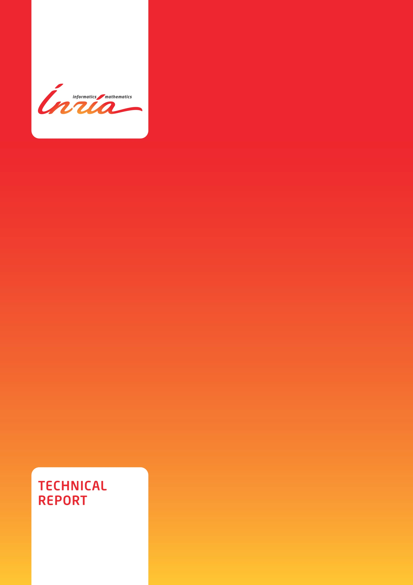

ISSN 0249-6399

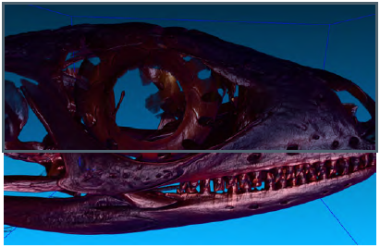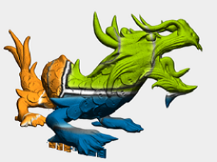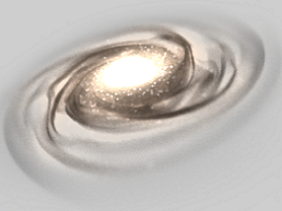

**GigaSpace Rendering Management**

Pascal Guehl , Fabrice Neyret

**N° 9999**

23/12/2012

Project-Team Maverick

**GigaSpace Rendering Management**

**Pascal Guehl****[1]** , Fabrice Neyret [2]

Project-Teams Maverick

Technical Report N° 9999 — 23/12/2012 —99 pages.

**Abstract:** This the programming guide of the GigaVoxels library.

**Key-words:** insérez ici les mots-clés en anglais



**GigaSpace Rendering Management**

**Résumé :** This is the GigaVoxels library programming guide for developers. It is an deep insight for make benefit glorious nation of voxels worshipers.

**Mots clés :** insérez ici les mots-clés en français

Contenu

I. Introduction 6

II. GigaVoxels 7

III. GigaSpace 9

IV. CUDA vs OpenGL vs GLSL 10

V. History and roots of GigaVoxels 11

Conclusion 22

Bibliography 23

1. Introduction

…

1. About this document

This document explains what is GigaVoxels, its philosophy, its origin and how it extends to GigaSpace.

1. GigaVoxels

GPU Computing

You probably also want to add a user-defined voxel shader to tweak the data on the fly or simply to tune

Stackless

1. Rendering to texture
2. Handling scene Color and Depth

Graphics Library

GLSL Renderer

Proxy Geometry

Hybrid

Optimization

ancestor



# Conclusion

…

# 

# Bibliography

[] “An Efficient and Robust Ray–Box Intersection Algorithm”, Amy Williams Steve Barrus R. Keith Morley Peter Shirley, University of Utah

[] “Understanding the Efficiency of Ray Traversal on GPUs – Kepler and Fermi Addendum, Timo Aila, Samuli Laine, Tero Karras, NVIDIA Research



Publisher

Inria

Domaine de Voluceau - Rocquencourt

BP 105 - 78153 Le Chesnay Cedex

inria.fr

ISSN 0249-6399

1. Pascal Guehl affiliation – pascal.guehl@inria.fr
2. Fabrice Neyret affiliation – fabrice.neyret@inria.fr