GigaVoxels

# Configuration System : GPU / Cuda / OpenGL / System

|  |  |
| --- | --- |
|  |  |
|  |  |

Datasets

# Aneurism – 256x256x256 – unsigned char (8 bits)

Rotational C-arm x-ray scan of the arteries of the right half of a human head. A contrast agent was injected into the blood and an aneurism is present.

Source : <http://www.gris.uni-tuebingen.de/edu/areas/scivis/volren/datasets/datasets.html>

Size / content / spacing : 256 x 256 x 256 - unsigned char (8 bits) – 1:1:1

Window Size : 1900 x 1069

## View of the octree

|  |  |
| --- | --- |
|  |  |

## FPS

(left to right) : 29 - 57 – 126

|  |  |  |
| --- | --- | --- |
|  |  |  |

Node Pool : 8 Mo

Data Pool : 256 Mo

# Head Aneuyrism – 512x512x512 – unsigned short (16 bits)

Source : <http://www.gris.uni-tuebingen.de/edu/areas/scivis/volren/datasets/new.html>

Size / content / spacing : 512 x 512 x 512 - unsigned short (16 bits) – 0.1953, 0.1953, 0.1953

Note : 12 bits set

Rotational angiography scan of a head with an aneurysm. Only contrasted blood vessels are visible.

Window Size : 1900 x 1069

## View of the octree

Without thresholding, we have bad octree due to noise.

|  |  |
| --- | --- |
|  |  |

We can use thresholding at run-time, but the associated octree remains the same. (more threshold on right)

|  |  |
| --- | --- |
|  |  |

If we use thresholding during mipmap-pyramid construction, we have better octree. But it’s not interactive, it’s a long process done manually. It may be done automatically with an histogram ?

|  |  |
| --- | --- |
|  |  |

## FPS

(left to right) : 34 - 72 – 189

|  |  |  |
| --- | --- | --- |
|  |  |  |

Node Pool : 8 Mo

Data Pool : 512 Mo

# Foot – 256x256x256 – unsigned char (8 bits)

Rotational C-arm x-ray scan of a human foot. Tissue and bone are present in the dataset.

Source : <http://www.gris.uni-tuebingen.de/edu/areas/scivis/volren/datasets/datasets.html>

Size / content / spacing : 256 x 256 x 256 - unsigned char (8 bits) – 1:1:1

Window Size : 1900 x 1069

## View of the octree

Without thresholding, we have bad octree due to noise.

|  |  |
| --- | --- |
|  |  |

We can use thresholding at run-time, but the associated octree remains the same. (more threshold on right)

|  |  |
| --- | --- |
|  |  |

If we use alpha in transfer function in real-time, we can remove skin on bones.

|  |  |
| --- | --- |
|  |  |
|  |  |
|  |  |

## FPS

(left to right) : 9 - 20 – 62 - 324

|  |  |
| --- | --- |
|  |  |
|  |  |

Node Pool : 8 Mo

Data Pool : 256 Mo

Exemple 3D

512x512x512 - “unsigned char 4” : rgb+a (4 components color)

Normals are computed at real-time for shading (appearence) by central finite differences (6 neighbors)

Window Size : 1900 x 1069

FPS : 15 – 25 – 79 – 354 – 597 – 666 (as distance to viewer increase)

|  |  |
| --- | --- |
|  |  |
|  |  |
|  |  |

Node Pool : 8 Mo (cache de neouds spatiaux)

Data Pool : 256 Mo (cache de données : “voxels” )

Tools

# Viewer – Customizable editor

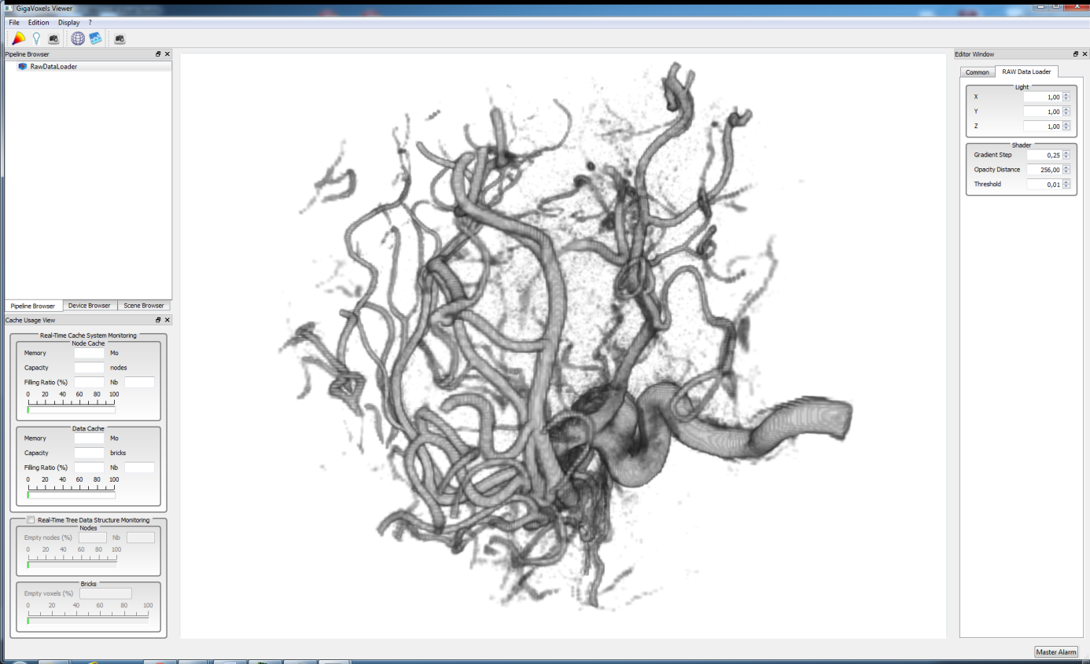

# Customizable Transfer Function Editor

RGB + A

But customizable

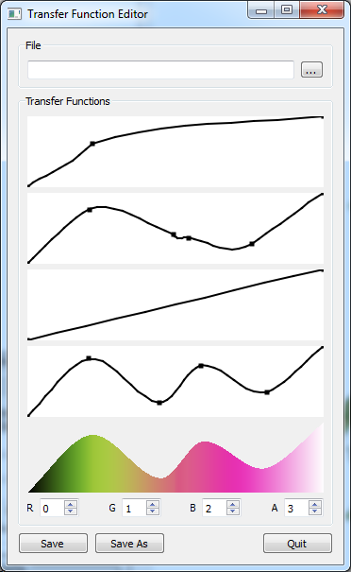

Features

# Producers

Only N3-tree (octrees, etc) => same size and same spacing

# Renderer

Other

# Limitations

Only N3-tree (octrees, etc) => same size and same spacing