My first unit test.

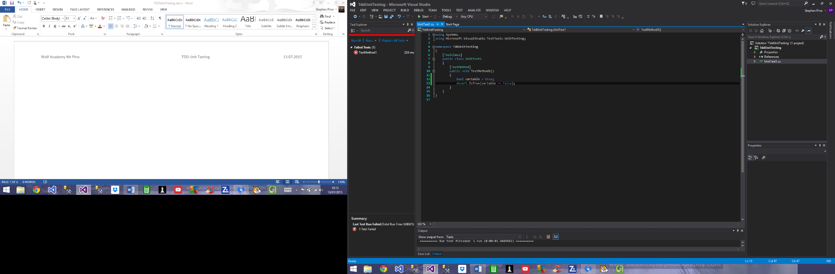

My first passed test run. False is equal to false is True.

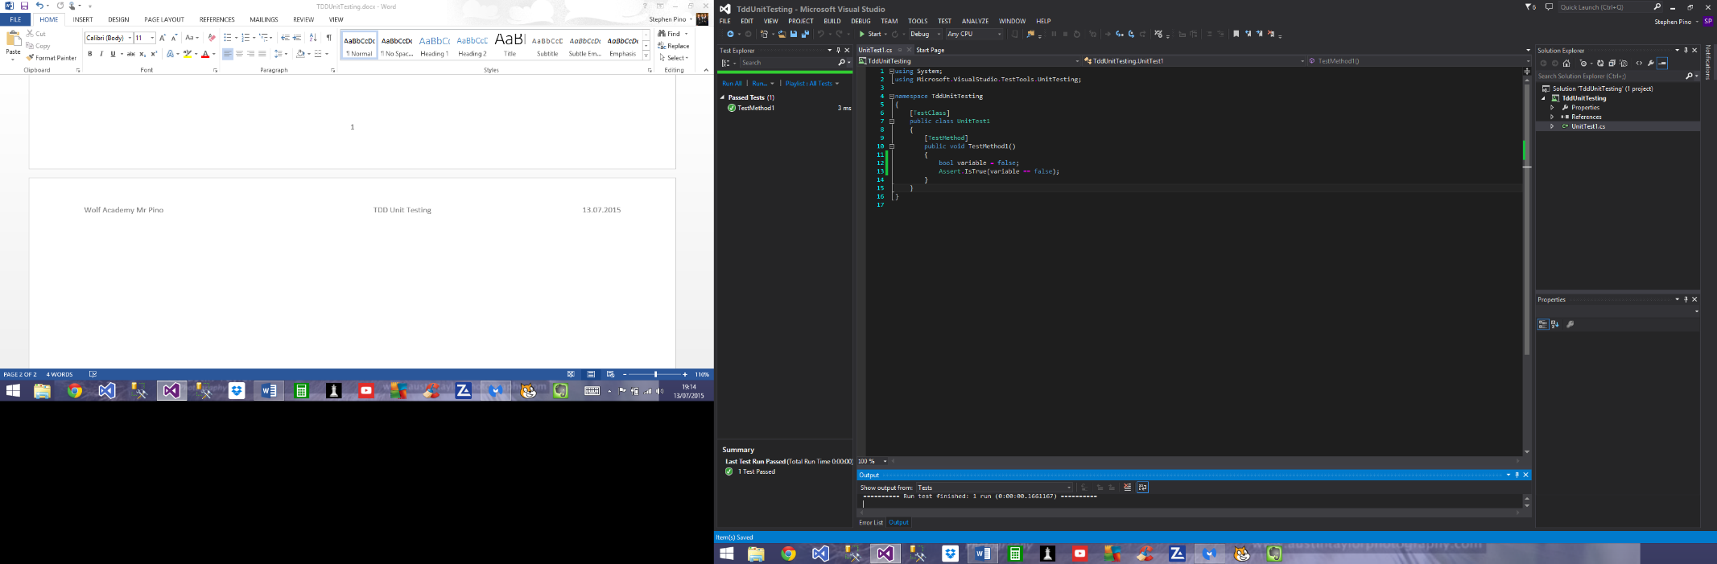

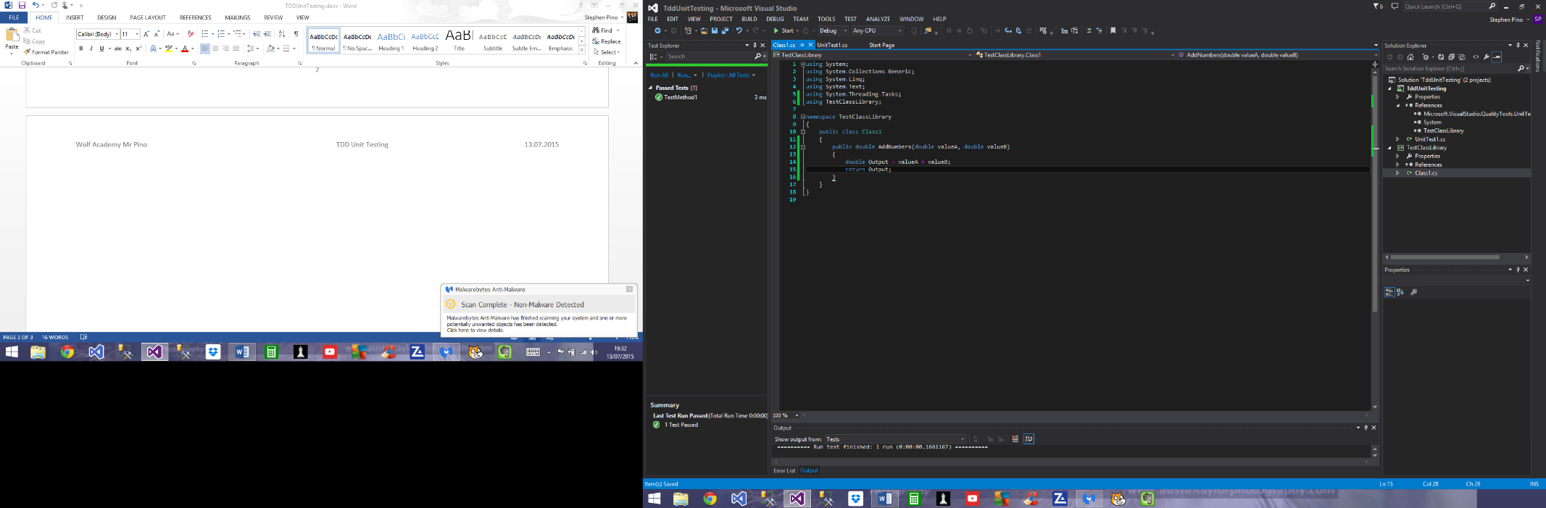Test Class created and reference to the class added including the using statement within the Class library code list.

Test failed due to output being more than 10.

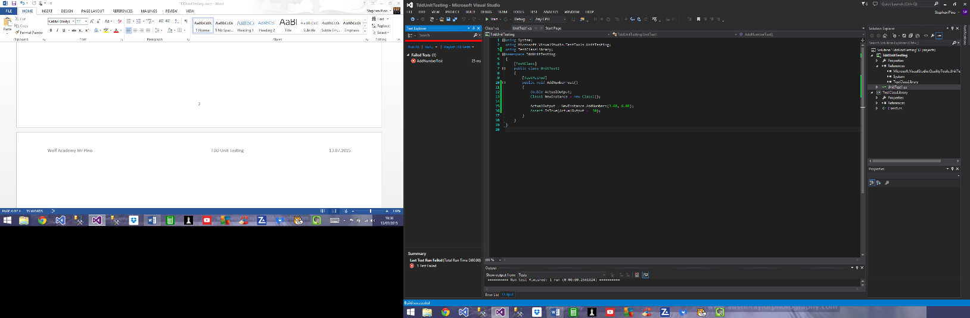

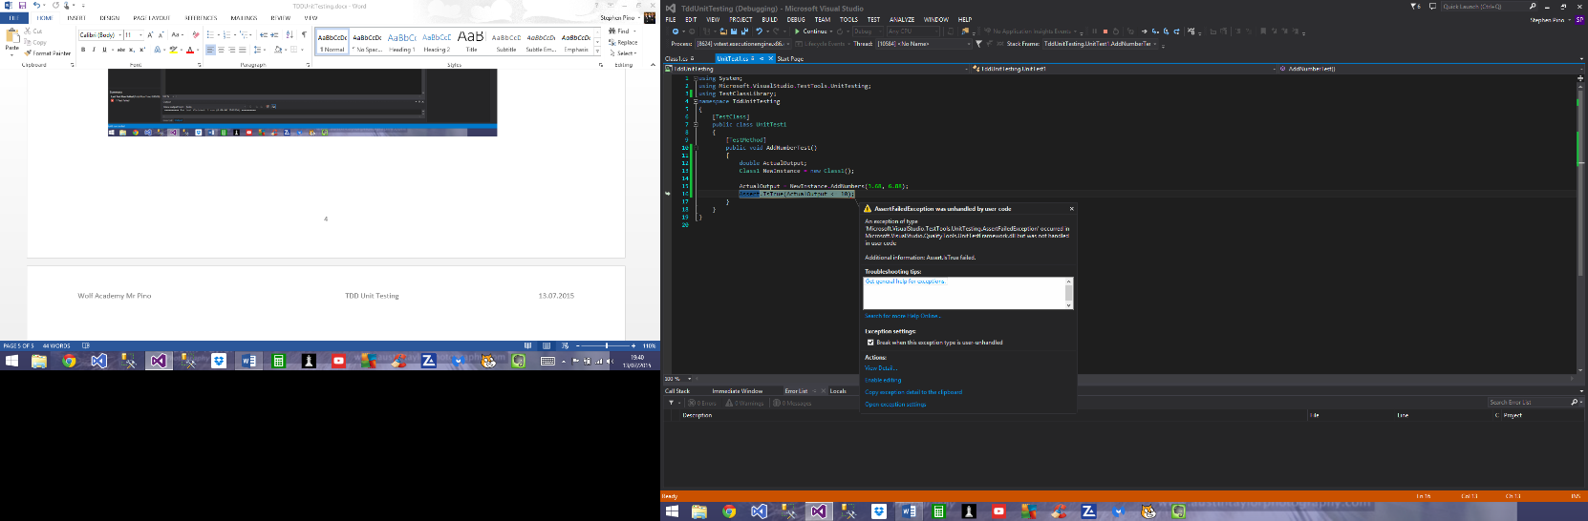

If statement added to TestClassLibrary and it now passes with flying colours.

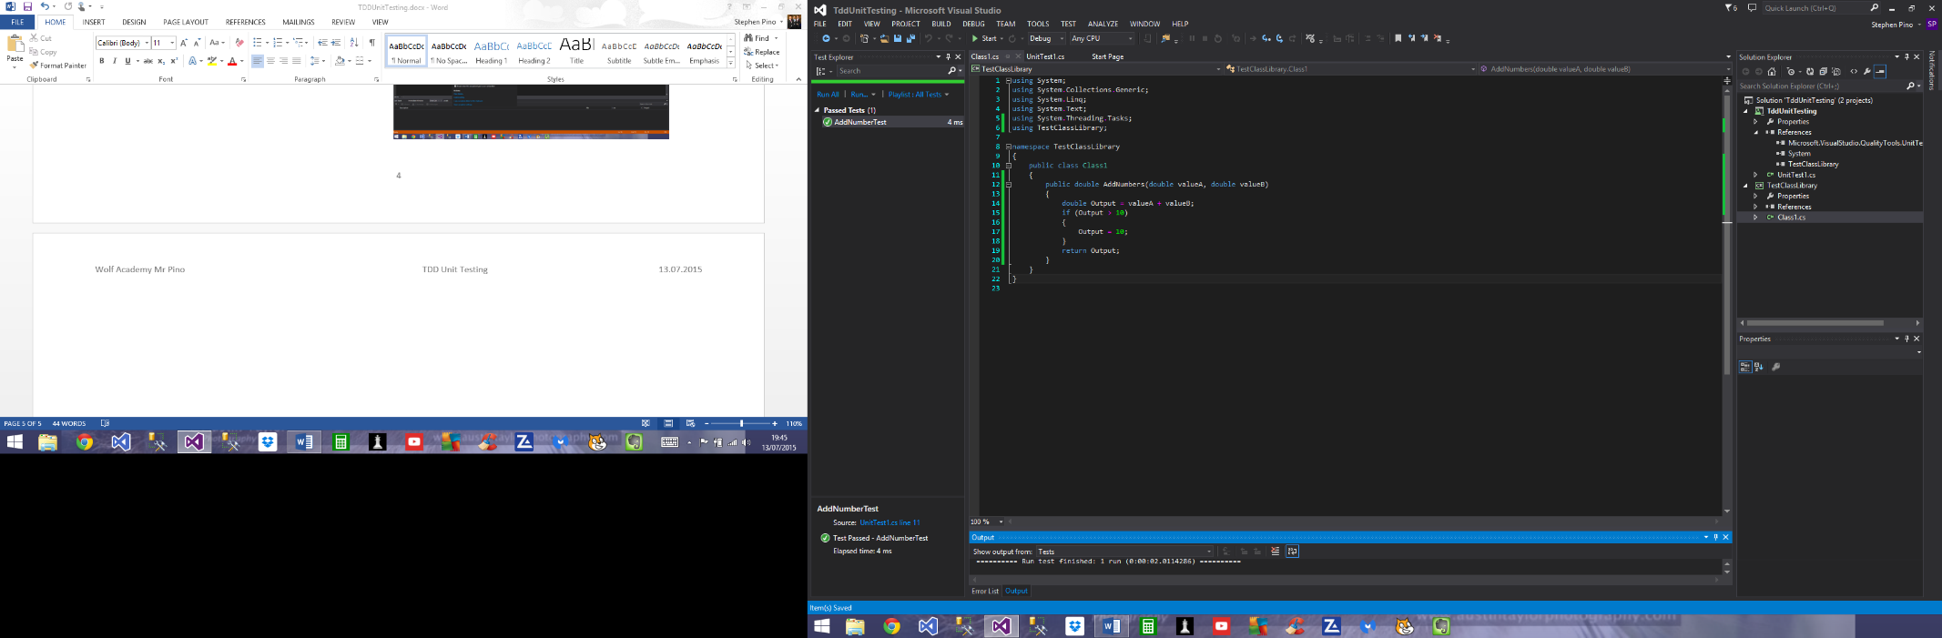

Building a Method Based on requirements:

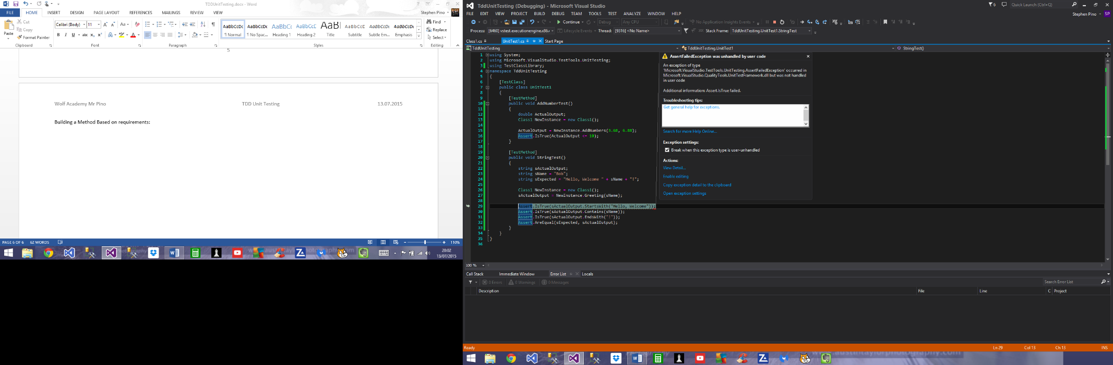

All Tests passed:

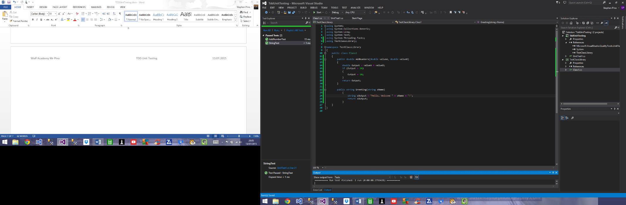

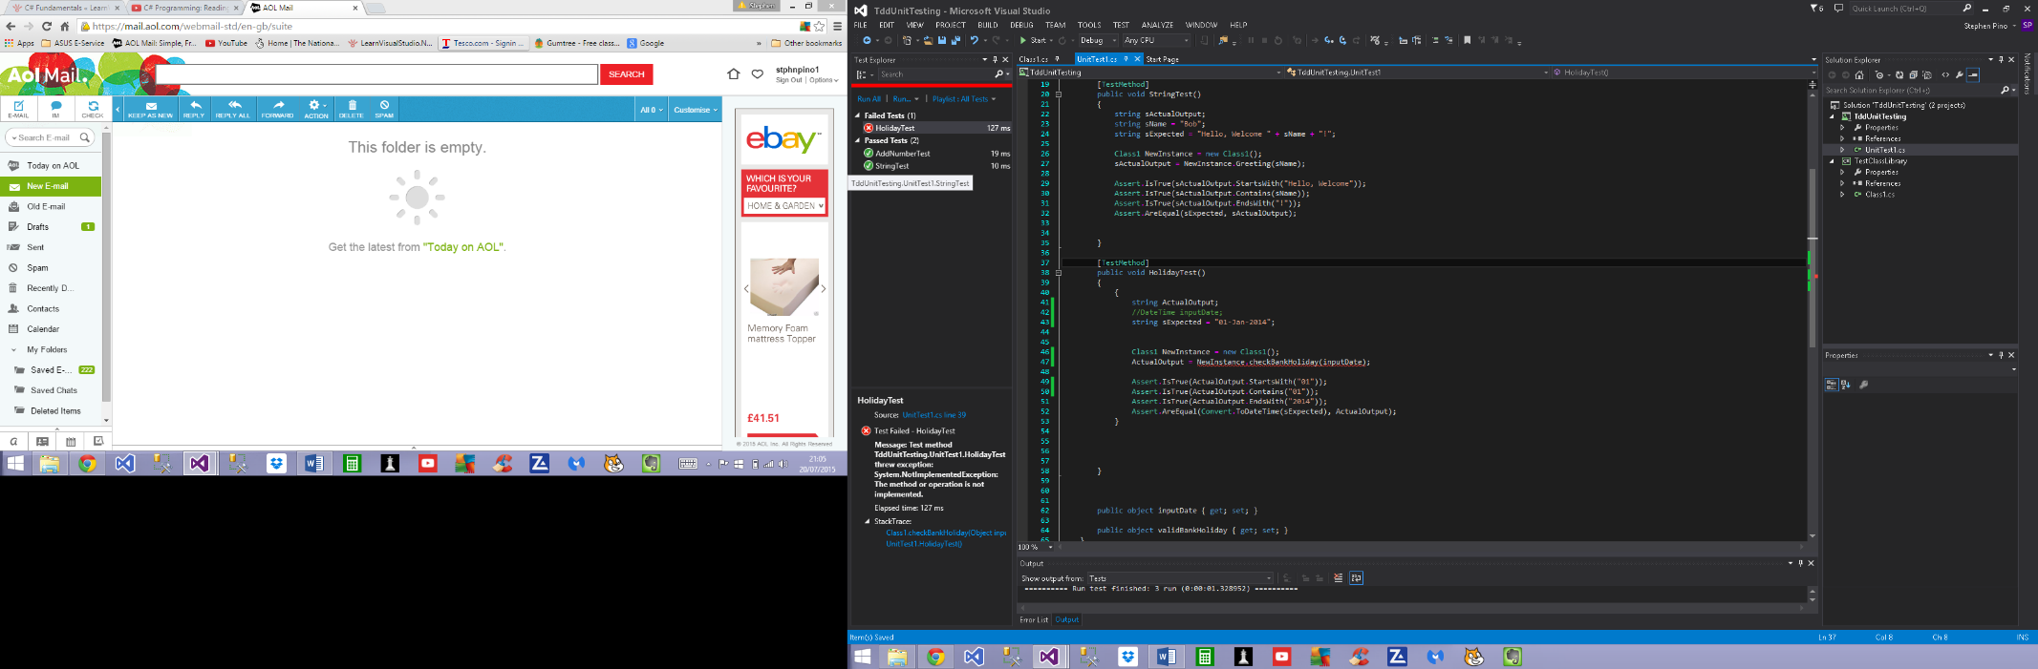

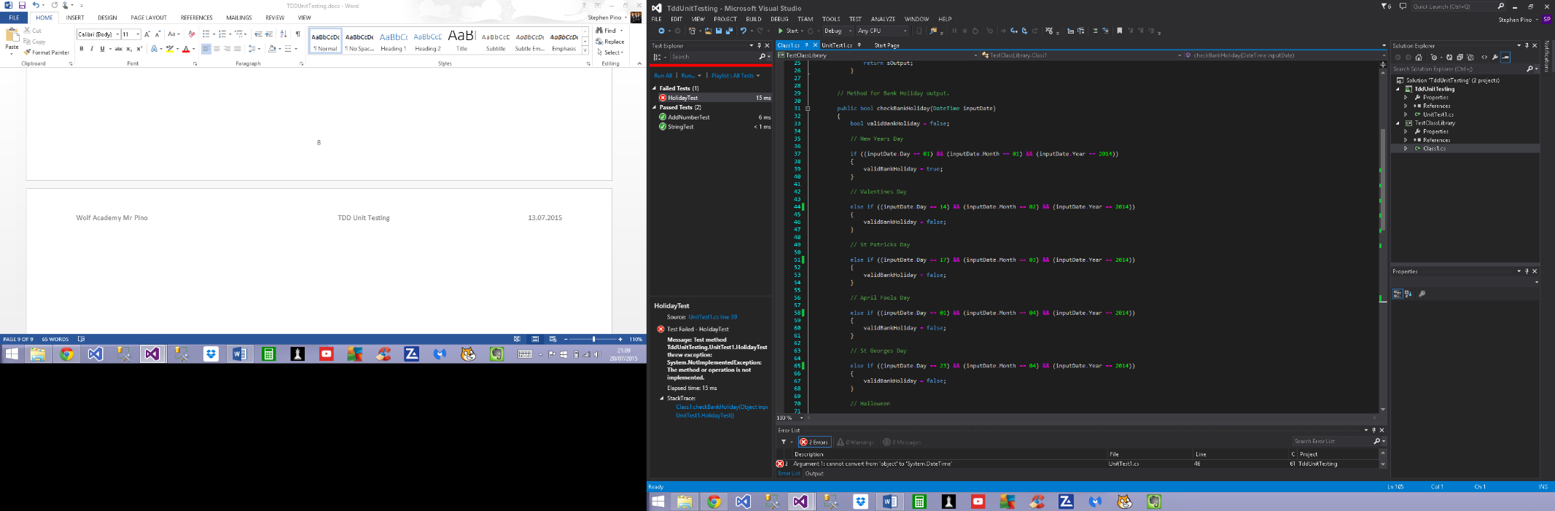Updated the method

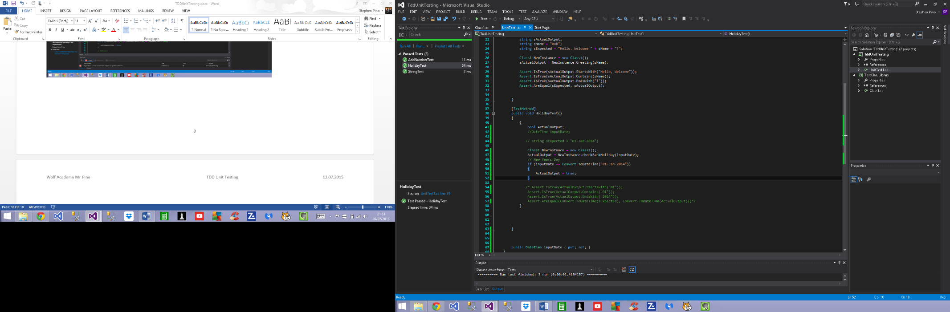After trying different ways of testing here is where I’m at: