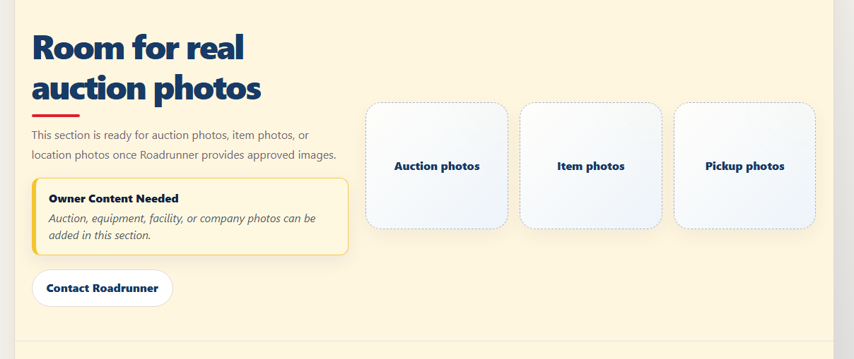
Home- images of your auctions

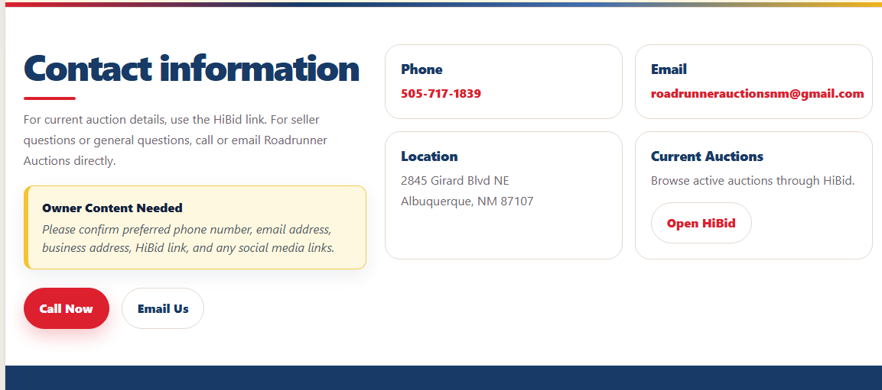
Contact – verify this is the correct phone and email you wanna use and I can add social medias to this page as well if you have any you would like to display.

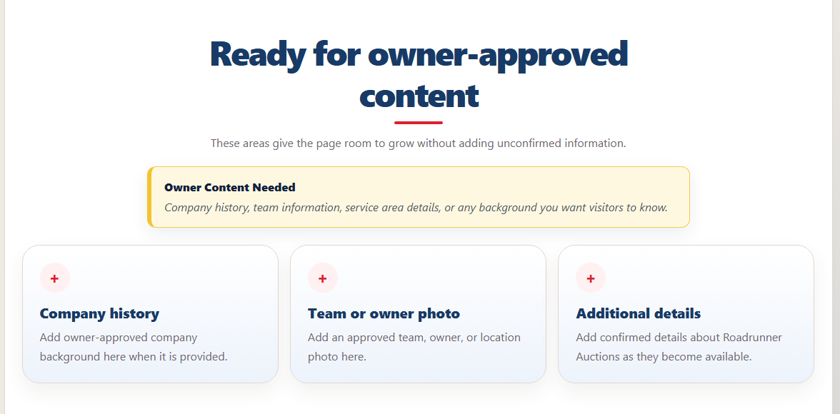
About- we could use some addition info and photos of your team and place of business, maybe we can talk about years of experience and history in abq here

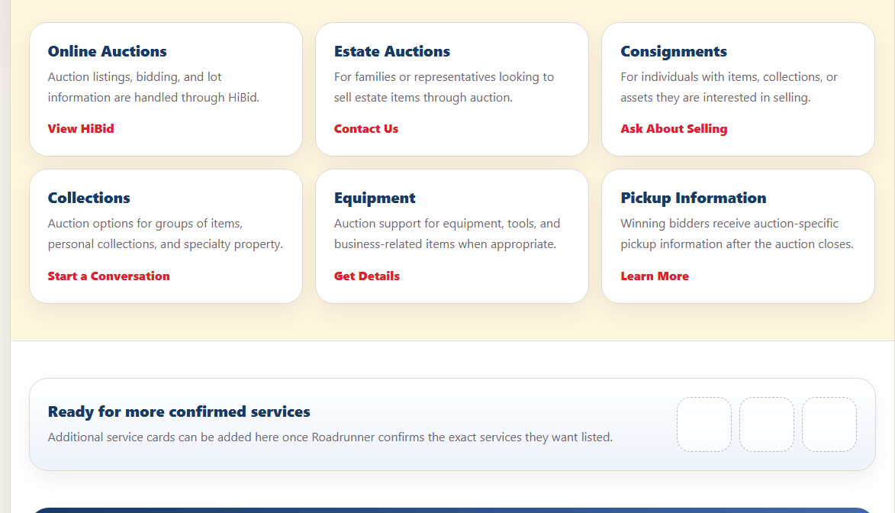
Servoices – just want to verify these are all the services make sure I didn’t miss anything

