并行计算程序设计（双语）

作业报告

学生：王磊

学号：202231060435

课程作业三 并行计算模式-规约与扫描
（一）目的
1) 熟悉基本的CUDA内存架构和编程架构；
2）掌握规约和扫描两种并行计算模式。

（二）内容
任务描述：
1）使用规约算法实现二维矩阵按行求和
实现二维矩阵按行求和，输入的原始二维数组如图1(a)所示。然后沿x轴方向并行规约求和得到图1(b)所示结果。参考A Basic Reduction Kernel和A Better Reduction Kernel实现两种不同的核函数并对比计算时间。
* 提示：可以利用每个线程块处理一行的求和
要求：原始输入的二维数组大小为1024*1024，数组中所有元素的初始值为1。
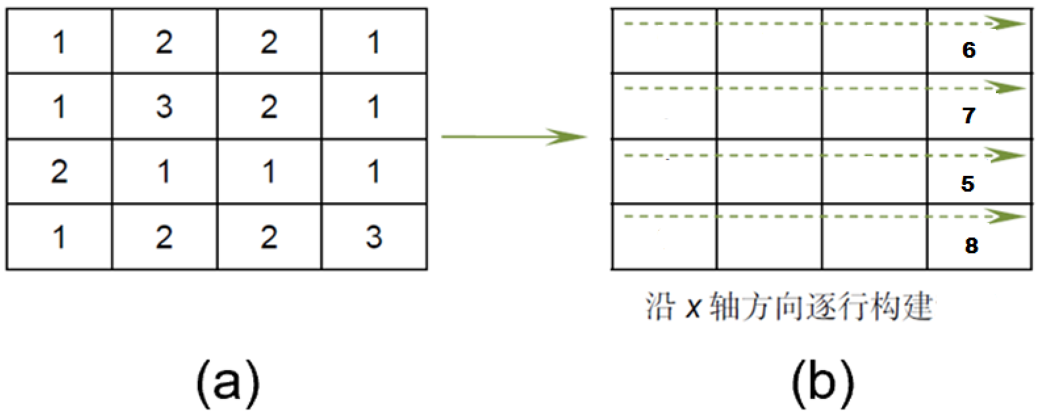
图1 按x轴方向求和示意图
2）使用扫描算法实现二维和表的计算
实现二维和表的计算，输入的原始二维数组如图2(a)所示。构建和表之前，首先需要对原始二维数组的每一个数据进行平方；然后先沿x轴方向扫描（前缀和）得到图2(b)所示结果，最后再沿y轴方向扫描得到如图2(c)所示。
参考A Work-Inefficient Inclusive Scan Kernel和A Work-Efficient kernel:

实现两种不同的核函数并对比计算时间。
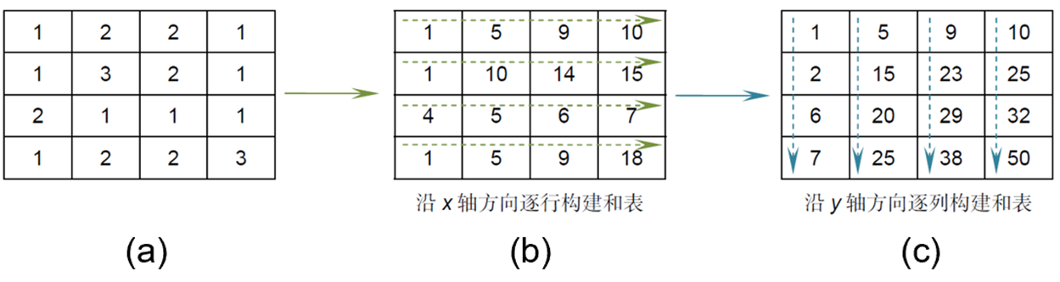
图2 和表的并行扫描构建

* 要求：原始输入的二维数组大小为1024*1024，数组中所有元素的初始值为1。

步骤一 列出任务1的CPU代码和两种GPU代码及运行时间结果
CPU核心代码：
void cpuRowSum(int *input, int *output, int width, int height) {
for (int row = 0; row < height; row++) {
int sum = 0;
for (int col = 0; col < width; col++) {
sum += input[row * width + col];
}
output[row] = sum;
}
}

Basic_Gpu核心代码:
__global__ void basicReductionKernel(int *input, int *output, int width) {
extern __shared__ int partialSum[];
unsigned int t = threadIdx.x;
unsigned int row = blockIdx.x;

partialSum[t] = input[row * width + t];
__syncthreads();

for (unsigned int stride = 1; stride < blockDim.x; stride *= 2) {
__syncthreads();
if (t % (2 * stride) == 0) {
partialSum[t] += partialSum[t + stride];
}
}

if (t == 0) {
output[row] = partialSum[0];
}
}

Better_Gpu核心代码:
__global__ void betterReductionKernel(int *input, int *output, int width) {
extern __shared__ int partialSum[];
unsigned int t = threadIdx.x;
unsigned int row = blockIdx.x;

partialSum[t] = input[row * width + t];
__syncthreads();

for (unsigned int stride = blockDim.x / 2; stride > 0; stride /= 2) {
__syncthreads();
if (t < stride) {
partialSum[t] += partialSum[t + stride];
}
}

if (t == 0) {
output[row] = partialSum[0];
}
}

完整代码:
#include <iostream>
#include <chrono>
#include <cuda_runtime.h>

#define WIDTH 1024
#define HEIGHT 1024

// CPU版本的按行求和
void cpuRowSum(int *input, int *output, int width, int height) {
for (int row = 0; row < height; row++) {
int sum = 0;
for (int col = 0; col < width; col++) {
sum += input[row * width + col];
}
output[row] = sum;
}
}

// 基本规约核函数
__global__ void basicReductionKernel(int *input, int *output, int width) {
extern __shared__ int partialSum[];
unsigned int t = threadIdx.x;
unsigned int row = blockIdx.x;

partialSum[t] = input[row * width + t];
__syncthreads();

for (unsigned int stride = 1; stride < blockDim.x; stride *= 2) {
__syncthreads();
if (t % (2 * stride) == 0) {
partialSum[t] += partialSum[t + stride];
}
}

if (t == 0) {
output[row] = partialSum[0];
}
}

// 改进的规约核函数
__global__ void betterReductionKernel(int *input, int *output, int width) {
extern __shared__ int partialSum[];
unsigned int t = threadIdx.x;
unsigned int row = blockIdx.x;

partialSum[t] = input[row * width + t];
__syncthreads();

for (unsigned int stride = blockDim.x / 2; stride > 0; stride /= 2) {
__syncthreads();
if (t < stride) {
partialSum[t] += partialSum[t + stride];
}
}

if (t == 0) {
output[row] = partialSum[0];
}
}

int main() {
int *h_input, *h_output_cpu, *h_output_gpu;
int *d_input, *d_output;
size_t size = WIDTH * HEIGHT * sizeof(int);

// 分配主机内存
h_input = (int *)malloc(size);
h_output_cpu = (int *)malloc(HEIGHT * sizeof(int));
h_output_gpu = (int *)malloc(HEIGHT * sizeof(int));

// 初始化主机数组
for (int i = 0; i < WIDTH * HEIGHT; i++) {
h_input[i] = 1;
}

// CPU版本计算
auto start_cpu = std::chrono::high_resolution_clock::now();
cpuRowSum(h_input, h_output_cpu, WIDTH, HEIGHT);
auto end_cpu = std::chrono::high_resolution_clock::now();
std::chrono::duration<double> cpu_duration = end_cpu - start_cpu;
std::cout << "CPU Time: " << cpu_duration.count() * 1000 << " ms" << std::endl;

// 输出CPU结果（前10行）
std::cout << "Partial results after CPU reduction (first 10 rows):" << std::endl;
for (int i = 0; i < 10; i++) {
std::cout << "Row " << i << ": " << h_output_cpu[i] << std::endl;
}

// 分配设备内存
cudaMalloc(&d_input, size);
cudaMalloc(&d_output, HEIGHT * sizeof(int));

// 将数据拷贝到设备
cudaMemcpy(d_input, h_input, size, cudaMemcpyHostToDevice);

// 定义块和网格大小
dim3 blockSize(WIDTH);
dim3 gridSize(HEIGHT);

// 创建CUDA事件用于计时
cudaEvent_t start, stop;
cudaEventCreate(&start);
cudaEventCreate(&stop);

// 启动基本规约核函数
cudaEventRecord(start);
basicReductionKernel<<<gridSize, blockSize, WIDTH * sizeof(int)>>>(d_input, d_output, WIDTH);
cudaEventRecord(stop);
cudaEventSynchronize(stop);

float milliseconds = 0;
cudaEventElapsedTime(&milliseconds, start, stop);
std::cout << "Basic Reduction Kernel Time: " << milliseconds << " ms" << std::endl;

// 将结果拷贝回主机
cudaMemcpy(h_output_gpu, d_output, HEIGHT * sizeof(int), cudaMemcpyDeviceToHost);

// 输出GPU结果（前10行）
std::cout << "Partial results after basic reduction (first 10 rows):" << std::endl;
for (int i = 0; i < 10; i++) {
std::cout << "Row " << i << ": " << h_output_gpu[i] << std::endl;
}

// 启动改进的规约核函数
cudaEventRecord(start);
betterReductionKernel<<<gridSize, blockSize, WIDTH * sizeof(int)>>>(d_input, d_output, WIDTH);
cudaEventRecord(stop);
cudaEventSynchronize(stop);

cudaEventElapsedTime(&milliseconds, start, stop);
std::cout << "Better Reduction Kernel Time: " << milliseconds << " ms" << std::endl;

// 将结果拷贝回主机
cudaMemcpy(h_output_gpu, d_output, HEIGHT * sizeof(int), cudaMemcpyDeviceToHost);

// 输出GPU结果（前10行）
std::cout << "Partial results after better reduction (first 10 rows):" << std::endl;
for (int i = 0; i < 10; i++) {
std::cout << "Row " << i << ": " << h_output_gpu[i] << std::endl;
}

// 释放内存
free(h_input);
free(h_output_cpu);
free(h_output_gpu);
cudaFree(d_input);
cudaFree(d_output);

// 销毁CUDA事件
cudaEventDestroy(start);
cudaEventDestroy(stop);

return 0;
}
运行结果及时间：
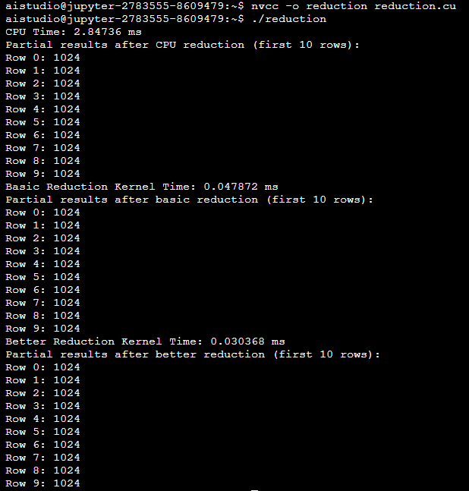

步骤二 列出任务2的CPU代码和两种GPU代码及运行时间结果
CPU：
#include <iostream>
#include <vector>
#include <chrono> // 用于计时

const int SIZE = 1024;

int main() {
// 初始化二维数组，所有元素为1
std::vector<std::vector<int>> array(SIZE, std::vector<int>(SIZE, 1));

// 开始计时
auto start = std::chrono::high_resolution_clock::now();

// 对每个元素进行平方操作
for (int i = 0; i < SIZE; ++i) {
for (int j = 0; j < SIZE; ++j) {
array[i][j] = array[i][j] * array[i][j];
}
}

// 沿x轴方向计算前缀和
for (int i = 0; i < SIZE; ++i) {
for (int j = 1; j < SIZE; ++j) {
array[i][j] += array[i][j - 1];
}
}

// 沿y轴方向计算前缀和
for (int j = 0; j < SIZE; ++j) {
for (int i = 1; i < SIZE; ++i) {
array[i][j] += array[i - 1][j];
}
}

// 结束计时
auto end = std::chrono::high_resolution_clock::now();

// 计算执行时间
std::chrono::duration<double> elapsed = end - start;
std::cout << "Execution time: " << elapsed.count() * 1000<< " ms" << std::endl;

// 输出结果（可选，仅用于调试）
// std::cout << "2D Prefix Sum (first 5x5):" << std::endl;
for (int i = 0; i < 10; ++i) { // 仅打印前5行和前5列
for (int j = 0; j < 10; ++j) {
std::cout << array[i][j] << " ";
}
std::cout << std::endl;
}

return 0;
}
执行结果：
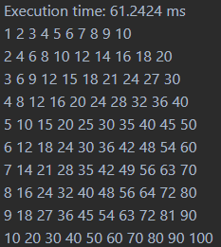
Work-Inefficient_Gpu:
#include <iostream>
#include <cuda_runtime.h>
#include <device_launch_parameters.h>

#define SECTION_SIZE 1024
#define BLOCK_SIZE 32

__global__ void work_inefficient_scan_kernel(float *X, float *Y, int width, int height) {
__shared__ float XY[SECTION_SIZE];
int x = blockIdx.x * blockDim.x + threadIdx.x;
int y = blockIdx.y * blockDim.y + threadIdx.y;
int i = y * width + x;

if (x < width && y < height) {
XY[threadIdx.y * blockDim.x + threadIdx.x] = X[i] * X[i]; // Square the element
}
__syncthreads();

// Perform scan along x-axis
for (unsigned int stride = 1; stride < blockDim.x; stride *= 2) {
if (threadIdx.x >= stride) {
float in1 = XY[threadIdx.y * blockDim.x + threadIdx.x - stride];
__syncthreads();
XY[threadIdx.y * blockDim.x + threadIdx.x] += in1;
}
__syncthreads();
}

// Perform scan along y-axis
for (unsigned int stride = 1; stride < blockDim.y; stride *= 2) {
if (threadIdx.y >= stride) {
float in1 = XY[(threadIdx.y - stride) * blockDim.x + threadIdx.x];
__syncthreads();
XY[threadIdx.y * blockDim.x + threadIdx.x] += in1;
}
__syncthreads();
}

if (x < width && y < height) {
Y[i] = XY[threadIdx.y * blockDim.x + threadIdx.x];
}
}

int main() {
const int width = 1024;
const int height = 1024;
const int size = width * height;
const int bytes = size * sizeof(float);

float *h_X = (float*)malloc(bytes);
float *h_Y = (float*)malloc(bytes);

// Initialize the array with 1.0f
for (int i = 0; i < size; i++) {
h_X[i] = 1.0f;
}

float *d_X, *d_Y;
cudaMalloc(&d_X, bytes);
cudaMalloc(&d_Y, bytes);

cudaMemcpy(d_X, h_X, bytes, cudaMemcpyHostToDevice);

dim3 blockSize(BLOCK_SIZE, BLOCK_SIZE);
dim3 gridSize((width + blockSize.x - 1) / blockSize.x, (height + blockSize.y - 1) / blockSize.y);

cudaEvent_t start, stop;
cudaEventCreate(&start);
cudaEventCreate(&stop);

cudaEventRecord(start);
work_inefficient_scan_kernel<<<gridSize, blockSize>>>(d_X, d_Y, width, height);
cudaEventRecord(stop);

cudaMemcpy(h_Y, d_Y, bytes, cudaMemcpyDeviceToHost);

cudaEventSynchronize(stop);
float milliseconds = 0;
cudaEventElapsedTime(&milliseconds, start, stop);

std::cout << "Time taken: " << milliseconds << " ms" << std::endl;

// Print some results
for (int y = 0; y < 10; y++) {
for (int x = 0; x < 10; x++) {
std::cout << h_Y[y * width + x] << " ";
}
std::cout << std::endl;
}

free(h_X);
free(h_Y);
cudaFree(d_X);
cudaFree(d_Y);

return 0;
}
执行结果：
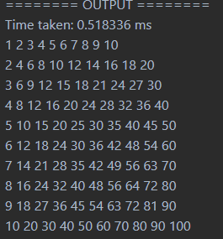
Work-Efficient_Gpu:
#include <iostream>
#include <cuda_runtime.h>
#include <device_launch_parameters.h>

#define BLOCK_SIZE 32
#define WIDTH 1024
#define HEIGHT 1024

// Kernel for Hillis-Steele Scan along rows (x-axis)
__global__ void scan_rows(float *X, float *Y, int width, int height) {
__shared__ float temp[BLOCK_SIZE][BLOCK_SIZE + 1]; // Shared memory for each block
int row = blockIdx.y * blockDim.y + threadIdx.y;
int col = blockIdx.x * blockDim.x + threadIdx.x;

if (row < height && col < width) {
// Load data into shared memory
temp[threadIdx.y][threadIdx.x] = X[row * width + col];
__syncthreads();

// Hillis-Steele Scan
for (int stride = 1; stride < BLOCK_SIZE; stride *= 2) {
if (threadIdx.x >= stride) {
temp[threadIdx.y][threadIdx.x] += temp[threadIdx.y][threadIdx.x - stride];
}
__syncthreads();
}

// Write back to global memory
Y[row * width + col] = temp[threadIdx.y][threadIdx.x];
}
}

// Kernel for Hillis-Steele Scan along columns (y-axis)
__global__ void scan_columns(float *X, float *Y, int width, int height) {
__shared__ float temp[BLOCK_SIZE][BLOCK_SIZE + 1]; // Shared memory for each block
int row = blockIdx.y * blockDim.y + threadIdx.y;
int col = blockIdx.x * blockDim.x + threadIdx.x;

if (row < height && col < width) {
// Load data into shared memory
temp[threadIdx.x][threadIdx.y] = X[row * width + col];
__syncthreads();

// Hillis-Steele Scan
for (int stride = 1; stride < BLOCK_SIZE; stride *= 2) {
if (threadIdx.y >= stride) {
temp[threadIdx.x][threadIdx.y] += temp[threadIdx.x][threadIdx.y - stride];
}
__syncthreads();
}

// Write back to global memory
Y[row * width + col] = temp[threadIdx.x][threadIdx.y];
}
}

int main() {
const int width = WIDTH;
const int height = HEIGHT;
const int size = width * height;
const int bytes = size * sizeof(float);

float *h_X = (float*)malloc(bytes);
float *h_Y = (float*)malloc(bytes);

// Initialize the array with 1.0f
for (int i = 0; i < size; i++) {
h_X[i] = 1.0f;
}

float *d_X, *d_Y;
cudaMalloc(&d_X, bytes);
cudaMalloc(&d_Y, bytes);

cudaMemcpy(d_X, h_X, bytes, cudaMemcpyHostToDevice);

dim3 blockSize(BLOCK_SIZE, BLOCK_SIZE);
dim3 gridSize((width + blockSize.x - 1) / blockSize.x, (height + blockSize.y - 1) / blockSize.y);

cudaEvent_t start, stop;
cudaEventCreate(&start);
cudaEventCreate(&stop);

cudaEventRecord(start);

// Step 1: Square each element
cudaMemcpy(d_Y, d_X, bytes, cudaMemcpyDeviceToDevice); // Copy X to Y
scan_rows<<<gridSize, blockSize>>>(d_Y, d_Y, width, height); // Scan along rows
scan_columns<<<gridSize, blockSize>>>(d_Y, d_Y, width, height); // Scan along columns

cudaEventRecord(stop);
cudaEventSynchronize(stop);

float milliseconds = 0;
cudaEventElapsedTime(&milliseconds, start, stop);

std::cout << "Time taken: " << milliseconds << " ms" << std::endl;

// Copy results back to host
cudaMemcpy(h_Y, d_Y, bytes, cudaMemcpyDeviceToHost);

// Print some results
for (int y = 0; y < 10; y++) {
for (int x = 0; x < 10; x++) {
std::cout << h_Y[y * width + x] << " ";
}
std::cout << std::endl;
}

free(h_X);
free(h_Y);
cudaFree(d_X);
cudaFree(d_Y);

return 0;
}
执行结果：
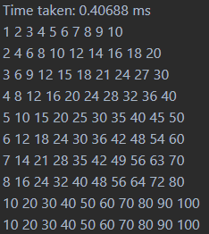

结论：
计算时间:
扫描算法：
0.40688ms(优化后) < 0.518336 ms(优化前) << 61.2424ms(CPU)

规约算法：
0.030368ms(better) < 0.047872ms(basic) << 2.84736ms(CPU)

结论：
- 规约：
- GPU版本的规约算法明显优于CPU版本，执行时间减少了约两个数量级。
- Better GPU版本比Basic GPU版本进一步优化，执行时间减少了约36%。这表明改进后的规约算法在并行计算中更加高效。
- 扫描：
- GPU版本的扫描算法同样显著优于CPU版本，执行时间减少了约两个数量级。
- Work-Efficient GPU版本比Work-Inefficient GPU版本更快，执行时间减少了约21%。这表明优化后的扫描算法在并行计算中更加高效。

总结：
GPU并行计算在处理大规模数据时具有显著优势，尤其是在优化后的算法下，性能提升更为明显。通过本次实验，验证了规约和扫描两种并行计算模式在GPU上的高效性，并展示了算法优化对性能提升的重要性。

