Defence outline
Slides 1-46. Three blocks, from overview to detail. Planned duration: 26 minutes, plus 1 minute of reserve.
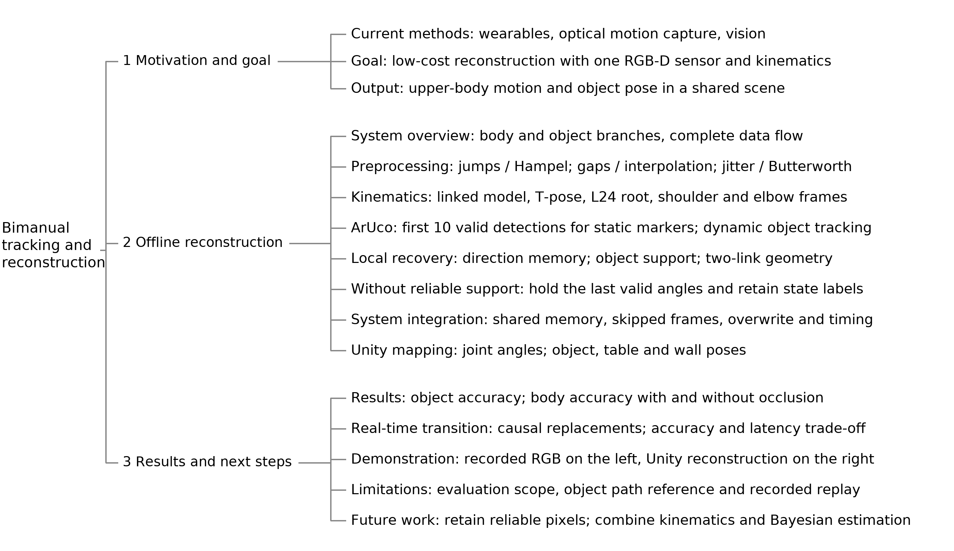

QA index
Find topics by slide number. Hidden slides 47-77 contain 31 QA pages, starting with coordinate transforms and handedness.
Topic | Slides | Key points
Coordinate transforms | 47 | Rotation and origin; inverse transforms; chained transforms
Left- and right-handed body models | 48 | 8 input points; 5 output rotations; comparison of the two workflows
ArUco and AprilTag | 49-50 | Published comparisons; corner error; detection time
Data transfer and frame packets | 51-52 | Shared memory, TCP and UDP; measurement scope
Filtering methods | 53-57 | Savitzky-Golay, median, Butterworth and One Euro
Body kinematics | 58-65 | Camera and chain frames; root; shoulder swing and twist; elbow frame
Object pose | 66 | Camera to World; pose composition; sample acceptance
Occlusion recovery | 67-70 | Grasp offset; direction memory; wrist targets; sphere-intersection circle
Unity mapping and scene calibration | 71-74 | Axis conversion; rig and rest axes; gravity and floor
Evaluation metrics | 75-76 | Length error; scatter around a line; joint positions and reference data
Real-time pipeline logs | 77 | Frame number; processing time and rate; dropped frames; merger ticks
References: slides 42-44. QA pages are outside the main presentation time.

