Chapter 2: Experimental Setup and Measurements
Chapter 1 set out to establish the extent to which a person and a manipulated object can be reconstructed from one consumer-grade RGB-D viewpoint. This chapter builds the measurement layer for that task, from the calibrated scene to the filtered landmark and marker observations.

2.1 The Recording Setup
The recording took place in a controlled lab to limit lighting and background interference. The subject moves a cube along the desk and a wooden rail, with one hand in the rail recording of this chapter and with a handover between the hands in the handover recording of Chapter 7. Chapter 7 compares the reconstructed separations between the endpoints of that route with physical references measured on the setup with a tape, and it draws the reconstructed trajectories. The physical route is not registered into the calibrated world frame, so no physical path is drawn. Figure 2.1 shows the setup, and Table 2.1 lists its objects.
The task runs in five phases, and the later chapters refer to them by these names. The hand acquires the cube at its initial position in the object acquisition, and the carry translates the cube from that position toward the rail. The lift raises the cube from the desk level to the rail level, the slide translates it along the rail, and in the release the hand leaves the cube at the far end. The handover recording has the same physical phases, and its slide also contains a right-hand segment, a handover interval and a left-hand segment.
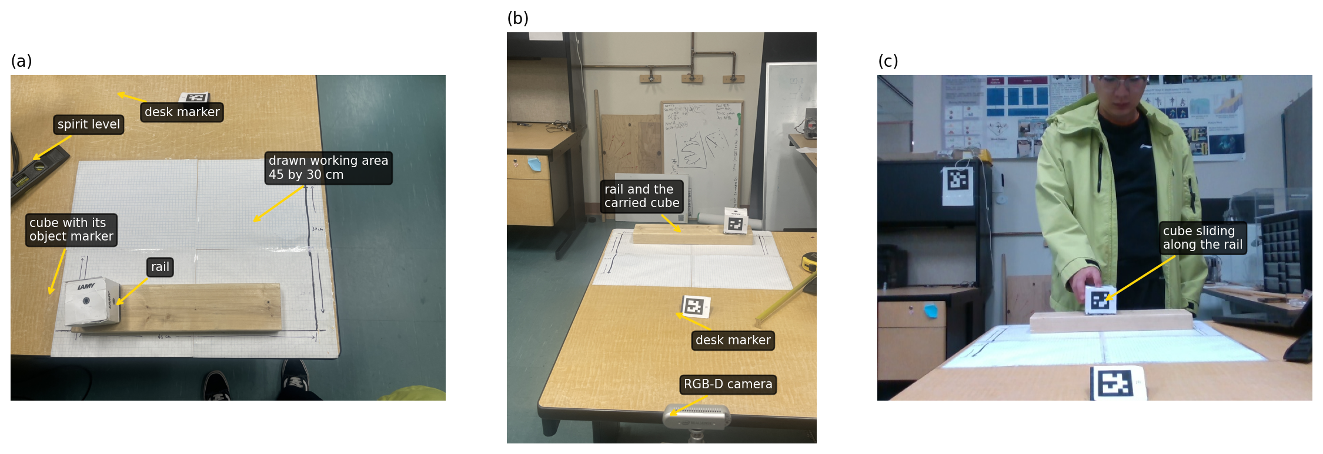
Figure 2.1. The recording setup. (a) The working area on grid paper, with the rail, cube and desk marker. (b) The view from behind the camera. (c) A colour frame.
Object | Role | ArUco identifier | Dictionary | Printed size (mm) | Physical dimensions
Wall marker | Static; gravity reference | 0 | 5 by 5 | 150 | -
Desk marker | Static; world origin | 2 | 5 by 5 | 45 | -
Object marker | Dynamic; tracked cube | 1 | 5 by 5 | 45 | Cube: 70 mm per side
Wooden rail | Reference object | - | - | - | 387 by 88 by 38 mm, lying flat
Table 2.1. The objects in the scene. All markers are from the OpenCV 5 by 5 dictionary, and the size is the side of the printed black square. The translation a planar marker solver returns scales with the size it is given, so every object-derived distance in this thesis rests on it.
Figure 2.2 labels the parts of the scene. The camera is an Intel RealSense D435 on a fixed support at the edge of the desk, about 1.3 metres from the subject. The subject stays within 2 metres of it for the whole experiment, because the depth error of the sensor grows with the square of the distance [37], [38], [58].
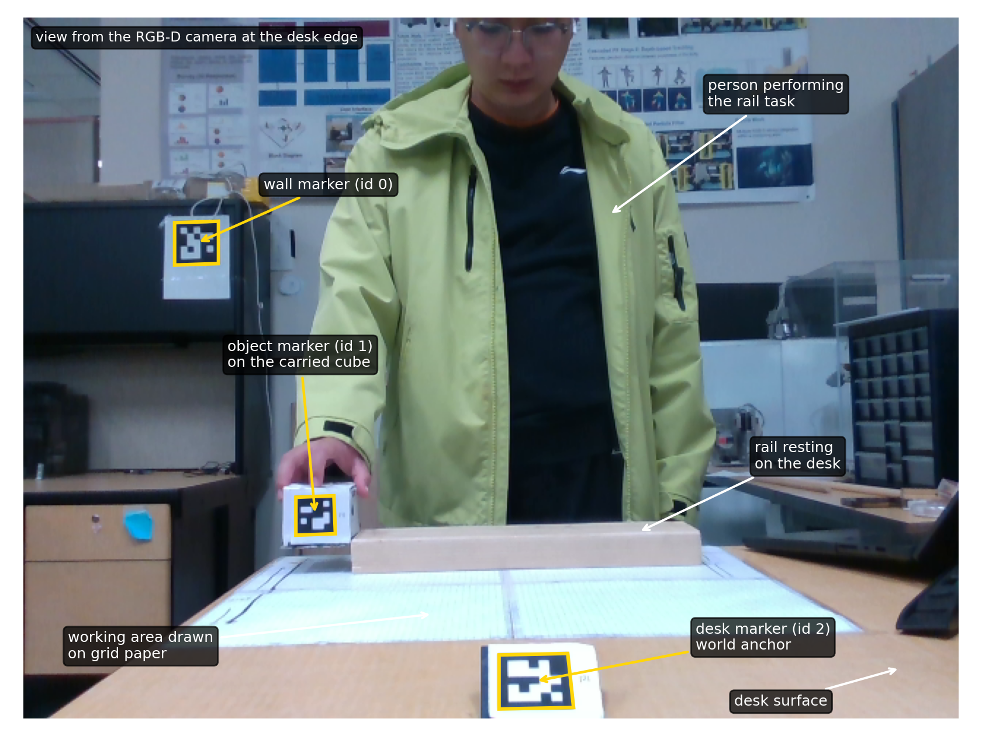
Figure 2.2. The experimental setup seen from the RGB-D camera, with the subject, the rail, the carried cube, and the three ArUco markers labelled.
The recording is saved as a bag file, the format of the Intel RealSense software. Each frame holds a colour image, a depth image aligned to it, and a shared frame index that pairs the person and object measurements of one moment. Appendix A describes the recording and the file layout.
Figure 2.3 follows the recording through two parallel pipelines. Pipeline A combines landmark detection, depth, filtering and the body solve of Chapters 3 and 5. Pipeline B measures the scene and object poses of Sections 2.2 and 2.4 and Chapter 4, which also support the recovery of Chapter 5. Chapter 6 pairs the two outputs at a common render time for Unity. Appendix B lists the workstation.
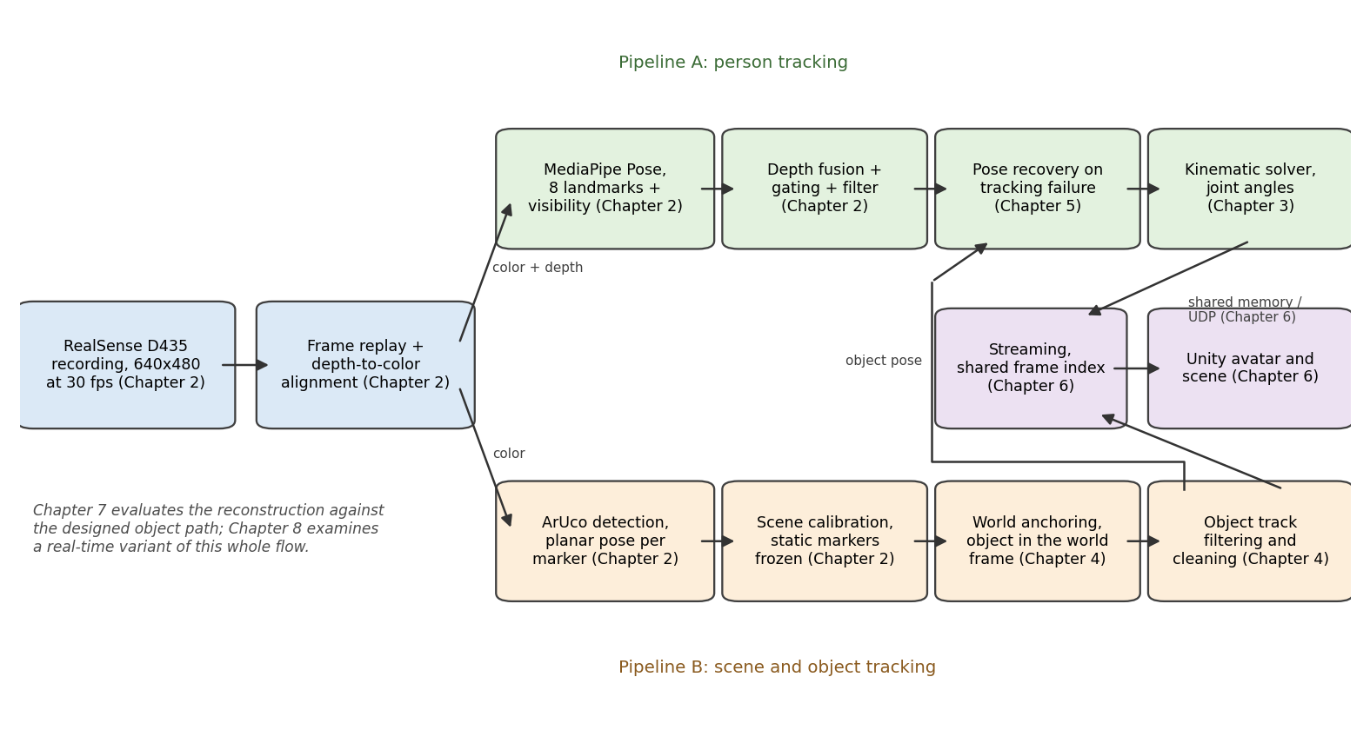
Figure 2.3. Overall data flow. Pipeline A (top) tracks the person, Pipeline B (bottom) the scene and object, and each block names the chapter that develops it.

2.2 Coordinate Frames and Scene Calibration
Each position and orientation is expressed in a coordinate frame, an origin with three perpendicular axes. The transformations between them follow standard robotics notation [42]. Every frame of this thesis carries a name. A name in braces is that frame's label in the superscript and subscript slots of a transformation.

2.2.1 The Frames
The raw camera frame {Camera} is the frame of the colour camera to which each depth image is aligned. Its origin is at the colour camera lens, the x axis points to the right of the image, the y axis points down, and the z axis points forward into the scene [10], which makes it right-handed. The depth of a point is its z coordinate in that frame. Every raw measurement of both pipelines starts there, and Figure 2.4(a) draws it on the sensor as the letter C.
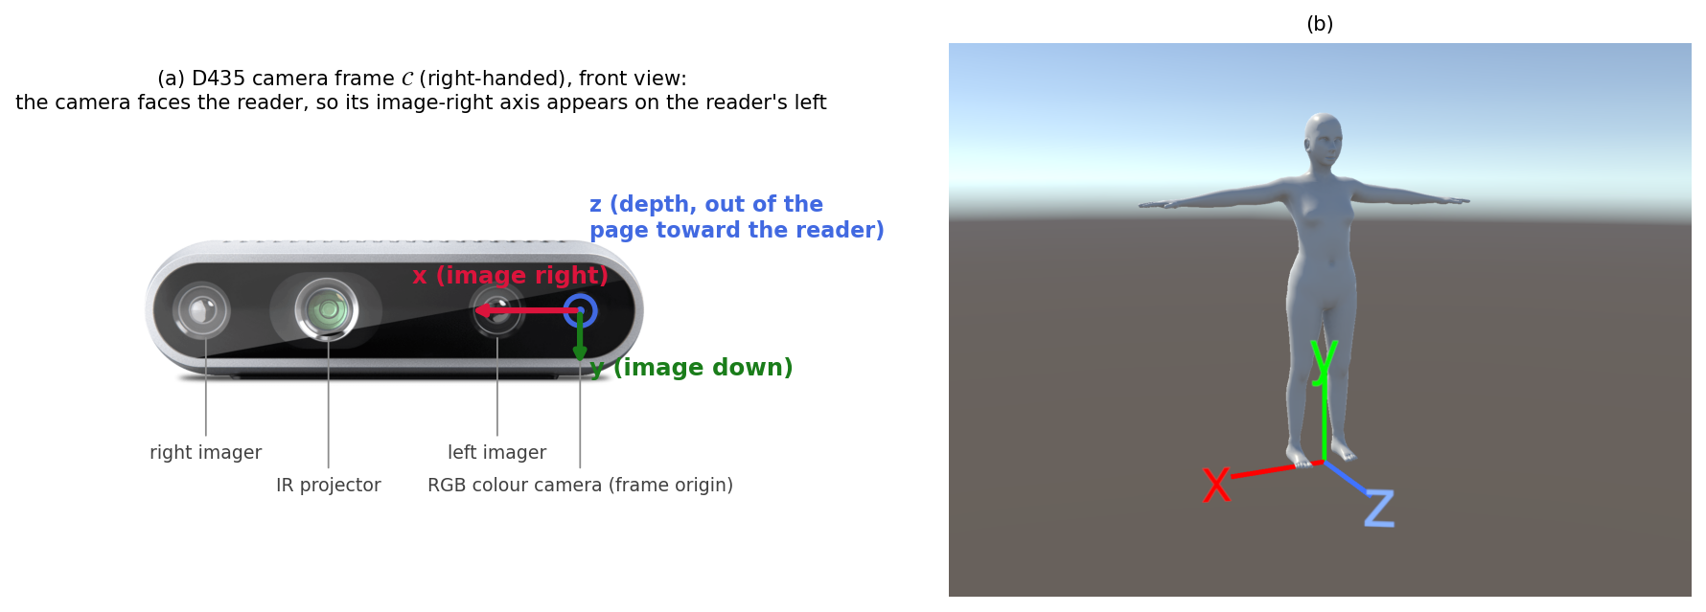
Figure 2.4. (a) The sensor frame C on a D435 photograph (Intel [59]; axes added). (b) The coordinate system of the Unity scene, left-handed, y up, origin on the floor.
Every printed marker of Table 2.1 has a right-handed frame of its own. Its origin is at the centre of the printed square, its x and y axes lie in the printed plane and its z axis points out of the printed face. The world frame is the desk marker's, fixed to the desk. Every object pose ends up in it, and Chapter 6 brings the reconstructed body into it as well. The wall marker's frame sits behind the working area and is never used as an origin. Section 2.2.2 states the assumptions under which its up axis gives the direction of gravity, and the calibration uses that marker for this purpose only. The object frame rides the marker on the cube.
The y-up camera frame {Camera'} shares the optical centre of {Camera} and differs only by flipping the y axis upward, which makes it left-handed. It is the coordinate convention used for body kinematics. Chapter 3 builds the body model in it as a chain of frames, each named after the landmark at its origin, which also gives the side. The root frame sits at the right hip landmark L24 and carries the orientation of the torso. A shoulder frame sits at each shoulder landmark, L12 on the right and L11 on the left, and inherits the orientation of the root. An elbow frame sits at each elbow landmark, L14 on the right and L13 on the left, and carries the basis of the root turned by the solved shoulder rotation.
Chapter 6 first converts the calibrated world coordinates to the left-handed display convention {Unity}. This convention retains the desk-marker origin; its second axis follows the desk-marker normal and is not generally vertical. Gravity alignment then rotates these coordinates, and a recording-specific translation places the drawn floor at zero height. The result is the final {Scene} frame of Figure 2.4(b), and Section 6.4 combines those two operations into one transformation without defining an intermediate frame.
The pose of a frame B seen in a frame A is written ${}_{B}^{A}T$, a 4 by 4 matrix that holds a rotation and a translation, and Chapter 3 gives its form in equation (3.2). The same matrix carries a point of B into A, so that $\left[\begin{matrix}{}_{ }^{A}P \\ 1\end{matrix}\right] = {}_{B}^{A}T \left[\begin{matrix}{}_{ }^{B}P \\ 1\end{matrix}\right]$. A pair of them composes when the subscript of the first matches the superscript of the second, and the shared name drops out of the product. Figure 2.5 draws the frames of the scene, with an arrow for each transformation. Arrows point from the reference frame to the described frame, and the labelled transformation maps coordinates in the opposite direction.
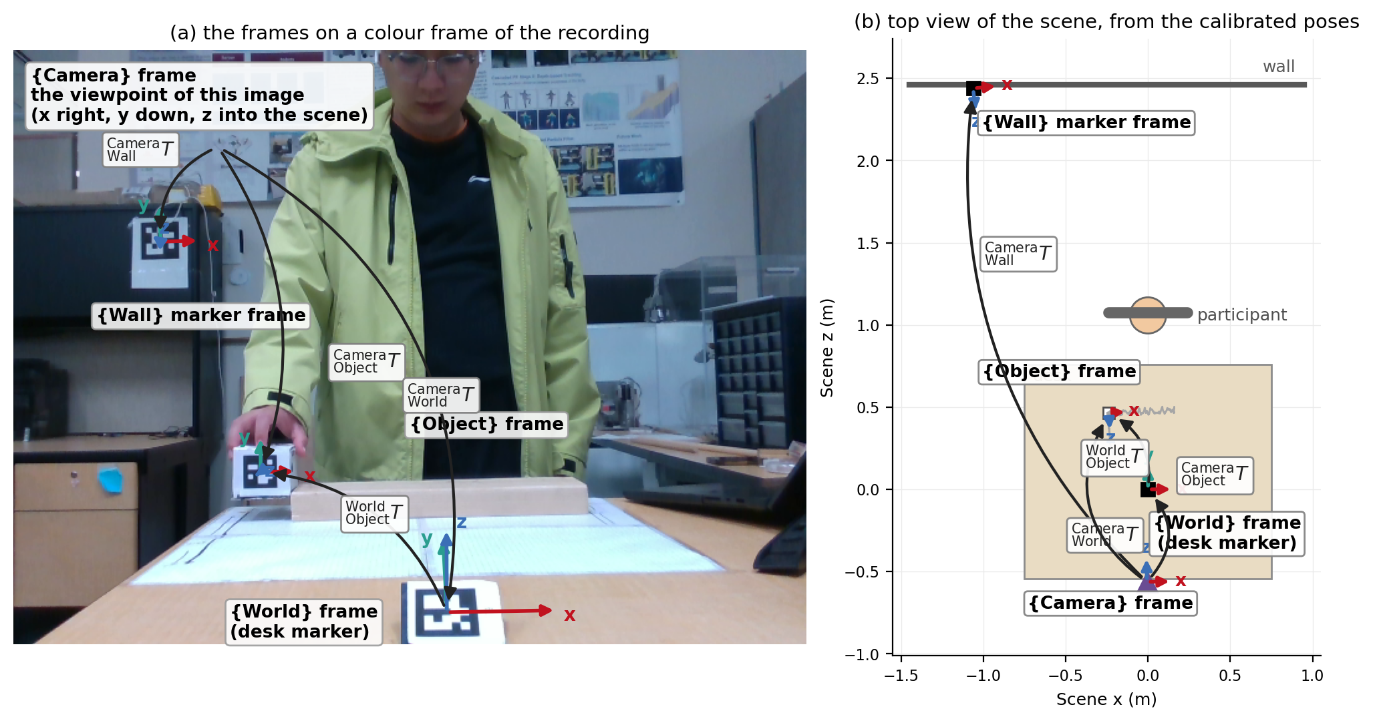
Figure 2.5. The scene frames. (a) A colour frame carrying {Wall}, {World} and {Object}, with an arrow for each transformation. (b) A top view of {Scene} and the object track.
The flip and the swap both reverse handedness. The flip $F$ takes the right-handed sensor frame to the left-handed y-up camera frame, and as a matrix it is $diag\left(1, −1, 1\right)$. The swap $S$ takes the right-handed world frame to the left-handed Unity frame by exchanging the second and third coordinates, so it is $\left[\begin{matrix}1 & 0 & 0 \\ 0 & 0 & 1 \\ 0 & 1 & 0\end{matrix}\right]$. Each has determinant −1, so neither is a rotation, and each is its own inverse. Where an orientation crosses one of them, Chapter 6 prints the change of basis as a conjugation rather than as a multiplication on one side.

2.2.2 Scene Calibration
The desk and wall markers are assumed fixed. Their poses are calibrated at the start and held constant throughout the recording.
Calibration averages the first ten detections of each static marker. Translation uses the arithmetic mean. The element-wise rotation mean generally loses orthonormality, so it is projected onto the nearest proper rotation [45], giving the chordal mean. Let $\bar{M}$ be the element-wise mean of the rotation blocks of ${}_{B}^{A}T$ across the window. Its singular value decomposition is $\bar{M} = U Σ V^{T}$. The projection is
 | ${}_{B}^{A}R = U diag\left(1, 1, det\left(UV^{T}\right)\right) V^{T},$ | (2.1)
where the determinant factor excludes reflections and the result is orthonormal. The calibration runs it on ${}_{World}^{Camera}{\bar{M}}$ for the desk marker and on ${}_{Wall}^{Camera}{\bar{M}}$ for the wall marker, which gives ${}_{World}^{Camera}R$ and ${}_{Wall}^{Camera}R$. Chapter 4 uses the same projection to smooth the object rotations ${}_{Object}^{World}R$.
Freezing the anchor prevents later desk-marker noise from rotating the reconstructed scene. An anchor orientation error displaces each point in proportion to its distance from the anchor. The frozen calibration can still be biased, but it adds no per-frame anchor wobble.
Calibration also measures the geometry of the scene around the markers, on two physical assumptions. The wall carrying the wall marker is plumb, and the marker is mounted with its printed up axis vertical. Under these assumptions, the up axis in the plane of the calibrated wall marker gives the direction of gravity. A plumb wall alone fixes only the normal of the marker plane, and the marker could still be turned within that plane. The upright mounting was not measured, so an error in the angle at which the marker hangs enters every gravity-referenced height and tilt of this thesis.
The axes of the world frame are not lined up with gravity because the desk marker card sits on a small stand that tilts it toward the camera. Gravity is therefore taken from the wall marker.
A coarser estimate of the same direction comes from a plane fitted to the depth pixels in a ring around that card, once the deprojection of Section 2.3 has turned those pixels into metric points. Its normal fixes the sign of the gravity direction and settles the two-solution ambiguity of the planar pose estimation of Section 2.4. The fitted plane also supplies a point on the tabletop, which fixes the horizontal tabletop model whose normal is the calibrated gravity direction.
The pipeline hands this scene calibration to the reconstruction once, before any per-frame streaming begins, and Chapter 6 builds the Unity scene from it.

2.3 Pose Landmarks From MediaPipe
Pipeline A starts with MediaPipe Pose. It is an open-source detector [28], and it runs in real time on ordinary hardware. For each colour frame, it first locates the person and then regresses 33 body landmarks. Landmark indices are fixed. The pipeline can therefore select the eight required upper-body points directly: shoulders L11 and L12, elbows L13 and L14, wrists L15 and L16, and hips L23 and L24. Every result includes image coordinates, an appearance-derived depth estimate, and a visibility score between 0 and 1. Appendix C gives the detector architecture, the steps that extract the landmarks, and a numerical example.
Because MediaPipe estimates depth from two-dimensional (2D) appearance rather than physical sensor measurements, the pipeline discards those values and uses the depth readings from the aligned RealSense stream instead. It then uses the camera intrinsics to back-project each landmark pixel into metric 3D coordinates (Appendix D). The pipeline treats landmarks with visibility scores below 0.50 as missing data. Figure 2.6 illustrates the detector output.
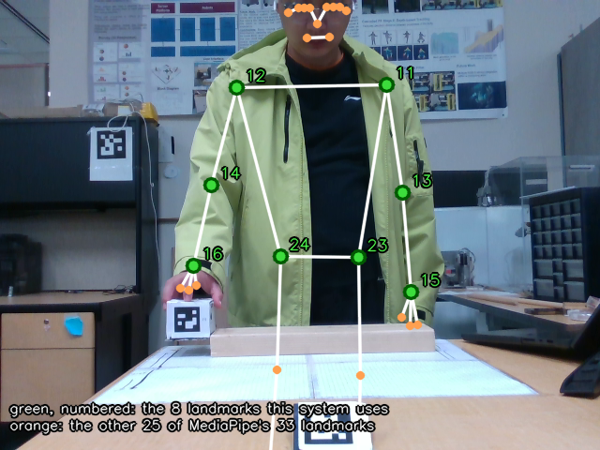
Figure 2.6. MediaPipe Pose output on a mid-task frame. The eight numbered upper-body landmarks are the ones this system uses. The visibility gate removes the leg landmarks the desk hides.

2.4 Object Pose From ArUco Markers
Pipeline B gets its measurements from ArUco fiducial markers [29], which have a black square border around a unique binary identifier (ID) grid. Once supplied with the marker's physical side length, it solves the planar Perspective-n-Point problem [52] to resolve both position and orientation in a single pass. The result is the pose of the marker in the sensor frame. For the object marker that pose is ${}_{Object}^{Camera}T$, and it is measured on every frame.
The wall marker (ID 0, 150 mm) is mounted on a plumb wall. It is printed larger only because it sits farthest from the sensor. Appendix E covers corner detection, planar ambiguity, and rotation matrix conversion.

2.5 Measurement Filtering
The raw 3D landmark trajectories carry three kinds of error:
Case A, spikes: an isolated sample jumps far off the local trajectory for one frame, from a depth speckle or a momentary false detection.
Case B, gaps: a few consecutive samples are missing, because the visibility gate of Section 2.3 blocked them or the depth sample was invalid.
Case C, jitter: every sample carries small broadband noise from detection and depth measurement.
If a filter is strong enough to remove a sharp spike, it also distorts fast motion. No smoothing filter can fill in missing data gaps either. The pipeline therefore handles each case in a separate stage.
A rolling Hampel test handles case A. The Hampel identifier [53] spots outliers by the distance of a point from the local median. It works well on time-series data because a sudden spike will not pull the median off track the way it pulls a mean [54]. The test uses a 7-frame window and a threshold of three times a robust scale. On each coordinate, the pipeline subtracts each sample's own centred rolling median and takes the absolute residual. A second centred 7-frame rolling median over those residuals, multiplied by about 1.48, supplies the scale (Appendix F). A baseline floor of 2 centimetres prevents small sensor noise from triggering the test when the subject is standing still. The pipeline discards any spike the test flags and marks it as missing data, which then passes into case B. Figure 2.7 shows the test flagging a wrist spike that jumped 2.9 centimetres off track in a single frame.
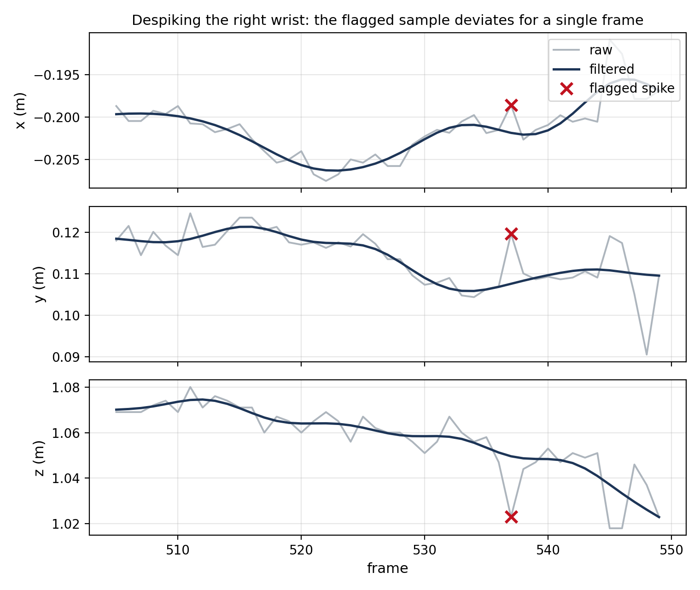
Figure 2.7. Despiking on the right wrist of the recording: per-axis raw and filtered trajectories, with a mark on the sample flagged by the Hampel test.
Linear interpolation handles case B. The interpolation fills interior gaps no longer than 5 frames, a sixth of a second, along a straight line between the two valid endpoints. Longer gaps remain missing, and the pose recovery of Chapter 5 handles them. Figure 2.8 shows bridged wrist dropouts from the recording.
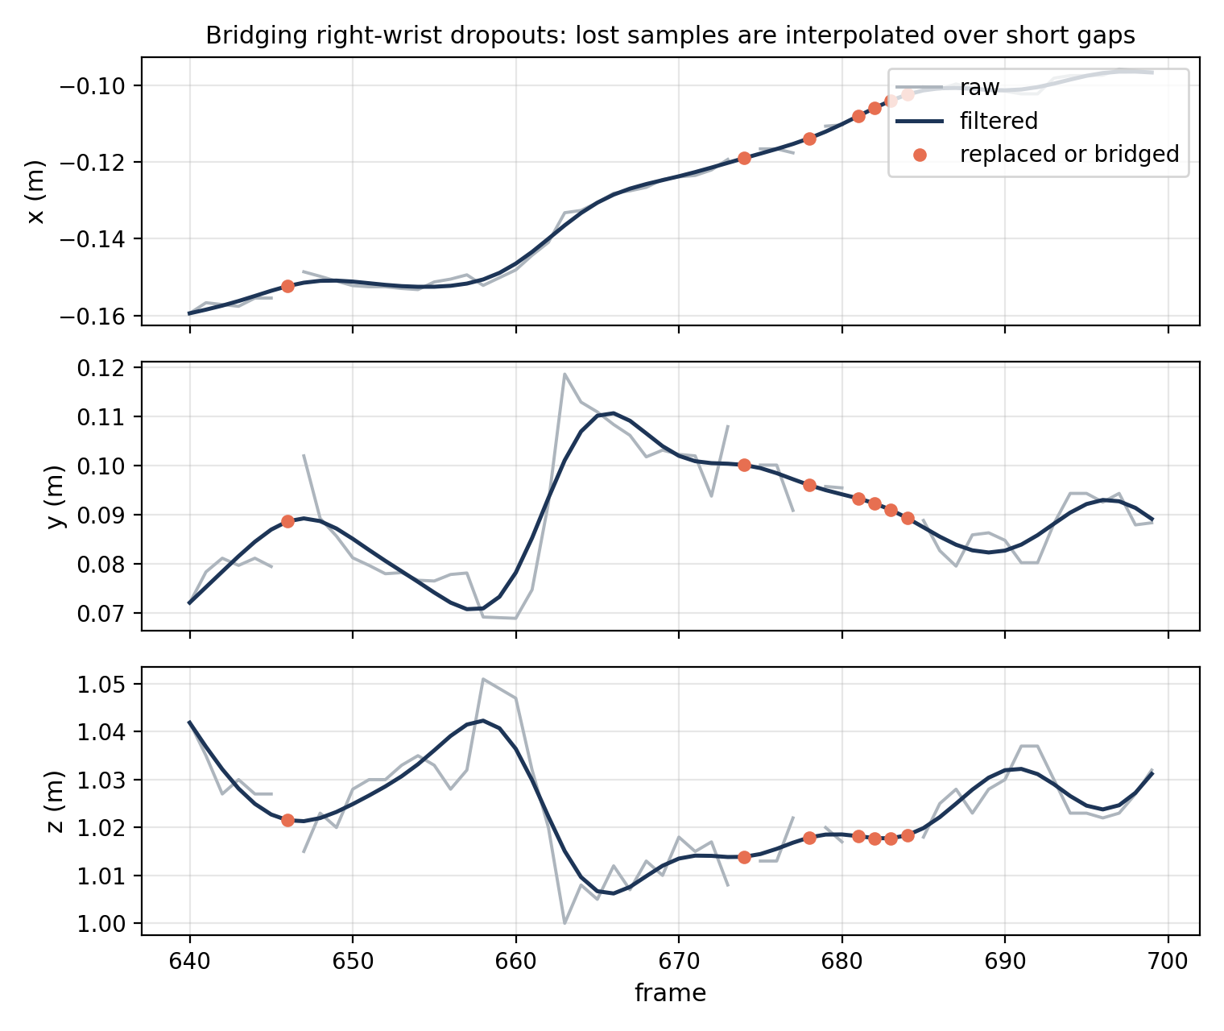
Figure 2.8. Gap bridging on the right wrist of the recording: the short gaps filled by interpolation, with the replaced samples marked.
A zero-phase Butterworth low-pass filter then handles case C. The filter follows the design procedure of [55]. The Butterworth family has a flat passband, so it passes the motion without ripple [56]. A fourth-order filter with a 3 Hz cutoff runs forward and backward over the recording [57]. The two passes cancel the phase delay. The forward and backward low-pass filter reduces jitter but also attenuates motion near its cutoff. The backward pass needs the whole recording, so the filter can only run offline. The real-time alternative is the One Euro filter [40]. Chapter 8 compares the causal filter with the offline one on the same recording (Section 8.3). Appendix F compares the candidate smoothers side by side. Figure 2.9 shows the raw jitter against the filtered track.
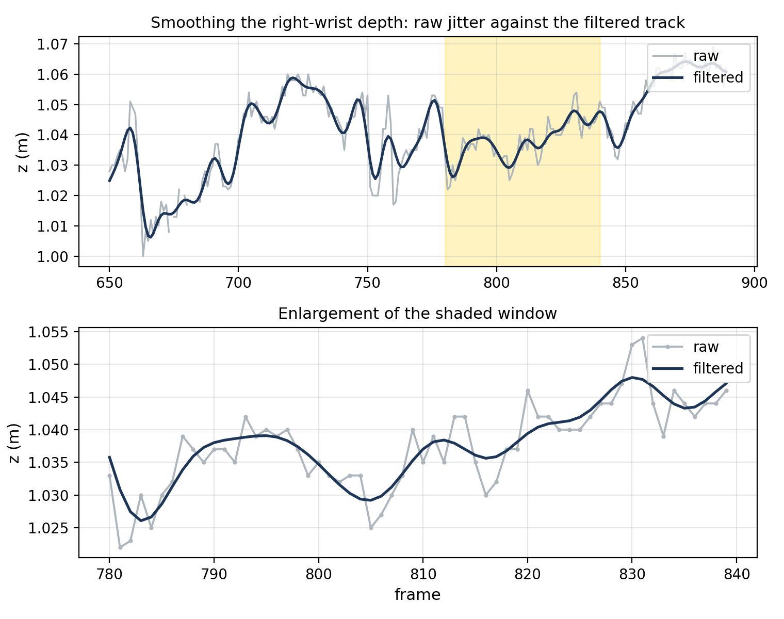
Figure 2.9. Smoothing on the right-wrist depth of the recording: the raw and filtered tracks over an eight-second span, with the shaded window enlarged below.
Every repaired sample keeps a flag, which separates measured data from filled-in data for later stages. Chapter 3 solves the joint angles from these filtered landmarks.

2.6 Hip Depth Preparation
A visible landmark can take the depth of the desk or rail in front of the body. Before solving the body angles, the pipeline checks hip and shoulder widths against calibrated values, then compares the directions of the hip line and shoulder line. It next rejects a torso landmark whose depth is more than 10 centimetres from its remembered value. A final check rejects a hip more than 15 centimetres nearer the camera than the input shoulder midpoint. These checks run in that order, so the replacement described below takes priority over the last check.
Depth memory starts empty. The first sample that survives the checks seeds it; later accepted samples update it with 70 percent previous depth and 30 percent new depth. A repaired sample does not update it, and the memory does not expire. The pipeline places a single rejected point on its retained camera ray at the remembered depth, or at the shoulder-midpoint depth for the last check. Rebuilding a whole pair instead restores its calibrated width, so its final endpoints can leave their original rays.
Appendix G gives the branching, fallbacks and output states. The preparation assumes usable landmark pixels and, for the shoulder-depth check, limited trunk lean. It does not establish anatomical hip depth. Chapter 5 uses the prepared torso for arm recovery. The plain, direction-memory and object-assisted solves of Chapter 7 all rest on this preparation. The hold-last solve keeps the last accepted joint angles and does not use it. The causal path's angle solve includes this preparation, but its pelvis translation still uses the original hip midpoint.
The measurement layer leaves three things unresolved: the landmarks are metric points, not a kinematic state; the object poses are not yet joined into a track; and nothing links the body to the object. Chapter 3, Chapter 4 and Chapter 5 take each in turn.

