Chapter 3: Kinematic Modelling
Chapter 2 delivers eight body landmarks per frame as metric 3D positions in one calibrated scene (Appendix C, Appendix D). Points carry no orientation. This chapter converts them into a kinematic state: a root pose, four angles per arm, and the wrist as a point. The model is closed form: every angle comes from the landmark geometry of the current frame, with no optimization and no state carried between frames.
Figure 3.1 draws the information flow.
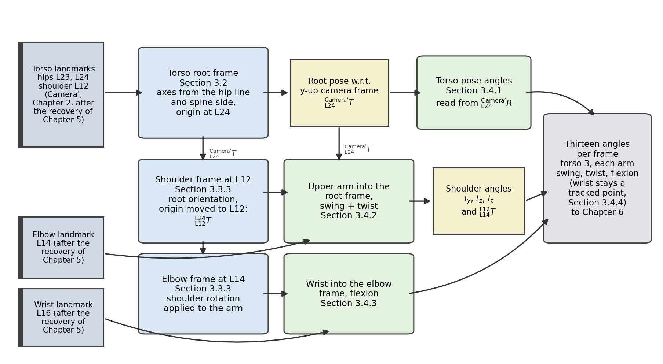
Figure 3.1. The chapter's information flow. Landmarks enter from Chapter 2 on the left, the stored thirteen-angle pose leaves on the right, and the section numbers locate each construction.

3.1 Coordinate Systems and Transformations
This chapter attaches a coordinate frame to each body segment. Unity uses a left-handed frame with y upward, so the kinematics uses the matching axis convention of {Camera'}.
Converting a position into {Camera'} changes the handedness itself rather than relabelling the axes. If p is a landmark position in the sensor frame, its position q in the y-up camera frame is
 | ${}_{ }^{Camera'}q = F {}_{ }^{Camera}p, F = diag\left(1, −1, 1\right).$ | (3.1)
The determinant of F is -1, the sign of a reflection. F applies to points only, never to rotation matrices, so every rotation in the pipeline comes out proper. Figure 3.2 draws the two frames with the right wrist of Section 3.5. Every landmark position in this chapter is a y-up camera-frame value unless stated otherwise.
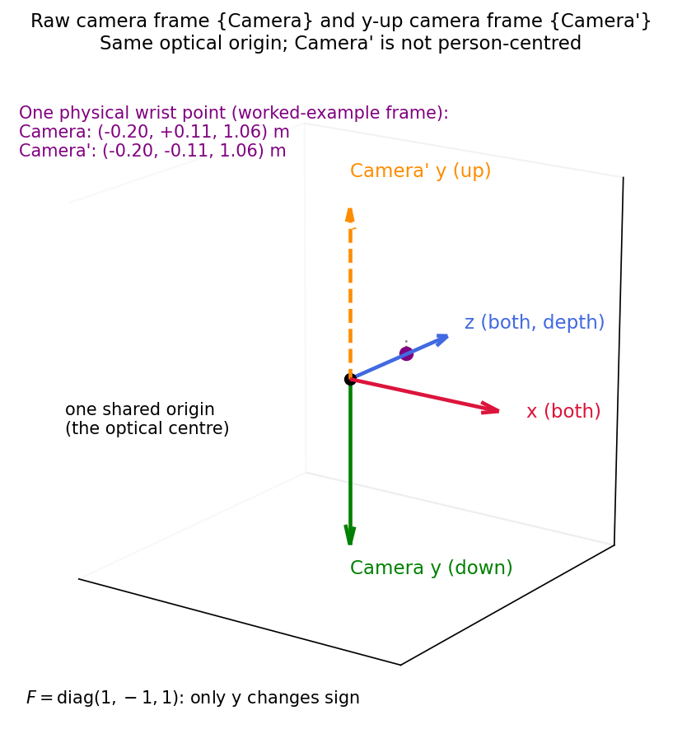
Figure 3.2. The raw camera frame {Camera} and y-up camera frame {Camera'} drawn from one optical centre. Only the y axis differs: {Camera} reads y downward and {Camera'} upward.
The frame {Camera'} is not person-centred, and it is not the frame of the finished Unity scene of Figure 2.4(b), which Chapter 6 builds from the calibrated camera pose and the desk marker of Section 2.2.
The left-handed choice changes no physical result. The object track keeps the right-handed world frame instead, and Chapter 6 converts it for Unity with the axis swap of equation (6.1).
Section 2.2 fixes the notation of a rigid body transformation [42]. The reference frame A is a left superscript and the described frame B a left subscript, so ${}_{B}^{A}R$ is the orientation of a child frame B in a parent frame A. The columns of the rotation part ${}_{B}^{A}R$ are the axis directions of B in the coordinates of A, ${}_{B}^{A}R = \left[\begin{matrix}{}_{ }^{A}{{\hat{X}}_{B}} & {}_{ }^{A}{{\hat{Y}}_{B}} & {}_{ }^{A}{{\hat{Z}}_{B}}\end{matrix}\right]$. They are perpendicular unit vectors, so the transpose of ${}_{B}^{A}R$ is its inverse, which the transformations of this chapter use directly. With the origin of B expressed in A as the translation part ${}_{ }^{A}{P_{BORG}}$, the two combine into the 4 by 4 homogeneous transformation matrix ${}_{B}^{A}T$:
 | ${}_{B}^{A}T = \left[\begin{matrix}{}_{B}^{A}R & {}_{ }^{A}{P_{BORG}} \\ 0 & 1\end{matrix}\right], \left[\begin{matrix}{}_{ }^{A}P \\ 1\end{matrix}\right] = {}_{B}^{A}T \left[\begin{matrix}{}_{ }^{B}P \\ 1\end{matrix}\right].$ | (3.2)
Running the rotation the other way expresses a measured segment direction in the coordinates of the child frame B:
 | ${}_{ }^{B}v = {}_{A}^{B}R {}_{ }^{A}v, {}_{A}^{B}R = {\left({}_{B}^{A}R\right)}^{T}.$ | (3.3)
Throughout, ${}_{ }^{A}P$ is a measured landmark point carrying the frame it is expressed in, and v a segment vector between two points. Equation (3.3) is the rotation part acting alone, so it applies to directions. The chain frames sit at different places, so a landmark moves between them by the full transformation of equation (3.2), whose inverse is
 | $\begin{aligned}{}_{ }^{B}P = {\left({}_{B}^{A}R\right)}^{T} \left({}_{ }^{A}P − {}_{ }^{A}{P_{BORG}}\right) \\ {}_{A}^{B}T = {\left({}_{B}^{A}T\right)}^{−1} = \left[\begin{matrix}{\left({}_{B}^{A}R\right)}^{T} & −{\left({}_{B}^{A}R\right)}^{T} {}_{ }^{A}{P_{BORG}} \\ 0 & 1\end{matrix}\right].\end{aligned}$ | (3.4)
Figure 3.3(a) draws the chain on the worked-example frame of Section 3.5.
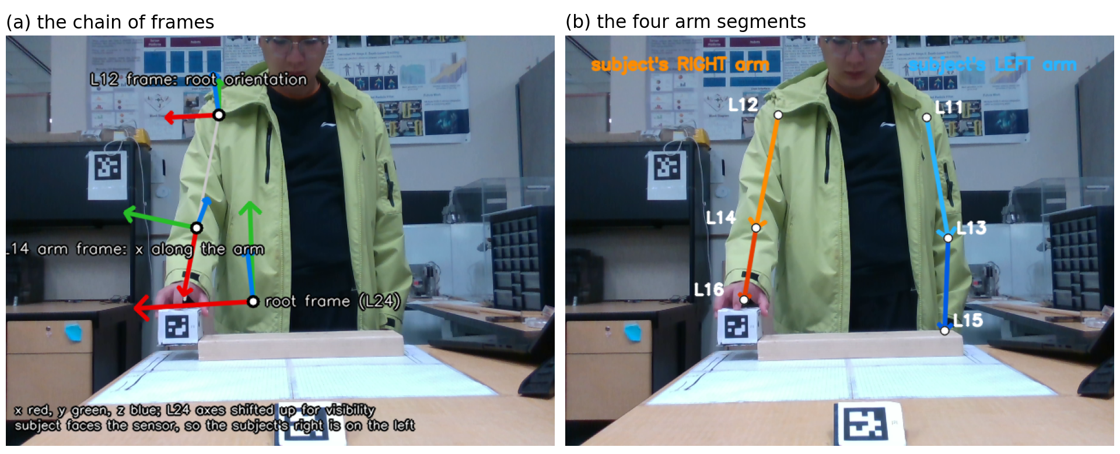
Figure 3.3. The worked-example frame, front view. (a) The chain of frames, the root at right hip L24, shoulder at L12, elbow at L14. (b) The four arm segments.
Each neighbouring pair in Figure 3.3(a) is related by its own homogeneous transformation:
 | $\begin{aligned}{}_{L24}^{Camera'}T = \left[\begin{matrix}{}_{L24}^{Camera'}R & {}_{ }^{Camera'}{P_{L24ORG}} \\ 0 & 1\end{matrix}\right] \\ {}_{L12}^{L24}T = \left[\begin{matrix}I & {}_{ }^{L24}{P_{L12ORG}} \\ 0 & 1\end{matrix}\right] \\ {}_{L14}^{L12}T = \left[\begin{matrix}{}_{L14}^{L12}R & {}_{ }^{L12}{P_{L14ORG}} \\ 0 & 1\end{matrix}\right].\end{aligned}$ | (3.5)
A frame that exists once per arm takes its label from its landmark, so the side needs no further subscript: L12 and L14 on the subject's right, L11 and L13 on the left. The root transformation ${}_{L24}^{Camera'}T$ is the pose of the root frame with respect to the y-up camera frame. The two that follow carry the shoulder frame with respect to the root and the elbow frame with respect to the shoulder, with ${}_{L11}^{L24}T$ and ${}_{L13}^{L11}T$ their left counterparts. Section 3.2 builds the root pose, Section 3.3.3 places both origins, and Section 3.4.2 solves the shoulder rotation that fills the last block and mirrors the construction for the left arm. Chaining the three describes the right elbow frame directly in the y-up camera frame,
 | ${}_{L14}^{Camera'}T = {}_{L24}^{Camera'}T {}_{L12}^{L24}T {}_{L14}^{L12}T.$ | (3.6)
Every landmark is converted to the y-up camera frame by equation (3.1), and the inverse transformations of equation (3.4) carry it into the frame where its joint is solved. The shoulder landmark goes into the root frame by ${}_{Camera'}^{L24}T$. The elbow goes into the shoulder frame by ${}_{Camera'}^{L12}T$ for the angles of Section 3.4.2. The wrist goes into the elbow frame by ${}_{Camera'}^{L14}T$ for the flexion of Section 3.4.3. Section 3.5 prints all three as numbers.

3.2 Torso Reference Frame

3.2.1 Landmark Selection
The right hip L24, the left hip L23, and the right shoulder L12, three MediaPipe landmarks [43], define the torso root. Left and right always refer to the subject, who faces the sensor, so the right side appears on the left of the image.
These points move more slowly than the hands and forearms, the object rarely hides them, and they form a broad triangle across the trunk, so a small position error changes the angles little.
With three torso points, the model cannot separate the pelvis from the upper trunk. The torso is therefore one rigid plate with no twist between shoulders and hips, and a forward lean pitches the root frame with it. Chapter 9 lists the simplification among the limitations.

3.2.2 Derivation of the Torso Frame
The flip F of equation (3.1) converts the three positions to the y-up camera frame, giving ${}_{ }^{Camera'}{P_{23}}$, ${}_{ }^{Camera'}{P_{24}}$ and ${}_{ }^{Camera'}{P_{12}}$. Figure 3.4(a) shows the two input vectors on frame 1400 of the two-hand rail recording, and Figure 3.4(b) the finished frame at L24.
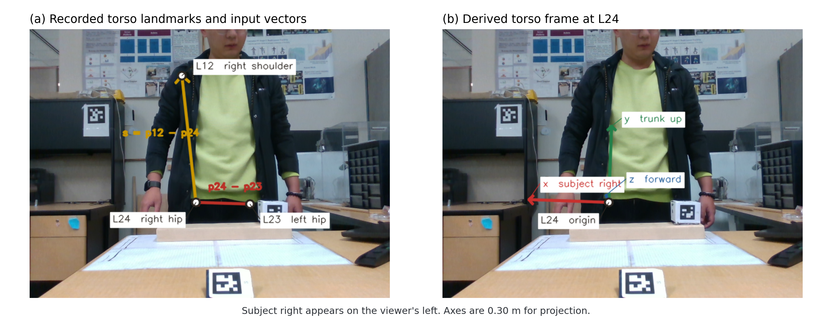
Figure 3.4. Torso-frame construction. (a) The measured shoulder L12 and hips L23 and L24 define the hip vector and the spine-side vector s. (b) The derived axes at L24.
The x axis points along the hip line toward the subject's right, and the hat marks a unit vector.
 | ${}_{ }^{Camera'}{{\hat{X}}_{L24}} = \frac{{}_{ }^{Camera'}{P_{24}} − {}_{ }^{Camera'}{P_{23}}}{\left|{}_{ }^{Camera'}{P_{24}} − {}_{ }^{Camera'}{P_{23}}\right|}.$ | (3.7)
The second input is the spine-side vector from the right hip up to the right shoulder.
 | ${}_{ }^{Camera'}s = {}_{ }^{Camera'}{P_{12}} − {}_{ }^{Camera'}{P_{24}}.$ | (3.8)
This vector is not an axis, because it is generally not perpendicular to the hip line: in the worked-example frame the angle between them is 83.8 degrees. It only selects the torso plane, the one plane through the hip line that also contains ${}_{ }^{Camera'}s$.
The z axis is the normalized cross product of the two inputs:
 | ${}_{ }^{Camera'}{{\hat{Z}}_{L24}} = \frac{{}_{ }^{Camera'}{{\hat{X}}_{L24}} × {}_{ }^{Camera'}s}{\left|{}_{ }^{Camera'}{{\hat{X}}_{L24}} × {}_{ }^{Camera'}s\right|}.$ | (3.9)
The order of the factors sets the sign: with ${}_{ }^{Camera'}{{\hat{X}}_{L24}}$ to the subject's right and ${}_{ }^{Camera'}s$ up the trunk, the product points forward, out of the chest toward the camera.
The y axis closes the frame with a second cross product.
 | ${}_{ }^{Camera'}{{\hat{Y}}_{L24}} = {}_{ }^{Camera'}{{\hat{Z}}_{L24}} × {}_{ }^{Camera'}{{\hat{X}}_{L24}}.$ | (3.10)
The vectors ${}_{ }^{Camera'}{{\hat{Z}}_{L24}}$ and ${}_{ }^{Camera'}{{\hat{X}}_{L24}}$ are unit vectors at right angles, so their product needs no normalization. The construction gives an orthonormal frame whenever the two hips are distinct and the shoulder does not lie on the hip line.
The three axes assemble into the root rotation matrix, its columns in the y-up camera-frame order right, up, forward.
 | ${}_{L24}^{Camera'}R = \left[\begin{matrix}{}_{ }^{Camera'}{{\hat{X}}_{L24}} & {}_{ }^{Camera'}{{\hat{Y}}_{L24}} & {}_{ }^{Camera'}{{\hat{Z}}_{L24}}\end{matrix}\right].$ | (3.11)
The right hip is the origin of the root frame, ${}_{ }^{Camera'}{P_{L24ORG}} = {}_{ }^{Camera'}{P_{24}}$, so the three axes fill in the first transformation of equation (3.5).
 | ${}_{L24}^{Camera'}T = \left[\begin{matrix}{}_{L24}^{Camera'}R & {}_{ }^{Camera'}{P_{24}} \\ 0 & 1\end{matrix}\right].$ | (3.12)
Figure 3.5 shows the reference configuration that fixes the meaning of the finished matrix: the subject upright, facing the sensor, arms straight out to the sides, the T-pose that is the zero of every arm angle in Section 3.3. Such a subject has the right side toward the camera's left and the chest toward the negative z of the y-up camera frame, giving ${}_{L24}^{Camera'}R$ the columns (-1, 0, 0), (0, 1, 0), (0, 0, -1). These decode in the convention of Section 3.4 to the Euler angles (0, 180, 0).
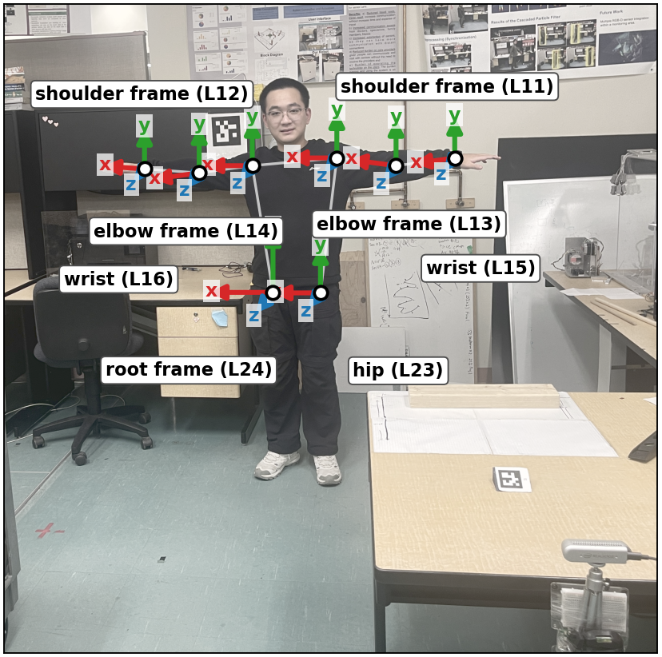
Figure 3.5. The reference configuration: the subject in the T-pose with a frame at each landmark. All frames share the root orientation, right arm along +x, left arm along -x.

3.3 The Arm Model

3.3.1 Kinematic Schematic and Solved Angles
A human arm is described in [42] with seven rotational degrees of freedom, three at the shoulder, one at the elbow and three at the wrist. This model solves the first four: the two shoulder swing angles, the shoulder twist and the elbow flexion. The chain ends at the wrist as a tracked point, since the three wrist rotations cannot be observed from the eight body landmarks.
The wrist orientation is not solved. Section 3.4.4 gives the reason no algebra over these landmarks reaches it. Fingers, contact points and grip force lie outside the landmark set, the torso is the single rigid plate of Section 3.2.1, and the legs are not tracked. The recovery of Chapter 5 and the avatar of Chapter 6 use segment lengths to rebuild positions. These are effective lengths, medians of a segment over the landmark track rather than anatomical bone lengths, and Section 6.3 sets them against the subject's own measurement.
Figure 3.6 places those four joints on the body as a manipulator diagram. The shoulder at L12 is a cluster of three revolute joints with one shared centre, and a single hinge sits at the elbow L14.
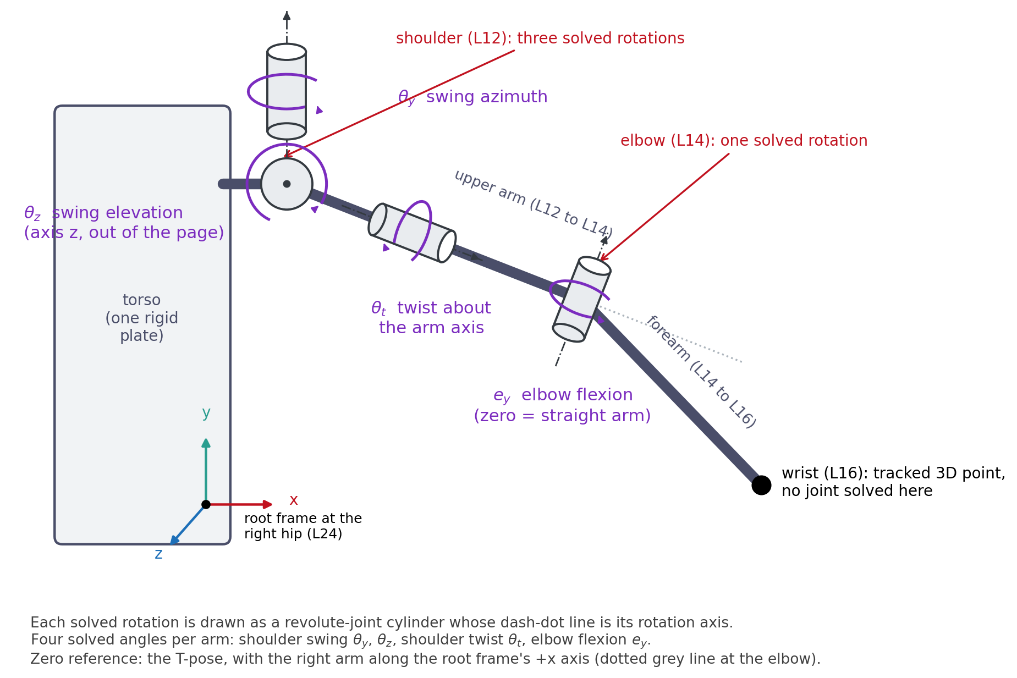
Figure 3.6. The kinematic schematic of the right arm, a chain of revolute-joint cylinders in the Programmable Universal Machine for Assembly (PUMA) style. Each dash-dot line is a rotation axis.
The azimuth $t_{y}$ turns the arm about the torso's y axis, the elevation $t_{z}$ raises it about the z axis, the twist $t_{t}$ rolls the upper arm about its own length. The flexion $e_{y}$ bends the forearm relative to the upper arm.

3.3.2 Definition of Shoulder, Elbow, and Wrist
Each arm is a chain of two rigid segments, the upper arm from the shoulder to the elbow and the forearm from the elbow to the wrist. Figure 3.3(b) shows the four segments, the right arm on L12, L14 and L16 and the left arm on L11, L13 and L15.

3.3.3 Establishing Local Arm Frames
Every joint rotation is measured relative to its parent frame, the shoulder relative to the torso and the elbow relative to the rotated upper arm.
The parent frame of the shoulder is L12, the root orientation ${}_{L24}^{Camera'}R$ moved up the trunk to the shoulder landmark. No separate orientation is derived there: a second basis from the shoulder line and the upper arm would add a shoulder-girdle degree of freedom the data cannot support. With the shoulder angles at zero, the right upper arm points along +x. This fills in the second transformation of equation (3.5):
 | ${}_{L12}^{L24}T = \left[\begin{matrix}I & {\left({}_{L24}^{Camera'}R\right)}^{T}\left({}_{ }^{Camera'}{P_{12}} − {}_{ }^{Camera'}{P_{24}}\right) \\ 0 & 1\end{matrix}\right].$ | (3.13)
The rotation block is the identity, ${}_{L12}^{L24}R = I$, and the origin ${}_{ }^{L24}{P_{L12ORG}} = {\left({}_{L24}^{Camera'}R\right)}^{T}\left({}_{ }^{Camera'}{P_{12}} − {}_{ }^{Camera'}{P_{24}}\right)$ is the measured shoulder landmark in torso coordinates, by the mapping of equation (3.4).
The parent of the elbow is the upper arm, so the elbow frame L14 is the root orientation composed with the solved shoulder rotation, with its origin at the elbow landmark. This follows the PUMA robot model, where each new frame is the previous one turned by the joint rotation [42]. In the T-pose, the forearm continues the arm axis along the local +x. The third transformation of equation (3.5) is then
 | ${}_{L14}^{L12}T = \left[\begin{matrix}{}_{L14}^{L12}R & {\left({}_{L24}^{Camera'}R\right)}^{T}\left({}_{ }^{Camera'}{P_{14}} − {}_{ }^{Camera'}{P_{12}}\right) \\ 0 & 1\end{matrix}\right],$ | (3.14)
with the solved shoulder rotation ${}_{L14}^{L12}R$ of Section 3.4.2 in the rotation block and the elbow landmark in shoulder-frame coordinates, ${}_{ }^{L12}{P_{L14ORG}}$, as its origin. The shoulder frame shares the root orientation, so the same ${\left({}_{L24}^{Camera'}R\right)}^{T}$ maps it.
A measured segment reaches its parent frame in two steps. It is formed as a vector between two landmarks, for the right upper arm ${}_{ }^{Camera'}v = {}_{ }^{Camera'}{P_{14}} − {}_{ }^{Camera'}{P_{12}}$, and equation (3.3) pulls it into the parent frame as ${}_{ }^{L24}v = {\left({}_{L24}^{Camera'}R\right)}^{T} {}_{ }^{Camera'}v$. Section 3.4 works backwards from it to the angles.

3.4 Joint Angle Computation
The root orientation is encoded by three Euler angles in the Unity convention (Chapter 6), applied about the parent-frame axes in the order z, then x, then y. The arm angles are joint coordinates; Section 3.4.2 defines their separate composition. In the matrix product the rotation applied first sits nearest the column vector, so the convention reads
 | $R = R_{y}\left(y\right) R_{x}\left(x\right) R_{z}\left(z\right),$ | (3.15)
where $R_{x}$, $R_{y}$, $R_{z}$ are the elementary rotations about the coordinate axes. Multiplied out, with c for cosine and s for sine, the product is the matrix this section reads its angles from:
 | $R = \left[\begin{matrix}c_{y}c_{z} + s_{y}s_{x}s_{z} & −c_{y}s_{z} + s_{y}s_{x}c_{z} & s_{y}c_{x} \\ c_{x}s_{z} & c_{x}c_{z} & −s_{x} \\ −s_{y}c_{z} + c_{y}s_{x}s_{z} & s_{y}s_{z} + c_{y}s_{x}c_{z} & c_{y}c_{x}\end{matrix}\right].$ | (3.16)
Write $m_{ij}$ for the entry of a measured numerical matrix $m$ in row i and column j. The three angles follow from its entries:
 | $x=asin\left(−m_{23}\right), y=atan2\left(m_{13},m_{33}\right), z=atan2\left(m_{21},m_{22}\right).$ | (3.17)
The arcsine restricts x to -90 to +90 degrees. At either end of that range ($\left|m_{23}\right| = 1$) the y and z rotations turn about the same axis and only their combined angle is defined, the configuration called gimbal lock. The z angle is set to zero there by convention, so only the split between the two angles is a choice. The entries $m_{13}$ and $m_{33}$ of the third column both vanish there, so the locked branch reads y from $m_{12}$ and $m_{11}$ instead:
$\begin{aligned}x = +90°: y=atan2\left(m_{12},m_{11}\right), z = 0 \\ x = −90°: y=atan2\left(−m_{12},m_{11}\right), z = 0.\end{aligned}$

3.4.1 Torso Pose
The torso is not a joint. Its pose is the pair ${}_{L24}^{Camera'}R, {}_{ }^{Camera'}{P_{L24ORG}}$, and equation (3.17) applied to ${}_{L24}^{Camera'}R$ gives its three angles, as Section 3.5 shows on measured data.

3.4.2 Shoulder Orientation
A shoulder pose must describe the direction of the upper arm and its roll about its own axis, the three angles labelled at the shoulder of Figure 3.6. They separate into swing and twist [44], with the twist innermost:
 | ${}_{L14}^{L12}R = R_{y}\left(t_{y}\right) R_{z}\left(t_{z}\right) R_{x}\left(t_{t}\right),$ | (3.18)
where $t_{y}$ and $t_{z}$ are the swing angles and $t_{t}$ the twist about the arm axis +x of the T-pose. A rotation about x leaves the x axis fixed, so with the twist innermost the first column of ${}_{L14}^{L12}R$ is free of the twist factor. This column is the upper arm direction ${}_{ }^{L12}{\hat{a}}$ of the elbow frame described in the shoulder frame,
 | ${}_{ }^{L12}{\hat{a}} = {}_{ }^{L12}{{\hat{X}}_{L14}} = {}_{L14}^{L12}R {}_{ }^{L14}{{\hat{X}}_{L14}} = R_{y}\left(t_{y}\right) R_{z}\left(t_{z}\right) {}_{ }^{L14}{{\hat{X}}_{L14}} = \left(c_{y}c_{z}, s_{z}, −s_{y}c_{z}\right),$ | (3.19)
so the upper-arm direction depends on the swing alone. The twist is invisible in the shoulder-to-elbow vector and has to be measured from a second segment, the forearm. The joint order is not an Euler order, so Chapter 6 rebuilds the rotation from the three angles as three factors in this order. Figure 3.7 shows both halves of the decomposition.
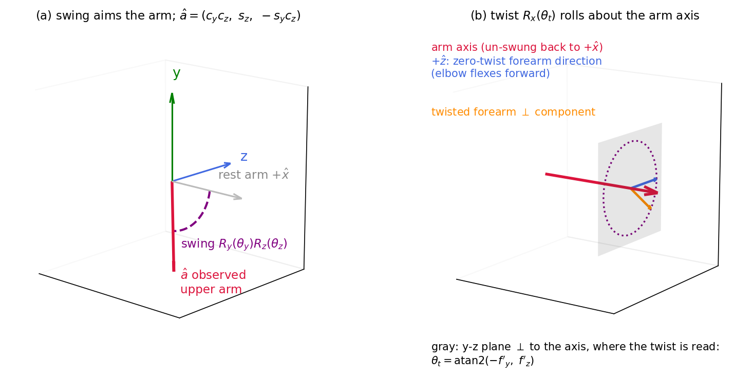
Figure 3.7. The swing-twist decomposition. (a) The swing aims the rest direction +x of the arm into the observed direction â. (b) The twist rolls about the arm axis.
The swing angles follow from the components of ${}_{ }^{L12}{\hat{a}}$. Its y component is $s_{z}$, so
 | $t_{z} = asin\left(a_{y}\right),$ | (3.20)
the elevation of the arm, positive upward and restricted to -90 to +90 degrees. The x and z components share the factor $c_{z}$, which cancels in the two-argument arctangent:
 | $t_{y} = atan2\left(−a_{z}, a_{x}\right),$ | (3.21)
the azimuth of the arm, positive when sweeping backward. It is undefined for the arm pointing straight up or straight down ($t_{z} = ±90°$), where the x and z components both vanish. The convention $t_{y} = 0$ is applied there, and any axial rotation folds into the twist.
A rotation about the arm axis is only visible in the plane perpendicular to it, so the procedure undoes the swing first, making that plane the y-z plane of the shoulder frame. The matrix product below is a rotation operator given by its axes and its angles, not a frame-relative rotation, so it carries no pair of frame labels. Its input and output are described in the shoulder frame L12:
 | ${}_{ }^{L12}{f′} = R_{z}\left(−t_{z}\right) R_{y}\left(−t_{y}\right) {}_{ }^{L12}f,$ | (3.22)
where ${}_{ }^{L12}f$ is the forearm vector in the parent frame of Section 3.3.3. Once the swing is undone, the nonzero perpendicular component of ${}_{ }^{L12}{f′}$ points along the +z axis of L12 at zero twist. Under a twist $t_{t}$, its unit direction in the (y, z) plane is $\left(−sin t_{t}, cos t_{t}\right)$, so the twist reads
 | $t_{t} = atan2\left(−{f′}_{y}, {f′}_{z}\right).$ | (3.23)
The two components the arctangent reads are components of the rotated vector ${}_{ }^{L12}{f′}$ in the shoulder frame L12. The twist is positive for internal rotation, where the forearm rotates downward from forward.
The left arm is solved on mirrored inputs. Both left segment vectors are expressed in the root basis and their x components flipped with $M = diag\left(−1, 1, 1\right)$, the sagittal mirror. The same right-arm solver then runs on the result, so a mirror-symmetric pose gives identical angles on both sides with the same anatomical meaning.

3.4.3 Elbow Flexion and Extension
The elbow is solved in the elbow frame L14 of Section 3.3.3. Its orientation in the y-up camera frame is ${}_{L14}^{Camera'}R = {}_{L24}^{Camera'}R {}_{L12}^{L24}R {}_{L14}^{L12}R$, where the middle factor is the identity of equation (3.13) and the last the solved shoulder rotation of equation (3.18). The unit forearm direction there is ${}_{ }^{L14}{\hat{g}} = \frac{{\left({}_{L14}^{Camera'}R\right)}^{T} \left({}_{ }^{Camera'}{P_{16}} − {}_{ }^{Camera'}{P_{14}}\right)}{\left|{}_{ }^{Camera'}{P_{16}} − {}_{ }^{Camera'}{P_{14}}\right|}$, and its swing is read from the components of ${}_{ }^{L14}{\hat{g}}$ as at the shoulder:
 | $e_{z} = asin\left(g_{y}\right), e_{y} = atan2\left(−g_{z}, g_{x}\right).$ | (3.24)
Here $e_{y} = 0$ is a straight arm and $e_{y} = −90$ is a right angle bend, the hinge angle labelled in Figure 3.6.
The angle $e_{z}$ is always zero. The shoulder twist aligns the perpendicular component of the forearm with local +z, so the flexion plane is already the x-z plane of the elbow frame by the time the elbow is solved. That closes the dimension count: two measured segment directions give four observable degrees of freedom and the model extracts four independent angles. The angle $e_{z}$ stays among the streamed angles for generality but holds no independent information.
A three-landmark arm breaks down in one case. When the arm is straight, the forearm is parallel to the upper arm, its perpendicular component vanishes, and no algebra can recover a roll about an axis from two collinear segments. The solver detects this when the forearm lies along the upper arm axis and the perpendicular part of the forearm vanishes against its length, applies $t_{t} = 0$ so the elbow frame stays defined, and flags the twist as unobservable; later stages hold the last valid value. A nearly straight elbow leaves the flexion well conditioned but makes the twist sensitive to noise, a limitation Chapter 9 discusses.

3.4.4 The Wrist as a Tracked Point
The wrist L16 is not a solved joint. It enters as a tracked 3D point, as Figure 3.6 draws it, and does two jobs: it gives the forearm direction the elbow flexion is read from, and it makes the shoulder twist observable.
A full three-degree-of-freedom wrist orientation would need a landmark beyond the wrist. Forearm pronation, the roll of the forearm about its own axis, does not move the wrist point, so no algebra over these landmarks can observe it. The tracked position is still kept and transmitted, and when the landmark is lost during a grip the recovery in Chapter 5 rebuilds it with an additional geometric constraint from the object pose. A hand model such as [41] would attach at the same point.

3.5 Worked Example
Frame 533 of the rail recording, drawn in Figure 3.3, is taken while the cube slides along the rail in the task of Chapter 2. All eight landmarks are measured on it, none flagged by the despiking stage or filled by the gap-bridging stage of Section 2.5, and no failure detector of Chapter 5 fires on it. Values are computed from the unrounded positions and printed rounded to two decimals, so a step recomputed by hand from the printed inputs can differ by several degrees where the arguments are small. The two-argument arctangent of the printed 0.06 and 0.03 gives 63.4 degrees, while the unrounded values give the 59.9 degrees printed below.
Table 3.1 lists the eight landmark positions in both frames, after the filtering of Section 2.5 and before the hip depth preparation of Section 2.6. The same frame runs through the worked examples of Appendix C, Appendix D and Appendix E.
Landmark | Camera (m) | Camera' (m)
L11 left shoulder | (0.22, -0.34, 1.36) | (0.22, 0.34, 1.36)
L12 right shoulder | (-0.16, -0.33, 1.31) | (-0.16, 0.33, 1.31)
L13 left elbow | (0.28, -0.03, 1.38) | (0.28, 0.03, 1.38)
L14 right elbow | (-0.20, -0.04, 1.19) | (-0.20, 0.04, 1.19)
L15 left wrist | (0.24, 0.20, 1.25) | (0.24, -0.20, 1.25)
L16 right wrist | (-0.20, 0.11, 1.06) | (-0.20, -0.11, 1.06)
L23 left hip | (0.12, 0.18, 0.99) | (0.12, -0.18, 0.99)
L24 right hip | (-0.06, 0.19, 0.99) | (-0.06, -0.19, 0.99)
Table 3.1. The eight landmarks of the worked-example frame in the sensor frame and in the y-up camera frame, printed to two decimals. Each column carries the frame its entries are expressed in, the left superscript of the position symbols used from here on. The conversion flips only the sign of y, and the hips read negative in the y-up camera frame because they sit below the camera height.
The torso construction of Section 3.2 needs three of these points:
$\begin{aligned}{}_{ }^{Camera'}{P_{23}} = (0.12, −0.18, 0.99) \\ {}_{ }^{Camera'}{P_{24}} = (−0.06, −0.19, 0.99) \\ {}_{ }^{Camera'}{P_{12}} = (−0.16, 0.33, 1.31).\end{aligned}$
Equations (3.7) and (3.8) give the hip line, 0.18 m long, and the spine-side vector, 0.63 m long. The cross products of equations (3.9) and (3.10) close the frame:
$\begin{aligned}{}_{ }^{Camera'}{{\hat{X}}_{L24}} = (−1.00, −0.05, −0.04) \\ {}_{ }^{Camera'}{{\hat{Z}}_{L24}} = (0.01, 0.53, −0.85) \\ {}_{ }^{Camera'}{{\hat{Y}}_{L24}} = (−0.06, 0.85, 0.53).\end{aligned}$
The x component of ${}_{ }^{Camera'}{{\hat{X}}_{L24}}$ is close to -1, and ${}_{ }^{Camera'}{{\hat{Z}}_{L24}}$ is tipped upward by the hip-to-shoulder depth difference. Equation (3.11) assembles the columns:
${}_{L24}^{Camera'}R = \left[\begin{matrix}−1.00 & −0.06 & 0.01 \\ −0.05 & 0.85 & 0.53 \\ −0.04 & 0.53 & −0.85\end{matrix}\right].$
Appending the origin ${}_{ }^{Camera'}{P_{L24ORG}} = {}_{ }^{Camera'}{P_{24}}$ gives the root pose of equation (3.12) as numbers:
${}_{L24}^{Camera'}T = \left[\begin{matrix}−1.00 & −0.06 & 0.01 & −0.06 \\ −0.05 & 0.85 & 0.53 & −0.19 \\ −0.04 & 0.53 & −0.85 & 0.99 \\ 0 & 0 & 0 & 1\end{matrix}\right].$
Equation (3.13) needs the shoulder landmark in the torso's own coordinates, which equation (3.4) gives as (0.07, 0.63, 0.00). The forward offset is zero, since the spine-side vector lies in the torso plane by construction:
${}_{L12}^{L24}T = \left[\begin{matrix}1 & 0 & 0 & 0.07 \\ 0 & 1 & 0 & 0.63 \\ 0 & 0 & 1 & 0.00 \\ 0 & 0 & 0 & 1\end{matrix}\right],$
an identity rotation with a pure origin shift. Equation (3.17) decodes the root matrix:
$\begin{aligned}x = asin\left(−0.53\right) = −32.1° \\ y = atan2\left(0.01, −0.85\right) = 179.5° \\ z = atan2\left(−0.05, 0.85\right) = −3.3°.\end{aligned}$
Compared with the T-pose (0, 180, 0), the subject faces almost straight at the sensor and the hip line is almost level. The frame is pitched by 32.1 degrees because the hips sit nearer the camera than the shoulders. The two hip landmarks fall on the pixels where the pelvis meets the rail, so the depth sampled there is the depth of the rail, 0.99 m against 1.31 and 1.36 m at the shoulders. Chapter 5 describes this kind of failure. The pipeline replaces the hip depth with the preparation of Section 2.6 before it solves, and the numbers of this section are taken before that replacement. The arm angles below are read against the pitched frame, and these three values are the torso pose of Section 3.4.1.
The y-up camera-frame upper arm vector of the right arm is
${}_{ }^{Camera'}v = {}_{ }^{Camera'}{P_{14}} − {}_{ }^{Camera'}{P_{12}} = (−0.04, −0.29, −0.12),$
with length 0.32 m. Equation (3.3) pulls it into the parent frame and normalizing gives the local arm direction:
$\begin{aligned}{}_{ }^{L24}v = {\left({}_{L24}^{Camera'}R\right)}^{T} {}_{ }^{Camera'}v = (0.05, −0.31, −0.05) \\ {}_{ }^{L12}{\hat{a}} = (0.17, −0.97, −0.16).\end{aligned}$
The upper arm points slightly outward, strongly downward and slightly behind the pitched torso plane, since +x for this right arm points outward to the subject's right. Figure 3.3(b) shows that pose, the right arm reaching down to the cube. The same two steps on the forearm give
${}_{ }^{L12}f = {\left({}_{L24}^{Camera'}R\right)}^{T} \left({}_{ }^{Camera'}{P_{16}} − {}_{ }^{Camera'}{P_{14}}\right) = (0.01, −0.20, 0.03),$
with length 0.20 m. Equations (3.20) and (3.21) read the two swing angles of the right arm (Figure 3.6):
$\begin{aligned}t_{z} = asin\left(−0.97\right) = −76.6° \\ t_{y} = atan2\left(0.16, 0.17\right) = 43.0°.\end{aligned}$
The arm points 76.6 degrees below horizontal, and equation (3.22) undoes this swing on the forearm vector:
${}_{ }^{L12}{f′} = R_{z}\left(76.6°\right) R_{y}\left(−43.0°\right) {}_{ }^{L12}f = (0.19, −0.06, 0.03).$
Its perpendicular part points mostly along negative y. Equation (3.23) gives the twist:
$t_{t} = atan2\left(0.06, 0.03\right) = 59.9°.$
The forearm turns inward across the front of the body, an internal rotation. In the elbow frame, the forearm direction is
${}_{ }^{L14}{\hat{g}} = (0.94, 0.00, 0.34).$
Its y component is zero, the $e_{z} = 0$ property of Section 3.4.3 on the measured frame. The flexion of equation (3.24) is
$e_{y} = atan2\left(−0.34, 0.94\right) = −19.8°.$
The solved shoulder rotation and the local upper-arm vector ${}_{ }^{L24}v$ complete the last transformation of equation (3.5), the elbow pose of equation (3.14):
${}_{L14}^{L12}T = \left[\begin{matrix}0.17 & 0.95 & −0.27 & 0.05 \\ −0.97 & 0.12 & −0.20 & −0.31 \\ −0.16 & 0.30 & 0.94 & −0.05 \\ 0 & 0 & 0 & 1\end{matrix}\right].$
Its first column is exactly ${}_{ }^{L12}{\hat{a}}$ and its last column is the elbow position in the shoulder frame. The numeric chain closes with two checks. The product of the three matrices of equation (3.6), applied to the origin, $\left[\begin{matrix}{}_{ }^{Camera'}{P_{L14ORG}} \\ 1\end{matrix}\right] = {}_{L14}^{Camera'}T {\left(0, 0, 0, 1\right)}^{T}$, lands on (-0.20, 0.04, 1.19), the measured elbow position of Table 3.1, to machine precision. Equation (3.4) applied three times carries the measured wrist through the inverse chain into the elbow frame, $\left[\begin{matrix}{}_{ }^{L14}{P_{16}} \\ 1\end{matrix}\right] = {\left({}_{L14}^{Camera'}T\right)}^{−1} \left[\begin{matrix}{}_{ }^{Camera'}{P_{16}} \\ 1\end{matrix}\right]$. The result is (0.19, 0.00, 0.07), whose length is the forearm length 0.20, and dividing by that length reproduces the ${}_{ }^{L14}{\hat{g}}$ used for the flexion.
The left arm runs through the same mirrored solver and gives a shoulder azimuth of 76.1 degrees, an elevation of -53.5 degrees, a twist of 108.9 degrees and an elbow flexion of -37.3 degrees, the arm hanging at the side in Figure 3.3(b). The stored pose has thirteen angular values: three root Euler angles, two shoulder swing angles, shoulder twist and elbow flexion for each arm, plus the two redundant elbow elevation fields, eleven of them independent.
Appendix H records the verification of the chapter's mathematics against synthetic exact references. A missing or misplaced landmark leaves that arm without a state. Chapter 5 supplies an additional geometric constraint from the object Chapter 4 tracks. Chapter 6 carries the finished state into the reconstruction.

