Chapter 4: Object Tracking and Scene Reconstruction
Chapter 2 left the marker branch at its raw product: each detected marker's pose relative to the camera. This chapter builds that pose into an independent branch that describes the carried object in the same calibrated metric scene. Appendix E covers the conversion of a detection into a pose.

4.1 World Anchoring and Camera Placement Invariance
The static calibration of Section 2.2.2 fixed the world frame at the desk marker and the other quantities of the scene. Every pose the detector returns is expressed relative to the camera, which is the wrong frame for a reconstruction: the same cube on the same spot gives a different camera-relative pose when the camera moves to another corner of the room. The object must instead be expressed relative to the desk marker's own frame, the world frame W. Figure 2.5 draws the three frames of the chain: the camera frame C, the world frame W at the desk marker, and the object frame O, which moves with the cube.
Figure 4.1 shows the object marker as the camera sees it at four moments of the task. On each frame the outline and the axes drawn on the cube are the pose the detector returns for its marker in the camera frame. The axes on the desk marker show the per-frame detected estimate of the world frame W, while the reconstruction uses the frozen calibrated anchor.
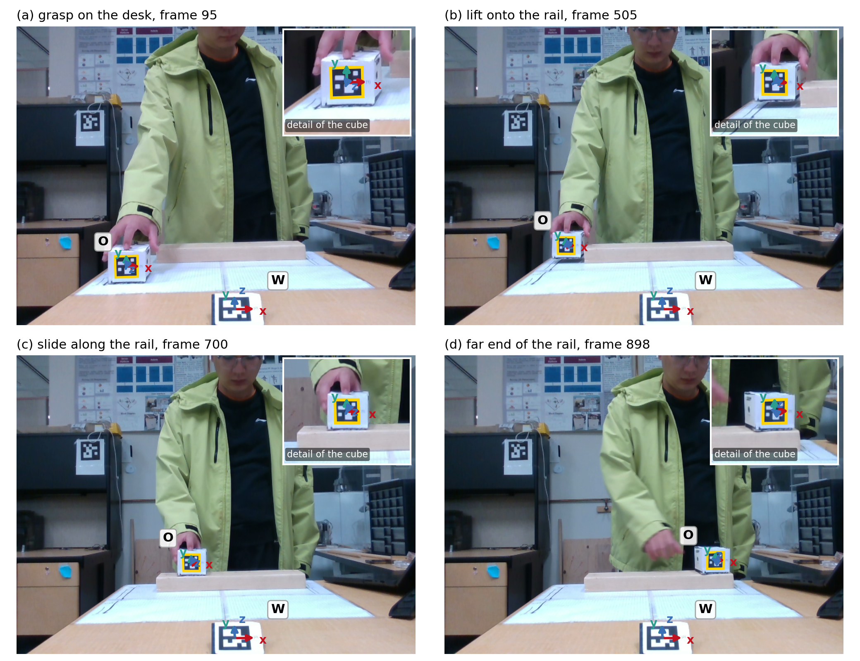
Figure 4.1. The object marker: (a) on the desk, frame 95; (b) lifted, frame 505; (c) sliding, frame 700; (d) the rail end, frame 898. The wall marker is omitted.
The marker branch writes each pose as the 4 by 4 homogeneous transformation of Chapter 3. The calibrated anchor ${}_{World}^{Camera}T$ maps a point of the world frame into camera coordinates, and the per-frame object pose ${}_{Object}^{Camera}T$ maps a point of the object frame into camera coordinates. Both are available on any frame on which the cube is seen. The chain must deliver ${}_{Object}^{World}T$, the object as seen from the world, and only one path connects the two frames:
 | ${}_{Object}^{World}T = {}_{Camera}^{World}T {}_{Object}^{Camera}T.$ | (4.1)
The first factor is the inverse of the calibrated anchor, ${}_{Camera}^{World}T = {\left({}_{World}^{Camera}T\right)}^{−1}$, which equation (3.4) gives as a transpose and one matrix-vector product. Its translation column is the camera's own position in the world frame, so the camera pose in the reconstructed scene comes from the anchoring without a separate measurement. Chapter 6 places the sensor in the Unity scene at that pose.
The chain makes the reconstruction independent of the location where the camera is set up. Both measured transformations change when the camera moves, but the camera frame enters equation (4.1) twice, as the described frame of the inverted anchor and as the reference frame of the object pose. Those two labels are adjacent in the product and cancel, so the remainder depends only on the cube's position relative to the desk. They cancel only if the anchor and the object pose are measured from the same camera position. On a recording the anchor is the frozen one of Section 2.2.2. The reconstruction is therefore invariant to a camera placed differently before the calibration window. A camera moved after that window breaks the invariance. The camera stands on a fixed support at the desk edge for the whole session. The world frame and the Unity frame are defined in Section 2.2.1, and Chapter 6 converts between them before anything is drawn.

4.2 Filtering and Cleaning the Object Track
The track that Section 4.1 delivers holds one entry per frame in the world frame, with a flag that records the marker's detection status. It passes a signal filter, the Pipeline B counterpart of the landmark filtering of Section 2.5, and then a single cleaning step against marker failure.
The filter runs the three stages of Section 2.5 over the track, with rotation added to each and with its own parameters, among them a bridging limit of eight frames rather than five. A spiked pose solution is wrong as a whole, so the despike test on position drops its rotation along with its position. Bridging turns along the shortest path between the endpoint rotations. A run at either end of the recording holds the first or the last valid pose, and an interior run longer than the bridging limit holds the valid pose before it. The smoothing stage runs a Savitzky-Golay filter on position [46]. On rotation the filter takes a rolling chordal mean, equation (2.1) applied to the world-frame object rotations over a short window.
The detection flag passes through every stage unchanged. A row the marker was never seen on stays marked as not detected, and a despiked sample keeps its incoming flag while carrying the bridged pose. The raw track is kept unmodified in its own output. Figure 4.2 shows the track before and after the filter.
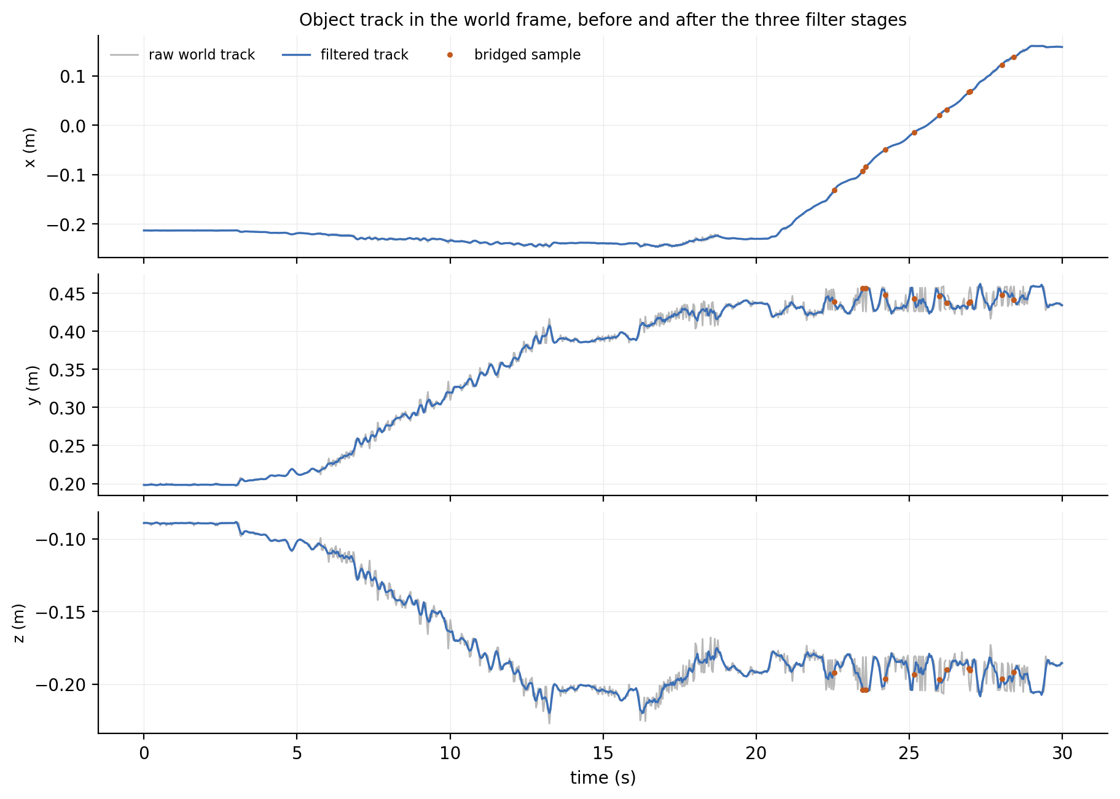
Figure 4.2. The object marker origin in the world frame, one panel per axis: grey detected, blue filtered, orange the eleven bridged rows, ten despiked and one undetected.
On the recording the hand never covers the marker, and the detector returns a pose on 899 of the 900 frames. The filter bridges that one undetected row along with the ten the despike test emptied. The held case of the filter, which the recording does not show, has a physical cause. A hand closing over the marker leaves the detector with nothing for longer than the bridging limit, so the track stays where the cube was last seen. Chapter 9 shows such a loss on the loop recording.
The branch ends with two cases, and neither clears the detection flag. A detected row beside a held run is smoothed together with that run, so its pose can drift from the detection on its own frame while it still carries the detected flag. A partly covered marker, which the recording does not show either, may decode into a pose that is not right.
The cleaning step at the end of the branch answers both cases. No later stage carries marker logic of its own: the recovery of Chapter 5, the streaming of Chapter 6, and the evaluation of Chapter 7 read the same cleaned track, and Section 8.2 gives the timing of the cleaning step in the live path.
The rule is physical, carries no tuning to a particular recording, and walks the track forward. It keeps a sample only if the marker was detected, the pose is finite, and the step from the last kept sample is no larger than the task's slow movement can produce in the time between the two:
 | $\begin{aligned}\left\|{}_{ }^{Unity}{P_{ObjectORG}}\left(i\right) − {}_{ }^{Unity}{P_{ObjectORG}}\left(last\right)\right\| ≤ v_{max} \left(t_{i} − t_{last}\right) \\ angle\left({}_{MappedMarker(i)}^{MappedMarker(last)}R\right) ≤ w_{max} \left(t_{i} − t_{last}\right).\end{aligned}$ | (4.2)
Equation (4.2) uses the Unity frame of Section 2.2.1, because the rule reads the Unity copy of each row. That frame exchanges two coordinates of the world frame, which changes no distance and no relative angle, so the rule bounds the same two quantities in either frame. In that frame the object's own axes are the mapped marker axes, which Chapter 6 obtains by applying that exchange to both sides of the object rotation. The rule forms the second bound from the two orientations of the Unity copy, ${\left({}_{MappedMarker(last)}^{Unity}R\right)}^{T} {}_{MappedMarker(i)}^{Unity}R$, in which the reference frame cancels and leaves the relative rotation between the two samples.
The two bounds are rates rather than fixed steps: $v_{max}$ bounds the linear step and $w_{max}$ the angular step, each an allowance per unit of elapsed time between the candidate and the last kept sample. A real occlusion, during which the cube does travel, therefore leaves the rule ready to accept the marker when it is detected again. Measuring against the last kept sample rather than the previous row keeps one bad pose from dragging the track behind it. Both bounds carry a margin of about a factor of two over the largest step the clean parts of the recording show, so the rule is a guard.
A sample that fails the test has its pose columns blanked and its detection flag cleared, and so does every row the marker was never detected on. A later stage reads filtered poses on the kept rows and blanks elsewhere, and on a blanked row it holds the last kept pose and flags it as held.

4.3 Worked Example
The transformation chain runs on frame 533 in the scene image of Figure 2.5, the worked-example frame of Chapter 3, where the subject holds the cube against the rail and its marker is cleanly detected. The cleaning step runs on frame 786, the one frame of the recording on which the marker is not detected.
Vectors and matrices are printed to two decimals. Averaging the ten desk rotations of the calibration window element by element gives
${}_{World}^{Camera}{\bar{M}} = \left[\begin{matrix}1.00 & 0.00 & −0.02 \\ −0.02 & −0.48 & −0.88 \\ −0.01 & 0.88 & −0.48\end{matrix}\right],$
which is not a rotation matrix, since its determinant is not exactly one and its columns are only nearly perpendicular. Equation (2.1) projects it back onto the nearest rotation, and at the precision printed here no entry changes, because the ten input rotations disagree so little. With the mean of the ten translations, the projected rotation forms the frozen anchor ${}_{World}^{Camera}T$. That anchor puts the calibrated desk marker 55.3 cm in front of the camera and 18.7 cm below it.
The same calibration gives the scene description of Section 2.2.2. Gravity, taken from the wall marker, is the unit direction ${}_{ }^{World}{\hat{g}} = (−0.02, 0.53, 0.85)$, at 32.0 degrees to the world z axis, which is the tilt of the desk marker card on its stand. The world origin sits 3.8 mm below the horizontal tabletop model of Section 2.2.2.
Transposing the anchor rotation gives ${}_{Camera}^{World}R$, and applying it to the negated translation gives the inverted anchoring transformation of equation (3.4),
${}_{ }^{World}{P_{CameraORG}} = −{}_{Camera}^{World}R {}_{ }^{Camera}{P_{WorldORG}} = (−0.01, −0.39, 0.43) m,$
which puts the camera 58.4 cm from the world origin and 15.4 cm above the same tabletop model.
The chain of equation (4.1) runs on the scene image. The object marker is detected there, and its origin in the camera frame is
${}_{ }^{Camera}{P_{ObjectORG}} = (−0.21, 0.16, 1.02) m.$
The cube is therefore 106 cm from the camera, on the rail in front of the subject. Multiplying the inverted anchoring transformation by that object transformation gives one expression for each block: the transposed anchor rotation multiplies the object rotation and the object translation, and the translation block also includes the camera position:
$\begin{aligned}{}_{Object}^{World}R = {}_{Camera}^{World}R {}_{Object}^{Camera}R \\ {}_{ }^{World}{P_{ObjectORG}} = {}_{Camera}^{World}R {}_{ }^{Camera}{P_{ObjectORG}} + {}_{ }^{World}{P_{CameraORG}}.\end{aligned}$
Adding the camera position to the transformed object translation gives the world translation, with the rotation product beside it:
$\begin{aligned}{}_{ }^{World}{P_{ObjectORG}} = (−0.24, 0.43, −0.19) m \\ {}_{Object}^{World}R = \left[\begin{matrix}1.00 & 0.01 & 0.07 \\ 0.05 & 0.52 & −0.85 \\ −0.05 & 0.86 & 0.52\end{matrix}\right].\end{aligned}$
Projected onto ${}_{ }^{World}{\hat{g}}$, the marker centre is 6.3 cm above the tabletop model. The cube is held against the rail at that instant, and the rail height measured with a tape puts the cube centre 7.3 cm above the tabletop. The comparison uses marker-centre height in place of cube-centre height for this mounting and orientation. The sources of the discrepancy have not been separated.
For the cleaning step, the object marker is seen on frames 785 and 787, at world x 3.0 cm and 3.4 cm, and the detector returns nothing on frame 786 between them. The gap is one frame, inside the bridging limit of eight, so the filter bridges it. The bridged position sits 1.0 mm from the mean of the two detections beside it.
The rule then walks the filtered track. Frame 786 is 3.3 mm and 1.2 degrees from the last kept sample, frame 785, well inside the allowance. The marker was never seen on it, so the row is blanked. Frame 787, two frame intervals later, is 4.9 mm from frame 785 and is kept. The rule rejects no detected sample anywhere in the recording.
The frozen scene fixes the desk, gravity, tabletop, camera and cube edge of Table 2.1 in one frame. The cleaned track gives a measured cube pose, a marked gap where the marker was missed, and the marker identity on each row. A grip ties the branches together in Chapter 5, constraining the carrying arm. Chapter 6 streams the position and orientation. Section 7.2 evaluates the track against the physical route; a line fit to the slide samples describes spread, not accuracy. No second measurement chain checks the streamed orientation.

