Chapter 6: System Integration and Graphical Reconstruction
Chapters 2 to 5 leave two measurement branches in one calibrated scene. The landmark branch of Chapters 3 and 5 delivers, for every frame, a pelvis position in the y-up camera frame {Camera'}, thirteen joint angles, and the state the recovery layer gave each joint group, measured, held or constrained. The marker branch of Chapters 2 and 4 delivers a cleaned track of the carried object in the world frame. This chapter renders both in one Unity scene.

6.1 Communication Architecture
Unity performs no measurements and runs no solver. The receiver composes the transforms of Sections 6.2 to 6.4 from the streamed values, so Unity holds no second implementation of the kinematic model of Chapter 3.
Figure 6.1 shows the processes at run time.
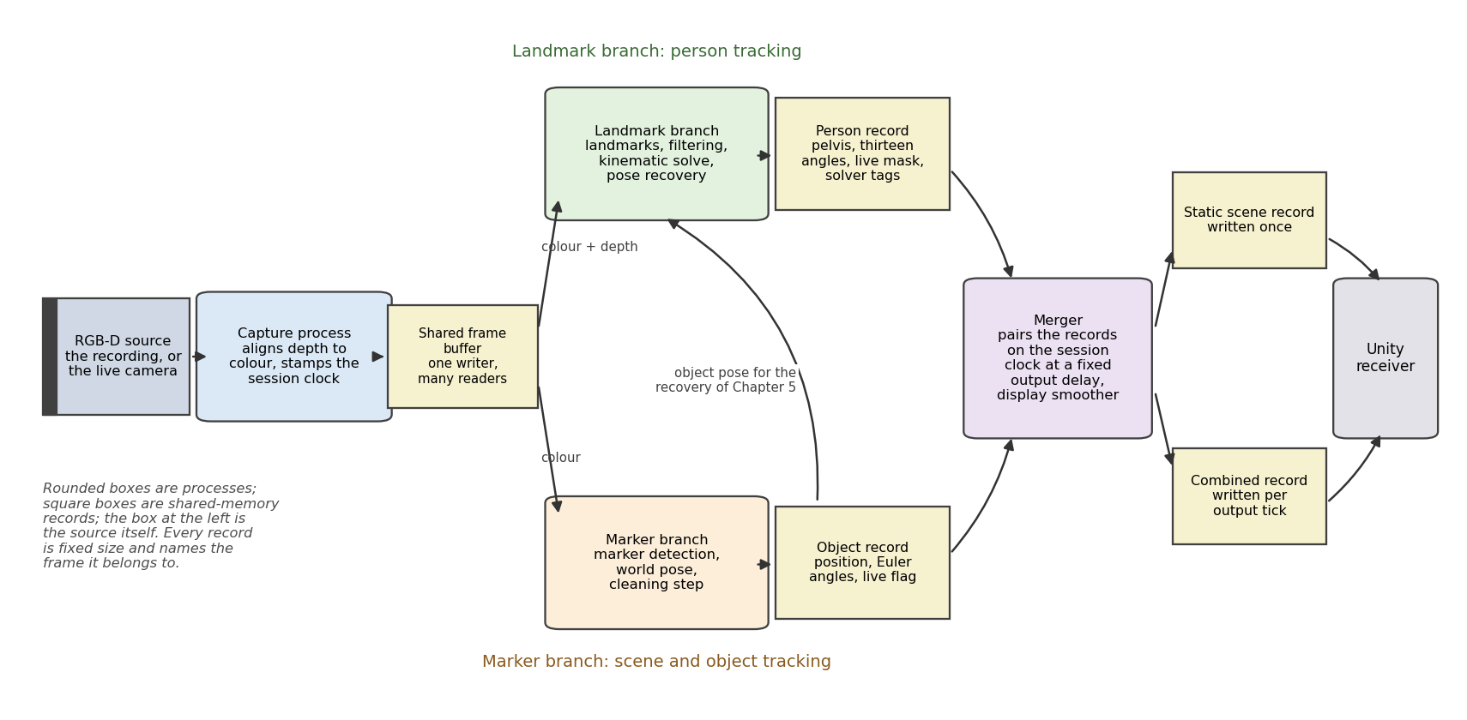
Figure 6.1. The integration architecture: the capture process, the two branches, the link from the landmark branch to the object record, and the merger that feeds the display.
The two branches run as independent processes. The marker branch imports nothing from the landmark branch. The landmark branch accesses the marker branch only through the link, which reuses the marker branch's swap and Euler routines to read the object record.
The frame buffer carries the images from the capture process to the two branches; Unity never reads it. The four records of Table 6.1 carry the computed numbers between the branches, the merger and Unity, which reads the scene record once and the combined record on every rendered frame.

6.1.1 The Frame Buffer: Capture Process to the Branches
Only the capture process opens the source, since two processes cannot share one camera. It aligns the depth frame to the colour frame once and stamps each frame with a session timestamp from the sensor's hardware timestamps. It then publishes the pair into a shared frame buffer with one writer and any number of readers.
The buffer is a ring of eight slots, one aligned colour and depth pair in each (Figure 6.2). The session timestamp is the hardware timestamp less the clock origin held in the header. The capture process numbers the frames as it publishes them, and that frame index travels in every record that describes the frame. Frame n lands in slot n modulo 8, so a reader has eight frames, about a quarter of a second at the sensor's 30 frames per second, before the writer comes round to that slot again.
A sequence counter on each slot separates a settled slot from one being written. The capture process never waits for a branch, so a branch that falls behind loses whole frames rather than reading a half-written one.
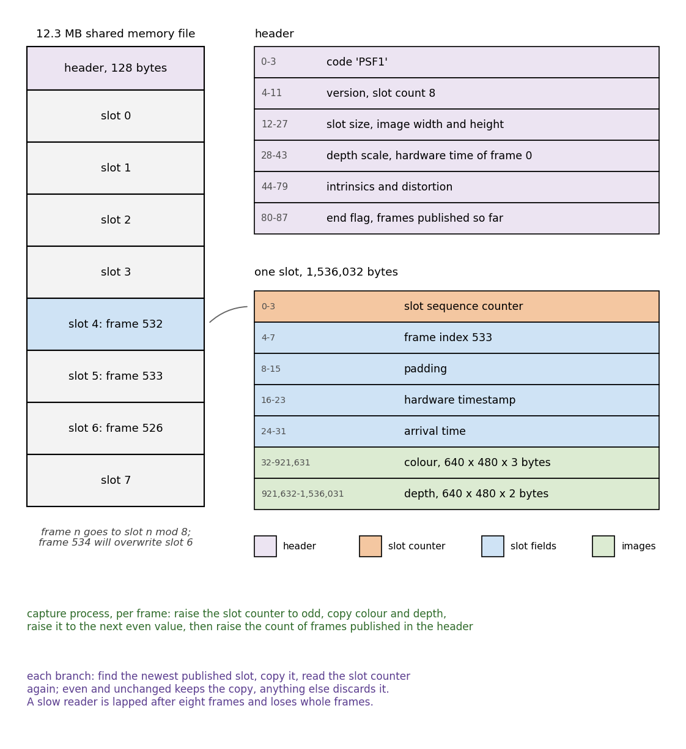
Figure 6.2. The frame buffer: the header, the eight slots, the byte layout of one slot, and the write and read steps. Frame 533 of the rail recording, traced in Section 6.5, sits in slot 5, since frame n goes to slot n modulo 8.
Both branches see the same aligned frame, so a shared frame index means the same captured instant on both sides. The capture process also selects the source, a recording or the camera, so no later stage needs to know which it is. Section 8.5 lists the remaining requirements of a live session.

6.1.2 The Records: Branches to the Merger and Unity
The person, object, scene and combined records are blocks of shared memory of one shape: a four-character code, a sequence counter, the frame or tick described, and the payload in a fixed byte order. Each carries the output of one stage to the next under the counter rule of Section 6.1.1. The person record is 84 bytes, the object record 44 and the scene record 100. Table 6.1 sets out each record's contents, its writer and its frequency, and Figure 6.3 gives the byte layout of the combined record.
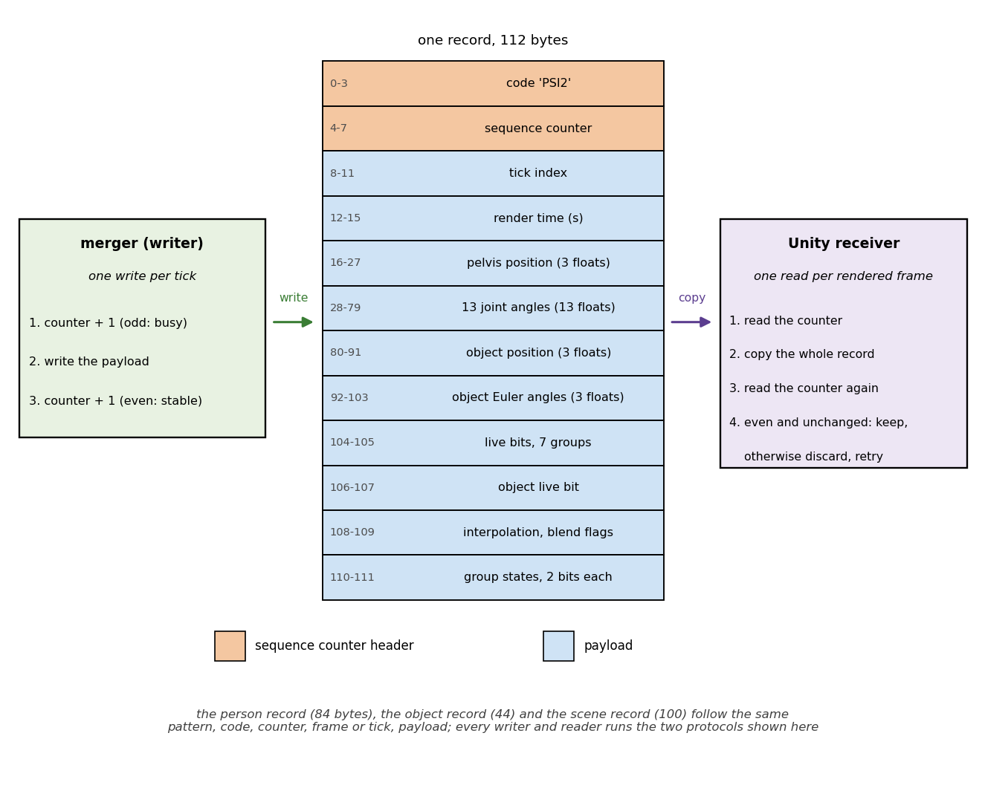
Figure 6.3. The combined record as a memory block: 112 bytes with their offsets, the merger's write protocol on the left and the receiver's read protocol on the right.
Record | Code | Written by | Rate | Contents
frame buffer | PSF1 | capture process | per frame | slot: aligned colour and depth images, frame index, timestamps; header: image size, intrinsics, clock origin, frames published
person record | PSR2 | landmark branch | per frame | frame index, session timestamp, pelvis in {Camera'}, thirteen angles, live bit and state per group
object record | PSB2 | marker branch | per frame | frame index, session timestamp, object pose in display axes, live bit down when unmeasured
scene record | PSB3 | merger | once | frozen scene description, Section 2.2.2, display axes
combined record | PSI2 | merger | per output tick | tick index, render time, pelvis, thirteen angles, object pose, per-group and object live bits, interpolation flags, group states
Table 6.1. The shared memory blocks. Every block is fixed size and begins with its four-character code. The records carry the sequence counter in their header, the frame buffer in each slot.
The live bit of a joint group indicates the measured status of that group on this frame. Its state is measured, held or constrained in the sense of Chapter 5.
The link crosses in one direction only: the landmark branch reads the object record, because the wrist recovery of Chapter 5 needs the object pose. Bringing that pose back into the camera frame undoes the axis swap of Section 6.2 into the world frame, then applies the calibrated pose of the world frame in the camera frame from Section 2.2.2. The link rejects a record whose frame index sits more than three frames from the frame being solved.
The merger keeps a short buffer of recent samples from each output stream and emits 30 ticks per second. Each tick renders the world at a render time on the session clock two frame intervals behind the tick, not at the newest sample. That offset is the configured buffering and render delay described in Section 8.2. By that render time both branches usually hold a sample to pair. Only samples whose live bit is up enter the object buffer.
Each stream leaves the merger in one of four states: measured, interpolated, held or blended. A stream is measured when a sample lands on the render time and interpolated when the render time falls between two samples no more than three frame intervals apart. The merger holds it across a longer gap, and blends the held pose into the next sample over two ticks. The merger interpolates the angles component by component, and the object pose in display axes by a straight line in position with a shortest-arc path in orientation.
The record's flags mark a stream as interpolated or blended, and distinguish an interpolation that bridged a dropout from one that only resampled between two adjacent frames. A held person shows in its group states. A held object lowers the object live bit of the combined record once its last sample is more than half a second older than the render time. The group states travel through the same buffer, ordered measured, held, constrained. On an interpolated tick each group takes the higher of the two states in that order, and on a held tick the merger raises every group to at least held.

6.2 Coordinate System Conversion
The two branches reach the display through four frames, drawn in Figure 6.4.
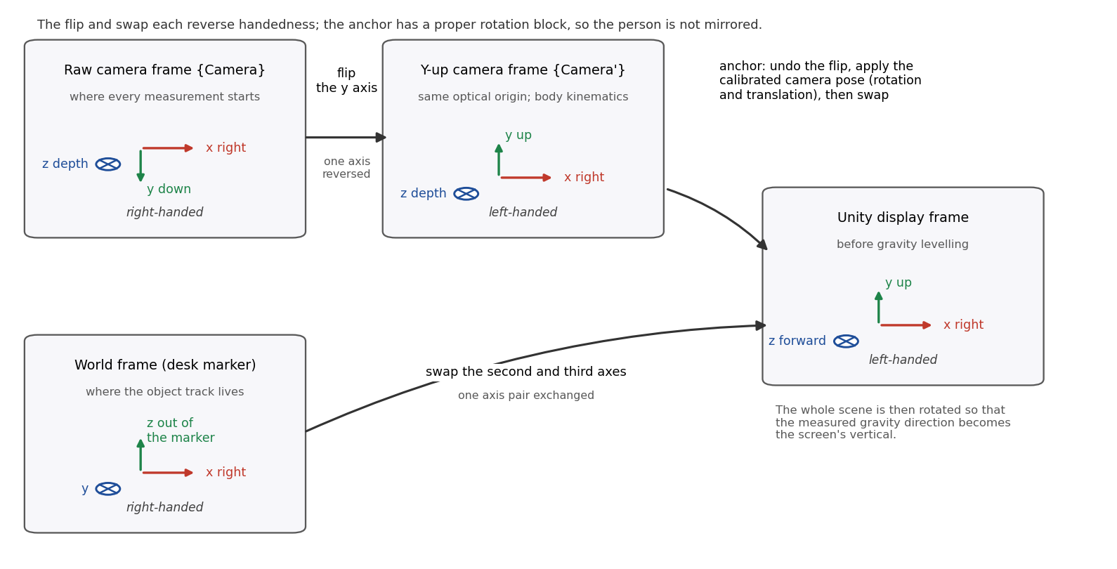
Figure 6.4. The four frames of the coordinate conversion before gravity alignment, with the path of each branch to the display. Section 6.4 completes the mapping to the scene frame.
The landmark branch works in the y-up camera frame {Camera'}, which shares the optical centre of {Camera} and flips only its y axis through F of Section 3.1. The marker branch works in the desk-anchored world frame of Section 2.2.1. Unity uses left-handed coordinates [47]. The swap S exchanges the second and third world coordinates into the display frame {Unity}; its second axis follows the desk marker normal until gravity alignment is applied,
 | $\begin{aligned}{}_{ }^{Unity}P = S {}_{ }^{World}P \\ {}_{MappedMarker}^{Unity}R = S {}_{Object}^{World}R S \\ S = \left[\begin{matrix}1 & 0 & 0 \\ 0 & 0 & 1 \\ 0 & 1 & 0\end{matrix}\right].\end{aligned}$ | (6.1)
Here S changes both the reference axes from {World} to {Unity} and the marker axes from {Object} to {MappedMarker}. Changing both bases requires conjugation. Changing only the reference basis requires left multiplication, as in the subsequent levelling and rig mapping. The swap is its own inverse, so the link of Section 6.1.2 undoes it by applying it again. Its determinant is minus one, as is that of the flip F, so each changes the handedness of the frame.
The two results do not land in the same place, because a y-up camera-frame point is expressed relative to the camera and a world point relative to the desk marker. The calibration of Section 2.2.2 froze the camera's own pose in the world, which Section 4.1 obtains by inverting the anchoring transformation, and that pose closes the gap. The inverse flip, equal to F because F is self-inverse, returns a y-up camera-frame point q to raw sensor coordinates. The calibrated camera orientation rotates it into the world, and the swap carries it into the display frame. The swapped camera position supplies the offset. Collecting the three linear maps into one matrix, and the whole map into one homogeneous transformation,
 | $\begin{aligned}{}_{ }^{Unity}P = {}_{Camera'}^{Unity}R {}_{ }^{Camera'}q + {}_{ }^{Unity}{P_{CameraORG}}, {}_{Camera'}^{Unity}R = S {}_{Camera}^{World}R F^{-1}, \\ \left[\begin{matrix}{}_{ }^{Unity}P \\ 1\end{matrix}\right] = {}_{Camera'}^{Unity}T \left[\begin{matrix}{}_{ }^{Camera'}q \\ 1\end{matrix}\right], {}_{Camera'}^{Unity}T = \left[\begin{matrix}{}_{Camera'}^{Unity}R & {}_{ }^{Unity}{P_{CameraORG}} \\ 0 & 1\end{matrix}\right],\end{aligned}$ | (6.2)
where ${}_{Camera}^{World}R$ and ${}_{ }^{World}{P_{CameraORG}}$ are the rotation block and the translation column of ${}_{Camera}^{World}T$, the calibrated camera pose in the world of Section 4.1. ${}_{Camera'}^{Unity}T$ is the same map as one homogeneous transformation matrix, the product of the 4 by 4 forms of the swap, ${}_{Camera}^{World}T$ and the flip. The determinant of ${}_{Camera'}^{Unity}R$ is minus one times plus one times minus one, so the two handedness changes cancel and the person arrives in {Unity} without a mirror image. The product combines two handedness-changing basis maps with the calibrated rigid transform [42]. The y-up camera frame and the display axes are both left-handed, so the algebra of the reference carries over, although its frames are right-handed and these are not.
The composition splits into a factor the display already has and a constant. Inserting the swap twice in the middle changes nothing. Regrouping then gives the anchor rotation as the calibrated camera orientation conjugated into display axes, times the fixed pair formed by the swap of equation (6.1) and the flip of equation (3.1). That pair is a rotation of minus ninety degrees about the x axis,
 | $\begin{aligned}{}_{Camera'}^{Unity}R = S {}_{Camera}^{World}R F^{-1} = S {}_{Camera}^{World}R \left(S S\right) F^{-1} = \left(S {}_{Camera}^{World}R S\right) \left(S F^{-1}\right), \\ {}_{MappedCamera}^{Unity}R = S {}_{Camera}^{World}R S, {}_{Camera'}^{MappedCamera}R = S F^{-1}, \\ S F^{-1} = \left[\begin{matrix}1 & 0 & 0 \\ 0 & 0 & 1 \\ 0 & 1 & 0\end{matrix}\right] \left[\begin{matrix}1 & 0 & 0 \\ 0 & −1 & 0 \\ 0 & 0 & 1\end{matrix}\right] = \left[\begin{matrix}1 & 0 & 0 \\ 0 & 0 & 1 \\ 0 & −1 & 0\end{matrix}\right] = R_{x}\left(-90 deg\right).\end{aligned}$ | (6.3)
The first factor is the orientation the display already uses to place the sensor body in the scene. It relates the display axes to the mapped camera frame, the sensor node's own system in the display, with the optical axis upward and the downward image direction forward. The receiver creates one static anchor node at the calibrated camera pose composed with the constant rotation. Every quantity from the person record passes through this node, positions as points and rotations by multiplying on the left. Conjugating a body rotation by the anchor would cancel the camera orientation out of the pose and turn the figure the wrong way.
The root orientation and the object pose travel as Euler angles in the fixed order the animation system uses [47], which is the order Section 3.4 decodes a rotation matrix into. The receiver rebuilds those two rotations from the three numbers. The arm angles travel as the joint coordinates of Section 3.4, which Section 6.3 reassembles.

6.3 Avatar Reconstruction in Unity
The avatar is a humanoid character supplied by the laboratory. The receiver drives five of its bones. The spine bone at the base of the trunk takes the root rotation and the position, and the upper arm and forearm of each side take the arm rotations. Everything else, the legs included, keeps its rest pose, since the eight tracked landmarks measure no leg.
The thirteen streamed angles reassemble five rotations. The root Euler triple rebuilds the trunk rotation directly. The shoulder swing pair and twist of Section 3.4 follow as axis-angle factors about the up, forward and right axes in that order. The elbow adds two angles about up and forward. The left arm repeats the pattern with every component except the twist reversed in sign, the sagittal mirror of Chapter 3.
Each reconstructed rotation relates two frames of the chain of Chapter 3: the root frame at landmark L24 in the y-up camera frame, the upper arm frame at landmark L14 in the root frame, and the forearm frame in the upper arm frame. The forearm frame has its origin at the wrist landmark L16 and its first axis along the forearm. Chapter 3 uses the elbow rotation as an operator on a vector while here it relates two frames, because the notation follows the way a rotation is used. The spine bone takes the root rotation alone, and the chain composition adds one factor per joint,
 | $\begin{aligned}{}_{L14}^{Camera'}R = {}_{L24}^{Camera'}R {}_{L14}^{L24}R, \\ {}_{L16}^{Camera'}R = {}_{L24}^{Camera'}R {}_{L14}^{L24}R {}_{L16}^{L14}R.\end{aligned}$ | (6.4)
The shoulder frame at landmark L12 inherits the orientation of the root frame, so the shoulder factor is equally the upper arm frame taken in that shoulder frame.
The rest pose is the first correction, since the receiver composes the chain product against it. Each driven bone carries two frames: the segment frame that the chain of equation (6.4) ends on, and the bone frame, the axes the rig's author gave that bone. Nothing is expressed in the bone frame; it is named because the rotation written to the bone relates it to the scene frame of Section 6.4. That rotation, taken one bone at a time, is
 | ${}_{Bone}^{Scene}R = {}_{Camera'}^{Scene}R {}_{Segment}^{Camera'}R {}_{Bone}^{Segment}R.$ | (6.5)
The leading factor includes the proper gravity alignment operator $G$ of Section 6.4:
${}_{Camera'}^{Scene}R = G {}_{Camera'}^{Unity}R.$
The receiver reads this global anchor rotation. The bone and segment axes are unchanged by the anchor, so the chain is left-multiplied rather than conjugated. The floor translation changes joint positions but not this orientation.
In equation (6.5), the leading factor is the orientation of the y-up camera frame in the scene frame. The trailing factor is the bone's rest rotation, captured when the scene starts, which absorbs the axis conventions built into the rig as a constant. Reading it as the relation between the segment frame and the bone's own axes rests on an assumption this thesis states rather than establishes.
The avatar is taken to be authored so that with every driven bone at its identity rotation it stands upright, its right side along the scene's first axis and its chest along the third. It is taken to be placed with no rotation, so the model's axes coincide with the scene axes when the scene starts. The model's zero configuration is then the reference configuration of Section 3.2.2, the T-pose that is the zero of every arm angle. The composition is correct only under that alignment. The setup therefore forces the T-pose first, rotating each arm segment straight out to the side, and captures the five rest rotations once the arms are aligned and the rig sized.
Proportions are the second correction. The landmark branch sends joint angles and one point, so the rendered hand ends up wherever the rig's bone lengths put it. The avatar setup scales the character uniformly to 170 centimetres. It then sizes the rig from five lengths supplied for the recording being replayed, the four arm segments and the trunk. The capture writes those five values to a file before the scene starts, and the receiver reads them there when the scene starts. Each arm length is the median of that segment over the landmark track of that recording, which is the length the recovery of Chapter 5 solved on. The avatar therefore reproduces the geometry the solver used.
The rail recording gives a right upper arm of 31.7 centimetres and a right forearm of 20.5, with a left upper arm of 31.0 and a left forearm of 25.7. The handover recording gives 24.1 and 23.3 centimetres on the right, with 25.2 and 22.3 on the left.
The trunk length is supplied in the same way, because it runs from the pelvis point the record carries to the mid-shoulder. This thesis defines that length by two rules, and each capture states which one it used. The rail and handover captures take the median distance from the recovery pelvis of Chapter 5 to the measured mid-shoulder, over the frames whose torso solve did not fail, on the filtered landmarks. That rule gives 57.5 centimetres over 620 frames on the rail recording and 51.7 centimetres over 1173 frames on the handover recording. That pelvis is the corrected point of the hip depth preparation of Section 2.6, which sits deeper than the raw hips.
The loop capture was not repeated and keeps its own five lengths. Its arms are 25.6 and 25.2 centimetres on the right and 26.2 and 24.7 on the left, again the medians of that recording's landmark track. Its trunk is 47.9 centimetres by the second rule, the distance from the raw hip midpoint to the mid-shoulder over the whole track.
Section 5.6 prints the rail lengths in the worked example of the recovery. Every length named here is a landmark median, so the recordings differ mainly in the split of the arm between the upper arm and the forearm. The totals of the right arm are 50.8 centimetres on the loop recording and 52.2 on the rail recording.
A direct measurement of the subject gives about 25 centimetres for both the upper arm and the forearm. That measurement is an independent anatomical comparison. It sets no length of the avatar and no length of the solver. The loop medians lie near it and the rail medians do not, which is consistent with the elbow landmark sitting farther along the arm on the rail recording. Scaling the trunk matters because the trunk moves the shoulder joints. Uniform scaling leaves every rotation unchanged.
A display smoother on the angles and the pelvis is the third correction; the processing side applies it to the angles and the pelvis as they enter the output record. The solver of Chapters 3 and 5 changes state in short ramps because its rate limits cap the distance a joint may move between frames. A linear low-pass alone cannot remove a ramp, only delay it, so the smoother pairs a first-order low-pass with a cap on the angle change per output tick. It changes only the displayed values; the processing side writes the tables Chapters 7 and 8 analyse before the smoother runs.
Each tick the receiver maps the streamed pelvis point from {Camera'} into {Scene} through the anchor, including the levelling and floor translation of Section 6.4. It translates the root so that the spine bone lands on that point, and the root rotation orients the trunk about it.
A root, shoulder swing or elbow group not measured on a tick has a small sphere at its joint, at the pelvis, at the shoulder and at the elbow in turn, while the twist group has none. The sphere sits a little in front of the body along the line of sight of the camera that renders it. Red marks a held value and blue a constrained one, the states of Section 6.1.2. A smaller amber sphere at the pelvis shows a pose interpolated across a gap in the stream or ramping back after a long gap.
The captures of Figure 6.5 come from the receiver that applies both start-up corrections; it reads only the live bits, so every sphere there is red. The receiver that reads the merger's record draws all three colours. It applies the uniform height scale but neither the forced T-pose nor the supplied segment lengths, and it captures the rest rotations of equation (6.5) from the rig as authored.

6.4 Scene Reconstruction in Unity
The receiver builds the room from the static scene record, which holds the frozen scene description of Section 2.2.2, already in display axes by the swap of Section 6.2.
Levelling comes first. The world frame's third axis is the desk marker's face normal, and the card sits on a leaning stand, so raw world axes would draw a tilted room. The receiver creates a parent node for the scene geometry, object and person anchor, and rotates it by the shortest rotation that carries the gravity direction of Section 2.2.2 onto the screen's vertical. The object pose is applied beneath the node as a local pose, and the rig receives global poses through the anchor.
Write this gravity alignment operation as $G$, a proper rotation matrix. It acts on the swapped coordinates from {Unity}, preserving lengths and handedness. The receiver then adds the translation $t_{f}$ to raise the reconstruction until the drawn floor sits at zero height.
Together these operations define the final frame {Scene}, the coordinate system Unity itself draws in. Its second axis follows the calibrated upward gravity direction, and its origin lies on the drawn floor directly below the desk marker origin. The translation raises that marker origin by the recording-specific distance d. The full transformation from {Unity} to {Scene}, and its application to a world point after the swap, are
 | $\begin{aligned}{}_{Unity}^{Scene}T = \left[\begin{matrix}G & t_{f} \\ 0 & 1\end{matrix}\right], t_{f} = \left[\begin{matrix}0 \\ d \\ 0\end{matrix}\right] \\ {}_{ }^{Scene}P = G S {}_{ }^{World}P + t_{f}.\end{aligned}$ | (6.6)
The offset d belongs to the recording and not to the system. It is the height of the drawn desk top above the floor, the desk thickness plus the leg height, less the small offset between the horizontal tabletop model and the origin of the world frame. That gives 71.6 centimetres on the rail recording and 70.9 centimetres on the handover recording. The final coordinate system drawn in Figure 2.4(b) is the scene frame.
The wall is a thin slab in the plane of the calibrated wall marker, and the desk a horizontal slab on the tabletop model of Section 2.2.2. That model passes through a point on the tabletop derived from depth, with its normal set by calibrated gravity. No measurement sets the desk width, the slab thicknesses, the legs or the floor. The rail is not part of the scene record, so the receiver does not draw it.
A plate printed with the marker pattern sits at each calibrated marker pose. The receiver draws the desk card over the desk slab. Its calibrated centre lies 0.4 centimetres below the horizontal tabletop model, so the slab would otherwise cut the tilted card in half. The depth image puts that centre 1 to 2 centimetres above the desk around it, a difference within the pose error of a 45 millimetre marker seen from 58 centimetres. The object is a cube of the measured edge length, half an edge behind its own plate along the face normal. It turns red for a held pose once the object live bit drops, and amber for a pose interpolated across a dropout or blended back. A model of the sensor sits at the calibrated camera pose, and a camera attached to it renders an inset at the calibrated vertical field of view for comparison with the recorded colour frame.
Figure 6.5 shows the reconstruction on two frames of the rail recording, rendered from that camera at the sensor's pose. The root has a sphere at the pelvis on both frames, because the depth pixels of the hips land on the rail in front of the subject and the hip depth preparation of Section 2.6 corrects them before the solve. The idle left arm hangs at the subject's side, partly out of the frame, so its groups are not measured and it has one at its shoulder and one at its elbow.
On frame 114 the right arm reaches forward and down to the cube on the desk, and the rendered hand lands beside the cube, 13.3 centimetres from the measured wrist. The elbow is bent by 14.4 degrees there, so the rule of Section 5.5 holds the shoulder twist. The rendered difference includes the solver state and the placement of the shoulder, and this capture does not isolate their individual contributions. The rig carries the segment lengths of the recording being replayed, so no length of another recording enters this view. On frame 700 the elbow is bent by 31.0 degrees, the twist is measured, and the hand sits on the cube, 6.6 centimetres from the measured wrist.
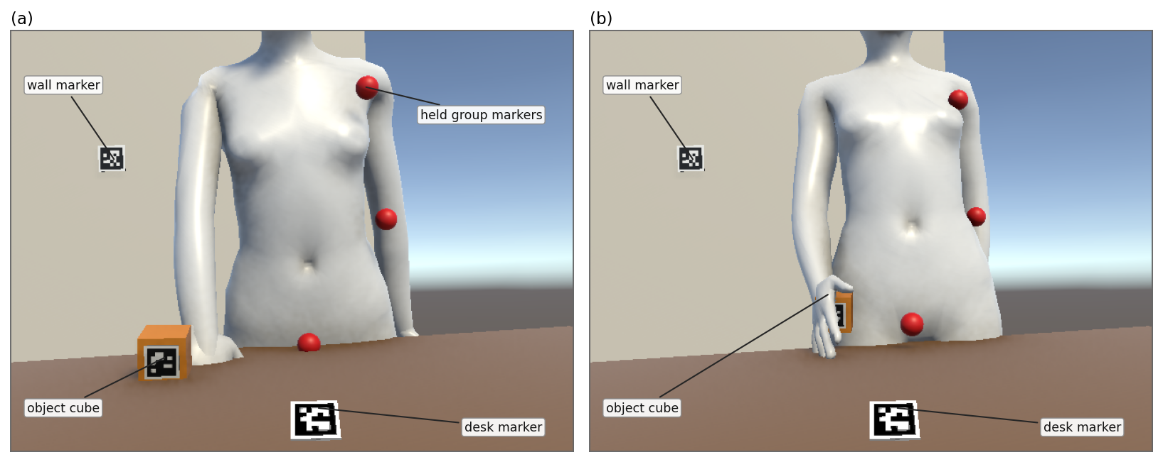
Figure 6.5. The reconstruction from the virtual sensor: (a) frame 114, the hand at the cube; (b) frame 700, sliding it along the rail. Section 2.1 defines the task phases.

6.5 Worked Example
This section takes one frame of the rail recording, so that the records of Section 6.1 and the maps of Sections 6.2 to 6.4 appear with their numbers, as Section 5.6 did for the recovery. The frame is 533, replayed through the causal structure of Section 8.2 at the recording's own pace (Section 8.4), at a moment when the cube slides along the rail. Table 6.2 collects the values.
The capture process published the frame at 17.78 seconds on the session clock into slot 5 of the frame buffer, 533 modulo 8. Both branches took their copy of slot 5.
The landmark branch then wrote the person record: frame 533, the pelvis and the thirteen angles. Its live bits are down for the root and the right shoulder twist. Its states say the root is constrained and the twist held. The record for frame 532 carried the same two states. The solve did draw on the object record on this frame: the right hand was inside a grip episode, so the link of Section 6.1.2 offered the solve a right wrist position derived from the cube pose. The left hand was offered none.
The marker branch wrote the object record with its live bit up, as it had for frame 532: the marker was detected on both frames, so no dropout runs into this one. Table 6.2 lists the processing time stored in each branch's record for this frame. Section 8.4 reports processing times per frame over the recording.
The merger's tick at 17.82 seconds on the session clock, with frame 534 just published, rendered the world as of 17.75 seconds, two frame intervals earlier. The person samples of frames 532 and 533 lay on either side of that render time, 5 milliseconds before it and 29 milliseconds after it, so the merger interpolated between them. The object stream had both of those frames as well, so the merger interpolated the object pose between the same two and raised no dropout flag. Into the combined record went both poses, with the root still constrained and the twist still held.
The pelvis in the person record is (3.1, −18.7, 99.0) centimetres in the y-up camera frame. Equation (6.2) carries it into display axes, and the calculation runs here with its numbers. The rotation block and the translation column of the calibrated camera pose of Section 4.1 are
$\begin{aligned}{}_{Camera}^{World}R = \left[\begin{matrix}1.00 & −0.02 & −0.01 \\ 0.00 & −0.48 & 0.88 \\ −0.02 & −0.88 & −0.48\end{matrix}\right] \\ {}_{ }^{World}{P_{CameraORG}} = (−0.01, −0.39, 0.43) m.\end{aligned}$
The swap, this rotation and the flip multiply into the anchor rotation, and the swap carries the camera position into display axes:
$\begin{aligned}{}_{Camera'}^{Unity}R = S {}_{Camera}^{World}R F^{-1} = \left[\begin{matrix}1.00 & 0.02 & −0.01 \\ −0.02 & 0.88 & −0.48 \\ 0.00 & 0.48 & 0.88\end{matrix}\right] \\ {}_{ }^{Unity}{P_{CameraORG}} = S {}_{ }^{World}{P_{CameraORG}} = (−0.01, 0.43, −0.39) m.\end{aligned}$
The pelvis point of the record then maps as
$\begin{aligned}{}_{ }^{Camera'}q = (0.03, −0.19, 0.99) m \\ {}_{ }^{Unity}P = {}_{Camera'}^{Unity}R {}_{ }^{Camera'}q + {}_{ }^{Unity}{P_{CameraORG}} = (0.00, −0.21, 0.38) m.\end{aligned}$
The matrices and vectors are printed to two decimals. The pelvis sits at (0.3, −21.2, 38.3) centimetres in display axes, before the parent levelling and floor translation of Section 6.4. The three steps below give the same point. Undoing the flip gives the raw camera point (3.1, 18.7, 99.0), within a millimetre of the midpoint of the two hip landmarks, which the hip depth preparation left unchanged on this frame. The calibrated camera orientation and position carry it into the world frame, (0.3, 38.3, −21.2), and the swap exchanges the last two coordinates into display axes. The camera itself sits at the swapped camera position, (−1.4, 43.1, −39.3) centimetres in the same axes.
The parent node of Section 6.4 applies the full transformation of equation (6.6). Its gravity alignment carries the calibrated gravity direction, (−0.02, 0.85, 0.53) in display axes, onto the screen's vertical, a turn of 32.0 degrees. Its translation uses the offset d at 71.6 centimetres on this recording, so that the drawn floor sits at zero height:
$\begin{aligned}G = \left[\begin{matrix}1.00 & 0.02 & 0.01 \\ −0.02 & 0.85 & 0.53 \\ 0.01 & −0.53 & 0.85\end{matrix}\right] \\ G {}_{ }^{Unity}P = (0.00, 0.02, 0.44) m \\ \left[\begin{matrix}{}_{ }^{Scene}P \\ 1\end{matrix}\right] = {}_{Unity}^{Scene}T \left[\begin{matrix}{}_{ }^{Unity}P \\ 1\end{matrix}\right] \\ {}_{ }^{Scene}P = G {}_{ }^{Unity}P + t_{f} = (0.00, 0.74, 0.44) m.\end{aligned}$
The spine bone lands at (0.1, 74.0, 43.7) centimetres in the scene frame, 2.0 centimetres above the drawn desk top at 72.0. In the replay of Section 6.3 the receiver's log places the spine bone on the mapped point to within a millimetre on every frame.
The object record holds the marker origin of the cube already in display axes, (−24.0, −19.6, 42.7) centimetres with Euler angles (−61.4, 1.5, −6.3) degrees. The link of Section 6.1.2 reverses the step above, from the world to the camera. The anchor's rotation block is the transpose of the one above and its translation column is the desk marker seen from the camera:
$\begin{aligned}{}_{World}^{Camera}R = {\left({}_{Camera}^{World}R\right)}^{T} = \left[\begin{matrix}1.00 & 0.00 & −0.02 \\ −0.02 & −0.48 & −0.88 \\ −0.01 & 0.88 & −0.48\end{matrix}\right] \\ {}_{ }^{Camera}{P_{WorldORG}} = (0.02, 0.19, 0.55) m.\end{aligned}$
The cube's marker origin then returns to the camera frame as
$\begin{aligned}{}_{ }^{World}P = S {}_{ }^{Unity}P = S (−0.24, −0.20, 0.43) = (−0.24, 0.43, −0.20) m \\ {}_{ }^{Camera}P = {}_{World}^{Camera}R {}_{ }^{World}P + {}_{ }^{Camera}{P_{WorldORG}} = (−0.21, 0.16, 1.02) m.\end{aligned}$
The result, (−21.2, 15.8, 102.4) centimetres in the camera frame, is the pose the marker branch reported, with the marker's face normal turned to the camera 4.4 degrees off the optical axis. The depth image reads 98.6 centimetres at the marker's pixel, 3.8 centimetres nearer than the pose, within the pose error of a 45 millimetre marker at that distance.
The thirteen angles become bone rotations by equation (6.5), composed here from the record's angles as the receiver of Figure 6.5 composes them. The right upper arm takes the root Euler angles (−13.2, 176.5, −2.4) degrees, the shoulder azimuth and elevation (−44.1, −76.3) degrees and the held twist of −0.1 degrees. After the anchor and the levelling they place the bone's axis along (−0.14, −0.93, −0.34), 0.4 degrees from the measured shoulder-to-elbow direction carried through the same maps. The elbow is bent by 17.7 degrees about the up axis and 0.0 about the forward axis. The forearm lands 10.0 degrees from the measured direction while the shoulder twist is held under the rule of Section 5.5.
The receiver that reads the merger's record draws the pelvis sphere blue, because the root's state is constrained, and no sphere for the twist. The cube keeps its plain colour on this tick: its pose lies between two live measurements, so it is neither held nor bridged nor blended back. Neither stream crossed a dropout, so the pelvis carries no amber sphere either. The receiver of Figure 6.5, which reads the live bits alone, would draw the pelvis sphere red.
Stage | Record or map | Frame 533
Capture process | frame buffer, slot 5 | 17.78 s on the session clock; colour and depth, 1,536,032 bytes
Landmark branch | person record | 8.7 ms; pelvis (3.1, −18.7, 99.0) cm; live bits down for the root and the right twist; root constrained, twist held
Marker branch | object record | 13.6 ms; (−24.0, −19.6, 42.7) cm, (−61.4, 1.5, −6.3) deg; live; frame 532 live as well
Merger | combined record | tick at 17.82 s, render time 17.75 s; person 532 to 533, object 532 to 533, no dropout bridged
Link | swap undone, anchor applied | cube marker origin (−21.2, 15.8, 102.4) cm in the camera frame
Receiver, position | equations (6.2) and (6.6) | pelvis (0.3, −21.2, 38.3) cm in display axes; (0.1, 74.0, 43.7) cm in the scene frame; 32.0 deg
Receiver of Figure 6.5, rotation | equation (6.5) | right upper arm 0.4 deg from the measured direction; forearm 10.0 deg
Table 6.2. Frame 533 of the rail recording through the causal structure and the receiver. Positions in centimetres; clock times on the session clock, durations in milliseconds.
Both branches now reach one rendered scene, with every joint group tagged measured, held or constrained. The chapter does not establish the reconstruction's accuracy or its real-time operation. Chapter 7 evaluates it offline, against physical references including the tape measurements of Section 7.2, against measured landmarks and manual wrist labels, and against within-recording comparisons. Appendix H holds the solver verification, and Chapter 8 tests the causal operation of the architecture.

