Chapter 7: Experimental Evaluation
This chapter reports the offline reconstruction results, the reference behind each comparison, and the claims the numbers do and do not support. The references are the tape-measured object route, the measured landmarks, manual wrist labels and within-recording comparisons, and the physical route is not registered into the world frame.

7.1 Evaluation Method
The evaluation uses the single-hand rail recording, the handover recording on the rail, and the loop recording for natural occlusion. Tape measurements provide the reference for object segment lengths once the waypoints are matched at both ends. Rendered elbow and wrist positions are compared with synchronized MediaPipe landmarks deprojected using aligned depth. Synthetic removal uses valid unmasked kinematic reconstruction as its reference. Natural occlusion uses manual wrist labels, with their observed separation from accepted wrist measurements evaluated on clean frames.
Physical length error is defined as absolute and relative error. Positional differences and trajectory scatter are summarized by the median, the 95th percentile (p95), and the maximum. Each joint and method uses its stated frame set; n is the number of evaluated frames. Percentiles use linear interpolation between ordered observations.
The reference wrist for quantitative reconstruction error is the accepted raw MediaPipe and depth three-dimensional wrist measurement, taken before temporal filtering. The same reference applies to the kinematic-model wrist error, to the rendered Unity rig wrist error, and to any clean-frame baseline that means reconstruction error against a measured wrist. A filtered wrist is used elsewhere for algorithmic purposes; wherever it appears it is named as a filtered measurement and is not the evaluation reference. No comparison table mixes the two references.
The object frame counts reported below use two terms. A detected frame is a frame on which the ArUco extractor returned a marker pose. An accepted object sample is a returned pose that remained usable after the cleaning rules of Section 7.2. The two answer different questions, so each count names the term it reports.

7.2 Object Reconstruction Accuracy
The route has four physical waypoint roles: W1 is the parked start on the desk, W2 is the foot of the lift, W3 is the start of the rail, and W4 is the far endpoint. The segments are W1 to W2, W2 to W3, and W3 to W4. A segment comparison requires the same named point on the object at both physically measured endpoints and at their corresponding reconstructed positions.
Let q_j and q_(j+1) be reconstructed positions at the independently identified waypoint events, and let L_j be the physically measured endpoint separation. Reconstructed length, absolute error, and relative error are defined by
 | $\begin{aligned}{Lrec}_{j}=\left\|q_{j+1}-q_{j}\right\| \\ A_{j}=\left|{Lrec}_{j}-L_{j}\right| \\ R_{j}=100\frac{A_{j}}{L_{j}} (\%).\end{aligned}$ | (7.1)
Here L_j is positive. Reconstructed length is endpoint separation, not accumulated sample-to-sample travel or the longest span of a fitted line. A stationary-frame interval, when available, defines an endpoint by the mean of its accepted reconstructed samples; an identified single-frame event uses that sample.
For reconstructed samples p_i, i = 1, ..., n, within one segment and expressed in {Scene} of Section 6.4, orthogonal least-squares line fitting uses the sample mean c and covariance C:
 | $\begin{aligned}c=\frac{1}{n}\sum_{i=1}^{n}{p_{i}} \\ C=\frac{1}{n}\sum_{i=1}^{n}{\left(p_{i}-c\right){\left(p_{i}-c\right)}^{T}}.\end{aligned}$ | (7.2)
Principal component analysis (PCA) gives a unit eigenvector u of C associated with its largest eigenvalue. This direction and the line through c minimize the squared perpendicular distances:
 | $\begin{aligned}\min_{\begin{aligned}c,u \\ \left\|u\right\|=1\end{aligned}}\sum_{i=1}^{n}{{\left\|\left(I-uu^{T}\right)\left(p_{i}-c\right)\right\|}^{2}} \\ line\left(s\right)=c+su.\end{aligned}$ | (7.3)
The parameter s ranges over the real numbers and I is the identity matrix. The perpendicular distance of sample p_i is
 | $d_{i}=\left\|\left(I-uu^{T}\right)\left(p_{i}-c\right)\right\|.$ | (7.4)
The distances d_i describe scatter of the reconstructed trajectory about its own fitted line. They do not measure physical accuracy. A degenerate sample set with no unique principal direction does not define a fitted segment direction. Physical length error and trajectory scatter are reported separately.
The measured point is the ArUco marker centre on the cube face, at both physically measured endpoints and in the reconstruction. The physical separations are tape measurements made by the author between marker-centre positions, at a resolution of 1 millimetre, and the physical setup is the same in both recordings. The physical route is not registered into the world frame of the desk-marker calibration or into {Scene}, so the trajectory plots report reconstructed samples rather than surveyed physical paths or physical waypoint coordinates.

7.2.1 Single-Hand Rail Task
The rail recording holds 900 frames, of which 889 supply accepted object samples of the marker centre. The other 11 frames are excluded because the marker was not detected, because the stored sample was filled by the tracker, or because the recorded position was not finite. No frame is excluded because of the size of any error.
Waypoint timing comes from the marker-centre motion of this recording alone. Each axis velocity is a centred difference over 7 accepted samples on either side. A transition is bracketed at the half-peak of the velocity of the moving axis, and the boundary is the last sample within 5 millimetres of the local pre-transition level of that axis. W1 covers frames 0 to 92, an opening interval of 93 samples whose mean gives the position. W2 is frame 493 and W3 is frame 617, each a single transition sample, because the cube does not pause on either side of the lift and no dwell exists there to average. W4 covers frames 875 to 899, a closing interval of 25 samples whose mean gives the final position.
Table 7.1 compares the reconstructed segment lengths with the physical reference, using equation (7.1). Figure 7.1 places recorded views of the task above the accepted samples and the four waypoint positions.
Segment | Physical length (cm) | Reconstructed length (cm) | Absolute error (cm) | Relative error (%)
W1 to W2 | 25.5 | 24.36 | 1.14 | 4.45
W2 to W3 | 3.5 | 4.03 | 0.53 | 15.25
W3 to W4 | 37.5 | 38.59 | 1.09 | 2.91
Table 7.1. Rail recording: reconstructed marker-centre segment lengths against the physical reference, with absolute and relative error.
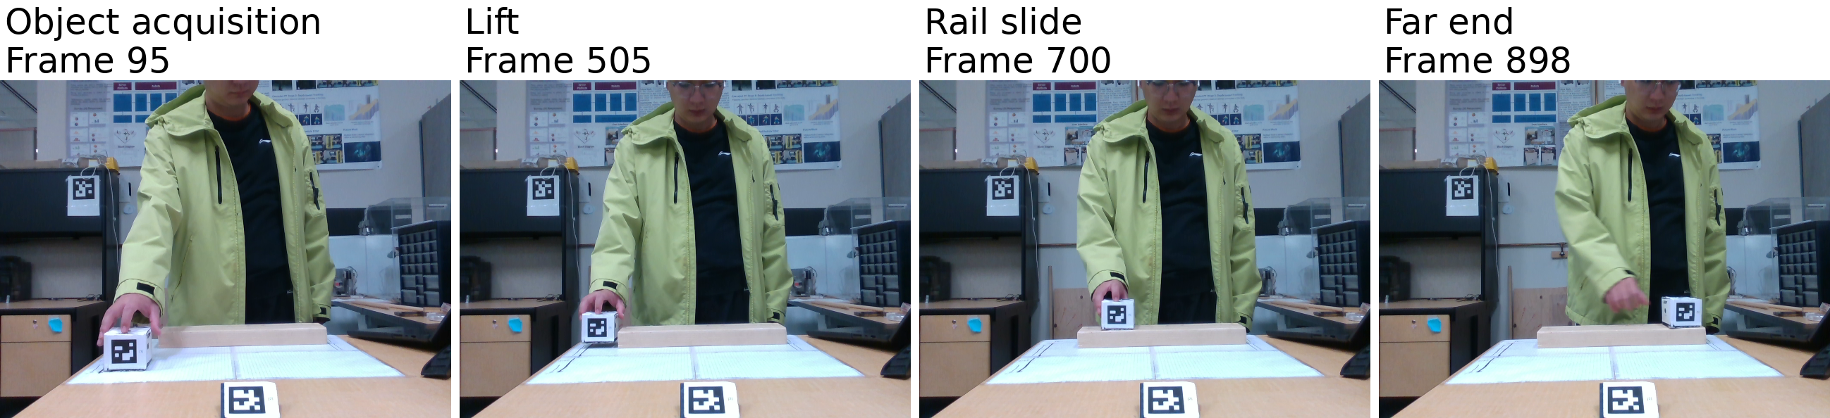
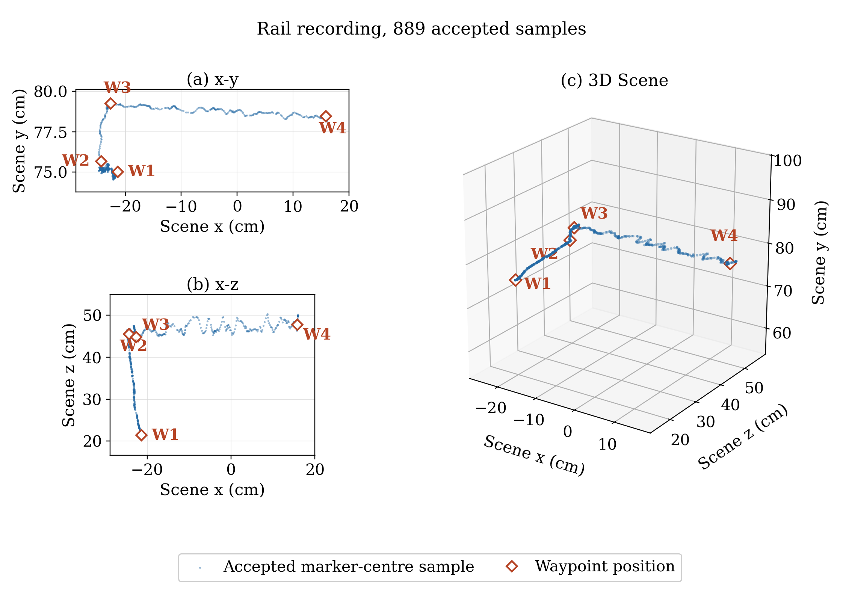
Figure 7.1. Rail recording: video frames, accepted marker-centre samples and the four reconstructed waypoints in {Scene}. The x-y view expands the height scale; the others use equal metric scale.
Each reconstructed length is reported with a range obtained by varying the detection parameters and shifting each boundary by two and by five accepted samples. Variants that no longer reproduce the depth, vertical and lateral phase pattern are excluded. The ranges are 23.95 to 25.15 centimetres for W1 to W2, 3.76 to 4.70 centimetres for W2 to W3 and 37.78 to 38.87 centimetres for W3 to W4. The point estimate alone overstates the precision of the result.
W2 and W3 are single accepted samples, so each carries the instantaneous depth error of one frame rather than an averaged value. Within 7 frames on either side the depth coordinate spreads 8.6 millimetres at W2 and 22.4 millimetres at W3. The criterion based on departure from the pre-transition level also fails to separate either boundary from the half-peak of its axis velocity. The reported sample is therefore the latest the search allows. The transition lies at or before it.
The W4 interval holds 25 samples, about 0.8 seconds. Its depth coordinate spans 38.1 millimetres, and its largest single-sample step is 9.0 millimetres, between frames 882 and 883. The closing interval is therefore not a single settled cluster. The recording ends about ten frames after the cube settles, and no longer settled interval is available to average.
Scatter about the fitted line is a separate within-recording comparison, defined by equations (7.2) to (7.4), between the reconstructed trajectory and a line fitted to the same samples. Over the 248 samples between W3 and W4 the median perpendicular distance is 0.83 centimetres, the p95 is 2.12 centimetres and the maximum is 2.92 centimetres. The fitted line lies 1.3 degrees from horizontal. These distances describe the spread of the reconstructed samples and are not comparable with the errors of Table 7.1.

7.2.2 Handover Task
The handover recording holds 1499 frames, of which 1487 supply accepted object samples of the marker centre, and the other 12 are excluded under the same rule. Its waypoints are detected from its own marker-centre motion, with the estimator and the parameters used for the rail recording.
W1 covers frames 0 to 138, an opening interval of 139 samples. W2 is frame 430 and W3 is frame 534, again single transition samples across the lift. W4 covers frames 1083 to 1498, a closing interval of 416 samples, because the cube stays on the rail while the recording continues after the transfer. Table 7.2 reports the resulting lengths against the same physical reference, and Figure 7.2 shows the trajectory.
Segment | Physical length (cm) | Reconstructed length (cm) | Absolute error (cm) | Relative error (%)
W1 to W2 | 25.5 | 22.68 | 2.82 | 11.06
W2 to W3 | 3.5 | 4.35 | 0.85 | 24.18
W3 to W4 | 37.5 | 40.33 | 2.83 | 7.56
Table 7.2. Handover recording: reconstructed marker-centre segment lengths against the physical reference, using the columns of Table 7.1.
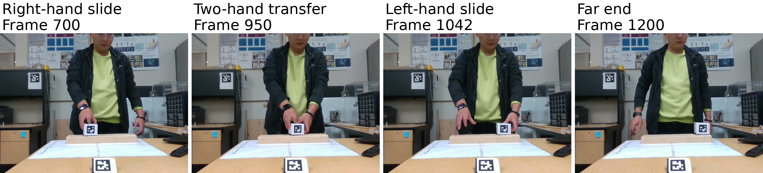
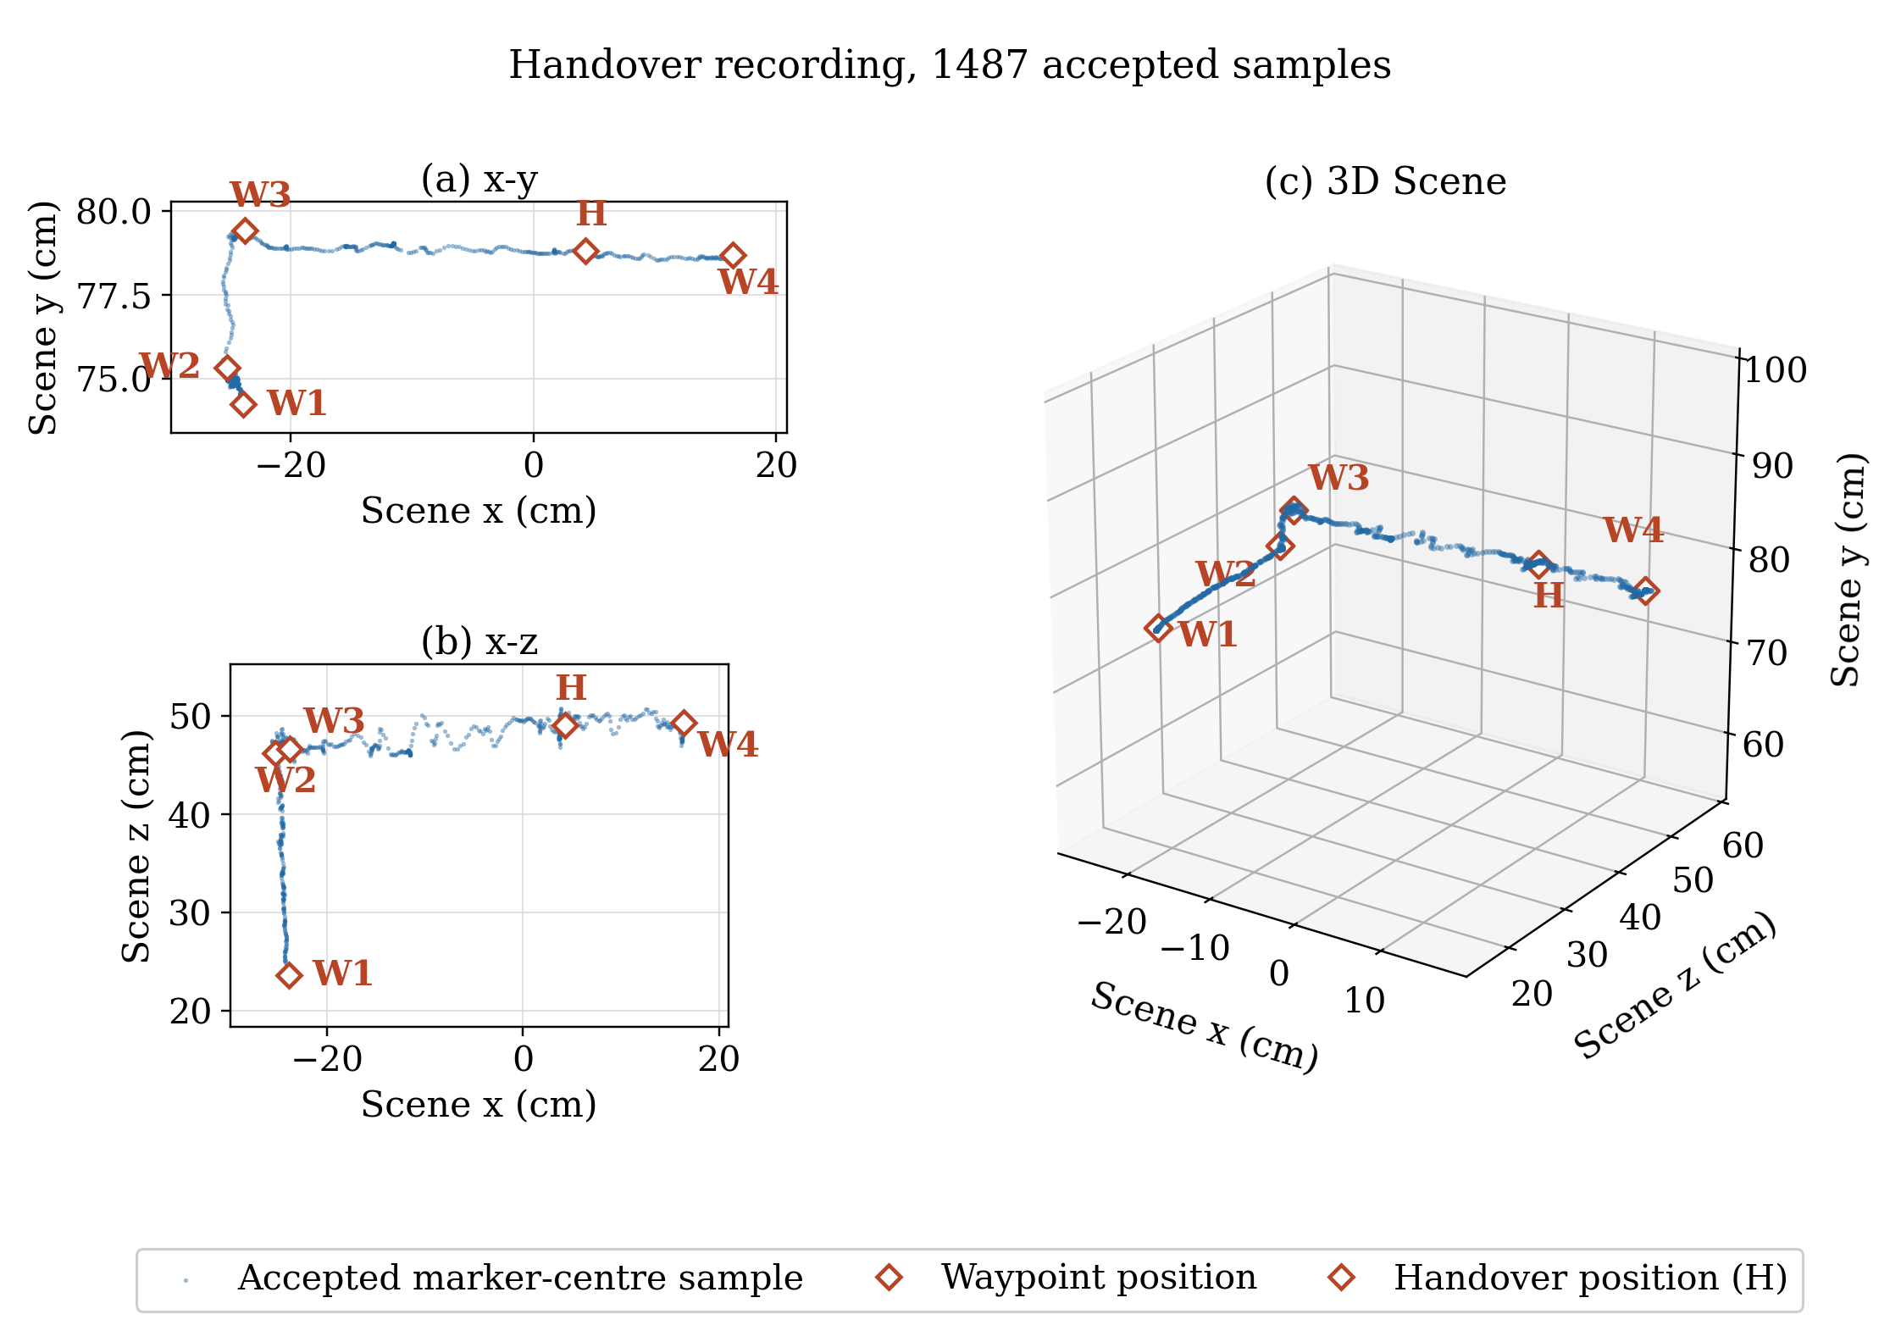
Figure 7.2. Handover recording: video frames, accepted marker-centre samples, the four reconstructed waypoints and handover position H in {Scene}, with this recording's floor translation and scale conventions of Figure 7.1.
The ranges of reconstructed lengths under the tested detection settings are 22.42 to 24.00 centimetres for W1 to W2, 4.28 to 4.76 centimetres for W2 to W3 and 38.78 to 40.60 centimetres for W3 to W4. W2 and W3 are again single accepted samples. Within 7 frames on either side the depth coordinate spreads 15.4 millimetres at W2 and 25.7 millimetres at W3, so the local depth variation at both transition endpoints is larger than in the rail recording.
Over the 539 samples between W3 and W4 the median perpendicular distance from the fitted line is 0.39 centimetres, the p95 is 1.44 centimetres and the maximum is 2.82 centimetres. The fitted line lies 0.6 degrees from horizontal. This remains a within-recording comparison and is reported separately from the length errors.
The two recordings agree on the sign of every error. The depth leg from W1 to W2 reconstructs short in both, while the two legs after the lift reconstruct long in both. The handover recording disagrees with the physical reference more than the rail recording on all three segments, in absolute and in relative terms. Every detection variant included in the ranges above keeps these signs, so the threshold changes the error magnitude within each range but does not produce the pattern. A wider sweep shifts a boundary by ten accepted samples. That sweep lies outside the set of variants above, and it reverses one sign in each recording: W3 to W4 in the rail recording and W2 to W3 in the handover recording.
The proper gravity-alignment rotation G and the common floor translation of Section 6.4 preserve Euclidean distances, including segment lengths and perpendicular distances from a trajectory to its fitted line. They therefore leave Tables 7.1 and 7.2 and the scalar scatter statistics unchanged. Absolute coordinates depend on the origin. Displacement components, fitted-line tilt and the checks used to confirm task phases depend on the axis orientation. Those checks identify which axis has the largest motion. The floor translation shifts the plotted positions without changing those displacements, tilts or checks. The trajectory panels of Figures 7.1 and 7.2 use the final Scene coordinates throughout.

7.3 Human Reconstruction Accuracy under Valid Landmark Measurements
For each arm, the reference contains raw MediaPipe elbow and wrist coordinates with valid aligned depth. A valid-landmark frame is a frame in which the shoulder, elbow, wrist and required torso inputs used by the reconstruction of this section satisfy the landmark-validity checks. Such a frame requires observed, finite, positive-depth shoulder, elbow, wrist and torso inputs. No input may be filled or rejected after filtering. The per-frame and per-event landmark checks must also accept the frame. Frames outside the detector evaluation interval are excluded. These checks define the conditions under which a measurement counts as valid; they do not establish an anatomical reference.
The corresponding Unity joints are the forearm bone head for the elbow and the hand bone head for the wrist. Their saved world positions include display filtering and rig mapping. The calibrated camera mapping, gravity alignment and recording-specific floor translation carry the measured landmarks into {Scene}, where the logged rig joints are expressed. Frame identifiers match exactly, and timestamp and pelvis correspondence checks verify the saved capture. For joint k at frame t, positional error is
 | $e_{k,t}=\left\|{}_{ }^{Scene}{{p_{k,t}}^{rig}}-{}_{ }^{Scene}{{p_{k,t}}^{measured}}\right\|.$ | (7.5)
Both positions in equation (7.5) are expressed in the Unity scene frame of Section 6.4. The left superscript names that frame, and the right superscript names the source of the position, either the rendered rig or the measured landmark. The statistics describe reconstruction error relative to measured 3D landmarks. Detector-accepted inputs can still produce constrained root or held twist output; the comparison retains those outputs as part of the rendered reconstruction. It does not isolate a kinematic solve whose output groups were all measured.
The chapter distinguishes two reconstruction quantities throughout, and neither is the other. The kinematic-model error compares the measured joint with the position that the kinematic model and forward kinematics place directly from the solved angles, before Unity rig mapping and display filtering. The rendered rig error compares the same measured joint with the final Unity rig joint, after the complete display and rendering path. Equation (7.5) applies to both, with the corresponding reconstructed position.
Both Unity captures ran the avatar with the arm and trunk lengths of the recording being replayed. The arm lengths are the landmark lengths the reconstruction of Chapter 5 solved on. The trunk length is the median distance from that reconstruction's pelvis to the measured mid-shoulder over the torso-clean frames of the same recording. A check on each capture compares the rig the receiver measured against the lengths requested for that recording, so a capture whose rig carries another recording's lengths cannot be scored here. Tables 7.3 and 7.4 are therefore end-to-end rendered results whose rig reproduces the geometry the solver used. Display filtering, rig mapping and the remaining stages of the display path are not separated by this comparison, so no part of the rendered difference is attributed to any one of them.

7.3.1 Single-Hand Rail Task
The working right arm supplies 102 matched valid-landmark frames from the saved capture. Table 7.3 reports the elbow and wrist errors on this same frame set. The captured frames are not a complete or uniform sample of the task. Every retained frame has a constrained root output, so these results do not establish reconstruction performance without root constraints.
The right forearm twist output is held on every valid-landmark frame of this recording, alongside the constrained root output just noted. A kinematic-model wrist distance computed here would include the effects of the held twist and the constrained root. It would not isolate the agreement between the kinematic model and the measured landmarks. No such distance is reported for this recording or compared with the handover results. The quantitative kinematic-model accuracy comes from the handover recording.
Arm | Joint | n | Median (cm) | p95 (cm) | Maximum (cm)
Right | Elbow | 102 | 6.4 | 7.5 | 19.5
Right | Wrist | 102 | 11.4 | 15.4 | 22.9
Table 7.3. Single-hand task: rendered joint error relative to accepted measured 3D landmarks on the captured subset of valid-landmark frames.
Figure 7.3 shows the marker-centre and model-wrist trajectories through the single-hand rail task. These views provide spatial context for the captured reconstruction.
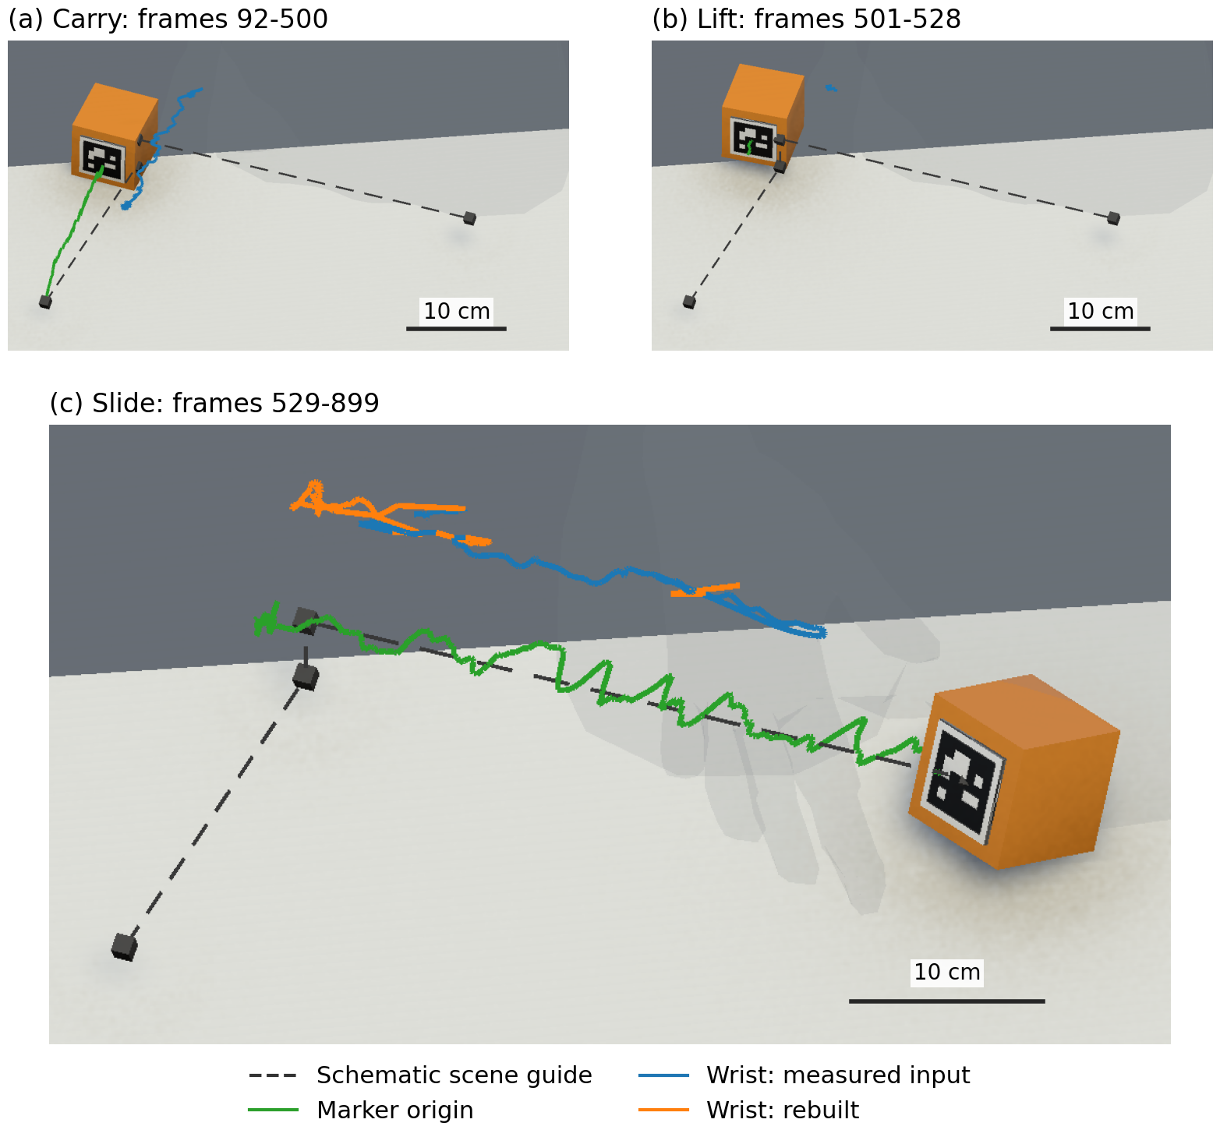
Figure 7.3. Single-hand rail task in Unity: marker-centre and model-wrist trajectories for carry, lift and slide. Wrist colours give the recorded state; avatar and cube show each interval's end.

7.3.2 Handover Task
Table 7.4 evaluates both arms separately. The elbow and wrist of each arm share a valid-landmark frame set; the two arms have different coverage because their measurement validity differs. Figure 7.4 shows the saved Unity trajectories through the handover for spatial context. The quantitative capture is incomplete and includes constrained root output on part of each valid-landmark set. Differences from Table 7.3 cannot be attributed solely to the handover condition because the recorded subsets and rig states also differ.
Arm | Joint | n | Median (cm) | p95 (cm) | Maximum (cm)
Right | Elbow | 650 | 5.3 | 6.7 | 9.4
Right | Wrist | 650 | 5.5 | 6.8 | 15.0
Left | Elbow | 589 | 6.1 | 11.9 | 17.7
Left | Wrist | 589 | 6.8 | 12.3 | 17.7
Table 7.4. Handover task: rendered joint error relative to accepted measured 3D landmarks, reported separately for each arm on its captured subset of valid-landmark frames.
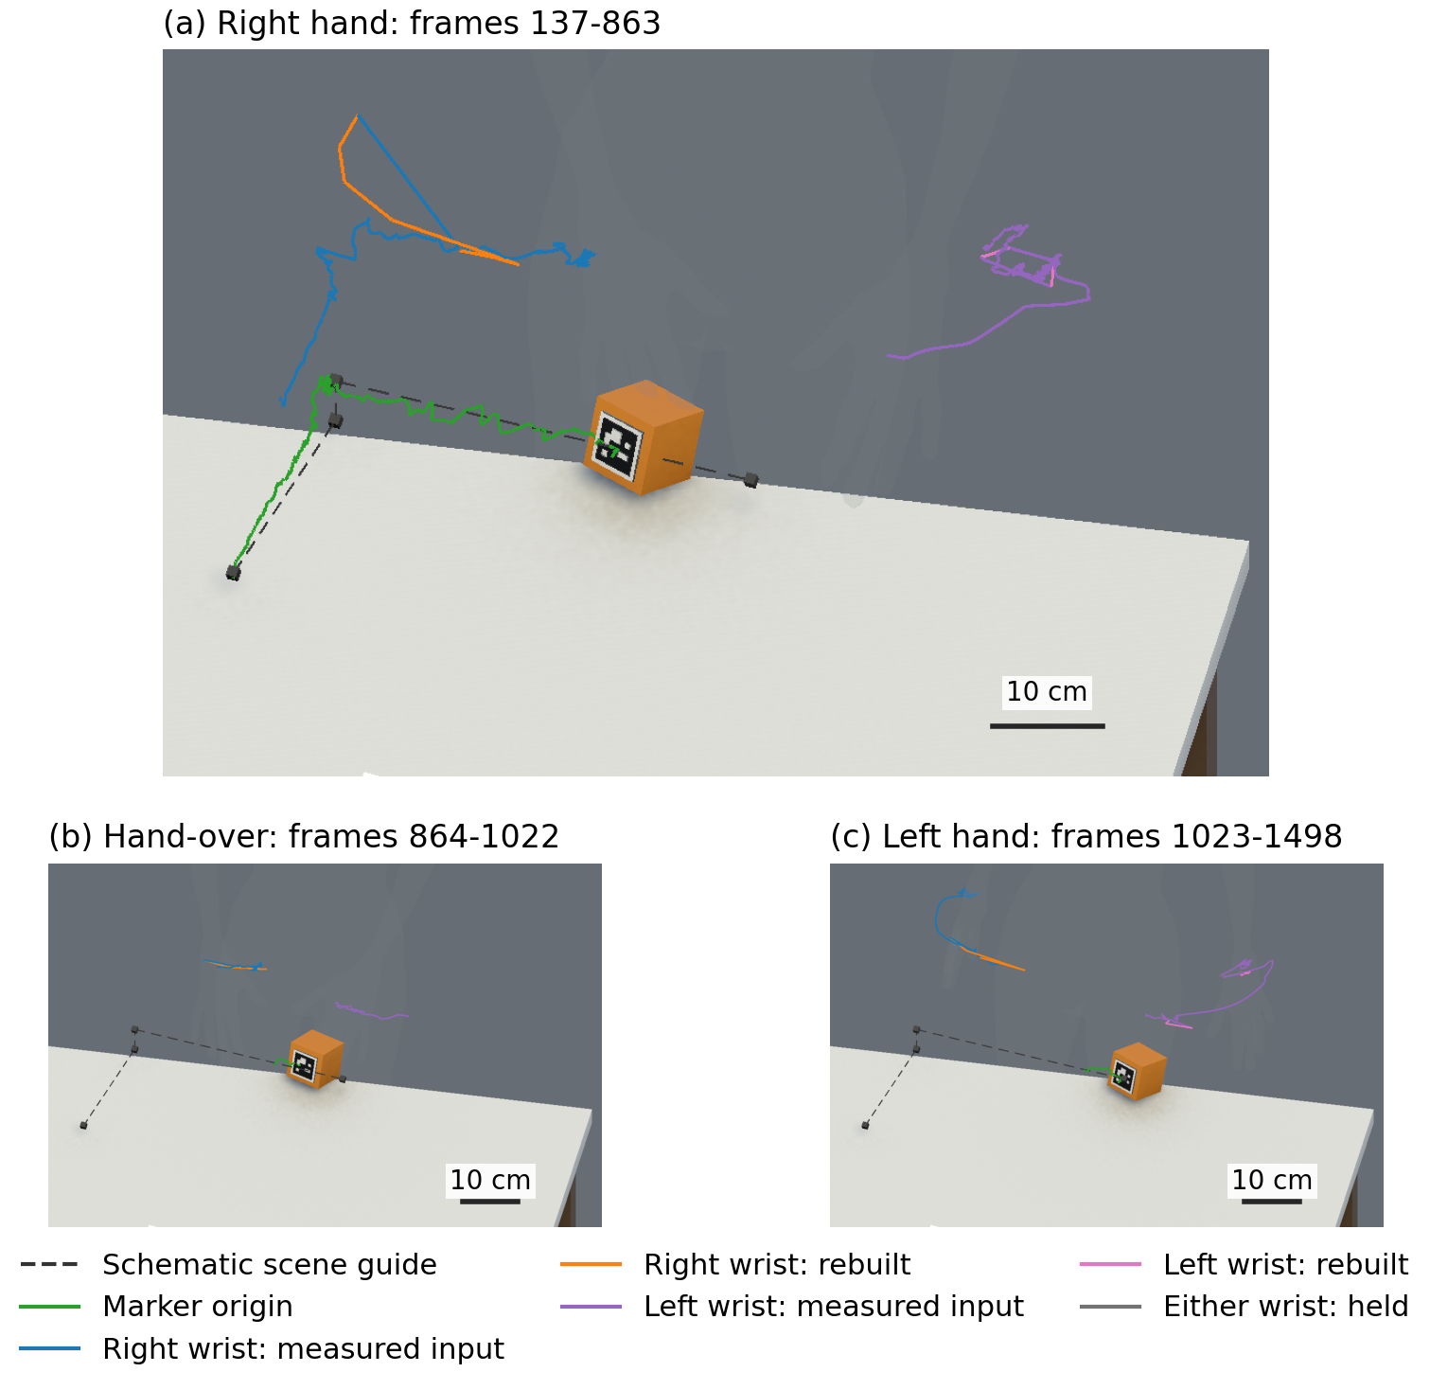
Figure 7.4. Handover task in Unity: marker-centre and both model-wrist trajectories for the right-hand, transfer and left-hand intervals. Wrist colours give the state; avatar and cube show each interval's end.
The kinematic-model wrist error separates the model from the display path. It uses the same 650 right-arm and 589 left-arm valid-landmark frames as Table 7.4. On those frames the kinematic-model wrist lies a median of 0.83 centimetres from the measured wrist on the right and 2.34 centimetres on the left, against the rendered rig medians in that table. The additional discrepancy arises after the kinematic model, along the path described above.
That capture subset is not representative of the full valid-landmark frame population, and least so on the left arm. It over-represents frames on which the forearm twist output is held, at 55 per cent of the subset against 41 per cent of the valid-landmark frames of the whole recording. Across all valid-landmark frames the kinematic-model wrist median is 1.03 centimetres on the right, over 1156 frames, and 1.03 centimetres on the left, over 1095 frames. These recording-wide values are the representative performance of the kinematic model, and they are not set against Table 7.4, whose frame set is different.
The state of the forearm twist output separates two cases. Where the twist is measured the kinematic-model wrist median lies between 0.6 and 0.9 centimetres; where it is held it lies between 2.3 and 2.8 centimetres. The elbow is almost unaffected, because the twist rotates about the upper-arm axis: on the frame sets of Table 7.4 the kinematic-model elbow median is 0.36 centimetres on the right and 1.08 centimetres on the left.

7.3.3 Human-Object Spatial Check
The separation between the wrist and the held cube has one external physical reference. The author measured approximately 16 centimetres between the physical location corresponding to the MediaPipe wrist landmark and the object ArUco marker centre, for a normal single-hand grip. This is a scalar physical reference, not a per-frame constraint.
Figure 7.5 pairs recorded and rendered views of the single-hand grip during acquisition, lift and slide, captured on 14 September 2026. Red spheres identify joint groups that the stream does not report as measured. The views illustrate the task and retain the captured pose and object-placement discrepancies; the numerical tables use their own logged frame sets and capture configurations.
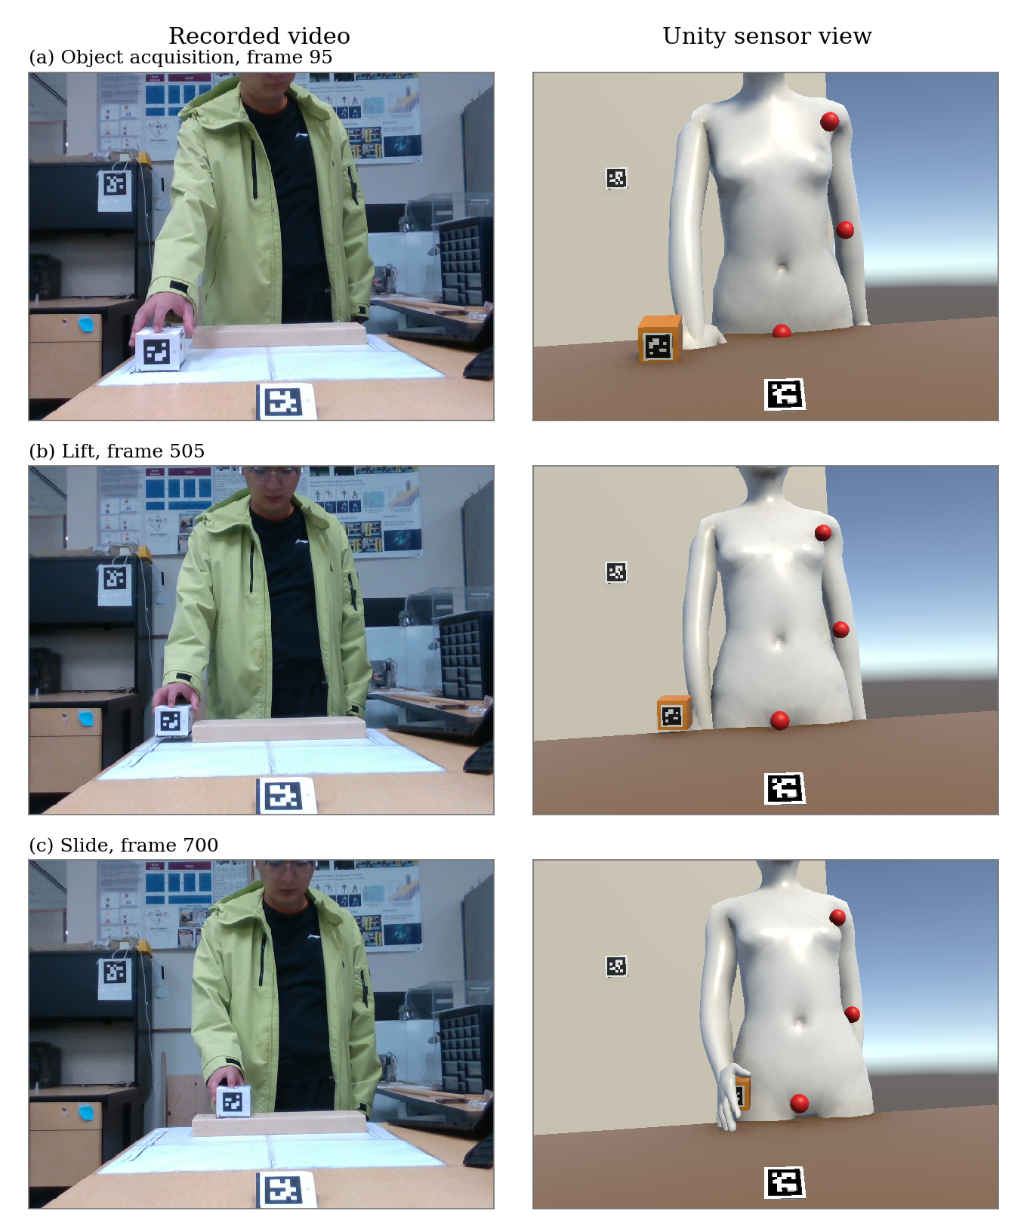
Figure 7.5. Rail recording: object acquisition, lift and slide, with recorded video on the left and the saved Unity sensor view on the right.
Reconstruction places the wrist a median of 15.77 centimetres from the marker centre while the right hand holds the cube alone, and 14.08 centimetres while the left hand holds it alone. Both reconstructed positions are expressed in {Scene}. The common floor translation cancels in their difference, and the proper gravity-alignment rotation preserves its norm, so these distances are unchanged. Both medians sit within about two centimetres of the physical reference, so the reconstructed human-object separation is of the correct magnitude.
The two medians recorded during the transfer itself, 17.91 centimetres for the right hand and 15.85 centimetres for the left, are not evaluated against the same reference. Grip geometry changes while both hands are on the cube, so the single-hand measurement does not describe that configuration. Those two values describe the reconstructed grip geometry during transfer.
Figure 7.6 shows the change of holding hand in the recorded scene and the corresponding saved Unity views.
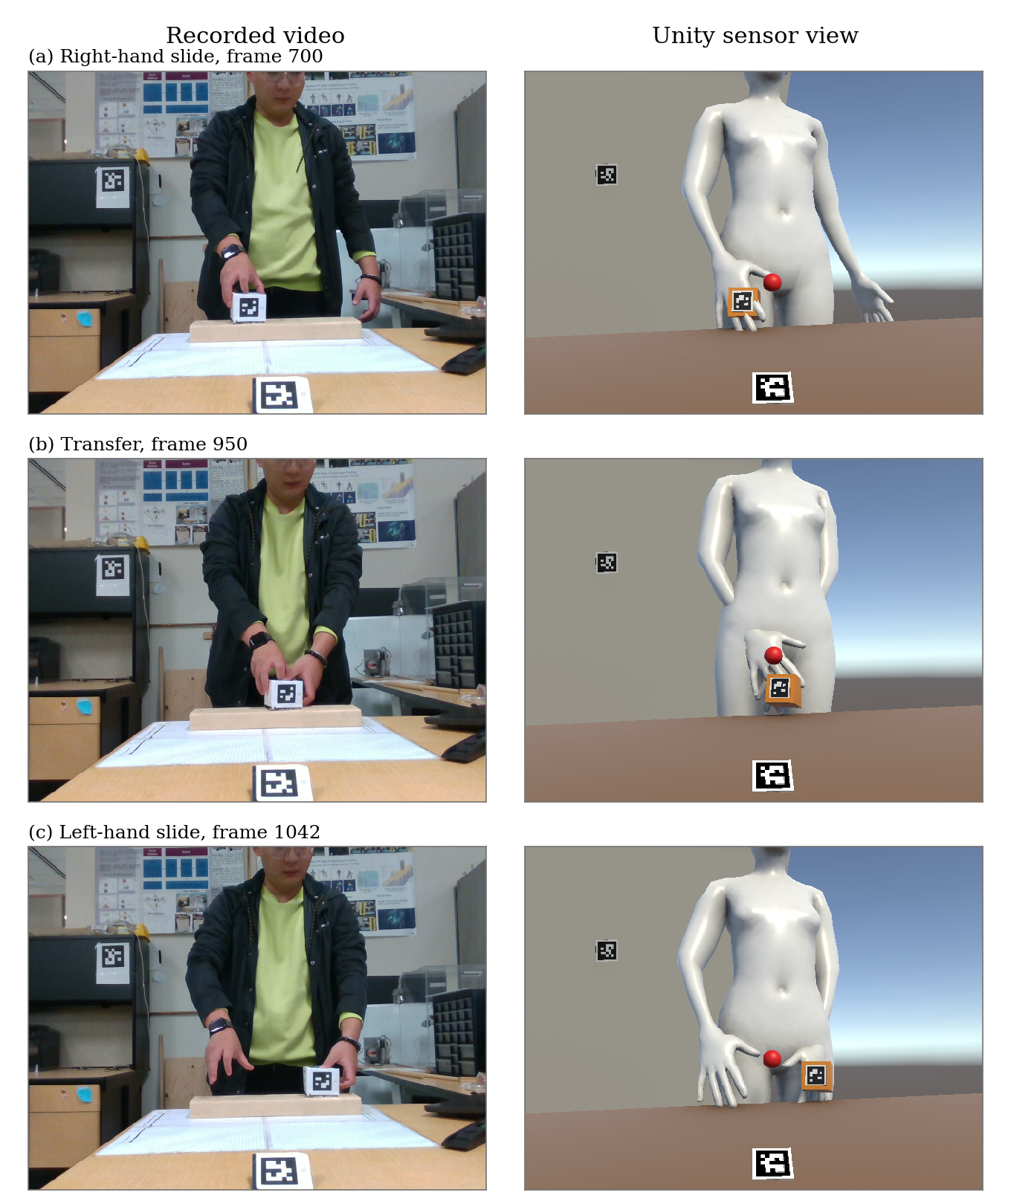
Figure 7.6. Handover recording: right-hand slide, transfer and left-hand slide, using the paired views of Figure 7.5. This visualization was captured on 9 September 2026 with a torso-length override. The visualization supplies qualitative examples; Table 7.4 uses a separate capture.
This is an approximate external physical check. It is not an anatomical reference for the wrist, because the physical endpoint is the location corresponding to a detector landmark rather than a joint centre. It also does not validate the three-dimensional hand-object offset that the recovery of Chapter 5 uses, because one scalar distance constrains neither the direction of that offset nor its behaviour from frame to frame.

7.4 Reconstruction During Landmark Failure

7.4.1 Synthetic Landmark Removal
The experiment removes the right elbow and wrist inputs after offline filtering, while retaining the measured shoulder and torso. The reference is the unmasked kinematic reconstruction of the same frames. Every selected reference frame has valid observed arm and torso inputs, accepted landmark checks, an established grip, and measured root, shoulder swing, shoulder twist and elbow output groups. The handover recording provides suitable windows; the single-hand recording does not provide a fully measured root-and-arm reference window under these conditions.
All eligible windows contain 45 frames, matching the recovery limit. Motion magnitude is the maximum distance of the unmasked wrist from its first position within a window. The windows were selected before any method was scored. The first window has the smallest excursion. The second has the largest excursion among windows that do not overlap the first. The third has the excursion closest to the median of all candidates and overlaps neither earlier selection. Table 7.5 lists the selections. These are contrasting windows from one recording, not independent experimental trials.
Window | Frame range | n | Reference wrist excursion (cm)
Lower motion | 490 to 534 | 45 | 0.6
Intermediate motion | 445 to 489 | 45 | 2.8
Higher motion | 557 to 601 | 45 | 5.1
Table 7.5. Synthetic removal windows selected using valid unmasked wrist motion before method errors were calculated.
The methods are hold-last joint angles, direction-memory recovery, and object-assisted recovery. Each method replays the recording from a fresh initial state and agrees with the reference immediately before removal. Masked landmarks do not update the hand-object offset, which is already established and remains frozen during the gap. Each method uses the same retained shoulder position and calibrated segment lengths to reconstruct the elbow and wrist. For method m, the deviation from the unmasked reference is
 | $e_{m,k,t}=\left\|{}_{ }^{Camera'}{{p_{m,k,t}}^{masked}}-{}_{ }^{Camera'}{{p_{k,t}}^{unmasked}}\right\|.$ | (7.6)
Both positions in equation (7.6) are expressed in the y-up camera frame {Camera'}, the left-handed frame of Section 3.1 in which the kinematic chain is built, and no display frame enters this section. Tables 7.6 and 7.7 use identical frames and metrics for every method. This is a test of missing solver inputs with fixed offline preprocessing and calibration. It does not measure anatomical accuracy or the effects of removing observations before filtering.
Window | Method | n | Median (cm) | p95 (cm) | Maximum (cm)
Lower motion | Hold-last | 45 | 0.4 | 0.8 | 1.0
Lower motion | Direction memory | 45 | 0.3 | 0.7 | 0.7
Lower motion | Object-assisted | 45 | 0.7 | 1.6 | 1.8
Intermediate motion | Hold-last | 45 | 0.7 | 1.4 | 1.4
Intermediate motion | Direction memory | 45 | 1.7 | 2.4 | 2.4
Intermediate motion | Object-assisted | 45 | 1.6 | 2.7 | 3.0
Higher motion | Hold-last | 45 | 0.6 | 1.3 | 1.4
Higher motion | Direction memory | 45 | 0.6 | 1.5 | 1.6
Higher motion | Object-assisted | 45 | 2.2 | 2.9 | 3.0
Table 7.6. Synthetic elbow reconstruction error relative to the valid unmasked model reconstruction.
Window | Method | n | Median (cm) | p95 (cm) | Maximum (cm)
Lower motion | Hold-last | 45 | 0.7 | 1.4 | 1.6
Lower motion | Direction memory | 45 | 0.4 | 0.7 | 0.8
Lower motion | Object-assisted | 45 | 1.2 | 2.0 | 2.4
Intermediate motion | Hold-last | 45 | 1.2 | 2.8 | 3.0
Intermediate motion | Direction memory | 45 | 1.9 | 3.0 | 3.0
Intermediate motion | Object-assisted | 45 | 1.2 | 2.0 | 2.2
Higher motion | Hold-last | 45 | 1.5 | 2.5 | 3.1
Higher motion | Direction memory | 45 | 2.5 | 4.2 | 4.6
Higher motion | Object-assisted | 45 | 1.9 | 2.7 | 2.8
Table 7.7. Synthetic wrist reconstruction error relative to the valid unmasked model reconstruction.
No method has the smallest error across every window and joint. Object assistance reduces the largest wrist deviation in the intermediate- and higher-motion windows, but increases elbow deviation in the higher-motion window. The lower-motion window favours direction memory. The results therefore support a window-dependent comparison rather than a general recovery ranking.

7.4.2 Natural Occlusion
Natural occlusion is evaluated on the loop recording. A single annotator marked the bead bracelet on the left wrist and the watch on the right wrist. The same visible feature defines the manual wrist label on clean and occluded frames. Each click is deprojected using the aligned depth and colour intrinsics. Table 7.8 compares the label with a filtered wrist measurement in the camera frame {Camera}, and Table 7.9 compares it with the reconstructed wrist in the y-up camera frame {Camera'}. The two frames share an origin and differ by the fixed axis flip of Section 3.1, which preserves distance, so every reported separation is the same in either frame.
The loop recording holds 2099 frames, of which 2058 are detected frames for the object marker. Of the 41 frames without a detected marker, 40 lie in the two-hand transfer on the desk, where a hand crosses the border of the printed square, and the remaining frame sits at its near edge. The object therefore supplies no geometric constraint across that stretch, while every frame labelled below carries a detected marker. A detected frame is not necessarily an accepted object sample or a reliable trajectory sample. Detection coverage records only the detector's return of an object observation, not the observation's survival through the later cleaning.
Figure 7.7 shows four retained video frames from the natural-failure sample, frames 1427, 1462, 1777 and 1890. The visible wrist features allow manual wrist labelling even when the corresponding landmark input fails.
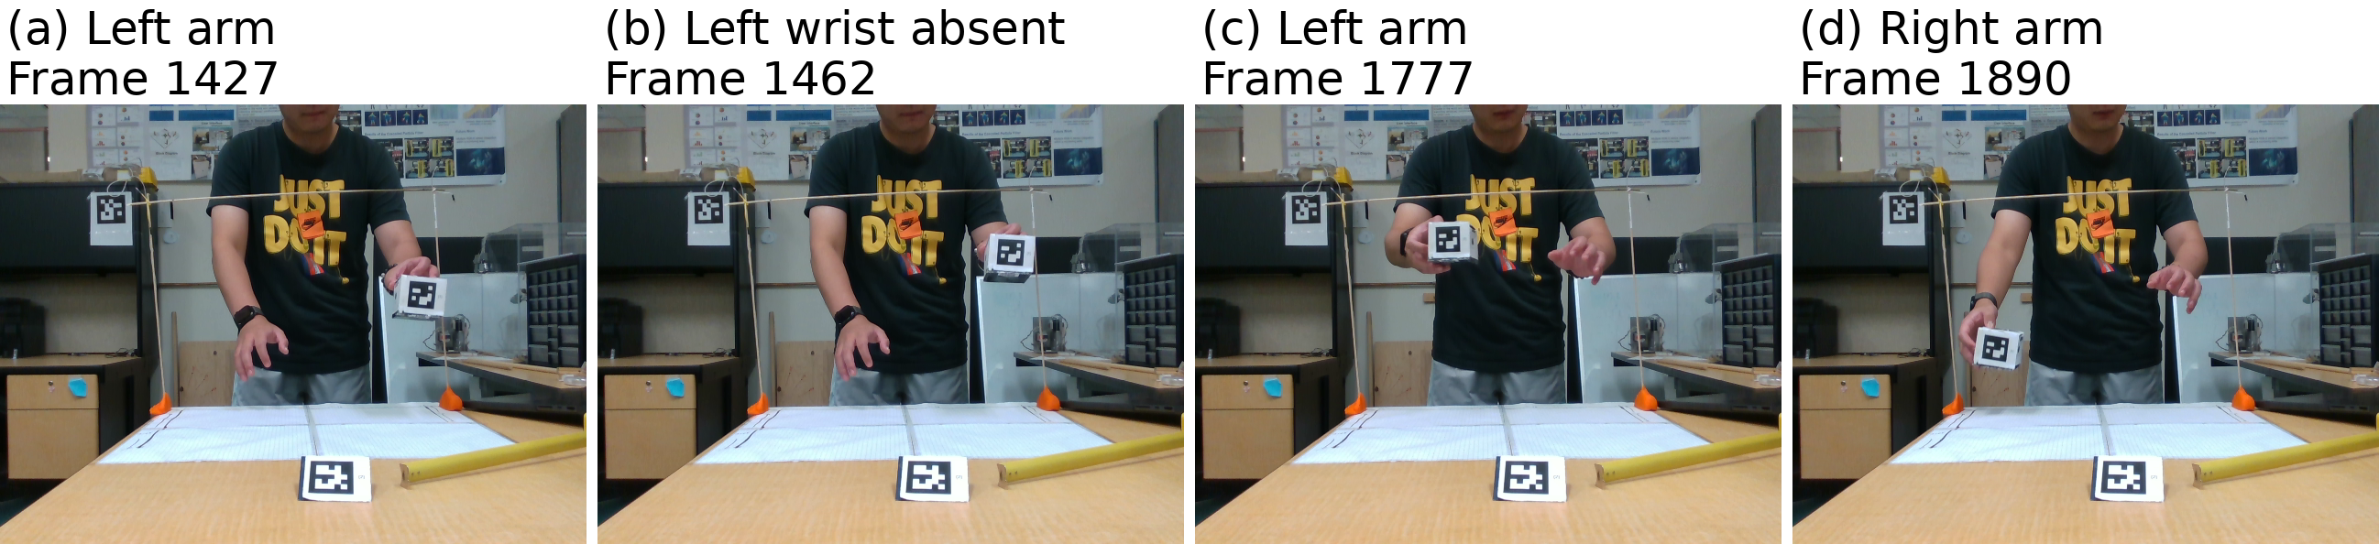
Figure 7.7. Loop recording: four natural-failure frames, with the affected arm named above each view. The bracelet or watch stays visible for manual wrist labelling.
Table 7.8 first measures the distance of the label from accepted, filtered MediaPipe and depth wrist measurements on clean wrist frames. That filtered measurement locates the detected landmark for this annotation comparison and is not the evaluation reference of Section 7.1; the table reports a label separation and not a reconstruction error. The visible feature is displaced from the landmark definition of the wrist; its separation is not an anatomical calibration.
Arm | Label | n | Median (cm) | p95 (cm) | Maximum (cm)
Left | Bracelet | 3 | 4.5 | 5.4 | 5.5
Right | Watch | 4 | 2.1 | 4.8 | 5.1
Table 7.8. Clean-frame distance between the manual wrist label and an accepted filtered wrist measurement.
During occlusion, the plain solve uses the reported landmarks, hold-last retains the last accepted joint angles, and object-assisted recovery reconstructs the missing inputs. Each method is evaluated against the same retained label points for that arm. The metric is the Euclidean distance from the reconstructed wrist to the label, summarized in Table 7.9; the clean-frame scalar offset is not subtracted.
Figure 7.8 illustrates a left-wrist failure with no MediaPipe wrist observation. The object-derived wrist estimate and the wrist placed by the reconstructed arm are distinct points. On that frame the plain-solve and object-assisted distances to the label are 14.0 and 13.7 centimetres.
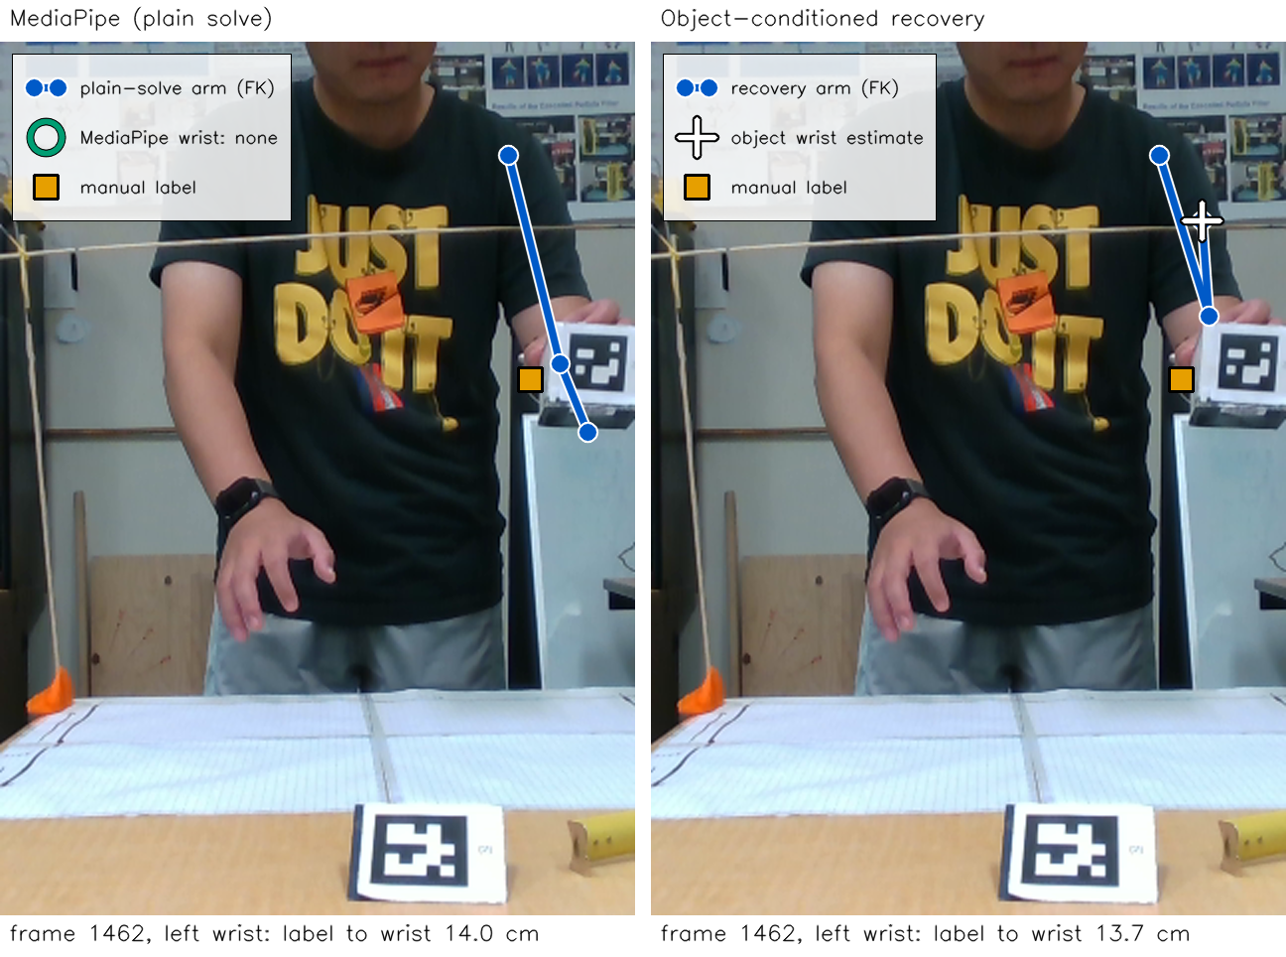
Figure 7.8. Loop frame 1462, left wrist: the square marks the manual wrist label, the blue chain is the reconstructed arm, and the cross is the object-derived wrist estimate.
Arm | Method | n | Median (cm) | p95 (cm) | Maximum (cm)
Left | Plain solve | 16 | 12.3 | 14.1 | 14.2
Left | Hold-last | 16 | 12.7 | 14.3 | 14.3
Left | Object-assisted | 16 | 13.1 | 15.2 | 19.1
Right | Plain solve | 4 | 11.4 | 13.6 | 14.0
Right | Hold-last | 4 | 17.6 | 20.0 | 20.4
Right | Object-assisted | 4 | 5.2 | 5.5 | 5.5
Table 7.9. Reconstructed wrist distance to the same manual wrist label on retained natural-occlusion frames, separately for each arm.
Figure 7.9 shows a right-wrist example in which object assistance places the reconstructed wrist closer to the manual wrist label. On loop frame 1890 the object-assisted wrist lies 5.0 centimetres from the label, against 14.0 centimetres for the plain solve. Together with Figure 7.8, it illustrates the reason the two arms are reported separately.
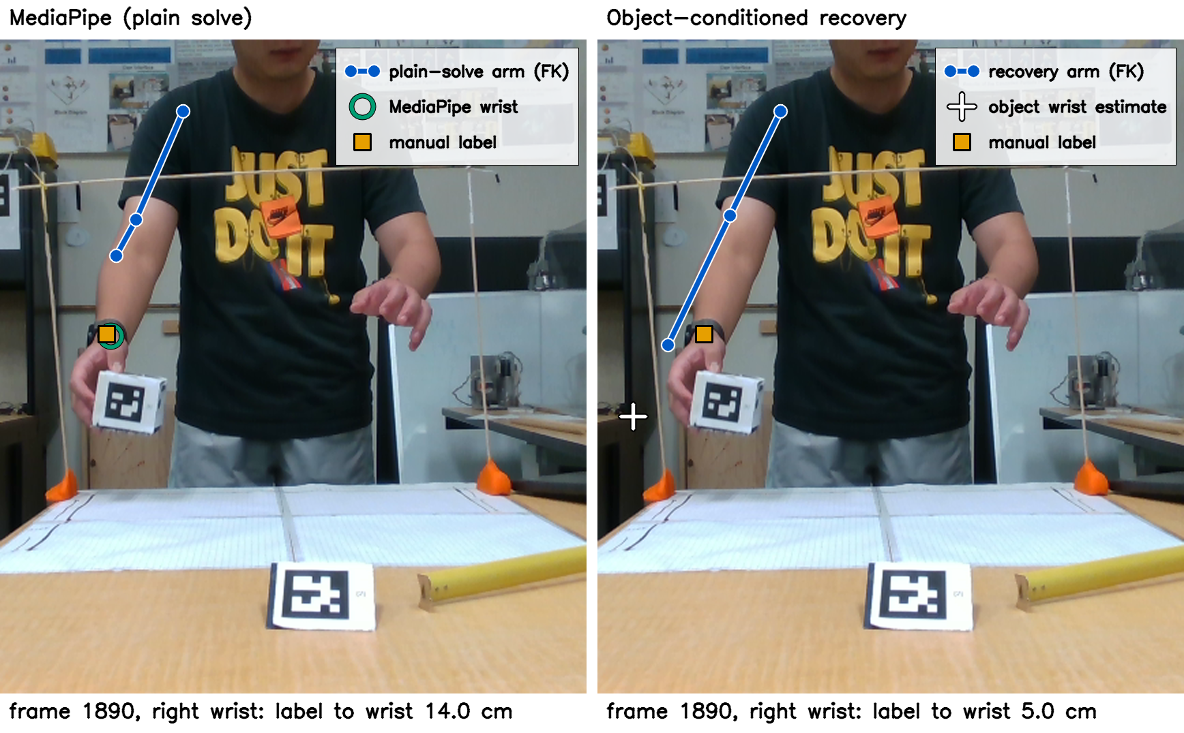
Figure 7.9. Loop frame 1890, right wrist, with the symbols of Figure 7.8. The cross marks the object-derived estimate, not the final reconstructed wrist.
Object assistance is closer to the right-wrist label on this small labelled set, while the left-wrist comparison shows no corresponding improvement. Label-to-wrist separation can change with arm orientation, clothing or jewellery motion, and depth selection. Repeated-click and depth uncertainties were not quantified. Frames on which the marked feature was completely hidden were excluded, so the results describe selectively visible samples rather than all occlusion frames. These distances do not establish anatomical accuracy. Checking the reconstructed wrist against the hand-object offset used by recovery tests only the compliance of the wrist with the recovery constraint. The offset is not an independent accuracy reference.

