Chapter 8: Real-Time Feasibility
Every result of Chapter 7 came from a finished recording, and a clinical or robotic use needs the reconstruction while the motion happens. This chapter tests the transfer of the architecture of Chapters 2 to 6 to causal processing, in which no sample from the future is available. It names the offline operations that read the future and gives the causal replacements.

8.1 From Offline to Causal Processing
A stage is causal when its output for a frame depends only on that frame and the frames before it [55]. The offline pass breaks that condition in six places, each one reading a sample a live system would not yet hold. The landmark smoother of Section 2.5 is a fourth-order Butterworth low-pass run forward and backward over the whole signal, and the two passes cancel the phase delay only because the backward pass starts at the end of the recording [55], [57]. The despiking test of the same section compares a sample with the median of a window centred on it, so half of that window lies ahead. Gap bridging needs the sample on the far side of a gap.
The hand-object offset of Chapter 5 warms up on the mean over a whole grip episode. The grip tracker of the same chapter confirms an episode exit over a run of five frames and then clears those frames, so the state of a frame changes after the frame has passed. The cleaning rule of Chapter 4 reads the object track as a complete time series, after it has been smoothed.
The causal structure must replace each of those operations with one that reads only the past, or do without it. This chapter tests the exchange by replaying the rail recording of Chapter 2 through the causal structure at its recorded pace and comparing the output with the offline pass frame by frame. The task phase names of this chapter, among them the lift and the slide, are those of Section 2.1. Replaying one recording keeps the scene fixed, so a difference between the two outputs follows from the processing path and not from the motion, the lighting or the camera placement.

8.2 Causal and Real-Time Architecture
Figure 8.1 sets the offline pass and the causal structure side by side. Offline, every script opens the recording itself and writes a table that the analysis tools of Chapter 7 read afterwards. Live, one capture process owns the sensor or the recording, aligns depth to colour once, stamps each frame with the session clock, and publishes the pair into a shared frame buffer (Section 6.1). The landmark branch and the marker branch read that buffer as separate processes and write their records. Every record carries the frame index and the session time of the frame it came from, and that pair is the only synchronization between the branches.
The merger pairs the two records at a render time that trails capture by a configured delay of two frames. It writes the combined record that the Unity receiver of Chapter 6 draws. The per-joint output states of Chapter 5 travel in the streamed packet, so a constrained joint group is distinguishable on screen from a held one.
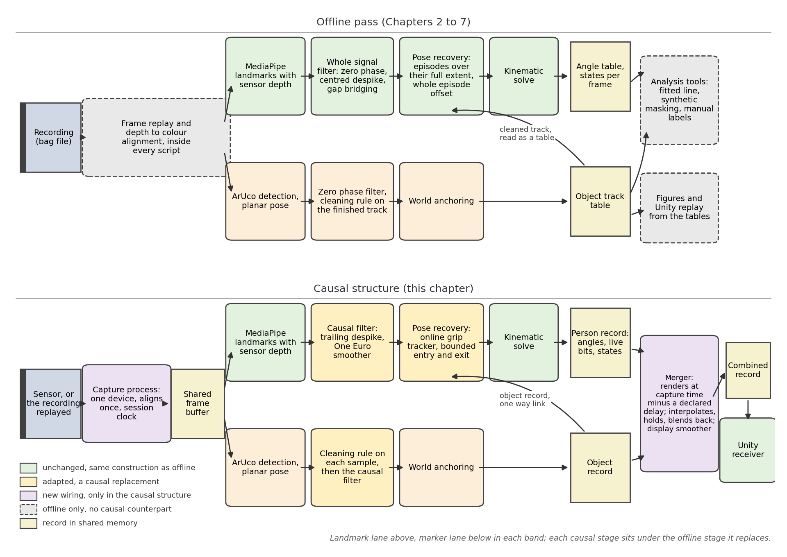
Figure 8.1. The offline pass (above) and the causal structure (below), each causal stage under the offline stage it replaces. The legend names the lane and role of each box.
The structure rests on three choices. A single process owns the device, because two processes cannot open the same camera. The merger renders at that delayed render time rather than at the newest sample. The delay is a buffering choice, distinct from the lag of the causal filter, which Section 8.3 shows and Section 8.4 separates from this delay. The display smoother of Section 6.3 acts on the output record only, so each branch's record holds only the values that branch computes.
Table 8.1 sorts the stages into three groups: unchanged, adapted, and analysis tools with no live form. The kinematic solve of Chapter 3 is closed form and holds no state across frames. The recovery layer of Chapter 5 does carry state: the direction memories, the offset estimate, the holding state, the twist hold and the rate limit. Every update reads the current frame and the state that earlier frames left behind, at a bounded cost per frame. The marker detector and the planar pose solver read a single image.
The despiking window trails the sample instead of surrounding it, and a rejected sample becomes a missing sample. After the filter rejects three samples in a row, it accepts the next one and rebuilds its window around it, so the trailing window does not go stale. Gap bridging moves into the merger, which bridges only within its delay and holds the last pose beyond it (Section 6.1.2). The zero-phase Butterworth smoother gives way to the One Euro filter on each landmark coordinate [40]. Its cutoff frequency increases as the coordinate changes faster, so it smooths a still pose and follows a moving one.
The marker branch keeps its mechanism and changes its order. The cleaning rule of Chapter 4 discards a sample farther from the last kept sample than the slow task can produce. Live, it runs on each detected sample ahead of the causal filter, whereas offline it runs on the smoothed track.
The grip tracker of Chapter 5 changes in two places. The hand-object offset keeps its slow update, and its warm-up becomes a running mean over the first clean frames of the episode, fitted in the frame the solver works in. The test for a carried object takes the first object samples as its rest reference and gates entry only, so a pause with the object held does not split an episode. Exit is confirmed only after five consecutive frames of a cleanly measured wrist beyond the release radius.
capability | offline form | live form | relation
Failure detectors, hip depth preparation, twist hold, angle rate limit | per frame | same construction | unchanged
Wrist from object pose; two-link elbow solve | per frame | same construction | unchanged
Object pose read by landmark branch | cleaned track, as a table | newest marker record, rebuilt in {Camera} | new data path
Per-joint output states to the reconstruction | in the record | in the streamed packet, through the merger's buffer | new data path
Landmark despiking | window centred on sample | trailing window; rejection becomes a missing sample | adapted
Interpolation across a gap | whole signal | only between samples the merger holds; beyond, last pose held | adapted
Landmark smoothing | forward-backward Butterworth | One Euro per coordinate | adapted
Cleaning rule on the object track | on the smoothed track | on the detected sample, before the causal filter | adapted
Hand-object offset and grip episodes | warm-up over whole episode, then slow update | warm-up over first clean frames, then same update; entry and exit decided over a few frames | adapted
Comparison against the line fitted to the slide; failure mask as reference; within-recording comparison under synthetic landmark removal | over a finished recording | none, beyond the solver's gates and the grip-plausibility detector | offline only
Table 8.1. The parts of the offline pass of Chapters 2 to 5 that the causal structure keeps; the replacements of this section are the adapted rows.
The two capabilities marked as a new data path needed no new mathematics. Live, the recovery reads the newest record the marker branch published and rebuilds the object pose in the camera frame {Camera}. It undoes the axis swap of Section 6.2. It then composes two poses: the calibrated pose of the world frame in {Camera} of Section 2.2.2, and the object pose in the world frame. It rejects a record whose frame index sits more than three frames from the frame being solved. The offline-only group has no live form beyond the grip-plausibility detector of Section 5.2 and the solver's own gates, which do the work of the failure mask.

8.3 Offline-Causal Comparison
Setting the two outputs against each other is a within-recording comparison, one output of the pipeline beside another output of the same recording. Neither path is the reference for the other, and a difference between them is a processing-path difference rather than an error against physical truth. Chapter 7 evaluates the offline pass against physical references, measured landmarks and manual wrist labels, and against its own outputs where no independent reference exists. Section 7.2 sets the reconstructed object segment lengths against tape measurements of the physical route, and Appendix H verifies the kinematic solve against synthetic exact references.
Figure 8.2 draws the right elbow flexion and the right shoulder twist of both paths on the same frame axis in three windows of the recording. Figure 8.3 draws both chains on the colour frame at one moment of each window. Each chain is carried back into {Camera} by the fixed axis flip of Section 3.1, and the colour intrinsics then place it on the image. The angles of the recovery solve of Section 7.4 place the offline chain and those of the causal path place the causal chain, both built in the y-up camera frame {Camera'} on the measured shoulder of the frame.
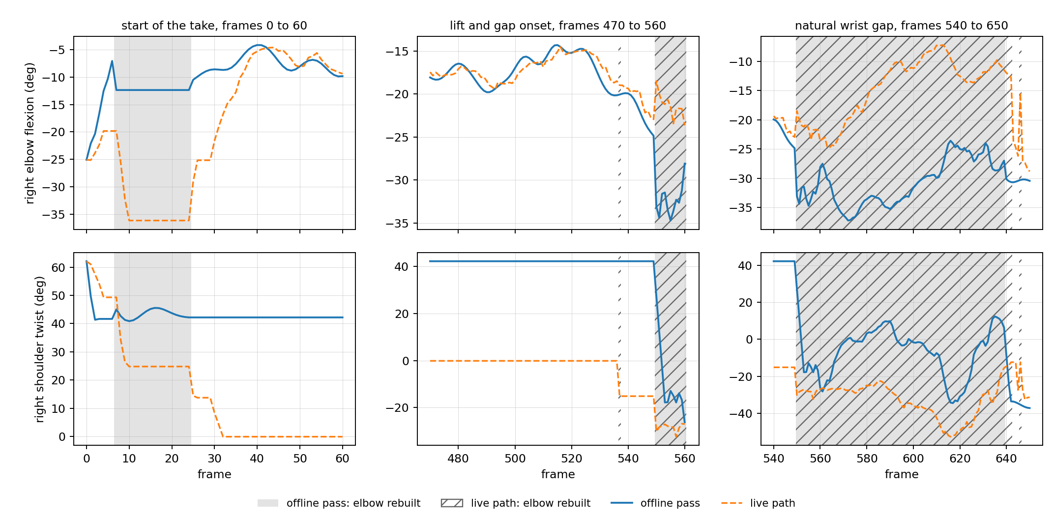
Figure 8.2. The two paths: the right elbow flexion above, the right shoulder twist below. The grey band marks frames the offline pass rebuilt, the striped band the causal path.
The smoother loses its view of the future, so the causal filter follows a moving joint late. In the lift onto the rail of Figure 8.2 the causal curve trails the offline one by a few frames and rounds its turns. The lag is small on this slow task and grows with the speed of the motion.
The states carried by the solver depend on the starting frames. The direction memories, the hand-object offset and the twist hold of Section 5.5, which acts while the elbow is nearly straight, all keep whatever the earliest frames gave them. On this recording the offline failure mask rebuilt the right arm over a window of frames 7 to 24 while the live gates held it. The two paths therefore froze shoulder twists about 40 degrees apart and kept them until the elbow bent far enough inside that window to release the twist hold (Figure 8.2, lower row). At frame 18 the offline pass rebuilt the arm and the causal path held it, and the wrists of the two forward-kinematics chains sit 12.0 centimetres apart (first panel of Figure 8.3). The frozen twists keep the two wrists apart on the later frames where every landmark is measured.
The hand-object offset differs as well, so the two paths rebuild the wrist onto different points of the object. Just before the natural wrist gap opens at frame 548, the offline pass still follows the tracker's wrist, which has already drifted onto the object, while the causal path has begun to rebuild from the object (second panel of Figure 8.3). Inside that gap the rebuilt elbow-flexion angles differ by as much as 24.1 degrees (Figure 8.2, right), although at frame 595 the wrists nearly coincide (third panel of Figure 8.3). The recovery also starts and ends on different frames along the two paths, because the live gates and the offline mask do not fire on the same frames. The causal exit rule keeps the wrist anchored to the object during the frames that confirm a release, while the offline episode logic clears those frames once it sees the release.
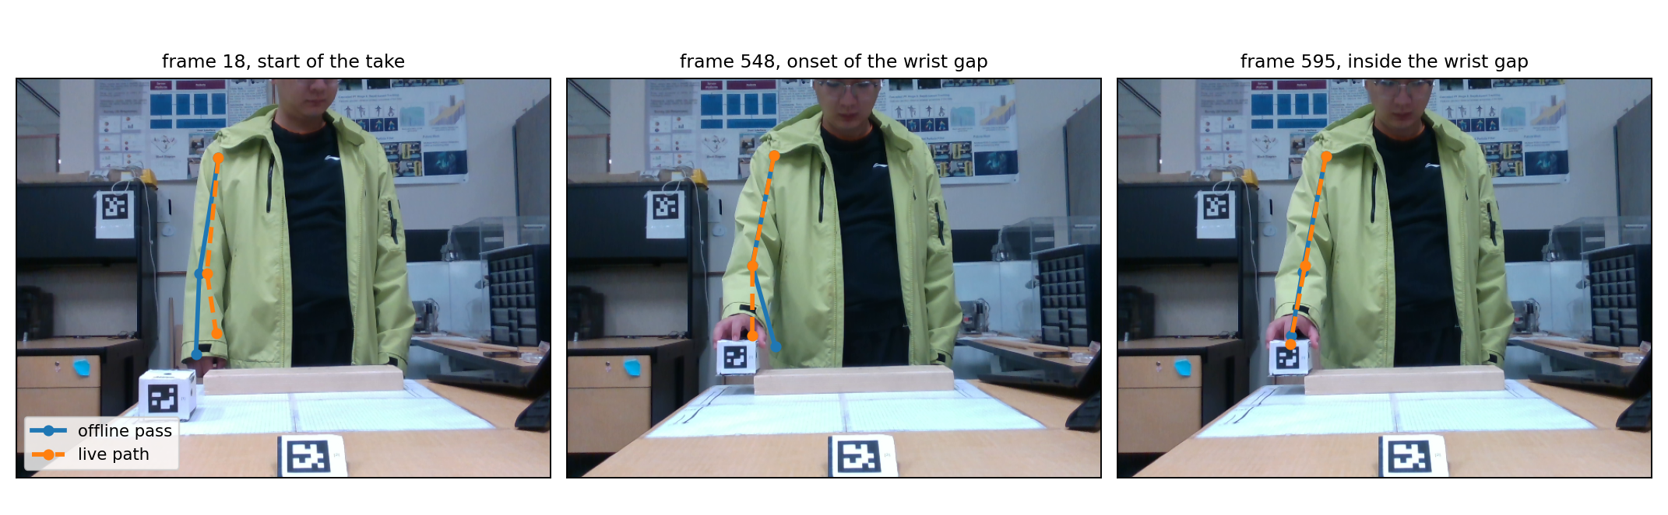
Figure 8.3. The offline chain (blue) and the causal chain (orange) drawn on the colour image at frames 18, 548 and 595, one moment from each window of Figure 8.2.
A rerun of the live validator on the archived records of the same replay puts numbers on the comparison. Each causal frame is paired with the offline frame the alignment places beside it, and the arm must be cleanly measured on both sides of the pair. The alignment that brings the two angle series closest together is five frames, and the pairing keeps 174 frames. At that alignment the elbow flexion of the two paths differs by a median of 0.4 degrees, the shoulder elevation by 1.4, and the shoulder twist by 7.0.
The shoulder azimuth differs by a median of 16.4 degrees and carries the shoulder group to a 95th percentile of 23.3 degrees. Section 3.4.2 gives the reason: the arm hangs close to straight down through the slide, near the configuration in which the azimuth is undefined. The comparison covers the arm alone, because the hip depth preparation of Section 2.6 rejects a measured hip on 858 of the 900 frames of this recording, so the root is rarely a measured group on both sides at once.
The merger blends a return from a long gap over two ticks instead of snapping to it (Section 6.1.2). On this recording the merger never had to hold a person record mid-run.

8.4 Runtime, Buffering, and Delay
On the workstation of Appendix B the causal structure consumed all 900 frames of the recording at its recorded pace, sustaining about 29 frames per second, with none dropped, and the merger emitted its output at a steady interval. Detection takes most of each frame's budget on both branches, and no stage this thesis adds exceeds 0.63 milliseconds at the 99th percentile. Each branch also finishes inside the frame budget of 33.3 milliseconds at the 99th percentile, the landmark branch within 13.0 milliseconds and the marker branch within 16.7. A lighter detector variant is the documented way to reduce the cost [43].
This chapter reports three timing quantities, and they are separate. The configured two-frame delay is a buffering and render delay: the merger renders the world two frame intervals behind capture so that it can interpolate between two samples it already holds. It is not a measured end-to-end latency from the sensor to the screen, which this thesis does not measure. The second quantity is the lag of the causal filter, which depends on the One Euro filter and the speed of the motion. The five-frame alignment of Section 8.3 is the third, an estimate of the shift that brings the two angle series into closest agreement on this recording. None of the three quantities bounds the others.

8.5 Feasibility and Remaining Validation Gap
Sections 8.2 to 8.4 show that the architecture transfers to causal processing on this recording. Causal forms replaced every operation that read the future, and the reconstruction still followed the task through the natural wrist gap of Section 8.3.
The experiment does not demonstrate a working live system. No complete live-camera session was validated, and the step from the recording to the device leaves several items untested. A scene calibration built from a live stream needs the printed size of each marker before the first detection, including the 45-millimetre desk and object markers of Table 2.1. The calibration of this thesis was computed from a recording. The rest reference of the grip tracker assumes that the object begins at rest and in view, which a recording guarantees and a live session does not. The capture process has been exercised on a file and not on the sensor. The synthetic landmark removal of Section 7.4.1 and the manual wrist labels of Section 7.4.2 both read a finished recording, so a live run can report only the outcome its own gates decided. Section 7.4.1 evaluates the removal against the unmasked reconstruction.
The result is therefore feasibility evidence for the architecture under causal processing, and not a validated real-time system. Chapter 9 relates the differences of Section 8.3 and the remaining validation gap to the rest of the thesis.

