Chapter 9: Discussion
This chapter reads the results of Chapters 7 and 8 as evidence about one integrated system. The system runs two branches from one RGB-D camera and three printed markers. The landmark branch gives a torso pose and four joint angles per arm, and the marker branch gives the world frame and the object pose. A recovery layer marks each joint group as measured, held or constrained, and the same chain also runs causally.
Each part was evaluated against a reference of its own. The points below state the conclusions those results support and the limits they reveal. The limits are of three kinds: the view of a single camera, the quality of the measurements, and the values the system carries over from earlier frames.
- Comparing the reconstructed object path with simple tape-measure distances shows a clear pattern in the errors: carry segments come out a bit shorter than they really are, while lift and slide segments come out a bit longer. Within the range of detector settings tested, adjusting them changes the size of the errors, not their direction. Lift points are the least reliable because each one depends on depth from a single video frame. Some extra uncertainty also comes from the wobble and rotation of the object, since those checks rely only on the recording itself, not an external reference. When the system loses the marker, it simply gives no position rather than a wrong one, and these losses happen only outside the labelled parts of the data, so the labelled comparisons remain unaffected. Figure 9.1 shows one such loss, and Figure 7.3 shows the three segments of the reconstructed path.
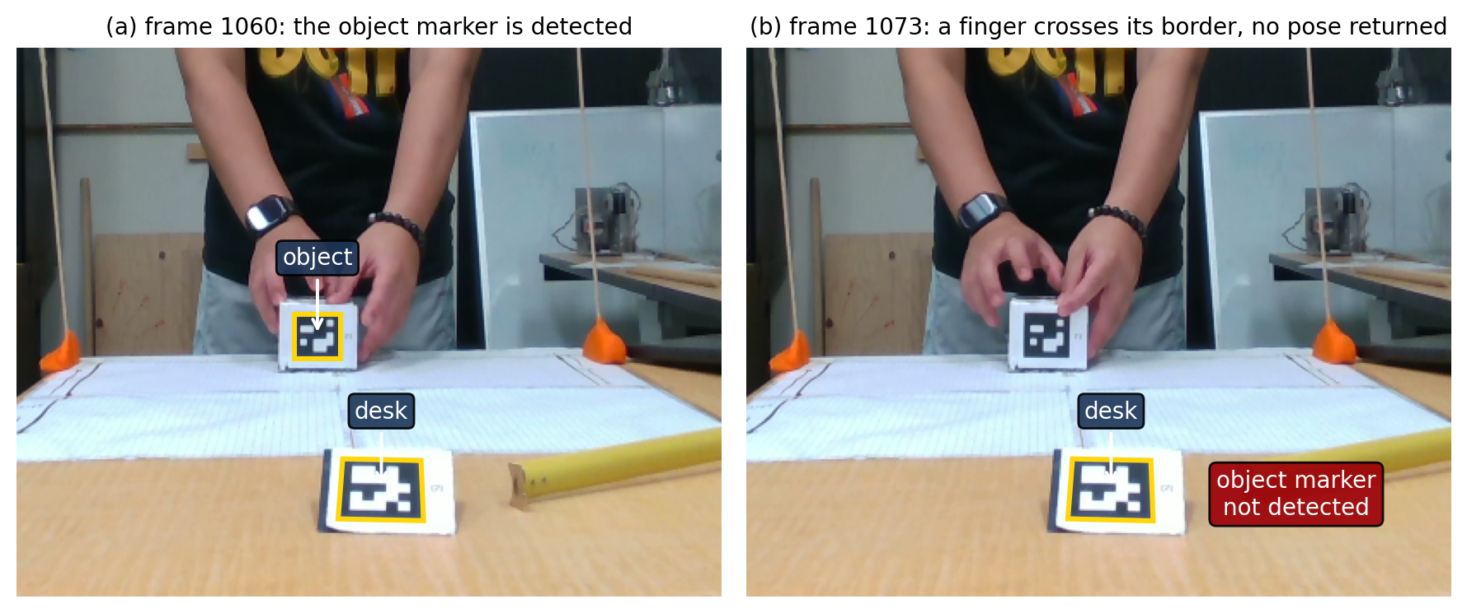
Figure 9.1. Object marker loss on the loop recording. (a) Both markers are detected, their corners outlined. (b) A finger crosses the printed square and no object pose is returned.
- The placement of the person and the object together in the scene has one outside check: the tape-measured distance from the wrist to the cube in the hand. The reconstruction comes close to it. The wrist the kinematic model places sits closer to the measured wrist than the wrist the drawn avatar shows, and the difference is not blamed on any single step of the path that draws the avatar. The distance also depends on the state of the forearm twist, measured or held; on the rail recording it is always held, so the avatar hand lands beside the cube. The two recordings also give different arm lengths, because the elbow landmark sits farther down the arm on one of them, and that is a property of the landmark rather than of the person. Figures 7.5 and 7.6 show the video beside the drawn avatar, and Figures 7.8 and 7.9 show a wrist label against the reconstructed arm.
- Using the object to place a hidden hand helped on one side and not on the other. The stored hand-to-object distance is learned while the hand is visible and updates slowly, so it lags behind a changing grip and freezes when tracking fails. An arm pointing straight at the camera leaves the wrist depth uncertain, so a small error there moves the elbow a long way, and a twist held through a gap is kept by the frames that follow. In the tests where landmarks were removed on purpose, no method was best on every window and joint. A closer wrist position on its own does not prove that the whole arm is right. Figure 5.3 shows the stored hand-to-object distance, Figure 5.5 the elbow reconstruction, and Figure 7.7 the natural failure frames.
- The torso frame that every arm angle is measured against depends on the two hip landmarks, and the desk can hide them. A hidden hip takes the depth of whatever is in front of it, so an upright person appears tilted forward, and because both hips shift together, no failure detector notices the shift. A landmark can also be wrong while the detector is confident about it: the detector once placed the elbow on the hand (Figure 9.2), and the check on the arm's length caught the mistake. When the hip depth preparation switches on or off, the torso frame moves with it. Holding the hips at their last good position while covered would look steady, but nothing measures the hips independently, so that rule remains untested. Figure 3.4 shows the torso frame built from the hips.
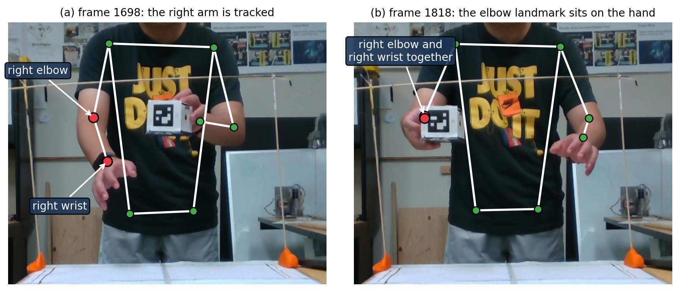
Figure 9.2. Landmark tracking failure on the loop recording. (a) The right elbow and wrist landmarks sit correctly. (b) The elbow landmark has moved onto the hand.
- The model itself solves four of the seven ways an arm can rotate, treats the wrist as a point with no orientation and the torso as one rigid plate, and does not track the legs. The other limits are of three kinds. A single camera cannot see a hand behind the cube or the desk, cannot judge depth well along the line of sight, and cannot tell the turn of a hanging arm or of a wrist. Measurements can be wrong: a landmark can sit off the body, a depth reading can come from the wrong surface, and marker corners can be noisy. The calibration's vertical direction also rests on the mounting angle of the wall marker, which was never measured. Finally, values carried between frames, such as a stored hand-to-object distance or a held angle, can be out of date. Figure 3.6 shows the arm chain and Figure 3.7 the swing and twist of a joint.
- Running the system live, frame by frame, gives a different result from processing the whole recording afterwards, because the live version cannot look ahead. In one gap the offline pass rebuilt the arm while the live pass held it, so the two froze the forearm twist at different angles, and their wrists ended up about 12 centimetres apart. The gap did not close once tracking returned. Live runs match each other only if both start from the same first frames, so running it for real needs a defined start, with the object at rest in view. The live version kept pace with the recording, but only as a replay of a file. Chapter 8 lists the points a real camera session still has to prove, and Figure 8.3 draws the offline and live chains on the same frames.
- The evaluation rests on one person doing a slow task in one controlled setup, recorded three times. Nothing here shows the accuracy of the system for other people, grips, clothing, tasks or rooms. The wrist labels used for checking are points clicked on a bracelet or a watch, not the exact wrist the detector defines, and the label sets are small, so a single frame can change a summary statistic. Some references are missing altogether. The physical route was never lined up in the same frame of reference as the reconstruction. The object's orientation has no reference of its own. The live result is a replay rather than a camera session, and the model stops at the upper body. Table 9.1 collects the six main limitations with the numbers behind them.
Limitation | Cause | Evidence on the recordings
Object lengths disagree with the physical reference | Not isolated by these recordings; the detector settings set the size of the disagreement, not its direction | Section 7.2: the carry reconstructs short on both recordings, by 1.14 and 2.82 cm, and the lift and the slide reconstruct long, by 0.53 to 2.83 cm
Physical route not registered | The measured route is a set of endpoint separations and is not expressed in the calibrated world frame | Section 7.2 compares endpoint separations and reports no distance from the reconstructed track to the physical path
Rendered output differs from the kinematic solve | The discrepancy appears downstream of the solve, in the rig and display path, whose stages these results cannot separate | Handover recording, captured frames: kinematic model wrist 0.83 and 2.34 cm from the measured wrist against 5.5 and 6.8 cm for the rendered rig joint (Section 7.3.2)
Segment lengths are effective, not anatomical | The calibrated upper arm and forearm are medians of the landmark track, and the elbow landmark need not sit at the anatomical elbow | Rail right arm 31.7 and 20.5 cm, loop right arm 25.6 and 25.2 cm, beside an independent measurement of about 25 cm for both segments on the subject; the rail elbow landmark sits 5.9 cm farther along the arm
Recovery helps on one occluded window and not on the other | Hand-object offset frozen with the estimator's lag; a nearly straight arm along the optical axis | Loop recording, right arm: object-assisted 5.2 cm from the manual wrist label against 11.4 and 17.6, on four retained frames (Section 7.4.2)
No live-sensor session | The capture process has not been run against the camera, and the online offset estimate needs the object at rest at the start | The real-time result comes from the recording replayed at its recorded pace
Table 9.1. The six principal limitations of the system, their causes, and the evidence for each on the recordings.
The results show that the approach works on the tasks that were recorded. They do not establish the accuracy of the system for other people or other tasks. Chapter 10 concludes and sets out future work.

