TRACKING AND RECONSTRUCTION OF BI-MANUAL
OBJECT HANDLING TASK USING RGB-D SENSING

by

Lanqing Luo

A thesis submitted in partial fulfillment
of the requirements for the degree of
Bachelor of Applied Science
in Systems Engineering

in the
School of Engineering Science
Faculty of Applied Sciences

Simon Fraser University
Burnaby, British Columbia, Canada

Summer 2026

Copyright Lanqing Luo 2026
All rights reserved. This work may not be reproduced in whole or in part,
by photocopy or other means, without the permission of the author.

Approval
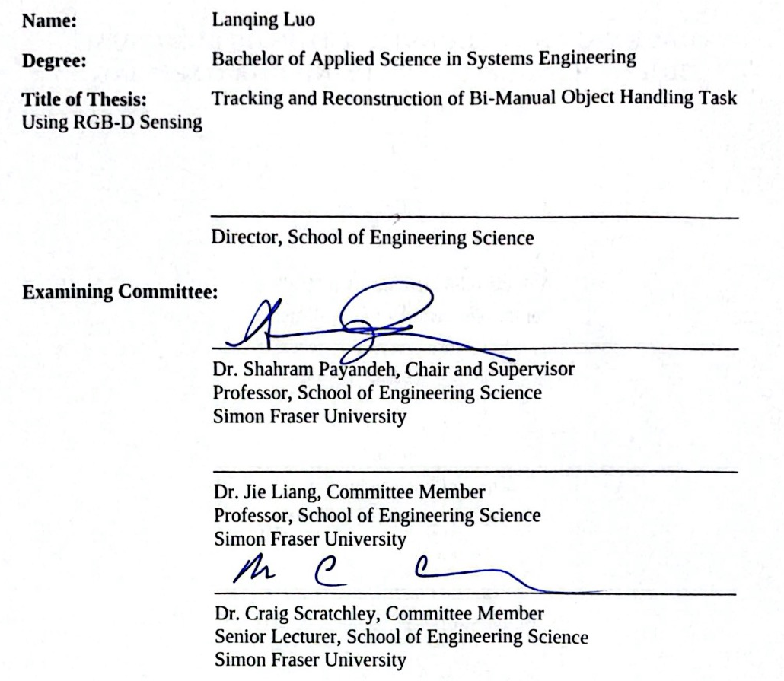

Date Approved: October 6, 2026

Abstract
Bimanual object handling is a fundamental human skill, and replaying such motions supports imitation learning, avatar animation, and clinical assessment. Conventional motion‑capture systems rely on multi‑camera rigs that require careful calibration and expert operation, while wearable systems impose hardware on the subject. This thesis demonstrates that a single consumer‑grade RGB‑D camera, combined with three printed ArUco markers, can track a person’s upper body and a hand‑held object during a desk‑based task and reconstruct both within a metric scene suitable for digital‑twin playback.
The core challenge lies in sensing reliability. The landmark detector may output points even when the corresponding body part is occluded or absent. The object and the opposite hand frequently hide the wrist; the hands themselves obscure the hips, causing the depth map to default to the desk surface. The landmark set does not uniquely determine wrist orientation, and each frame must be solved independently as it arrives.
The proposed pipeline contains two branches. The "landmark branch" converts RGB‑D body landmarks into a torso pose and four joint angles per arm. The "marker branch" establishes a world coordinate frame on the desk and tracks the object within it. The branches share only the captured frames and the world frame. Object pose information provides an additional geometric constraint when a wrist is lost, and the elbow pose follows from two‑link inverse kinematics. Outlier landmarks are rejected, remembered depth substitutes for occluded hips, and all reconstructed quantities are labelled as measured, held, or constrained before entering the rendered scene.
The evaluation tracks a cube moving across a desk and along a rail, both single‑handed and during a handover. Tape‑measured distances between marker‑defined waypoints range from 3.5 to 37.5 cm, while reconstructed lengths differ by 0.53 to 2.83 cm depending on detection settings. Desk‑level segments reconstruct slightly short, whereas later segments reconstruct long. Because the route is not registered into the world frame, point‑to‑path distances are unavailable. Under single‑hand grip, the reconstructed wrist‑to‑marker separation remains within roughly 2 cm of its tape measurement. Object constraints assist recovery during one natural occlusion interval but not another. The causal pipeline replays the motion at the recorded rate of approximately 29 fps, producing smooth output playback; however, a full live‑camera session was not validated.

Acknowledgements
Writing the acknowledgements has, unexpectedly, been one of the hardest parts of finishing this thesis.
The results of an experiment may be reproduced, but the uncertainty and frustration behind them cannot. Looking back, I still remember the nights I spent alone working through derivations by hand, again and again. Those difficult moments eventually became part of the work presented here.
I used to think that growing meant becoming better at solving problems on my own. Only now do I realize how many people supported me along the way.
I would like to thank my supervisor for his patience and guidance. He often reminded me not to rush and to take things one step at a time. When I was under too much pressure, he would tell me that it was okay to slow down and that my well-being mattered more. I am very grateful for that. I would also like to thank my committee for their patience and for giving me the time to complete this thesis.
I am especially grateful to my friends. When I was struggling financially, one of you lent me an entire month's salary without hesitation. During the most difficult period of the pandemic in China, while I was far from home, another helped my family and told me not to worry too much and to focus on my studies. I will always remember your kindness and support.
Finally, I want to thank my mother and my sister. When others questioned my choices, you continued to support me and simply told me, “Keep going. Don’t be afraid.”
I feel very fortunate to have had so much support throughout this journey. As my undergraduate years come to an end, I am glad to leave with a piece of work that I am genuinely proud of.
“Sometimes life knows what is best for us better than we ourselves know or think.”
Table of Contents
Approval
Abstract
Acknowledgements
List of Figures
List of Tables
Glossary
Chapter 1: Introduction
1.1 Motivation
1.2 Problem Statement and Literature Review
1.2.1 Hand and Object Tracking Approaches
1.2.2 Bimanual Manipulation in Motion Analysis
1.2.3 Graphical Reconstruction in Robotics and VR
1.2.4 Gap Analysis and Motivation for This Work
1.3 Research Objectives
1.4 Organization of the Thesis
Chapter 2: Experimental Setup and Measurements
2.1 The Recording Setup
2.2 Coordinate Frames and Scene Calibration
2.2.1 The Frames
2.2.2 Scene Calibration
2.3 Pose Landmarks From MediaPipe
2.4 Object Pose From ArUco Markers
2.5 Measurement Filtering
2.6 Hip Depth Preparation
Chapter 3: Kinematic Modelling
3.1 Coordinate Systems and Transformations
3.2 Torso Reference Frame
3.2.1 Landmark Selection
3.2.2 Derivation of the Torso Frame
3.3 The Arm Model
3.3.1 Kinematic Schematic and Solved Angles
3.3.2 Definition of Shoulder, Elbow, and Wrist
3.3.3 Establishing Local Arm Frames
3.4 Joint Angle Computation
3.4.1 Torso Pose
3.4.2 Shoulder Orientation
3.4.3 Elbow Flexion and Extension
3.4.4 The Wrist as a Tracked Point
3.5 Worked Example
Chapter 4: Object Tracking and Scene Reconstruction
4.1 World Anchoring and Camera Placement Invariance
4.2 Filtering and Cleaning the Object Track
4.3 Worked Example
Chapter 5: Pose Recovery During Tracking Failure
5.1 Assumptions and Parameters
5.2 Landmark Tracking Failures
5.3 Grip Episodes and the Hand-Object Offset
5.4 Wrist Recovery From the Object Pose
5.5 Elbow Recovery by Two-Link Inverse Kinematics
5.6 Worked Example: Frames 549 and 560
Chapter 6: System Integration and Graphical Reconstruction
6.1 Communication Architecture
6.1.1 The Frame Buffer: Capture Process to the Branches
6.1.2 The Records: Branches to the Merger and Unity
6.2 Coordinate System Conversion
6.3 Avatar Reconstruction in Unity
6.4 Scene Reconstruction in Unity
6.5 Worked Example
Chapter 7: Experimental Evaluation
7.1 Evaluation Method
7.2 Object Reconstruction Accuracy
7.2.1 Single-Hand Rail Task
7.2.2 Handover Task
7.3 Human Reconstruction Accuracy under Valid Landmark Measurements
7.3.1 Single-Hand Rail Task
7.3.2 Handover Task
7.3.3 Human-Object Spatial Check
7.4 Reconstruction During Landmark Failure
7.4.1 Synthetic Landmark Removal
7.4.2 Natural Occlusion
Chapter 8: Real-Time Feasibility
8.1 From Offline to Causal Processing
8.2 Causal and Real-Time Architecture
8.3 Offline-Causal Comparison
8.4 Runtime, Buffering, and Delay
8.5 Feasibility and Remaining Validation Gap
Chapter 9: Discussion
Chapter 10: Conclusions and Future Work
10.1 Conclusions
10.2 Future Work
Appendix A: RGB-D Data Acquisition
A.1 Acquisition Procedure
A.2 Structure of the Recorded Bag File
A.3 Replay and Visual Inspection
Appendix B: Hardware and Software Platform
Appendix C: Pose Landmark Detection
C.1 MediaPipe BlazePose Overview
C.2 Landmark Coordinate Extraction
C.3 Worked Example
Appendix D: Depth Sensing and Deprojection
D.1 RGB Camera Calibration
D.2 Depth-to-RGB Alignment
D.3 Pixel-to-Camera Mapping
D.4 Worked Example
Appendix E: Fiducial Marker Detection and Pose Recovery
E.1 Detection and Sub-Pixel Corners
E.2 Planar Pose Recovery and the Two-Solution Ambiguity
E.3 From the Rodrigues Form to a Rotation Matrix
E.4 Worked Example: Frame 533 Detections
Appendix F: Characteristics of the Candidate Filters
Appendix G: Hip Depth Preparation
G.1 Inputs and Initial State
G.2 Rejection Order
G.3 Memory Updates and Replacement
G.4 Output States and Scope
Appendix H: Kinematic Solver Verification
H.1 Synthetic Datasets
H.2 Measured Input
H.3 Scope of the Checks
References

List of Figures
Figure 2.1. The recording setup.
Figure 2.2. The experimental setup seen from the RGB-D camera, with the subject, the rail, the carried cube, and the three ArUco markers labelled.
Figure 2.3. Overall data flow.
Figure 2.4. (a) The sensor frame C on a D435 photograph (Intel [59]; axes added).
Figure 2.5. The scene frames.
Figure 2.6. MediaPipe Pose output on a mid-task frame.
Figure 2.7. Despiking on the right wrist of the recording: per-axis raw and filtered trajectories, with a mark on the sample flagged by the Hampel test.
Figure 2.8. Gap bridging on the right wrist of the recording: the short gaps filled by interpolation, with the replaced samples marked.
Figure 2.9. Smoothing on the right-wrist depth of the recording: the raw and filtered tracks over an eight-second span, with the shaded window enlarged below.
Figure 3.1. The chapter's information flow.
Figure 3.2. The raw camera frame {Camera} and y-up camera frame {Camera'} drawn from one optical centre.
Figure 3.3. The worked-example frame, front view.
Figure 3.4. Torso-frame construction.
Figure 3.5. The reference configuration: the subject in the T-pose with a frame at each landmark.
Figure 3.6. The kinematic schematic of the right arm, a chain of revolute-joint cylinders in the Programmable Universal Machine for Assembly (PUMA) style.
Figure 3.7. The swing-twist decomposition.
Figure 4.1. The object marker: (a) on the desk, frame 95; (b) lifted, frame 505; (c) sliding, frame 700; (d) the rail end, frame 898.
Figure 4.2. The object marker origin in the world frame, one panel per axis: grey detected, blue filtered, orange the eleven bridged rows, ten despiked and one undetected.
Figure 5.1. Information flow of the recovery layer in the Scene formulation of Section 5.3.
Figure 5.2. The six failure detectors, one panel each: acquisition, segment-length and line-angle in the upper row, width-ratio, landmark-step and grip-plausibility in the lower.
Figure 5.3. The hand-object offset.
Figure 5.4. The holding state of one hand: the five conditions of the instantaneous test, and the rules for entering, staying in and leaving the state.
Figure 5.5. The elbow reconstruction.
Figure 5.6. (a) Frame 549, the last clean frame of the right arm.
Figure 6.1. The integration architecture: the capture process, the two branches, the link from the landmark branch to the object record, and the merger that feeds the display.
Figure 6.2. The frame buffer: the header, the eight slots, the byte layout of one slot, and the write and read steps.
Figure 6.3. The combined record as a memory block: 112 bytes with their offsets, the merger's write protocol on the left and the receiver's read protocol on the right.
Figure 6.4. The four frames of the coordinate conversion before gravity alignment, with the path of each branch to the display.
Figure 6.5. The reconstruction from the virtual sensor: (a) frame 114, the hand at the cube; (b) frame 700, sliding it along the rail.
Figure 7.1. Rail recording: video frames, accepted marker-centre samples and the four reconstructed waypoints in {Scene}.
Figure 7.2. Handover recording: video frames, accepted marker-centre samples, the four reconstructed waypoints and handover position H in {Scene}, with this recording's floor translation and scale conventions of Figure 7.1.
Figure 7.3. Single-hand rail task in Unity: marker-centre and model-wrist trajectories for carry, lift and slide.
Figure 7.4. Handover task in Unity: marker-centre and both model-wrist trajectories for the right-hand, transfer and left-hand intervals.
Figure 7.5. Rail recording: object acquisition, lift and slide, with recorded video on the left and the saved Unity sensor view on the right.
Figure 7.6. Handover recording: right-hand slide, transfer and left-hand slide, using the paired views of Figure 7.5.
Figure 7.7. Loop recording: four natural-failure frames, with the affected arm named above each view.
Figure 7.8. Loop frame 1462, left wrist: the square marks the manual wrist label, the blue chain is the reconstructed arm, and the cross is the object-derived wrist estimate.
Figure 7.9. Loop frame 1890, right wrist, with the symbols of Figure 7.8.
Figure 8.1. The offline pass (above) and the causal structure (below), each causal stage under the offline stage it replaces.
Figure 8.2. The two paths: the right elbow flexion above, the right shoulder twist below.
Figure 8.3. The offline chain (blue) and the causal chain (orange) drawn on the colour image at frames 18, 548 and 595, one moment from each window of Figure 8.2.
Figure 9.1. Object marker loss on the loop recording.
Figure 9.2. Landmark tracking failure on the loop recording.
Figure A.1. Structure of the recorded session file: the one-time description topics on the left, the per-frame image and metadata messages on the right.
Figure A.2. (a) The recorded colour frame of the worked-example moment.
Figure C.1. The eight upper-body landmarks on the worked-example frame, drawn at the pixels the extractor sampled, with the segments between them.
Figure C.2. The same eight landmarks as metric position vectors from the sensor origin, with the camera axes drawn at the origin.
Figure D.1. (a) The pinhole geometry the intrinsics describe: a scene point, the ray to the camera centre, and the pixel where it crosses the image plane.
Figure E.1. Marker detection on the worked-example frame.
Figure E.2. (a) A nearly face-on plane admits two pose readings, tilted toward the camera or away from it, that are mirror images about the camera ray.
Figure F.1. (a) The four candidates on one constructed test signal, not recorded data: a profile that holds still, moves and holds again, with broadband noise and one single-frame spike added.

List of Tables
Table 1.1. Summary of the reviewed literature: each approach family, its representative work, its sensing arrangement, and its limitation for single-sensor bimanual capture.
Table 2.1. The objects in the scene.
Table 3.1. The eight landmarks of the worked-example frame in the sensor frame and in the y-up camera frame, printed to two decimals.
Table 6.1. The shared memory blocks.
Table 6.2. Frame 533 of the rail recording through the causal structure and the receiver.
Table 7.1. Rail recording: reconstructed marker-centre segment lengths against the physical reference, with absolute and relative error.
Table 7.2. Handover recording: reconstructed marker-centre segment lengths against the physical reference, using the columns of Table 7.1.
Table 7.3. Single-hand task: rendered joint error relative to accepted measured 3D landmarks on the captured subset of valid-landmark frames.
Table 7.4. Handover task: rendered joint error relative to accepted measured 3D landmarks, reported separately for each arm on its captured subset of valid-landmark frames.
Table 7.5. Synthetic removal windows selected using valid unmasked wrist motion before method errors were calculated.
Table 7.6. Synthetic elbow reconstruction error relative to the valid unmasked model reconstruction.
Table 7.7. Synthetic wrist reconstruction error relative to the valid unmasked model reconstruction.
Table 7.8. Clean-frame distance between the manual wrist label and an accepted filtered wrist measurement.
Table 7.9. Reconstructed wrist distance to the same manual wrist label on retained natural-occlusion frames, separately for each arm.
Table 8.1. The parts of the offline pass of Chapters 2 to 5 that the causal structure keeps; the replacements of this section are the adapted rows.
Table 9.1. The six principal limitations of the system, their causes, and the evidence for each on the recordings.
Table A.1. Contents of the recording's session file.
Table B.1. The workstation and the software versions behind every result in this thesis.
Table C.1. The eight MediaPipe landmarks used in this work, with the model's indices.
Table C.2. The right-arm landmarks of the worked-example frame, from the visibility score through the sampled pixel and depth to the back-projected position.
Table D.1. Factory colour-camera intrinsics, read from the calibration topic of the recording.
Table E.1. The three marker detections of the worked-example frame, in the order of the panels of Figure E.1.
Table F.1. The four candidate smoothers, with the parameters used in Figure F.1(a).
Table H.1. The six synthetic datasets.

Glossary
Selected terms and abbreviations used in this thesis.
Term | Meaning
camera frame {Camera}, C | the aligned colour optical frame: x right, y down, z forward
display frame {Unity}, U | left-handed axes formed by swapping the second and third world axes; the desk-marker origin is retained
marker, fiducial marker | a printed square pattern for measuring pose; ArUco markers are fixed to the wall, desk and object
object frame {Object}, O | centred on the object marker; its third axis is normal to the marker plane
p95 | 95th percentile: the value at or below which 95 percent of samples fall
PSF1, PSR2, PSB2, PSB3, PSI2 | pose-stream record identifiers: colour/depth frames (PSF1), person (PSR2), object (PSB2), calibration (PSB3), combined pose (PSI2); digits identify layout versions
PUMA convention | Programmable Universal Machine for Assembly: the robot drawing convention with revolute joints shown as cylinders
RGB-D camera, sensor | captures red, green and blue colour (RGB) plus depth (D); the sensor here is the Intel RealSense D435
scene frame {Scene} | the final Unity frame after gravity alignment and floor placement; y is vertical, with the origin on the drawn floor
T-pose | arms extended horizontally to the sides; all arm angles are zero
world frame {World}, W | fixed to the desk marker during calibration; the reference for object pose
y-up camera frame {Camera'}, C' | {Camera} with y flipped upward; the optical origin is unchanged

