Rapport:

* Clock frequentie, prescaler,…
* Stop modus (& metingen)
* Watchdog timer tijdens STOP laten freezen

## Verschillende slaapmodi

* Sleep
* Stop
* Standby
* Clock Frequency: the faster the CPU, the higher the power consumption. (leads to complex clock distribution tree)
* Unnecessary peripherals are shut off to save energy.
* LPUART Works in STOP2 mode using DMA
* The deeper the sleep, the longer it takes to wake up

INFO:

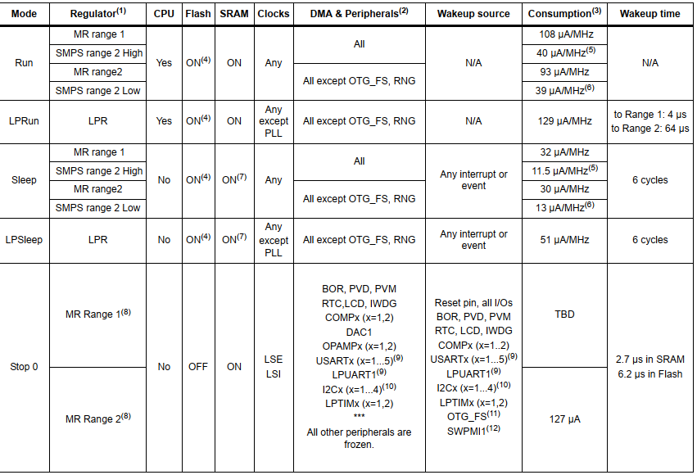

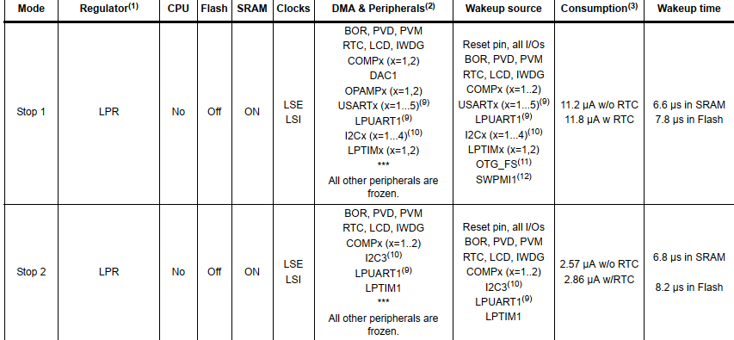

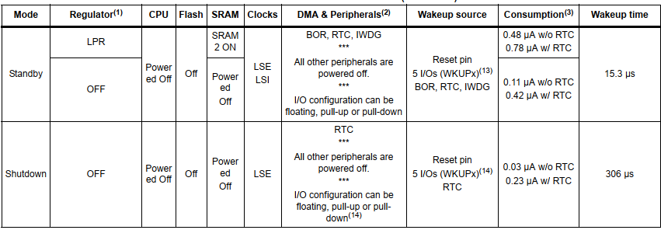

Sleep:

WFI(wait for interrupt): Goes to sleep and only wakes up when it receives an interrupt.   
WFE(wait for event): checks status of a particular event register and depending on the value it goes to sleep or not.

EXTI: Extended interrupts and Events Controller is hardware component that manages the external and internal asynchronous interrupts/events and generates requests to the CPU/NVIC Controller.

Door een GPIO pin op GPIO_MODE_EVT_* te zetten zal deze geen IRQ request genereren maar de event flag zetten. Dit maakt de core wakker met een WFE.

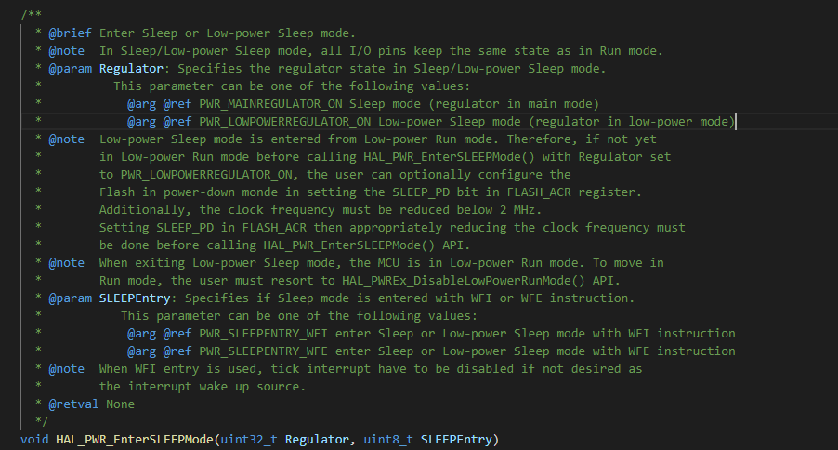

Stop:

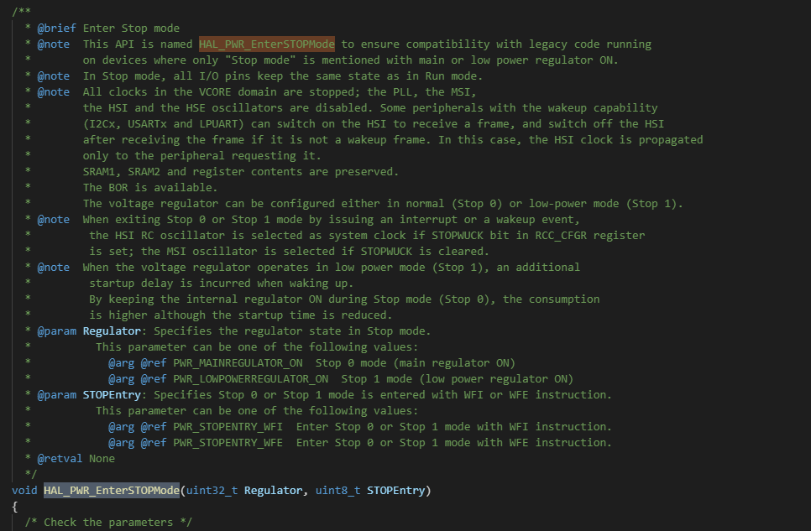

Standby:

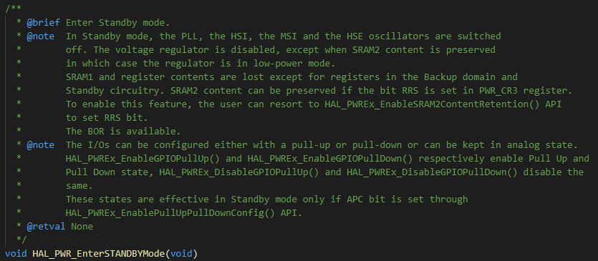

Watchdog:

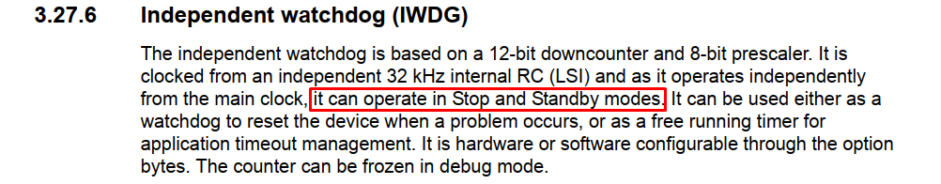

Freezing watchdog timer:

<https://www.st.com/content/ccc/resource/training/technical/product_training/d5/97/97/97/ef/b9/48/26/STM32L4_WDG_TIMERS_IWDG.pdf/files/STM32L4_WDG_TIMERS_IWDG.pdf/jcr:content/translations/en.STM32L4_WDG_TIMERS_IWDG.pdf>

