Model Documentation: FAST-ABM
Flood Adaptation via Social Transformation Agent-based Model

General description
This model was developed to study the role of social influence (interactions and norms) on the uptake of private climate change (flood) adaptation, whether transformational adaptation (large-scale uptake of adaptation across households) is possible, and if social tipping points play a role in these transformative processes. Fig. C1 provides a conceptual overview of the model:
- Household agents have attributes related to their perceptions around flood events and adaptation, derived from Protection Motivation Theory², as well as socio-demographic characteristics. Based on their perceptions, they form a protection motivation that, together with a perceived social norm forms their intention to adapt. If finances (savings) allow, the household agent takes an adaptation decision: to adapt by wet- or dry-proofing, or not taking action. Depending on their adaptation decision and their exposure, in case of a flooding event, they experience damage.
- Household agents are influenced by their social surroundings in 2 ways:
  - Social network: Each household agent is a node within a network structure. The network is built based on empirical insights into the number of connections and preferential attachment. We use one possible network structure that results from this and place the households based on their characteristics (homophily, neighbors, …). Within this network, household agents exchange views with their connections using an opinion dynamics model. In this process, the household agents’ perceptions get updated, essentially altering their protection motivation.
  - Social norm: Household agents have a perceived social norm, depending on the fraction of adapted household agents around them. This is essentially a translation of the fraction of adapted households overall (global social norm) or within their district (local social norm) into the perceived social norm.
We initiate the model using survey data from England for the households, and insights gained from social influence around climate adaptation from coastal areas in three countries (England, Netherlands, United States). One timestep corresponds roughly to one year; we currently run the model for 50 timesteps.
The remainder of this document provides an overview of the model in more detail, following the model implementation using the python library mesa for agent-based modelling. The code with the files mentioned here can be found on GitHub [link].

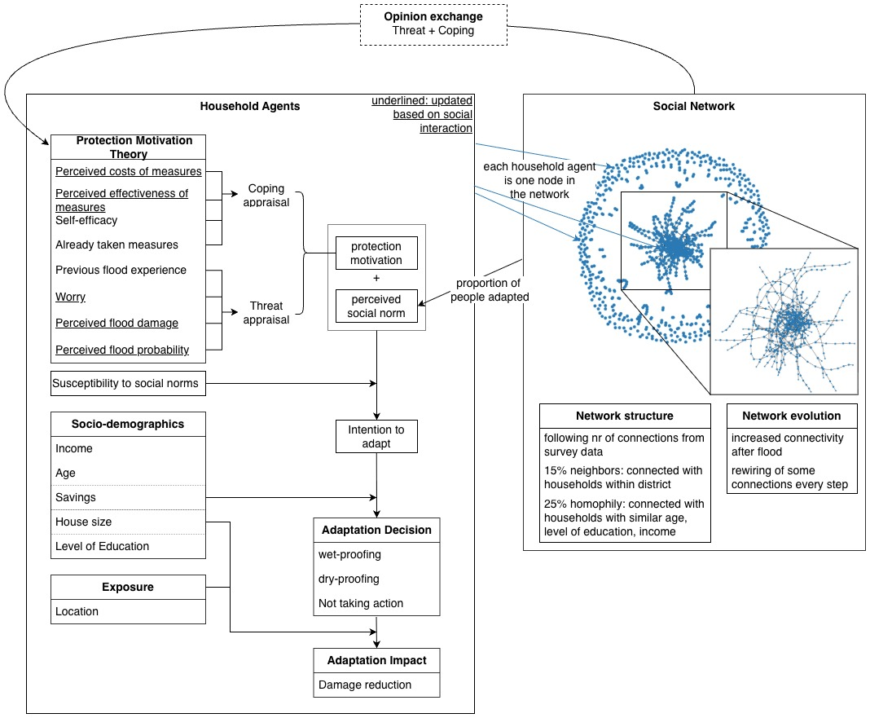
Figure C1: Overview of FAST (Flood Adaptation via Social Transformations) agent-based model.

Model

Initialization

Make grid
Grid is currently 5x5 cells. See Fig. C2 for how it looks.
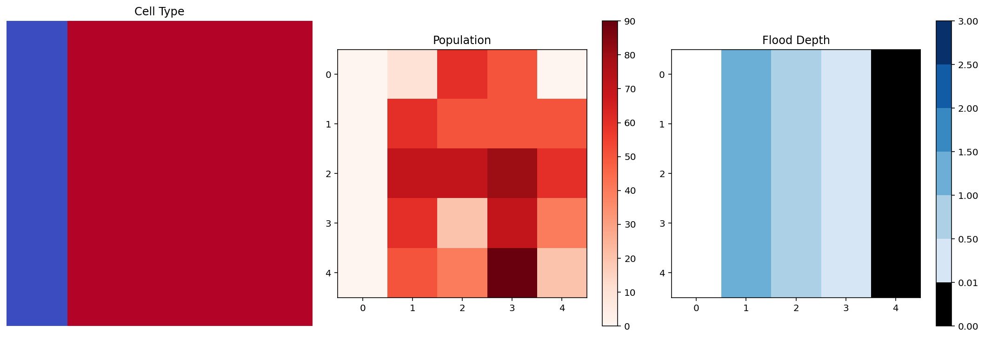
Figure C2: Model landscape. Left: cell type (blue - water, red - residential). Middle: Population distribution. Right: Flood depth. Note: all are set in the initial setup.
- One column is water, the rest residential.
- The population distribution is given for now per grid cell as a listed list. The sum needs to fit the total number of household agents modelled. Through changing the household agents per cell, different population distributions can be realized.
- Water depth is given as a list. Every value represents the flood depth for one column.
It is a Mesa multigrid with the properties type (water or residential), population (number of agents in cell), and flood_depth (flood depth experienced in that cell).

Add HH agents to grid
Places household agents randomly on the grid, taking into account the maximum population that can be placed in each cell.

Read network structure
Reads the network structures. The structure is generated outside the model in a separate notebook (see Preparation Network Structure). It reads in the network structure in the form of a .graphml file. If the number of nodes in the network doesn’t correspond with the number of household agents in the model, an error is given.

Place HH agents on network considering proportion of neighbors
The idea is to have 15% of the connections with households that are placed in the same cell (based on the findings from the survey data as outlined in ³, this is a input parameter that can be adjusted). We do this by selecting that fraction of edges out of all edges and placing the households with the same value on the corresponding nodes. How many households in the end are connected within the same cell depends also on the number of households and the number of cells, as the rest of the households are assigned to nodes randomly and might also be placed in the same cell.

Update node id node id = agent id
Ensure that node ID and agent ID are the same. Just for consistency and to access the agent ID directly from the node.

Add homophily to network assign income, education, age, savings, house size to agents
Similar to step 4, the idea is to have 25% of connections between households that share similarities in terms of income, level of education, and age (same income category, same level of education, max 10 years difference in age, see Find_homophily_indexes function; based on the findings from the survey data as outlined in ³; again an input parameter that can be changed). It picks the relevant index from the Sociodemographics.csv data frame (see Household data) and, based on that, assigns annual income, level of education, and age, as well as the variables house size and savings to each agent.

Assign more weight to family&friends ties
55% of ties get more weight assigned to represent a closer relation between these households (based on the findings from the survey data as outlined in ³, input parameter can be adjusted). This is then used in the opinion dynamics model.

Run

Check if flood
Flood occurs at given time step(s).

Advance HH agents 1 step
See Household Agents Run.

Update model variables
Calculate the adaptation rate across all households as well as adaptation intentions. Also updates the network descriptives.

Evolve network
No network evolution if proportion_ties_removed_per_step, fraction_ties_added_at_flood and proportion_ties_added_per_step are all 0.
Some people will start talking about flooding, some will stop. Therefore, a couple of edges are added and removed each step if the parameters are not set to 0.
After a flood event, the adding and removing of edges depends based on the timely distance to the event.

Remove edges
If removing of edges, the edges to remove are selected randomly.

Add new edges
The edges are added conforming to the same criteria for network formation outlined in the Initialization (x% neighbors, y% homophily).
The proportion of nodes getting newly connected is generally constant. After a flood event, the proportion is increased and then slowly decreases again. The network in the model represents the flood interaction network. In reality, we would expect people to engage in more discussions on flooding shortly after a flood event. After some time, the topic slowly becomes less prominent. Therefore, just after a flood event, many new connections are added to the network.
Propotion if flood_time <= steps <= flood_time + flood_remembrance_period:
Proportion after flood = fraction_ties_added_at_flood/(steps-flood_time +1)

Collect data
The following data is collected
Model data collector
Variable collected | comment
Network-related  - edges  - avg_clustering  - density_nw | Can calculate from it:  - avg_degree = 2*edges/nr_households
Damage  - cumulative_damage  - cumulative_damage_no_adaptation | adaptation_benefit = cumulative_damage_no_adaptation – cumulative_damage
Adaptation
- fraction_wet_proofed
- fraction_dry_proofed
- fraction_adapted_any
- fraction_adapted_both
Severely affected HH  - nr_HH_severely_affected  - nr_HH_severely_affected_adapted_any | Can calculate:  - nr_HH_moderately_affected = nr_households – nr_HH_severely_affected  - fraction_severely_affected = nr_HH_severely_affected/nr_households  - fraction_adapted_sev_aff = nr_HH_severely_affected_adapted_any/ nr_HH_severely_affected  - nr_HH_moderately_affected_adapted_any = fraction_adapted_any * nr_households – nr_HH_severely_affected_adapted_any  - …
Transformative Adaptation  - transformative_adaptation | If fraction_adapted_any above threshold given in setup
Adaptation Intentions
- avg_intention_SN
- avg_intention_PMT_DP
- avg_intention_PMT_WP
- avg_intention_overall_DP
- avg_intention_overall_WP

Agent Data Collector (currently not collecting due to large data). Input parameter collect_agent_data = 0
Variable collected | comment
Money  - savings  - income | Income does not change – not sure if we need it. Savings probably more important as the adaptation and flood damage are paid from these
PMT  - risk_perception  - worry  - PMT_intention_DP  - PMT_intention_WP | Worry changes with flood, RP with social influence. Response_efficacy also changes with social influence but not collected so far  PMT_intention is sort of a combined variable of the changes due to social influence
Social influence  - nr_connections  - SN_intention | If HH agents don’t have any connections, no social influence. SN_intention the same if calculation done on “all”, but differs per agent if done on “neighbors” or “connections”.
Adaptation
- Overall_intention_DP
- Overall_intention_WP
- DP_taken
- WP_taken

Household Agents

Initialization
- Get location (model initialization step 1)
- Get PMT parameters from survey
  - Or if set_hh_adapted_at_start not False, measures_taken set to 1 for that proportion of HH agents
- If measures_taken is 1:
  - Set age of measures to anything between 0 and measures_aging
- Get income, age, etc via network homophily placement (model initialization step 6)

Run

Save money
Savings rate given by model. Currently 5% of annual income saved for taking measures and repairing damages.

Get connections
Check who they are connected to.

Get neighbors
Check who is located within the same grid cell.

Calculate worry
After a flood and in the personal_flood_remembrance_period, the worry decreases again step by step until the end of that period. This is only applicable if people experienced damage and therefore updated their worry with the flood shock

If connections:

Calculate influence of network on perceptions
Now there is a choice of two opinion dynamics (OD) models: either a similarity-biased one with a given threshold, or an assimilative one. The function works in a way that it checks the opinion and considers it depending on if the OD model is assimilative (takes all opinions into account) or if it is similarity-biased.
- Assimilative: Based on a reusable building block (RBB) for assimilative social influence if opinion_dynamics_model is “assimilative” and adapted to also have weight of opinion in there.
- Similarity-biased: threshold checked on each coping and threat opinions exchanged. If the difference is smaller than the threshold, opinions are taken into account.
In the model setup, it can be specified (Exchange_what) whether household agents are exchange opinions only on ‘threat’ variables, only on ‘coping’, or on ‘threat+coping’.

Calculate influence of social norm
Three ways in which social norm is calculated:
Connections: How many of the connecting agents have adapted. Fraction of adapted connections to all connections. If no connections, probability from social norm is 0.
Neighbors: how many of the neighbors ie agents with the same location have adapted. Fraction of adapted neighbors to all neighbors
All: How many in total have adapted. Fraction of adapted overall to number household agents.
Then we use a logistic function to translate that into the probability from the social norm. The midpoint for the curve is set in the input parameters.

Calculate intention to take measure (PMT)
Calculate probability to take measure based on PMT perceptions inspired by RBB. The regression for the weights is based on the survey data. We build the logistic regression from the variables worry, perceived probability, perceived severity, perceived response efficacy of measures, self-efficacy related with measures, perceived costs of measures to the implementation of these (see Logistic regression for more information).

Calculate intention to take measure overall
Combine the probability from the social norms (see Calculate influence of social norm) with the probability from PMT (see directly above). The weight for each comes from the survey data (Q30_adapt_against) or is set in the model input (weight_SN_vs_PMT) reflecting how likely people are to take adaptation measures if no one else does so. Together they form the probability to take a measure.
Intention_to_adapt[measure] = protection_motivation[measure] * (1 – weight )+ perceived_social_norm * weight

If measures left to take, probability higher than minimum probability to take measure, and it is a step where they consider measures:

Try to take measure based on probability (stochastic) and savings
Stochastically, their probability to take a measure overall is checked. If it is high enough, they go ahead and take the measure. If not, nothing happens. If yes, next it is checked whether the household agent has enough savings to pay for the measure (savings >= costs measure). If this is true, the measure is taken, so the flood damage is recalculated with the new protection status, the savings are reduced by the cost of the measure and the measure is marked as taken.

Age measures
If aging of measures, add a year to it. If end of lifetime of measure is reached, it is removed.

Calculate (potential) flood damage
Damage calculation is based on the depth-damage curves for residential buildings in Europe ⁴.
We calculate the damage based on flood depth and house size, and then it is reduced depending on the measures taken.

If flood: Experience flood shock
Subtract damage from savings
The damage is subtracted from the savings. This means people can have negative savings, which will not allow them to buy adaptation measures until they have built up enough savings again.
Flood experience becomes 1
If a HH agent experiences a flood ie they incur damages, their flood experience is set to 1. The flood experience is binary (0 or 1)
Worry is updated
Worry increases by worry_increase_with_flood. Furthermore, the worry_decrease_rate is calculated so that by the end of the personal_flood_remembrance_period, the households have 10% more worry than before the flood.

Functions
File: functions.py

Find_homophily_indexes
Related to the initialization of the network in the model. Here we look for 2 random indexes within the sociodemographic data that fulfil the following criteria:
- Same income category
- Same level of education
- Age difference maximum 10 years
People with these characteristics are considered “homophilic,” ie, there is a homophily relation between them.
Function returns a list of ‘homophilic’ pairs.

Logistic_adapted_to_SN
Logistic curve (S-curve) to reflect how the fraction of adapted households translates into an intention to adapt from social norm. Scaled between 0 and 1, with an adjustable midpoint (see Fig. C3).
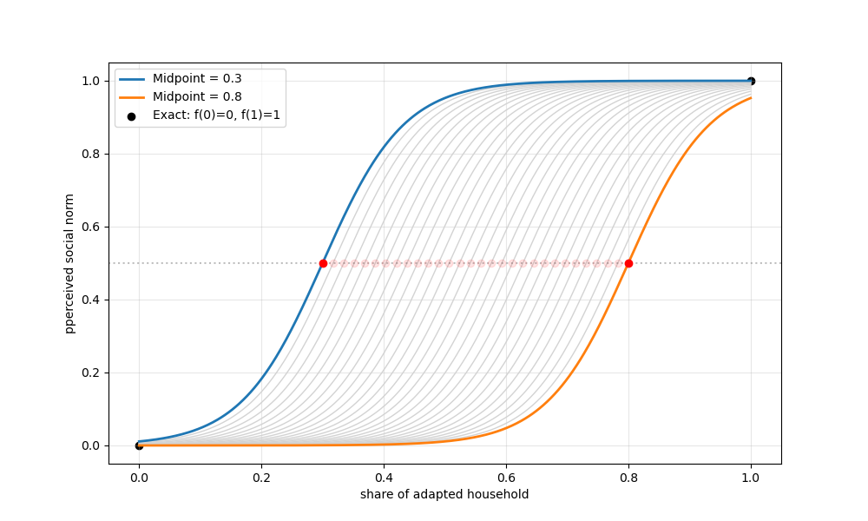
Figure C3: Translation of the share of adapted households to perceived social norm via an S-curve.
See notebooks/preparatory_analysis/SN_to_fraction_adapted_curve.ipynb for more information.

Decrease_rate_worry_in_flood_remembrance_period
Calculating the decrease rate for worry for the agent’s flood remembrance period. Worry increases with flood experience and then decreases until the end of the flood remembrance period linearly. At the end, it will still be higher than the pre-flood worry.

Running the model

Inputs
Name | Type | Default value | Possible other values | notes
seed | Int | None
nr_households | Int | 100 |  | Standard running with 1000 now
Set_hh_adapted_at_start | Float or boolean | False | [0-1] | If False, just uses the adaptation from the empirical data. Of value between 0 and 1, sets that amount of households as adapted at start
Prop_inc_for_damage_adaptation | Float | 0.05 |  | Percentage of income available for adaptation and damage each months. Accumulates.
Exchange_what | String | ‘threat+coping’ | ‘coping’, ‘threat’
Social_norm_calculation | String | ‘all’ | ‘connections’, ‘neighbors’ | Based on what population the proportion of adapted households is calculated to be considered in the decision-making of the household agent
per_HH_adapted_to_SN_prob_midpoint | Float | 0.5 | [0,1] | Midpoint of logistic regression for translating % adapted to the probability from social norm
Weight_SN_vs_PMT | Float or string | ‘empirical’ | ‘empirical’, [0,1] | Either using Q30_adapt_against to determine weight or the given weight for the consideration of social norm in the likelihood to act
Opinion_dynamics_model | String | ‘assimilative’ | ‘similarity_biased’
Weight_opinion_others | Float | 0.5 |  | If an agent has connections, they assign this weight to them
Threshold_similarity_bias | Float | 0.3 |  | Only used when using similarity_biased OD model
Grid_width | Int | 5
Grid_height | Int | 5
Flood_depth_in_m | List | [99, 1, 0.6, 0.4, 0] |  | Has to have length of grid_height, first value is waterfront
Threshold_severe_flood_exp | Int | 2 |  | Above what water level HH agents are considered severely affected
Flood_time | List | [10, 50]
Population_density | Listed list | [[0,5,5,5,5],  [0,5,5,5,5],  [0,5,5,5,5],  [0,5,5,5,5],  [0,5,5,5,5]] |  | Has to add up to nr_households. Has to be size of grid_width x grid_height
Network_structure_file_path | String | '../data/network_structures/  social_network1.graphml' | '../data/network_structures/  Network_empirical.graphml' | Network structure that is used, needs to have same number of nodes as nr_households
Fraction_neighbors | Float | 0.15 |  | Connections between household agents in one grid cell
Fraction_homophily | Float | 0.25 |  | Connections between household agents with similar age, income, level of education
Fraction_family_and_friends | Float | 0.55 |  | Connections with more weight assigned to them
Proportion_ties_added_per_step | Int | 0.01 |  | Network growth
Proportion_ties_removed_per_step | Int | 0.01 |  | Network shrinking
Fraction_ties_added_at_flood | Float | 0.1 |  | Network growth at flood
Flood_remembrance_period | Int | 5 |  | How long the fraction ties added is active/affects the network evolution
Consider_measure_every_x_steps | Int | 5 | Min 1 | Every how many steps households try to take a measure
Minimun_intention_to_consider_measure | Float | 0.1 | [0,1] | Minimum intention needed to consider taking a measure
Worry_increase_with_flood | Float | 0.4 | [0, 1] | How much worry increases when experiencing a flood
Min_worry_after_flood | Float | 0.1 | [0,1] | Minimum worry after experiencing a flood
Max_damage_per_sqm | Float | 950 |  | From ⁴ in €, adjusted for inflation to 2023 value, EU based
CCA_costs | dict | {'dry-proofing': 10300,  'wet-proofing': 8000} |  | See brainstorm document (money) (in €), based on ⁵
Damage_reduction | Dict | {'dry-proofing': 0.5,  'wet-proofing': 0.4} |  | See brainstorm document (money), based on ⁵
Measures_aging | dict | {'dry-proofing': 20,  'wet-proofing': 20} | {'dry-proofing': 0,  'wet-proofing': 0} | If 0, no aging of that measure. Number of years after which measure loses effect and needs to be rebought
Transformative_threshold | Float | 0.8 | [0, 1] | Threshold above which transformative adaptation is reached
Collect_agent_data | Int | 0 | 1 | 0: no data collection on agent-level, 1: data collection on agent-level

Visuals
Can be turned on and off when running the model (currently not implemented for batch-runs but just for simple runs (run_model.py)).
Visualizes the grid
The network and the degree distribution
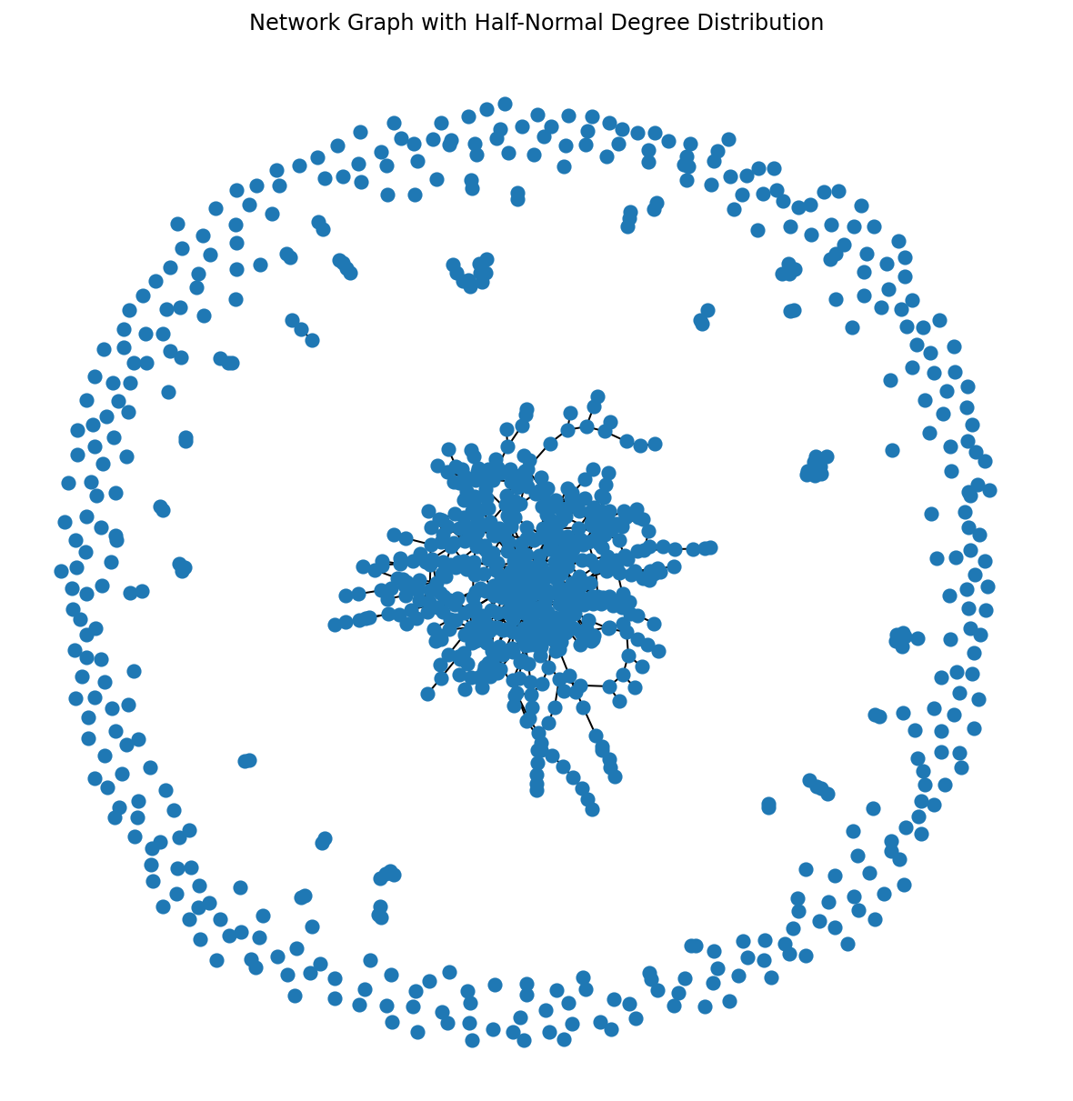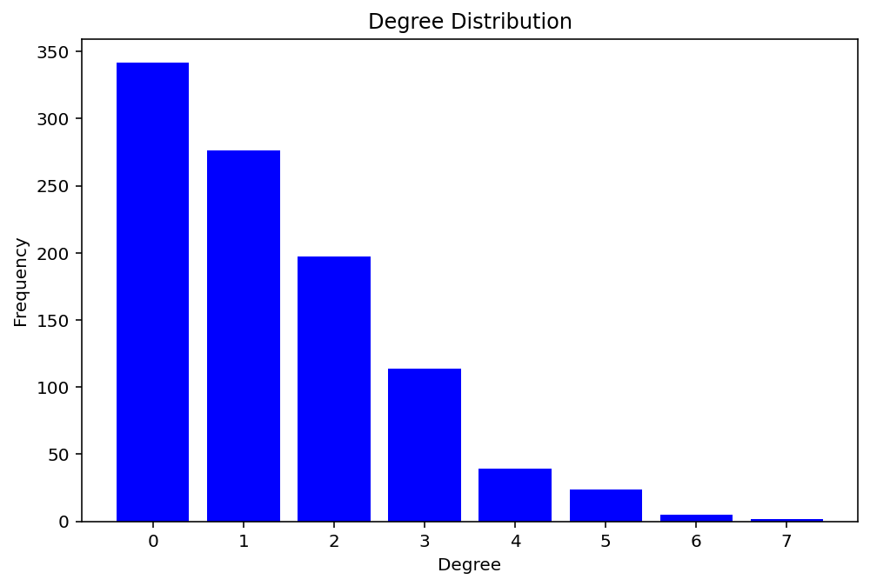

Output data
.csv file with data given from the setup and the data collection. Be aware that these files can become quite large.

Preparation

Adaptation measures considered
We look at two overarching measures, wet- and dry-proofing. They include different measures as shown in Tab. C1.
Table C1: Grouping, costs, and efficacy of structural adaptation measures. Based on Table S5 in the Supplementary Material of ⁶, and ⁵, costs corrected for inflation to 2023 values.
Structural adaptation measure | Category | Cost | Flood protection
Installing anti-backflow valves on pipes | Dry-proofing | 10300€ | 50%
Installing a pump and/or more system(s) to drain flood water | Dry-proofing | 10300€ | 50%
Fixing water barriers (e.g., water-proof basement windows) | Dry-proofing | 10300€ | 50%
Strengthening the housing foundations to withstand water pressure | Wet-proofing | 8000€ | 40%
Reconstructing or reinforcing walls and/or the ground flood with water-resistant materials | Wet-proofing | 8000€ | 40%
Raising the electricity meter above the most likely flood level or on an upper floor | Wet-proofing | 8000€ | 40%

- Assumption: if one of dry-(wet-)proofing measures are taken, we consider the household to have undergone dry-(wet-)proofing
- For self-efficacy, perceived costs of measures, and perceived effectiveness, we take the mean across the different measures that fall under the category.

Logistic regression for protection motivation
Notebook: logistic_regression_PMT\LogisticRegression_w5_NL_UK.ipynb
The logistic regression is done using the survey data. UK and NL wave 5 data are combined. For the NL wave 5 data, perceived damage was not correctly collected; therefore, we estimate this using data from wave 1 from NL. See Tab. C2 for the coefficients.
Table C2: Weighted coefficients to estimate the protection motivation of the household agents.
 | WP – done | WP – planned soon | DP – done | DP – planned soon
Intercept | -2.3829 | -2.5338 | -4.6718 | -2.3562
Perc probability | -0.3450 | 0.3566 | -0.0588 | 0.4870
Worry | 0.8352 | 0.7271 | 0.3524 | 1.1819
Perc damage | 0.1587 | 0.0342 | 0.3452 | 0.0915
Flood experience | 0.7249 | 0.1332 | 0.2407 | 0.5010
Self-efficacy | 0.6433 | 2.0608 | 0.7431 | 1.9037
Resp efficacy | 0.4269 | 0.3347 | 0.2379 | 0.2593
Perc costs | -1.4259 | -1.9260 | -0.6505 | -1.8763
Done other | 1.6349 | 0.7853 | 6.1051 | -1.5433
Count of taken (total: 359) | 61 | 55 | 47 | 63

- Currently, the weights for WP – done and DP – done are read into the model.

Network Structure
Notebook: SN_structure_for_model_input.ipynb
To reduce the stochasticity of the model, we decided to pre-generate some network structures. This was done in 3 steps:
- Get a degree distribution based on a half-normal distribution or from the empirical data.
- Construct the network with configuration_model from the network python package.
- Rewire the network for preferential attachment.
Each step is described in slightly more detail below.

Degree distribution

Get_connections_distribution_halfnormal
The goal is to get a degree distribution as an input for the network. Inspired by the distribution of nr people talked to, nr conversations had on flooding in the last year, we decided on a half-normal distribution. You can set the end value (ie max degree), and what proportion of degrees should be below a certain value (ie 80% of nodes should have a degree of 3 or less).
The function then generates a probability density function (pdf), that is used as the input in the network construction.

Empirical option
Taking the responses for Q31_fl_convo_people, we make a list of degrees by extending/reduce that list with Q31_fl_convo_people, keeping the same distribution to get a list of degrees.

Construct_network

From half-normal distribution
Taking the degree distribution from the above-mentioned function, this makes a network with the given degree distribution. It takes the pdf, and generates a list of degrees from it. Taking this list into the configuration_model function from network to generate the network.

Empirical
Feed the list directly into network configuration_model function to generate the network.

Rewire_for_preferential_attachement
We rewire the constructed network, preferring connections between nodes with similar degrees. The idea behind this is to eventually get a network that mimics a scale-free network, but without given degree distribution. The number of iterations needed/wanted depends on the size of the network.

Data to run the model

Household data
Notebook: Household_data.ipynb
CSV files: Sociodemographics.csv, PMT_variables.csv
- 2 sets of data:
  - PMT_variables.csv
  - Sociodemographics.csv
- Sociodemographics.csv based on UK survey data for now, PMT_variables.csv on UK + NL data from wave 5
- ‘Don’t know’ answers largely removed leaves 421 for the UK data from the original 743
Assumptions
- Normalized perceptions between 0 and 1
  - Perceived probability: turned the answer into the probability: completely safe (0), less than 1/500 (0.001), 1/100 (0.01), etc.
- Implementation: just 0 or 1
- For dry-/wet-proofing:
  - just took averages of the three measures that fall under each
  - took the information from table S5 from CRAB (see above) the damage costs are in €, so is the damage function from deMoel/Huizinga
    - also we corrected everything for inflation, taking the summer 2023 as the baseline
- Income
  - In GBP but converted to € with average conversion rate in July 2023
  - picked random number in the range
    - for 1 (below 17600 GBP): range between 12000-17600
    - for 5 (above 44300 GBP): range between 44301-70000
- house size:
  - in square meters
  - didn’t remove don’t know answers, but replaced them with random number within the full range
- level of education reduced to 4 levels: no high school, high school, college, post-graduate degree

PMT calculation
Logistic regression coefficients to calculate the probability to take action from the PMT variables.
See Notebooks/preparatory_analysis/logistic_regression_PMT for more details.

Network structure
.graphml files that are read into the model.
See Notebooks/preparatory_analysis/SN_structures_for_model_input.ipynb for more information.

References
1. Filatova, T., Noll, B., Need, A. & Wagenblast, T. SCALAR household climate change adaptation and resilience survey. DANS Data Station Social Sciences and Humanities https://doi.org/10.17026/dans-x9h-nj3w (2022).
2. Grothmann, T. & Reusswig, F. People at Risk of Flooding: Why Some Residents Take Precautionary Action While Others Do Not. Nat Hazards 38, 101–120 (2006).
3. Wagenblast, T., Ghorbani, A., Warnier, M. & Filatova, T. Challenging Myths: Social Influence on Individual Risk Perceptions and Climate Change Adaptation. Preprint at http://dx.doi.org/10.2139/ssrn.5220708 (2025).
4. Huizinga, J., De Moel, H. & Szewczyk, W. Global Flood Depth-Damage Functions: Methodology and the Database with Guidelines. https://data.europa.eu/doi/10.2760/16510 (2017) doi:10.2760/16510.
5. Kreibich, H., Bubeck, P., Van Vliet, M. & De Moel, H. A review of damage-reducing measures to manage fluvial flood risks in a changing climate. Mitig Adapt Strateg Glob Change 20, 967–989 (2015).
6. Taberna, A., Filatova, T., Hadjimichael, A. & Noll, B. Uncertainty in boundedly rational household adaptation to environmental shocks. Proc. Natl. Acad. Sci. U.S.A. 120, e2215675120 (2023).

