Training Accuracy:
if your model has 100% training acc that usually means that the gradient won’t change the model since its already at the lowest loss it can (since its optimizing the train error) so it probably means more epochs won’t change your model in a meaningful way.

Usually what is done is a technique called early stopping and usually that avoids over-fitting. Regularization is also often used (via l1,l2, dropout, batch norm, etc).

Precision-Recall :

- While precision refers to the percentage of your results which are relevant,

- Recall refers to the percentage of total relevant results correctly classified by your algorithm

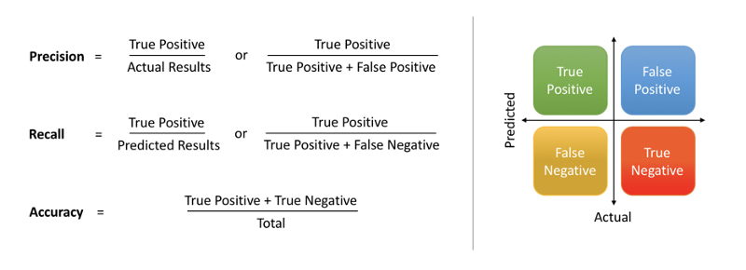

F1 – Score:

- called F-1 score, which is a harmonic mean of precision and recall.

