**CS355 Assignment 10**

**Task 1) Install Apache, PHP and MYSQL**

As we have already installed mysql in our system for lab. I have window operating system. So, I have installed Xampp server that provides both apache and mysql servers. I have installed xampp and turned ON the servers from the xamp control Panel. Screen Shot of control panel is attached below.

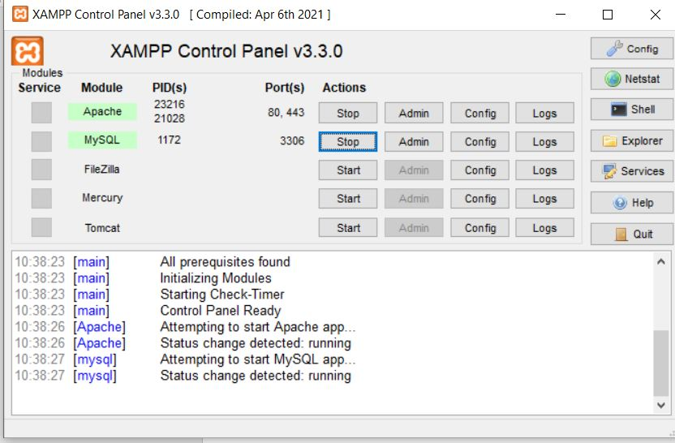

After turning ON the servers we can run the PHP files.

**Task 2)**

**Create Database Employee and Table Emp and insert 5 relevant records**

I have created a new database **Employee** and a new table **emp** that has the following attributes-

* empID (varchar,primary key)
* passwd (varchar)
* empName (varchar)
* DoJ (Date)
* Salary (int)
* Department (varchar)
* Mobile No. (varchar)
* Email (varchar)

The following below screen shot describes the created table employee-

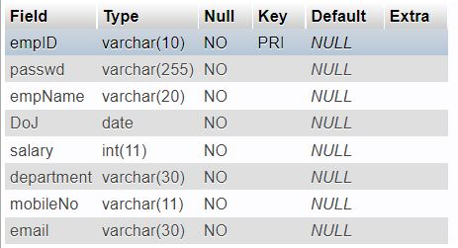

Now after inserting 5 records the table looks like-

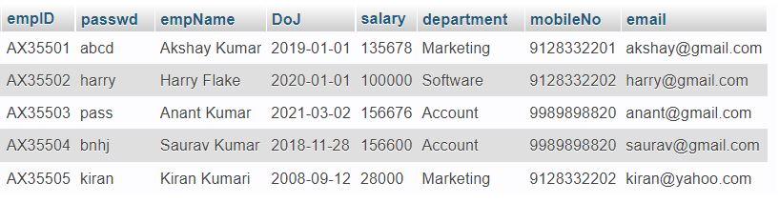

The table above is showing total 5 records that is to be inserted.

**Creating PHP pages for Registration, Login and Profile Update-**

In addition I have also created a php page ***connect.php*** that establishes the connection between Database and servers.

So, I have created these four php pages

* login.php
* signup.php
* profile.php
* connect.php

Also, I have uploaded these files on my gihub acoount

[*https://github.com/Roar47/PHP-Login-System/tree/main/DBProject*](https://github.com/Roar47/PHP-Login-System/tree/main/DBProject)

1. **connect.php Page**

The main function of this page is to establish the connection between the server and database so we can check whether our queries are executed correctly or not.

Given below snap shot shows the code of this file

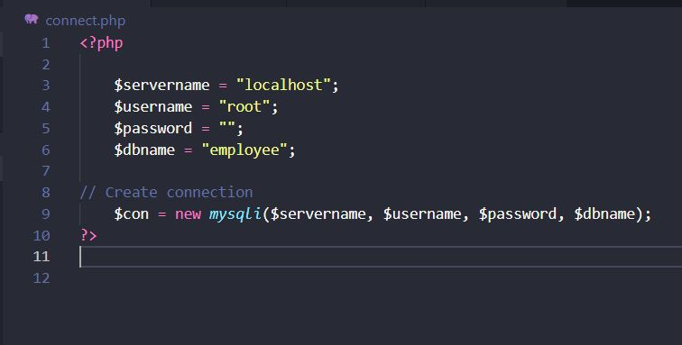

We will include this *connect.php* page in all the other pages use the connection by using the above **$con** variable.

1. *signup.php* Page

database s This page also contains some html codes that makes a form type interface where user can enter the required information and can register. The registration form interface is look like this-

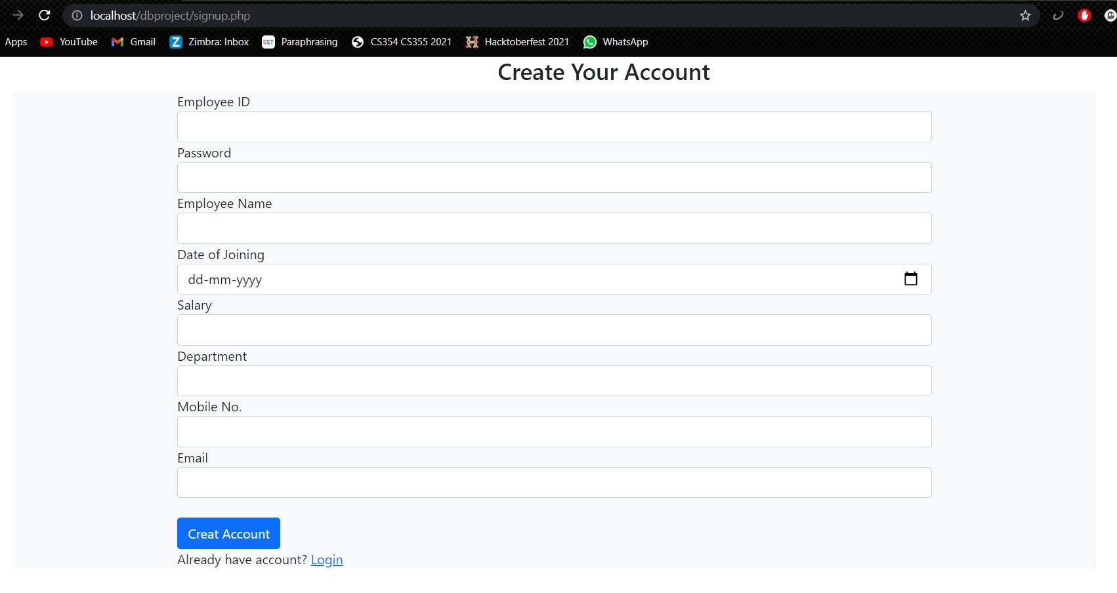

Here user have to enter the all required input fields showing on the snap shot above. If user fills all the required fields and the empID is unique. After clicking the “**Create Account”** button user gets an success alert message and the details will be inserted on the emp table. The below snap shot shows the insert query for the details in the table emp-

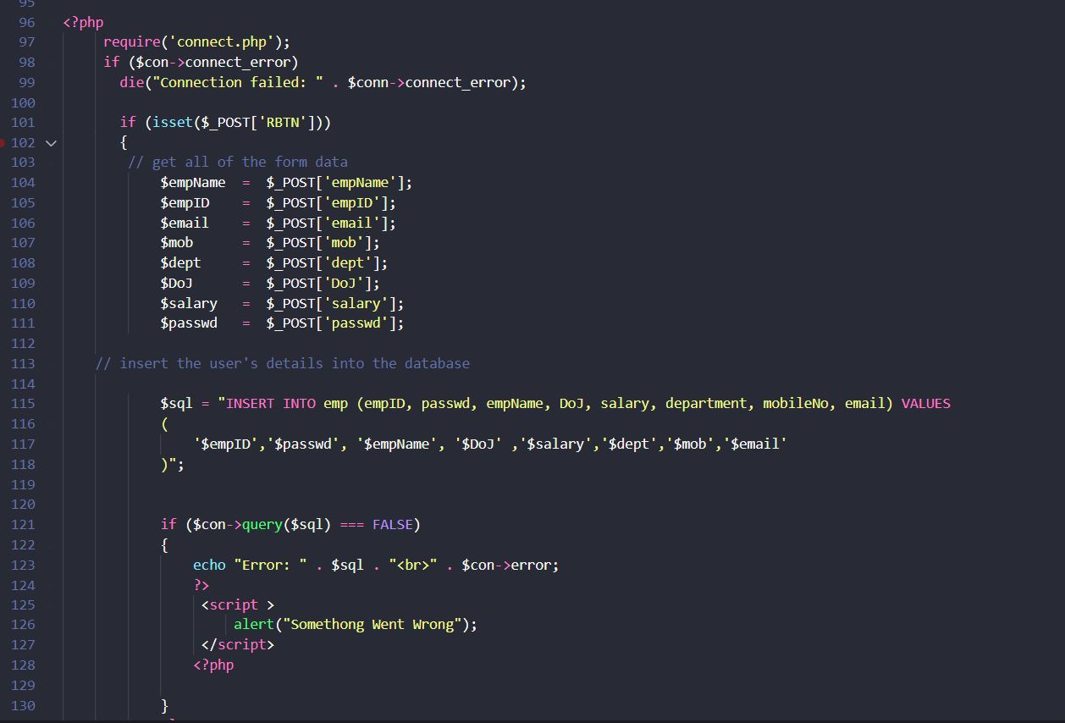

If user inputs something wrong or duplicate username empID, I will get a “Something went Wrong” alert message.

For Example – We want to register a new account having following details-

* empID = AX35506
* passwd = tiger
* empName = Scot Evans
* DoJ = 2019-11-09
* Salary = 30000
* Department = Software
* Mobile No. = 9898989898
* Email = [scot@gmail.com](mailto:scot@gmail.com)

Now we will fill the above values in the signup page and will create the account. After clicking the create button if we get an success message the details are inserted in the database.

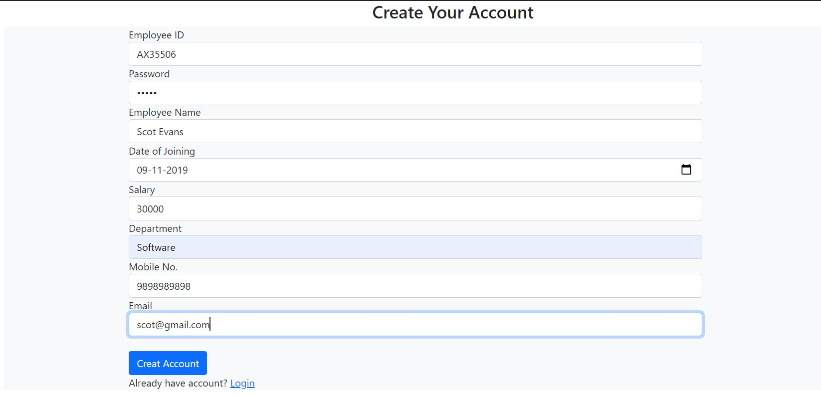

After clicking on “**Create account”** button we get –

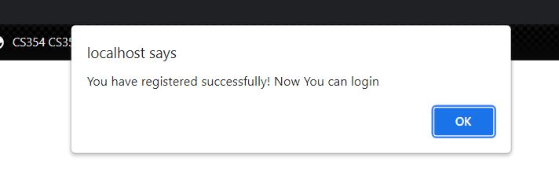

So we got the success message that means the details are inserted in the table emp.

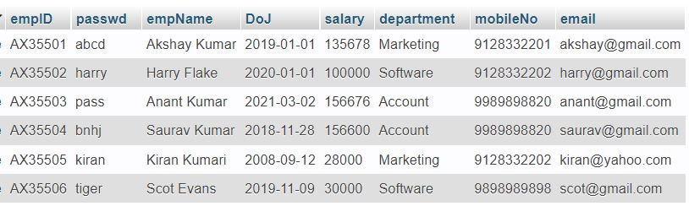

M Here we can see the last row is inserted int the ***emp*** table.

If we try to insert the same record again, we will get the error message ast the empID is the primary key and it should be unique. Let’s try to insert the same record.

After clicking on “**Create account”** button we get –

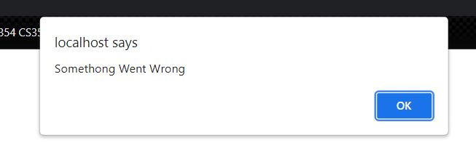

This shows that signup page is working correctly.

c) *login.php* Page

This page requires empID and password for login. If the provided fields are correct then it will send the user to its profile page.

The interface of this page is look like this –

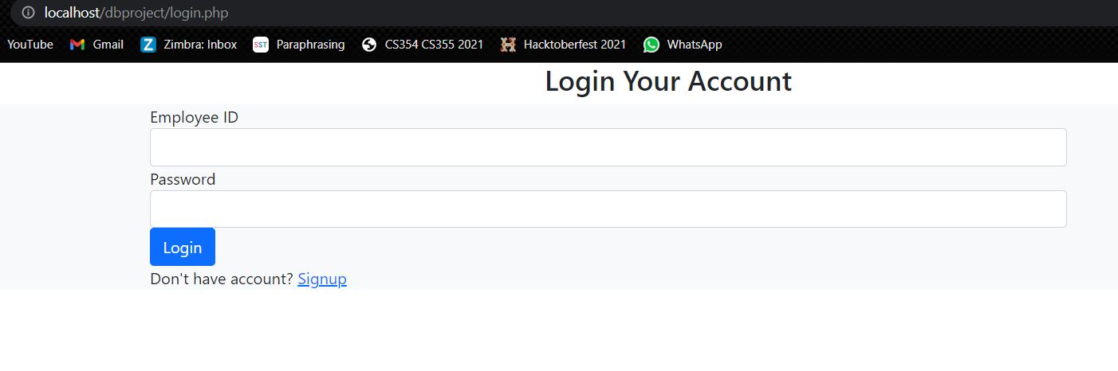

When a user enters empID and password it checks whether the entered information is right or not. If information is right user will automatically go to the profile page,

If users input is correct it will also show the alert message of successful login otherwise it will show an error alert message.

The given below is the snap shot for the php code for verification of users input information-

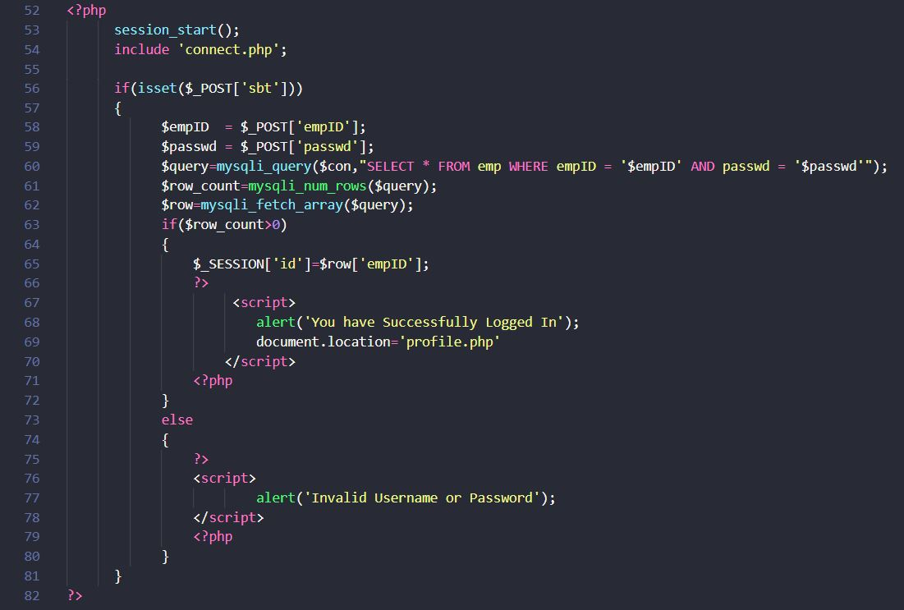

the snap shot For example – we try to login using empID = AX35506 and password = tiger which we fill previously during the registration time and see what happens

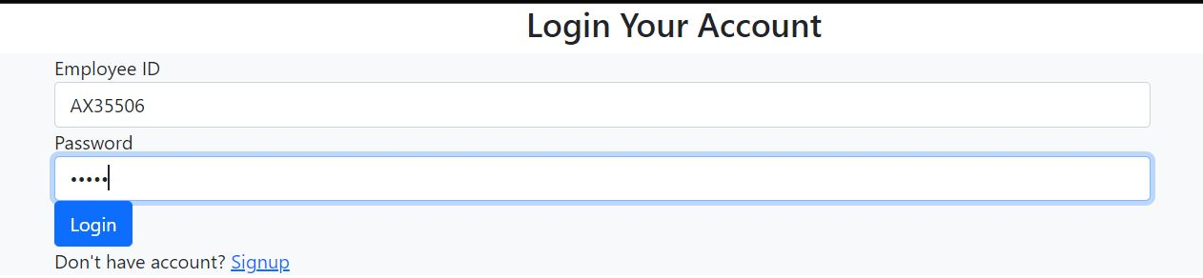

App After clicking on “**Login”**  button we get –

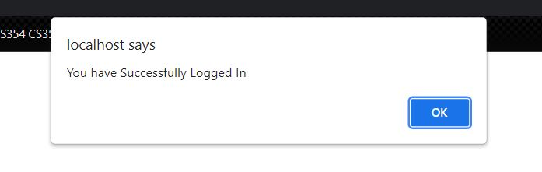

App This shows that we have logged in successfully and on clicking “OK” button we reach to the profile page.

If we try to login invalid credential an error message will be displayed. So let’s try to login using empID=AX355XY and password is tiger the we get –

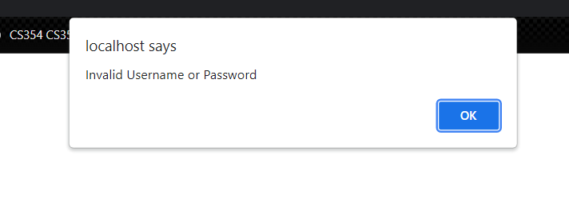

So this shows that login page is also working correctly.

d) profile.php Page

This page show the all details of the employee and has a “**Update Your Profile”** button which allows user to update it’s email and phone number.

After ogin using empID = AX35506 and password = tiger we reach to the profile page and snapshot of that page is given below-

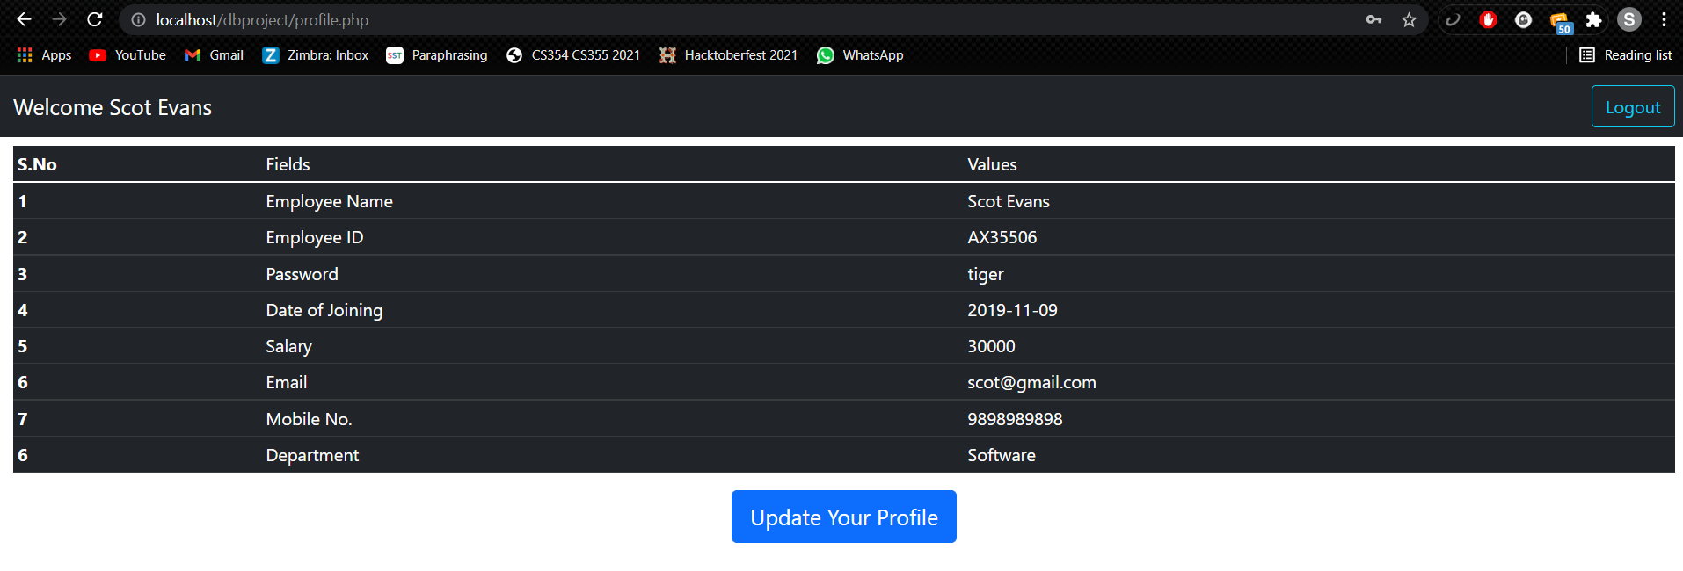

password = tiger Here we can see the all information that we have filled during the registration also below there is button. On clicking this button we get a pop up type form for updating mobile number and email. The following below snap shot shows the pop form.

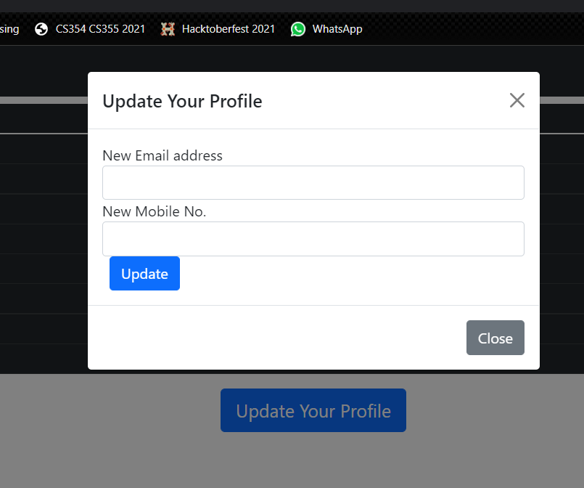

We have used update query for updating the information. The snap shot of code for the php page is also attached here-

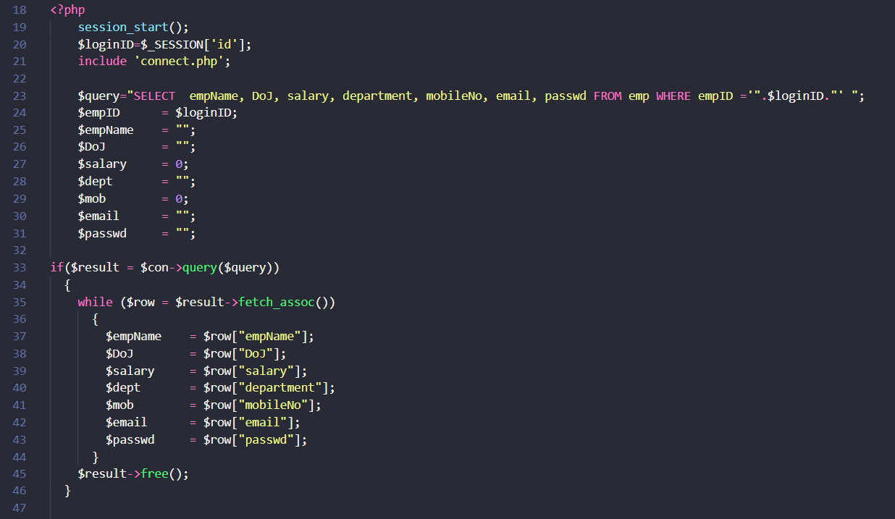

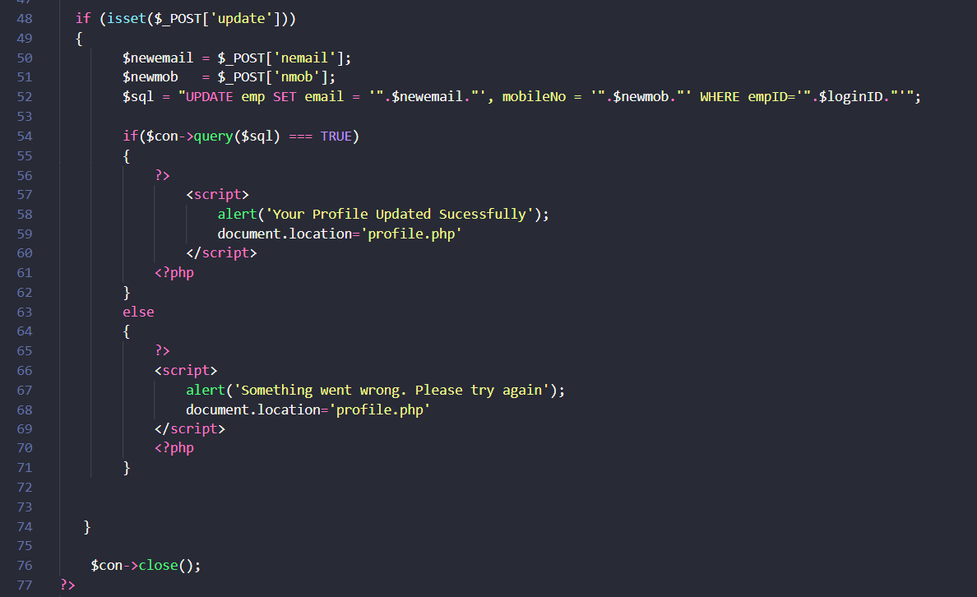

Now we will try to update email and phone no. for Scot Evans. We will update email ID from [scot@gmail.com](mailto:scot@gmail.com) to [scot@yahoo.com](mailto:scot@yahoo.com) and mobile number from 9898989898 to 9800000000.

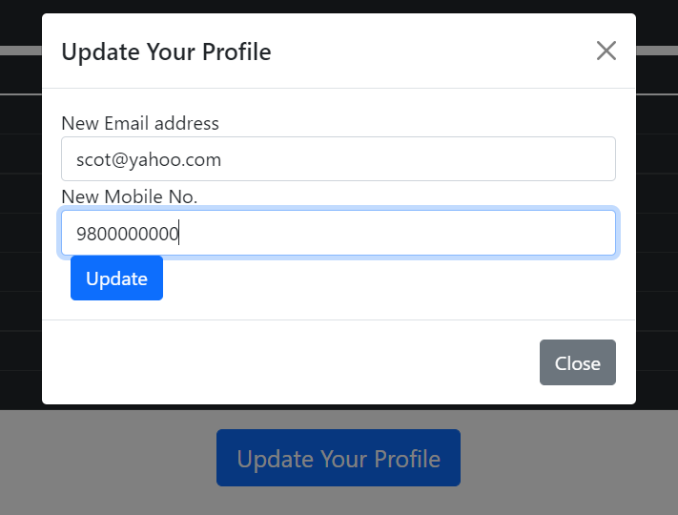

We have to click on “Update Your Profile button” after filling form. After clicking the button we get an success message and inform will be updated.

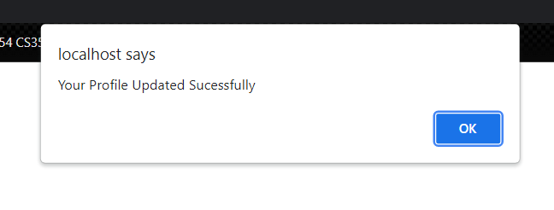

This shows that information update and clicking on “OK” we reach to again to the profile page and update information is displayed there-

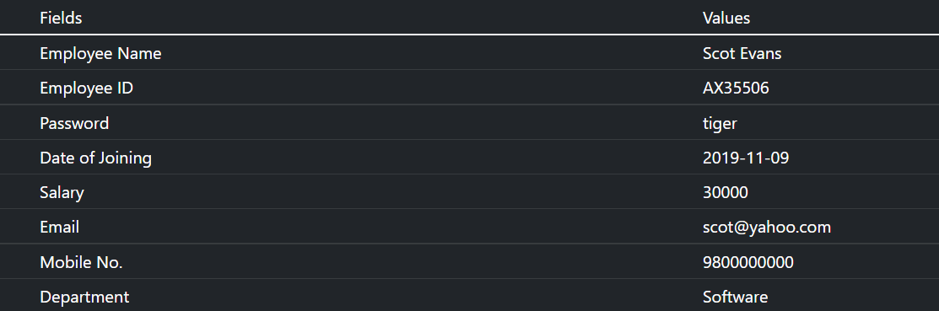

We can see that email and phone no. is now updated and we can also check the emp table-

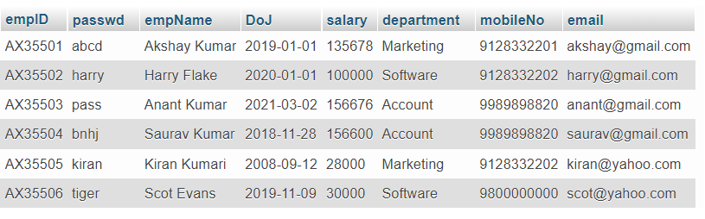

We can se that table information is also updated. There is also an log out option in addition on clicking it user will get logged out and reach to the login page again.

So it shows that all pages are working correctly.