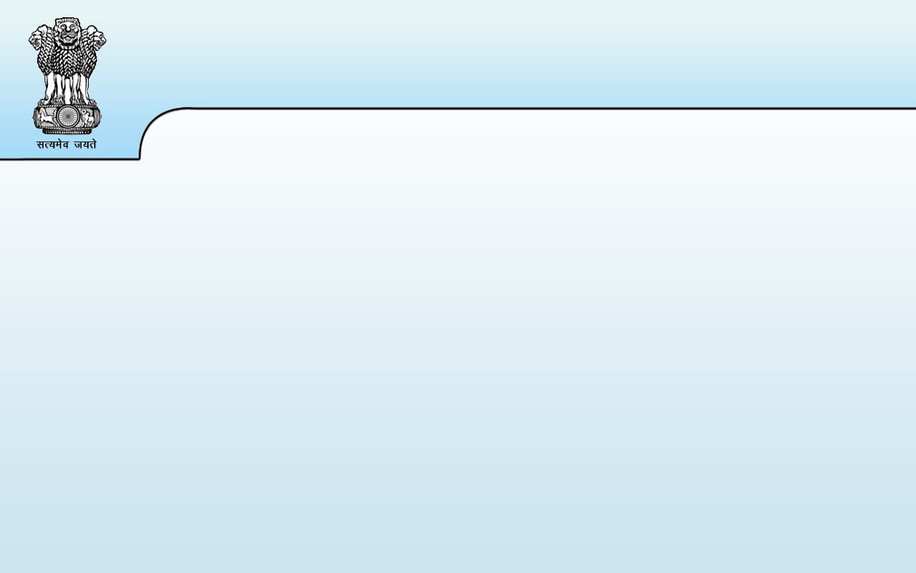
Indian Union Vehicle Registration Certificate Issued by GOVERNMENT OF RAJASTHAN

NT RJ


Regn No  RJ60CC5213 | Date of Regn.  25-Nov-2024 | Regn. Validity  24-Nov-2039 | Owner 1  Serial

Fuel
PURE EV

Emission Norms
NOT AVAILABLE


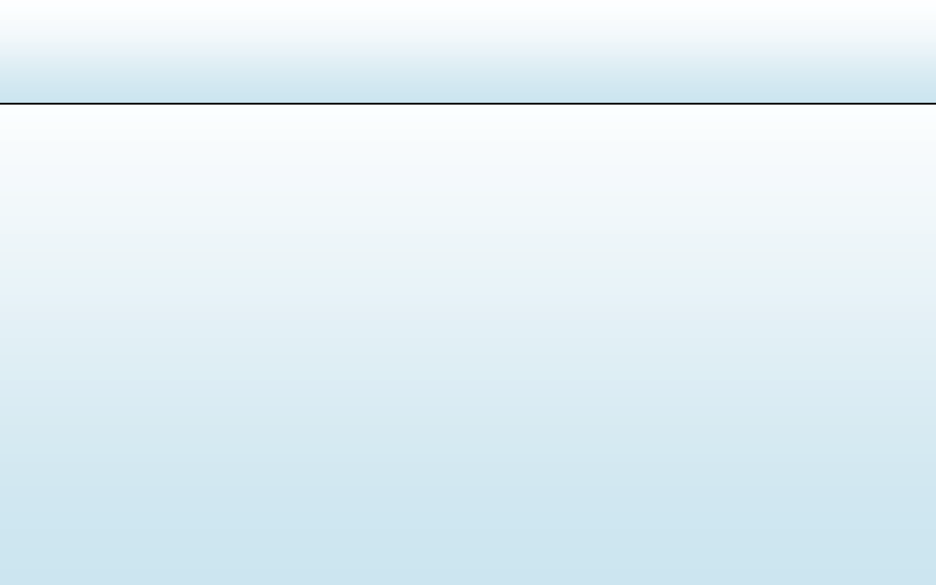
Chassis No
0.00 / 134.0
Financier:
BANK OF INDIA

Maker's Name:
MG MOTOR INDIA PVT LTD
Model Name:
WINDSOR EV EXCLUSIVE
Colour: / Body Type:
STARBURST BLACK / MONOCOQUE
Seating(in all) Capacity
5
Unladen / Laden Weight (Kg)
1533 / 1960
Cubic Cap. / Horse Power (BHP/Kw) / Wheel Base(mm)
Regn. Number RJ60CC5213
Month-Year of Mfg.
11-2024
No. of Cylinders 0
NT RJ
Vehicle Class: MOTOR CAR (LMV)
MZ72D5CEL7H005078
Card Issue Date (28-Nov-2024)

Engine/Motor No
U1R8300324

Owner Name
SANAM PREET SINGH

Son/Wife/Daughter of (In case of Individual Owner)
UPKAR SINGH

Ownership
INDIVIDUAL

Address
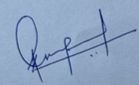
FLAT NO.-30,PARTH SARTHI, PLOT NO.-B15-17,KRISHNAPURI, BEHIND DROM MARBLES,MANSAROVAR, JAIPUR-RAJASTHAN-3020
/ 2700
FINONEST
CHANDRMAULI MG
Form 23A

