


Functional Safety Concept Lane Assistance
Document Version: 1.0
Template Version 1.0, Released on 2017-06-21

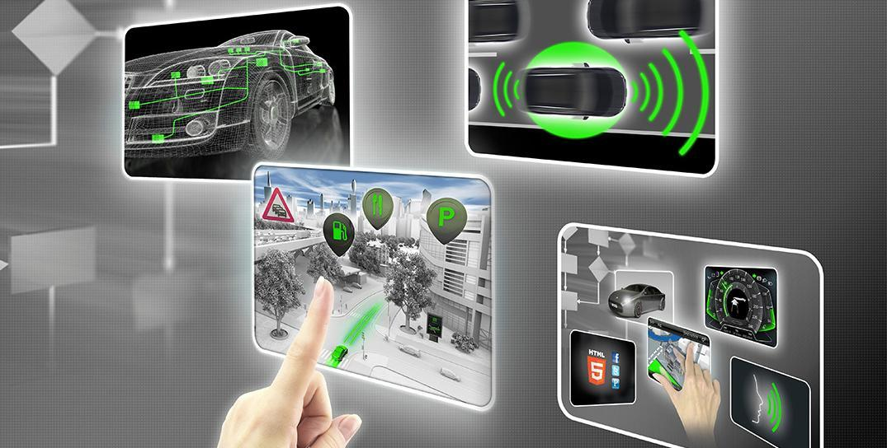

Document history
[Instructions: Fill in the date, version and description fields. You can fill out the Editor field with your name if you want to do so. Keep track of your editing as if this were a real world project.

For example, if this were your first draft or first submission, you might say version 1.0. If this is a second submission attempt, then you'd add a second line with a new date and version 2.0]

Date | Version | Editor | Description
6/23/19 | 1.0 | R.Crane | Initial draft of functional safety concept

Table of Contents
Document history
Table of Contents
Purpose of the Functional Safety Concept
Inputs to the Functional Safety Analysis
Safety goals from the Hazard Analysis and Risk Assessment
Preliminary Architecture
Description of architecture elements
Functional Safety Concept
Functional Safety Analysis
Functional Safety Requirements
Refinement of the System Architecture
Allocation of Functional Safety Requirements to Architecture Elements
Warning and Degradation Concept

Purpose of the Functional Safety Concept

This document describes the project’s functional safety requirements – requirements derived the high-level functional safety goals and then allocated to an item in the system architecture.

Inputs to the Functional Safety Concept

Safety goals from the Hazard Analysis and Risk Assessment

ID | Safety Goal
Safety_Goal_01 | The oscillating steering torque from the lane departure warning function shall be limited.
Safety_Goal_02 | The lane keeping function shall be limited in time and additional steering torque shall end after given interval to prevent misuse.

Preliminary Architecture

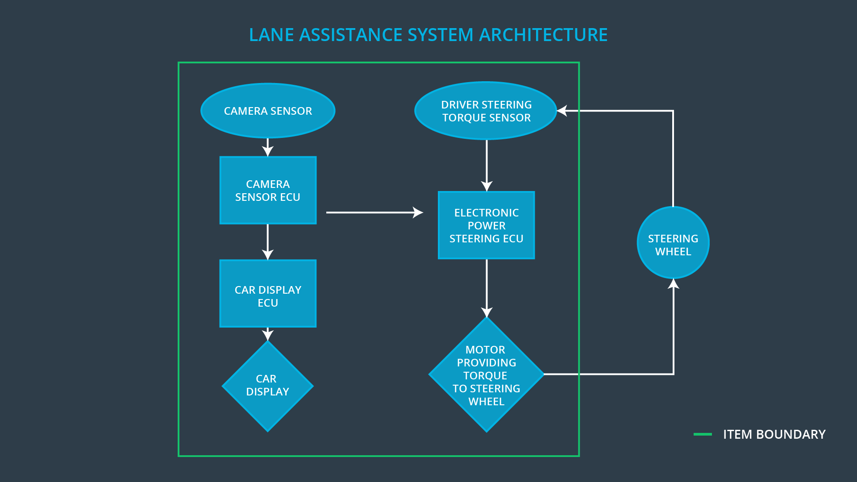
Figure 1. Lane Assistance Architecture.
The Lane Assistance System consists of three subsystems:
- The Camera system
- The Electronic Power Steering system
- The Car Display system

Description of architecture elements

Element | Description
Camera Sensor | Creates and transmits imagery data of the road surface to an extent that lane lines are visible.
Camera Sensor ECU | Processes imagery to detect lane lines and determine vehicle lateral position in the lane.
Car Display | Display visual indication of system readiness and activation. Provide an interface for disabling system.
Car Display ECU | Process the control signals from the display and dispatch commands to appropriate controls for enabling/disabling.
Driver Steering Torque Sensor | Determines the amount of steering input being provided by driver.
Electronic Power Steering ECU | From position information and control signals, determine to apply torque on the steering wheel for lane departure warning and lane keeping assistance.
Motor | Create the physical torque when signalled

Functional Safety Concept
The functional safety concept consists of:
- Functional safety analysis
- Functional safety requirements
- Functional safety architecture
- Warning and degradation concept

Functional Safety Analysis

Malfunction ID | Main Function of the Item Related to Safety Goal Violations | Guidewords (NO, WRONG, EARLY, LATE, MORE, LESS) | Resulting Malfunction
Malfunction_01 | Lane Departure Warning (LDW) function shall apply an oscillating steering torque to provide the driver a haptic feedback | MORE | The lane departure warning function applies an oscillating torque with very high torque amplitude (above limit).
Malfunction_02 | Lane Departure Warning (LDW) function shall apply an oscillating steering torque to provide the driver a haptic feedback | MORE | The lane departure warning function applies an oscillating torque with very high torque frequency (above limit).
Malfunction_03 | Lane Keeping Assistance (LKA) function shall apply the steering torque when active in order to stay in ego lane | NO | The lane keeping assistance function is not limited in time duration which leads to misuse as an autonomous driving function.

Functional Safety Requirements
[Instructions: Fill in the functional safety requirements for the lane departure warning ]

Lane Departure Warning (LDW) Requirements:

ID | Functional Safety Requirement | ASIL | Fault Tolerant Time Interval | Safe State
Functional  Safety  Requirement  01-01 | The EPS ECU shall ensure that the lane departure oscillating torque amplitude is below MAX_TORQUE_AMPLITUDE. | C | 50ms | LDW shall set torque amplitude to 0.
Functional  Safety  Requirement  01-02 | The EPS ECU shall ensure that the lane departure oscillating torque amplitude is below MAX_TORQUE_FREQUENCY. | C | 50ms | LDW shall set torque frequency to 0 Hz.

Lane Departure Warning (LDW) Verification and Validation Acceptance Criteria:

ID | Validation Acceptance  Criteria and Method | Verification Acceptance  Criteria and Method
Functional  Safety  Requirement  01-01 | Validate that torque values up to MAX_TORQUE_AMPLITUDE allow continued safe operation of vehicle. | Verify that a torque in excess of MAX_TORQUE_AMPLITUDE causes amplitude to change to 0.
Functional  Safety  Requirement  01-02 | Validate that torque values up to MAX_TORQUE_FREQUENCY allow continued safe operation of vehicle. | Verify that a torque in excess of MAX_TORQUE_FREQUENCY causes frequency to change to zero.

Lane Keeping Assistance (LKA) Requirements:

ID | Functional Safety Requirement | ASIL | Fault Tolerant Time Interval | Safe State
Functional  Safety  Requirement  02-01 | The electronic power steering ECU shall ensure that the lane keeping assistance torque is applied for only MAX_DURATION. | B | 500ms | LKA shall apply 0 additional torque to power steering.

Lane Keeping Assistance (LKA) Verification and Validation Acceptance Criteria:

ID | Validation Acceptance  Criteria and Method | Verification Acceptance  Criteria and Method
Functional  Safety  Requirement  02-01 | Validate that limiting LKA application to MAX_DURATION dissuades drivers from treating system as an autonomous system. | Verify that continued system operation past MAX_DURATION causes system to stop applying additional torque to steering.

Refinement of the System Architecture

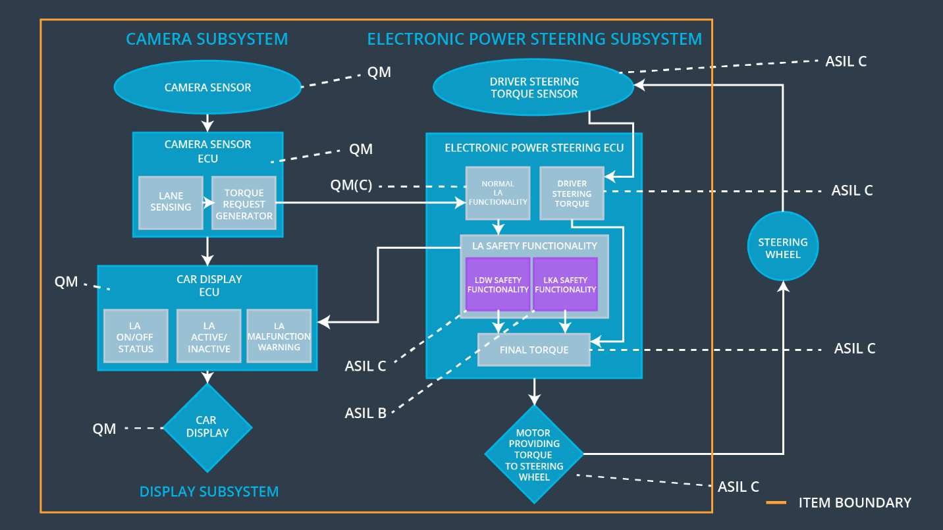
Figure 2. Refined System Architecture
The functional safety requirements for LKA and LDW are derived from ASIL B and C assigned safety goals. They are both allocated to the Power steering ECU. ASIL decomposition creates a single LA Safety Functionality module within the ECU in which two modules can assume the responsibility for meeting the functional safety requirements. These are assumed to be independent. If they were not independent, both would receive ASIL C ratings (the higher).

Allocation of Functional Safety Requirements to Architecture Elements
ID | Functional Safety Requirement | Electronic Power Steering ECU | Camera ECU | Car Display ECU
Functional  Safety  Requirement  01-01 | The lane keeping item shall ensure that the lane departure oscillating torque amplitude is below MAX_TORQUE_AMPLITUDE. | X
Functional  Safety  Requirement  01-02 | The lane keeping item shall ensure that the lane departure oscillating torque amplitude is below MAX_TORQUE_FREQUENCY. | X
Functional  Safety  Requirement  02-01 | The electronic power steering ECU shall ensure that the lane keeping assistance torque is applied for only MAX_DURATION. | X

Warning and Degradation Concept

ID | Degradation Mode | Trigger for Degradation Mode | Safe State invoked? | Driver Warning
WDC-01 | Turn off functionality | Violation of MAX_TORQUE_AMPLITUDE or MAX_TORQUE_FREQUENCY | Yes | Visual indication
WDC-02 | Turn off functionality | Violation of MAX_DURATION | Yes | Visual indication

