


Technical Safety Concept Lane Assistance
Document Version: 1.0
Template Version 1.0, Released on 2017-06-21

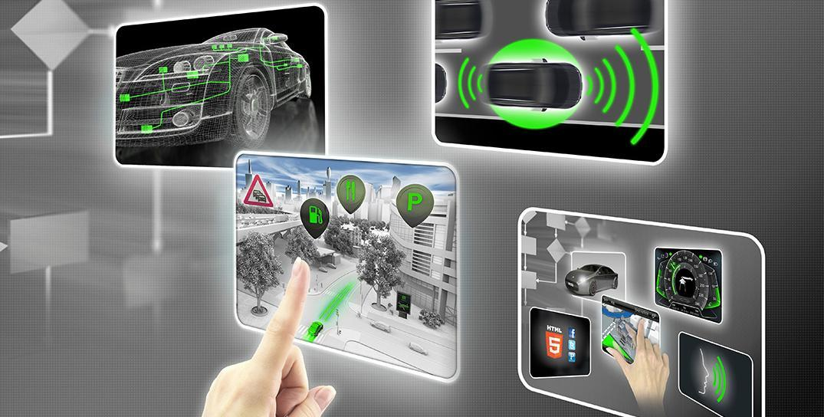

Document history
Date | Version | Editor | Description
6/23/19 | 1.0 | R.Crane | Initial draft version

Table of Contents
Document history
Table of Contents
Purpose of the Technical Safety Concept
Inputs to the Technical Safety Concept
Functional Safety Requirements
Refined System Architecture from Functional Safety Concept
Functional overview of architecture elements
Technical Safety Concept
Technical Safety Requirements
Refinement of the System Architecture
Allocation of Technical Safety Requirements to Architecture Elements
Warning and Degradation Concept

Purpose of the Technical Safety Concept
The Technical Safety Concept document turns functional safety requirements identified in the Functional Safety Concept into technical safety requirements that are determined during the system design. Technical safety requirement allocation to system architecture is identifed.

Inputs to the Technical Safety Concept

Functional Safety Requirements

ID | Functional Safety Requirement | ASIL | Fault Tolerant Time Interval | Safe State
Functional  Safety  Requirement  01-01 | The lane keeping item shall ensure that the lane departure oscillating torque amplitude is below MAX_TORQUE_AMPLITUDE. | C | 50ms | System turned off
Functional  Safety  Requirement  01-02 | The lane keeping item shall ensure that the lane departure oscillating torque amplitude is below MAX_TORQUE_FREQUENCY. | C | 50ms | System turned off
Functional  Safety  Requirement  02-01 | The electronic power steering ECU shall ensure that the lane keeping assistance torque is applied for only MAX_DURATION. | B | 500ms | System turned off

Refined System Architecture from Functional Safety Concept
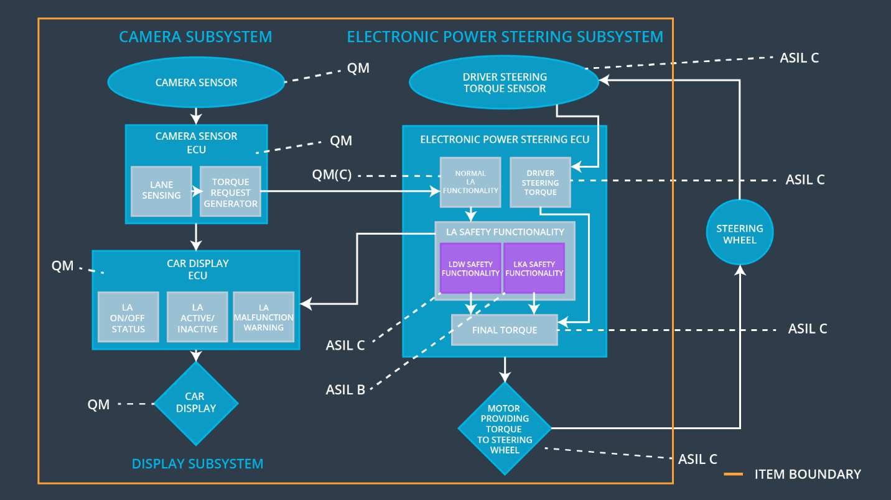
Figure 2. Refined System Architecture
The functional safety requirements for LKA and LDW are derived from ASIL B and C assigned safety goals. They are both allocated to the Power steering ECU. ASIL decomposition creates a single LA Safety Functionality module within the ECU in which two modules can assume the responsibility for meeting the functional safety requirements. These are assumed to be independent. If they were not independent, both would receive ASIL C ratings (the higher).

Functional overview of architecture elements

Element | Description
Camera Sensor | Creates and transmits imagery data of the road surface to an extent that lane lines are visible.
Camera Sensor ECU - Lane Sensing | Determine boundaries of lanes and vehicle position in lane from imagery data.
Camera Sensor ECU - Torque request generator | Generate a request for additional steering torque to move vehicle closer to center of lane.
Car Display | Display activation and enable states to user. Display warning and fault conditions.
Car Display ECU - Lane Assistance On/Off Status | Make requests to display to display state based on system inputs.
Car Display ECU - Lane Assistant Active/Inactive | Make requests to display to display state based on system inputs.
Car Display ECU - Lane Assistance malfunction warning | Make requests to display to display state based on system inputs.
Driver Steering Torque Sensor | Determine existing torque input to steering to compute appropriate amount to set.
Electronic Power Steering (EPS) ECU - Driver Steering Torque | From driver steering torque sensor, provide final torque component with measurement of driver input.
EPS ECU - Normal Lane Assistance Functionality | From the Camera component input, generate normal torque requests for lane keeping assistance.
EPS ECU - Lane Departure Warning Safety Functionality | Validate the torque request meetings safety requirements before forwarding request to final torque component.
EPS ECU - Lane Keeping Assistant Safety Functionality | Validate that the system has been activated for less than the nominal value.
EPS ECU - Final Torque | Synthesize the requested torque values with the driver steering to generate appropriate signal to motor for steering actuation.
Motor | Provide actual torque values to steering system on request.

Technical Safety Concept

Technical Safety Requirements
Lane Departure Warning (LDW) Requirements:

Functional Safety Requirement 01-01 with its associated system elements
(derived in the functional safety concept)
ID | Functional Safety Requirement | Electronic Power Steering ECU | Camera ECU | Car Display ECU
Functional  Safety  Requirement  01-01 | The lane keeping item shall ensure that the lane departure oscillating torque amplitude is below Max_Torque_Amplitude | X

Technical Safety Requirements related to Functional Safety Requirement 01-01 are:
ID | Technical Safety Requirement | ASIL | Fault Tolerant Time Interval | Architecture Allocation | Safe State
Technical  Safety  Requirement  01 | The LDW safety component shall ensure that the amplitude of the 'LDW_Torque_Request' sent to the 'Final electronic power steering Torque' component is below 'Max_Torque_Amplitude. | C | 50 | LDW Safety software | The departure warning torque request amplitude shall be set to zero.
Technical  Safety  Requirement  02 | As soon as the LDW function deactivates the LDW feature, the 'LDW Safety' software block shall send a signal to the car display ECU to turn on a warning light. | C | 50 | LDW Safety software | The departure warning torque request amplitude shall be set to zero.
Technical  Safety  Requirement  03 | As soon as a failure is detected by the LDW function, it shall deactivate the LDW feature and the 'LDW_Torque_Request' shall be set to zero. | C | 50 | LDW Safety software | The departure warning torque request amplitude shall be set to zero.
Technical  Safety  Requirement  04 | The validity and integrity of the data transmission for 'LDW_Torque_Request' signal shall be ensured. | C | 50 | Data Transmission Integrity Check Component | The departure warning torque request amplitude shall be set to zero.
Technical  Safety  Requirement  05 | Memory test shall be conducted at start-up of the EPS ECU to check for any faults in memory. | A | Ignition Cycle | Safety Startup Component | The departure warning torque request amplitude shall be set to zero.

Functional Safety Requirement 01-2 with its associated system elements
(derived in the functional safety concept)
ID | Functional Safety Requirement | Electronic Power Steering ECU | Camera ECU | Car Display ECU
Functional  Safety  Requirement  01-02 | The lane keeping item shall ensure that the lane departure oscillating torque frequency is below Max_Torque_Frequency | X

Technical Safety Requirements related to Functional Safety Requirement 01-02 are:
ID | Technical Safety Requirement | ASIL | Fault Tolerant Time Interval | Architecture Allocation | Safe State
Technical  Safety  Requirement  01 | The LDW safety component shall ensure that the frequency of the 'LDW_Torque_Request' sent to the 'Final electronic power steering Torque' component is below 'Max_Torque_Frequency. | C | 50 | LDW Safety software | The departure warning torque request amplitude shall be set to zero.
Technical  Safety  Requirement  02 | As soon as the LDW function deactivates the LDW feature, the 'LDW Safety' software block shall send a signal to the car display ECU to turn on a warning light. | C | 50 | LDW Safety software | The departure warning torque request amplitude shall be set to zero.
Technical  Safety  Requirement  03 | As soon as a failure is detected by the LDW function, it shall deactivate the LDW feature and the 'LDW_Torque_Request' shall be set to zero. | C | 50 | LDW Safety software | The departure warning torque request amplitude shall be set to zero.
Technical  Safety  Requirement  04 | The validity and integrity of the data transmission for 'LDW_Torque_Request' signal shall be ensured. | C | 50 | Data Transmission Integrity Check Component | The departure warning torque request amplitude shall be set to zero.
Technical  Safety  Requirement  05 | Memory test shall be conducted at start-up of the EPS ECU to check for any faults in memory. | A | Ignition Cycle | Safety Startup Component | The departure warning torque request amplitude shall be set to zero.

Lane Keeping Assistance (LKA) Requirements:

Functional Safety Requirement 02-1 with its associated system elements
(derived in the functional safety concept)

ID | Functional Safety Requirement | Electronic Power Steering ECU | Camera ECU | Car Display ECU
Functional  Safety  Requirement  02-01 | The lane keeping item shall ensure that the lane keeping assistance torque is applied for only Max_Duration | X

Technical Safety Requirements related to Functional Safety Requirement 02-01 are:
ID | Technical Safety Requirement | ASIL | Fault Tolerant Time Interval | Allocation to Architecture | Safe State
Technical  Safety  Requirement  01 | The LKA safety component shall ensure that the 'LKA_Torque_Request' sent to the 'Final electronic power steering Torque' component is applied for no longer than MAX_DURATION. | B | 500 | LKA Safety software | The departure warning torque request amplitude shall be set to zero.
Technical  Safety  Requirement  02 | As soon as the LKA function deactivates the LKA feature, the LKA Safety' software block shall send a signal to the car display ECU to turn on a warning light. | B | 500 | LKA Safety software | The departure warning torque request amplitude shall be set to zero.
Technical  Safety  Requirement  03 | As soon as a failure is detected by the LKA function, it shall deactivate the LKA feature and the ‘LKA_Torque_Request' shall be set to zero. | B | 500 | LKA Safety software | The departure warning torque request amplitude shall be set to zero.
Technical  Safety  Requirement  04 | The validity and integrity of the data transmission for 'LKA_Torque_Request' signal shall be ensured. | B | 500 | Data Transmission Integrity Check Component | The departure warning torque request amplitude shall be set to zero.
Technical  Safety  Requirement  05 | Memory test shall be conducted at start-up of the EPS ECU to check for any faults in memory. | A | Ignition Cycle | Safety Startup Component | The departure warning torque request amplitude shall be set to zero.

Refinement of the System Architecture
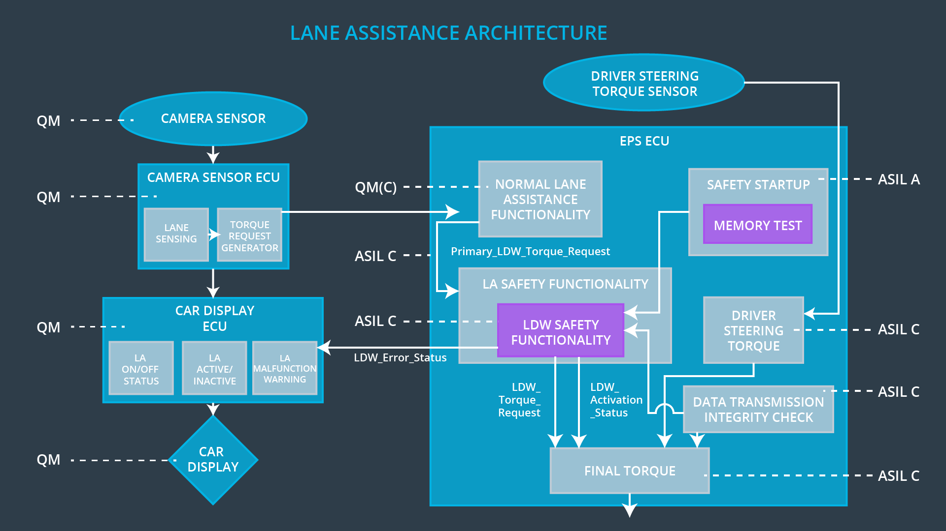

Allocation of Technical Safety Requirements to Architecture Elements
All technical safety requirements are allocated to the Electronic Power Steering (EPS) ECU.

Warning and Degradation Concept
ID | Degradation Mode | Trigger for Degradation Mode | Safe State invoked? | Driver Warning
WDC-01 | Turn off functionality | Violation of MAX_TORQUE_AMPLITUDE or MAX_TORQUE_FREQUENCY | Yes | Visual indication
WDC-02 | Turn off functionality | Violation of MAX_DURATION | Yes | Visual indication

