**CS420 Project 2:**

**Creation of Spatial Structure by Activator / Inhibitor Cellular Automaton**

Robby Ferguson

February 26, 2016

**Introduction**

For Project 2, we studied the spatial structures produced by numerous examples of activator/inhibitor cellular automata by calculating and examining certain quantifiable characteristics of these systems—primarily spatial correlation and mutual information. In order to perform these studies, many instances of 30x30 cellular automata were generated with initially random conditions. Each of the 900 cells within a given system was randomly assigned a starting state value of -1 or 1. After the grid was fully initialized, the automaton was programmed to undergo a series of state transition phases until the system settled into a stable state. It was asynchronously updated such that for each time-step iteration, cells were randomly chosen one at a time and subjected to the following state transition function:

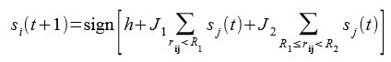

In the above equation, R1 and R2 are near and far radius distances, respectively, with regard to a primary cell (the one currently being considered for a state transition). Neighboring cells within the R1 distance were considered “attractive,” and the primary cell’s next state would be influenced to try to match the average state of those neighbor cells. On the contrary, cells further away from the R1 radius but within the R2 radius were considered “repulsive,” and the primary cell’s next state would try to be the opposite of the average state of those repulsive cells. The J1 and J2 values act as attraction and inhibition multipliers, respectively, and magnified or reduced the impact of the near and far cells’ average states as the primary cell’s new state was determined. The h value introduced additional bias into the state transition function.

After every cell had been passed through this function and was potentially assigned a new state, the entire updating process would repeat itself. Eventually, the system would stabilize such that no cell underwent a state transition for an entire time step, and the updating process would stop.

**Experiments**

In order to gather meaningful data about how each of the parameters described above influenced the general spatial structure of the system as a whole, many simulations were conducted, and they can be categorized into three primary experiments based on the constant values that were used for J1 and J2 in the state transition function. For Experiment 1, J1 = 1 and J2 = 0. For Experiment 2, J1 = 0 and J2 = -0.1. For Experiment 3, J1 = 1 and J2 = -0.1. Within each of these main experiments, the J1 and J2 values were kept constant, but the values for h, R1, and R2 were systematically varied over many different simulation runs according to the following table:

|  |  |  |  |
| --- | --- | --- | --- |
|  | **Experiment 1** | **Experiment 2** | **Experiment 3** |
| **h** | 0, -1, -2, -3, 1, 2, 3 | 0, -1, -3, -5, -6 | 0, -1, -2, -3, -4, -6 |
| **R1** | 1, 3, 6, 9, 12 | 1, 4, 9 | 1, 3, 7, 12 |
| **R2** | 6, 7, 12, 13 | 2, 4, 5, 6, 7, 12, 13 | 2, 5, 9, 14 |

For each experiment, every combination of h, R1, and R2 values were used as the parameters for a separate simulation. With each of these parameter sets, 3 separate simulations were run with varying initial conditions, and the results were averaged together to get less biased data.

The resulting data of each experiment (1, 2, or 3) was stored in a separate .csv file. For every simulation with a given set of parameters, a .pgm image was also produced to show the general structure of the converged automaton. For simple viewing, the .pgm was converted to a .jpg. Additionally, many sets of parameters produced automata that converged entirely (or nearly) to a single state, which was an uninteresting system to study. To compensate for this, any simulation in which at least 95% of the state space converged to a single state was entirely discarded and the results were not considered (nor was an image produced).

**Calculations**

Within each simulation, the spatial correlation, mutual information, and joint entropy were calculated at every possible cell distance between two cells in the board (0-14). Additionally, the characteristic correlation length (lambda) and the entropy of the system as a whole were also calculated. To get more accurate data, 3 different simulations were run with every set of possible combinations. For each of these 3 simulations, the resulting spatial correlation, mutual information, and joint entropy at each possible distance were averaged together, and the overall characteristic correlation lengths and general entropy values were also averaged. These averages were separately stored, and these were the data values added to the respective .csv documents and used for determining parameter correlations for a given simulation.

After all simulations were completed and these averaged values were saved, I made many graphs for particularly interesting parameter sets. These graphs compared the mutual information, spatial correlation, and joint entropy of these systems to facilitate easier parameter comparison with regard to the spatial structure of a given automaton. For example, the following graph from Experiment 1 shows the resulting values when J1 = 1, J2 = -0.1, h = 0, R1 = 1, and R2 = 2:

And the following images show the stabilized systems from each of the 3 simulations that were conducted with those same parameters:

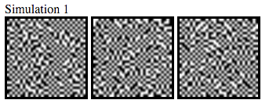

**Results/Conclusions**

For each of 3 experiments, some interesting patterns emerged based on the combination of parameters used to generate the system. The simulations referenced in each section are specific to the experiment being discussed.

**Experiment 1 (J1 = 1, J2 = 0)**

In Experiment 1, J1 remained the same as in Experiment 3, but the J2 value was set to 0, rather than -0.1. As a result, the inhibition multiplier effectively sent the entire inhibition expression to 0. Therefore, the state of a new cell was primarily determined by the states of its nearest neighbors within the specified radius R1. Cells would try to transition to the same state as their neighbors within radius R1 but were not influenced by cells outside of that radius. However, the h value still added bias to the system, and a large value would cause the system to be biased toward either positive or negative states, depending on the sign of h. Because of this lack of influence from the J2 value, many more simulations converged to nearly a single state. Most of the remaining experiments were not particularly interesting, unlike the simulations from Experiment 3. The majority of simulations from this experiment were very ordered and structured with little variation. For example Simulation 75 was run with the parameters h = 1, R1 = 6, and R2 = 12. One of the simulations was discarded for converging to a single state and the other two looked like this:

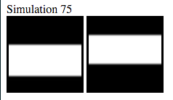

**Experiment 2 (J1 = 0, J2 = -0.1)**

For Experiment 2, the J1 and J2 parameters were manipulated similarly to Experiment 1. In this case, J1 = 0 and J2 = -0.1. Essentially, setting the activation scalar to 0 meant that the nearest neighbors of a cell (within radius R1) had no effect on the transition state of the cell. Instead, a cell’s new state was entirely determined by the inhibition expression in the state transition function. Ultimately, this means a particular cell was not positively influenced by another cell, but it was repulsed by other cells. State transitions were determined by wanting to change to the opposite state of the cells at a distance between R1 and R2. Nevertheless, the h value still added bias to the system, and a large value would cause the system to be biased toward either positive or negative states, depending on the sign of h. Because of this lack of influence from the J1 value, most of the simulations tended to be very chaotic or overly structured. The majority of simulations were not particularly interesting, unlike the simulations from Experiment 3. Two examples of the general trends found throughout the experiment can be found below:

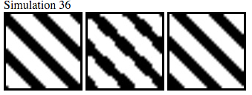

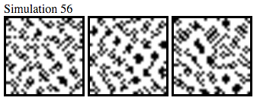

Simulation 36 was run with h = -6, R1 = 1, and R2 = 12. Simulation 56 was run with h = -1, R1 = 4, and R2 = 5.

**Experiment 3 (J1 = 1, J2 = -0.1)**

For this experiment, the J1 value was much higher than the J2 value. Because the J1 value acted as an activator multiplier, and the J2 value acted as an inhibitor multiplier, this combination would suggest that cells in the system would be much more affected by their closer neighbor’s (distance < R1) than more distant cells (R1 < distance < R2). Because J1 and J2 both had nonzero values, the uninteresting aspects of Experiment 1 and Experiment 2 combined to produce much more interesting simulations in general. Overall, several interesting patterns emerged.

If h = 0, there is no additional bias introduced into the system, so state transitions were entirely determined by the pairs of values for J1 and R1 and the pairs of values for J2 and R2. Because J1 is so much larger than J2, the influence of near neighbors was high. In Simulations 1, 7, 13, and 19, h remained at zero and R1 remained at 1, which means a given cell would want to be in the same state as its immediate neighbors. The only parameter variation between the runs was with R2, which held the values 2, 5, 9, and 14, respectively. The resulting images for the 3 simulations with each of these parameter combinations shows how R2 influences the convergence of an automaton when R1 is very low and there is no additional bias:



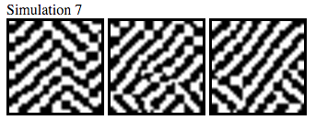

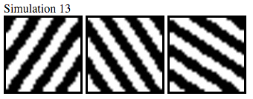

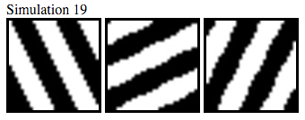

The graphs (above) for Simulation 1 and Simulation 14 show how the calculated values vary with the change in R2 from one extreme to the other. When R1 and R2 are both very small, the spatial correlation of the system is highest at small distances. In the extreme case of R1 = 1 and R2 = 2 (as in Simulation 1), the correlation quickly drops to almost 0 as distance increases because cells in the system want to be like their nearest neighbor and different from their second-nearest neighbor, which limits the “clumping” of same-state cells. In Simulation 19, R1 = 1 and R2 = 14. In this scenario, cells still want to be in the same state as their nearest neighbor, but now the radius of “repulsive” cells is much larger, which allows for larger clumps of same-state cells to form as the average state in that larger radius is less likely to be for an opposing state value. Accordingly, the spatial correlation for Simulation 19 is greatest at smaller distances, but steadily drops to a minimum distance of about 6. However, because solid stripes of same-state cells start to form again at radii greater than 6, the spatial correlation starts to curve back upwards before falling again (again, in accordance with the large stripes that form). The mutual information and joint entropy of Simulation 1 and Simulation 19 also reflect the general disorder of each system. In Simulation 1, both mutual information and joint entropy quickly converge to a nearly horizontal line because the system itself is quite chaotic and uncertain. In Simulation 19 on the other hand, both values fluctuate more in “waves” as the distance increases because those stripes of same-state cells appear in regular intervals across the space.

Keeping the bias at 0, if R1 is allowed to increase (but not exceed R2), then the linearity that emerged in the spatial structure of the previously described simulations (7, 13, and 19) becomes less defined. This trend is likely due to the fact that a given cell is more heavily influenced by more than its immediate neighbors when R2 increases. As such, structures begin to become more curved and form into “blobs,” rather than simple stripes. Simulation 31 (in which h = 0, R1 = 3, and R2 = 5) provides an example of this structural shift:

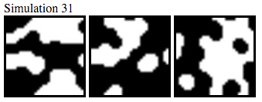

Generally, with higher R2 values, the structures become a bit thinner and less curved. However, if both R1 and R2 are allowed to grow too large, the space generally divides into large, uninteresting rectangles as the range of attractive and repulsive states for a given cell start to overlap excessively. For example, Simulations 43, 67, and 91 all have h = 0 and R2 = 14. The R1 value for each experiment varies from 3 to 7 to 12, respectively. The spatial structure for each and the corresponding graphs can be seen below. Simulation 91 has only one image because the other two runs with those parameters converged to nearly one state and, as a result, were discarded.

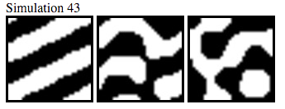

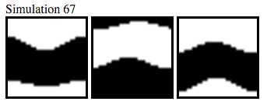

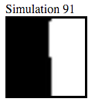

From the graphs, the similarity between the results for Simulation 67 and Simulation 91 is quite apparent. Although they have slightly different structures, the space is so densely populated by large groups of same-state cells that the corresponding values are not particularly interesting. Like Simulation 19 above, the graph for Simulation 43 shows more variation as the distance increases.

Although the last few patterns were noticed when h = 0, the introduction of a non-zero h value tended to noticeably influence a system, as well. When the R1 value is low, the h value as a much stronger influence on the resulting state of a particular cell. For example, Simulations 16, 17, and 18 have the same parameters as one another, except the h value varies from -3 to -4 to -6, respectively. The resulting state spaces are displayed below.

