Robert Mulligan
B01051740 | Word count: 2744

Conceptual ER model and Database implementation for Olist

Table of Contents
Table of Figures: 2
Introduction 3
Relevant Data and Entities for an Olist database: 3
The Importance of a Database for Olist: 3
Olist’s System Objectives: 4
Theoretical Framework: 4
Entity relationship (ER) modelling: 4
Description of Entities 5
Business Rules: 5
Consolidated ER Diagram 9
System catalogue: 9
Implementation Details: 10
Data Selection & Querying 13
Proposed queries: 13
Query results: 16
Recommendations and Conclusions: 18
References: 19

Table of Figures:
Figure 1: Customer Entity 6
Figure 2: Order Entity 6
Figure 3: Order Entity 6
Figure 4: OrderReview Entity 6
Figure 5: Order Entity 7
Figure 6: OrderPayment Entity 7
Figure 7: Order Entity 7
Figure 8: Product Entity 7
Figure 9: OrderDetail Entity 7
Figure 10: Seller Entity 8
Figure 11: Order Detail Entity 8
Figure 12: Collection of CSV Files 10
Figure 13: Every Entity in a Single Excel File 10
Figure 14: Translating Product Names 11
Figure 15: Ensuring Correct Data Types 11
Figure 16: Deleting Unnecessary Entities 11
Figure 17: Deleting Duplicates 11
Figure 18: Navigating to Import Data 11
Figure 19: The Import Wizard 11
Figure 20: Selecting the Worksheet 12
Figure 21: Ensuring Headers 12
Figure 22: Ensuring Correct Data Types 12
Figure 23: Choosing Key Options 12
Figure 24: Renaming the Table 12
Figure 25: Query 1 13
Figure 26: Query 2 14
Figure 27: Query 3 14
Figure 28: Query 4 14
Figure 29: Query 5 15
Figure 30: Query 6 15
Figure 31: IF Statement 15
Figure 32: Query 7 16
Figure 33: Query 8 16
Figure 34: Query 2 Results 17
Figure 35: Query 4 Results 17
Figure 36: Query 6 Results 18
Figure 37: Query 7 Results 18

Introduction
This report outlines the design and implementation of a relational database management system (RDBMS) for Olist, a Brazilian e-commerce intermediary that connects small and medium businesses with major online marketplaces such as Amazon. Olist’s core functions include marketplace integration, order and inventory management, logistics coordination, and payment tracking for its network of 45,000 merchants.

Relevant Data and Entities for an Olist database:
To create a database which can support Olist’s operations, it needs the following entities: Customer, Order, OrderDetail, Product, Seller, OrderReview, and OrderPayment. These entities reflect the transactions and relationships that are at the core of what Olist does.
With such a large volume of data being generated from the 45,000 merchants on Olist, a relational database is critical to ensure data integrity (i.e., the data is accurate, complete, and consistent), multi-user access of the data (sellers and customers need to see the different parts of the data), and continued scalability (Olist can continue to increase the number of merchants that use its service).

The Importance of a Database for Olist:
If Olist does not use a relational database system, they could face several problems including data redundancy, data inconsistency, lack of real-time updates, poor customer/seller experience, and manual errors.
Data redundancy can occur when each department maintains a separate data file. For example, a customer could have their information appear in the sales department file, the delivery department file, and the customer service department file. Now there is three separate copies of the customer’s data across three files. If anything changes about this customer, all three files must be changed separately. This is a bad database design and a waste of storage, as they could just have a single customer entity with each customer’s information.
When there is no database system, there is an increased chance of manual errors. These errors could include special character errors e.g., typing Sāo Paulo instead of São Paulo, missing decimals e.g., entering a product price as 1499 instead of 14.99, and case inconsistency e.g., Order department uses “KG” in one file, but the Product department uses “kg”. These small errors can compound into serious errors such as failed deliveries (city names are wrong), financial reports being off by hundreds/thousands, and failed data queries (due to inconsistency and spelling errors)

Olist’s System Objectives:
The database system Olist needs should aim to achieve these five objectives:
- Every order is uniquely recorded and traceable
- Customers are linked to their orders and their reviews
- Inventory should be tracked
- Order details are stored accurately and linked to the order, product, and customer
- Order payments are tracked and traceable to support financial reconciliations.

Theoretical Framework:

Entity relationship (ER) modelling:
ER modelling, first introduced by Chen (1976), is a data modelling technique that diagrammatically represents the logical structure of a conceptual database. The purpose of ER modelling is to take abstract business processes and break them down into three main components: entities (e.g., tables of data such as Customer), attributes (properties within entities such as Customer_id), and relationships (how the entities relate to each other e.g., each order in the Order entity also contains a Customer_id from the Customer entity). ER modelling helps translate business objectives into database design (Connolly & Begg, 2015).
The ER model’s main advantage over file-based systems is in its ability to facilitate database design by identifying relationships before implementation to protect data integrity. For Olist, this means that potential data redundancies are pointed out during the design phase, not during deployment (Elmasri & Navathe, 2014). This advantage is critical for Olist as ecommerce is a multi-layered business environment. Moreover, Boehm and Basili (2001) show that fixing errors in the design phase can be 50-200 times cheaper than fixing them in production, which directly addresses Olist’s need for data integrity.
For an ER model to work, you need business rules. These are the rules that govern the context and direction of the relationships. Without them, it is impossible to know how the diagram functions. Below are the descriptions of key entities and the five business rules for Olist’s ecommerce business

Description of Entities
Table 1:Description of entities
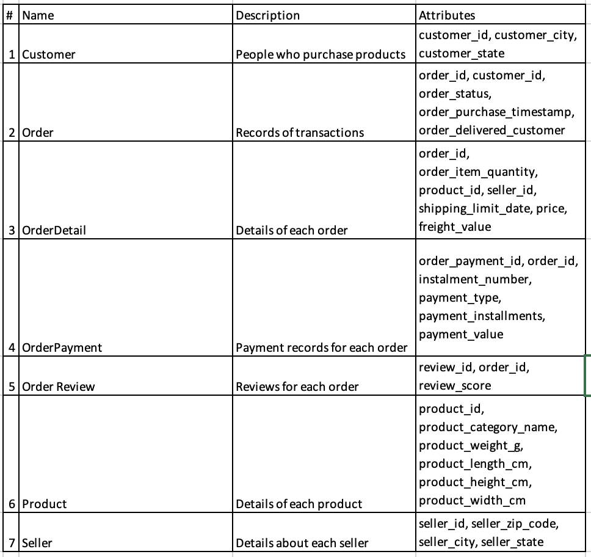

Business Rules:
Business rule 1:
A customer can place many orders but must place at least one order to be a customer. Each order must belong to exactly one customer.
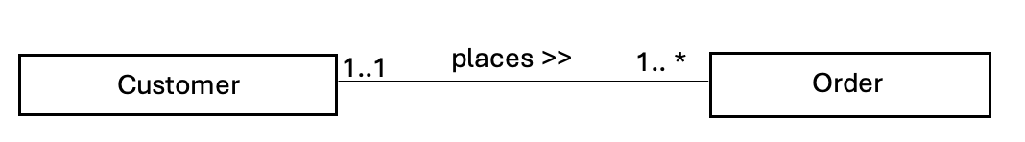
Relationship Type: one-to-many
Rule for one-to-many relationship: the one-side (here, Customer) is always the source, and the many-side (here, Order) is always the destination. The primary key (PK) of the source is repeated as a foreign key (FK) on the many side. In doing so, each order will be linked to a specific customer (1..1) and every customer will be linked to all their orders (1..*).
Figure 1: Customer Entity | Figure 2: Order Entity
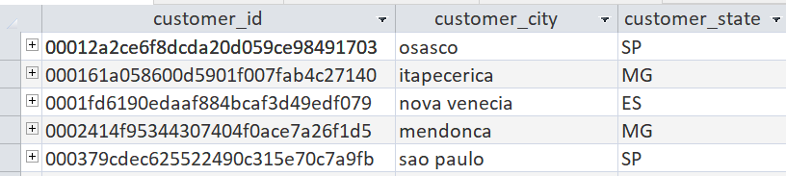 | 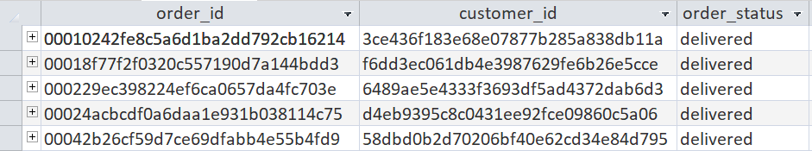

Business rule 2:
An order can be reviewed once only, but not every order needs to be reviewed. Each review is attached to maximum one and minimum 1 order.
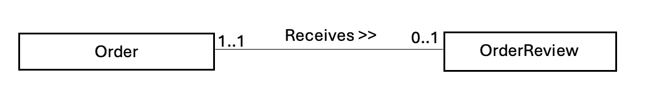
Relationship Type: one-to-one
Rule for one-to-one relationship: In this one-to-one relationship, the obligatory side, OrderReview, has the FK. This is because not every order needs a review but for a review to be placed, there needs to be an order. The FK cannot be placed on the non-obligatory side, as it will result in many blanks inside the Order table. Here, Order is the source and OrderReview is the destination.
Figure 3: Order Entity | Figure 4: OrderReview Entity
 | 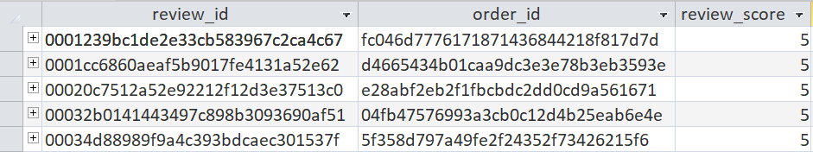

Business rule 3:
An order must be settled but can be settled in many instalments. However, every order payment belongs to at least one order and one order only.
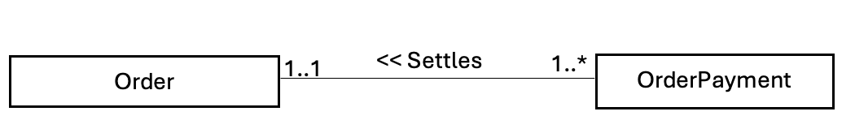
Relationship Type: one-to-many
Rule for one-to-many relationship: the one-side (here, Order) is the source, and the many-side (here, OrderPayment) is the destination. The primary key (PK) of Order is repeated as a foreign key (FK) in OrderPayment to minimize data redundancy. In doing so, each payment will be linked to a specific order (1..1) and every order will be linked to all their instalment payments (1..*).
Figure 5: Order Entity | Figure 6: OrderPayment Entity
 | 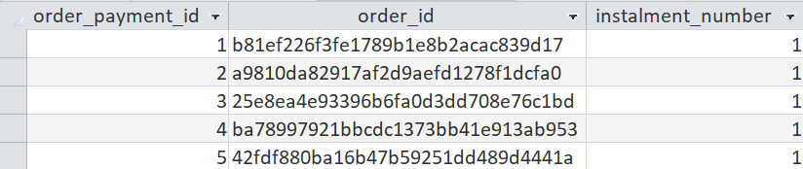

Business rule 4:
Business Rule 4 resolves a many-to-many relationship between Order and Product through the introduction of a junction entity, OrderDetail. This prevents the fan trap that would occur if Order were directly linked to Product, which would ambiguously associate multiple products with multiple orders without specifying exact quantities per order. Instead, one order can contain many details (1..*) and each order detail belongs to exactly one order (1..1). And one product can be listed many times in order details (1..*) but each order detail specifies one product (1..1)
Relationship Type: many-to-many

Rule for many-to-many relationship: By added the table OrderDetail, Order and Product are now connected through two one-to-many relationships. This way, OrderDetail becomes a destination for both the Order and Product Tables.
Figure 7: Order Entity | Figure 8: Product Entity
 | 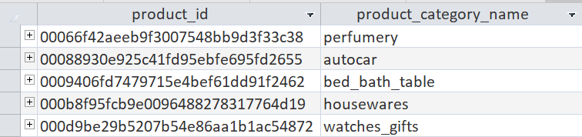

Figure 9: OrderDetail Entity
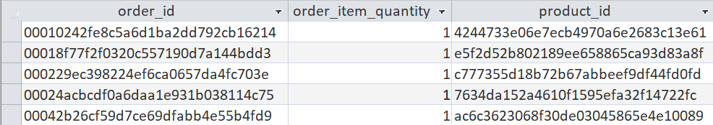

Business rule 5:
A seller can supply many order items, but each order item is supplied by exactly one seller. To be a seller, you must supply at least one item.
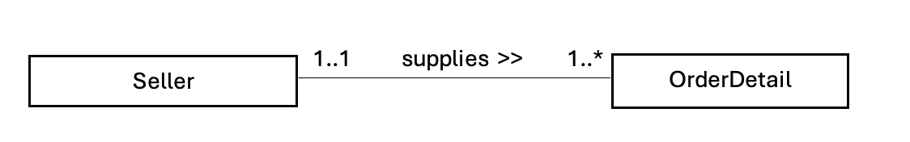
Relationship Type: one-to-many
Rule for one-to-many relationship: the one-side (here, Seller) is the source, and the many-side (here, OrderDetail) is the destination. The primary key (PK) of Seller is repeated as a foreign key (FK) in OrderDetail to minimize data redundancy. The OrderDetail entity has a composite key as the combination of order_id, product_id, and seller_id functions as a composite primary key, ensuring uniqueness of each item. Each order item will be linked to a specific seller (1..1) and every seller will be linked to all their order items (1..*).
Figure 10: Seller Entity | Figure 11: Order Detail Entity
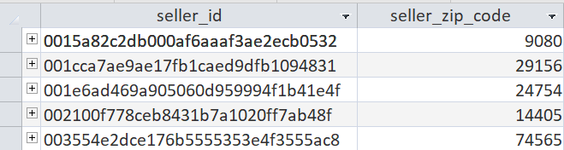 | 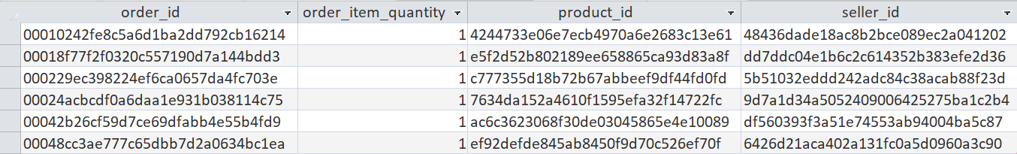

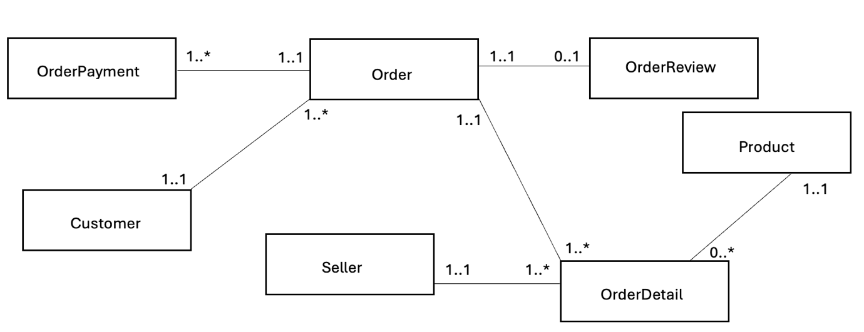
Consolidated ER Diagram

This consolidated ER diagram integrates all five business rules into one unified model. It shows how all transactions flow from the Customer entity through the Order entity, to the Product and Seller entities, all supported by the Review and Payment entities. By consolidating the diagrams, the model ensures referential integrity e.g., every OrderDetail record must link to both an Order and a Product.

System catalogue:
This system catalogue follows the structure demonstrated in the course materials and documents all the field names, table names, data type, field size/format, if each field is a primary or foreign key, and whether duplicates are ok of all the data in Olist’s database.
Table 2: Metadata
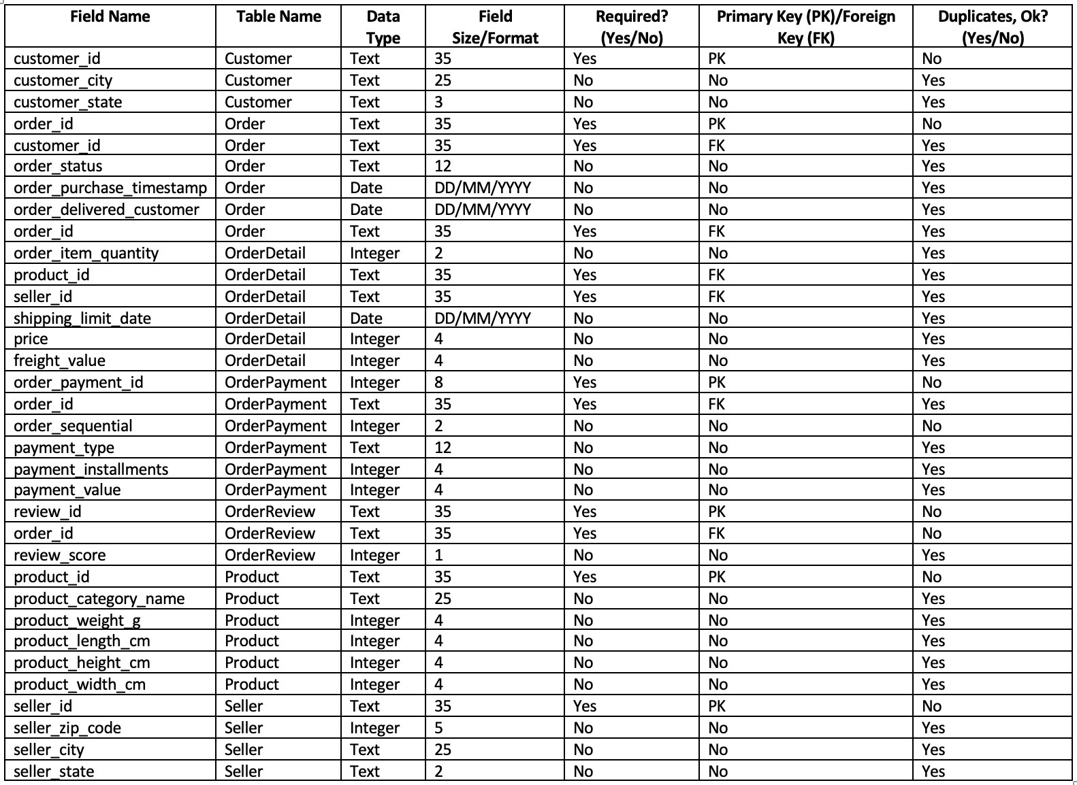

Implementation Details:
To implement the database in Microsoft Access, the first step was to download the raw data. Each entity was originally provided as a separate CSV file, so I downloaded and combined them into a single Excel workbook. Keeping everything in one place made the subsequent cleaning steps more controlled and repeatable.
Figure 12: Collection of CSV Files | Figure 13: Every Entity in a Single Excel File
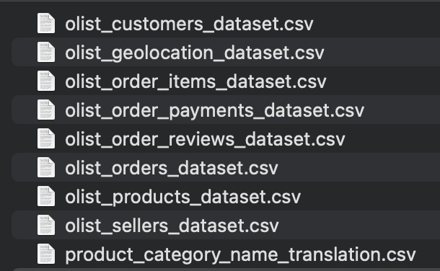

Once the data was consolidated, it could be cleaned. The product names were in Portuguese, so these were translated into English to ensure consistency across the dataset. I also standardised the data types; price-related fields were converted from general text to currency formats so Access would recognise them correctly during import. After that, I removed entities that were not required for my model, such as the Geolocation and ProductTranslation files, as these did not contribute to the business rules defined above. Before moving on, I checked all fields intended to become primary or foreign keys e.g., order_id, to ensure there were no duplicate values that could compromise referential integrity. The dataset was then ready to be imported into Access.
Figure 14: Translating Product Names | Figure 15: Ensuring Correct Data Types
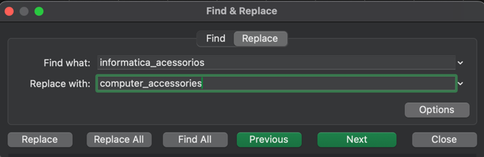 | 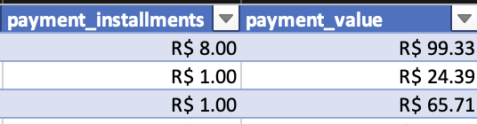
Figure 16: Deleting Unnecessary Entities | Figure 17: Deleting Duplicates
 | 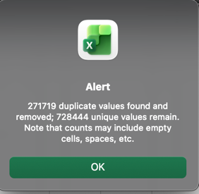

First a blank Access database was created, and then I navigated to the External Data ribbon > New Data Source > From File > Excel. This opened the import wizard where I selected my excel file from.
Figure 18: Navigating to Import Data | Figure 19: The Import Wizard
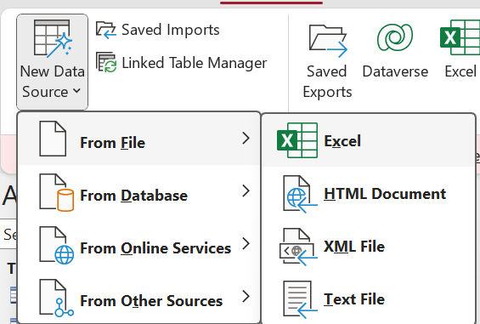 | 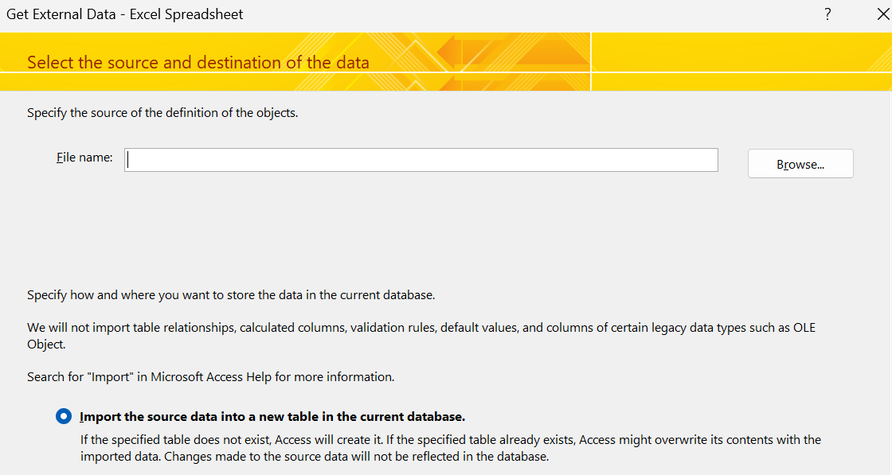

After selecting the workbook, I chose the sheet for each table e.g., OrderItem. I confirmed that the first row contained the correct column headings, then reviewed the data types Access had assigned to each attribute to ensure they matched what I had defined in my system catalogue. For destination tables such as OrderItem, I selected the option to import the data without a primary key, as these keys are inherited through foreign key relationships elsewhere in the model. I also renamed each table to follow standard singular naming conventions used in database design (Brumm, 2017). This import procedure was repeated for every entity included in the final consolidated ER model.
Figure 20: Selecting the Worksheet | Figure 21: Ensuring Headers
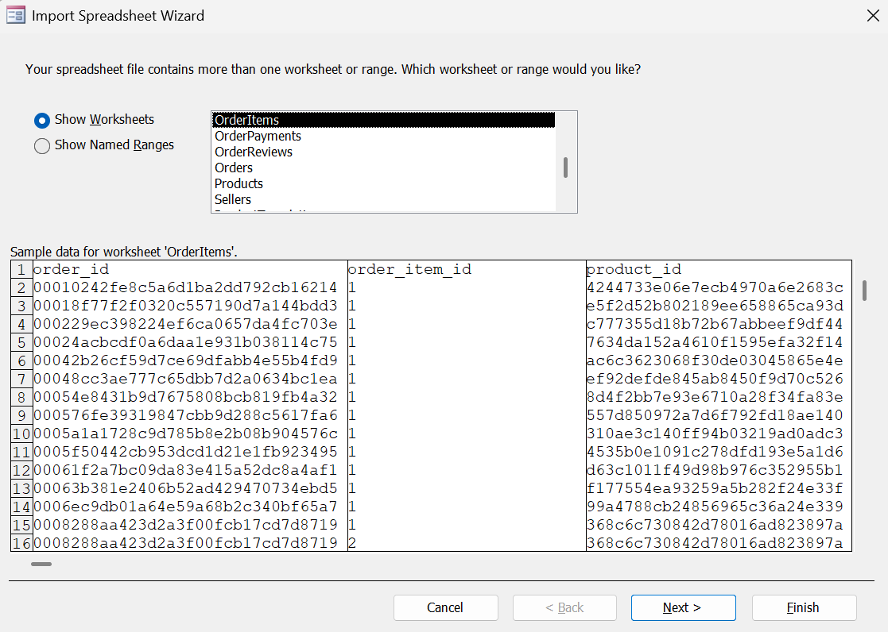 | 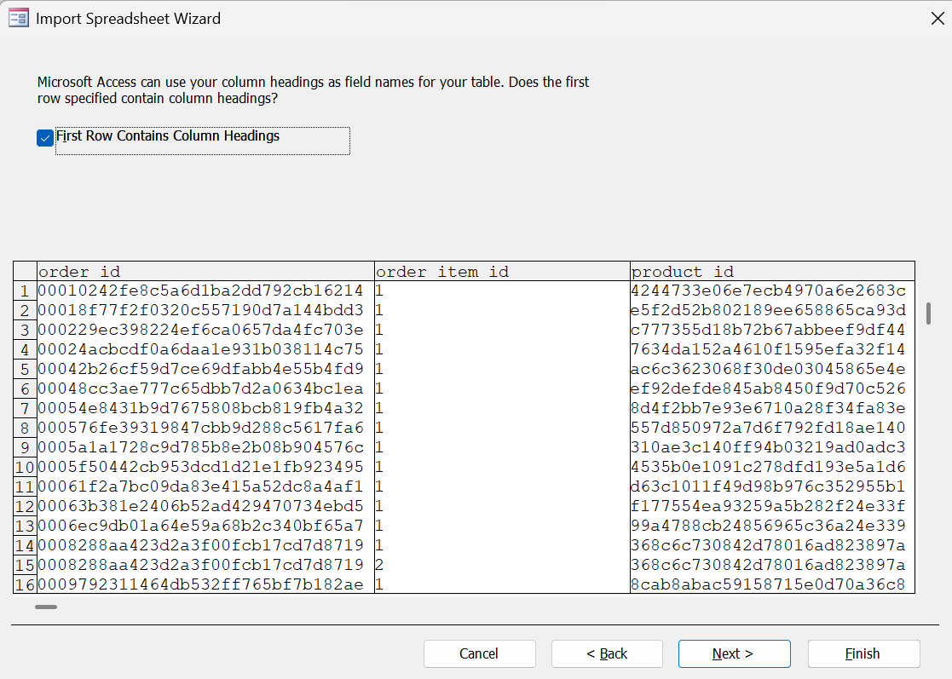
Figure 22: Ensuring Correct Data Types | Figure 23: Choosing Key Options
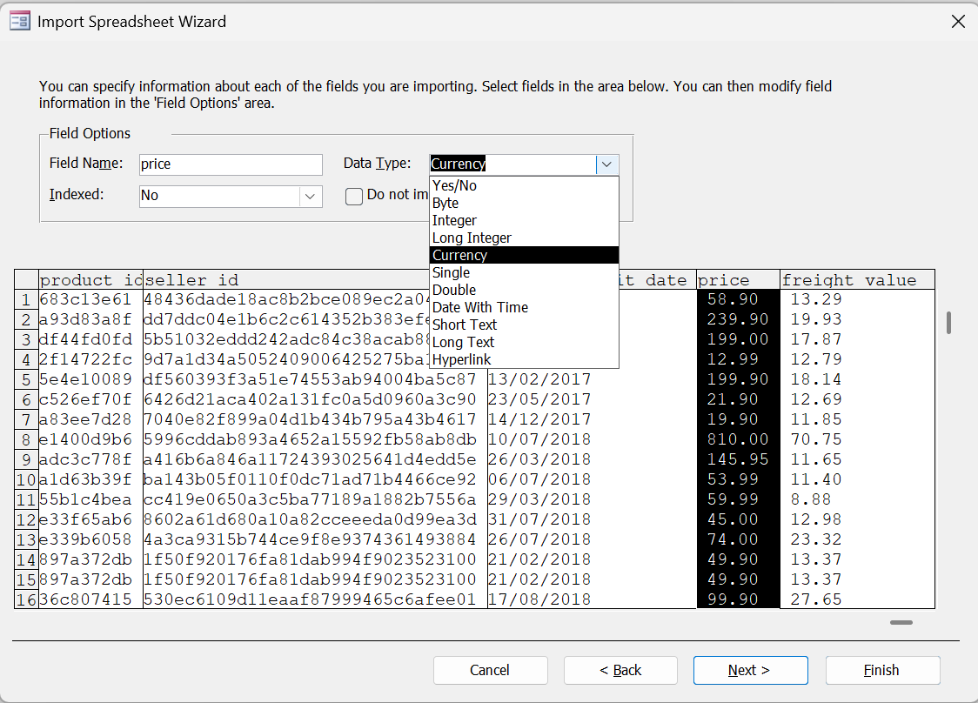 | 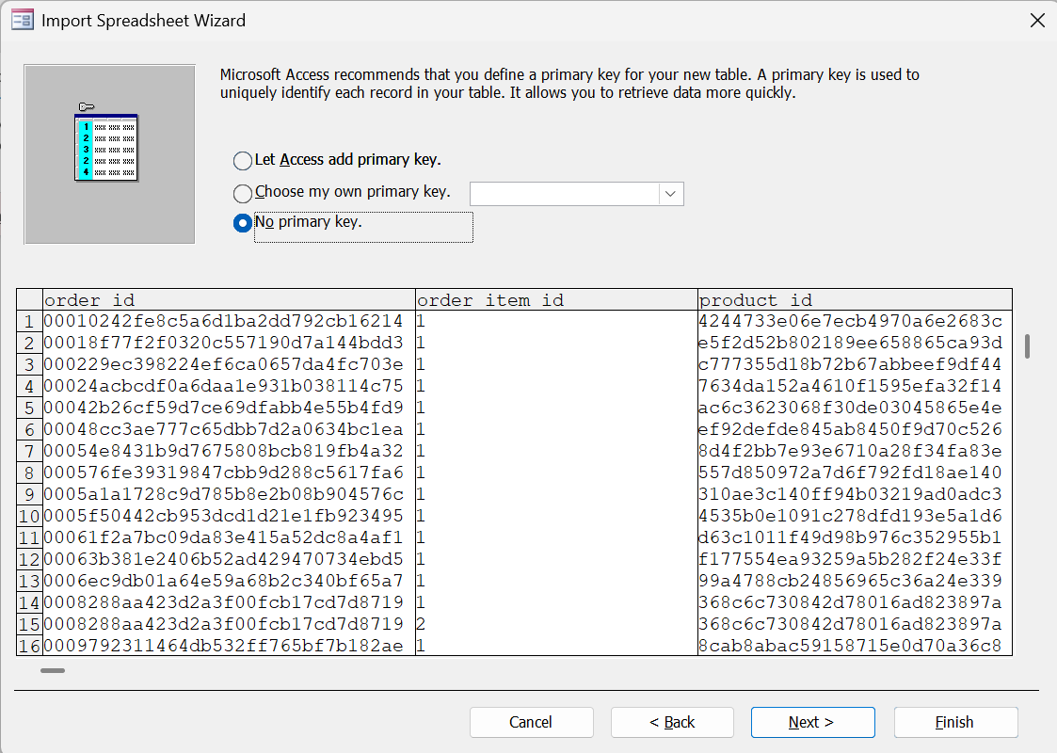
Figure 24: Renaming the Table
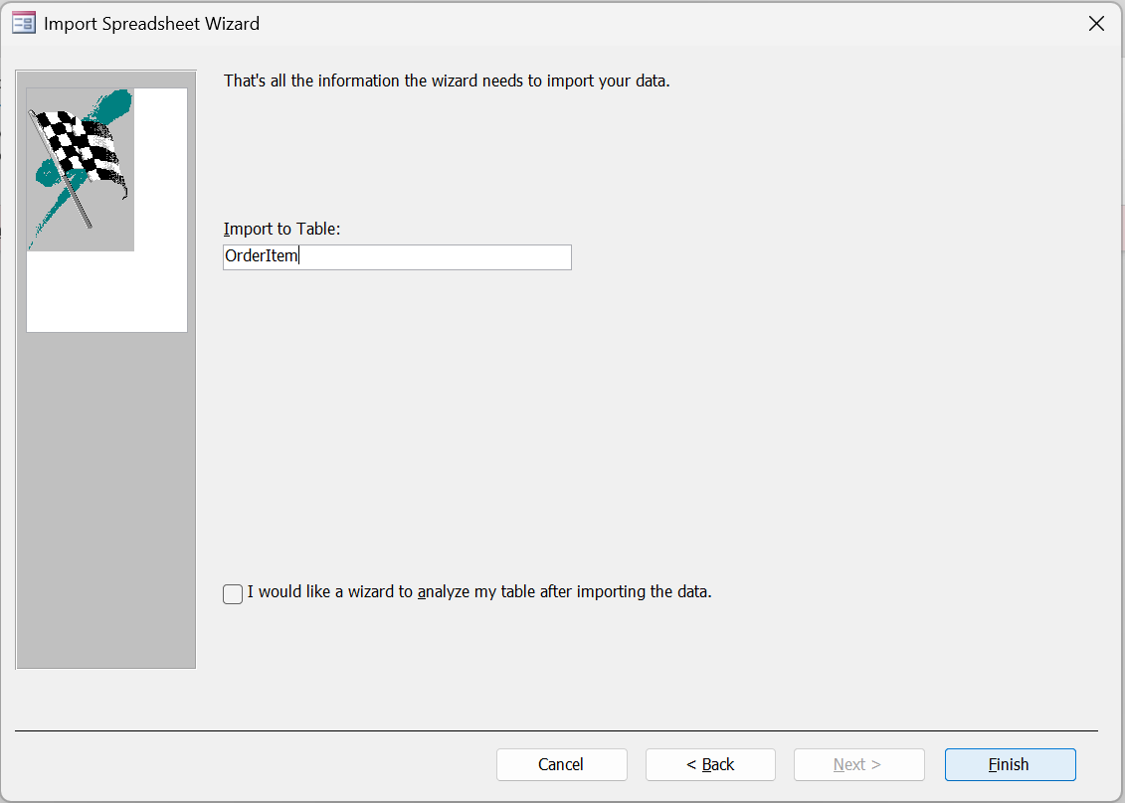

Data Selection & Querying
From a database context, the original definition of querying comes from Codd (1970). In this paper querying is defined as a formal way of specifying any subset of data from the larger database. This specification is written using structured query language (SQL). Querying has many advantages; firstly, SQL is declarative which means you describe the result, rather than the steps the system must follow to product it. Secondly, querying supports ad-hoc data retrieval. This is useful because you can never predict every user requirement at the design stage, so querying can help you fulfil any needs after implementation. Querying also supports data independence; after a query is performed, the original data is unchanged. Moreover, users of the data do not need to understand the architecture of the database to use the results of the queries (Silberschatz & Sudarshan, 2020).

Proposed queries:
For my ecommerce database I have come up with the following 8 queries:
- Order for a specific customer
This query is being performed to demonstrate that each order can be traced back to a customer.
Figure 25: Query 1
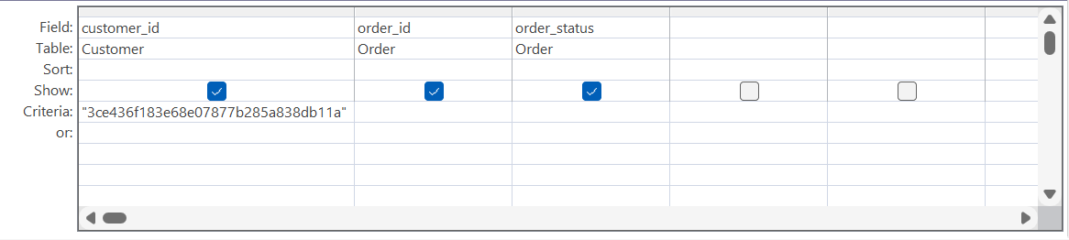
Description: This select query shows data from the Customer and Order entities for the specific customer ID in the criteria field

- Total revenue per order
This query is being performed to calculate the amount of revenue per order
Figure 26: Query 2
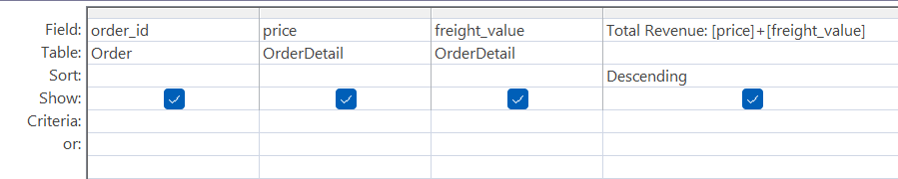
Description: By summing price and freight value, this query shows the sales revenue generated for each order from greatest to least.

- All order details for a specific order:
This query is being performed to demonstrate the success of the OrderDetail entity as a junction table between the Order and Product entities.
Figure 27: Query 3
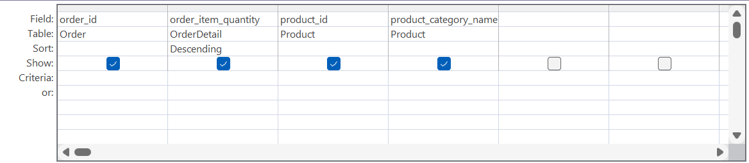
Description: By selecting data from the Order, OrderDetail, and Product entities, this select query shows that for each order there can be multiple order items.

- Top selling product categories
This query aims to show which of the product categories sell the most
Figure 28: Query 4
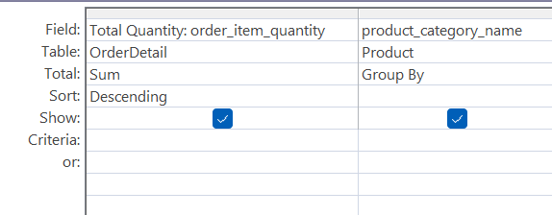
Description: By using a group by column, this query shows the most ordered product categories from greatest to least.

- Highest rated orders
By linking the Review entity to OrderDetail entity, this aims to show the highest rated products.
Figure 29: Query 5
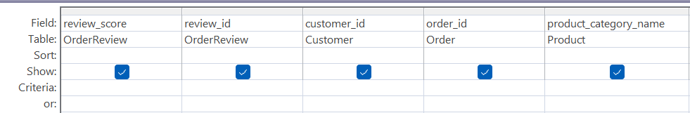
Description: this select query is pulling the OrderReview, Customer, Order, and Product tables together to show each customer’s reviews and to discern which product categories are highest rated.

- Identifying late deliveries
By comparing the shipping limit date and the delivered date, this query aims to show which of the deliveries are made on time and which are late
Figure 30: Query 6 | Figure 31: IF Statement
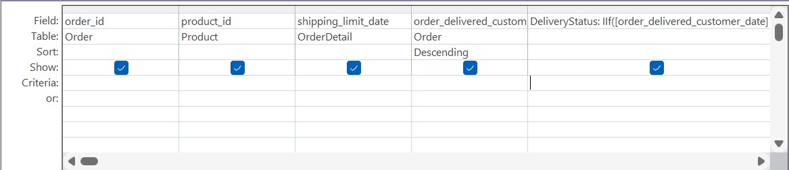 | 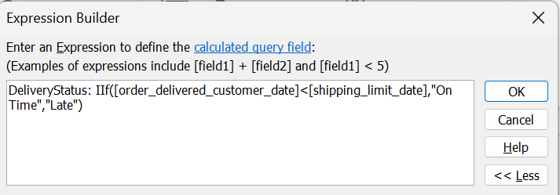
Description: By using an IF statement, this query shows which products have made it to customers on time

- Checking payment balances
By comparing the total price of the items and the number of payments made, this query aims to show which orders still have outstanding balances
Figure 32: Query 7
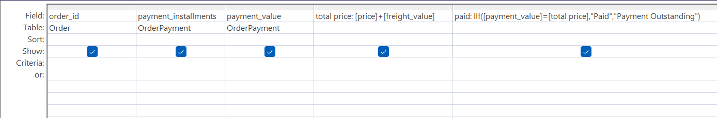
Description: By using an IF statement, this query is showing if the orders have been paid for or are still outstanding by linking both the Order and OrderPayment entities.

- Top producing sellers
This query aims to show which sellers are selling the greatest number of items.
Figure 33: Query 8
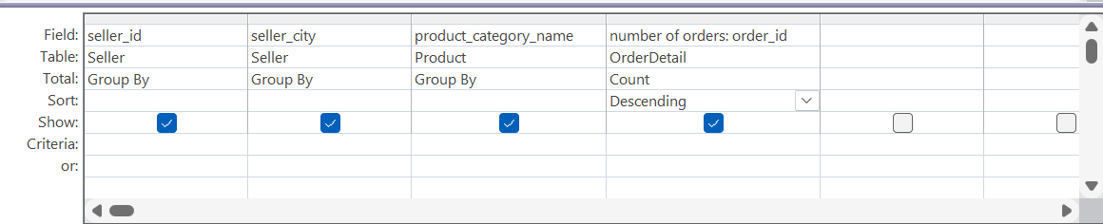
Description: This select and grouping query uses the Seller, Product, and OrderDetail entities to highlight the highest number of orders supplied by each seller.

Query results:
Query 1 showed that each customer_id is linked to a specific order despite the business rules allowing customers to order many times. Repeat purchases were rare despite a customer base of 100,000 plus. This behaviour suggests weak customer retention or data problems. Customers may be making return purchases but are being issued unique IDs. This problem could inflate customer count and distort KPIs. Olist should investigate if returning customers are issued new IDs or if they need to increase their product quality.
Query 2 shows that the revenue distribution is skewed in that a small number of expensive items (£3000-6000) generate most of the revenue, while most of the orders were for low-value items (£0-100). Olist’s financial performance being disproportionately reliant on a small number of customers has operational implications. Olist should target the customers who buy high-value items with personal marketing and expand the number of high-value items they sell since the demand exists.
Figure 34: Query 2 Results
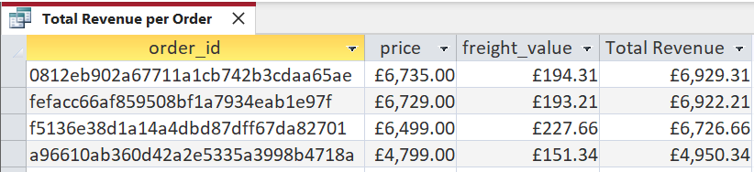

Query 3 shows that OrderDetail is successfully acting as a junction table between the Order and Product entities. This is important from a database design perspective as it solves the problem of a many-to-many relationship between Order and Product. A working junction table reduces unnecessary duplication and supports accurate order histories. The data could also help ensure proper order tracking and product recommendations.
Query 4 shows the highest selling product categories from highest to lowest. The highest volume categories included bed, bath, and table, furniture and décor, and health and beauty. The lowest were PC games, security services, and musical DVDs. Sales concentration is important for Olist as it provides the clearest category level demand signal. With this information they could attract more sellers for the high-volume items to prevent stock shortages and decide to either help or prune low selling items.
Figure 35: Query 4 Results
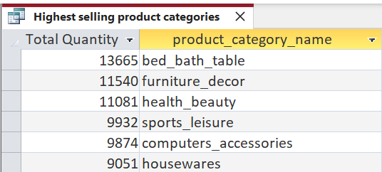

Query 5 shows the highest and lowest rated products. The query showed that some categories had extremely high average ratings but very few reviews (e.g., PC games), while others had stable and consistent ratings due to larger data volumes. This matters because a high rating is only meaningful when supported by an adequate number of reviews. Categories with consistent low ratings likely have issues related to product quality or misleading descriptions. Olist could use “top-rated” marketing labels to help sell more highly rated products.
Query 6 shows by comparing the shipping limit date and the order delivery date, whether the orders are getting to customers on time. The results showed that 20% are delivered late. Late deliveries can lead to decrease return purchases and depressed ratings. Olist handle the logistics of the selling on behalf of the seller and therefore need to give longer estimated times of delivery to customers, or partner with a better logistics partner.
Figure 36: Query 6 Results
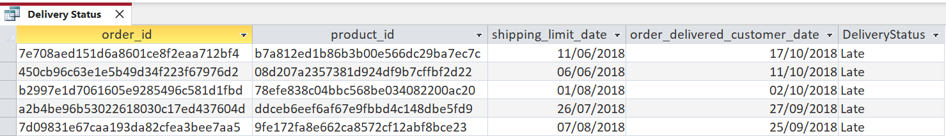

Query 7 shows which payments are still outstanding by comparing the price of the item to the value of payments made by the customer. The query’s results showed that 73% (86006 orders) were fully paid. Tracking receivables is important if Olist are offering instalment payments. If outstanding balances become significant, this could indicate customer default or larger operational problems such as incorrect credit authorisation. Olist should flag risky accounts early and set automated reminders for overdue instalments to decrease the risk of instalments becoming bad debts.
Figure 37: Query 7 Results
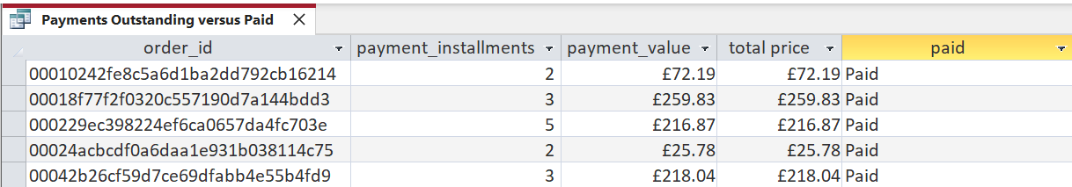

Query 8 shows the highest performing sellers. The sellers that sell the most sell the following three categories garden tools, watches, and bed bath and table items. By highlighting seller contributions, Olist can implement seller-tier incentives and prioritise top sellers for promotional slots. In doing so, they could attract more and higher quality sellers to the platform.

Recommendations and Conclusions:
The overall objective of the system was to ensure data integrity, allow multi-user access of the data, and enable continued scalability. The advantage of this system is that by having enough entities, all the necessary data generated by the users can be collected and accessed in a complete and accurate manner. Secondly, the system will continue to work as Olist grows its customer base. Although they may want to collect different types of data, this system captures all the data that is necessary to the day-to-day operations of the business.
The system also helps Olist make the following decisions:
- Using query 4 and 5, they can choose which products to highlight (i.e., highest sellers/ best reviews), and which ones to offer more support for, or to remove from the site (i.e., lowest sellers/ worst reviews)
- Using query 6, they can decide to continue to handle their own logistics, or they could outsource delivery to improve customer wait times.
- Using query 7 on outstanding balances, they can come to a decision whether to continue to offer instalment payments or to remove the option based on the number of bad debts accumulating from late payments
The system is not without fault. The first fault is that the business rules are logically enforced instead of through database constraints. The lack of repeated customer IDs despite the unlikelihood that not a single customer has made a return purchase is an example. The system is not identifying returning customers and is instead issuing new IDs. To fix this, Olist needs to collect a broader depth of data on customers e.g., emails, so the system can recognise them as return customers.
Secondly, the logical schema of the model is set up for transactional data storage instead of operational analysis. The lack of a temporal dimension means that performance tracking or auditing operational structures is going to be difficult for Olist. To improve this, Olist should focus on capturing lifecycle events. Using deliveries as an example, Olist should have a date row for each stage of the process instead of just capturing the result. This way they could find out at exactly what stage the delivery process is causing late deliveries.
In conclusion, this system provides the necessities for an e-commerce business to remain operational. The database supports logical business rules that help run useful queries and make important business decisions. However, the system has major structural limitations that could skew Olist’s view of their own performance.

References:
- Brumm, B. (2017) Singular vs plural and other database table naming conventions, Database Star: Home. Available at: https://www.databasestar.com/database-table-naming-conventions/ (Accessed: 10 December 2025).
- Chen, P.P.S., 1976. The entity-relationship model—toward a unified view of data. ACM transactions on database systems (TODS), 1(1), pp.9-36.
- Codd, E.F., 1970. A relational model of data for large shared data banks. Communications of the ACM, 13(6), pp.377-387.
- Connolly, T.M. and Begg, C.E., 2005. Database systems: a practical approach to design, implementation, and management. Pearson Education.
- Elmasri, R. and Navathe, S., 2014. Fundamentals of database systems (Vol. 7). Pearson.
- Silberschatz, A., Korth, H.F. and Sudarshan, S. (2020) Database system concepts. 7th edn. New York,, NY: McGraw-Hill Education.

.

