

Name: Robert Mulligan
B-Number: B1051740
Assignment Title: Coursework 1: Visualisation Dashboard
Course title: ACF763: Data Analytics for Finance Professionals
Course Instructor: Arshad Raza Syed
Date Submitted: 25/10/2025

Word Count: 1636

Introduction

Data Visualisation and its Relation to Descriptive Data Analytics:
Data visualisation is the process of graphically representing data so that it can be better understood by its users. The purpose of data visualisation is to distil large amounts of data into easily digestible graphs that answer key questions for the intended users of the data. In this way, there is overlap between descriptive data analytics and data visualisation. In short, descriptive data analytics is analysing what has already happened (Unwin, 2020). An example of which could be this year’s sales figures.
Knowing the right decision to make relies on understanding key performance indicators (KPIs), which are central to both data visualisation and descriptive analytics. KPIs are agreed-upon goals and the metrics used to gauge progress toward those goals. For example, politicians aim to be elected, so their vote count serves as a KPI to indicate how close they are to meeting their quota. Data visualisation supports managing these metrics by helping users quickly see whether progress is being made. Using simple visualisations enhances understanding and supports faster decision-making (Richardson, 2020).
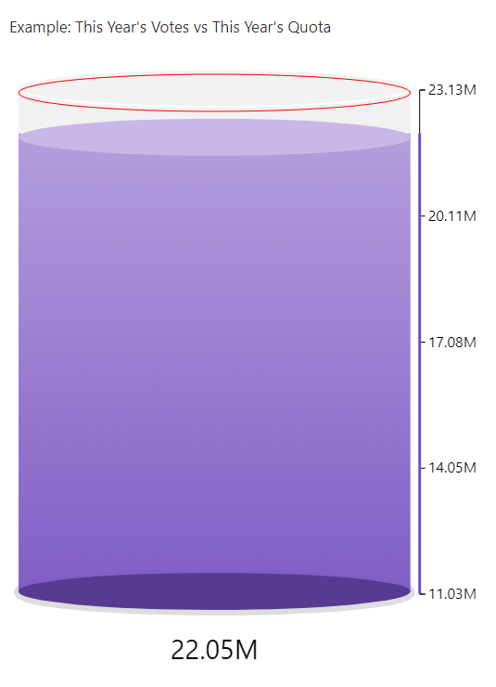
Dashboards guide users through key decisions. For example, a car dashboard helps a driver make choices while driving, like adjusting speed to follow traffic rules. Similarly, a vital-signs monitor in medicine displays patient data, enabling doctors to make quick, life-saving decisions.
For a dashboard to be effective in helping users make decisions, there are a few design principles that must be upheld. The dashboard must include all necessary information in an understandable way. It should present users with a real-world view of the environment with relevant data (Martins et al., 2021).

My Dashboard:

The Data Context:
The data used in this dashboard is a subset of the European Social Survey (ESS) named “Trust in Politicians”. It takes a selection of variables from the full ESS that encompass different European countries’ attitudes towards politicians, various social issues, and their socioeconomic and demographic information. The dataset can be found at the following link (requires registration): ESS: Trust in Politician Dataset, (2019). I have used Power BI to create this dashboard as it is user-friendly and allows for clear graphs and seamless data drill-through.

Data Description:
This dataset started with 572 variables, of which I kept 16 for my analysis. These variables are listed in the table below and include columns made during the transformation process.
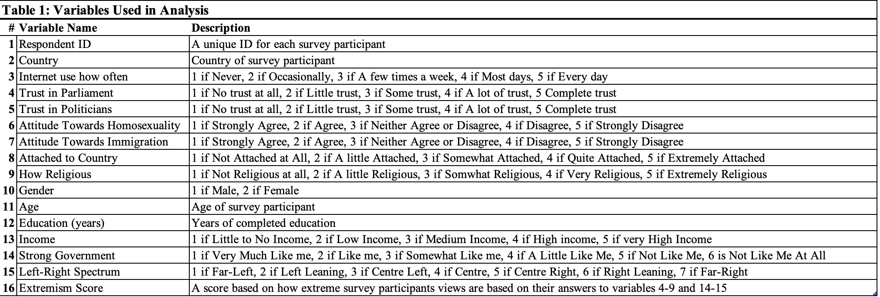
Importantly, it includes an ordinal measure of how much each respondent trusts politicians, their internet usage, education in years, income level, gender, and views about various social issues such as immigration, homosexuality, and nationalism.

The Value of the Data:
- Descriptive analytics can be applied to investigate the determinants of trust in politicians
- This dataset can be analysed and used to inform governments on policy targets or reforms that will increase the trust of the population.
- This dataset can be used to identify high-trust countries and use them as a model for low-trust countries.
- Due to the sample size of countries, reliable measures of central tendency can be calculated as benchmarks for struggling countries to hit.

Data Objectives and Transformation:
Due to the large volume of data, I had to focus on the variables needed for the analysis. To get a list of necessary variables, I first created a list of the questions I wanted to answer within the data (See Table 2).
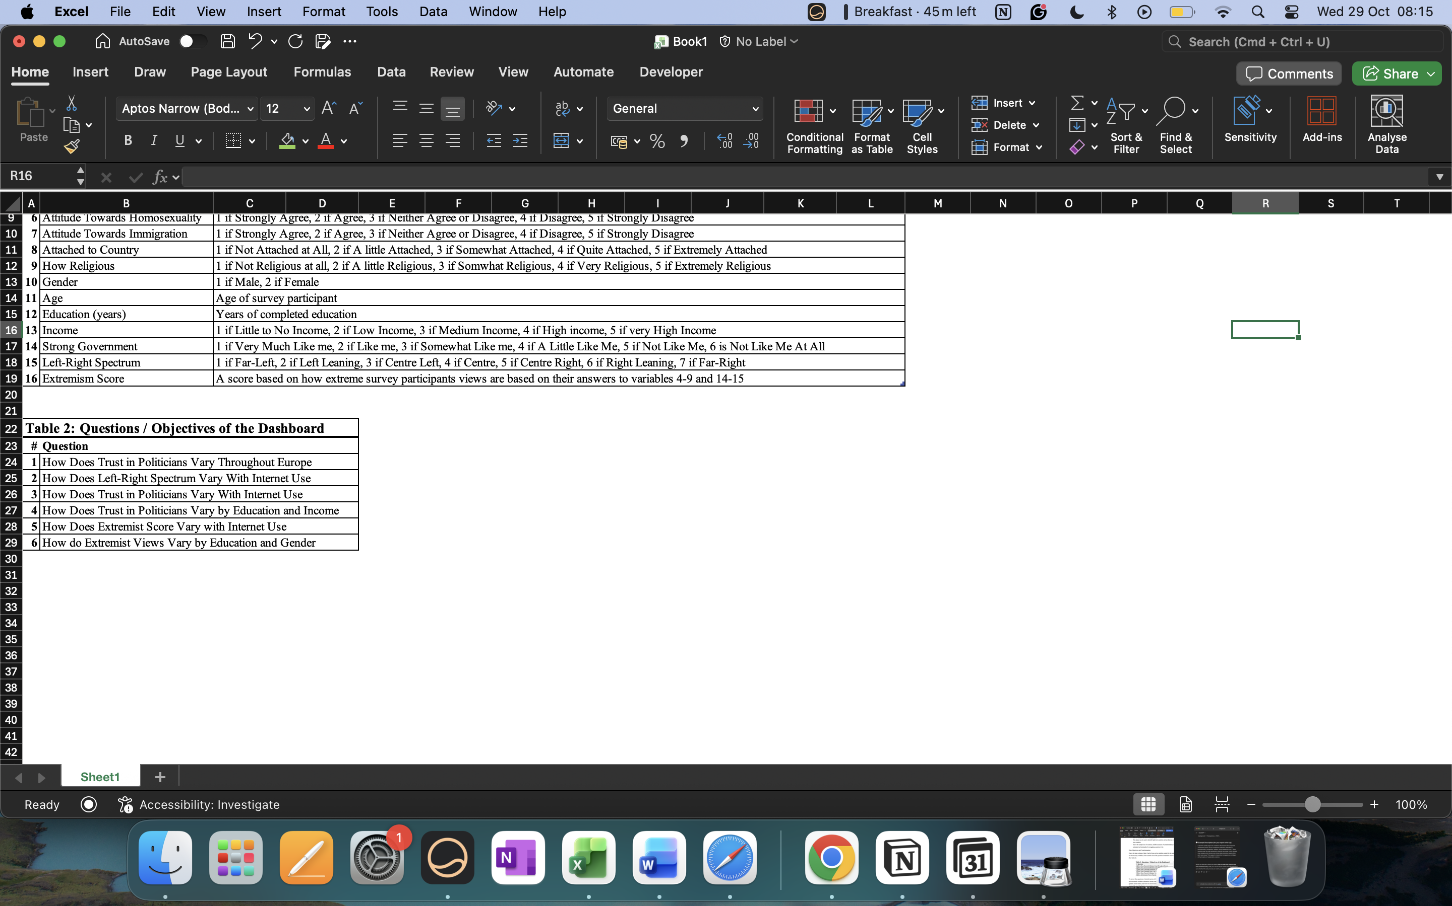

To answer these questions, I selected a proxy of trust in politicians, a measure for internet use, socio-economic variables (education, income, employment status), socio-demographic variables (gender, marital status), and views on social issues. I deleted all unnecessary columns and renamed the ones I had kept to more intuitive names, e.g., TRSTPLT -> Trust in Politicians.
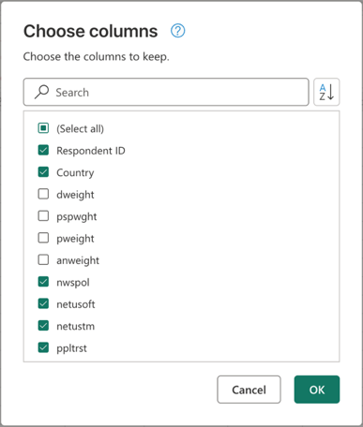 | 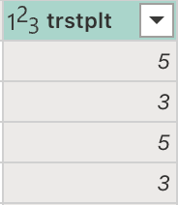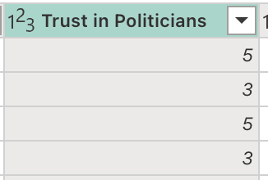
Selecting Necessary Columns | Renaming Variables

Due to the survey nature of the data, not every person answered every question. To fix this, I replaced all rows which were coded for no answer to a null value. This transformation then allowed me to easily delete all null rows from the columns. I did not have to worry about duplicate answers as each respondent had a unique ID.

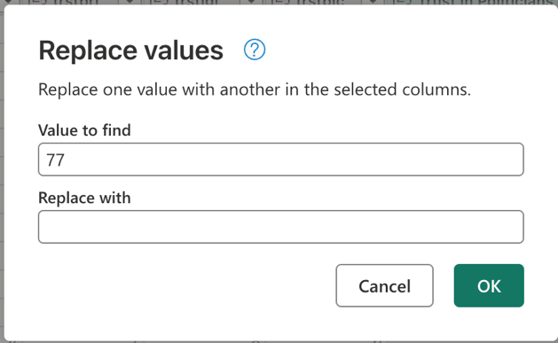 | 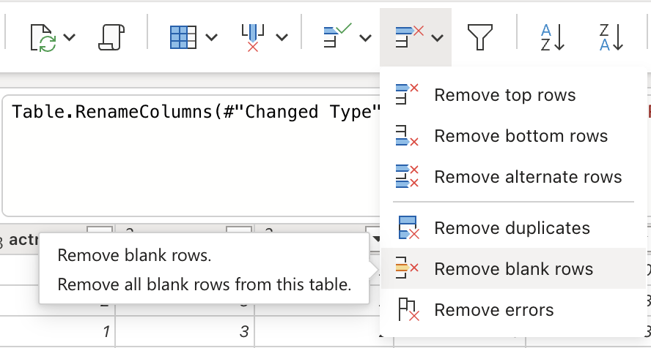
Recoding No Answers to Null Values | Removing Null Values

The biggest challenge was changing the data in a way so that Power BI understood that it was ordinal data. To do this, I created labelled columns for each variable and used these in the graphs. This was to ensure the correct bins were showing instead of Power BI wrongfully aggregating the data. This transformation also made the graphs easier to read, as the label was displayed instead of the ordinal category. For example:

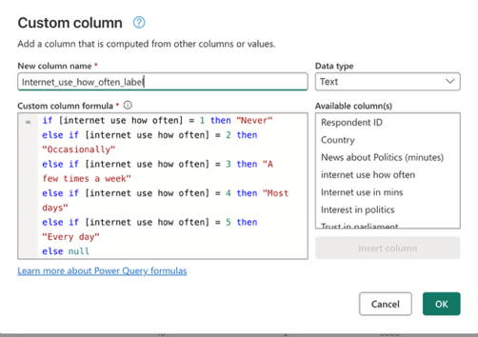
Creating Label Columns

To examine the respondents’ extremist views, multiple binary columns were created from their answers on social issues. If the respondent responded with an extreme answer, i.e., 1 or 5 to questions relating to immigration, homosexuality, nationalism, strong government, placement on left-right spectrum, religiousness, or trust, they were marked 1 for their respective column. I then created a custom column that aggregated the scores and gave it a descriptive label. For example, people who scored between 5 and 6 were labelled “Radical” while those who scored between 0 and 1 were labelled “Mainstream”.
Step 1: Creating extremist columns:
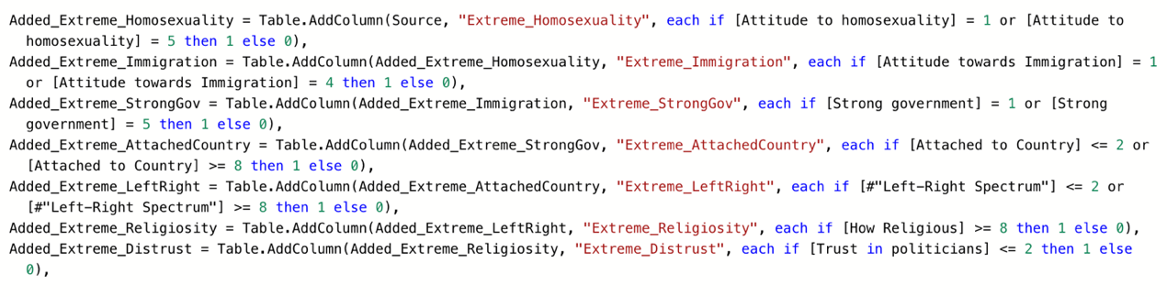

Step 2: Adding them together to get an extremist score for each respondent:
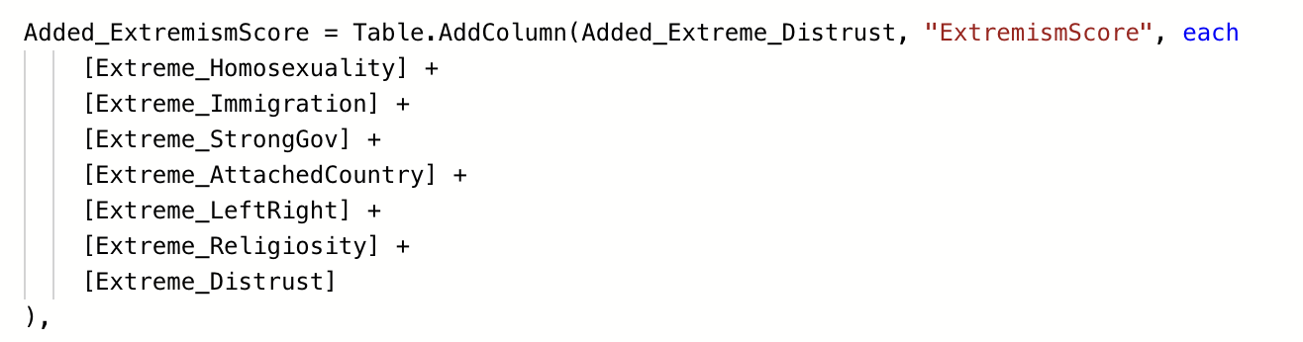

Step 3: Categorising the scores for improved readability:
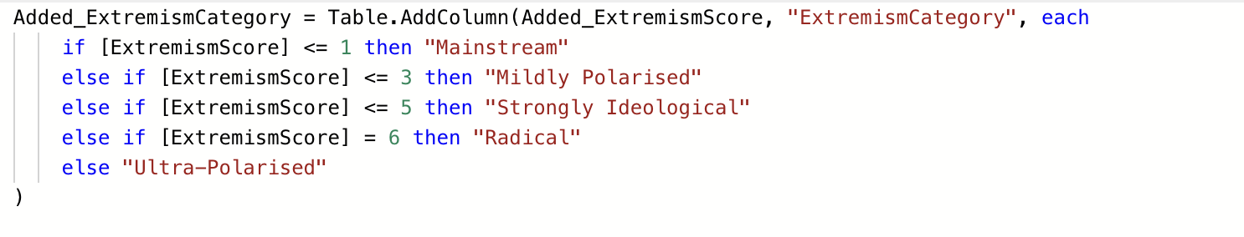

To ensure graph readability and useful tooltips, I also then created average measures for my most salient variables such as trust in politicians, income, education, extremist score, and left-right spectrum placement.
Measures created for analysis
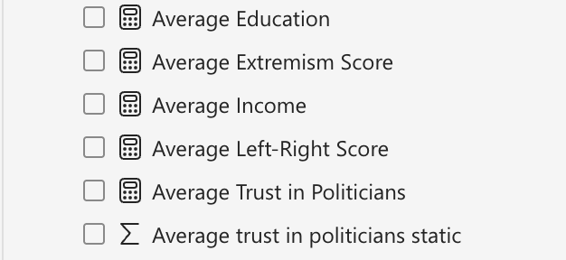

Data Decisions:
From this dashboard, governments can make multiple decisions:
  - Based on the gauge chart, which benchmarks each country’s trust in politicians against the European mean, the EU can identify low-performing countries and provide cross-national support from countries with higher trust to improve outcomes.
  - Based on the horizontal bar chart, there is a positive correlation between internet use and trust in politicians. Governments should prioritise engagement through online channels to increase transparency and encourage more democratic participation.
  - The dual line chart highlights that lower income is associated with both lower education and less trust in politicians. Knowing this, governments should sponsor outreach programs in low-income areas in their countries to address the low-trust issues. Reducing marginalisation of low-income voters could lead to more representative voting of their views (OECD, 2024).
  - The segmented bar chart reveals that extremist scores have a negative correlation with education. To reduce harmful extremist attitudes, policymakers can invest in civic and social education programs in lower-education/lower-income areas. Reducing susceptibility to extremist and populist ideologies can boost social cohesion and reduce social unrest (Mercy Corps, 2022).
  - From the area chart, extremist scores tend to fall with moderate internet users but rise again among heavy users. Governments can implement stricter rules on social media companies to combat extremist content and misinformation campaigns to increase digital safety and avoid creating harmful echo chambers that lead to catastrophic events, e.g., school shootings (Ferenczi, N. et al. 2021).

Details of the Dashboard Design:
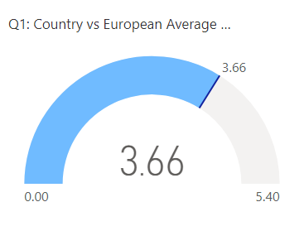
A gauge chart was selected to benchmark each country’s average trust against the European average, allowing for immediate identification of under-/overperforming nations. This design allows for an easy comparison through a single KPI.

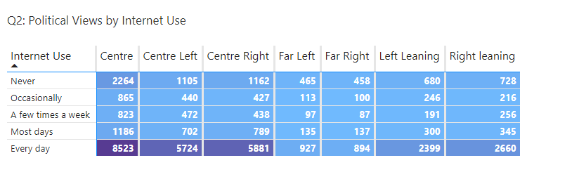

A heat-map conditioned matrix visualises internet use frequency and political self-placement. As the light blue turns to purple, the more people are in that intersection. This chart reveals to policymakers that most people use the internet every day and consider themselves to be centred politically, which allows for focused digital-policy outreach.

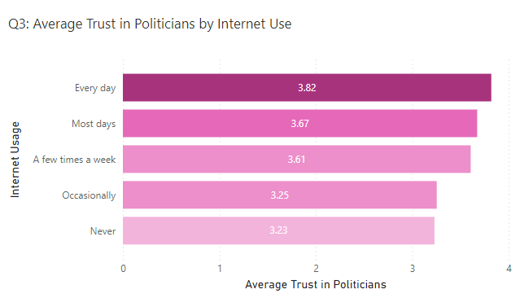

A horizontal bar chart conveys respondents’ average trust in politicians by their internet use. The gradient and orientation allow for improved readability between the ordered groups. Using mean values opposed to counts, the graph suggests a positive correlation between internet use and trust in politicians.
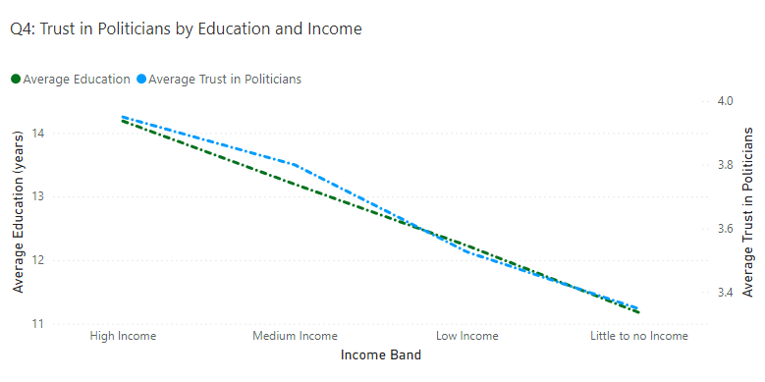

This dual-line axis chart compares the trends in both average education and average trust in politicians across different income bands. The dual-line chart effectively shows policymakers the co-movement between socioeconomic and attitudinal variables. The simultaneous decline in education and trust at lower income levels highlights a real need for targeted civic-education initiatives.
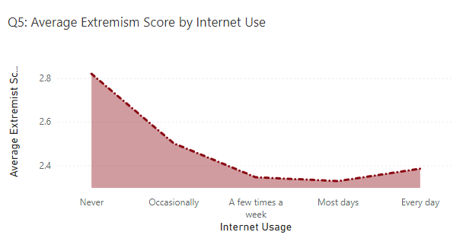

An area line chart was chosen to show the variation of extremist views across internet-use categories. Compared to a standard line chart, the filled area highlights the difference in magnitude between categories, showing a distinct U-shaped pattern. This pattern supports the need for risk-profiling analysis when governments are creating digital safety policies.

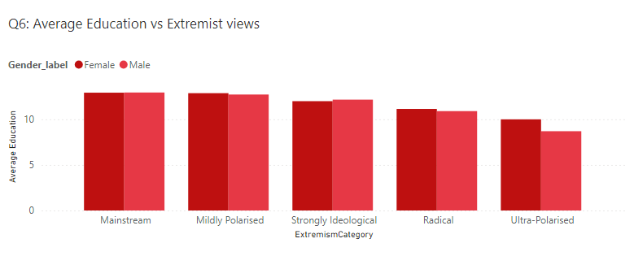

A segmented bar chart compares the average education of respondents with their extremist views. This elucidates the negative correlation between education and extremist views. The graph is also segmented by gender, revealing that females are marginally more extremist on average than men. The design of this graph allows for communicating group disparities whilst maintaining visual simplicity.

All graphs use a combination of average measures and ordinal categories that are descriptively labelled and ordered. This labelling enhances readability and lets the users know exactly what the graph is measuring and representing. A tooltip is also included to give the user a quick summary of the most important measures used in the report. A slicer is available to drill down through the specific countries for enhanced analysis.
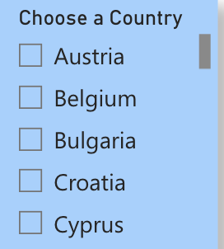 | 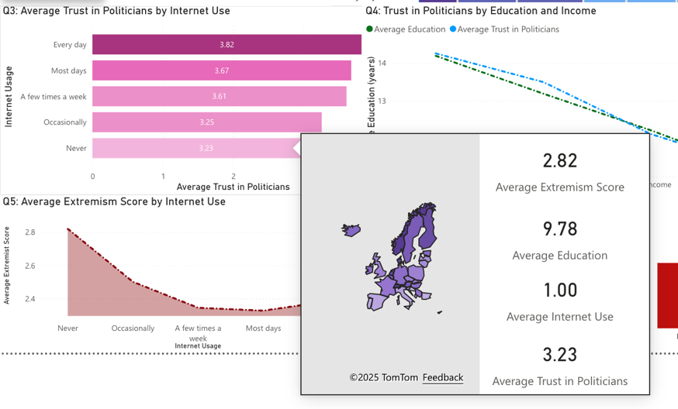
Country Slicer | Tooltips

Conclusion
Data visualisation and the descriptive analytics it visualises are extremely important in an ever-increasing data driven world. By following basic design principles, it is possible to create dashboards that track and measure KPIs which enable more efficient and correct decision making in business environments and beyond. After cleaning and transforming the data, I created a dashboard representing the variable trust in politicians across Europe using the ESS. My graphs show how trust in politicians changes depending on the education, income, and internet use of individuals. Finally, by using my dashboard I listed several ways in which governments could use the information presented to make decisions which would increase societal welfare.

[References]
- Ferenczi, N. et al. (2021) Cultural Drivers of Radicalisation in the UK. UK/D5.1 Country Report, D.Rad [D5.1]. UK: doi: 10.5281/zenodo.6385520. [Accessed 20 October 2025].
- Martins, N., Martins, S. and Brandão, D., (2021). Design principles in the development of dashboards for business management. In Perspectives on Design II: Research, Education and Practice. 353-365.
- Mercy Corps, (2022) Mobilising communities to build social cohesion and reduce vulnerability to violent extremism, Mercy Corps. Niger: Available at: https://europe.mercycorps.org/en-gb/research-resources/communities-social-cohesion-violent-extremism?.com [Accessed: 25 October 2025].
- OECD (2024), OECD Survey on Drivers of Trust in Public Institutions – 2024 Results: Building Trust in a Complex Policy Environment, OECD Publishing, Paris, https://doi.org/10.1787/9a20554b-en. [Accessed 23 October 2025].
- Richardson, V., (2020) Data analytics for accounting. NY: McGraw-Hill US Higher Ed ISE.
- Unwin, A., 2020. Why is data visualization important? what is important in data visualization?. Harvard Data Science Review, 2(1).

