**EC2 Instance - Windows**

**Steps to Create EC2 Windows Instance in the AWS Console (Web Portal)**

**STEP 1**

Login to [AWS Console](https://signin.aws.amazon.com/signin?redirect_uri=https%3A%2F%2Fconsole.aws.amazon.com%2Fconsole%2Fhome%3Fstate%3DhashArgs%2523%26isauthcode%3Dtrue&client_id=arn%3Aaws%3Aiam%3A%3A015428540659%3Auser%2Fhomepage&forceMobileApp=0&code_challenge=DQPPPPwJLFPYXZ). using your Administrator account

**STEP 2**

After login successfully, you are on the dashboard page. Select ‘**Services’** from the top navigation bar and click ‘**EC2’** under the category ‘***Compute’***.

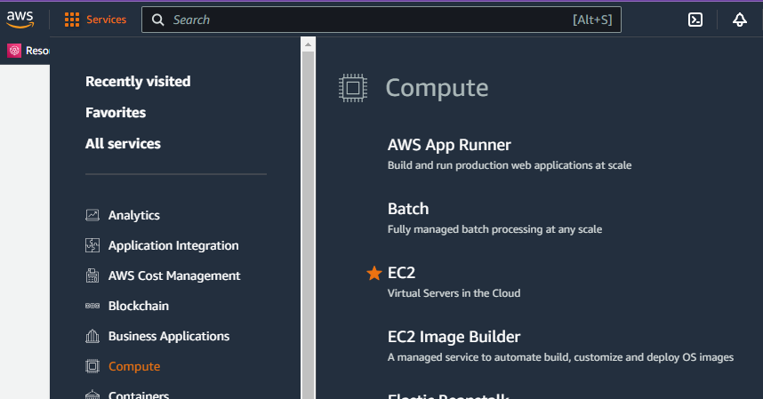

**STEP 3**

On the EC2 instance dashboard page, select N. Virginia as your region.

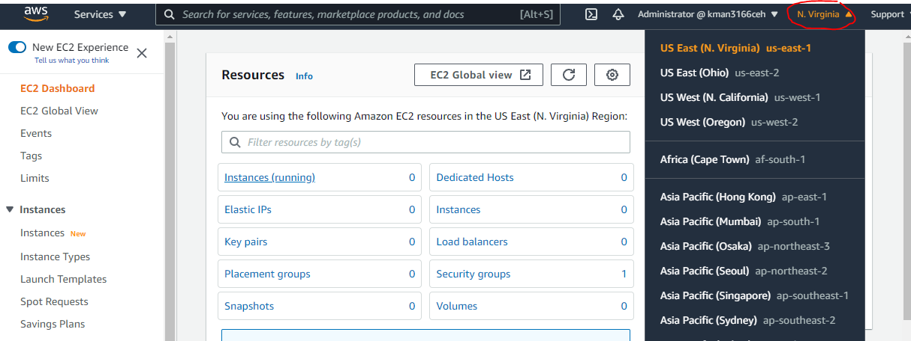

**STEP 4**

Scroll down, and in the ‘***Launch Instance****’* area, check that the selected region appears below the “Launch Instance’ button. Click on the ‘**Launch Instance**’ button.

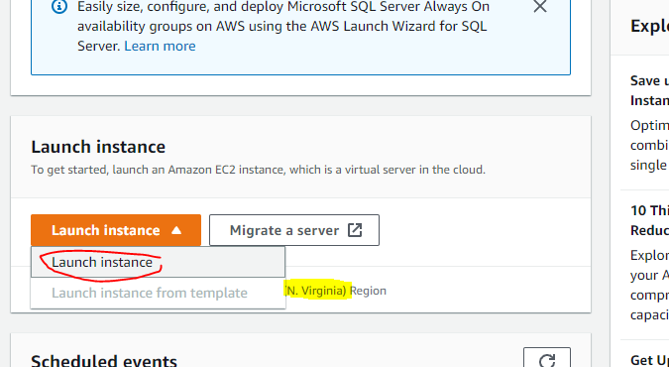

**STEP 5**

Under **Name and Tags**, type **yourlastname-WinSvr1** in the field.

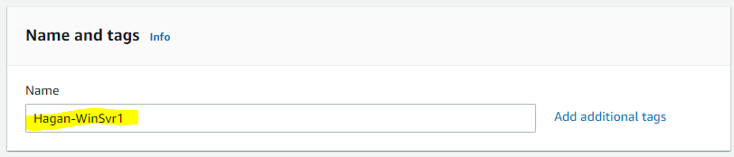

**STEP 6**

Under **Application and OS Images (Amazon Machine Images)**, select **Windows** under *Quick Start*.

Under **Amazon Machine Images (AMI)**,select *Microsoft Windows Server 2019 Base (Free tier eligible)* from the drop down. **(Don’t select 2019 Core Base)**

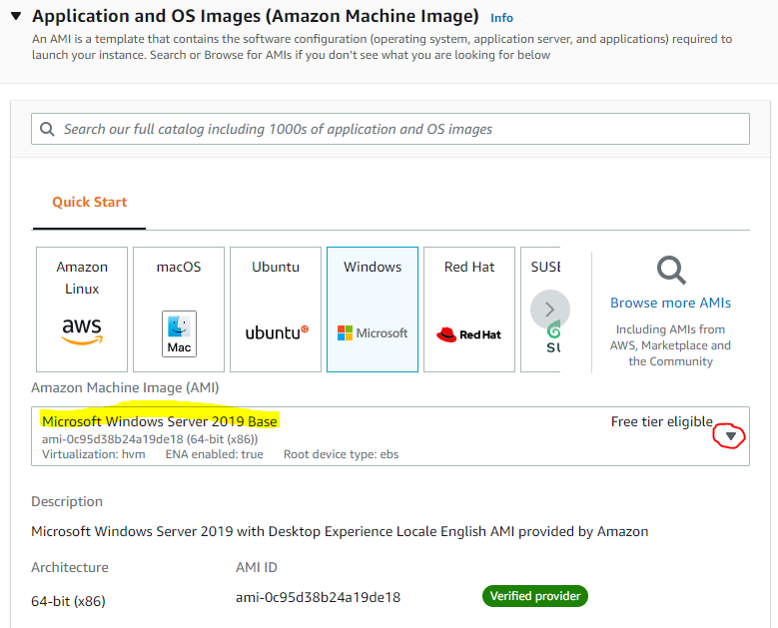

**STEP 7**

Under **Instance type**, make sure it *t2.micro Free tier eligible*.

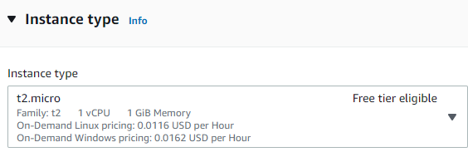

**STEP 8**

Under **Key pair (login)**, select *Create new key pair*.

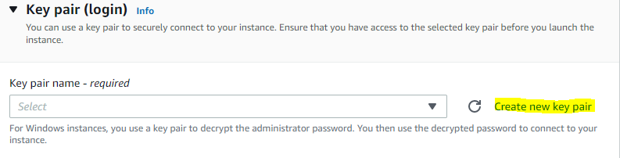

In the **Create Key pair** window, type in yourlastname-WinSvr1-key as the *Key pair name* and leave the format as *.pem* . Click the **Create key pair** button. Save *yourlastname-WinSvr1-key.pem* file to the directory of your choosing. This will be retrieved later.

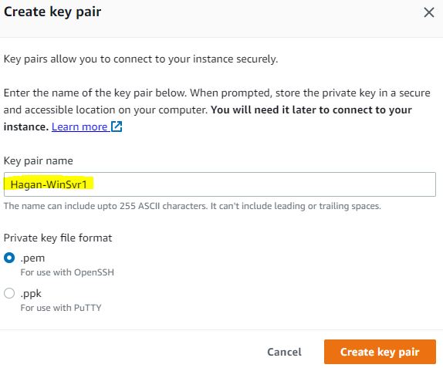

**STEP 9**

Under **Network settings**, click the **Edit** button on the right. In the *Security group name – required* field, type in *yourlastname-WinSvr1-sg*. Make sure *Allow RDP traffic from* and *Anywhere 0.0.0.0/0* are showing by default.

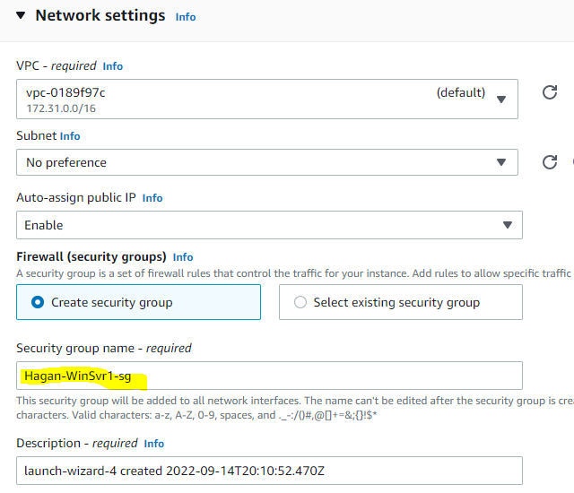

**STEP 10**

Under **Configure storage**, leave as is.

**STEP 11**

Scroll to the bottom and click the **Launch instance** button.

**STEP 12**

Scroll down the page and click on the ‘View Instances’ button.  
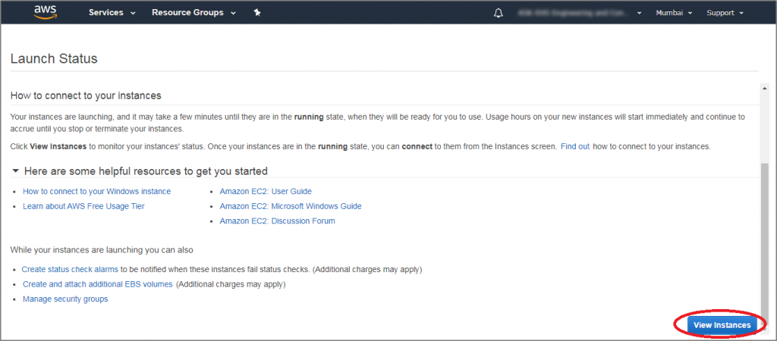

**STEP 13**

All the available instances are displayed. The following image shows your instance is initializing. Wait until status checks have completed. You can refresh periodically if necessary.  
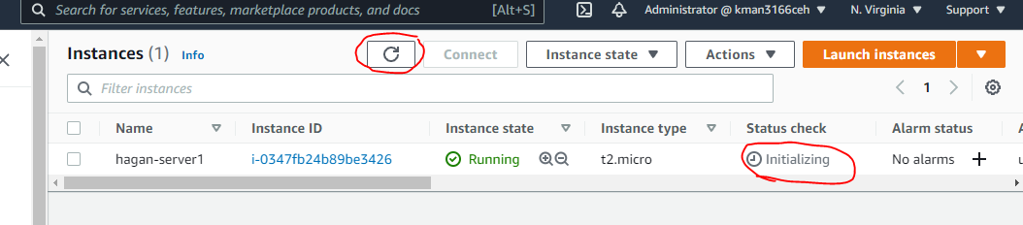

**STEP 14**

The new instance is shown running in the list of instances.  
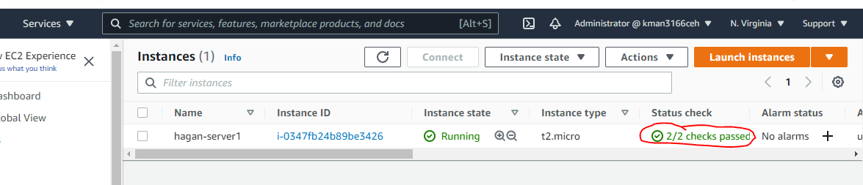

**STEP 15**

Check the box next to the newly created instance and click on the ‘**Connect’** button.

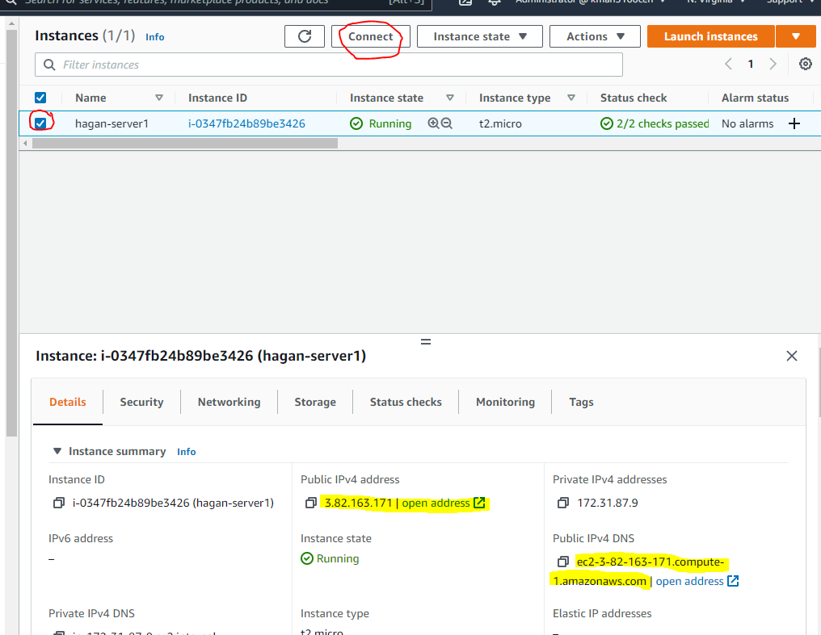

**STEP 16**

In the ‘Connect to your instance’ window, click **RDP client** and then ‘**Download the Remote Desktop File**’ button to download the RDP file. Save it on your computer.   
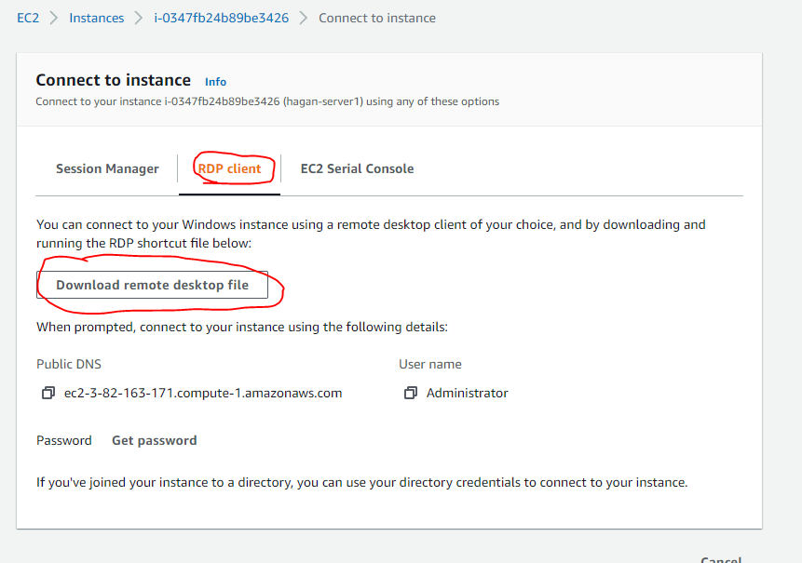

**STEP 17**

Click the ‘**Get Password**’ button.

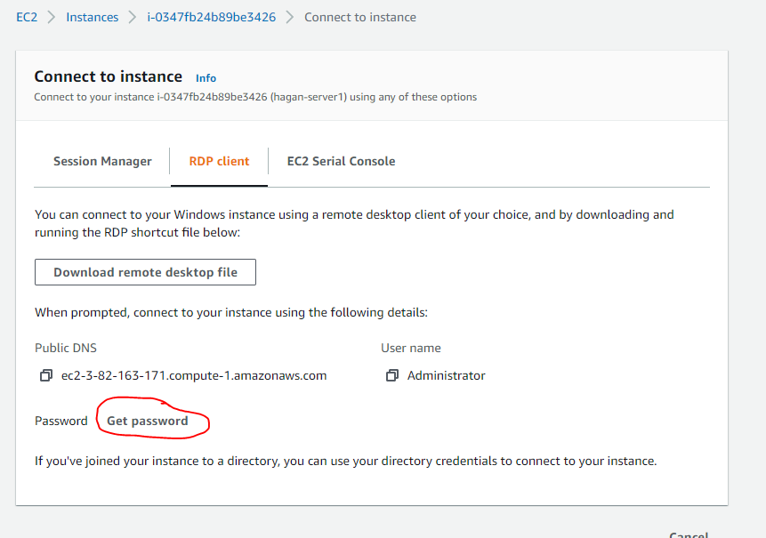

**STEP 18**

In the Get Windows Password window, click on the ‘**Browse’** button and select the already downloaded key pair file. Once you key is in the window, click on the ‘**Decrypt Password**’ button.

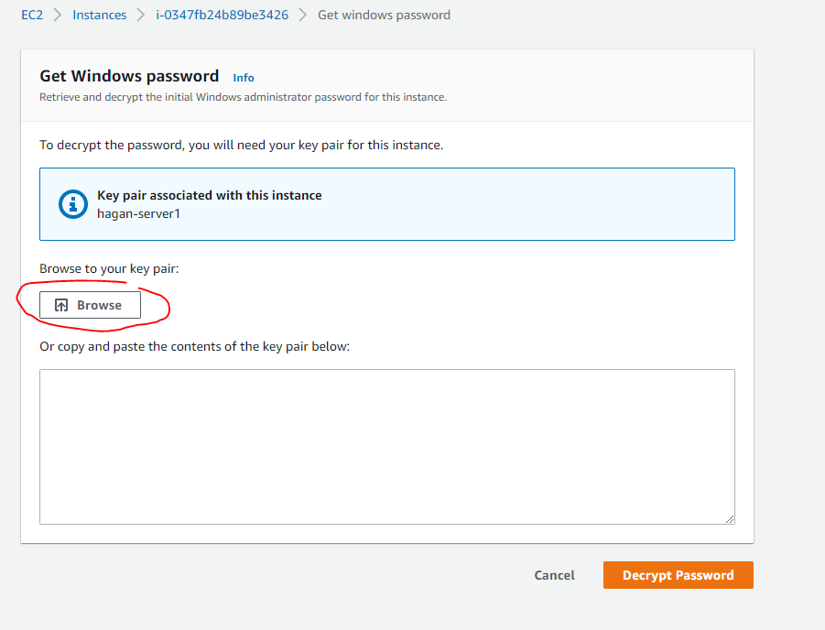

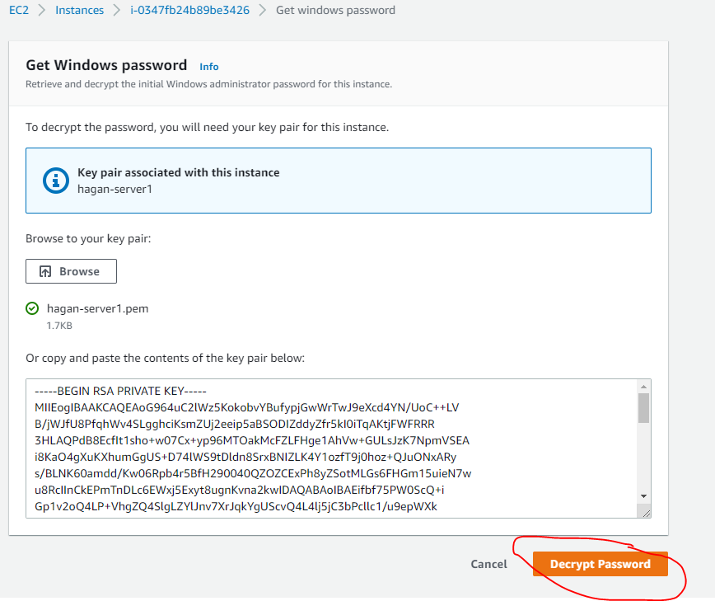

**STEP 19**

The decrypted password will appear. Open Notepad or any text editor. Copy the Password and paste into editor. Save this txt file. Click the ‘**Cancel’** button.

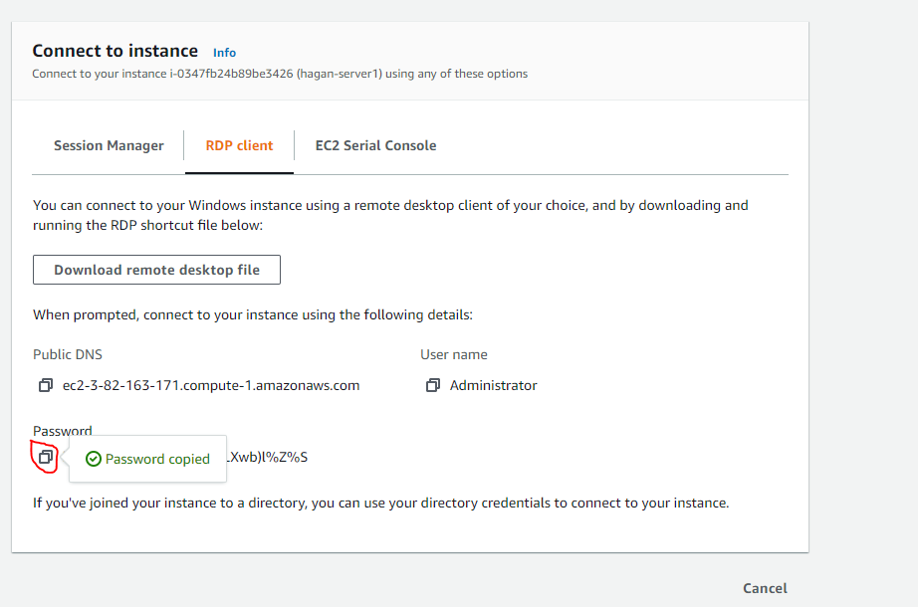

**STEP 20**

Now, go to your downloaded RDP file. Run it by simply clicking on it. The RDP software prompts to connect with EC2 instance. Click the ‘Connect’ button. In the popped up ‘Windows Login’ window, paste the previously copied password from the AWS console and click the ‘OK’ button. It will start to establish connections with the AWS EC2 instance. MAC user will need to download Microsoft Remote Desktop for Mac and install it (<https://apps.apple.com/us/app/microsoft-remote-desktop/id1295203466?mt=12>). Run it and supply the *Public IPV4 Address* in **Step 15** to access the instance.

See screenshots below:

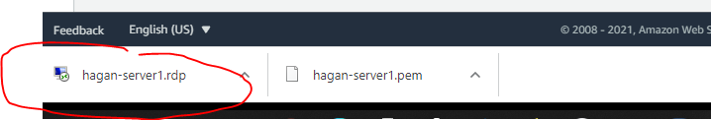

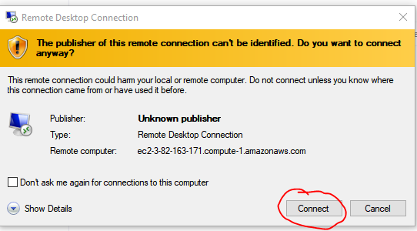

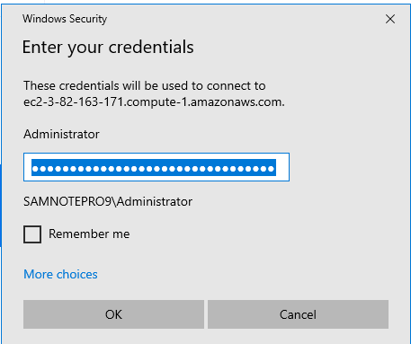

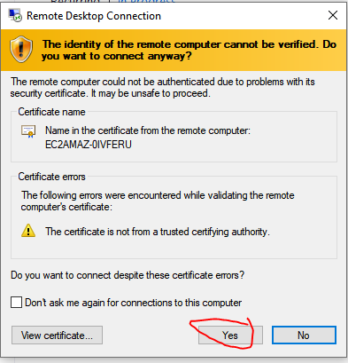

**Step 21.** Once logged in successfully, upload in Bb for credit the screenshot below. The screenshot must include what’s in the red circle.

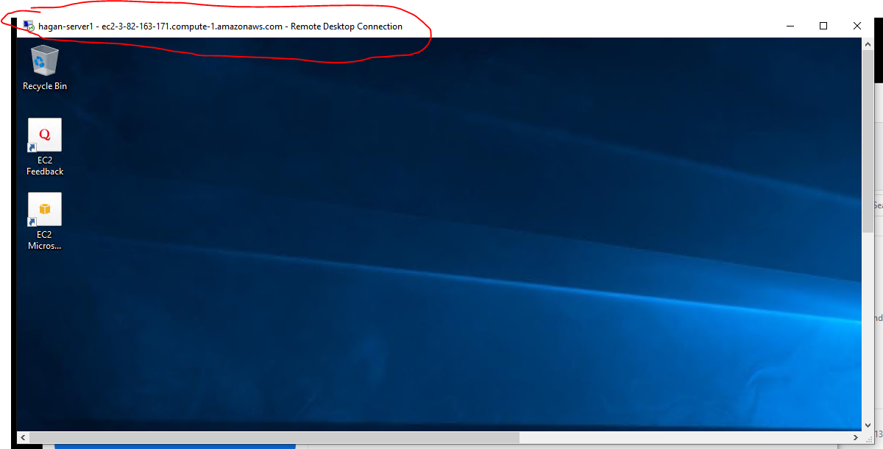

**Step 22**.

Return to the AWS console. Under *Instances*, select **yourlastname-WinSvr1** and then the *Instance State* dropdown. Select **Terminate Instance** to delete server. Click the **Confirm** button.