**Azure – Create a Virtual Machine**

In order to access Azure, you will need to create an account. This will be a student account so you will not need a credit/debit card to setup you account. If you have an account already, you can proceed with the lab. If your Student free account has expired (12 months free), you can setup an account using a credit/debit card for 12 months free using a personal email.

To create a student account, follow the instruction in the following link:  
<https://docs.google.com/document/d/14fCB4YQY7B6NaMafzsQAfBZ1mTGqpHYh4QvIfJ79d_o/preview>

1. Log into your Azure account.
2. Enter **virtual machines** in the searchbox at the center top.
3. Under *Services*, select **Virtual machines**.
4. In the *Virtual machines* page, select **Create** and then **Azure virtual machine**. The Create a virtual machine page opens.
5. Under *Project Details*, choose your **Subscription**. For most of you it will be ***Azure for Students***. Create a New **Resource group** called ***yourlastname-WebSv1-rg***.
6. Under *Instance details*, enter the following:  
   **Virtual machine name** - yourlastname-WinSvr1   
   **Region** – *Any US region*   
   **Availability options** – No infrastructure redundancy required  
   **Security type** – Standard  
   **Image** – Windows Server 2019 Datacenter – Gen2  
   **Size** – Standard_DS_1 – 1 vcpu, 3.5 GiB memory
7. Under *Administrator account*:  
   **Username** – *yourlastname-adminacc1*  
   **Password** – you choose and confirm
8. Under *Inbound port rules*:  
   Select RDP and HTTP from the dropdown
9. Click on the **Next: Disk** button
10. Under *OS disk*:  
    **OS disk type** - Standard SSD  
    **Delete with VM** – checked
11. Under **Data disk for *yourVM***, click **Create and attach a new disk**.
12. Click on **Change size**. For **Storage type**, choose *Standard SSD* and make sure *1024GiB* is selected. Click **OK**. Check **Delete disk with VM**. Click the **OK** button. You sure now see a disk under **Data disk for *yourVM***.
13. Click on the **Next: Networking** button and leave defaults.
14. Click on the **Next: Management** button and leave defaults.
15. Click on the **Next: Monitoring** button and leave defaults
16. Click on the **Next: Advanced** button and leave defaults
17. Click on the **Next: Tags** button and leave defaults
18. Click the **Review + create >** button (the one to the right of **< Previous** button)
19. Make sure you have the green check with Validation passed and review your VM setting. Click **Create**.
20. The Deployment is in progress screen will show for a few minutes.
21. Once the Your deployment is complete shows, make sure the Deployment detail list your newly created resources.
22. Click on the **Go to resource** button. This screen should look somewhat familiar. **Screenshot (the top part of this under Essentials) under the heading Screenshot1 and paste into a Word doc called yourlastname-AzureVM-Lab.docx**.

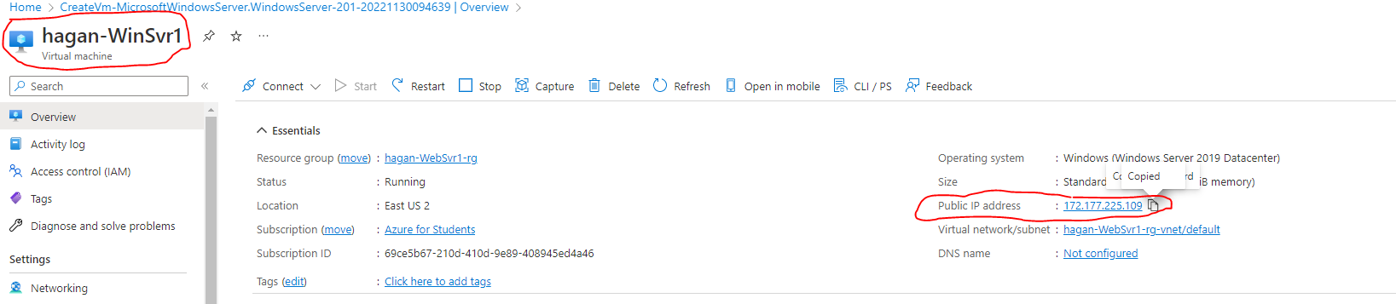

1. Under *Essential*, go over to **Public IP Address**. When you hover your mouse over it, a *Copy to Clipboard* icon should appear to the right. Click on it to copy the IP.
2. Open Remote Desktop (use whatever RDP client for Mac) and paste in the IP address. Type in your username and password to login.
3. After logging in and Server Manager comes up, click on Local Server on the left. **Screenshot this under the heading Screenshot2 and paste into a Word doc.**

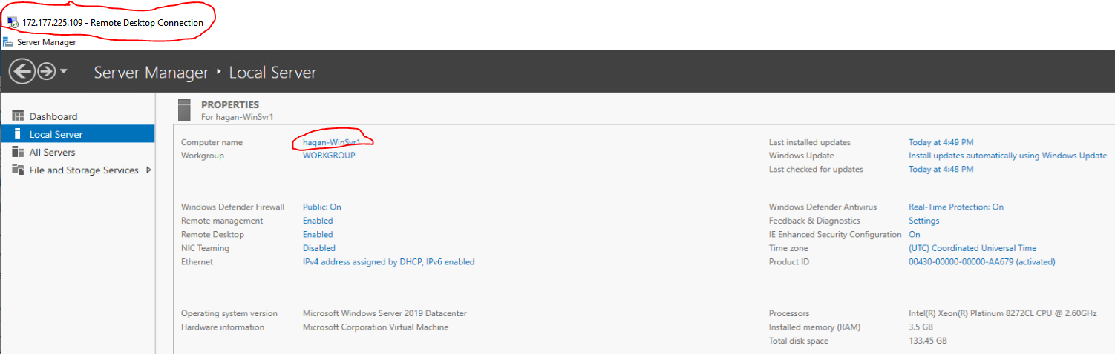

1. On Server Manager, click on **File and Storage Service** then **Disks**. **Screenshot this under the heading Screenshot3 and paste into a Word doc.**  
   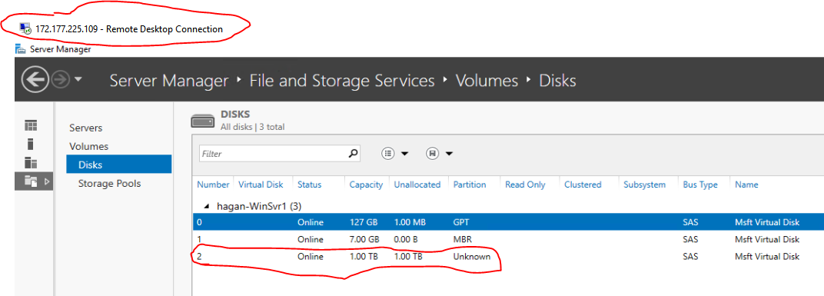
2. Close Server Manager.
3. If you’re not attempting the extra credit, power off the server as you would any Windows machine.
4. Go to the Azure console and click **Stop** to shutdown your instance if you didn’t shut it down from the RDP window.
5. Click **Delete** to remove this VM.
6. **Save your Word doc and Upload to Bb**.

**Extra Credit**

1. On the Server, install the Web Server role using Powershell. (Figure it out!!!)
2. Once the web service has been installed go to the **C:\inetpub\wwwroot** directory and open the **iistart.html** file in NotePad.
3. Under the <title> tag, add the line **<h>yourlastname Web Server</h>**.  
   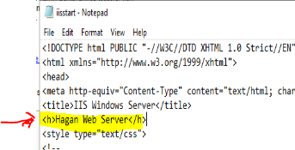
4. Save the file.
5. Test the Web Server by putting the IP address (the same one you used for RDP) into an Incognito (Private) browser tab of your host PC (**NOT THE WINDOWS SERVER**). **Screenshot this under the heading Extra Credit and paste into a Word doc.**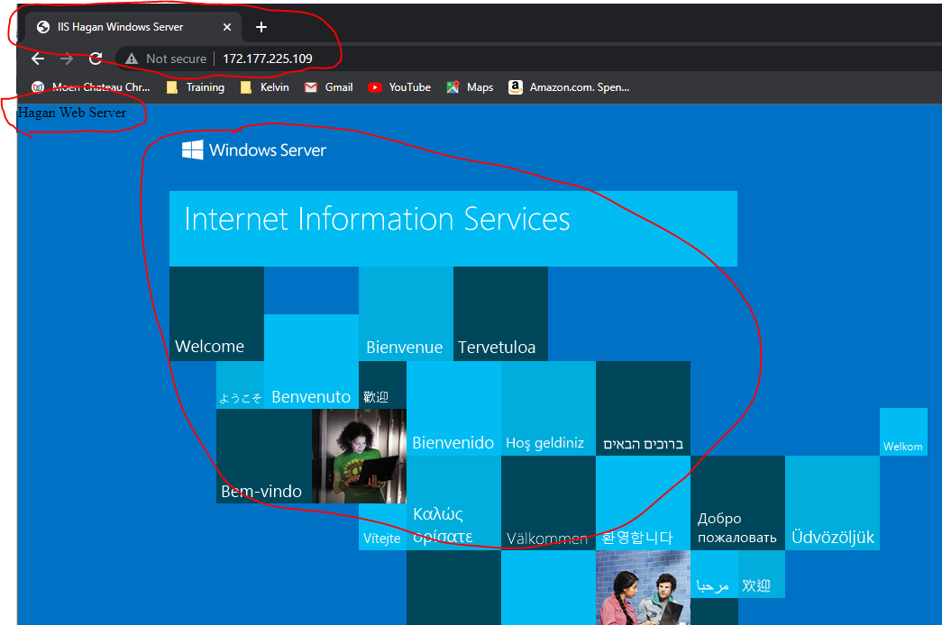
6. Do Steps 28 – 30 from the previous section to wrap-up.