Blue Springs Hotel – Web Project

# Overview

## Web Technologies

For this project, we will need a suitable coding IDE, design software, and multiple coding languages.

Firstly, the coding languages we will use are HTML, CSS and JavaScript.

HTML is the language we will use for the basic webpage and content.

CSS will be used to control the style and layout of the web pages.

JavaScript will be used to give specific pages interactivity & ability to send/receive data from a database.

The IDE (Integrated Development Environment) that we will use on this project is Microsoft Visual Studio Code. It is a flexible IDE that includes helpful features like automatic language markup for readability, and GitHub extensions, which provide version control and easy access to the project from multiple locations.

There are several options for the design software that we can use for this project. A few that stand out are:

* Canva – A graphic design platform that can handle a variety of design tasks, including webpage design.
* Adobe XD – A vector-based design tool for creating wireframes and prototyping.
* Figma – A popular tool for website design and prototyping.

## Requirements

1. This website requires seven pages, see the case study for the required content.
2. index.htm. The design will contain:
3. the logo
4. navigation to other pages can be done in a way different to the other pages. You can be creative.
5. acknowledge.htm
6. staff.htm. Popup pages will be generated using CSS and do not require a design at this point.
7. cossack.htm
8. interest.htm
9. activities.htm
10. guestbook.htm
11. Each page other than index.htm will have:
12. a header at the top with a heading and the provided logo
13. a nav section beneath the header which navigates between pages
14. a main section which contains the relevant information
15. The main section of guestbook.htm will have a form at the top to allow guests to enter reviews and a table underneath listing reviews from the last 10 guests
16. The guestbook form requires a JavaScript that tests
17. whether each field has been completed
18. no field contains the text “<”

## Prototype

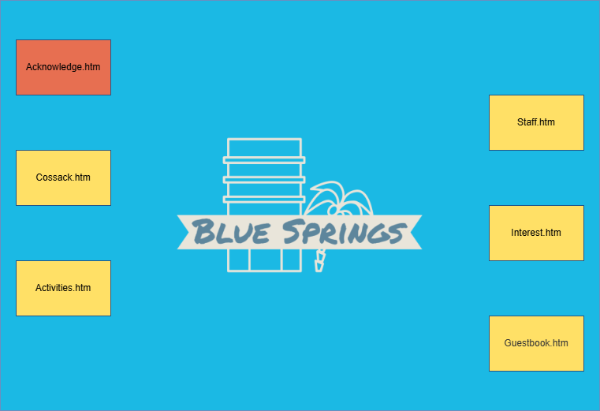

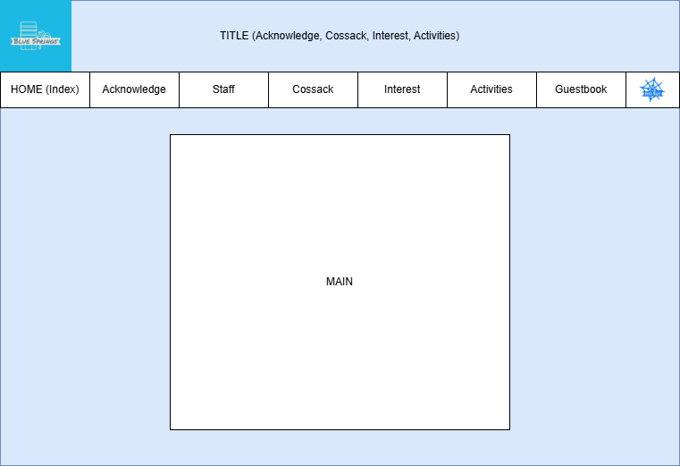

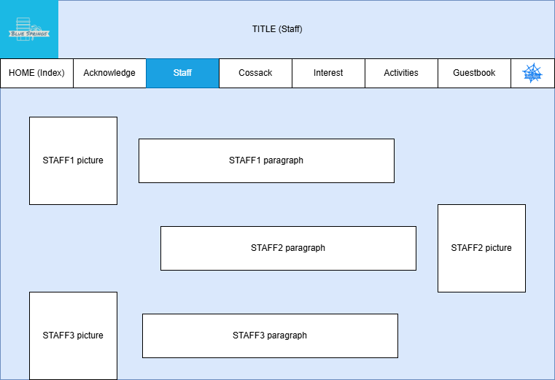

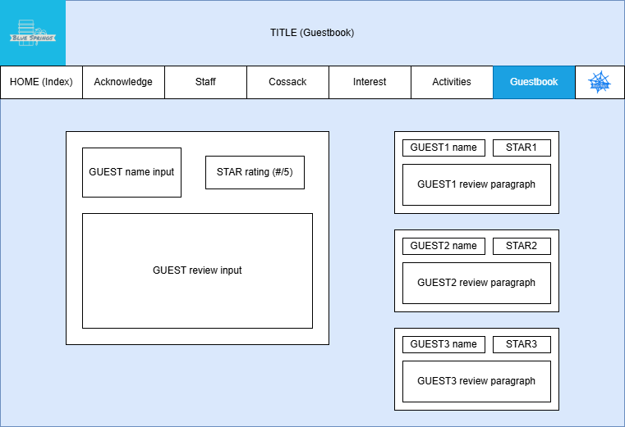

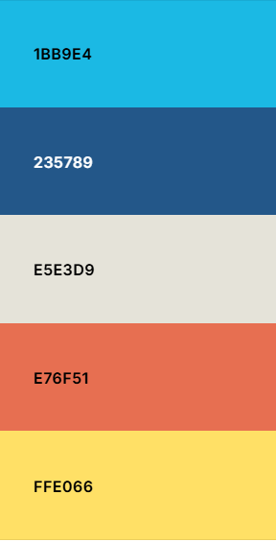

Proposed colour scheme

1BB9E4 (Aero)

E5E3D9 (Alabaster)

235789 (Lapis Lazuli)

E76F51 (Burnt sienna)

FFE066 (Naples yellow)

8AA5B1 (Cadet grey)

Font to be used:

Roboto – Sans serif, minimalistic, web safe.

## Communication

## Review notes

Try to use contrast as opposed to different colours for buttons – this will improve colour-blindness accessibility

Keep the client in the loop, make sure they are happy with every iteration. If you don’t, you risk them being unhappy with the final design, which will require further work, or loss of the client.

Don’t teach the client how things work, as this can lead to scope creep.

## Final Draft Design

