**Which Neighborhood to Invest in a Restaurant?**

Robert Hosack

August 7, 2020

**Introduction:**

In this first section of the project, I will be the lead consultant in helping an investor/ entrepreneur find the best location for their new restaurant.

Deciding where to setup a restaurant is a large financial commitment and can be very risky if not executed properly.

The aim of this consultation is to provide an analysis for the investor to discover where they would have a greater probability of success based on the recommended neighborhood location of their new restaurant.

**What We're Trying to Solve**

The purpose of this project is to find the best neighborhood for the investors' new restaurant. We will be exploring an ideal location based on factors such as:

- Distance to competitors

- Existing opportunities within neighborhoods

**Location**

We are exploring regions within Toronto, Canada. This is a very diverse community, which correlates with a plethora of dining choices.

**The Data:**

Here is a link to the data: [https://en.wikipedia.org/wiki/List\_of\_postal\_codes\_of\_Canada:\_M](https://en.wikipedia.org/wiki/List_of_postal_codes_of_Canada:_M" \t "_blank)

The analysis will be utilizing the Toronto dataset, which was scrapped from the link above on Week 3 of this course. The dataset will consist of neighborhoods, boroughs, postal codes, latitude, longitude, and venue information.

### Foursquare API

Data will be acquired about various venues from different neighborhoods. The Foursquare tool will be utilized, as it provides location data along with information about the venue within the selected area. Included information provided are as follows:

\* Venue Names

\* Locations

This will be the only data source that is used since all required information is obtainable through the API.

We will connect the Neighborhoods with the Foursquare API to procure information about venues (restaurants) inside each neighborhood.

The data output from Foursquare contained information regarding venues and their specific distance from the neighborhood coordinates. The information gathered per venue was as follows:

1. Neighborhood

2. Neighborhood Latitude

3. Neighborhood Longitude

4. Venue- Restaurant

5. Name of the Venue

6. Venue Latitude

7. Venue Longitude

8. Venue Category

**Methodology:**

### Foursquare

This analysis would use Foursquare API as its primary source for gathering data. Their database has millions of places; specifically, their Places API component, which allows for the ability to perform searches based on location and venue.

### Cluster Approach

To see where these existing opportunities for a new restaurant may be located, we decided to explore restaurants in different neighborhoods, segment them, and group them into clusters. This will be accomplished by machine learning- specifically, the k-means clustering algorithm.

The K-Means Clustering approach was utilized, which aims to partition “n” observations in “k” clusters in which each observation belongs to a cluster with the nearest mean. The cluster center is also known as the centroid.

After the K-Means was completed, each of the clusters were examined to fine tune the analysis.

### Libraries used in this Analysis

Pandas: Creating and manipulating dataframes

Folium: Python visualization library would be used to visualize the neighborhoods cluster distribution

Scikit Learn: For importing k-means clustering

JSON: Library to handle JSON files

Geocoder: To retrieve Location Data

Requests: To scrap and handle URL requests

Matplotlib: Python Plotting Module

**Discussion and Results:**

The image below is of Toronto and the results of the K-Means cluster analysis separated into 5 clusters.

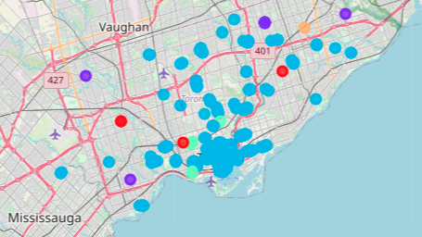

University of Toronto

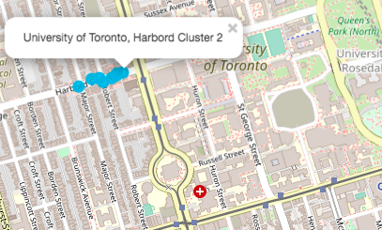

Church and Wellesley

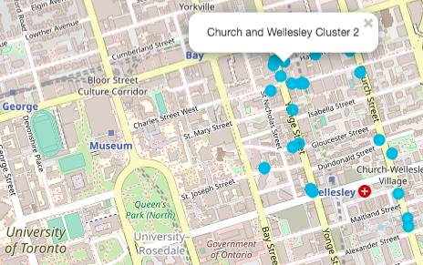

Central Bay Street

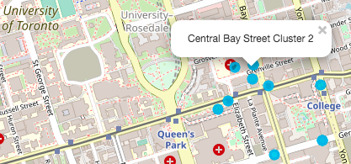

Based on total restaurant venues and their locations returned by Foursquare API, we see a very high concentration of restaurants near Commerce Court and First Canadian Place found in Old Toronto. We would not recommend investing in these areas, as the competition would be too great. There are many diverse restaurants to choose from along with multiple options per Venue Category.

Neighborhoods that have a single restaurant will not typically bring the amount of foot traffic needed to be successful. Neighborhoods with a single restaurant such as Agincourt, Wexford, West Deane Park, South Steeles, and Glencairn for example would be locations that we would recommend avoiding at this time.

There looks to be an opportunity to invest in a restaurant near the University of Toronto. We would recommend a low to medium price point on menu items if deciding to invest in a restaurant with close proximity to the college. Higher priced menu items may exclude a large portion of the customers in the area.

Another compelling location is Central Bay Street, which is in walking distance to Queens Park (South) and a local hospital.

The Church and Wellesley location is very similar to Central Bay Street; however, it is on the North side of Queens Park.

Below is a table of Restaurant Venues per Neighborhood. In this table, we are showing the extremes, which range from isolated to too much competition.

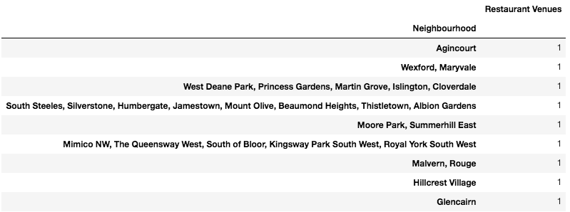

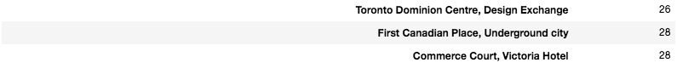

**Conclusion:**

Based on the findings of this analysis, we can conclude the following top 3 locations to our client based on restaurant locations per neighborhood. These sections of Toronto still show an opportunity to capitalize on the restaurant market share.

* University of Toronto
* Central Bay Street
* Church and Wellesley

While this analysis was not intended to select which type of restaurant to open/invest in, we do suggest additional analyses if the investor has not decided this factor yet.