Robert Anderson

000380293

Lab 1

Lab Status – Working ( No test plan, unsure of how to write test plan in ASP.NET)

What I learned:

1. Learned how to set up a bare authentication app using ASP.NET
2. Have a basic understanding of the “magic” that is created through the automatic generation provided by visual studio. My co-op works with angular and I see many similarities between the two now.
3. Learned how to set roles for authorization that can be connected to controllers within the project.

What needs work:

1. My understanding of asp.net in general is weak, I did not take the previous course so I feel like I need to do a lot of catch up.
2. Writing testing plans is a major weakness of mine. I understand that the Enterprise version can assist in this but I need to find some spare time to dig into this as it is clearly a portion of the lab requirements.
3. Time management is a huge issue I have right now. I am working part time for my co-op and I always feel like I'm either neglecting work or school. It is a horrible feeling.

Screenshots:

1. Unauthorized/Not logged in user has no access to the team controller at all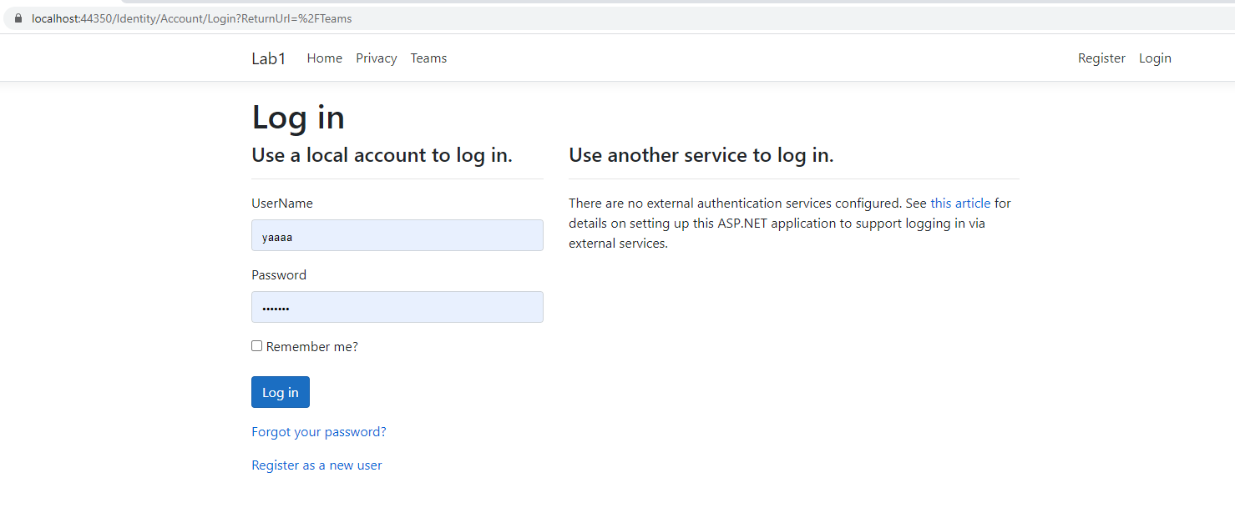
2. Player is logged in, able to view the GET from team controller

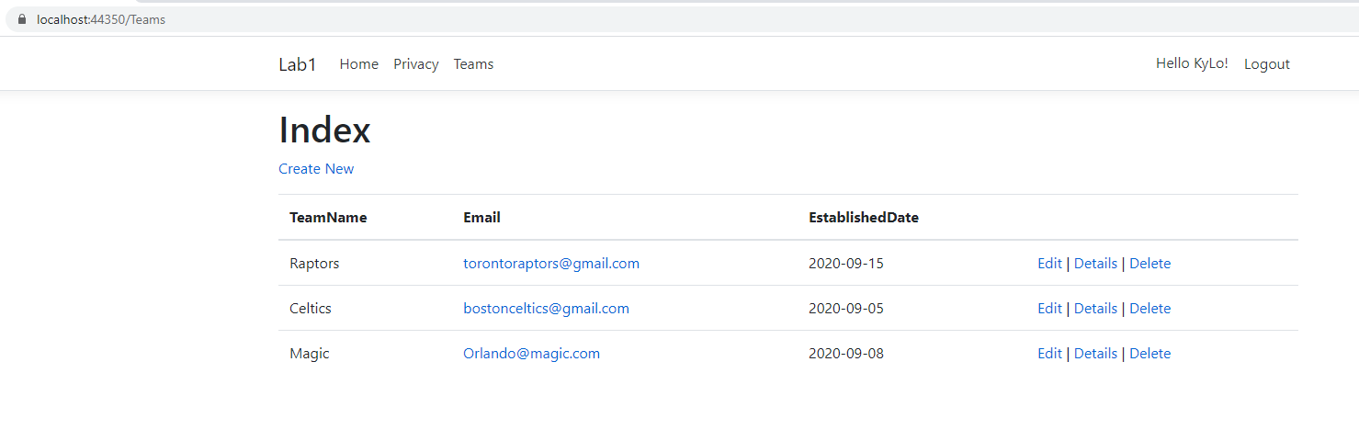

1. Player is logged in, unable to EDIT from team controller

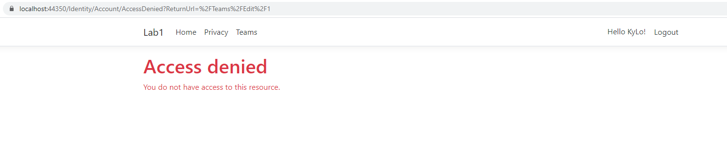

1. Player is logged in, unable to CREATE from team controller

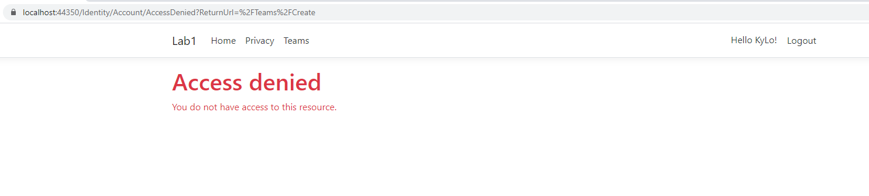

1. User that is logged in, not a PLAYER or MANAGER is unable to view index from team controller

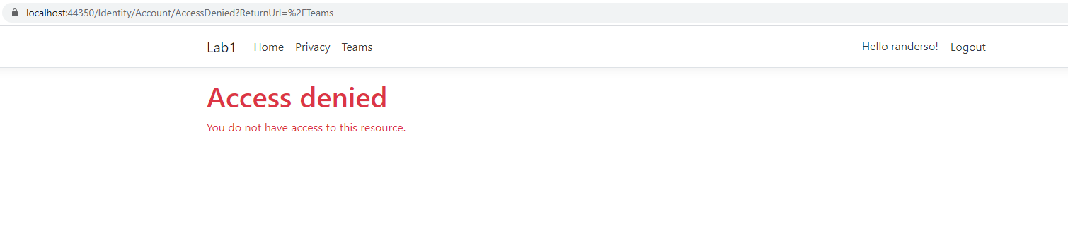

1. User given MANAGER role viewing index from team controller

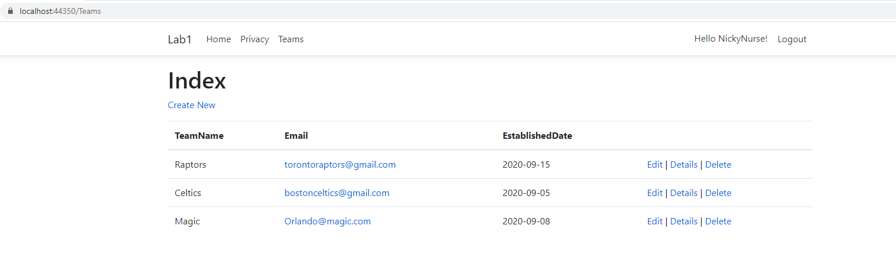

1. User given MANAGER role viewing CREATE from team controller

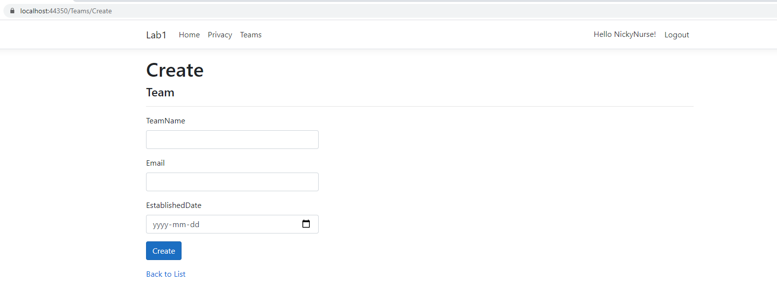

1. User given MANAGER role viewing DELETE from team controller

